Friendship News, May 2022
First Congregational United Church of Christ, Brainerd
An Open and Affirming Congregation
The Church Office Winter Hours: Wednesdays – Fridays from 10:00 am – 1:00 pm
Pastor Leslie’s Drop-in Hours: Wed. 2:00pm – 4:00pm, Friday 11:00am – 1:00pm
Office phone 218-829-2528 Office E-mail uccbrainerd@gmail.com Pastor’s E-mail: pastorleslieucc@gmail.com Website: www.uccbrainerdmn.org
Schedule a 1 to 1 (in-person or by Zoom or Phone) with Pastor Leslie:
www.calendly.com/pastorleslieucc/1to1
No matter who you are, or where you are on life’s journey, you are welcome here.
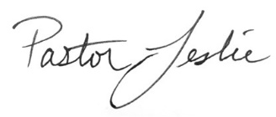
“May is mental health awareness month. In that spirit, I share with you this article by the Rev. Sarah Lund. Rev. Lund serves on the national staff of the United Church of Christ as Minister for Disabilities and Mental Health Justice. She also serves as senior pastor of First Congregational UCC of Indianapolis, Indiana.”

Go Live the Resurrection by Rev. Dr. Sarah Lund
Did you know that psychiatric medications have the power to raise the dead? I am a witness! It is my testimony that we can find new life with the help of anti-depressants, hospitalizations, and outpatient treatment. I am here to glorify God, rising from the tomb of trauma through the power of ongoing therapy.
Resurrection comes to us in the form of recovery and treatment for mental health conditions. This is the good news: there is help and hope for people living with mental health challenges and illness. As the Church, we can proclaim the truth of the Gospel of Jesus Christ: there is no shame in being who we are, no matter what our mental health status might be on any given day, because we are created in the image of God and God loves us.
People living with mental health challenges and their loved ones are Easter People. We are people who have been through the valley of the shadow of depression. We have carried the cross of mental illness. We have laid in the silent tomb of suicide loss. And, by God’s grace, we rise from the grave of despair and into a hope-filled new day.
Our world is hurting emotionally, psychologically, and spiritually. It is the Church’s mission to respond to the world’s profound pain with ministries of healing, wholeness, and love. The Spirit calls the Church to embody the resurrection power of God by creating communities of welcome, inclusion, support, and engagement for people with mental health challenges. Working together, we can dismantle the stigma and shame of mental illness.
I continue to give thanks to God for the UCC Mental Health Network’s ministries, showing us all how to become WISE (Welcoming, Inclusive, Supportive, and Engaged) for mental health, providing support and training for faith communities. Blessings to you, dear Easter people of God. Be the WISE people of God. Go live the resurrection
0

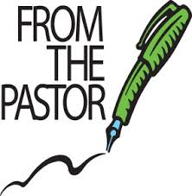
Out of the Office
Pastor Leslie will be out of the office from April 28th through May 3rd. She is attending the Next Generation Leadership Initiative (NGLI) training in Detroit.
0

First Congregational UCC News & Updates
>> Pastor Leslie will be out of the office for NGLI Continuing Ed from 4/28 - 5/3/22 <<
How to watch Sunday worship
The worship service is broadcasted on the church Facebook page every Sunday at 10:00 am.
To watch worship on Facebook, go to https://www.facebook.com/uccbrainerd/live
We are working with a new system for streaming are still working out the kinks for streaming to YouTube.
Worship Bulletins are available for download each week at http://tinyurl.com/UCCBrainerdBulletins. The bulletins will be ready for download first thing Sunday morning. They are available in both Word and PDF formats and are labeled by date. You can download the document and print it at home or follow along on your screen.
Financial Help Available
Your Church Council voted last year to allow the Pastor's Discretionary Fund to be used to assist church members and others in the Brainerd area who are experiencing financial distress during this time. We received many generous donations! If you need assistance, please email, call, or text Pastor Leslie. Let her know what your situation is and how the church might be of help.
You can now donate to the church online! We are now accepting your offerings and donations using PayPal. You do not need to have a PayPal account to make an online donation with a credit card. To use PayPal, go to: https://www.paypal.me/uccbrainerd

May Birthdays

Ellen Pishko May 3
Terri Chidester May 5
Lance James May 5
Sue Hadland May 9
Emily Jones May 10
Kai Lukanen May 14
Laura Raedeke May 16
Morgan Twamley May 16
Carla Benjamin May 17
Shon Boman May 22
Janice Morton May 22
Max Ferrie May 23
Jean Widmark May 24
Nancy Waller May 25
Preston Newgord May 26
Anthony Newgord May 29
Charlotte Goedsche May 30
Kathy Ogden May 30

Church Office Hours
Wednesday, Thursday and Fridays 10:00 am to 1:00 pm.
Please call Terri at the office for further assistance at 218-829-2528

Pastor Leslie’s drop-in hours*
Wednesdays 2:00pm – 4:00pm Fridays 11:00am – 1:00pm

*These are hours that, barring an emergency, Pastor Leslie will be in the office and available for drop-in conversations or meetings. Appointments are preferred to best manage her schedule, but don’t hesitate to drop in during the above times. Pastor Leslie will be in the office at other times but may not always be available due to other obligations.
To make an appointment, go to calendly.com/pastorleslieucc/1to1
or call or email Pastor Leslie directly.

Get Involved in Church Leadership!
Get Involved, Give Back, Grow Connections – Volunteer at Church!

There are many opportunities for you to share your talents:
--Treasurer, serves a 1-year term (may renew for 6 terms). The primary role is oversight of bookkeeping, church finances and Executive Committee discussions. For a full description of this role, contact Joe Stattine. This candidate should have a strong background or interest in finance or banking.
--Assistant Moderator, serves a 1-year term (may renew for 3 terms. The primary role is to serve as Moderator in case of absence or incapacity of the Moderator, participate in the service for reception of new members as the representative of the Church, serve as liaison between the Council and the various small group ministries functioning within the Church.
Committees needing fresh faces
-Christian Education -Trustees -Memorial -Christian Ministry
-Music -Arts -The Foundation Board

Call or text Joe Stattine - Moderator, with your nominations: 218-838-1311
“Volunteers do not necessarily have the time; they just have the heart.” ~Elizabeth Andrew

Highlights from the Council Meeting April 21st, 2022 - 7:00 pm (via Zoom)
~ These are highlights. If you would like a copy of the full minutes, please contact the church office ~

Present: Joe Stattine, Colleen LeBlanc, Barb Stokke, Deb Griffith, Marcia Ferris, Sue Hadland, Lowell Johnson, Alvin Velsvaag, Admin Terri Chidester, and Pastor Leslie.

Report Highlights:
Clerk: *A memorial service for Bob Heiser, son of member Vi Heiser, was held March 26, 2022, at Nelson Doran Funeral Home, Rev. Leslie Moughty officiated. *Easter Sunday, April 17, 2022, five new members joined First Congregational UCC: Charlotte Goedsche, Cynthia Janes, Linda Tossey, and Kay Cox and Mark Stults who transferred from Spearfish, SD, November 3.
Pastor: *The Youth Pride Event will be held on Friday, June 17 from 2:00-5:00 on the south lawn of CLC. Members and friends of First Congregational are encouraged to host an information table and engage with the youth from local GSA groups including, Pierz, Little Falls and Pequot Lakes. *In preparation for young families attending the 150th Anniversary events with us, Pastor Leslie would like to work with Christian Ed and other volunteers to update the children’s worship activity bags, spruce up the nursery, and create a space in the sanctuary for young children. *Pastor Leslie will be attending Next Generation Leadership Initiative continuing education event in Detroit, MI, April 28-May 4.
Financial: The church’s income looks good. Utilities are up, and the budget includes some annual one-time payments that are paid in the beginning of the fiscal year.
Trustees: Trustees announce the spring outdoor cleanup on Friday, May 13 from 10 -12, and the painting of first floor walls on Sunday, May 15 after worship service. The Trustees’ schedule also includes cleaning windows and carpet. *Trustees will assume the care of the Memorial Garden previously done by Landsburg Nursery. *Trustees will complete their walk-through of the church; the parsonage walk-through will be done in May. *CenterPoint Energy did not find a gas leak but suggested the reported smells could be caused by sewer gas and recommended pouring bleach into the drains. *Dutch’s Electric will be redoing the bid for the replacement of the sanctuary lights.
Stewardship: * Everyone is invited to the Volunteer Brunch after the service on Sunday, April 24. *The bylaws review for the Stewardship department has been completed. *A new 10-minute video featuring members in 2020 is ready for distribution.
Christian Ministry: CM is preparing the Sunday service for May 1 when Pastor Leslie will be attending a continuing ed conference. *CM expressed concerns about the amount of planning and work for the Anniversary falling on a few people and creating burnout. *CM is seeking two new members to replace Karen Ford and Sue Hadland who have completed their terms.
Christian Education: CE has scheduled these adult forums: *May 1 – Trauma to Transformation. Josh will be telling his story of early trauma leading to addition, mental illness and suicidal ideation. Josh did not kill himself and instead got sober and dealt with his mental illness through a system of supportive emotional relationships. *May 8 – A Story Circle around mothers and mental health, *May 15 – Ten Warning Signs of Alzheimer’s. *CE has heard requests to bring back Process Film night to be held in the church. Council does not anticipate a problem with raising funds for the license fee.
Members-at-Large: The April 10 adult forum “Alano Societies in the World” went well. *The Families in Recovery Project grant request was approved and included $200 more than requested.

Old Business:
- Four positions on the Council remain open for 2022-2023: assistant moderator, treasurer, and two members-at-large. It was noted that becoming a member-at-large would be a good way for those who would like to be more involved in the church to become familiar with the church organization and leadership.
- The T-Coil Hearing Assistance system, approved by the Foundation Committee, has been ordered.
- About 70 out of 150 Connection Letters sent out in early February have been returned. The information is used to update the directory and the subscriber lists for church correspondence and provide emergency contact information. Members and friends are encouraged to send in their letters if they have not done so.
- The UCC Pastoral Care Grant offered by the Conference was approved.
- The Committee Reports for the Annual Meeting are due April 22, 2022.
- The Fellowship Hall A/V request was updated and reapproved. It includes one or two large-screen TVs with industrial carts that may be used in adult forums, for Process Film nights, during Sunday services, etc. In the next couple of months, it is hoped that updated quotes from the sound consultant are received, and the right price is found.
- The Pequot Parents for Kindness Event held March 27 at First Congregational was well received with approximately 100 people attending in person and online. The intention is to hold a second event. The possibility of other Ecumenical forums was also discussed.
- A short meeting for the church volunteer cleaners will be held right after church May 1st immediately after the service.
- After seven months, contact was finally made with Raymond James. Council will be seeking investment information from other firms, such as Ameriprise and Thrivent.
- Council heard a review of activities planned for the 150th Anniversary, including an Organ Concert and Stained-Glass Window tour June 19; All-Church Reunion and Silent Auction June 25; Outdoor Music Service June 26; Church Neighborhood Block Party at Gregory Park July 19 with Park United, St. Paul’s Episcopal and TheShop with food, games, art, music and dancing; and 150th Sunday Service August 14.
- Crow Wing County COVID risk level remains low, but Council remains cautious and encourages members to wear masks during services and when meeting in enclosed spaces. Updated signs will be posted.
- Review of department bylaws will continue when the new election year begins in June. Christian Ed and Stewardship have completed the review. Trustees, Christian Ministry, and Memorial reviews are still pending.

New Business:
- Council passed a motion to accept the recommendation of PPRC for a five-week sabbatical for Pastor Leslie from August 24 to September 27. This includes a week of continuing education through the Next Generation Leadership Initiative August 24-August 30 and other events yet to be finalized.
- Moderator Stattine reported on the Brainerd’s Juniper Street Improvement Project, a three-phase project scheduled for this summer. The project includes reconstructing curbs, driveway approaches, water lines, and storm and sanitary sewers on Juniper Street, the street in front of the parsonage and bordering the south side of the church property. First Congregational will be most affected by phase 2 from mid-July through August, but the church can still be accessed via 5th Street, Ivy Street. Council will research how best to cover the church’s estimated assessment of $12,000.
- The Annual Election Meeting is scheduled for Sunday, May 22, 2022, at 11:30.
- The MN UCC Annual Conference will be held June 10-11, 2022, at the College of St. Benedict, St. Joseph, MN.
- Special Offerings: June – Operation Sandwich, July – The Food Shelf, August – TheShop

Respectfully submitted,
Barbara Stokke, Clerk of Council

Next Council Meeting: Thursday, May 19th, 2021, 3:00 pm in-person & via Zoom

Welcome new members!
Easter Sunday, April 17, 2022, five new members joined First Congregational UCC: Charlotte Goedsche, Cynthia Janes, Linda Tossey. Kay Cox and Mark Stults transferred from Spearfish, SD, last November 3, 2021. Each member wrote a short bio.
Charlotte Goedsche - As a young girl I wanted to become a scientist, but at 18 while in Germany I fell in love with German, so I became a German professor. Meanwhile, at 13 I fell in love with Cynthia, attended the Methodist Youth Fellowship, went to Germany, went to graduate school, had various interesting jobs, returned to Germany, became a birder, and in 1981, upon receiving a letter from Cynthia, returned to the U.S. Since then, Cynthia and I have lived together and birded, listened to classical music, and become political activists working for equal rights for lesbians, gay, bisexuals, transgender people, and racial minorities. Around 2014 we decided to move to Brainerd, where we attend the UCC and volunteer for the Lakes Area Music Festival. My other passion is working on the 21 years of data from my monitoring of Cerulean Warblers on the Blue Ridge Parkway near Asheville, NC.
P.S. In 2013 Rev. Linda Crowe married us in Brainerd in front our whole family.

Cynthia Janes - Growing up in Evanston, Illinois, Charlotte and I used to take long drives along the north shore of Lake Michigan on Sunday nights after MYF (Methodist Youth Fellowship) to discuss the meaning and purpose of life. Although eventually going our separate ways, apparently, we both valued learning enough that both of us became university professors. We have enjoyed life together for the past 41 years, still periodically discussing the meaning of life. Speaking just for myself now, I am drawn to this church primarily because of the basic tenet here that all are welcome just as we are. It sounds so simple, yet I have never before found myself in such a community. In this church I feel an energy pushing me to become the whole, authentic person that I was born to become. And being our very best selves, we each have so much to give others, both within the church and throughout the community. And that, to me, is the meaning and purpose of life. My hobbies include knitting, sailing, renovating houses, making pottery on the wheel, and doing just about anything with Charlotte (except going to [most] operas).

Mark Stults - I was born in Southern Minnesota. I am one of three boys and grew up Catholic. I have struggled with religion most of my life and consider myself more spiritual than religious. I attended Mankato State College, now the University of Minnesota, Mankato, in the late 60’s and early 70’s and graduated with both a BS and MS degree. I am a veteran of the Army Reserve/National Guard. I am married to Kay Cox and have one daughter, from a previous marriage. We lived in western South Dakota for over 30 years and it was time to move closer to Keely and our only grandchild. I am retired from a Minneapolis based paint company. I enjoy many nature-based outdoor activities, reading, family and friend gatherings and walking with our Springer Spaniel, Vinnie. I have a very positive feeling about the Brainerd Congregational UCC, thank you for welcoming me.

Kay Cox - I grew up in northeastern Wyoming as the oldest of 5 kids. Horses were at the center of the family with everyone rodeoing including Mom and Dad. I continued to live in Wyoming until age 32 when I moved to Spearfish, SD to finish college. For the next 21 years I worked for the State of South Dakota as a Social Worker, a career that morphed into Disability Advocate for the last 6 years, retiring in 2014. Retirement is the best job I've ever had!
There was a note on the side of my refrigerator that said, "It's going to take one heck of a man to be better than no man." And then God dropped Mark Stults into my life. Thirty years later Mark is still my best friend.
I'm a proud grandmother of Bode and so glad to be in Baxter where we can spend more time with this rambunctious 8-year-old!
Even though it was so hard to leave Spearfish and the proximity to my family in Wyoming, the move to Baxter has been so rewarding! We love this church and all it stands for, we've found a terrific Kiwanis Club, and our dog, Vinnie, thinks he's in heaven with water all around! God knew what he was doing when he pushed me out of my comfort zone!

Linda Tossey - Born and raised in Flint, Michigan, Linda graduated from Michigan State University and pursued careers in education and marketing. Later in life, in response to a "God nudge", she attended United Theological Seminary of the Twin Cities, graduated with a Master of Divinity degree and subsequently served as Senior Pastor to a church near Chicago and one near the Twin Cities. Her careers and family life have taken her to five states, and she now is living in Minnesota for the third time. Grandmother to three children who live in the Brainerd area, she is happy to have found First Congregational United Church of Christ and its dedication to following the teachings of Christ in including, welcoming. and affirming all who walk the planet.

From the Trustees
“Outdoor Springtime Projects” Friday, May 13th, 10 am – 12 noon
Your trustees are conducting their annual springtime outdoor cleanup and are asking you, our congregation, to help us. Especially with this year’s 150th anniversary we want the grounds to look really nice for all of the events. There will be cleaning and mulching of flower bed areas, raking and picking up of yard debris, clean out of two rain gardens and the outdoor columbarium, set up of columbarium fountain, blowing off the paved parking lot, and readying trash for the landfill. Please bring extra rakes and flat nose shovels if you have them. Pizza will be served after. About ten to twelve people are needed for this project.

“Paint Clothes Sunday” --- Sunday, May 15, 11:15 am ---
TheTtrustees and Christian Ministry are teaming up to re-paint part of the church hallway and the if time the Pastor’s office. A color similar to what is on the wall will be furnished along with all materials needed to do the job. So, what we need is people who are available Maybe you are good at cutting in with a brush or taping or painting. Your help will be so appreciated, and our walls will have a fresh new look just in time for our 150th anniversary celebration. About ten people are needed for this project.

Contact Deb Griffith to sign-up.
May Adult Forum
Sundays after Worship - 11:30am
May 1st: “Trauma to Transformation” - Josh will be telling his story of early trauma leading to addition, mental illness and suicidal ideation. Josh did not kill himself and instead got sober and dealt with his mental illness through a system of supportive emotional relationships.
May 8th: “Mothers Day Story Circle” - Using a story circle process, participants will share memories of their mothers.
May 15th: “10 Warning Signs of Alzheimer's Disease” - Kent O'Grady from the Alzheimer's Assn will help people recognize the onset of this common disease of aging.
May 29th: “TheShop BBYC Presentation” - Erica Stepanek will talk about the programs and community partners of TheShop. She will also address the mental health needs of area youth, and what is and could be done to improve the mental health of our youth.

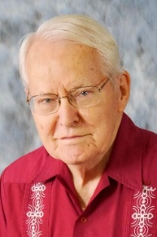
Rev. Jerry L. Kuehn Memorial Service
Rev. Jerry L. Kuehn, age 93, passed away on Saturday, April 23, 2022, at the Tomah Hospital. He was born October 11, 1928, to Gerhardt and Myrtle (Swanson) Kuehn. Memorial Services was held on Friday, April 29, ,2022, 2:00 p.m., at the Torkelson Funeral Home in Tomah. Jerry’s close friend, Dr. Chuck Mize, will officiate. Family and friends are invited for visitation from 1:00 p.m. until the time of service at the funeral home on Friday. Burial will be held in the Alma Cemetery in Alma, WI on Monday, May 2, 2022, at 10:00 a.m. For those not able to attend, services will be livestreamed via Torkelson Funeral Home Facebook page with a link to be provided on Jerry’s obituary. The Torkelson Funeral Home in Tomah is assisting the family with arrangements. Online condolences are available at www.torkelsonfuneralhome.com
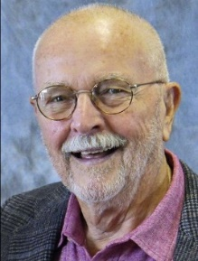
Rev. Dr. David Crum Memorial Service Details
The memorial for David Crum will be held at 3pm on Saturday May 14th, 2022.
The officiants will be Leslie Moughty and Linda Crowe. The service will be at First
Congregational Church in Brainerd.
After the service, all are invited to gather for a Celebration of Life at the
Northland Arboretum from 4:30 to 7:30. Food and beverages will be served. Dave often expressed his desire for a party with laughter and love after his passing. Please wear cheerful colors and bring stories to share. We will be in the lower level. If stairs are a limiting factor, you can arrange to be dropped off at the lower level handicapped access.
The Arboretum is located at 14250 Conservation Drive in Baxter.
Questions: Contact Steve Crum at 218-851-2291 or Bonnie Crum at 218-330-3167

Mark Your Calendars!
Church Annual Meeting - Sunday May 22nd
After Sunday Worship
All voting members are encouraged to attend as we elect new committee members and review the last 12 months. Reports will be emailed the second week of May.. Please contact the church office you need a printed copy mailed to you.

Every Wednesday at Noon
You are invited to a casual fellowship at various locations in the Brainerd Lakes area. Please contact Jack Kraywinkle for location each week.
Jack’s cell” 612-396-3480 or email: kraywinklej@gmail.com

Cooking For Everyone
This group is OPEN FOR EVERYONE!
Email Lowell johnsonlowells@gmail.com and he will add you to the member list so that you will know when and where we will next meet.
TheShop Meal – Wednesday May 18th - 3:45 pm church kitchen.
We meet once a month on the third Wednesday.
We are working with the young people from TheShop (Brainerd/Baxter's Youth Empowerment Center) and are preparing a meal and serving it at TheShop for the participants in the program.
Thanks to all who have expressed an interest in helping out. If you are interested in helping,
please call Sharon Carlson at 828-1581.

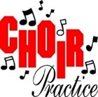
Choir Practice First Three Sundays
Meet in the Sanctuary.
Choir will be singing Palm Sunday and Easter Worship.
Please contact Diane Hauan for more information:
218-839-0669 or diane.hauan5@gmail.com

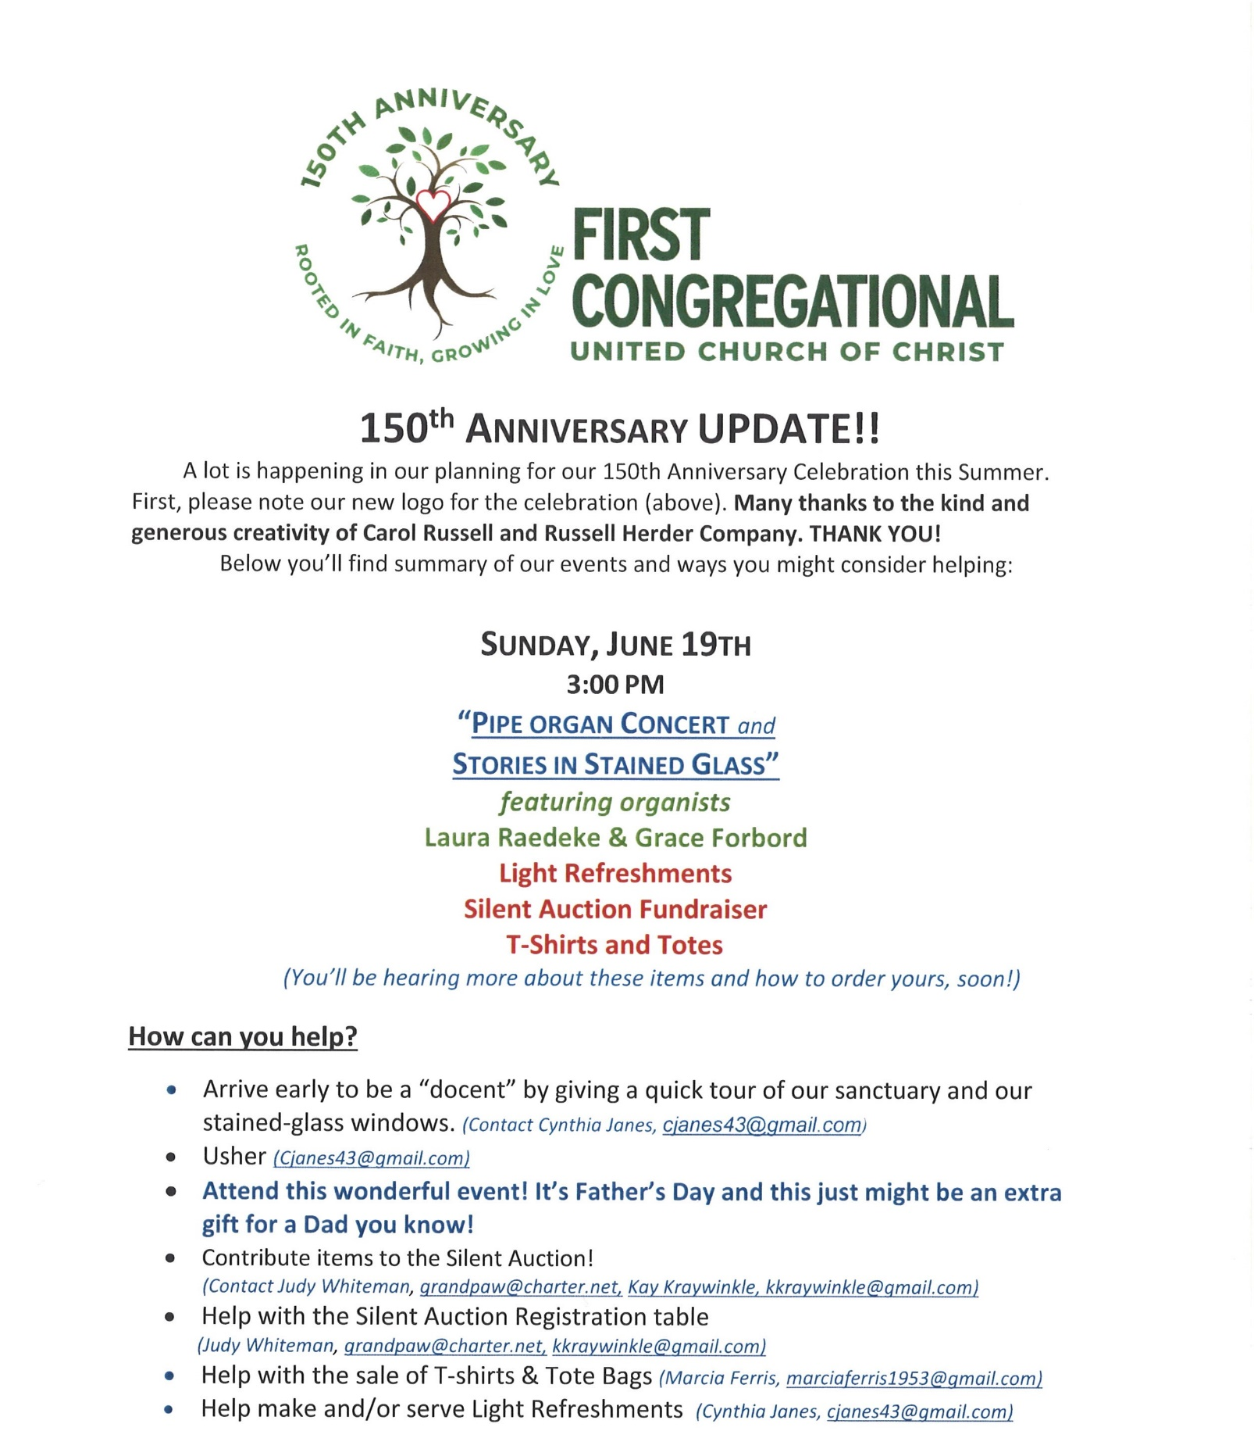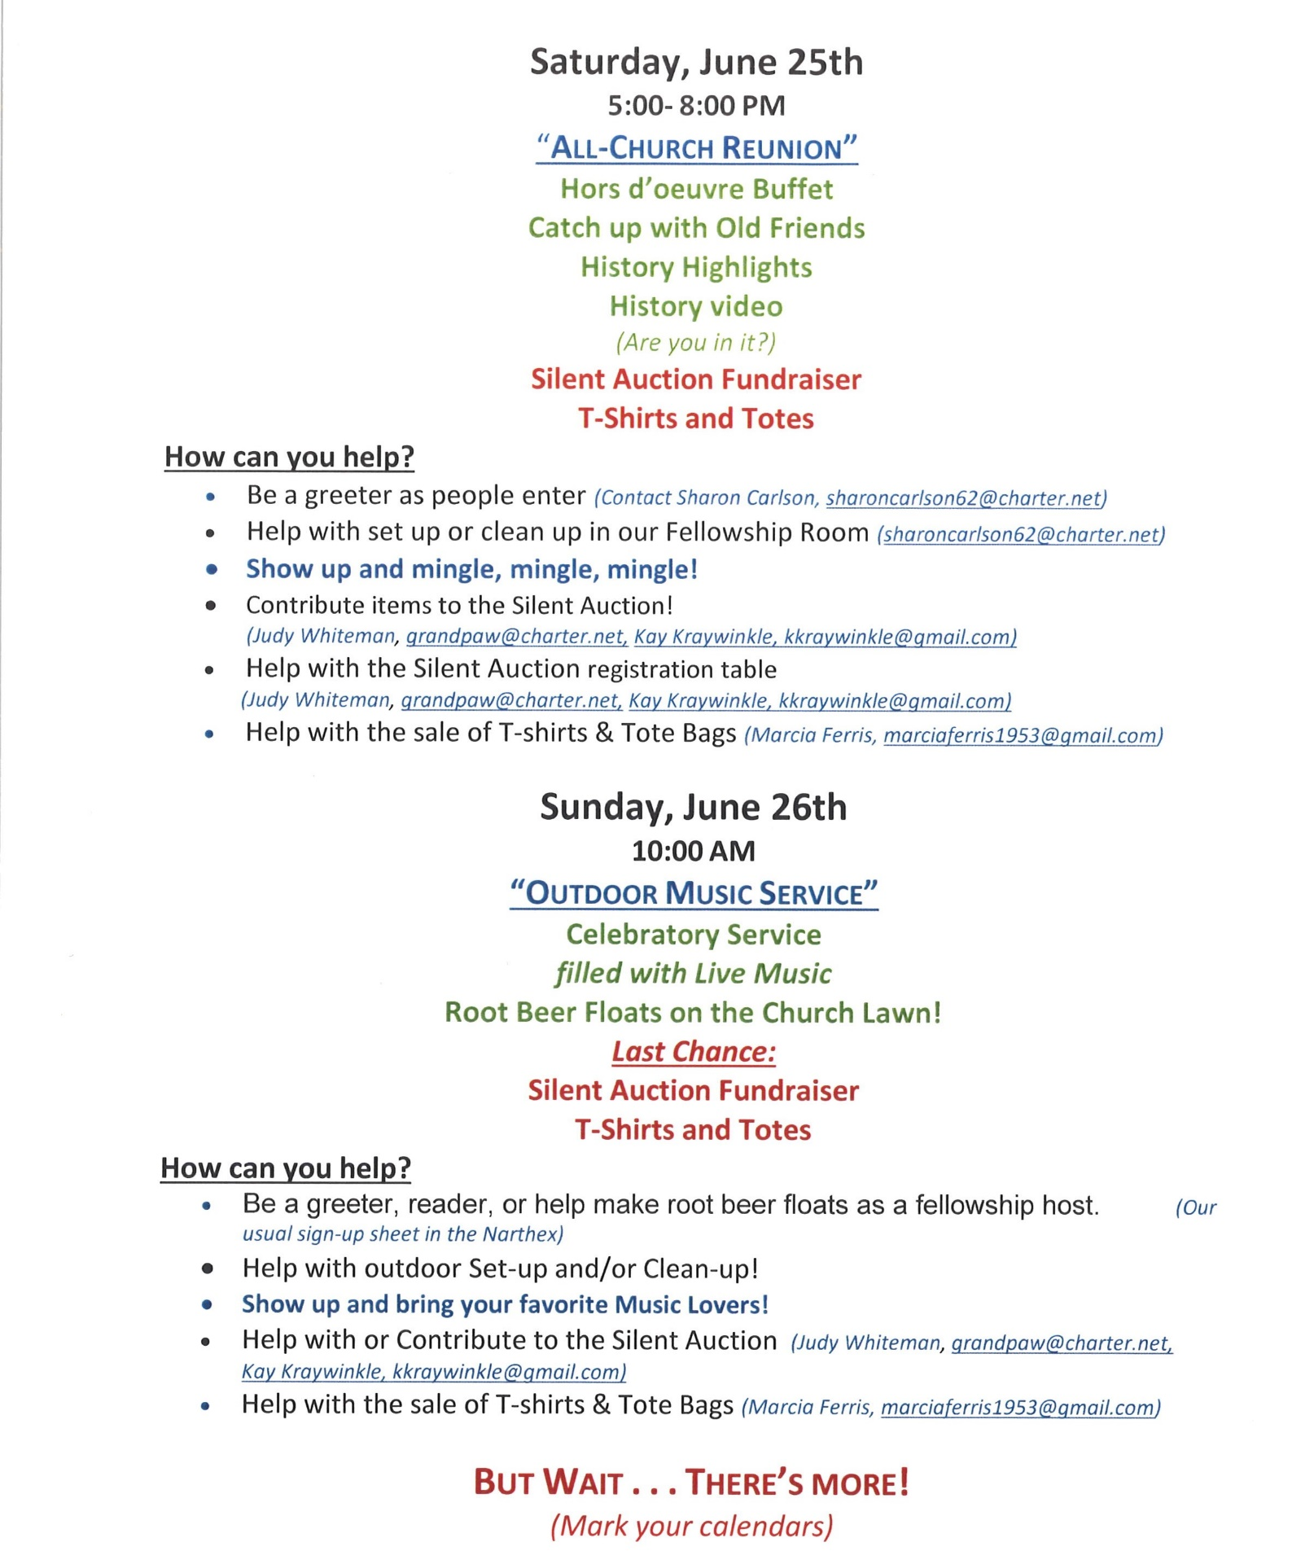

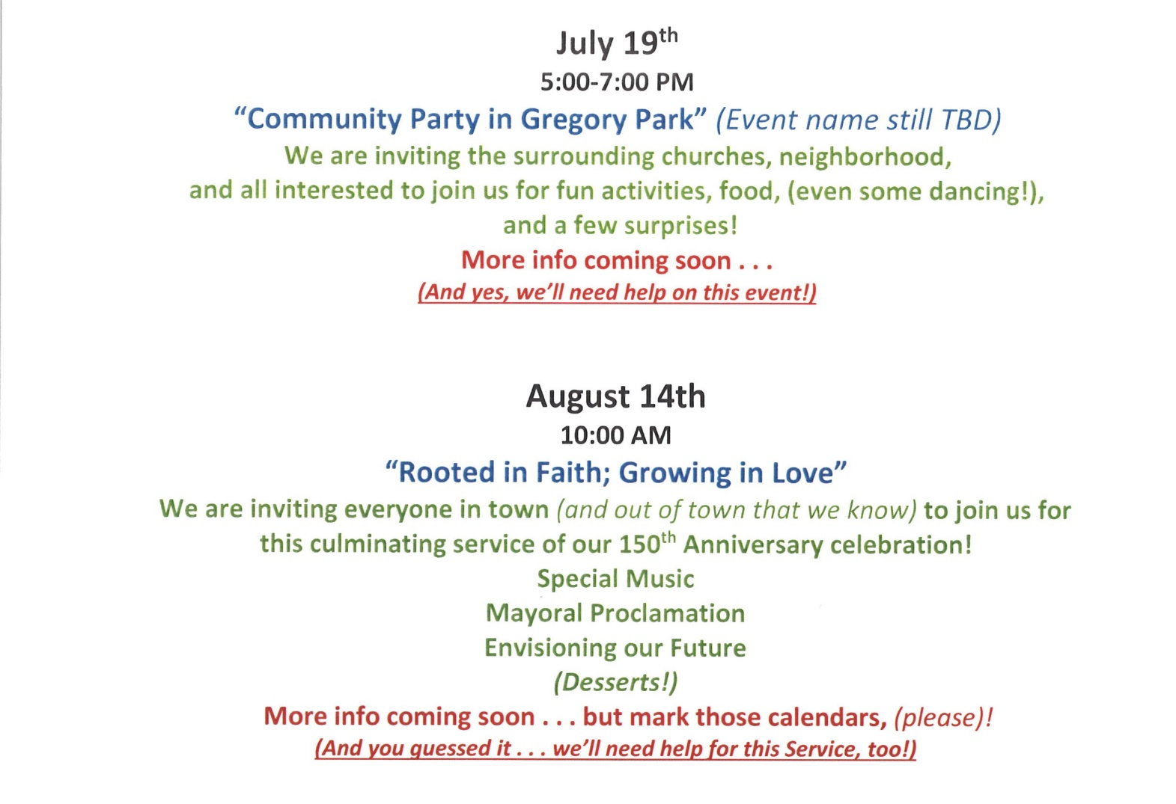

Collecting Memories!
As part of the 150th Anniversary celebration, we are collecting “memories” by decade. The last booklet was published in 1972, so that is our beginning date. You may not realize that some of our current faces here have been active members for fifty (yes, 50) years or more. That is quite an oral history! Now, to make a record for the “future” historians!
we are asking questions and putting out trivia from the 1970s to present, hoping to jog your memories in an effort to tell our stories and get re-acquainted. New visitors and members can share their interests and hopes for future activities, while others will have photos and anecdotes about the past this church represents. Please send all responses to Jan Kurtz at: rmjkurtz@brainerd.net

May 1st  #10 | 1990s: Work Site for OSP Students  The Occupational Skills Program at Central Lakes College is designed for students with disabilities who can work in entry-level jobs with training and support. Through the guidance of Itty Newgord, Sharon Carlson and others, students from this program developed important work skills while keeping our church clean. | - Would you volunteer to help clean the church and/or its ground? We’ll put you on the list!
May 8th  #11 | 1990s: Inclusive Speech In honor of Mothers’ Day:  In 1995, after much discussion about morphing from “patriarchal” vernacular to a gender neutral/inclusive speech, Betty Turnquist (Lee) donated a full church set of The New Century Hymnal in memory of her husband, Don. | - Did we have a vote on this change?
May 15th  #12 | 1990s The Twelfth Night  Our Christmas celebrations added a community concert at our church, bringing a new tradition to the closure of the season. Area musicians, the Legacy chorale, Hans Blix and the Weapons Inspectors, and Brainerd High School Choir are/were among the many participants. Grace Forbord and Laura Raedeke ended the event with their “standing ovation” piano and organ duet. | - Was this the brainchild of Shirley McConnell-Utzman? Who else was  on the original planning?  - When was our first 12th Night event? Year?
May 22nd  #13 | 1990s Hand Bell Choir  The sounds of the Gregorian hand bells graced the sanctuaries of both our church and the United Methodist Church when members combined their talents as "bell ringers" and performed during services and special concerts. Early participants from our church included Doris Anderson, Judy Whitman, Jan Morton, Karen Ogdahl, and Lance Janes. Many others followed. | - Were you one of the original musicians in the Bell Choir?  - Did we have our own bell choir before combining with Park Methodist  - How were the bells acquired? Donation by Claxton family? Other memorials?
May 29th  #14 | 2000s: Peace Poles began to spring up as a global movement, making a visible, public statement as being supporters and promoters of PEACE. Many of our members were/are active in Peace activism. Ask Marcia Ferris for the story. | - Do you know where the Peace Pole is located on the church grounds!?

Calling all singers and musicians!
We want to include your voice and instruments during the worship services.
Please contact Diane Hauan for more information: 218-839-0669 or diane.hauan5@gmail.com

Special Offering Sunday May 22nd
UCC Missions Strengthen the Church
The Strengthen the Church (STC) Offering reflects the shared commitment of people across the United Church of Christ to cooperatively build up the UCC. The funds raised support leadership development, new churches, youth ministry, and innovation in existing congregations. By your generosity to this offering, you build up the Body of Christ. As God calls our congregations to be the church in new ways, your generosity will plant new churches, awaken new ideas in existing churches and develop the spiritual life in our youth and young adults.
Please send your donation to First Congregational UCC, 415 Juniper St. Brainerd, MN 56401. Make sure to note on your offering: STC Special Offering. Thank you!
Or for your convenience use our Paypal account at: paypal.me/uccbrainerd
Be sure to note on your offering STC Special Offering in comments. Thank you!

The Columbarium at First Congregational UCC, Brainerd
The Columbarium is located in the historic space that once was our church’s front entry way.
How appropriate it is that our Columbarium now marks another entry way into a new life — where the Spirits of Love and Truth are always present!
Should you wish to learn more about the purchase of a niche for your own cremains or for the ashes of a loved one, please call the church office at (218) 829-2528. Terri Chidester, Administrative Assistant, can send you a prepared information packet via email or regular mail. The packet contains all the details you will need as you consider inurnment here at First Congregational UCC.
Have any other questions? Contact Dawn Stattine at dawnstattine@gmail.com

Education Minnesota’s Teacher of the Year Award Finalist!
First Congregational member, Erin Karlgaard is included in the 11 finalists for the 2022 Minnesota Teacher of the Year Award. Erin teaches Elementary Grade 1 at Lowell Elementary School, in Brainerd. The 2021 Minnesota Teacher of the Year, Natalia Benjamin of Century High School in Rochester, will announce this year’s honoree at a banquet of the Saint Paul RiverCentre on May 1st. Congratulations Erin!
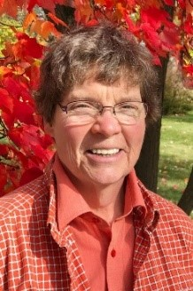
Carla Benjamin Art Exhibit in Fellowship Hall
Carla Benjamin is exhibiting regionally inspired photo encaustic works April 2022 through June 2022 at the Brainerd UCC, 5th & Juniper Street, Brainerd, MN. Original photos combined with paint containing beeswax, resin and pigment fill the exhibit space with enchanting and intimate views from our region. Many artworks will be available for purchase with a portion of the sales benefitting the Brainerd UCC. A life-long artist, Benjamin has studied photo encaustic technique with MN artist Jodi Reeb and continues a biweekly mentoring engagement with Reeb. Carla Benjamin is a fiscal year 2021 recipient of a Creative Support for Individuals grant from the Minnesota State Arts Board. This activity is made possible by the voters of Minnesota through a grant from the Minnesota State Arts Board, thanks to a legislative appropriation from the arts and cultural heritage fund. The artist can be reached through her website: carlabenjamin.com and at carlabenjaminartist@gmail.com

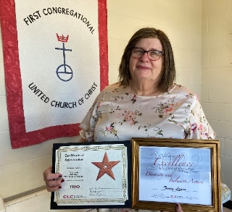
Tracy Lyons
CLC Recognition Awards
Tracy a student at Central Lakes College received awards
in recognition for "Diversity and Inclusion" and the
"TRIO Student of the Year". Congratulations Tracy!

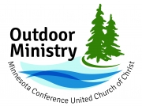
UCC Minnesota Outdoor Ministry 2022-2023 Gatherings & Retreats

For Adults: Spiritual Immersion “Through the Seasons”
*June 24th – 26th Summer - Camp Onomia, Onamia MN
*November 6th – 8th Fall – Luther Crest, Alexandria MN
*January 20th – 22nd 2023 Winter – Clearwater Forest, Deerwood MN
For more information and registration: www.uccmn.org/event/spiritual-immersion-through-the-seasons

~Brainerd Lakes Area Information~
~Opportunities to Know and Share God’s Love ~

- Church Reservations -
If you would like to join church members with table reservations made in advance by Karen Ford,
please contact Karen at: 651-492-3600

Families in Recovery Project
Our Lakes Area Guys Network (LAGN) has received a grant from Crow Wing Energized to begin a new program this summer at the Up Front Alano Club called Learn and Play the Recovery Way. We will need volunteer help to pull this off and are inviting you to join us. We will program 11:30 -1:30 on Saturdays. The dates are May 28, June 11 and 25, July 9 and 23, August 13 and 27, and September 10.. You are not expected to be at every single event, but if you can participate on any of those dates it would help with the planning. Parents and children will arrive to eat a healthy lunch and play in the Recovery Garden area. At about 12:30 the parents who wish to participate will go inside the Club and have discussion around parenting and recovery. We need 4-5 people who can pass background checks and therefore are vetted to volunteer with children during this time.
If you are interested in participating, contact Lowell Johnson at johnsonlowells@gmail.com or 218-820-5290.

New ShopCart Program
ShopCart is a completely free resource that anyone in the community can use. We deliver hot meals, as well as frozen meals, toiletries, and other household essentials to a household within a 23 mile radius of TheShop.
Anyone who would like to take part in this program can text our ShopCart phone (218-513-4751) before 4pm to receive their delivery. ShopCart will be happening every Friday.
Thank you, Erica Stepanek, Executive Director of TheShop (Brainerd Baxter Youth Center).

First Congregational Collects Items for
the Salvation Army Food Shelf
Our donation box is located in the entrance of the back door parking lot. Please consider bringing your donations during our office hours:
Wed. Thurs. Fri. 10am - 1pm.
Help Make a Difference: You can also conveniently donate online.
https://centralusa.salvationarmy.org/northern/BrainerdLakes/cure-hunger/

Crisis Services - All are available 24-hours (unless noted), FREE and confidential

Crisis Line & Referral Service: 218-828-4357, 218-828-HELP or 1-800-462-5525
CRISIS: from cell phone call CRISIS (274747)
Crisis Nursery-Crow Wing County: 218-692-2859
Crisis Text Line: Text “MN” or HopeLine” to 741741
Bridges of Hope: 218-825-4357 or 1-800-462-7682
Minnesota 1st Call for Help: 211
Minnesota Farm & Rural Helpline: 833-600-2670
National Suicide Prevention Lifeline: 1-800-273-8255
Suicide & Mental Illness: 1-800-462-5525
Teen Crisis Line: 310-855-4673
The Trevor Project (LGBTQ Crisis & Suicide Hotline – Youth under 25): 866-488-7386
Trans Lifeline: 877-565-8860
Veteran’s Crisis Line: 1-800-273-8255 – press 1
WARMLINE: Speak with peers who are there to listen and support adults experiencing emotional distress. 1-844-739-6369 from 5:00pm -7:00am.

May 2022 Calendar
Sunday | Monday | Tuesday | Wednesday | Thursday | Friday | Saturday
 | Office Closed  Open by Appt. | Office Closed  Open by Appt. | Office Hours  10am – 1pm  Pastor Drop-in  2-4pm | Office Hours  10am – 1pm | Office Hours  10am – 1pm  Pastor Drop-in  11am-1pm
8:30am Choir Prac- Y 1  8:30am Bnrd Frnds-Y  10am CM/Wrship-Y&V  11am Fellowship-Y  11:30am Adult Forum-Y | 12pm Vets Bk 2  Grp- Our Zoom  4pm Grl Scts #373-Y  7pm BACP-ZorY? | 3  2pm Emotions  Anon- Y  5:30pm Overeaters Anon- Y | 4  10am Pray Crcle-Y&Z 12pm Mens Grp-Y  7pm AA Common-Y | 5  Terri Admin Asst. Vacation Day | 6  10:30am Book Grp-Z | 7
8:30am Choir Prac- Y 8  8:30am Bnrd Frnds-Y  10am Wrship & Communion-Y&V  11am Fellowship-Y  11:30am Adult Forum-Y | 9  12pm Vets Bk  Grp- Our Zoom | 10  2pm Emotions  Anon- Y  5:30pm Overeaters Anon-Y  LARJP Mtg. (Deb)-Y | 10am Pray Crcle-Y&Z 12pm Mens Grp-Y 11  1pm Memorial Mtg-Y&Z.  7pm AA Common-Y  7pm Trustee Mtg-Y&Z | 12  8:30am Christian Ministry Mtg-Y  6:30 BLUE-YorV? | 13  10:30am Book Grp-Z  10am Trustees Outdoor Spring Clean  Annual Packet sent out for Annual Mtg. | 14  2pm – David Crum Memorial at church
8:30am Choir- Y 15  8:30am Bnrd Frnds-Y  10am Wrship-Y&V  11am Fellowship-Y  11:15am Trustees/CM Painting-Y  11:30am Adult Forum-Y | 16  12pm Vets Bk  Grp- Our Zoom  4pm Grl Scts #373-Y | 17  2pm Emotions  Anon-Y  5:30pm Overeaters Anon-Y | 10am Pray Crcle-Y&Z  12pm Mens Grp- Y 18  3:30pm TheShop Cooking-Y  7pm AA Common-Y | 19  3pm Council Mtg-Y&V  7pm AA Dist-Y | 20  10:30am Book Grp- Z | 21
22 8:30am Bnrd Frnds-Y 10am Wrship-Y&V  11am Annual Mtg-Y  Special Offering-STC  1:15pm Sarah Gorham Recital in Sanctuary | 23  12pm Vets Bk  Grp- Our Zoom  4pm Grl Scts #373-Y | 24  2pm Emotions Anon-Y  5pm LeMesa-V  5:30pm Overeaters Anon-Y | 10am Pray Crcle-Y&Z  12pm Mens Grp-Y 25  7pm AA Common-Y | 26 | 27  10:30am Book Grp- Z | 28
8:30am Bnrd Frnds-Y 29  10am Wrship-Y&V  **New Member Welcomed  11am Fellowship-Y  11:30am Adult Forum-Y  *Newsletter Deadline** | Memorial Day 30  12pm Vets Bk  Grp- Our Zoom | 31  2pm Emotions  Anon-Y  5:30pm Overeaters Anon-Y |  | ** Pastor Leslie will be at NGLI for Continuing Ed 4/28 through 5/3/22 |  | V or Z –Virtual Online or Zoom  C- Cancelled  Y- Mtg. in person  N-None

