
Friendship News, November 2026
0
First Congregational United Church of Christ, Brainerd
An Open and Affirming Congregation
The Church Office Hours: Tuesday, Wednesday, Thursday from 10:00am – 2:00pm
Office phone 218-829-2528 Office E-mail uccbrainerd@gmail.com
Pastor Leslie’s E-mail: pastorleslieucc@gmail.com Website: www.uccbrainerdmn.org

No matter who you are, or where you are on life’s journey, you are welcome here.
0

Pastor’s Pen
0
Pastor Laura Callender
I made a sojourn out to Washington state to be with a special group of friends recently. For 25 years, we have observed, celebrated, and borne each other through almost everything life can send. It brings great comfort know that while God is blowing me in yet another direction, I have the touchstone anchoring they provide—that we will always belong to and have each other.
Two members of our original group were there in Spirit—one gone to dementia, the other gone to glory. Two years before she died, my best friend asked me to arrange a sort of “living wake” for her with our small group. Diagnosed with a terminal condition, she wanted a chance to share what this family of heart, pieces of one soul, had meant to her.
I encourage you to think of someone you hold deep in your heart—not a blood relative, not a teacher nor mentor, but someone whom you trust, who matters to you. Now, ask yourself—What if that person didn’t know they matter that much to you?
My friend battled depression and low self esteem her entire (all too short) life. She didn’t know until the last few years of her life how much she was admired, respected, and loved. She had wisdom, groundedness, and zest for learning that made her fascinating. But, life experiences made it difficult to express herself. The world never felt safe enough for her to shine openly. It wasn’t until death had nearly snatched her from us—and was once again looming—that she found inner and outer peace enough to open herself to others.
Openly being who we are—vulnerable, honest, letting our Spirit lead—is risky. Those who have been teased or bullied have reason to hesitate dropping their public masks. Anyone can say they’re different, they’re trustworthy, they’ll accept you as you are. But, actions don’t always reflect words. It takes intentionality to build that kind of relationship.
When Jesus started the movement we follow, he taught this intentionality—to center our minds, our hearts, our spirits, our actions on God’s love, and then be that love for others. At some point in history, perhaps, the word Christian intimated that message. It no longer does. At some point in history, perhaps, the word Church intimated that message. It no longer does. A glance at history shows that not all “Christian” intentions mirrored Jesus’ words.
It isn’t enough to tell people we’re different from those “other” Christians or “other” churches. We can throw open our doors and blast welcome messages—but, anyone whose been bitten by a dog, understandably, doesn’t visit the pound.
Jesus didn’t teach religion. He taught RELATIONSHIP. Everyone desires an anchor, a tether to something that is both beyond themselves and yet a part of themselves. We have that with God, but only through RELATIONSHIP with others. That relationship can only come when we fully accept each other as we are—dropping the publicly palatable masks. The lessons these friendships taught me are that we have to intentionally embrace others’ quirks (my friends have plenty of them) and let others see our own (I have plenty of them), and that people have to EXPERIENCE that we aren’t rabid dogs before they’ll be willing to be among us.
Many who profess to be Christian (Christ Followers), point to John 3:16 as a guiding message: “For God so loved the world that he gave his only Son, so that everyone who believes in him may not perish but may have eternal life.” The key take-away here is that God didn’t stay up in heaven, disconnected from the people. God came to the people—to us—with Love.

Pastor Laura’s Workday Schedule

Pastor Laura’s first day in the office is Monday, November 23rd.
Pastor Laura’s office hours are yet to be determined as she becomes acclimated and settled in.
Her first Worship Service is Sunday, November 29th.
0
Moderator’s Column
0
Dan Hegstad
It was over 25 years ago that our congregation embarked on a fundraising campaign called “Deep Roots. New Branches.” We raised significant money to remodel the sanctuary, rebuild the organ and more. While the sanctuary was unavailable, we met for Sunday Services at the gymnasium of Whittier School for several weeks.
I assumed the remodel would include a new sound system because what we had was inadequate. But when I walked in the sanctuary after the remodel, there was that yellow box speaker still hanging from the ceiling.
I learned several lessons. First, people don’t know what good sound is until after they hear it. Second, if you want change to happen you have to get involved. Get on the committee that’s making decisions. Be, “In the room where it happened.”
The yellow box has been in place since the mid 60’s. It was state-of-the-art at the time, but that time passed a while ago. Now, all these years later, the yellow box is coming down, and a modern speaker array will replace it.
Thanks to generous donations from Don Bennet and the Foundation, the new system will be installed in the next few weeks.
We hired an acoustic engineer several months ago who guided us through the process. The technology has, like everything else, advanced remarkably in the past few years. The sound that can be reproduced by modern speakers with a digital processor is quite remarkable.
The new system will be purchased from and installed by Security & Sound Inc. of Watertown, Minnesota. They are knowledgeable, professional and personable. Nice guys who know what they’re doing. You will be hearing the new system before Christmas.
Hanging the new speaker array will require a lift. It’s 40 feet up to the ceiling! As long as we have the lift, Security & Sound said they would gladly replace the burned-out lights at no extra cost.
A while ago someone noticed that the cross hanging from the ceiling is coming apart. That, too, has been there since the 60’s. We are told it is “delaminating” and will need to come down for repairs. As long as we have the lift, I think this is a good time to take it down to inspect and repair.
So, be aware that at some point in the next few weeks you will come into the sanctuary and the cross will not be there. I don’t know if it will be downstairs or if it will have to go out to a woodworking shop. We’ll know more later.
0
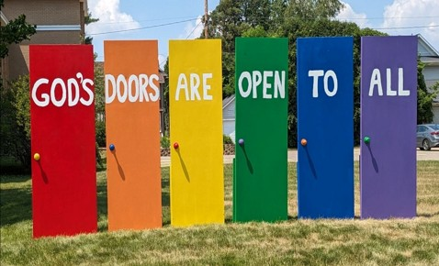

Mission Statement of
First Congregational United Church of Christ

“To know and share God’s love within us.”

Purpose Statement of First Congregational United Church of Christ

“First Congregational UCC is a welcoming, inclusive, and progressive community committed to promoting social justice, spiritual growth, and love for all people. We reject discrimination and advocate for equality and dignity for marginalized communities. Through worship, education, and service, we work to make a positive impact on the world and invite all individuals to join us in this journey of faith and service.”

0

Church Office Hours
Tuesday, Wednesday, Thursday 10:00 am - 2:00 pm
Closed Mondays and Fridays
Please call for assistance - office 218-829-2528

November 10th The Office will be closed - Terri Admin. Asst. Vacation Day

The Office will be closed for Thanksgiving - Thursday, November 26th

0
0
Stay Connected

How to watch Sunday worship
The worship service is broadcasted on the church Facebook page and YouTube every Sunday at 10:00 am.
To watch worship on Facebook, go to:
https://www.facebook.com/uccbrainerd/live

To watch our NEW YouTube channel, go to https://www.youtube.com/@uccbrainerdworship6443
Past church and special services are saved on this YouTube:
https://www.youtube.com/firstcongregationaluccbrainerd

How to stay connected with First Congregational friends and members: Join the private group for our Facebook Connections Page at: https://www.facebook.com/groups/uccbrainerd.
Financial Help Available: The Pastor's Discretionary Fund is available to assist church members and others in the Brainerd area who are experiencing financial distress with modest financial help. If you need assistance, please email, call, or text Pastor Leslie. Let her know what your situation is and how the church might be of help.
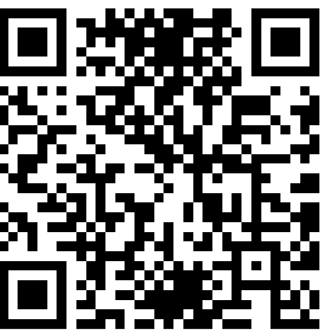
Donate to the church online!
We gladly accept offerings and donations
using the church PayPal account: paypal.biz/uccbrainerd
To use PayPal without an account: www.paypal.com/ncp/payment/MUJ5S7YMLDFM8
Or scan QR code
0
First Congregational UCC News & Updates
0


November Birthdays
Sally Campbell Nov. 1 Maggie Anderson Nov. 16
Eleanor Burkett Nov. 4 Jan Kurtz Nov. 20
Dale Hadland Nov. 9 Mike North Nov. 25
Becky Stadem Nov. 13

0

0
All Saints Day - Dia de Muertos
November 1st Sunday Worship Service
Join us for this special service with Jan Kurtz & Denis Slipy leading worship!
We will be remembering our dearly departed. Whose name will you lift up this year? How do you want to be remembered?
0

Choir Practice and Worship Singing
Practice: November 1st @ 8:45 am
Sing for Worship Service 10:00 am
Tentative dates
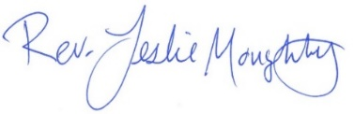
2026: Nov. 15, 29 - Dec. 13, 27
2027: Jan.10, 24 - Feb. 7, 21 - March 7, 21 - April 4, 18 - May 2, 16, 30.

Stewardship Commitment Season
0


Dear Church Family,
Our theme this year is “There Our Hearts Will Be.”

The Stewardship Pledge Drive for our next year 2027 budget is nearly over. During worship on October 25th many pledges were returned. Thank you for your thoughtful and prayerful consideration.

If you have not handed in a pledge, a friendly reminder; the Deadline is November 1st. It’s not too late! Please mail them, hand them in at Sunday worship or drop them off at the office (slide under the door if after office hours).


Your UCC Stewardship Committee;
Marcia Ferris, Sarah Jo Armstrong & Maggie Anderson

0

Adult Forum – 11:30 after Worship Service
October 18th -


November 1st - Justice Sunday - Justice Table Action Teams: Teams will provide an update on their work with time for Q&A and a discussion time. This is your opportunity to hear what the teams are planning and add your perspective.

If you want to join a Justice Team, email Steve Newcom, Justice Ministries at snewcom17@gmail.com and plan to join us this November. It is an open, welcoming process.

November 15th - “Loving Our Less Fortunate Neighbor”. People from the My Neighbor To Love Coalition (mntlc.org) and Lake's Area Christian Fellowship will share lessons learned while working with some of the less fortunate among us.

0
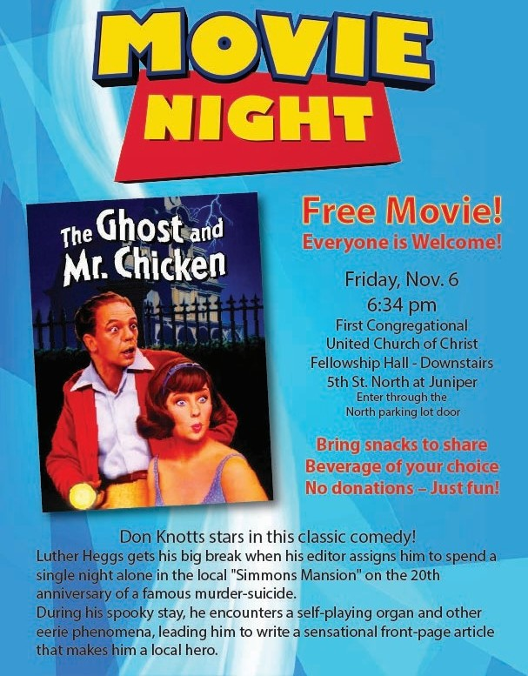


0
Imagining God: Three-Part Sermon Series
Rev. Steve Newcom

Join us on Sundays, November 8, 15, and 22, as we reimagine God together.

We all carry images of God. While Genesis affirms that we are created in the image of God, we often imagine God in the image of earthly powers: kings and emperors, lords and judges, or creditors who tally what we owe.
Where did these images come from? Are they our only options? Over these three weeks, we will explore our images of God, how they inform our actions and how we live our lives, and how we might reimagine how we picture God.

November 8th - “The God of the Altar”: In the ancient world, people came to the altar to strike a bargain with the divine: offerings in exchange for rain, harvest, and safety, an attempt to have control in an uncertain world. What began as the people's search for control soon became a way for kings to control the people. We begin with one of the Bible's most unsettling stories, Abraham on the mountain with his knife raised over his son, and hear how Israel's prophets provided an alternative image for understanding God.

November 15th – “The God of the Tomb”: The tomb outside Jerusalem holds two days, Friday and Sunday. For many Christians, Friday is where everything happens, and the cross is understood as the price paid for our sins. How did that understanding take shape, and what did the cross mean to those who first stood before it? We'll walk from Friday through Saturday's silence to Sunday morning and ask what each day reveals about God.

November 22nd – “The God in Whom We Live”: Paul stood in Athens, a city full of altars, and spoke of a God "in whom we live, and move, and have our being." What might it mean to imagine God that way, and what would it ask of us? In our final sermon, we'll explore images of God from both the Bible and modern theology and ask how the way we imagine God shapes the way we live with one another.

About Pastor Steve. For those who are new to First Congregational, Rev. Dr. Steven Newcom is our volunteer Pastor of Justice Ministries, supporting the WISE, Environment, DEI, and Families in Poverty justice teams. He also facilitates the Lakes Area Justice Table, a regional coalition with five priority areas: Supporting Public Education, Advancing Social and Mental Wellbeing, Deepening Democracy, Caring for the Environment, and Promoting Diversity and Inclusion.
Before retiring and moving to Brainerd, taught at United Theological Seminary of the Twin Cities, where he was the founding director of the Kaleo Center for Faith, Justice, and Social Transformation. His book, A Theo-Ethical Praxis and Discipline of Social Transformation, will be published by T & T Clark in March 2027.
0

0
Next Council Meeting
Wednesday, November 19th, 2026, 3:00 pm
in-person and via Zoom tinyurl.com/uccbrainerdzoom
Reports are due via email on Tuesday 17th

First Congregational Approved Council Meeting Minutes are available upon request.
Please contact Terri Admin Asst. at the Church Office.

0
Volunteer at Church!
There are many other opportunities for you to share your talents

These committees need your gifts:
*Clerk * Trustees * Christian Education * Christian Ministry

Please contact Dan Hegstad or Ellie Burkett if interested in any of these opportunities.
0
UCC Fellowship


Men’s Lunch

Each Wednesday
11:45 am at Wings Airport Café
Not Organized—No Agenda Join Us!


Women’s Lunch

Thursday, November 19th at 11:30 am
at Local 218
Question of the day: What are you Thankful for?


October 18th –
November Special Offering - Sunday November 22nd
Sharing Bread Soup Kitchen

This month we have an opportunity as we give, our Fourth Sunday to the Sharing Bread Soup Kitchen. A lifeline for hungry souls in the Brainerd Lakes Area since 1987. The Soup Kitchen’s mission is to demonstrate the love of Christ by providing meals to the hungry of our community. Please send your donation to First Congregational UCC, 415 Juniper St. Brainerd, MN 56401. Make note on your offering: “Soup Kitchen”. Thank you!
Or for your convenience use our Paypal account at: paypal.biz/uccbrainerd To use PayPal without an account: www.paypal.com/ncp/payment/MUJ5S7YMLDFM8
0
0
Chili Cook-off & Church Greening

Sunday, November 22nd

Chili Competition
11:15 after worship service

Bring your best pot of Chili!
Dust off your favorite recipe! Whether you like it mild, spicy, traditional, or with a creative twist, we want to taste it!

Not a cook? Come hungry and help us crown our Chili Champion!
Bragging rights are on the line!


And when the chili competition is over,
let’s Deck the Halls & warm your hearts!

It’s time to come together for a little holiday magic and wonderful fellowship!

Join us as we transform our church into a beautiful celebration of the Christmas season! We’ll hang the greens, decorate the sanctuary, and fill our church with the warmth and joy of the holidays. Help us prepare our church for the Advent and Christmas season! Many hands make light work, and everyone is welcome.

Come for the chili, stay for the decorating, and leave with a heart full of Christmas spirit! Let’s kick off the season with laughter, fellowship, and a little friendly competition. All are welcome – bring a friend, bring your family and bring your appetite.

Chili Cook-off Sign-up sheet in the Narthex
0
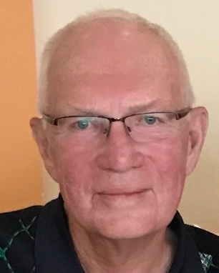
Greg L. Johnson (Greg) Memorial & Obituary
0
Greg is survived by his wife Mary after 61 years of their precious time together; son Douglas; daughter Kristin; granddaughters Miriam (Lillian), Selma (Likhwa), and Lena; brother Allen; sister Cheryl; and many nieces, nephews, cousins and their families.

A memorial service followed by a buffet reception and celebration of life will be held on November 21st at Lakewood Cemetery,
3600 Hennepin Ave S, Minneapolis, MN
Memorial Service: from 1-2 pm in the Memorial Chapel
Reception: from 2-4 pm in the Garden Mausoleum
Dress to celebrate Greg’s life

In lieu of flowers memorial donations may be made to First Congregational United Church of Christ, Brainerd, 415 Juniper Street, Brainerd, MN 56401 or to an organization of your choice.
Additional information at Gearty-Delmore Funeral Chapels www.gearty-delmore.com


Thanksgiving Day!
October 18th –

Thursday, November 26th @ 11:30 am

Turkey & Gravy Provided.
Bring a side dish to share (not necessary)

Open to the public
To our Neighbors & Friends

First Congregational UCC Brainerd
415 Juniper St.
Fellowship Hall

Sign-up Sheet in the Narthex


October 18th –
First Congregational Food Shelf Collection

Our church continues to collect non-perishable food items for the Salvation Army Food Shelf. Please consider bringing items and donating.
There are two collection boxes: one in the parking lot entry hallway, the other in the Narthex. Brian Twamley or Stephanie Lee pick up and deliver the food.
Thank you!

October 18th –

UCC Care Team
October 18th –
For anyone who wishes to join in making calls or visits, the Care Team meets every month on the first Thursday @ 10:00 am.

If you know of anyone who would enjoy a call from the care team, please contact one of our Care Team; Jack and Kay Kraywinkle, Pat Scott, Deb Griffith, Nancy Gould, Tracy Lyons and Cynthia Janes.

October 18th –
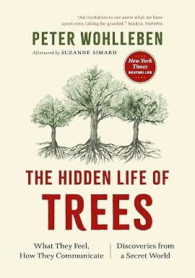
Friday Book Group
We meet each Friday morning at 10:30 am via zoom.
Church Zoom link: https://tinyurl.com/uccbrainerdzoom

We are reading “Hidden Life of Trees: What They Feel”
by Peter Wohlleben.
The Hidden Life of Trees invites us to look at forests with renewed wonder and appreciation, emphasizing the importance of conserving these vital ecosystems and seeing them not just as resources but as living entities deserving our respect and protection.


October 18th –
H.U.G.S.
Hosts, Ushers, Greeters, Scripture-readers
Sunday morning greeters/ushers and coffee hosts play an important part in making our church a warm and welcoming place for all.
Online signups are no longer available

Signup sheet in the Narthex or call or send an email to the office to be added.

**Notice – Hosts may be reimbursed for snacks/food that are purchased for Fellowship Coffee Hour. Reimbursement Forms are in pocket folders outside the office. Please fill out and submit with receipts in the folder provided next to the form.

October 18th –

Our Building Is a Great Event Venue!
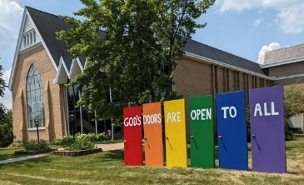
We are blessed to be able to share our beautiful church facilities for purposes that match the values of the church and its mission which is “To know and share God’s love within us.” We are an open church valuing the diversity of age, culture, gender identity, opinions, physical and mental abilities, and sexual orientation. Take a virtual tour of our building by visiting our website at uccbrainermn.org
To request a space for general use, ask for a “Request for Church Building Use” form and policy packet from Terri in the church office, at 218-829-2528 or email uccbrainerd@gmail.com. Submit the request form back to Terri in the office, and it will be submitted for approval at the next Council Meeting.
For wedding or funeral use, contact the church office.
October 18th –
T
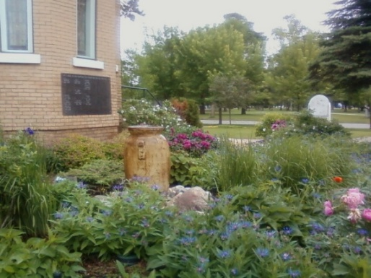
The Columbarium & Memorial Garden
October 18th –
First Congregational UCC, Brainerd
The Columbarium is in the historic space that once was our church’s front entry way. How appropriate it is that our Columbarium now marks another entry way into a new life — where the Spirits of Love and Truth are always present!

The Memorial Garden is located on the south lawn of the church. The Garden provides a place for cremains of your loved one to be buried in the ground among natural plantings.

The Garden fee includes the inscription of your loved one’s name on a granite plaque that is mounted on the outside wall of the church. Should you wish to learn more about the purchase of a niche for your own cremains or for the ashes of a loved one, please call the church office at (218) 829-2528 and a packet of materials will be sent to you via email or regular mail.

0
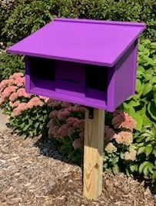
Community Prayer Box

You can find the Community Prayer Box in the Memorial Garden on the South side of the church (the side that faces Juniper Street.)

Community members frequently walk through the garden, and this box will offer our wider community an opportunity to share their prayers. Prayer cards and pens are provided, and the box is secured with a padlock, so the submitted prayers don’t fly away with the wind!

The box is checked weekly for any prayers submitted as well as sharing them with the Care Team.
October 18th –

Save The Date in December!
First Congregational UCC Brainerd

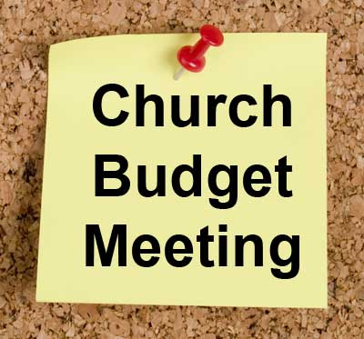
Annual Budget Meeting

Sunday, December 13th, at 11:15 am
after worship in-person and via Zoom
Please attend the congregational budget meeting to review and vote on the 2027 church budget. Meeting packets will be distributed in person on the previous Sunday December 6th and emailed to voting members on December 9th.
Please notify Terri in the office if you need a packet sent to you by snail mail.
0

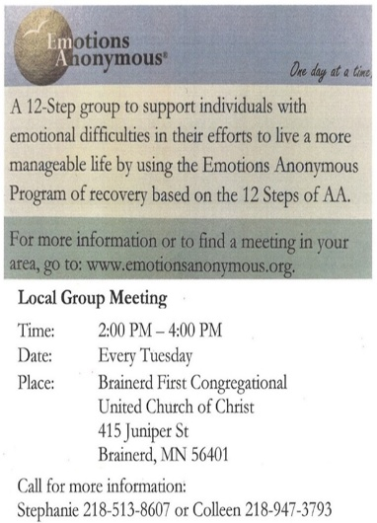

0

Crow Wing County
Military Family Support Group

1st & 3rd Wednesday
of each month
7:00 - 8:00 pm

Meets at First Congregational UCC
415 Juniper St., Brainerd MN 56401

Join us to support military families if you: have someone joining the military, have an active military member or have someone that has previously been in the military.

More info: drttbsby@msn.com

0
Where the Creator and creation pray, play, and wonder together.

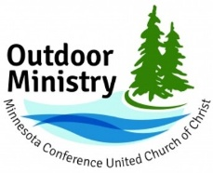
The Outdoor Ministry of the Minnesota Conference UCC offers events for individuals and families of all ages, abilities, and stages of life to experience rest, renewal, and reconnection through a retreat or camp experience.
Upcoming Events
We are living in a collision of crises right now. Amid that collision, the MN Conference UCC is offering a series of three in-person retreats between August 2026 and February 2027. Each retreat stands on its own and is related to the other two in the series. All three retreats will be hosted at Camp Onomia in Onamia, Minnesota. The registration fee for each retreat is $175, and participants who register for all three will receive a 25% discount for all three retreats.
Retreat 2 – Rest and Resilience, November 17-19, 2026 (Adult Event)
Retreat 3 – Remembering New Beginnings, February 12-15, 2027
Registration at https://www.uccmn.org/programs-support/outdoor.
Download flyer: www.uccmn.org/wp-content/uploads/2026/06/2026-Joy-Retreat-Series.pdf

0

Brainerd Lakes & Surrounding Area Information
0
~ Opportunities to Know and Share God’s Love ~
0
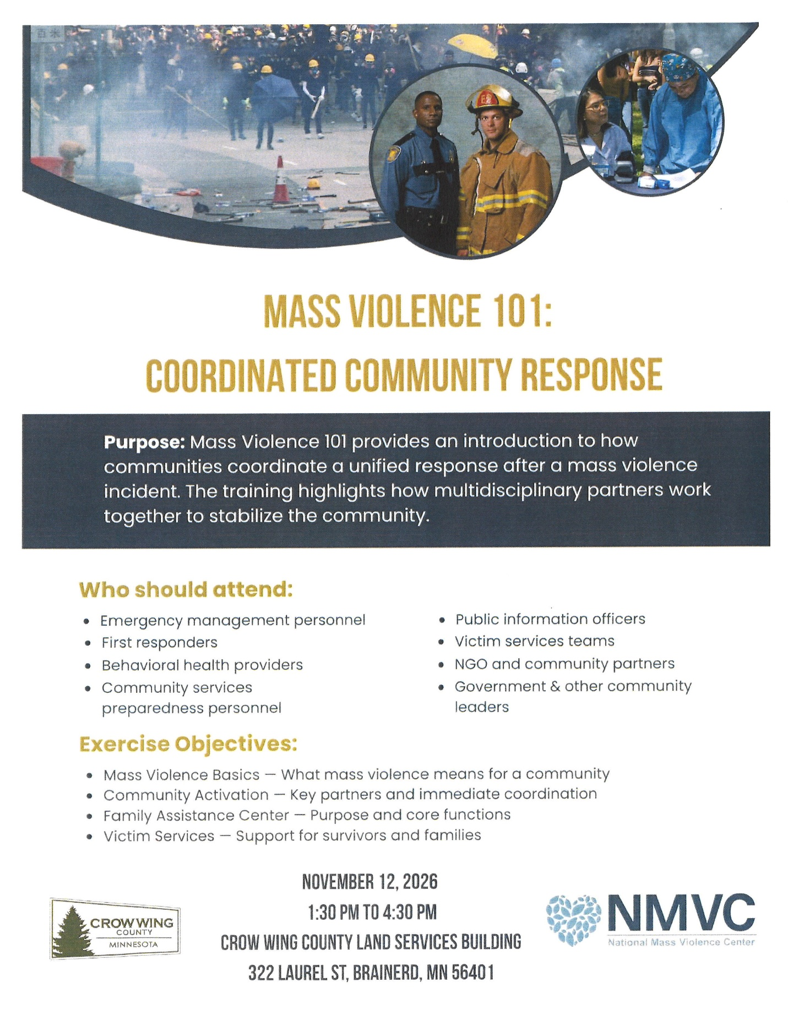

November 2026 Calendar
Sunday | Monday | Tuesday | Wednesday | Thursday | Friday | Saturday
Y- Yes Meeting in person  FB -Facebook Live Stream Online  C- Cancelled N-No Meeting  P-Postponed Z-our church Zoom | Office Closed | Office Hours  10am – 2pm | Office Hours  10am – 2pm | Office Hours  10am – 2pm | Office Closed
8:30am Brainerd Friends-Y 1  8:45am Choir Practice  10am Worship All Saints Day/Dia de los Muertos, Communion, Choir-Y& FB & YouTube Jan Kurtz & Denis Slipy lead worship  Pledge Commitment Forms Due  11:15am Fellowship-Y  11:30am Adult Forum: Justice Sunday Team Mtgs-Y. | 2  5pm BACP/BLUE church-backup | 3  6pm BLA Indivisible Monthly Civics Mtg.-Y Fellowship Hall | 11:45am Men’s Grp 4  @ Wings Cafe-Y  Pastoral Relatns Mtg.-P  4:30pm Christian Ministry Mtg.-Y  7pm Military Family  Support Grp-Y  7pm AA Common-Y | 5  10am Care Team-Y | 6  10:30am Book Grp-Z  6:30pm Movie Night-Y | 7
8:30am Bnrd Frnds-Y 8  10am Worship--Y& FB & YouTube  *Rev. Steve Newcom preaching  11:15am Fellowship-Y | 9  2:00pm Trustees Mtg.-Y | 10  2pm EA-Y  5:30pm OA -Y | 11:45am Men’s Grp 11  @ Wings Cafe-Y  2:00pm Exec Mtg.-Y  7pm AA Common-Y | 12 | 13  10:30am Book  Grp- Z | 14  9:30am-1:30pm AAUW in Fellowship Hall
8:30am Bnrd Frnds-Y 15  8:45am Choir Practice  10am Worship & Choir--Y&FB& YouTube  *Rev. Steve Newcom preaching  11:15am Fellowship-Y  11:30am Adult Forum: My Neighbor To Love Coalition presentation | 16 | 17  2pm EA-Y  5:30pm OA -Y  Council Reports Due | 18  11:45pm Men’s Grp  @ Wings Cafe-Y  7pm AA Common-Y | 11:30am 19  Women’s Lunch @ Local 218 Brainerd  3pm Council Mtg- Y&Z  6:30pm AA Dist.7-Y | 20  10:30am Book  Grp- Z | 21
8:30am Bnrd Frnds-Y 22 10am Worship--Y& FB & YouTube  *Rev. Steve Newcom preaching  11:15am Greening the Church & Chili Cook-off-Y  *Special Offering: Soup Kitchen  *Newsletter Deadline-December | 23  Interim Pastor Laura’s First Day in the Office | 24  2pm EA-Y  5:30pm OA -Y | 11:45pm Men’s Grp 25  @ Wings Café-Y  7pm AA Common-Y | Office closed 26  Thanksgiving Day  Thanksgiving Meal & Potluck – Open to the public 11:30 am – 2:00 pm | 27  10:30am Book  Grp- Z | . 28
8:30am Bnrd Frnds-Y 29  8:45am Choir Practice  10am Worship & Choir-Y& FB & YouTube  Pastor Laura’s First Sunday Worship  11:15am Fellowship-Y | 30

