
Friendship News, June 2026
0
First Congregational United Church of Christ, Brainerd
An Open and Affirming Congregation
The Church Office Hours: Tuesday, Wednesday, Thursday from 10:00am – 2:00pm
Office phone 218-829-2528 Office E-mail uccbrainerd@gmail.com
Pastor Leslie’s E-mail: pastorleslieucc@gmail.com Website: www.uccbrainerdmn.org

No matter who you are, or where you are on life’s journey, you are welcome here.
0
Pastor’s Pen
0

Acts of Faith: (Re)Making Church
Ancient Stories. A Church Evolving

Spring has a way of reminding us that living things do not stay the same. Gardens grow, trees bud, and even the longest winters eventually give way to something new. Growth is beautiful, but it can also be messy and unpredictable. Sometimes what looks like disruption is actually transformation beginning to take shape.
This summer, we will begin a new worship series called “Acts of Faith: (Re)Making Church.” Together we will explore stories from the book of Acts—the story of the early church after Jesus’ death and resurrection. It is a book filled with courage and confusion, disagreement and discovery, setbacks and surprising possibilities.
The first followers of Jesus were not handed a finished blueprint for how to be a faithful community. They were trying to figure things out as they went. They wrestled with difficult questions. They navigated conflict. They expanded their understanding of who belonged. They learned to trust the movement of the Spirit in places they did not expect.
Acts is the story of a community learning how to become church. Even those disciples who knew Jesus personally, had to adapt and change their thinking about what being a faithful community looked like. I find that encouraging.
Sometimes we worry that change means something has gone wrong. We can become anxious when traditions shift, challenges arise, or new questions emerge. But Acts reminds us that faithful change is not the opposite of church—it has always been part of the story. The church was never meant to be frozen in time. Like faith itself, it is living, growing, and continually being shaped by love, justice, and the Spirit of God.
As we continue discerning the ever-evolving nature of being a people of faith together, I hope this series offers more than ancient history. I hope it offers companions for the journey. The stories in the Book of Acts do not provide easy answers, but they remind us that uncertainty and faithfulness can exist side by side.
God called the early church to adapt and evolve. God is still speaking. We are called to keep evolving faithfully. I look forward to exploring this journey with you.
With Peace,

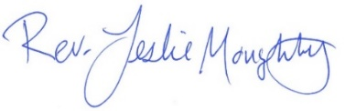
Mission Statement of First Congregational UCC
“To know and share God’s love within us.”

Purpose Statement of First Congregational United Church of Christ
“First Congregational UCC is a welcoming, inclusive, and progressive community committed to promoting social justice, spiritual growth, and love for all people. We reject discrimination and advocate for equality and dignity for marginalized communities.
Through worship, education, and service, we work to make a positive impact on the world and invite all individuals to join us in this journey of faith and service.”
0
Church Office Hours
Tuesday, Wednesday, Thursday 10:00 am - 2:00 pm
Closed Mondays and Fridays

Please call for assistance - office 218-829-2528
0
Pastor Leslie’s Workday Schedule
Sunday through Thursday (Days off are Friday and Saturday)
Drop-in Hours: Wednesdays 11:00 am – 1:00 pm
*Drop-in hours are times set aside for “drop-in” conversations, much like a professor’s office hours.
Everyone is encouraged to make an appointment, especially if the above times are not convenient. You can go to www.calendly.com/pastorleslieucc and select a day and time that works for you, or you can email Pastor Leslie at pastorleslieucc@gmail.com or call/text at 218-656-0096.
0

Stay Connected

How to watch Sunday worship: The worship service is broadcasted on the church Facebook page every Sunday at 10:00 am.
To watch worship on Facebook, go to https://www.facebook.com/uccbrainerd/live
How to stay connected with First Congregational friends and members: Join the private group for our Facebook Connections Page at https://www.facebook.com/groups/uccbrainerd.
Financial Help Available The Pastor's Discretionary Fund is available to assist church members and others in the Brainerd area who are experiencing financial distress with modest financial help. If you need assistance, please email, call, or text Pastor Leslie. Let her know what your situation is and how the church might be of help.
Donate to the church online! We gladly accept offerings and donations using PayPal.
You do not need to have a PayPal account to make an online donation with a credit card. To use PayPal, go to: https://www.paypal.me/uccbrainerd
0

First Congregational UCC News & Updates
0
New Council Leadership!
Moderator: Dan Hegstad
Past Moderator Mentor: Kim Slipy
Assistant Moderator: Ellie Burkett

0
Volunteer at Church
There are many other opportunities for you to share your talents

These committees need your gifts:
*Treasurer *Clerk * Trustees * Stewardship * Christian Ed

Please contact Dan Hegstad or Ellie Burkett if interested in any of these opportunities.
0
Moderator’s Report
Dan Hegstad – June 2026
Thank you for allowing me to serve again as Moderator. Having served one and a half terms several years ago, I am grateful for the opportunity to step into this role once more.
I want to thank Kim for her excellent service as Moderator. I am especially grateful that she will continue to be available over the coming year as a source of support and guidance.
I also want to welcome Ellie Burkett as she joins the Council as Assistant Moderator. Ellie and I bring different strengths and perspectives, and I am confident that we will work well together.
To the others serving on Council, thank you for offering your gifts to this unique church. I know of no other congregation in our area that is as welcoming to everyone. It remains true that, “No matter who you are or where you are on life’s journey, you are welcome here.”

Our Current Challenge
We are currently facing a significant budget deficit. Rather than reacting impulsively, we will take the time to find a thoughtful and workable solution. There is an old saying that “the generals are always fighting the last war.” The idea is simple: we often try to solve today’s problems using yesterday’s assumptions.
To find the right answers, we must ask the right questions. Instead of forcing new challenges into old frameworks, we need to look honestly at the world as it is and ask how our systems must change to meet today’s reality.

How We Will Move Forward
None of us wants to make a mistake, and that can lead to hesitation. We are being asked to let go of what is familiar, and that is not easy. But as a faith community, we are called to move forward not with fear, but with trust. As Bob Proctor said, “Both faith and fear demand that you believe in something you cannot see. You choose.” We choose faith, and we will move forward together in that spirit.
I am not a general or an accountant, but I am a leader, and you have trusted me to help lead us forward. My role is to find the people and the solutions that fit the needs of the 21st century. We have a strong team of experienced leaders, and we will also seek guidance from the Minnesota UCC Conference, from other churches that have faced similar challenges, and, if needed, from outside consultants.
We also need an accounting structure that is practical, transparent, and sustainable, one that a person with basic financial skills can operate, one that produces reports everyone can understand, and one that does not depend on the expertise of a single volunteer.
We must also update our governance structure. As I have said many times, the way we operated in 1950 will not carry us into 2050. We now have a template for a new structure that I believe can serve us well for years to come. Under this approach, volunteers can focus more of their energy on the work of their committees and less on the mechanics of church governance. Long meetings filled with operational details should become far less common. We will share more information as this work moves forward.

What I Ask of You
Today, I ask two things of you:
- Please be patient. The issues before us are significant, but none is an immediate crisis. We will work through them carefully, and that will take time.
- Please stay informed. I will write a monthly column to keep you updated, and important information will continue to be shared through the newsletter, the This Week email update, and the weekly bulletin. I cannot promise that every detail will appear in every communication, but if something feels new or surprising, there is a good chance it has already been shared in one of these places.

Thank you again for your patience, your faith, and your trust as we move forward together.
0

T.A.C.O. Tuesdays for Youth

Tuesday, June 2nd 3:00 - 6:00 pm
Fellowship Hall/Rainbow Room.

TACO stands for Teaching, Activities, Community, and Outreach.

Emily LeClaire leads this after-school program to engage youth of our church and the wider community.
Scheduled for the First Tuesday of each Month
(will pause in the summer, July and August)

Connect with Emily for more information including adult volunteer opportunities.
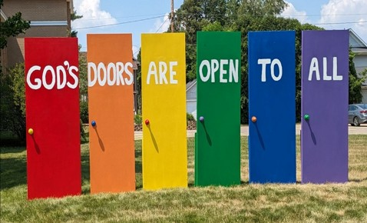
0

Door Rededication &
Neighborhood Picnic Potluck

Saturday, June 6
Noon - 2:00 pm

Please bring a dish to share or just bring yourself!
Bring a lawn chair, yard games, and anything else you might want for this outdoor event.

Sign-up sheet for the potluck is in the Narthex.


0
June Adult Forum - 11:30 after Worship Service

June 7 – “Generosity Now and Later”: There are many ways to be generous. Traditionally the church explores being generous with finances, time and advocacy. In the spectrum of finances most congregations focus on the now of giving – offerings, pledges, donations. In a forum led by Rev. Wendy Vander Hart, Generosity Officer with the MN Conference UCC, we will consider ways people can be generous across the life span and later.
June 21 – “Fathers Story Circle”: Join us as we tell stories about the influence of our fathers in our lives, and/or the influence of being a father yourself.
0
0
Father’s Day BBQ and Potluck

Sunday, June 21st @ Noon
On the church lawn

Hot Dogs & Brats provided.
Bring a dish to share or just bring yourself!
Bring a lawn chair, sunscreen, and anything else you may need to enjoy this outdoor event.
0
UCC Fellowship


Men’s Lunch

Each Wednesday
11:45 am at Wings Airport Café

Not Organized—No Agenda Join Us!

Women’s Lunch

Thursday, June 25th
11:30 am at Black Bear Lodge & Saloon
Question of the month: If you could have one or two superpowers, what would they be?
0
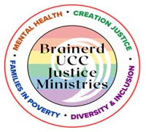
Justice Minsitries Meeting Minutes - May 24, 2026
Justice Table Teams meet every other month on the fourth Sunday of September, November, January, March, and May from 11:30 am - 1:00 pm.
Families in Poverty
Poverty, Children, Families, homelessness & Housing
Present: Marcia Ferris, Sharon Carlson, Dan Hegstad
We will continue to promote the Special Offering Sundays with the area nonprofits we support. We have had Vicky Kinney (My Neighbor to Love Coalition) and Lori Rubin (Habitat for Humanity) attend and give our congregation a Mission Moment during the service.
WeAre is June. Marcia will make sure Terri has WeAre info for the June Newsletter. The Director will be contacted for a date they could speak and asked if they have a display or information to hand out.
July is the Special Offering for the two area food shelves. Council has approved that the donation be split between the Salvation Army and the (new) Lakes Area Food Shelf.
August is PRIDE, October is The Shop and November is the Sharing Bread Soup Kitchen. All of these are related to our team’s focus areas.
Instead of display boards for each special offering we discussed having a bulletin board in the main hallway featuring these agencies, along with positive events at our church. (This bulletin board could be shared by all our teams.)
We will check back with Vicky Kinney for opportunities to speak to the MNTLC group once their new community building is open. We will continue to work with the (now year around!) Bridge on S 7th shelter to volunteer and donate what they need. Both have Facebook pages listing what is going on and how to help.

Watch for the new bulletin board that will be filled with interesting information.
Mental Health
WISE
Lowell Johnson is talking to Jessica Schwartz of Essentia Health to talk about Substance Use Disorder.
The group wants to kick-off a mental health movie night on Sept. 27. Movies under consideration: Resilience and Still Alice.
Discussion about coordinating with other entities (possibly "The Center”) on Alzheimer's Story Circles. Also invite the Lakes Area Dementia Choir to a worship service.
Region 5 Plus Adult Mental Health will provide mental illness trainings for clergy and religious leaders.
Discussion about outreach to “Persons Served” from area group homes for possibly a game night or art cart.
0

June Birthdays
Sarah Jo Armstrong June 5 Lowell Johnson June 20
Ryan Kelley June 8 Dawn Stattine June 22
Shelly Trimble June 8 Patrick Bertram June 23
Barb Stokke June 10 Claire Steen June 25
Becky Twamley June 10 Steve Waller June 25
Larry Anderson June 14 James Flath June 27

0
Special Offering: Sunday, June 28th - WeARE

Advocates for Reproductive Education (WeARE) is a 501c3 nonprofit organization, committed to promoting and providing comprehensive reproductive education and healthcare services for youth, young adults, and the underserved in Brainerd and the surrounding community.
Through community collaboration, led by compassionate healthcare professionals, the underserved living in the Brainerd Lakes Area are empowered to make informed decisions about their health and wellbeing.
Please send your donation to First Congregational UCC, 415 Juniper St. Brainerd, MN 56401.
Or for your convenience use our Paypal account at: paypal.me/uccbrainerd. Make note on your offering “WeAre Special Offering.” WeARE on Facebook: www.facebook.com/WeAREbrainerd

Mission Moment: Sunday, June 28th

Jenna Weiss, the Executive Director, WeARE-The Clinic (Advocates for Reproductive Education) will briefly speak about the mission of WeARE during worship service.

0
UCC Care Team

For anyone who wishes to join in making calls or visits, the Care Team meets every month on the first Thursday @ 10:00 am.

If you know of anyone who would enjoy a call from the care team, please contact one of our Care Team; Jack and Kay Kraywinkle, Pat Scott, Chris Yager, Deb Griffith, Nancy Gould, Tracy Lyons, Cynthia Janes,
Joey Halvorson (text or email) and Pastor Leslie.

0
Next Council Meeting
Thursday, June 18th, 2026, 2:00 pm (Note time change)
in-person and via Zoom tinyurl.com/uccbrainerdzoom
First Congregational Approved Council Meeting Minutes are available upon request.
Please contact Terri Admin Asst. at the Church Office.

0

Friday Book Group

We meet each Friday morning at 10:30 am via zoom.
Church Zoom link: https://tinyurl.com/uccbrainerdzoom

We are reading "By Any Other Name” by Jodi Picoult. Two women, centuries apart—one of whom is the real author of Shakespeare’s plays—who are both forced to hide behind another name and navigate the barriers for women artists being acknowledged for their work.

0

Cooking For Everyone – Including YOU!

Email Lowell Johnson or Kay Cox to be added to the contact list. You will be notified of upcoming events.

0

H.U.G.S.
Hosts, Ushers, Greeters, Scripture-readers
Sunday morning greeters/ushers and coffee hosts play an important part in making our church a warm and welcoming place for all. Signup sheet in the Narthex or call or send an email to the office to be added.
0
0
Volunteer Opportunity – Overnight Shelter Bridge on 7th

Sign up for a morning shift as a team of two or/individually. You can choose a time to volunteer online. The staff and shelter guests appreciate our involvement. The link is below. Create an account. Pick a date. They need your birth date and your ok for a background check.

Start at this link to sign up to volunteer: www.bridgesofhopemn.org/volunteer

Then choose a date here: volunteer.bloomerang.co:443/JE/bas6nebexg029t
(They will need your birth date and consent for a background check.)
0
Garden Gleaning

A Biblical (and environmentally) inspired activity
This is how it works: Gardeners and plant people bring in their “gleanings” to share. This ranges from rhubarb and vegetable plants in the spring to daffodil bulbs in the fall. A table, poster and donation basket are in Narthex entrance. Enjoy the fruits of our labors!
All are welcome to help themselves at no charge! Monetary donations are welcome and are given to the Food Shelf.
Historical note: Begun here circa 1988 when our church began Hunger Action outreach, Central America updates and global food connections. Note: Using our resources, recycling, re-purposing, and not wasting our food are all acts of Creation Care and Justice.
Garden Gleaning is an Easy-Peasy way to put words into action.

0

First Congregational Food Shelf Collection
Our church continues to collect non-perishable food items for the Salvation Army Food Shelf. Please consider bringing items and donating.
There are two collection boxes: one in the parking lot entry hallway, the other in the Narthex. Brian Twamley or Stephanie Lee pick up and deliver the food. Thank you!

0
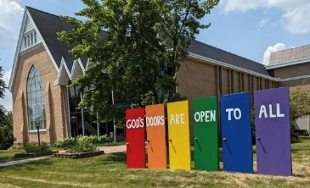
Our Building Is a Great Event Venue!
We are blessed to be able to share our beautiful church facilities for purposes that match the values of the church and its mission which is “To know and share God’s love within us.” We are an open church valuing the diversity of age, culture, gender identity, opinions, physical and mental abilities, and sexual orientation.
To request a space for general use, ask for a “Request for Church Building Use” form and policy packet from Terri in the church office, at 218-829-2528 or email uccbrainerd@gmail.com. Submit the request form back to Terri in the office, and it will be submitted for approval at the next Council Meeting.
For wedding or funeral use, contact Pastor Leslie: pastorleslieucc@gmail.com
0

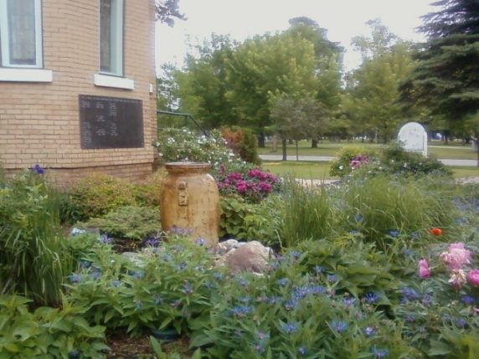
0
Memorial Garden Weekly Weeders

Would you like to help keep the UCC Memorial Garden beautiful?
We would love your help!
We'll be weeding every Wednesday at 10am.
Please complete the sign-up survey below and indicate when you are available to help.
Memorial Garden Weekly Weeders

Or contact Becky Twamley to be added to the sign-up.

Whether it's just one time, once a month or more often...we are grateful!

0
The Columbarium & Memorial Garden
First Congregational UCC, Brainerd
The Columbarium is in the historic space that once was our church’s front entry way.

How appropriate it is that our Columbarium now marks another entry way into a new life — where the Spirits of Love and Truth are always present!

The Memorial Garden is located on the south lawn of the church. The Garden provides a place for cremains of your loved one to be buried in the ground among natural plantings.

The Garden fee includes the inscription of your loved one’s name on a granite plaque that is mounted on the outside wall of the church. Should you wish to learn more about the purchase of a niche for your own cremains or for the ashes of a loved one, please call the church office at (218) 829-2528 and a packet of materials will be sent to you via email or regular mail.

0
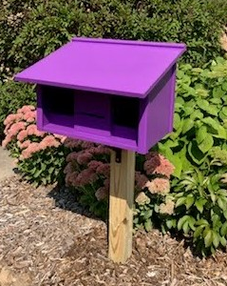
Community Prayer Box

You can find the Community Prayer Box in the Memorial Garden on the South side of the church (the side that faces Juniper Street.)

Community members frequently walk through the garden and this box will offer our wider community an opportunity to share their prayers. Prayer cards and pens are provided, and the box is secured with a padlock, so the submitted prayers don’t fly away with the wind!

Pastor Leslie checks the box weekly and pray for any prayers submitted as well as bring them to the Care Team for prayer as well.

0

Brainerd Lakes & Surrounding Area Information
0
~ Opportunities to Know and Share God’s Love ~
0
Crow Wing County Military Family
Support Group

1st & 3rd Wednesday of each month 7:00-8:00 pm

Meets at First Congregational UCC
415 Juniper St. Brainerd MN 56401

Join us to support military families if you: Have someone joining the military, have an active military member or have someone that has previously been in the military.

More info: drttbsby@msn.com
0
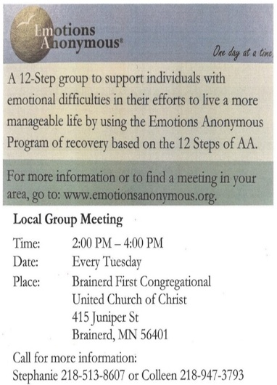



June 2026 Calendar
Sunday | Monday | Tuesday | Wednesday | Thursday | Friday | Saturday
Y- Yes Meeting in person  FB -Facebook Live Stream Online  C- Cancelled N-No Meeting  P-Postponed Z-our church Zoom | Office Closed | Office Hours  10am – 2pm | Office Hours  10am – 2pm  Pastor Drop-in Hours  11:00 am – 1:00 pm | Office Hours  10am – 2pm | Office Closed
 | 1  5pm BACP/BLUE church-backup  5-7pm BLA Indivisible in Fellowship-Y | 2  2pm EA-Y  3-6pm TACO  Tuesday-Y  5:30pm OA -Y | 11:45pm Men’s Grp 3  @ Wings Cafe-Y  1:30pm PRC Mtg.-Y  4pm LAJT Men’s Socialization Mtg-Y  4:30pm Christian Mnstry-Y  7pm Military Family  Support Grp-Y  7pm AA Common-Y | 4  10am Care  Team-Y | 5  10:30am Bk Grp-Z  Movie Night-C  Resume in Fall | 6  Noon-2pm Door Rededication & Potluck Neighborhood invited-Y.
8:30am Brainerd Friends-Y 7  10am Sunday Worship, Communion-Y&FB  Rev. Wendy Vander Hart Preaches  11am Fellowship-Y  11:30am Adult Forum:  “Generosity Now and Later” | 8  Pastor Leslie Out of the Office  2pm Trustees Mtg-Y | 9  Pastor Leslie Out of the Office  2pm EA-Y  5:30pm OA -Y | 10amTrustees-Y 10 11:45am Men’s Grp  @ Wings Cafe-Y  3:30pm Executive Mtg.-Y  7pm AA Common-Y | 11  Pastor Leslie at Training | 12  10:30am Bk Grp- Z  MN Conf.  Annual Mtg. | 13  MN Conf. Annual Mtg.
8:30am Bnrd Frnds-Y 14  10am Worship-Y&FB  11:15am Fellowship-Y | 15  5-7pm BLA Indivisible in Fellowship-Y | 16  2pm EA-Y  5:30pm OA -Y | 17  11:45pm Men’s Grp.  @ Wings Cafe-Y  7pm AA Common-Y | 18  2pm Council -YZ  6:30pm Dist.7 AA-Y | 19  10:30am Bk Grp- Z | 20  Noon-6pm Baby Shower in Fellowship-Trish Menk-Y
8:30am Bnrd Frnds-Y 21 :10am Worship-Y&FB  11:30am Adult Forum:  Fathers Story Circle  12pm Father’s Day BBQ  & Potluck-Y | 22  *Newsletter Deadline | 23  2pm EA-Y  5:30pm OA -Y | 11:45pm Men’s Grp 24  @ Wings Café-Y  TheShop Cooking-  7pm AA Common-Y | 25  11:30am Women’s Lunch @ Black Bear Lodge | 26  10:30am Bk Grp- Z | 2-4pm 27  Jan Morton 90th BD Open House Fellowshipl-Y
8:30am Bnrd Frnds-Y 28  10am Worship-Y&FB  **Mission Moment WeARE  *Special Offering WeARE  11:15am Fellowship-Y  1:30pm Heartland Symphony Orchestra Board of Dir. Mtg. Fellowship Hall-Y | 29  5-7pm BLA Indivisible in Fellowship-Y | 30  2pm EA-Y  5:30pm OA -Y

