Friendship News, May 2023
First Congregational United Church of Christ, Brainerd
An Open and Affirming Congregation
The Church Office Hours: Wednesdays – Fridays from 10:00 am – 1:00 pm
Pastor Leslie’s Drop-in Hours: Wed. 1:00pm – 3:00pm, Friday 10:00am – 12:00pm
Office phone 218-829-2528 Office E-mail uccbrainerd@gmail.com Pastor’s E-mail: pastorleslieucc@gmail.com Website: www.uccbrainerdmn.org
Schedule a 1 to 1 (in-person or by Zoom or Phone) with Pastor Leslie:
www.calendly.com/pastorleslieucc/1to1
No matter who you are, or where you are on life’s journey, you are welcome here.

Metamorphosis and Emergence
Spring and the Easter season beckon us to pay attention to new life that is emerging all around us. Flower bulbs that have been dormant through the cold winter months are shooting green stems and leaves even before the snow has completely disappeared. Butterflies have long been a symbol of rebirth, and resurrection. From the protective and nurturing darkness of the chrysalis to the unfurling of new wings, the butterfly’s journey of transformation is beautiful, messy, complicated, and awe-some. Our worship during the month of May will engage with the themes of metamorphosis and emergence. We will delve into stories from scripture that help us to engage with issues of fear, trust, and letting go as they relate to transformation.

May we unfurl our wings and dare to take flight as the beloved people God calls us to be.

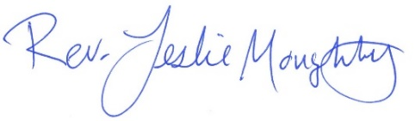
With peace,

Moderator’s Musings

Have you heard the song “All God’s critters have a place in the choir, some sing low and some sing higher, some sing out loud on the telephone wire and some just clap their hands or paws or anything they got now”?
That song entered my mind at a Sunday service, when around me I heard a bass, a soprano and an alto all singing joyfully in the “church as a whole” choir. Also, when I saw the volunteer recognition posters naming all of the people and things that are going on and getting done in our church and community.
Although a choir is generally thought of as a musical group, today, I will use it as a metaphor to mean everyone in our church working together to make beautiful things happen. Everyone has a place in our “choir”.
Our church year runs from June 1st to May 31st; therefore our annual meeting will be held after the church service on Sunday, May 21st. At the annual meeting, you will find out how, in the past year, folks have worked together to create a “concert” of completed activities and ideas for the future. We will receive the Annual Report, vote on renewing the WISE Covenant and elect new Council and Committee members.
I hope to see you at the Annual Meeting, and I look forward to the congregation and church’s 2023-24 encore.

Colleen
Council Moderator

0
First Congregational UCC News & Updates
0

Beginning May 1st!
New Summer Office Hours & Pastor Leslie’s New Workday Schedule
Pastor Leslie's Workdays: Sunday through Thursday
Pastor’s Drop-in Hours: Wednesday’s 2pm - 4pm &
Thursdays 11:00 am - 1:00 pm
*To make an appointment outside of the drop-in hours, go to calendly.com/pastorleslieucc/1to1 to schedule an appointment, or call or email Pastor Leslie directly.
Church Office Hours: Wednesday, Thursday, Friday
10:00 am - 2:00 pm (extended for the summer)
Please call Terri at the office 218-829-2528 or
cell 218-537-1636 for further assistance.

0
Directory Update

An updated directory will be emailed out the first part of May. Many photos are outdated, so please send new ones! If you have changes or new contact information, or want something removed, please let Terri in the office know asap.

New Members to First Congregation!
0
Please welcome three new members to our church! Greta Norlander, Jon Howard & Pam Wible. They will be officially received in a June Worship Service.
0
New Hearing Loop System Installed!
Sanctuaries don’t always have the best acoustics for people with hearing loss.
If you have a T-coil enabled hearing aid, you can now utilize the church’s new telecoil hearing system. The system will work best in the front section of the sanctuary. Your hearing aid must be enabled to receive the audio signal. Please contact your supplier if you need help in activating this feature.

Trustee - May Volunteer Clean-up Day Saturday, May 13th
0
Your trustee team is planning tasks for their annual outdoor grounds clean-up day, which is being held on Saturday, May 13th from 9:00am – 1:00pm with pizza, salad and beverage served at 1:15pm in fellowship hall. (Rain Date is scheduled for Saturday, May 20th from 9:00am – 1:00pm).
We are asking for 12 people to help. Work jobs needing volunteers: 1) paint UCC front lawn exterior wood sign; 2) re-stripe back parking lot; 3) install barrier poles in front of kitchen exhaust motor; 4) fill cement sidewalk cracks; 5) clean out rain gardens and flower beds; 6) set out memorial garden fountain 7) re-install the peace pole.
CUTRight Lawn Care will mow up any leftover leaf debris from last fall. The trustees will provide all paint supplies but are asking volunteers to bring a spade shovel, rakes, tarps and 5-gallon buckets.
Each Sunday there will be a sign-up sheet on the table in the narthex.
On behalf of the trustee team we hope you will consider volunteering with us on May 13th.

0
Annual Meeting - Sunday May 21st
After Sunday Worship
All voting members are encouraged to attend as we elect new committee members and review the last 12 months. Reports will be emailed the second week of May. Please contact the church office if you need a printed copy mailed to you.
0
0
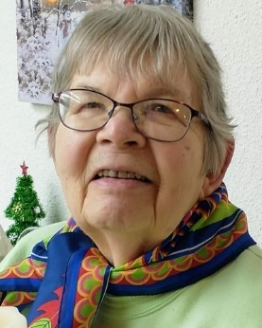
Doris Anderson Memorial
Memorial Service for Doris Anderson will be held on Wednesday May 24th, 2023 at 11:00am at the First Congregational Church in Brainerd.
Friends and family are invited to gather one hour prior to the start of the service at the church. All are invited to stay for lunch following the service. At the request of Doris, you are invited to wear bright colors to the Memorial Service.
Memorial Offerings may be sent to First Congregational UCC Brainerd, Salvation Army and HART.

May Birthdays
0

Ellen Pishko May 3
Terri Chidester May 5
Lance James May 5
Sue Hadland May 9
Emily Jones May 10
Kai Lukanen May 14
Laura Raedeke May 16
Morgan Twamley May 16

Carla Benjamin May 17
Shon Boman May 22
Janice Morton May 22
Max Ferrie May 23
Nancy Waller May 25
Preston Newgord May 26
Anthony Newgord May 29
Charlotte Goedsche May 30
Kathy Ogden May 30

0
How to watch Sunday worship The worship service is broadcasted on the church Facebook page and the church's YouTube channel every Sunday at 10:00 am.
To watch worship on Facebook, go to https://www.facebook.com/uccbrainerd/live
Live stream videos are saved and can be viewed at any time.
Financial Help Available Your Church Council voted last year to allow the Pastor's Discretionary Fund to be used to assist church members and others in the Brainerd area who are experiencing financial distress during this time. We received many generous donations! If you need assistance, please email, call, or text Pastor Leslie. Let her know what your situation is and how the church might be of help.
Donate to the church online! We are now accepting your offerings and donations using PayPal. You do not need to have a PayPal account to make an online donation with a credit card. To use PayPal, go to: https://www.paypal.me/uccbrainerd

0
Church Leadership
Get Involved, Give Back, Grow Connections – Volunteer at Church!
There are many opportunities for you to share your talents!

--Moderator, serves a 1-year term (may renew for 3 terms). Contact Colleen LeBlanc for more information 218-251-4065

--Treasurer, serves a 1-year term (may renew for 6 terms). The primary role is oversight of bookkeeping, church finances and Executive Committee discussions. This candidate should have a strong background or interest in finance or banking.

--Council Member-At-Large: Attend council meetings, act as a liaison for church members and council, help with nominations, spokesperson for historically underrepresented groups (HUGS).

Committees needing fresh faces and leadership:
-Christian Education -Trustees -Stewardship -Memorial
-Music -Arts -Christian Ministry

Call or text Colleen LeBlanc - Moderator, with your nominations: 218-251-4065

0
Highlights from the Council Meeting, April 20th, 2023
Thursday, 4:00 pm (In-person and Zoom)
~ These are highlights. If you would like a copy of the full minutes, please contact the church office ~

Present: Pastor Leslie, Marcia Ferris, Karen Ford, Colleen LeBlanc, Terri Chidester, Lowell Johnson, Sue Hadland, Tim Anderson Unable to attend: Alvin Velsaag

Additions to the Agenda - Situational Support Group Meeting on May 15 from 4-6pm
March Council Minutes - No corrections. Unanimously approved.
Clerk Report - Karen had no report
Financials - February 2022 Financial Report - Discussion - Place on File
Pastor Report - Rev Leslie also reported that there are three new members (Greta Norgaard, John Howard and Pam Wyble) as well as Steve Newcome will be joining. There may be two more new members (Sean Melo and Savannah O’Hare) if they complete the class.
Copies of Lily Grant Application handed out to council members for information.
Member at Large Report - Alvin: Lowell reported that the garden at Alano will have its first workday on May 6. WISE will be represented at Bethlehem Lutheran health fair on April 30.
Department Reports
- Trustees - Deb: April meeting and March budget.
- Stewardship - Marcia: More volunteers are needed to help with Sunday counting. It was suggested that a sign-up sheet be available at Sunday worship including the training information that is available via a video link.
- Christian Ministry - Sue: April meeting minutes. Good Friday “Stations” event was widely received with request to repeat next year. 30 people attended, all but one was from the congregation.
- Christian Education - Lowell: 10 CSA food boxes will be provided by Sprout with additional food provided for TheShop. More details to come for the months of June, July, August and September.
Adult Forums are planned through May.
Lowell met with Cathy Ogden and Mary Reardon who are interested in planning summer events (possibly with Park Methodist) with more details to come.
Old Business
A. By-laws revisions - Explained and discussed by the council. Unanimously approved. New
by-laws should be placed in council binders.
B. Sponsorship request - “The Laramie Project” play /Stage North Theatre Company/Oct.
2023. A discussion related to supporting the production of the Laramie Project resulted in a
Motion to disburse up to $500 from the Shirley McConnell Social Justice Fund. This money
will match a special offering to sponsor the Laramie Project play at Theatre North on
October 14, 2023. Approved unanimously. The distribution of complementary tickets
provided by Theatre North will be determined at a later date.
C. Congregation/Pastor Assessment - Survey sent April 19.
Thanks Cynthia Janes, Pastor Leslie, Karen Ford, and Tim Anderson for their continuing.
work on this.
D. Annual Meeting - Sunday, May 21, 2023. Reports due to Terri by May 10.
Draft Agenda - Nominations/Elections; Renewal of WISE Covenant; Analysis of cost of
keeping parsonage in collection of assets versus paying the pastor for housing costs.
Task Force
E. Council Position Nominations - No updates
New Business
New member approval - Pastor Leslie
FYI – Use of building space request by Sally Boos approved for meeting regarding Human Rights Commission was approved. Date is uncertain.
Adjournment
Meeting adjourned at 5:15pm

Minutes respectfully submitted by Karen Ford, Clerk

Next Regular Council Meeting: Thursday, May 18th, 2023, 4:00 pm
in-person and via Zoom tinyurl.com/uccbrainerdzoom

0
May Adult Forum – 11:30 am after worship

May 7th - Mothers Day Story Circle
Join us as we use a story circle process to remember and honor the influence of our mothers on our lives.

0
TheShop Meal with First Congregational UCC
Date to be determined - later in May
3:45 pm church kitchen.
We are working with the young people from TheShop (Brainerd/Baxter's Youth Empowerment Center) and are preparing a meal and serving it at TheShop for the participants in the program. Mary Benson is the new point person. If you are interested in helping, please email Mary at marybenson75@gmail.com

New Project - Fun with Food and Friends!

A new project at the church will be happening once a month from June - September. Organized by the Region 5 Economic Development Commission and Sprout, we will start by receiving 10 CSA boxes of local organic vegetables delivered to the church. Youth from TheShop, and any other youth we can get to attend, will learn about how to prepare that month's vegies, prepare a meal and enjoy eating together. The youth would like to have the adults bring their favorite music from the old days, and they will bring their favorite more modern music. The extra food not eaten that evening will be distributed to hungry folks.

We need UCC adult and youth volunteers to participate and spread the word about this free learning and community give back experience. Dates have not yet been set, but once those have been determined, we will let you know. Please consider volunteering for this exciting new project.

UCC Women’s Fellowship
0

Two times are scheduled each month to include as many as possible: one weekday and one Saturday.
The first luncheon was organized by Joy Persall. It was held and well attended at Sage on Laurel in downtown Brainerd.
Contact Joy Persall. The next weekday luncheon date in May to be determined.
The first Saturday meeting is Saturday, May 13th 9:30 am and was organized by Marcia Ferris. Meet in the Fellowship Hall for morning coffee and goodies. Contact Marcia Ferris for Saturday gatherings.
All updates will be posted on the Connections Facebook Group and RSVP’s may be made in the comments under the post at: www.facebook.com/groups/uccbrainerd

0
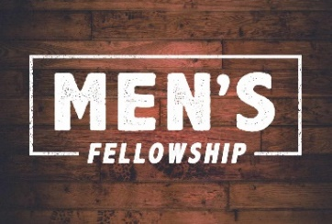
UCC Men’s Fellowship - Every Wednesday at Noon
0

You are invited to a casual fellowship at various locations in the Brainerd Lakes area.
Schedule 2023
First Wednesday: B-Meri
Second Wednesday: Four Seas in Brainerd
Third Wednesday: Dunmire’s East
Fourth Wednesday: Black Bear
Fifth Wednesday: El Tequila in Baxter

Contact Jack Kraywinkle for more information 612-396-3480 or email: kraywinklej@gmail.com

0
Cooking For Everyone
This group is OPEN FOR EVERYONE!
Email Lowell johnsonlowells@gmail.com and he will add you to the member list so that you will know when and where we will next meet. Fundraiser plans for small home-based meals and cooking experiences.

SPRING CLEANING
0
A number of our industrious members have been busy with spring organizing and cleaning of our church. It was time to "go through and clean out." As our church storage is limited. There are two long tables in the downstairs Rainbow (Sunday School) Room with items for our members to view. If any of them are ones you donated and would like back, please take. If there are any that you can use or know of some group that would appreciate them, please feel free to take. If you wish, you can leave a small donation. Item left over after a few weeks will be donated to a non profit.

Friday Book Group - 10:00 am
0
Via Zoom: tinyurl.com/uccbrainerdzoom

We started reading a new book on April 21st. "Water Always Wins: Thriving in an Age of Drought and Deluge by Erica Gies.
“A hopeful journey around the world and across time, illuminating better ways to live with water".

0
Special Offering Sunday Worship May 28th
UCC Missions Strengthen the Church
The Strengthen the Church (STC) Offering reflects the shared commitment of people across the United Church of Christ to cooperatively build up the UCC. The funds raised support leadership development, new churches, youth ministry, and innovation in existing congregations. By your generosity to this offering, you build up the Body of Christ. As God calls our congregations to be the church in new ways, your generosity will plant new churches, awaken new ideas in existing churches and develop the spiritual life in our youth and young adults.
Please send your donation to First Congregational UCC, 415 Juniper St. Brainerd, MN 56401.
Or for your convenience use our Paypal account at: paypal.me/uccbrainerd
Make note on your offering “STC Special Offering”. Thank you!
0
Hosts, Ushers, Greeters, Scripture-readers

Sunday morning greeters/ushers and coffee hosts play an important part in making our church a warm and welcoming place for all. Here’s a secret; it’s FUN!! If each household committed to 3 Sundays a year as greeter/ushers and/or coffee hosts, we would have a full complement of participants. Are you ready to take the leap into RADICAL HOSPITALITY? Give it a go and signup below for your first Sunday as the face of the church! https://www.signupgenius.com/go/10C0E48A9A823A5FFC07-hugs/16034811

0
First Congregation Food Shelf Collection
0
Our church continues to collect non-perishable food items for the Salvation Army Food Shelf. There are two collection boxes: one in the parking lot entry hallway, the other in the Narthex. Brian Twamley picks up and delivers the food.
Please consider bringing items and donating. You may also send a money donation to the church; First Congregational UCC, 415 Juniper St. Brainerd, MN 56401. Or for your convenience use our Paypal account at: paypal.me/uccbrainerd Make sure to write in memo “ Food Shelf”. Thank you!

0
The Columbarium at First Congregational UCC, Brainerd

The Columbarium is located in the historic space that once was our church’s front entry way.
How appropriate it is that our Columbarium now marks another entry way into a new life — where the Spirits of Love and Truth are always present!
Should you wish to learn more about the purchase of a niche for your own cremains or for the ashes of a loved one, please call the church office at (218) 829-2528 and a packet of materials will be sent you via email or regular mail.
The Memorial Committee has prepared the information packet, and it contains all the details you will need as you consider inurnment here at First Congregational UCC.
Have any other questions? Contact Dawn Stattine at dawnstattine@gmail.com

Brainerd Lakes Area Information
~ Opportunities to Know and Share God’s Love ~

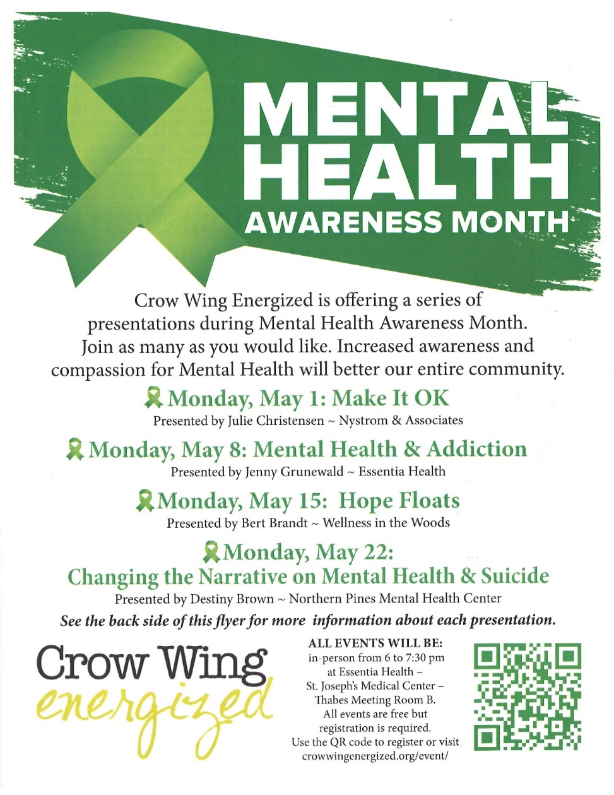

- Continued -
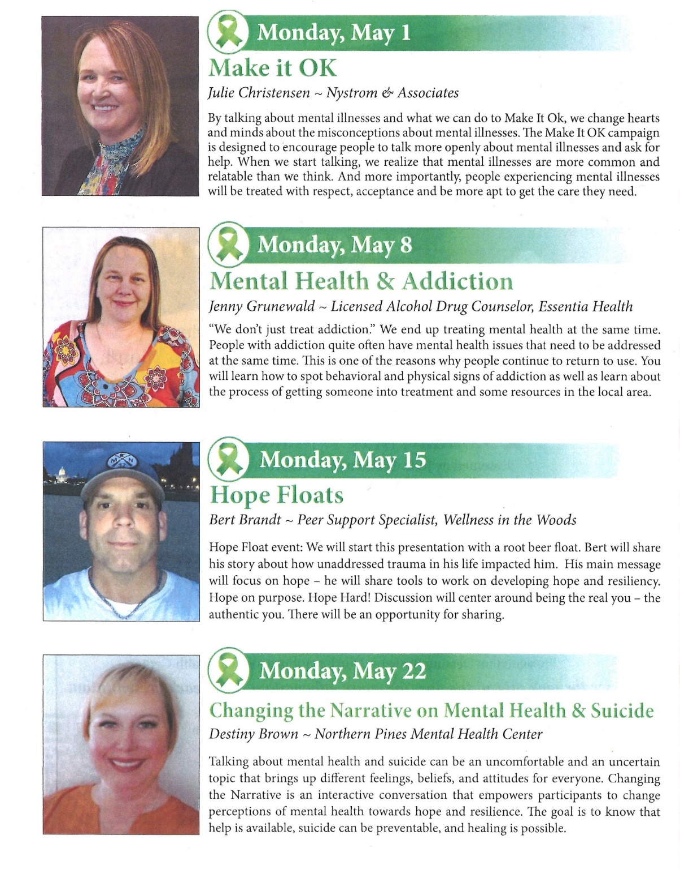
Youth for Understanding
Host Families Needed
There are 13 German high school students, both male and female, needing host families through the Youth for Understanding organization, which I represent. If you or anyone you know of would be able to host one of these students next year, please let me know. Once you have been accepted as host parents, I can give you more specific information. Contact Pat Scott @
For general information check out their website: https://www.yfuusa.org/host

Need your colors!
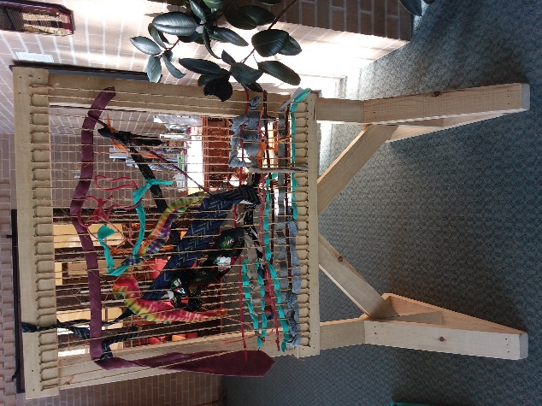
Weaving Community Project!

A couple of years ago, the Lakes Area Guys network (LAGN) built and gifted looms to various sites under its Weaving Community project. A number of you contributed strips of cloth and other weavable items to seed the project.
Three of those looms are permanent outdoor looms and those looms need a refreshing of materials due to weathering. If you have strips of colorful fabric, old neckties, or other beautiful items that would be suitable for weaving on a loom, please bring them to the church during May and put them in the bin marked Weaving Community.

UCC News & Updates!

Annual Meeting 2023: Protecting God's Gift of Creation
We are excited to welcome you to this year's Annual Meeting June 9-10, where we will gather at the College of St. Benedict. Our theme is "Protecting God's gift of Creation." An online option will also be available. Workshops will be offered in person during the afternoon on Friday, June 9, for those attending in person.
VISIT OUR WEBSITE for more details including our keynote speaker, the agenda, and access to the newly opened registration link.

Upcoming Conference Events

- April 28-30: Spring Youth Conference Event
- June 8: Anti-Racism/Diversity Training
- June 8: Power & Boundary Training
- June 9-10: Annual Meeting of the Minnesota Conference UCC
- July 5-7: Summer Youth Camp
- August 5: One-Day Family Day Camp in Bayport
- August 6: One-Day Family Day Camp in Mankato
- September 8–10: Women's Retreat
- September 22-24: Women's Wilderness Walk: From the Inside Out
- September 29–October 1: 2023 Queer Walk
- October 6-8: Fall Youth Conference Event
- ﻿October 22-24: Faith Formation Leader Retreat

May 2023 Calendar
Sunday | Monday | Tuesday | Wednesday | Thursday | Friday | Saturday
Leslie Workday | Leslie Workday | Leslie Workday | Office Hours10am – 2pm  Pastor Drop-in 2pm-4pm | Office Hour  10am – 2pm  Pastor Drop-in  11am – 1pm | Office Hours10am – 2pm  10am – 2pm
Beginning-New Workday schedule- Leslie & Office Hours extended | 1 | 2pm Emotions 2 Anon-Y  5:30pm Overeaters Anon-Y | 3  12pm Men’s Grp-Y  @ B-Merri | 4 | 5  10:30am Book Grp- Z | 6
7  8:30am Bnrd Frnds-Y  10am Wrship Serv & Communion-Y&V  10am NUUF-Y Adult Forum Rm  11am Fellowship-Y  11:30am Adult Forum | 8 | 2pm Emotions 9  Anon- Y  5pm LeMesa-Y in Park/church backup  5:30pm Overeaters Anon- Y | Annual Reports 10  Due from Council/Depts  10am Care Team-Y  12pm Mens Grp-Y @  Four Seas  5:30pm Trustees-Y  7pm AA Common-Y | 11  8:30am CM Mtg.-Y  4pm Exec. Mtg-Y  7pm BLUE-in Park-Y/church backup | 12  10:30am Book Grp.- Z  . | 13  9am Trustees Clean-up Day  9:30am Women’s Fellowship-Y Fellowship Hall
Mother’s Day 14  8:30am Bnrd Frnds-Y  10am Wrship Serv-Y&V  11am Fellowship-Y  11:30am Confirmation-? | 15 | 2pm Emotions 16 Anon-Y  5:30pm Overeaters Anon-Y | 17  12pm Men’s Grp  @ Dunmire’s East-Y  7pm AA Common-Y | 18  4pm Council Mtg-Y&Z  7pm AA Dist-Y | 19  10:30am Book Grp- Z | 20  Rain date Trustees Clean-up Day
21  8:30am Bnrd Frnds-Y 10am Wrship Serv-Y&V  11am Annual Mtg-Y  11:30am Fellowship-Y  2pm Sarah Gorham Piano Recital-Y Sanctuary | 22 | 2pm Emotions 23 Anon-Y  5pm LeMesa-Y in Park/church backup  5:30pm Overeaters Anon-Y | 12pm Men’s Grp-C 24  Doris Anderson Memorial  10am Visitation-11am Memorial service-lunch after service  7pm AA Common-Y | 25  11:30am Women’s Grp @Dunmire’s on Lake.-Y  6:30pm Dist.7 AA-Y | 26  10:30am Book Grp- Z | 27
8:30am Bnrd Frnds-Y 28 10am Wrship Serv-Y&V  11am Stewardship Volunteer Recognition Brunch-Y  11:30 am Adult Forum-Y  Special Offering:  STC  **Newsletter Deadline | 29  5-9pm AAUW-Program Mtg. Fellowship-Y | 2pm Emotions 30 Anon-Y  5:30pm Overeaters Anon-Y | 31  12pm Men’s Grp @ El Tequilla-Y |  | Foundation No Mtg.  Memorial No Mtg. | V or Z –Virtual Online or our Zoom  C- Cancelled  N-None  ? – No update  Y- Yes Mtg. in person

