Friendship News, November 2023
First Congregational United Church of Christ, Brainerd
An Open and Affirming Congregation
The Church Office Hours: Wednesdays – Fridays from 10:00am – 2:00pm
Pastor Leslie’s Drop-in Hours: Wed. 2:00pm – 4:00pm, Thurs. 11:00am – 1:00pm
Office phone 218-829-2528 Office E-mail uccbrainerd@gmail.com Pastor’s E-mail: pastorleslieucc@gmail.com Website: www.uccbrainerdmn.org
Schedule a 1 to 1 (in-person or by Zoom or Phone) with Pastor Leslie:
www.calendly.com/pastorleslieucc/1to1
No matter who you are, or where you are on life’s journey, you are welcome here.
Pastor’s Pen
Taking Time to Be Grateful
With the first snow of the season fresh on the ground, it’s clear that Christmas is right around the corner. While shopping at Menards last week, Christmas decorations vastly outnumbered the Halloween decorations (which were marked down to sell what was left). The days and weeks seem to fly so quickly sometimes. In the words of one of the most memorable movies from my childhood “Life moves pretty fast. If you don’t stop and look around once in a while, you could miss it.”
So a few weeks ago, I decided to take some time to breathe in the beauty of the current season before hurrying on to the next one. To literally stop and look around. A friend of mine invited me to climb the fire tower at Kathio State Park to look at the fall colors before they were gone. Part of me resisted, telling myself that driving almost an hour each way to look at the tops of trees was a waste of time. Think of all the laundry I could do in that time! But I am so glad I took the time to climb the 130 stairs to the top of the fire tower and look out over the canopy of yellows, reds, oranges, golds, and greens. I was reminded of the beauty and wonder that each season offers. The precious gift of the creation of God and how grateful I feel when I take the time to stop and look around.
I hope you choose to make some time for gratitude this season. Don’t wait for it to come to you. Just stop and look around once in a while.
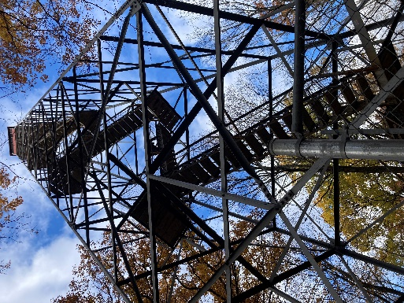
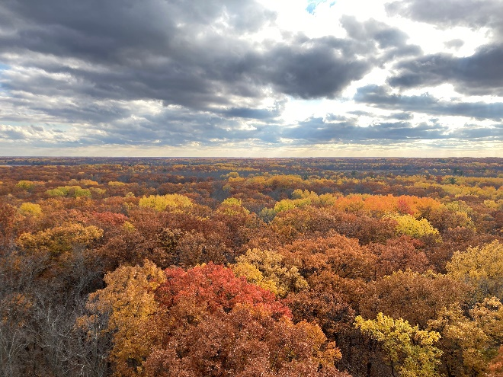
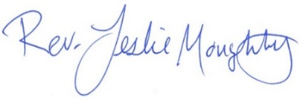
With peace,

Pastor Leslie’s Workday Schedule
>> Sunday through Thursday (Days off are Friday and Saturday) <<
Pastor’s Drop-in Hours*
Wednesdays 2:00 – 4:00pm Thursdays 11:00am – 1:00pm
*Drop-in hours are times set aside for “drop-in” conversations, much like a professor’s office hours. Pastor Leslie is typically working at the church the rest of the week, but it is possible that she may be in meetings, at a community event, or working off-site.
Pastor Leslie typically works off-site on Tuesdays for sermon research and writing.

Everyone is encouraged to make an appointment if the above times are not convenient.
You can go to www.calendly.com/pastorleslieucc and select a day and time that works for you, or you can email Pastor Leslie at pastorleslieucc@gmail.com or call/text at 218-656-0096.

Pastor Leslie will be out of the office for Clergy Retreat
November 14th through the 16th

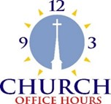
Church Office Hours
Wednesday, Thursday, Friday
10:00 am - 2:00 pm
Please call Terri at the office 218-829-2528 or
cell 218-537-1636 for further assistance.

Terri Admin. Asst. is taking vacation days
Thursday, November 9th & Friday, November 10th.
The Office will be closed on Friday, November 10th.

Please call the office for assistance and leave a voice mail.
Messages will be checked throughout the day and calls returned.

How to watch Sunday worship The worship service is broadcasted on the church Facebook page and the church's YouTube channel every Sunday at 10:00 am.
To watch worship on Facebook, go to https://www.facebook.com/uccbrainerd/live
Live stream videos are saved and can be viewed at any time.
Financial Help Available Your Church Council voted last year to allow the Pastor's Discretionary Fund to be used to assist church members and others in the Brainerd area who are experiencing financial distress during this time. We received many generous donations! If you need assistance, please email, call, or text Pastor Leslie. Let her know what your situation is and how the church might be of help.
Donate to the church online! We are now accepting your offerings and donations using PayPal. You do not need to have a PayPal account to make an online donation with a credit card. To use PayPal, go to: https://www.paypal.me/uccbrainerd

First Congregational UCC News & Updates
0
0

November Birthdays

Floyd Schultz Nov. 2 Larry Anderson Nov. 16
Eleanor Burkett Nov. 4 Jan Kurtz Nov. 20
Dale Hadland Nov. 9 Itty Newgord Nov. 21
Becky Stadem Nov. 13 Mike North Nov. 25

0
Church Leadership
Get Involved, Give Back, Grow Connections – Volunteer at Church!

There are many other opportunities for you to share your talents!
--Treasurer, serves a 1-year term (may renew for 6 terms). The primary role is oversight of bookkeeping, church finances and Executive Committee discussions. This candidate should have a strong background or interest in finance or banking.

--Council Member-At-Large: Attend council meetings, act as a liaison for church members and council, help with nominations, spokesperson for historically underrepresented groups (HUGS).

Committees needing fresh faces and leadership:
-Christian Education -Trustees -Stewardship
-Music -Arts

Contact Mary Reardon - Moderator, with your nominations

Highlights of Council Meeting, Thursday, October 19th, 2023
3:30 pm (In-person and Zoom)
~If you would like a copy of the minutes, please contact the church office ~

Present: Mary Reardon, Moderator; Leslie Moughty, Pastor; Terri Chichester, Admin, Zoom; Deb Griffith, Trustees; Lowell Johnson, Christian Education; Sue Hadland, Christian Ministry; Marcia Ferris, Stewardship; Alvin Velsvaag, At-Large (Mental Health); Shon Boman, At-Large (PRC); Dan Hegstad, Guest representing a group interested in Marketing; Cynthia Janes, Clerk.
August and September Council minutes: Both months’ minutes were approved as read.
Clerk Report— No activity reported.
Financials
- September, 2023 Financial Report –
  - Leslie reminded us that budgets are due by the end of the month, and that at next month’s Council meeting the budget will be a main topic. She also reminded the Council that our Council binders have calendar dates on which various things happen and/or are due.
  - City assessment for street resurfacing: The church has been billed about $17,000 for our part of the street resurfacing project in this neighborhood. There are optional ways to pay. Motion passed that we pay in installments the amounts due each year.
Reports
Special Report on Marketing --- Dan Hegstad
Dan reported that on Monday, October 16, a group interested in marketing the church to attract and maintain new members. Recently Sunday worship attendance seems to be growing. The group determined that this is a great time to put together a plan, including a budget, and go to work. The council agreed and tasked Dan and the group to bring in a written proposal with a purpose and mission. There was positive energy among Council members for the idea of making this a new committee, or task force. This and other decisions will await the further information to the church Council by this marketing group.
Committee Reports
Submitted with agenda. All committee chairs had additions to the written reports.
- Trustees – No meeting since the September Council meeting. Deb reported that there will be end-of-the-year walk-throughs of the church and parsonage to see what might be needed. She said that the Trustees proposed budget will stay about the same as it is this year. The current year’s insurance hike was a surprise and may be again in 2024. The amount is unknown until we are billed, which is in January.
- Stewardship – Marcia reported that the pledges for 2024 are “trickling in.” There had been a suggestion that something about the church’s financials be printed in church publications. Problems could arise if the financials are misunderstood, or the information improperly directed. Leslie suggested that the monthly newsletter would be the only possible appropriate place for that. The council showed little enthusiasm for any report of financial but left open the possibility that a quarterly report could be made to the membership.
- Christian Ministry – Sue Hadland reported that Christian Ministry’s budget is done. She also announced that a choir is being formed to sing at Christmas services. Cynthia mentioned that it would be great to have the choir sing something for 12th Night. After a short discussion the Council agreed to reinstating 12th Night in January of 2024.
- Christian Education – Lowell stated that the job of Christian Education is to decide on the weekly Adult Forum events throughout the year. He reported also that we got the grant that will allow us to publish a book about the personal stories told by marginalized people. There will also be a video project to record some of the 100 stories as told by their authors. Lowell announced that on October 26, 4-7 pm at the Old Courthouse would be a program entitled “4000 Words of Indigenous People’s History.”
- Pastoral Relations-- A supplementary material Shon pointed out the document entitled “Agreeing and Disagreeing with Love and Dignity,” created by the Pastoral Relations Committee, which we all need to read.
- Alvin (Member-at-Large) reported that he is doing a project with Kay, who was absent. More will be shared about this next month.
- Memorial Committee – Report submitted.
- Care Team Report— Communication with Council needed. Leslie would like team members to fill out a simple report when they have a conversation with a church person.
- Pastor Report – Submitted at Council meeting.
Old Business
- Halloween plans for the church were updated by Leslie. Nothing that could be construed as church advertising will go into kids’ bags. Planning for 1000. We may make a frame that kids can put their head through and parents take photos. Greta might be able to help with this because she has graphic arts in her background. Candy and cider are coming in. Halloween is on Tuesday.
- Report on Laramie project: Low attendance. Conclusion: Sponsoring this was the right thing for the church to have done.
- November 5 (not confirmed): We will have another “dream session” led by Mary Reardon about our future as a church, as Adult Forum. The report of the last session will be available.
- Leslie’s sabbatical leave dates are March 4-June 4, 2024. The schedule needs to be finalized and potential replacement pastor candidates interviewed. Kelly at the Conference will provide names to Leslie. Clear job description(s) are needed. For example, there may be different people for delivering the sermon vs providing pastoral care. The Christian Ministry department is responsible for planning three worship services during Leslie’s absence.

Respectfully submitted,
Cynthia Janes, Cleark of Council

Next Regular Council Meeting: Thursday, November 16th, 2023, 3:30 pm
in-person and via Zoom tinyurl.com/uccbrainerdzoom

0 Movie Night is starting up again this month!
Mark your Calendars!

Stewardship Commitment Season
Because of You, our Church Changes Lives!

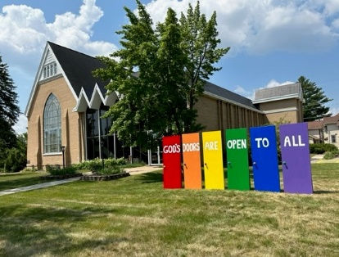
Dear Church Family,
The Stewardship Pledge Drive for our 2024 budget is nearly over. A blessing ceremony was held during worship on October 22nd and many pledges were returned. Thank you for your thoughtful and prayerful consideration.

If you have not handed in your pledges, please mail them, hand them in at Sunday worship or drop them off at the office (slide under the door if after office hours).

Extra Pledge Forms are on the table in the Narthex.

In faith, First Congregational UCC Stewardship Committee, Judy, Marcia, Maggie & Sarah Jo)

Calling all Christmas singers!
We are looking to form a temporary choir to sing during the Advent season and on Christmas Eve. Are you interested?

Send an email to Sue Hadland at dghrose@charter.net.

Sign up sheet is in the Narthex.

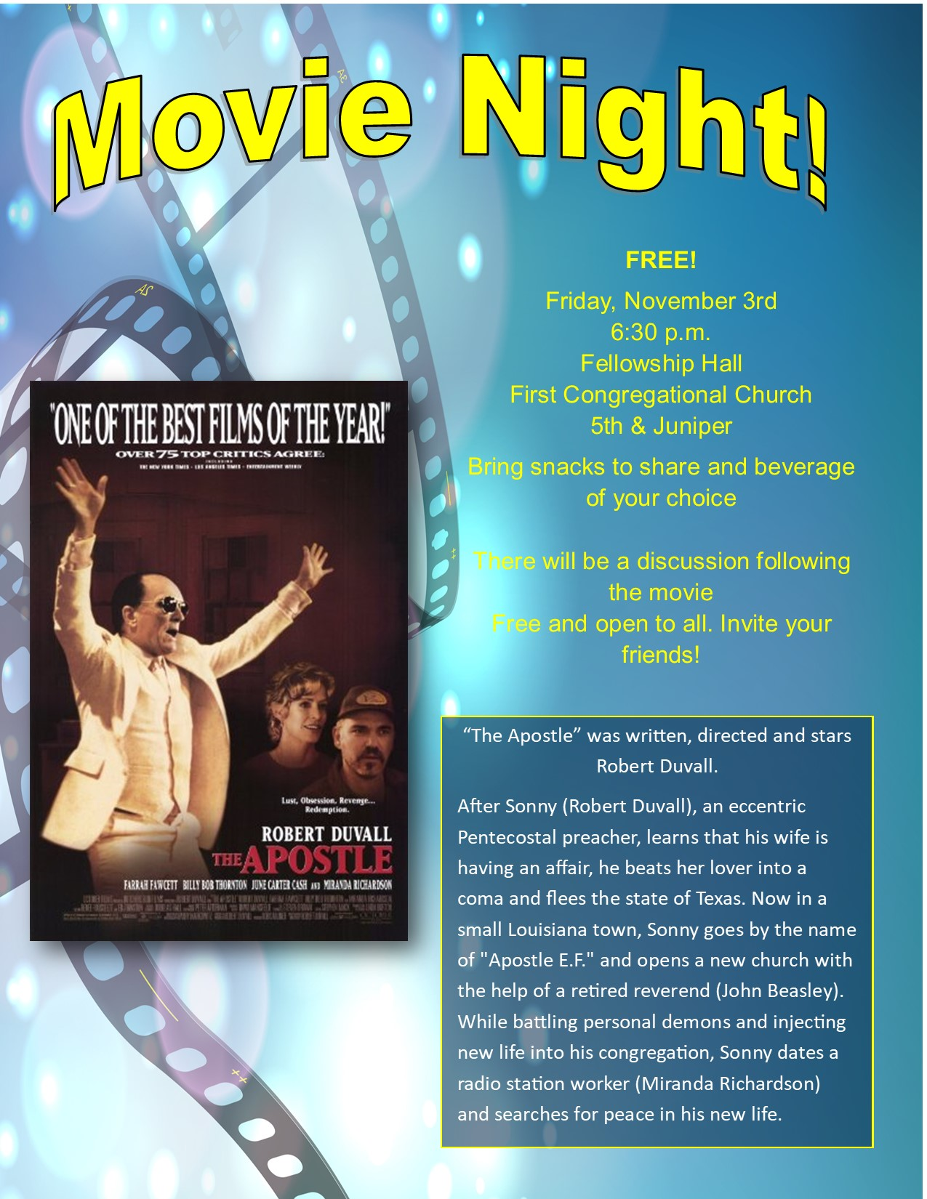

UCC & TheShop Meal!

Meal cooking is Thursday, November 9th at 4:00 pm.
For the last several years, UCC volunteers have provided a meal to the youth at TheShop - Brainerd Baxter Youth Drop-in Center. A number of youth from TheShop come over to our kitchen and help prepare a delicious meal that is then brought back to TheShop for the hungry and appreciative teens there.
Mary Benson is coordinating the meals, so if you are interested in joining in and enjoy cooking with youth, please call or email Mary. 218-839-4990 or marybenson75@gmail.com
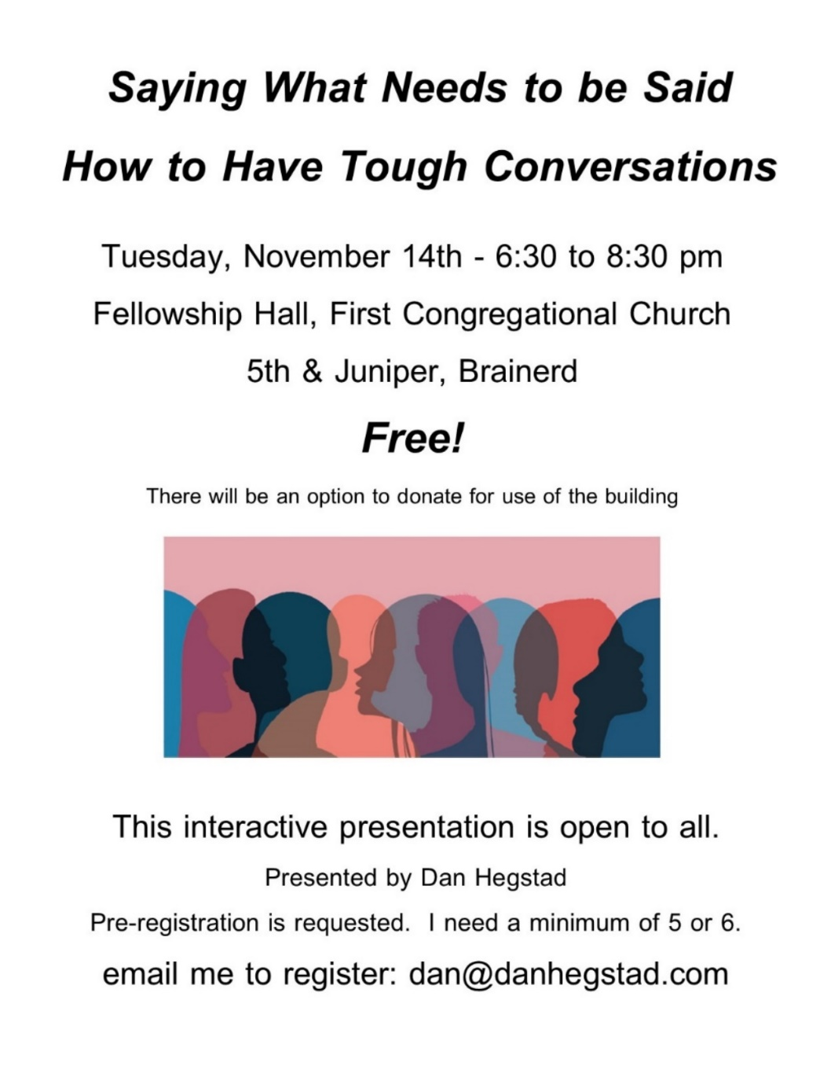

Saying what needs to be said isn’t ‘touch love’ or ‘brutal honesty.’ This is an adulting skill that is crucial for all employers and employees as well as couples, parents and even friends. This is a skill that can be taught and learned.
Not communicating is the stuff of movies and silly comedies. To not communicate out of fear or being passive/aggressive is unhealthy for everyone. Saying what needs to be said is not saying whatever you want. This is adult communication.
You will learn:
- How to talk to prepare for your conversation
- How to take the fear and emotion out of the interaction.
- How to “speak truth to power.”
- How to communicate your needs and expectations in a clear and understandable way.
- How to avoid drama and emotions.
- How to be on the other side of a touch conversation.
- How to be a good listener.
- How to apologize.

November Adult Forum - 11:30 am after worship

November 19th – "Poetry Slam”: Please attend if you love to read or just listen to good poetry. Participants can bring their favorite poems to read in a round robin fashion with a short reaction /discussion allowed between poems. We will read and discuss poems until our end time of 12:30 pm.

UCC Women’s Fellowship

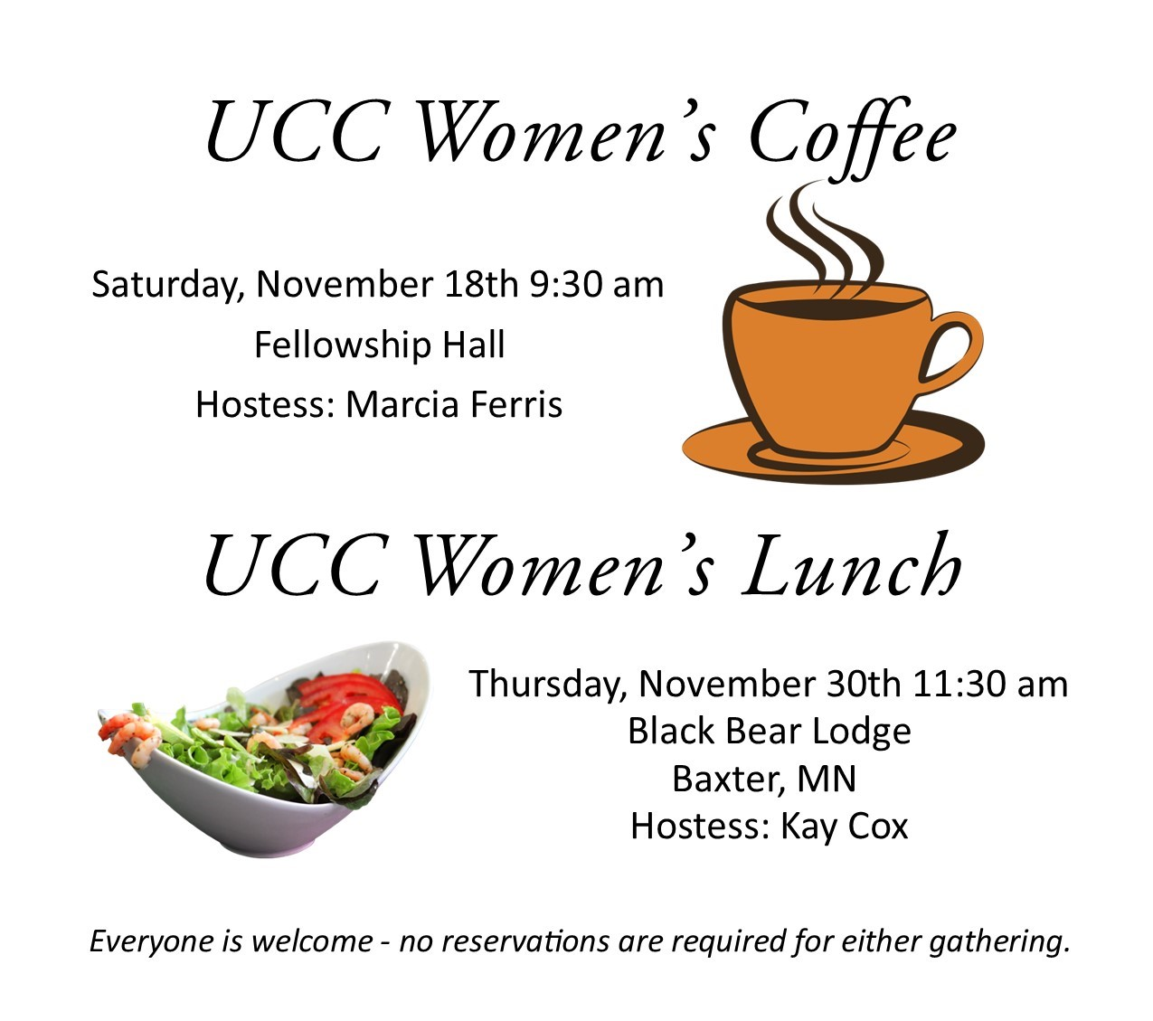

All updates will be posted on the Connections Facebook Group and RSVP’s may be made in the comments under the post at: www.facebook.com/groups/uccbrainerd

Friday Book Group
0 Movie Night is starting up again this month!
Mark your Calendars!
Our group is reading the book, “Gutsy Women”, by Chelsea and
Hilary Clinton.
We meet each Friday morning at 10:30 am via zoom.
Church Zoom link: https://tinyurl.com/uccbrainerdzoom

0 Movie Night is starting up again this month!
Mark your Calendars!
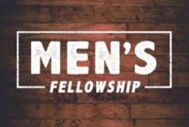
UCC Men’s Fellowship - Every Wednesday at Noon

You are invited to a casual fellowship at various locations in the Brainerd Lakes area.

Weekly Rotating Schedule:
1st Wednesday: B-Merri - 19624 Co. Rd. 3 Brainerd
2nd Wednesday: Four Seas - Brainerd
3rd Wednesday: Dunmire's East - Hwy 210 Brainerd
4th Wednesday: Black Bear - Baxter
5th Wednesday: El Tequila Mexican Restaurant - 7399 Garrison Rd. Baxter
Contact Jack Kraywinkle for more information 612-396-3480 or email: kraywinklej@gmail.com
0 Movie Night is starting up again this month!
Mark your Calendars!
Special Offering Sunday Worship - November 26th
Sharing Bread Soup Kitchen
This month we have an opportunity as we give our Fourth Sunday Special Offering to the Sharing Bread Soup Kitchen. A lifeline for hungry souls in the Brainerd Lakes Area since 1987. The Soup Kitchen’s mission is to demonstrate the love of Christ by providing meals to the hungry of our community.
Please send your donation to First Congregational UCC, 415 Juniper St. Brainerd, MN 56401. Make sure to note on your offering: “Soup Kitchen”. Thank you! Or for your convenience use our Paypal account at: paypal.me/uccbrainerd Be sure to note on your offering “Soup Kitchen” in comments.
0 Movie Night is starting up again this month!
Mark your Calendars!
Mark Your Calendars - ANNUAL BUDGET MEETING

Sunday, December 10th, at 11:15 am
after worship in-person and via Zoom
Please attend the congregational budget meeting to review and vote on the 2024 church budget. Meeting packets will be emailed to voting members on December 6th and distributed in person on the previous Sunday December 3rd. Please notify Terri in the office if you need a packet sent to you by mail.

0
0
CLIMATE JUSTICE UPDATE
On October 13th, a delegation of UCC laity and clergy delivered more than 6,500 postcards to the staff of the Environmental Protection Agency. Thirty-nine of those cards came from our Brainerd congregation. EPA staff have agreed to to discuss concerns about the EPA's rules regarding emissions from power plants as well as the EPA's Clean Trucks Plan.

Many of our congregation cards expressed concerns for future generations.
“Please let there be air that my great grandson can breath.”
“I am 87 but I have family who I hope will have a good eco-system in their lifetime.”
Others highlighted the urgent need for change.
“Please act fast and treat this like the crises it is!”
“Maui, Canadian wildfire smoke, water disappearing out west, & raging southern storms - what more proof we need?”
The Brainerd congregation was a leading congregation in this effort. If every UCC congregation had returned 39 cards, the total would have been 170,000.
Thank you for your climate action!
Justice Action Teams and Initial Members
WISE - Mental health and wellness: Alvin, Kay C., Chris, Tracy
Climate Justice - Mark, Kay K, Mabel Poverty - Georgia, Kim
Community Building - Kim, Denise, Jan Children and Families - Deb, Mabel
DEI-LGBTQ - Tracy, Jack, Chris

Each team will be responsible for providing leadership around their issue area. This doesn’t mean they do all the work but, instead, provide leadership for the congregation
Do you have a passion or concern around one or more of these issues? You can be part of a team leading a portion of the congregation’s Justice ministries! Contact stevenewcom@icloud.com for more information and join one of the teams.

0 Movie Night is starting up again this month!
Mark your Calendars!
UCC Care Team

The Care Team was formed with the purpose of reaching out to our congregation to ask how their lives are post covid, if our church is still valid to them and if they needed anything from our church.
A Congregational Care Team Visitation List was created to keep track of those parishioners who were homebound; living in a facility; living with chronic conditions; the bereaved and those with other concerns. Those who would like prayers are lifted up during worship and those wishing a pastoral call or visit are given to Pastor Leslie.
For anyone who wishes to join in on making calls or visits, the Care Team meets every month. Contact the church office for upcoming dates and times.
If you know of anyone who would enjoy a call from the care team, please contact one of our Care Team; Barb Hoeft, Jack and Kay Kraywinkle, Pat Scott, Chris Yager, Joey Halverson, Deb Griffith and Pastor Leslie.
0
First Congregation Food Shelf Collection Boxes
0
Our church continues to collect non-perishable food items for the Salvation Army Food Shelf. There are two collection boxes: one in the parking lot entry hallway, the other in the Narthex. Brian Twamley picks up and delivers the food.
Please consider bringing items and donating. You may also send a money donation to the church; First Congregational UCC, 415 Juniper St. Brainerd, MN 56401. Or for your convenience use our Paypal account at: paypal.me/uccbrainerd Make sure to write in memo “Food Shelf”. Thank you!

Hosts, Ushers, Greeters,
0
Scripture-readers
Sunday morning greeters/ushers and coffee hosts play an important part in making our church a warm and welcoming place for all. Here’s a secret; it’s FUN!! If each household committed to 3 Sundays a year as greeter/ushers and/or coffee hosts, we would have a full complement of participants. Are you ready to take the leap into RADICAL HOSPITALITY? Give it a go and signup below for your first Sunday as the face of the church! https://www.signupgenius.com/go/10C0E48A9A823A5FFC07-hugs/16034811

0
The Columbarium at First Congregational UCC, Brainerd
The Columbarium is located in the historic space that once was our church’s front entry way.
How appropriate it is that our Columbarium now marks another entry way into a new life — where the Spirits of Love and Truth are always present!
Should you wish to learn more about the purchase of a niche for your own cremains or for the ashes of a loved one, please call the church office at (218) 829-2528 and a packet of materials will be sent you via email or regular mail.
The Memorial Committee has prepared the information packet, and it contains all the details you will need as you consider inurnment here at First Congregational UCC.
Have any other questions? Contact Dawn Stattine at dawnstattine@gmail.com

0

November 2023 Calendar
Sunday | Monday | Tuesday | Wednesday | Thursday | Friday | Saturday
Leslie Workday  LeMesa Grp-Meets some Tuesdays @ Gregory Park w/church backup | Leslie Workday | Leslie Workday | Office Hours10am – 2pm  Pastor Drop-in 2pm-4pm | Office Hour  10am – 2pm  Pastor Drop-in  11am – 1pm | Office Hours  10am – 2pm
 |  |  | 12pm Mens 1  Fellowship @ B-Merri-Y  1:30 PRC Mtg.-Y  7pm AA Common-Y | 2  1pm Care Team Mtg.-Y. | 3  10:30am Book Grp-Z  6:30pm Movie Night in Fellowship Hall-Y | 4
8:30am Bnrd Frnds-Y 5  10am Wrship & Communion-Y&FB  11am Fellowship-Y  11:00am Stwrdship Mtg.-Y  12:00pm Confirmation Class-Y | 6  4:30pm AAUW  Mtg.-Y  7pm BACP/BLUE church backup | 7  11am PEO Mtg.-Y  2pm EA-Y  5:30pm OA -Y | 8  12pm Men’s Fellowship  @ 4 Seas-Y  5:30pm Trustees-Y  7pm AA Common-Y | Admin. Asst. 9 Vacation Day  8:30am CM Mtg-Y  4pm Executive Team Mtg-Y  4pm TheShop Cooking-Y | 10  Office Closed  Admin. Asst. Vacation Day  10:30am Book Grp- Z | 11
8:30am Bnrd Frnds-Y 12  10am Wrship-Y&FB  11am Fellowship-Y | 13 | 2pm EA-Y 14  5:30pm OA -Y  6:30pm Presentation “Saying What Needs to be Said”-Y  Pastor-Clergy Retreat | 15  12pm Men’s Fellowship-@ Dunmire’s East-Y  7pm AA Common-Y  Pastor-Clergy Retreat | 16  3:30pm Council Mtg- Y&Z  6:30pm Dist.7 AA-Y  Pastor on Clergy Retreat | 17  10:30am Book Grp- Z | 18  9:30am UCC  Women’s Fellowship in Fellowship Hall-Y
8:30am Bnrd Frnds-Y 19 10am Wrship-Confirmation Service -Y&FB  11am Fellowship-Y  11:30am Adult Forum Poetry Slam-Y | 20 | 21  2pm EA-Y  5:30pm OA -Y | 22  12pm UCC Men’s Fellowship @ Black Bear Grill-Y  7pm AA Common-Y | 23  Thanksgiving Day  Office Closed | 24  10:30am Book Grp- Z | 25
8:30am Bnrd Frnds-Y 26 10am Wrship-Y&FB  11am Fellowship-Y  *Special Offering-Sharing Bread Soup Kitchen  *Newsletter Deadline | 27 | 28  2pm EA-Y  5:30pm OA -Y | 29  12pm Men’s Grp @  El Tequilla-Y | 30  11:30am UCC Women’s Luncheon @ Black Bear Grill-Y |  | FB –Stream Online  Z- our Zoom  C- Cancelled  N-None  ? – No update  Y- Yes Mtg. in person

