Friendship News, October 2023
First Congregational United Church of Christ, Brainerd
An Open and Affirming Congregation
The Church Office Hours: Wednesdays – Fridays from 10:00am – 2:00pm
Pastor Leslie’s Drop-in Hours: Wed. 2:00pm – 4:00pm, Thurs. 11:00am – 1:00pm
Office phone 218-829-2528 Office E-mail uccbrainerd@gmail.com Pastor’s E-mail: pastorleslieucc@gmail.com Website: www.uccbrainerdmn.org
Schedule a 1 to 1 (in-person or by Zoom or Phone) with Pastor Leslie:
www.calendly.com/pastorleslieucc/1to1
No matter who you are, or where you are on life’s journey, you are welcome here.
Pastor’s Pen

What Will Make Your Heart Sing?
“What will make your heart sing?” was the guiding question for the application for competitive grant program for clergy renewal (formerly known as a sabbatical), which is funded by Lilly Endowment Inc. and administered by Christian Theological Seminary in Indianapolis. You may remember we began the application process last year with an adult forum and group discussion. Then a small group of church members and I went about crafting a grant proposal. I am thrilled to announce that our grant proposal was approved for the full amount we applied for: $45,485! The grant includes $12,570 for the church to spend on pastoral coverage and programming while I am away.
I almost can’t believe that it was 9 years ago this month I met the search committee from First Congregational UCC for the first time over Zoom for an interview. Then in November of 2014 I was visiting Brainerd for the first time and getting to know the members of the search committee and preaching in a neutral pulpit at Union UCC in Hackensack before the committee offered me the opportunity to be the pastor at First Congregational (which I enthusiastically accepted!) January came and I was back in Brainerd to meet the rest of the congregation and preach before a vote was held to make it all official. By February 2015 I was moving into the Parsonage with the help of some very generous volunteers, and on Transfiguration Sunday, I delivered my first sermon as the called pastor.
We’ve been through a lot together as pastor and congregation. We’ve started new initiatives like W.I.S.E., we’ve become more public and outspoken about our Open and Affirming values by starting an annual Transgender Day of Remembrance service and speaking up publicly through letters to the editor in the face or prejudice, we’ve grieved together when we lost loved ones, and we’ve celebrated the joys of our lives together. We’ve been through a global pandemic together and we continue to find our way through the waters of change, seeking inspiration and vision for the future.
That’s one of the reasons I am so excited about this renewal opportunity. We are at a place in our life as a congregation, and in my life as your pastor and as an individual, where we are envisioning and being called into new possibilities. This renewal time will invite all of us into a time where we can reconnect with what makes our hearts sing – as individuals but also as a faith community.
What’s next? Council Moderator, Mary Reardon and I are working with Rev. Kelly Gallagher to begin the process of selecting a renewal coverage pastor, a small group will be formed to implement the programming plans for the congregation that were described in the application, and I am starting to solidify my plans for the renewal leave.
When is this happening? We will have a “Blessing Service” on March 3, 2024 to mark the beginning of the renewal time. My first day of renewal leave is officially March 4, 2024. I will return from leave on June 5 and we will celebrate the conclusion of the renewal time with a special worship service on June 9.
Please join me in thanking the folks who contributed to developing the renewal leave plans for the church and crafting the application materials that led to this generous grant – Colleen, LeBlanc, Steve Newcom, Dan Hegstad, Kay Cox, Sue Hadland, Charlotte Goedsche, Deb Griffith, Joe Stattine, Barb Stokke, and our fabulous Church Administrator Terri Chidester.
Stay tuned for more details as this time approaches.
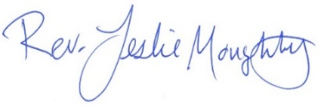
With peace,

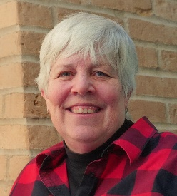
Moderator’s Musings

I can’t believe how quickly summer has flown by and that we have already passed the Fall Equinox! Wow!!!
First, I would like to send a HUGE THANK YOU to Cynthia Janes, our Clerk. She has been an enormous help this past summer while Tim (A.M.) and I have been dealing with family issues. And also, to Terri and Rev. Leslie who have also given some assistance as well. Thank you.
We have a lot happening this year, including homework assignments for us as a Church. Steve is really getting the Social Justice group working; Kelly Gallager will be here next week to teach, train and help our Church community facilitate healthy communication; between the Visioning coffee hour, last Sunday and the church survey we will be working on what we can implement. Just to name a few items.
Love and peace to all!
Mary

Pastor Leslie’s Workday Schedule
>> Sunday through Thursday (Days off are Friday and Saturday) <<
Pastor’s Drop-in Hours*
Wednesdays 2:00 – 4:00pm Thursdays 11:00am – 1:00pm
*Drop-in hours are times set aside for “drop-in” conversations, much like a professor’s office hours. Pastor Leslie is typically working at the church the rest of the week, but it is possible that she may be in meetings, at a community event, or working off-site.
Pastor Leslie typically works off-site on Tuesdays for sermon research and writing.

Everyone is encouraged to make an appointment if the above times are not convenient.
You can go to www.calendly.com/pastorleslieucc and select a day and time that works for you, or you can email Pastor Leslie at pastorleslieucc@gmail.com or call/text at 218-656-0096.
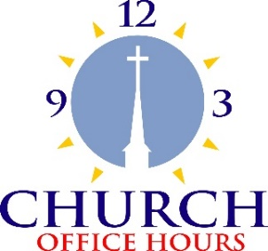
Church Office Hours
Wednesday, Thursday, Friday
10:00 am - 2:00 pm
Please call Terri at the office 218-829-2528 or
cell 218-537-1636 for further assistance.

Terri Admin. Asst. days off;
Wednesday, October 4th and Friday, October 6th.
The office will be closed Friday, October 6th.

First Congregational UCC News & Updates
0
0

October Birthdays

Bob Jones Oct. 7 Barb McColgan Oct. 20
Jolene Hojem Oct. 7 Cynthia Janes Oct. 25
Thomas Highum Oct. 8 Kamery Hauan Hahn Oct. 25
Eileen Kurpiers Oct. 11 Elissa Hartwig Oct. 28
Zachariah Johnson Oct. 11 Tracy Lyons Oct. 28
Robert Morgan Oct. 14 Andrew Pucko Oct. 29
Andrea Bertram Oct. 15 Elizabeth Paulson Oct. 30
Jim Newgord Oct. 15 Paxie Imsdahl Oct. 31
Megan Kath Oct. 16 Luann Rice Oct. 31
Louis Grabowski Oct. 20

0
How to watch Sunday worship The worship service is broadcasted on the church Facebook page and the church's YouTube channel every Sunday at 10:00 am.
To watch worship on Facebook, go to https://www.facebook.com/uccbrainerd/live
Live stream videos are saved and can be viewed at any time.
Financial Help Available Your Church Council voted last year to allow the Pastor's Discretionary Fund to be used to assist church members and others in the Brainerd area who are experiencing financial distress during this time. We received many generous donations! If you need assistance, please email, call, or text Pastor Leslie. Let her know what your situation is and how the church might be of help.
Donate to the church online! We are now accepting your offerings and donations using PayPal. You do not need to have a PayPal account to make an online donation with a credit card. To use PayPal, go to: https://www.paypal.me/uccbrainerd

0
September Council Meeting
~If you would like a copy of the minutes, please contact the church office ~

First Congregational UCC Council Meeting
Thursday, September 28, 2023, 4:00 pm

Meeting called to order by Moderator, Mary Reardon. In attendance: Pastor Leslie, Mary, Alvin, Deb, Jean, Kay, Tim, Vice-Moderator, Terri Admin Asst. via Zoom
August Council Minutes: Unavailable; table until next month
Clerk Report—No activity reported by Barb Stokke.
Financials: August, 2023 Financial Report: Motion to approve and motion passed.
Cards will be sent to Doris Anderson’s children for the generous donation.
Discussion about listing income/expenses in monthly newsletter; Leslie will talk to Conference re: protocol, advisability.
Department Reports
- Trustees
  - Deb asked that utilities and maintenance be kept track of
- Stewardship
  - Re: Signing pledge in public; Leaders are not comfortable. Mary will let them know.
- Christian Ministry
  - Christmas Eve Service: Will have one service at 4:00 pm; candlelight. No Service Christmas Day. Council approved.
  - Will have Potluck New Year’s Eve Day (Sunday, 12/31), Kay will organize.
- Christian Education
  - Written report submitted
- Members at Large Reports –
  - Alvin – Adult Forums
    - 10/08/23: Julie Vandeputte, NEAT, Non-Exercise Activity Thermogenesis (Work more exercise into your everyday life)
    - 10/15/23: Make it Okay presentation, Alvin & Kay. Other churches will be invited.

    - 10/08/23: Julie Vandeputte, NEAT, Non-Exercise Activity Thermogenesis (Work more exercise into your everyday life)
- PPRC
  - Need folks to sign up for training w/Kelly
  - Working on document titled “Agreeing and Disagreeing with Love and Dignity. Will be presented to Council when finished for approval.
- Care Team Report
- Pastor Report – Rev Leslie
  - Keep doors up through Halloween.
  - Ask people to tag us in their pictures of them/doors.
  - Memorial Garden – Suggestion: Put up "Prayer Box” where people can drop a prayer in.
  - Coordinator for Halloween needed (people need to stay to help clean up) (Times 5:00 – 8:00) Need list of tasks. Leslie will put together.
  - Sabbatical Grant approved; Leslie will use her “Pastor’s Pen” to announce to congregation.
  - Need sabbatical team to coordinate activities.
Old Business
- Sabbatical leave implementation team needed
- Laramie Project: 10/12 – 10/15
  - Kay, Leslie, Tim will man table on our night, Saturday, 10/14/23.
  - Have 20 tickets available. Leslie will give to High School members of GSA. Others will be distributed to congregation.
  - Need to register online; $12.
C. Indigenous People Day is 10/09/23. Should we do something to honor it?
a. Not at this time; too short of a window. Will hope to do something next year.
D. Stewardship ideas from July Council meeting.
a. Add to usher training guide the need to steer new folks to the guest register. Who?
b. In July meeting, Council endorsed the idea of gifting Mark Stadem bread to newbies. Who will make this happen? Table for now
c. Cleaning membership records: Mary & Leslie will talk about reactivating procedure for doing this. Is Executive Committee function.
New Business
- Coffee for Fellowship
  - Need to have receipt for purchase of Coffee; turn in to Terri.
  - Mary will purchase Caribou Coffee at Costco.
  - Money in jar needs to be taken out, put in envelope, & slid under Terri’s door. Note will be made to put on jar as reminder.
- Wise grant application for Crow Wing County Opiod Settlement monies
  - Lowell had requested Council’s approval to apply.
  - Money to be used to purchase Bold and Seldom Told; Crow Wing Community Stories, book that tells stories of marginalized members of our community including some in our Church.
  - Alvin moved, Tim seconded. Motion passed.
- Dream Session and the Survey results
  - Mary will discuss briefly each week following the postlude
- Changing our name
  - Several suggestions
  - Council made aware that “Congregational” is not accurate. The United Church of Christ was created from the merging of four denominations: Congregational, Christian, Evangelical and Reformed.
- Denise Slipy has offered to fill in on piano.
- Meeting changed to 3:30 due to length of meetings.
- Safety Measures for our Church?
  - Does our (progressive) church need more safety measures, especially as the next election cycle heats up? (E.g., locking doors during service, what to do if there is a disruption during a worship service).
  - Lock back door at 10:15?
  - Deb will check with insurance company & police regarding active shooter training.
  - Discussion will continue.
- Mary will set up gmail account for moderator that will be passed on to next moderator.
- Terri will be gone, Oct. 4th and 6th Days Off. Friday the office will be closed.
Respectfully Submitted,
Kay Cox, Substitute Secretary

0
Next Regular Council Meeting: Thursday, October 19th, 2023, 3:30 pm
in-person and via Zoom tinyurl.com/uccbrainerdzoom

Stewardship Commitment Season is Here

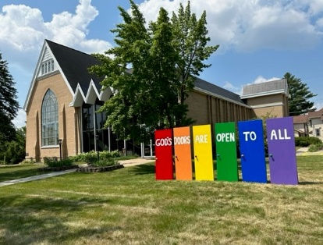
Because of You, our Church Changes Lives!
Fall is the time when your church’s Stewardship committee reaches out to all our members and friends to ask for your support for our church, now and into the future. Sunday, October 1st is Stewardship Kickoff.
We are the church that many are looking for – a church where no matter who you are or who you love you are welcome here.
From the beginning we have been an open door in our community. Recovery and community groups, educational forums, social and study groups meet here. Our members volunteer and do outreach to one another and in our community.
We also want to acknowledge our volunteers’ time and talents. They do so much, from cleaning, hosting Fellowship, serving on various committees, ground maintenance and so much more.
We are asking for your support now and for 2024. Our church is here for you in good times and in times of need. Our church is open to all, including those who cannot contribute.
We ask you to search your heart about what this church means to you and how you can help us thrive.

In faith, First Congregational UCC Stewardship Committee, Judy, Marcia, Maggie & Sarah Jo)
0 Movie Night is starting up again this month!
Mark your Calendars!
Interested in becoming a member?
Sunday, October 1st and October 8th 11:30 am. Curious about “joining” the church?” Or are you interested in learning more about the UCC and our congregation? Join Pastor Leslie after worship service. Each session will last about 90 minutes.
Please contact Pastor Leslie if you plan to attend to assure enough materials are available.

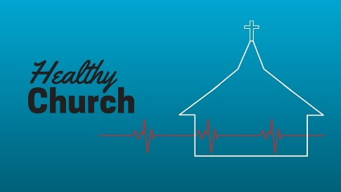
Healthy Communication - Healthy Church
0 Movie Night is starting up again this month!
Mark your Calendars!
Saturday, October 7, 9:00 am, Fellowship Hall: Please come to this All-Church workshop about the tools for healthy communication in church presented by Rev. Kelly Gallagher, Associate Conference Minister.
9:00 - 10:30 am: The first half of the workshop will focus on ways that healthy communication is fostered in a congregation. Coffee and light refreshments will be served.
10:30 - 12:00: The second half will focus on how a Pastoral Relations Committee functions effectively and is optional for people who are not serving on the Pastoral Relations Committee, though everyone is welcome to stay for a little extra knowledge!

0 Movie Night is starting up again this month!
Mark your Calendars!
October Adult Forums - 11:30 after worship

October 8th Julie Vandeputte who has worked in the fitness field for over 20 years is presenting NEAT –(Non Exercise Activity Thermogenesis) - an approach to mind/body/spirit holistic living on working exercise in daily life.
October 15th – A presentation regarding "Make It OK." A community campaign to reduce stigma by increasing understanding and creating caring conversations about mental health and illnesses. Presented by Alvin Velsvaag and Kay Cox, members of WISE.

2023 W.I.S.E. Resolution: The Adult Forum on the 15th is part of our ongoing study of mental illness and the WISE program
First Congregational UCC Brainerd will devote time during the next 12 months learning about mental health issues to become a WISE (Welcoming, Inclusive, Supportive and Engaged around mental health) Congregation registered with the United Church of Christ Mental Health Network.
After a year of study and raising awareness around mental health, a vote will be taken at our annual meeting in 2024 to reconfirm our WISE Covenant which will allow us to be designated as a WISE Congregation in the United Church of Christ.

0 Movie Night is starting up again this month!
Mark your Calendars!
Friday Book Group
On Friday, September 29th we began reading the book, “Gutsy Women”, by Chelsea and Hilary Clinton. We will meet each Friday morning at 10:30 am via zoom, except for October 20th, when we'll be meeting in-person at the Hearth Room at Arbor Glenn. Church Zoom link: https://tinyurl.com/uccbrainerdzoom

0 Movie Night is starting up again this month!
Mark your Calendars!
Congregation Identifies Social Justice Priorities!

Building on initial passions and concerns identified by the congregation last spring, the participants in the Adult Forum on Sunday, September 24th, clustered similar items, and identified six justice areas. Participants then identified which issue they wanted to tackle, and teams were formed.
Justice Action Teams and Initial Members
WISE - Mental health and wellness: Alvin, Kay C., Chris, Tracy
Climate Justice - Mark, Kay K, Mabel Poverty - Georgia, Kim
Community Building - Kim, Denise, Jan Children and Families - Deb, Mabel
DEI-LGBTQ - Tracy, Jack, Chris

Each team will be responsible for providing leadership around their issue area. This doesn’t mean they do all the work but, instead, provide leadership for the congregation. For example. A few years ago (before my time with the congregation), the congregation decided to shift from Styrofoam coffee cups to individual mugs and organized a system of cleaning and storing. A few people lead this effort, but we all participate every week.

Do you have a passion or concern around one or more of these issues? You can be part of a team leading a portion of the congregation’s Justice ministries! Contact stevenewcom@icloud.com for more information and join one of the teams.

UCC Women’s Fellowship
0 Movie Night is starting up again this month!
Mark your Calendars!

Saturday Morning Coffee: October 14th 9:30 am in the Fellowship Hall.
Contact Marcia Ferris for more information.

Church Basement Ladies' Luncheon: Thursday, October 26th 11:30 am at Yesterday's Gone - 9th St., Brainerd.
Contact Kay Cox for information.

All updates will be posted on the Connections Facebook Group and RSVP’s may be made in the comments under the post at: www.facebook.com/groups/uccbrainerd

0 Movie Night is starting up again this month!
Mark your Calendars!
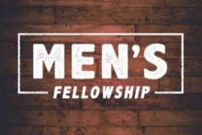
UCC Men’s Fellowship - Every Wednesday at Noon
You are invited to a casual fellowship at various locations in the Brainerd Lakes area. Rotating Weekly Schedule 2023
First Wednesday: B-Meri
Second Wednesday: Four Seas in Brainerd
Third Wednesday: Dunmire’s East
Fourth Wednesday: Black Bear
Fifth Wednesday: El Tequila in Baxter
Contact Jack Kraywinkle for more information 612-396-3480 or email: kraywinklej@gmail.com

0 Movie Night is starting up again this month!
Mark your Calendars!
UCC & TheShop Meal!

The next two months for October and November have been scheduled! Meal cooking is Thursday, October 12th and November 9th at 4:00 pm.
For the last several years, UCC volunteers have provided a meal to the youth at TheShop - Brainerd Baxter Youth Drop-in Center. A number of youth from TheShop come over to our kitchen and help prepare a delicious meal that is then brought back to TheShop for the hungry and appreciative teens there.
Mary Benson is coordinating the meals, so if you are interested in joining in and enjoy cooking with youth, please call or email Mary. 218-839-4990 or marybenson75@gmail.com

0
6th Annual Halloween Extravaganza!
Tuesday, October 31st 5:00pm to 8:00 pm
You can help the church connect with our neighbors!
      - Donate Candy and/or non-candy item - There is a box located outside the sanctuary for donations.
- Decorate – Monday, October 30th: Slots available.
- Volunteer on Halloween Night - Tuesday October 31, 5-8 pm, join us on Halloween to give out candy, make and/or serve cider, be a friendly face.
- Help with clean up. Take down and put away the decorations: 8:00-9:00 pm
Sign-up available Sunday, October 8th in the Narthex.

Special Offering Sunday Worship October 29th
0
The Crisis Line
The Crisis Line provides confidential and anonymous telephone support to people in distress and crisis, and to serve as a lifeline for positive change by connecting our clients to area resources and to give support and encouragement.
Serving friends and neighbors in Aitkin, Cass, Crow Wing, Morrison, Todd, and Wadena Counties it is a service that helps people when they are in crisis, or before their problems become a crisis. You can also call for a referral to resources in the area and surrounding counties. Your donation can help the Crisis Line & Referral Service provide services to improve the quality of life and improve the mental health of the community you live in.
To donate, send a check with "Crisis Line” in the memo line to: First Congregational UCC, 415 Juniper St. Brainerd, MN 56401 or donate online using PayPal and indicate "Crisis Line" in the Note. payl.me/uccbrainerd

0
UCC Care Team

The Care Team was formed with the purpose of reaching out to our congregation to ask how their lives are post covid, is our church still valid to them and if they needed anything from our church.
A Congregational Care Team Visitation List was created to keep track of those parishioners who were homebound; living in a facility; living with chronic conditions; the bereaved and those with other concerns. Those who would like prayers are lifted up during worship and those wishing a pastoral call or visit are given to Pastor Leslie.
For anyone who wishes to join in on making calls or visits, the Care Team meets every month. Contact the church office for upcoming dates and times.
If you know of anyone who would enjoy a call from the care team, please contact one of our Care Team; Barb Hoeft, Jack and Kay Kraywinkle, Pat Scott, Chris Yager, Joey Halverson, Deb Griffith and Pastor Leslie.

0
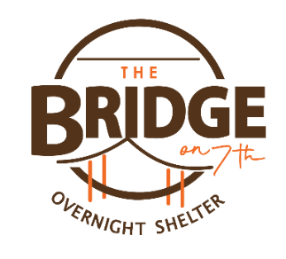
Volunteer at The Bridge on 7th!

First Congregational members and friends volunteer at the shelter.
Our week to volunteer is October 8th through the 15th. Chris Yager and Deb Griffith are our team organizers. Please call one of them to sign up and volunteer. There's video training and a background check (easy!) And of course a confidentiality pledge.

Coming back for the 3rd season, The Bridge on 7th Overnight Shelter is open to Adults 18+ who are experiencing homelessness are welcome to check in from 7 PM - 11 PM each night for a safe, warm place to sleep. Our staff will be happy to offer guests a hot cup of coffee and some snacks, as well as toiletries and a change of clothes if needed. Check out time is 8 AM each day with no limit to how many nights you can stay.
This shelter is funded by individuals, churches, grant funders, and businesses in the community that see a need to help our neighbors who are unsheltered. We appreciate your support!
0
First Congregation Food Shelf Collection Boxes
Our church continues to collect non-perishable food items for the Salvation Army Food Shelf. There are two collection boxes: one in the parking lot entry hallway, the other in the Narthex. Brian Twamley picks up and delivers the food.
Please consider bringing items and donating. You may also send a money donation to the church; First Congregational UCC, 415 Juniper St. Brainerd, MN 56401. Or for your convenience use our Paypal account at: paypal.me/uccbrainerd Make sure to write in memo “Food Shelf”. Thank you!

Hosts, Ushers, Greeters,
0
Scripture-readers
Sunday morning greeters/ushers and coffee hosts play an important part in making our church a warm and welcoming place for all. Here’s a secret; it’s FUN!! If each household committed to 3 Sundays a year as greeter/ushers and/or coffee hosts, we would have a full complement of participants. Are you ready to take the leap into RADICAL HOSPITALITY? Give it a go and signup below for your first Sunday as the face of the church! https://www.signupgenius.com/go/10C0E48A9A823A5FFC07-hugs/16034811

0
The Columbarium at First Congregational UCC, Brainerd
The Columbarium is located in the historic space that once was our church’s front entry way.
How appropriate it is that our Columbarium now marks another entry way into a new life — where the Spirits of Love and Truth are always present!
Should you wish to learn more about the purchase of a niche for your own cremains or for the ashes of a loved one, please call the church office at (218) 829-2528 and a packet of materials will be sent you via email or regular mail.
The Memorial Committee has prepared the information packet, and it contains all the details you will need as you consider inurnment here at First Congregational UCC.
Have any other questions? Contact Dawn Stattine at dawnstattine@gmail.com

0
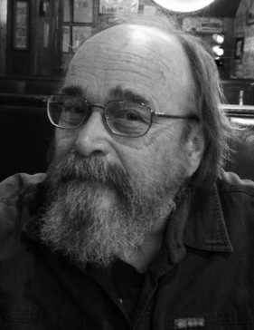
Dennis Scott Berndgen Memorial
December 11, 1948 ~ September 25, 2023 (age 74)
Dennis Berndgen, 74, of Brainerd, passed away at his home on Monday, September 25, 2023. A Mass of Christian Burial will take place at 11:00 a.m., Monday, October 2, 2023, at St. Francis Catholic Church in Brainerd. Family and friends are invited to gather one hour prior to Mass at the church on Monday as well as Sunday afternoon from 3-5 p.m. at Nelson – Doran Funeral Home in Brainerd. Interment with Military Honors will be held at 2:00 p.m., Monday, October 2, at Minnesota State Veterans Cemetery near Camp Ripley.
After graduation from De La Salle High School, Dennis earned an A.A. degree and attended the U of M before enlisting in the army, where he served several years in Germany. When he returned home, he married Barbara Stokke (First Congregational UCC Brainerd member), a teacher he had met on leave in the Brainerd Lakes Area. The couple made their home and raised their family in Brainerd. Dennis worked as an electrician for many years. After he retired, he volunteered at Habitat for Humanity and St. Francis Catholic Church.
At a young age, his family bought “the cabin” on Pelican Lake and it has always been Dennis’ favorite place. He loved hunting and fishing or sitting at the ball parks, gyms, and ice rinks watching his sons play sports or relaxing at the lake with the boys. He had a kind, gentle heart with the ability to make a short story quite long. His appreciation for details was in everything he did.
Memorials are preferred to Knute Nelson Hospice or Habitat for Humanity.

Upcoming Conference Events
0

- October 6-8: Fall Youth Conference Event
- October 20-22: Young Adult Retreat
- ﻿October 22-24: Faith Formation Leader Retreat

0

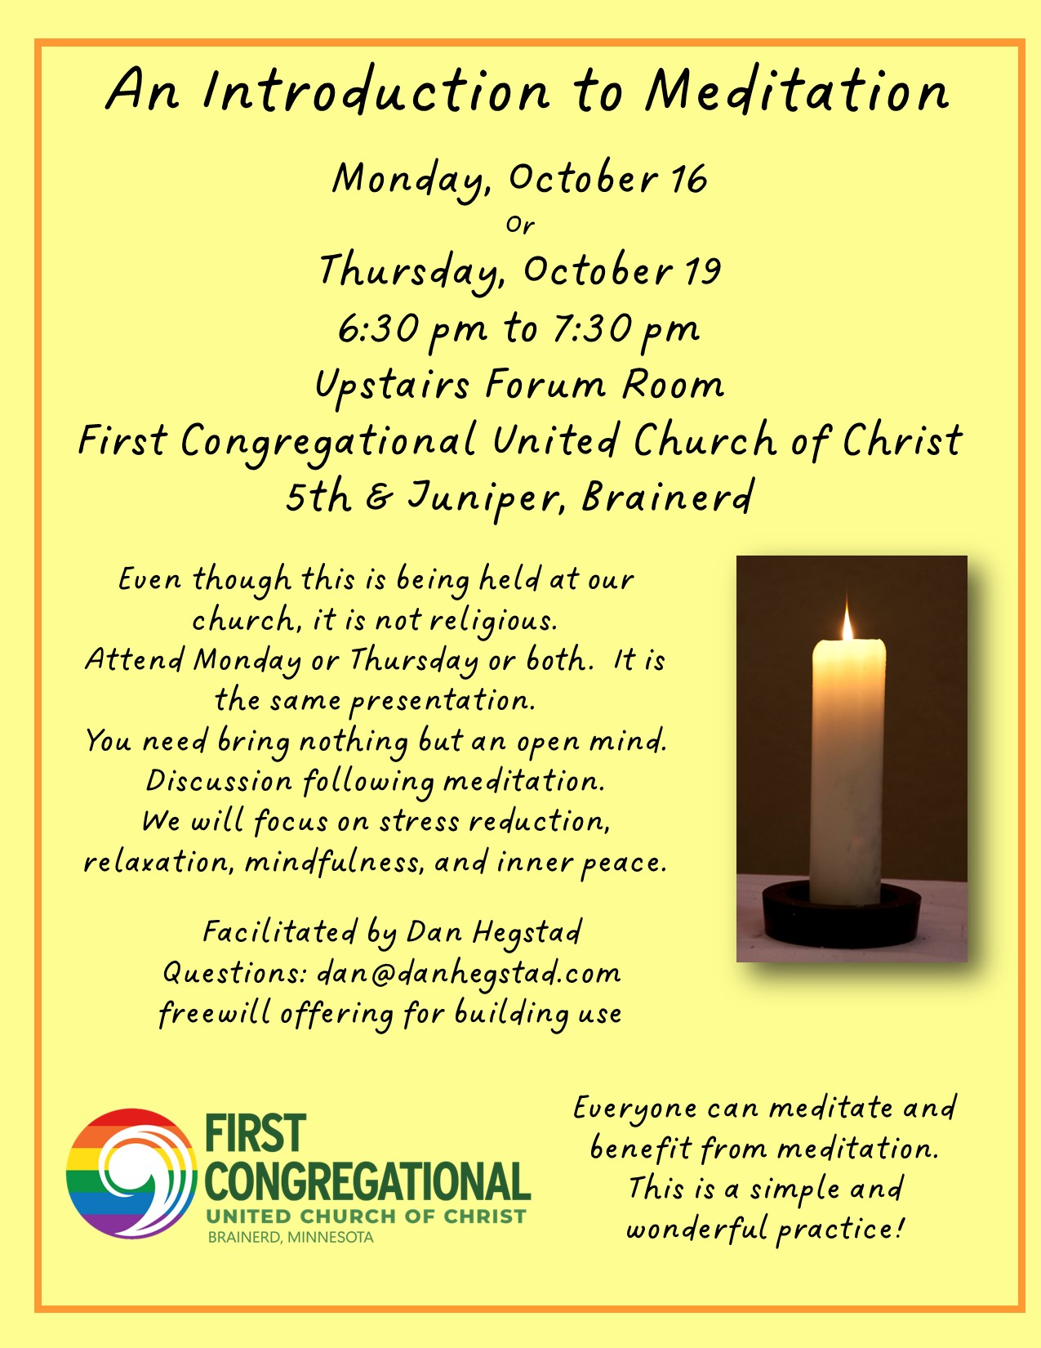

Brainerd Lakes Area Information
~ Opportunities to Know and Share God’s Love ~

Play worship 06/11-25/23

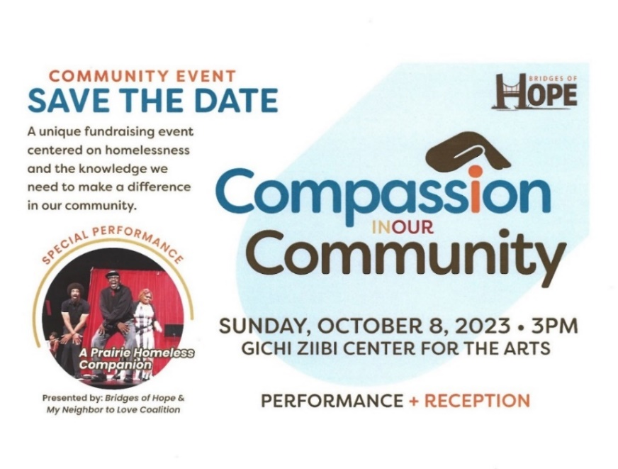

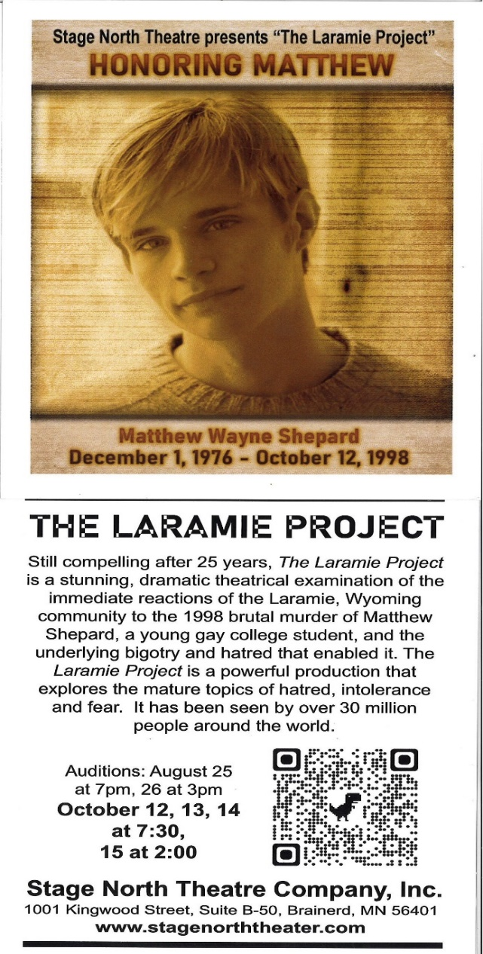

The Laramie Project
Save the dates! - Thursday, Friday Saturday October 12th, 13th & 14th at 7:30 pm. Sunday, October 15th at 2:00 pm.

Our church is sponsoring the performance on Saturday the 14^{th,} Contact Cynthia Janes or Tim Anderson to volunteer at the informational table.

Purchase tickets at www.stagenorththeater.com

October 2023 Calendar
Sunday | Monday | Tuesday | Wednesday | Thursday | Friday | Saturday
Leslie Workday  LeMesa Grp-Meets some Tuesdays @ Gregory Park w/church backup | Leslie Workday | Leslie Workday | Office Hours10am – 2pm  Pastor Drop-in 2pm-4pm | Office Hour  10am – 2pm  Pastor Drop-in  11am – 1pm | Office Hours  10am – 2pm
1  8:30am Bnrd Frnds-Y  10am Wrship & Communion-Y&FB  Stewardship Kickoff  11am Fellowship-Y  11:30am Prospective Member Class #1-Y | 2  6pm Girl Scout #43 Meeting-Y  7pm BACP/BLUE church backup | 3  2pm Emotions  Anon- Y  5:30pm Overeaters Anon- Y | 12pm Mens Grp-Y 4  @ B-Merri  1:30 PRC Mtg.-Y  7pm AA Common-Y | 5 | 6  10:30am Book Grp-Z  . | 7  9am Healthy Communication-Healthy Congregation Workshop
8:30am Bnrd Frnds-Y 8  10am Wrship-Y&FB  Stewardship Moment  11am Fellowship-Y  11:30am Prospective Member Class #2-Y  11:30 Adult Forum NEAT-Y  Church Volunteer ON Shelter | 9 | 9am Foundation-Z  2pm Emotions 10  Anon-Y  3:30pm  Stewardship-Y  5:30pm Overeaters  Anon-Y | 12pm Men’s Grp 11  @ 4 Seas-Y  2pm Care Team Mtg.-Y.  5:30pm Trustees-Y  7pm AA Common-Y | 12  8:30am CM Mtg-Y  4pm Executive Team Mtg-Y  4pm TheShop Cooking-Y | 13  10:30am Book Grp- Z | 9:30am UCC 14  Women’s Fellowship in Fellowship Hall  Church sponsor with info table for Laramie Project-Y
8:30am Bnrd Frnds-Y 15  10am Wrship-Y&FB  Stewardship Moment  11am Fellowship-Y  11:30am Adult Forum “Make It Ok”-Y | 16  6:30pm Intro to Meditation in Forum Rm. | 2pm Emotions 17  Anon-Y  5:30pm Overeaters  Anon-Y | 18  12pm Men’s Grp-@ Dunmire’s East-Y  7pm AA Common-Y | 3:30pm Council 19  Mtg-Y&Z  6:30pm Intro to Meditation in Forum Rm.  6:30pm Dist.7 AA-Y | 20  10:30am Book Grp- Z | 21
8:30am Bnrd Frnds-Y 22 10am Wrship-Y&FB  Pledge Sunday & Stewardship Moment  11am Fellowship-Y | 23 | 24  2pm Emotions Anon-Y  5:30pm Overeaters Anon-Y | 25  12pm Men’s Grp @ Black Bear Grill-Y  7pm AA Common-Y | 26  11:30am Women’s Fellowship Luncheon @ Yesterday’s Gone | 27  10:30am Book Grp- Z | 28
8:30am Bnrd Frnds-Y 29 10am Wrship-Y&FB  Stewardship Moment  11am Fellowship-Y  *Special Offering-Crisis Line  *Newsletter Deadline | 30  Halloween Decorating – slots open | 31  2pm Emotions Anon-Y  5pm Our church Trick or Treat-Y  5:30pm Overeaters Anon-Y |  |  |  | FB –Stream Online  Z- our Zoom  C- Cancelled  N-None  ? – No update  Y- Yes Mtg. in person

