Friendship News, March 2024
0
First Congregational United Church of Christ, Brainerd
An Open and Affirming Congregation
The Church Office Hours: Wednesdays – Fridays from 10:00am – 2:00pm
Office phone 218-829-2528 Office E-mail uccbrainerd@gmail.com
Pastor T.Michael’s E-mail: tmichaelrock@gmail.com Website: www.uccbrainerdmn.org

No matter who you are, or where you are on life’s journey, you are welcome here.
0
Pastor’s Pen
0
God Be with You Til We Meet Again
The time has arrived for me to embark on the journey we have been planning for almost 2 years – a three-month renewal leave. I wrote quite a bit about the renewal period in last month’s newsletter, so I won’t go into those details here. I thought I would use this space to speak to some logistics and FAQs.
What is the timeframe? My last working day is Sunday March 3 which will conclude with a luncheon in Fellowship Hall after worship. My first day returning to work is Monday June 3.
Will you be checking email or responding to phone calls? The short answer is no. In the words of the Lily Endowment Clergy Renewal Program who granted the funding for this renewal leave, “Renewal leaves are intended to provide pastors a chance to step away from the daily demands of parish leadership.” Rev. Rock and your church leaders are well equipped and empowered to handle pretty much any issue that might arise.
What if I need Pastoral Care? If you would like a visit or a phone call for either yourself or a loved one and the concern is not an emergency, Barb Hoeft and Deb Griffith from the Congregational Care team are available and would love to connect with you. Barb’s number is 218-851-5803. Deb’s number is 218-851-2949.
If you have an urgent pastoral care need (an unplanned hospitalization, a death, etc) please call or text Rev. Rock at 612-275-0387. If he is not in the area and unable to attend to the emergency, he has a list of local pastors who have agreed to be on-call during this time.
What’s happening with the parsonage? My friend Cory will be house-sitting and pet-sitting. You may see other people around the parsonage taking my dog Daisy for a walk or stopping by to play with my cat Gibson.
Is there a place we can keep up with your travels? I am in the process of creating a blog to document some highlights of this time. I will not be posting everyday but I intend to post photos and brief reflections for each stop along the journey. The address is renewal24.weebly.com.
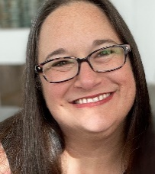
I am looking forward to seeing as many of you as possible on Sunday, March 3 for worship and fellowship. Thank you to all of you in the many ways you have made this time possible.
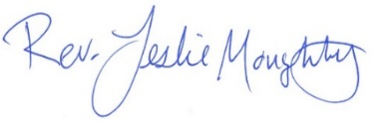
With peace,

Introducing T. Michael Rock – Renewal Leave Pastor
0
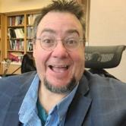
While Pastor Leslie is away on Renewal Leave, the Rev. T. Michael Rock will be shepherding us and supporting our own renewal journey.
From T. Michael –
I am super excited to be with you for the next three months. I have known Pastor Leslie for several years and have deep respect and honor for her ministry and the way she talks about the people at Brainerd UCC. I look forward to sharing the Good News with you and providing a pastoral presence where it is needed. While I am teaching at United and guiding the Chapel program, I will be available during the week for conversation and checking in. I plan to drive up to Brainerd on Friday morning to connect in the office and meet with any folks during that time. I’ll stay at a lake house on Friday and Saturday night in the area and be back at the church on Sunday morning and afternoon as church programs are happening.
It may be interesting to know that I am teaching Spiritual Formation this Winter. This is a class where we explore what is most real and most important for people training to be become Spiritual leaders. I get to help my students explore their calling to ministry and their movement to become people others want to imitate in their faith journey. We tell our own transformation first before we can lead others to follow Jesus. This work of transformation is powerful and humbling. I have had several transformations in my life, and I know that I am still learning and growing. I invite you in these three months to explore these possibilities as well. I hope to get to know you and love you.
When I am with you, I may bring along my partner, Morgan, who works as a nurse, my 16-year-old daughter, Bridget, who is an amazing kid, my 19-year-old child, Phenix, who will be coming home from college the last month, or my mom, Carolyn, a lifelong church musician. Along with my two dogs, these folks are my precious family who support me and hold me in this ministry.
And, because everyone asks, my first name is Theodore and I am a 4th generation Theodore, my parents called me Mike. When I was a 1st grader at a new school there were 4 kids named Mike and my teacher named us Mike, Mikey, Michael and T. Mike. It stuck. People generally use T. Michael or just T.
In Peace,
T. Michael

Rev. T. Michael Rock has been an ordained minister, liberation theologian, and educator in the United Church of Christ and is currently a Professor for Spiritual Formation and Contextual Education at United Theological Seminary of the Twin Cities. T. Michael also guides the Contextual Education and Spiritual Direction programs for United. He has served as a Spiritual Director and teacher of Spiritual Direction for over 20 years and has 30 years of congregational leadership serving UCC congregations in Minnesota, Rhode Island and Massachusetts. Throughout his career T. Michael has volunteered as a trauma-informed chaplain for prisons, police, at George Floyd Square, the World Trade Center, Occupy Wall Street, and other places of tragedy, violence, and transformation. T. Michael is also an activist on the local and national level and an experienced trainer in nonviolence, civil disobedience, and sexuality education.
First Congregational UCC News & Updates
0
“First Congregational UCC is a welcoming, inclusive, and progressive community committed to promoting social justice, spiritual growth, and love for all people. We reject discrimination and advocate for equality and dignity for marginalized communities. Through worship, education, and service, we work to make a positive impact on the world and invite all individuals to join us in this journey of faith and service.”
0

Pastor T.Michael’s Workday Schedule

>> Friday, Saturday & Sunday <<
Fridays 10:00am to 4:00pm
Saturdays by appointment as needed
March 15 through April 20
May 3 through May 18
May 31 through June 1

Leading Worship Services:
March 17, 24 & 31
April 7, 14 & 21
May 5, 12, 19 & June 2

you can email Pastor T.Michael at tmichaelrock@gmail.com or call/text at 612-275-0387.
0
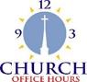
Church Office Hours
Wednesday, Thursday, Friday
10:00 am - 2:00 pm
Please call Terri at the office 218-829-2528 or
218-537-1636 (cell) for further assistance.

How to watch Sunday worship: The worship service is broadcasted on the church Facebook page and the church's YouTube channel every Sunday at 10:00 am.
To watch worship on Facebook, go to https://www.facebook.com/uccbrainerd/live
Live stream videos are saved and can be viewed at any time. All memorials, weddings and 12th Night Concert are on our church Facebook page.
How to stay connected with First Congregational friends and members: Join the private group for our Facebook Connections Page at https://www.facebook.com/groups/uccbrainerd
Financial Help Available Your Church Council voted last year to allow the Pastor's Discretionary Fund to be used to assist church members and others in the Brainerd area who are experiencing financial distress during this time. We received many generous donations! If you need assistance, please email, call, or text Pastor Leslie. Let her know what your situation is and how the church might be of help.
Donate to the church online! We are now accepting your offerings and donations using PayPal. You do not need to have a PayPal account to make an online donation with a credit card. To use PayPal, go to: https://www.paypal.me/uccbrainerd
Lent and Easter 2024
0
Sundays at 10:00 am – Worship in-person & live on Facebook
Saturday March 23rd – Pick up palm branches for Palm Sunday Time TBD
If you are planning to worship online, swing by the church parking lot to take home a palm branch. Branches will be available next to the parking lot door for un-staffed pick up. For those attending in person, palm branches will be given out at the worship service.
Stay Tuned for Holy Week Details
Sunday, March 31st 8:30 am – 9:30 am – Easter Breakfast potluck
Sunday, March 31st 10:00 am – Easter Worship in-person & Live on Facebook
0
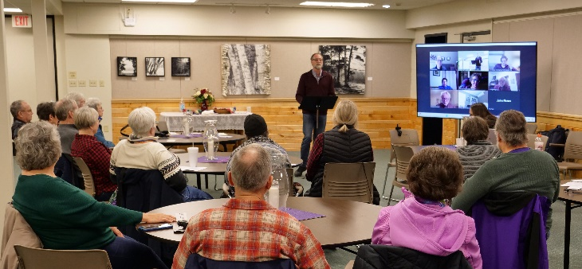
Congratulations Steve Newcom!

Thursday, February 29th the Ecclesiastical Council voted unanimously and approved
Steve as authorized minister within the
United Church of Christ!
Steve’s role within First Congregational UCC Brainerd will be as Pastor of Justice Ministries.

0

Easter Flowers 2024
You have the opportunity to give a gift in the name of your loved one(s).
We will use the money to purchase flower arrangements for the altar.
All memorials will be listed in the Easter bulletin.
* * * * * * * * * * * * * * * * * * * * * * * * * * * * * * * *
Please fill out the following completely.

Amount of Memorial Gift: $___________________________________

In Memory Of: ________________________________________________
________________________________________________
________________________________________________

Your Name(s): ________________________________________________

Write your check to: “First Congregational Church”
Memo: “Easter Flowers”
Leave this form with your check in the offering plate,
the church office, or mail it to:
First Congregational Church
415 Juniper Street Brainerd, MN 56401

0
Church Directory To Be Updated for 2024
0

Dan Hegstad will also be taking photos of your beautiful faces to be included in the directory after worship on the first two Sundays in March 3rd & 10th.
If you do not have a picture taken by Dan, please send us an updated photo. Email your photo to Terri in the office at uccbrainerd@gmail.com A jpeg is the best format. Or you may bring a photo into the office or mail it and Terri will scan it for you. Please note if you would like the photo returned.

Has your contact information changed? Do you want to be removed from or added to the directory? Please contact Terri in the office by email or using the information update section on the prayer cards in the back of the pews. Help us stay connected! Thank you!

March Birthdays
0

Sharon Carlson March 4 Deb Griffith March 21
Mary Johnson March 4 Brian Gustafson March 24
Michael Imsdahl March 6 Melinda Ellis March 27
Marina Grabowski March 16 Dorothy Lundberg March 27
Tim Anderson March 21 Karen Ogdahl March 28
Jonathan Howard March 23 Patricia Scott March 29

0
Church Leadership
Get Involved, Give Back, Grow Connections – Volunteer at Church!
There are many other opportunities for you to share your talents!

--Treasurer, serves a 1-year term (may renew for 6 terms). The primary role is oversight of bookkeeping, church finances and Executive Committee discussions. This candidate should have a strong background or interest in finance or banking.

--Council Member-At-Large: Attend council meetings, act as a liaison for church members and council, help with nominations, spokesperson for historically underrepresented groups (HUGS).

Committees needing fresh faces and leadership:

*Christian Education *Stewardship *Music *Arts *Trustees
Contact Mary Reardon - Moderator, with your nominations
0
Highlights from the Council Meeting, February 15th, 2024
Thursday, 3:30 pm (In-person and Zoom)
~ These are highlights. If you would like a copy of the full minutes, please contact the church office ~

Present: Pastor Leslie, Mary Reardon (Moderator), Sue Hadland (Christian Ministry), Dan Hegstad (Marketing), Kay Cox (PRC), Deb Griffith (Trustees), Marcia Ferris (Stewardship). Tim Anderson (Assistant Moderator), Cynthia Janes (Clerk), Terri (Admin Asst., ZOOM). Absent because of health reasons: Alvin Velsvaag (At-Large, Mental Health), Absent because out of country: Lowell Johnson (Christian Education)
Approval of January, 2024 Council Minutes Approved as read.
Clerk Report — no changes reported
Financials
1. Revisit: Decision about paying off City street improvement assessment. Since we have a cash surplus in the General Fund at the end of the year, we will use this to pay off the City’s assessment fee, and roll over the CD maturing in February 2024, rather than use the latter to pay off the assessment. The balance of the assessment will be paid in full of the amount that has been certified to the pay-year 2024 property taxes. This amount is due to Crow Wing County).
2. Review of January 2024 financial report. Pastor Leslie reported that the Aitkin UCC is now closed and sent us $2000 to use as we wish. Pastor Leslie reported that January giving was up about 20% over last year’s amount. The church had a net gain for the month of January as a result.
Department Reports
Christian Ministry - Update on Sunday morning programming during Pastor’s sabbatical: March 3 will be “Send-off Sunday,” for Leslie as she embarks on her sabbatical. The interim pastor, T. Michael Rock will be in attendance as well, and will co-lead the service with Pastor Leslie. A pulled pork luncheon will be served, with the congregation contributing salads and other side dishes. On March 10 Christian Ministry will lead the service. Theme is “Where have you seen God in your life?”
Stewardship - April 28 will be Volunteer Appreciation as well as a Justice Sunday. Stewardship will provide brunch.
PRC/Marketing - Update on training folks on use of sound system: Joe Stattine understands how the system works and will help our A-V productions also know how to work the system (s).
Trustees – Deb will do a thorough investigation of insurance options, as the rate increased 36% in January. This may be in line with the insurance rates across the industry, but she will find out. Mat cleaning service: Our contract with this service (5 -yr. contract) will end at the end of 2024 and we will not renew but take care of our own mats. (Contract does not include kitchen and dish room mats.)
PRC – Per report
Pastor - Discussion of plans with the Interim Pastor, T. Michael. Coverage of emergency needs: Pastor Leslie is contacting area pastors about being on call for emergencies. T. Michael will be the contact person and will arrange for one of the on-call pastors to provide the service needed, or may do it himself, if circumstances allow. T. Michael plans to attend Council meetings by ZOOM. T. Michael’s schedule is that he plans to be in the Brainerd area most Fridays, Saturdays, and Sundays. His schedule will be flexible, however. He will preach all but one Sunday each month. On April 28 Steve Newcom will preach. Justice Groups will meet that day after the service and Stewardship brunch.
June 7-8th at College of St. Benedict (St. Joseph) the annual MN UCC Annual Conference meeting. Funds are available for two adults and a youth delegate to attend, in addition to Pastor Leslie. Pastor Leslie asked that Council think about this opportunity.
Christian Ed. – Per report
Care Team—Sent out Valentine’s for Valentines Day to people they were seeing.
Memorial -- Per report.
Old Business
- Usher’s training plans?: Wanted to do this as a forum, but the forums are pretty filled up.
- Statement of Purpose (handout): Ready for filing after clarification: “Our” journey or “this” journey??
- Council voted to word it as “this “journey, because if we are inviting others, it is their journey, too, not just ours.
- Immediate Past Moderator (handout): Clarification needed about voting rights. Council voted the IPM will have voting privileges on both Council and the Executive Committee. IPM will be the acronym for this officer.
- Nominating committee update: Tim is the chair, as Assistant Moderator. Mary will stay on a second year as moderator. Officers needed are assistant moderator, secretary, and treasurer.
- Church name change research update (Dan Hegstad)—Dan has researched more about several churches that have changed their names or are in the process of doing so. He called Kelly Gallagher our MN Conference Associate minister for more info. Dan said that it sounds as if “we are on the right track.” We would remain a UCC church. This effort will stay in the background during the time that Leslie is on sabbatical and should be here for the discussion.
New Business
- Choir Director: Diane Hauan, our former choir director, resigned for health reasons. Mary Reardon will investigate the idea of paying a new choir directory, starting with research on the going rate locally. She will report back to Council.
- Marcia announced that March is Food Share Month. Discussion. Marcia will get logos & info for the church newsletter and encourage our members to donate food or cash to support our local Food Shelf.
- On Easter Day, March 31st there will be a breakfast potluck @ 8:30-9:30 am at the church.

Respectively Submitted,
Cynthia Janes, Clerk

Next Regular Council Meeting: Thursday, March 21st, 2024, 3:30 pm
0

in-person and via Zoom tinyurl.com/uccbrainerdzoom
0

0

Movie Night
First Friday of each Month!

March 1st

Come early to visit & settle-in!
Movie promptly starts at 6:30 pm.

WISE Food for Thought
0

We can't control the wind, but we can adjust our sails.

W.I.S.E. Welcoming, Inclusive, Supportive and Engaged
2023 W.I.S.E. Resolution: First Congregational UCC Brainerd will devote time during the next 12 months learning about mental health issues to become a WISE (Welcoming, Inclusive, Supportive and Engaged around mental health) Congregation registered with the United Church of Christ Mental Health Network. After a year of study and raising awareness around mental health, a vote will be taken at our annual meeting in 2024 to reconfirm our WISE Covenant which will allow us to be designated as a WISE Congregation in the United Church of Christ.

0

Cooking for Everyone
Cooking for Everyone is a loosely knit group of church folks who like to cook and eat good food, and occasionally do fundraisers for the c hutch. If you would like to be included on the email list, contact Lowell Johnson at johnsonlowells@gmail.com

0

UCC Care Team

For anyone who wishes to join in on making calls or visits, the Care Team meets every month on the first Thursday at 10:00 am. The next meeting is Thursday, March 7th.
If you know of anyone who would enjoy a call from the care team, please contact one of our Care Team; Barb Hoeft, Jack and Kay Kraywinkle, Pat Scott, Chris Yager, Joey Halverson, Deb Griffith, and Pastor Leslie.

Friday Book Group
0

Our group is reading the book, “Gutsy Women”, by Chelsea and
Hilary Clinton. We meet each Friday morning at 10:30 am via zoom.

Church Zoom link: https://tinyurl.com/uccbrainerdzoom

We have picked a non-fiction book about animals for our next book: “Eight Bears: Mythic Past and Imperiled Future”, by Gloria Dickie. We expect to start it around March 29.
Contact Pat Scott for more information.

0

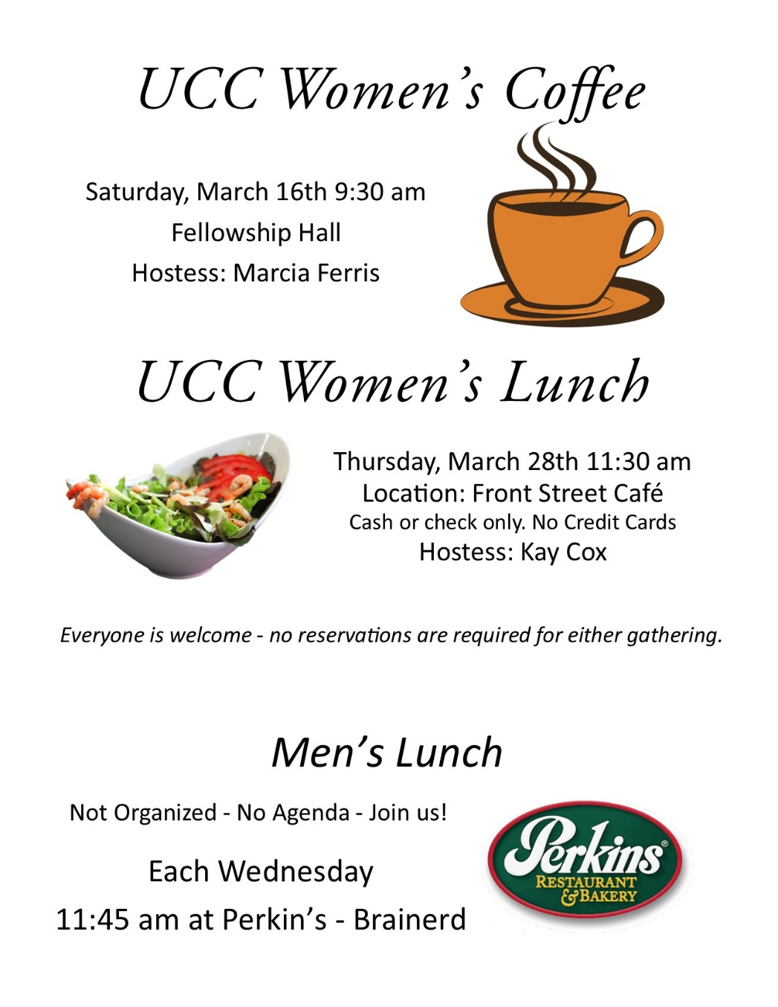
0

All updates will be posted on the Connections Facebook Group and RSVP’s may be made in the comments under the post at: www.facebook.com/groups/uccbrainerd

0
March Adult Forums – 11:30 am after worship

March 10th - “Tell It Like It Is - Reclaiming the Practice of Testimony” by Lillian Daniel: Learn how testimony can deeply affect, and finally transform, the life of a congregation.
March 17th – “Time to Talk About Mental Illness”: Following up on the theme from the Make It Okay campaign, our WISE Ministry Team will be holding a panel discussion of people who have a variety of lived experiences of mental illness. How different conditions express themselves, and how others can be understanding and supportive will be featured in the discussion.
March 24th – “The Art of Compassion”: The Surgeon General Vivek Murthy has stated that loneliness is an epidemic. While most social problems cost millions of dollars to address, the art of compassion is something that can radically transform lives. What does it mean to extend compassion? What are healthy ways to engage another person with compassion? Through the lens of biblical texts, we will consider the art of compassion.
The Rev. Dr. Candace Adams has over thirty years of experience extending compassion to those who are all too often overlooked by society. She is the missionary leader for The Compassionate Way, a newly formed ministry in the Baxter/Brainerd area. She extends compassion to women experiencing incarceration, men and women who are struggling with homelessness and mental health issues, women receiving substance abuse treatment, women residing in sober living homes, and more.
0
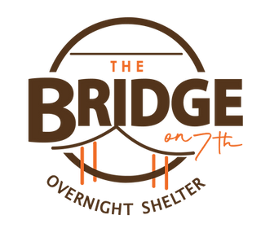
UCC Volunteers for The Bridge on 7th
First Congregational volunteers at the Warming Shelter. Our scheduled volunteer dates: March 10th through the 17th.
If you are interested please use the link to the volunteer sign-up page, https://whocanbethere.com/SignUp/week-of-feb-19ucc/1A4WgptOw4x which you must use to sign up.
Training video: https://whocanbethere.com/SignUp/week-of-march-10ucc/1WXxzYtQK4O?fbclid=IwAR2SmuutplfTj3Iq3H4NMFIWTHnpGKV-MtXbR7Ld8T8DJ2FuN8yXiPLUXsM
If you know of anyone else who may wish to volunteer, please share this information with them. If you have any questions email Deb Griffith at ranger2949@gmail.com.

UCC & TheShop Meal
0
SECOND Thursday of the month!
The next cooking date is March 14th at 3:45 pm.
First Congregational is working with the young people from TheShop (Brainerd/Baxter's Youth Empowerment Center) and are preparing a meal and serving it at TheShop for the participants in the program. Mary Benson is the point person. If you are interested in helping, please email Mary at marybenson75@gmail.com

Special Offering Sunday Worship
0
March 24th
One Great Hour of Sharing - UCC Missions
One Great Hour of Sharing® is a pillar among the United Church of Christ's special mission offerings. This Lenten offering provides crucial support to the disaster, refugee, and development ministries within Love of Neighbor ministries One Great Hour of Sharing is one of four special mission offerings of the United Church of Christ. Your support provides clean water, food, medicines, shelter, healthcare, education and so much more. What is One Great Hour of Sharing? The UCC works with international partners to provide sources of clean water, food, education and health care, small business micro-credit, advocacy and resettlement for refugees and displaced persons, and emergency relief and rehabilitation. One Great Hour of Sharing also supports domestic and international ministries for disaster preparedness and response.

Please send your donation to First Congregational UCC, 415 Juniper St. Brainerd, MN 56401. Make sure to note on your offering: “Special Offering One Great Hour of Sharing (OGHS)”.
Or for your convenience use our Paypal account at: paypal.me/uccbrainerd
Be sure to note on your offering “Special Offering One Great Hour of Sharing (OGHS)”. in comments. Thank you!
0
Easter Potluck Breakfast
Sunday, March 31st, 8:30 - 9:30 am.
Please bring a dish to share!
(sign-up sheet will be available March 10th).
Contact Kay Cox for more information.

0
H.U.G.S.
Hosts, Ushers, Greeters, Scripture-readers
Sunday morning greeters/ushers and coffee hosts play an important part in making our church a warm and welcoming place for all. Here’s a secret; it’s FUN!! If each household committed to 3 Sundays a year as greeter/ushers and/or coffee hosts, we would have a full complement of participants. Are you ready to take the leap into RADICAL HOSPITALITY? Give it a go and signup below for your first Sunday as the face of the church! https://www.signupgenius.com/go/10C0E48A9A823A5FFC07-hugs/16034811

First Congregatinal Food Shelf Collection
0

Our church continues to collect non-perishable food items for the Salvation Army Food Shelf. There are two collection boxes: one in the parking lot entry hallway, the other in the Narthex. Brian Twamley picks up and delivers the food.

Join us as First Congregational delivers for Minnesota Food Drive!
Thank you!
Please consider bringing items and donating.

You may also send a money donation to the church; First Congregational UCC
415 Juniper St. Brainerd, MN 56401. Or for your convenience use our Paypal account at: paypal.me/uccbrainerd Make sure to write in memo “Food Shelf”.
0

0
0

UCC Brainerd hosts Events, Group Meetings & Activities

0
0

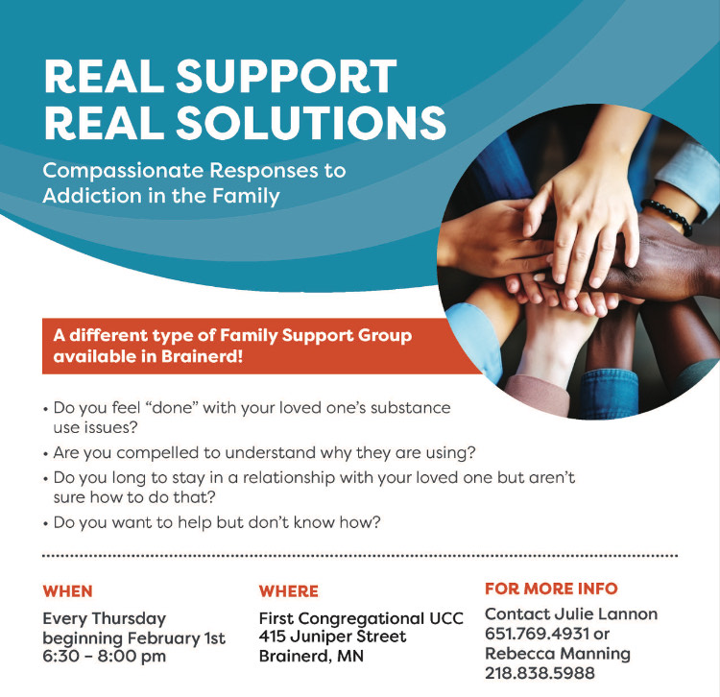

0
Art Exhibit in Fellowship Hall

Carla Benjamin has a new art exhibit in the Fellowship Hall.

10% of purchased artwork will be donated to First Congregational.
Thank you Carla for beautiful artwork!

Visit Carla’s website at: carlabenjamin.com

0

Brainerd Lakes Area Information
0
~ Opportunities to Know and Share God’s Love ~
0

0
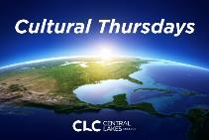
Cultural Thursday CLC – Calberg Theater
March 7th 12:00 Noon

“Faith in Public Life: Learnings from 50 years of social ministry”. Join Rev. Steven Newcom as he shares the experiences and insights gained from a lifetime dedicated to faith-rooted community ministry. Pastor Newcom will share his work within multi-faith, cross-class, and multi-race organizations and movements striving for social justice across various sectors, including community, philanthropy, religious, non-profit, and academia. He will highlight his discoveries and lessons learned from numerous organizations, ranging from small grassroots community groups to regional organizations and national movement centers. Gain invaluable insights into the transformative power of faith-based community engagement and social activism from one of its innovative leaders.
0
Our Neighbors To Love Coalition
Upcoming Events

Wednesday, March 20th - Pints for a Purpose at Jack Pine Brewery. Stay tuned for more information. MNTLC is planning a fun evening to help raise funds for our next housing structure. There will be pizza, games, and prizes!

Our current needs: We are so grateful to be the recipients of a $600,000 Affordable Housing Program grant from FHLB towards building a multi-family 12-plex. We have other funding secured also, and still have $474,000 left to raise before we can break ground.
Now is your chance to DOUBLE YOUR GIFT! A donor is offering a matching grant of $100,000! go to: www.mntlc.org/donate

We work very hard to keep our operational costs as low as possible. We have no paid staff or office rental costs, etc. - yet we still have ongoing expenses such as property assessments, accounting costs, printing, grant writing help, etc. Please consider becoming a FOUNDATIONAL MONTHLY GIVER. Sign up by going to the Donate tab on our website to help us with these expenses so more money can go to building homes. We are so grateful for our faithful current monthly contributors. It makes all the difference.

0
THE BRIDGE ON 7th – Warming Shelter
We are well into our 3rd season at the Bridge on 7th Overnight Shelter.
At the end of 2023 Ann Hunnicutt stepped down as shelter director, and
Bill Wear was promoted to take her place with both the shelter and
Operation Sandwich. Bill has a great understanding of our mission at The Bridge and is excited to work with our staff, guests, and volunteers in this new capacity. As he is typically working overnights, email is a great way to contact him. His email is bill@bridgesofhopemn.org.
So far this season our shelter is staying busy, and unfortunately, we don't expect that to change. To date we have offered over 143 unique individuals 2038 nights of sleep - that is an average of 15 guests each night since we reopened in September. We are thankful to the volunteers and donors that make this program possible.

0
March 2024 Calendar
Sunday | Monday | Tuesday | Wednesday | Thursday | Friday | Saturday
Leslie Workday |  |  | Office Hours  10am – 2pm | Office Hour  10am – 2pm | Office Hours  10am – 2pm  T. Michael Office Hours 10am-4pm
Pastor Leslie is on Sabbatical March 4th through June 8th |  |  |  |  | 10:30am Bk Grp-Z 1  6:30pm Movie Night: Fellowship Hall-Y | Sharon Carlson’s 2  BD Celebration 2-5pm @ 3Event Ctr.
8:30am Bnrd Frnds-Y 3  10am Wrship & Communion-Y&FB Blessing Service w/ T. Michael  11:15am Lunch Served-Y  Dan H. Photo Taking | 4  7pm BACP/BLUE via Zoom for the winter | 5  2pm EA-Y  5:30pm OA -Y | 6  12pm UCC Men’s  Fellowship-Perkins -Y  7pm AA Common-Y | 7  10am Care Team Mtg.-Y  6:15 pm Thrive Ministries-Y | 8  10:30am Book Grp- Z | 9  9:30am-1pm AAUW Meeting in Fellowship Hall
8:30am Bnrd Frnds-Y 10  10am Wrship -Y&FB CM/Sue H. leads  Testimony – Marcia Ferris  11am Fellowship-Y  11:30am Adult Forum-Testimonies-Y  UCC Volunteer @ Warming Shelter  Dan H. Photo Taking | 11 | 12  2pm EA-Y  Mtg.-Y  5:30pm OA -Y | 12pm UCC Men’s 13  Fellowship-Perkins -Y  5:30pm Trustees-Y  7pm AA Common-Y | 3:45pmTheShop 14  Cooking-Y  4pm Exec. Mtg.-Y  6:30pm Dist.7 AA-Y  6:15 pm Thrive Ministries-Y | 15  TBD CM Mtg.-Y  10:30am Book Grp- Z  3:30pm Stewardship-Y | 16  UCC Women’s  Fellowship in Fellowship Hall-Y
8:30am Bnrd Frnds-Y 17  10am Wrship -Y&FB Rev. T.Michael  Testimony-TBD  11am Fellowship-Y  11:30 Adult Forum-Y WISE Panel  1-4pm Girl Scouts Mtg.-Y | 18  . | 19  2pm EA-Y  5:30pm OA -Y | 12pm UCC Men’s 20  Fellowship-Perkins -Y  1:30pm PRC Mtg.-Y  7pm AA Common-Y | 21  3:30pm Council Mtg-Y&Z  6:15 pm Thrive Ministries-Y | 22  10:30am Book Grp- Z | 23  Pick up Palms back door – Time TBD
8:30am Bnrd Frnds-Y 24  10am Wrship-Y&FB Palm Sunday  Rev. T.Michael  Testimony -TBD  11am Fellowship-Y  11:30 Adult Forum-Y  *Special Offering OGHS  *Newsletter Deadline | 25  . | 26  2pm EA-Y  5:30pm OA -Y | 27  12pm UCC Men’s Fellowship-Perkins -Y  7pm AA Common-Y | Maundy Thursday  28  11:30am UCC Women’s Lunch @ Front Street Café-Y  6:15 pm Thrive Ministries-Y | Good Friday 29  10:30am Book Grp- Z Plan Start New Book? | 30
8:30am Bnrd Frnds-Y 31  8:30am Easter Breakfast  Easter Sunday 10am Wrship-Y&FB  Rev. T.Michael  Testimony-TBD  11am Fellowship-Y |  |  |  |  | N - None  ? - No update  Y- Yes Mtg. in person | FB - Stream Online  Z- our Zoom  C- Cancelled

