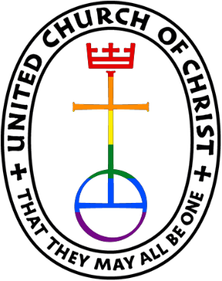
Friendship News, October 2025
0
First Congregational United Church of Christ, Brainerd
An Open and Affirming Congregation
The Church Office Hours: Tuesday, Wednesday, Thursday from 10:00am – 2:00pm
Office phone 218-829-2528 Office E-mail uccbrainerd@gmail.com
Pastor Leslie’s E-mail: pastorleslieucc@gmail.com Website: www.uccbrainerdmn.org

No matter who you are, or where you are on life’s journey, you are welcome here.
0
Pastor’s Pen
0

Dreaming God’s Dream
“Why do we give money to the church?” a child asks her mother, who is filling Sunday’s offering envelope. How will the mother answer her daughter’s question? How do we answer this question for our children? How does the preacher answer this question for us? Do we say that we give to help pay the church’s bills? Do we say that we give because of all the good things the church does—teaching children, standing for the best things in the community, fostering happiness and human welfare, providing help and friendship, and caring for people in need? How about answering by reciting a Bible verse or telling a Bible story? What verse would we choose? What story would we tell?
This is how Craig Satterlee begins his Alban Institute article entitled “Why Do We Give?” which I found myself rereading over and over again as I prepared to write this month’s Pastor’s Pen. October is Stewardship month at First Congregational UCC – that season when we pay attention to what we give to the church, especially our money, and prayerfully and thoughtfully discern what we will pledge to give in the next calendar year. Money is usually an uncomfortable topic for most people. It’s uncomfortable with friends, it’s especially uncomfortable at church, and it can be really uncomfortable as the pastor of a church! And yet, I feel called to pastor to every part of our life together and money is a big part of our lives because that is just the reality of being a human being in 21st century America.
So why do we give to the church? I invite you to give yourself some space to truly think about this question before filling out your pledge cards this month. There is no right answer to this question but I think it is important for each of us to have an understanding of our own answer. Would you even be willing to share your answer with me or with someone at church? Hearing each other’s reasons for giving to the church can be a powerful and transformative experience. I would love to share a small part of my answer with all of you.
Attending and becoming active in the church has literally changed my life and not only because I ended up becoming a pastor. Being part of a church drew me back into a meaningful relationship with God and into a deeper relationship with other human beings. It changed the way I perceive and respond to the world. And being a disciple of Jesus is challenging! Jesus’ teachings are as radical today as they were 2000 years ago, and I need a community of faith to walk with me as we seek to interpret and follow his teachings together. I give to the church because this community of faith matters to me and I want it to continue for generations to come.
I also give to the church because I value an inclusive and loving voice in a society that too often excludes and demeans. I value the message of Jesus to welcome all to the table. I have seen the positive impact the church has had on individuals and institutions. I have witnessed tears when someone at last believes that God really does love them for exactly who they are, that each and every single one of us is a beloved child of God, created with a divine spark. I want everyone to experience the unconditional and unbounded love of God, and the church is an important piece of that experience for many people.
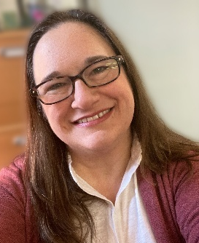
We all have different capacities to give financially, just as we all have different capacities to give of our time and our talents. Each person and household must give what is right for them. I truly believe in our theme for this year – “No dream too big. No Gift too small.” I know this congregation is capable of dreaming some incredible dreams and I know that God has big dreams for our little community. As we dream together, may this season of reflection and discernment be meaningful and inspiring for each of us.
With Peace,
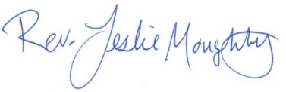

0
Mission Statement of First Congregational UCC
“To know and share God’s love within us.”

Purpose Statement of First Congregational United Church of Christ
“First Congregational UCC is a welcoming, inclusive, and progressive community committed to promoting social justice, spiritual growth, and love for all people. We reject discrimination and advocate for equality and dignity for marginalized communities. Through worship, education, and service, we work to make a positive impact on the world and invite all individuals to join us in this journey of faith and service.”

0
Church Office Hours
Tuesday, Wednesday, Thursday 10:00 am - 2:00 pm
Closed Mondays and Fridays

Please call Admin. Asst. Terri at the office 218-829-2528
Terri Admin. Asst. Vacation Days – Wednesday, October 15th & Thursday, October 16th
0

Pastor Leslie’s Workday Schedule

Sunday through Thursday (Days off are Friday and Saturday)
Drop-in Hours: Wednesdays 11:00 am – 1:00 pm
*Drop-in hours are times set aside for “drop-in” conversations, much like a professor’s office hours.
Everyone is encouraged to make an appointment, especially if the above times are not convenient. You can go to www.calendly.com/pastorleslieucc and select a day and time that works for you, or you can email Pastor Leslie at pastorleslieucc@gmail.com or call/text at 218-656-0096.

Pastor Leslie will be out of the office for a UCC Minnesota Conference event:

Tuesday, Wednesday, Thursday, October 21st, 22nd, 23rd

For pastoral care emergencies, please contact the church office.
0
Stay Connected

How to watch Sunday worship: The worship service is broadcasted on the church Facebook page and the church's YouTube channel every Sunday at 10:00 am.
To watch worship on Facebook, go to https://www.facebook.com/uccbrainerd/live
**Live stream videos are saved and can be viewed at any time. All memorials, weddings and 12th Night Concert are on our church Facebook page.
How to stay connected with First Congregational friends and members: Join the private group for our Facebook Connections Page at https://www.facebook.com/groups/uccbrainerd.
Financial Help Available The Pastor's Discretionary Fund is available to assist church members and others in the Brainerd area who are experiencing financial distress with modest financial help. If you need assistance, please email, call, or text Pastor Leslie. Let her know what your situation is and how the church might be of help.
Donate to the church online! We are now accepting your offerings and donations using PayPal. You do not need to have a PayPal account to make an online donation with a credit card. To use PayPal, go to: https://www.paypal.me/uccbrainerd
0
First Congregational UCC News & Updates
0

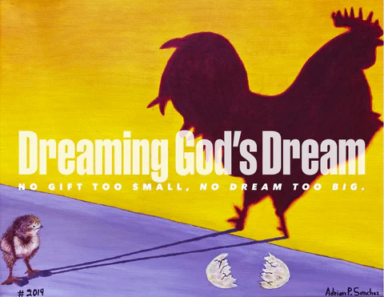
Stewardship Commitment Season is Here

Greetings Members & Friends of First Congregational UCC, Brainerd,
Our theme this year is “Dreaming God’s Dream,
No Gift Too Small. No Dream To Big.”

At First Congregational United Church of Christ, we believe that God calls us to love boldly, welcome radically, and work tirelessly for justice. Every week our community gathers to worship, to learn, and to live out the teachings of Jesus: a vision of abundant life for all people.
This sacred work is only possible because of your prayers, your presence, and your generosity. Together, we have:
Welcomed newcomers seeking an inclusive spiritual home.
Stood alongside neighbors in need through food, housing, and advocacy ministries.
Lifted our voices for creation care, racial equity, LGBTQ+ inclusion, and peace.
Nurtured children, youth, and families with programs grounded in compassion and hope.
As we look to the coming year, we invite you to make a financial pledge to sustain and expand the vital ministries of our church. Your pledge is more than a gift—it is an investment in a church that dares to live out God’s dream of justice, peace, and love in the world. Every gift, large or small, is an act of faith, a spiritual practice, and a building block for the future of our community.
You can set up a monthly automatic donation (information is enclosed in your Pledge Packet) or use an RMD (Required Minimum Distribution from certain tax ) that is tax free. Letting us know your intentions (weekly, monthly, quarterly or an annual donation) will help us set a realistic budget.
Please mail back the Commitment Form or bring it with you to worship on Pledge Sunday, October 26th 2025. Final deadline to return your pledge to the office is November 1st.
By mid-November we will set a budget for 2026 based on pledges and dedication.
Thank you for being a part of this movement of grace. With your support, we will continue to be a church where all are welcome, where hope is renewed, and where love takes action.

Your UCC Stewardship Committee;
Sarah Jo Armstrong & Maggie Anderson

0

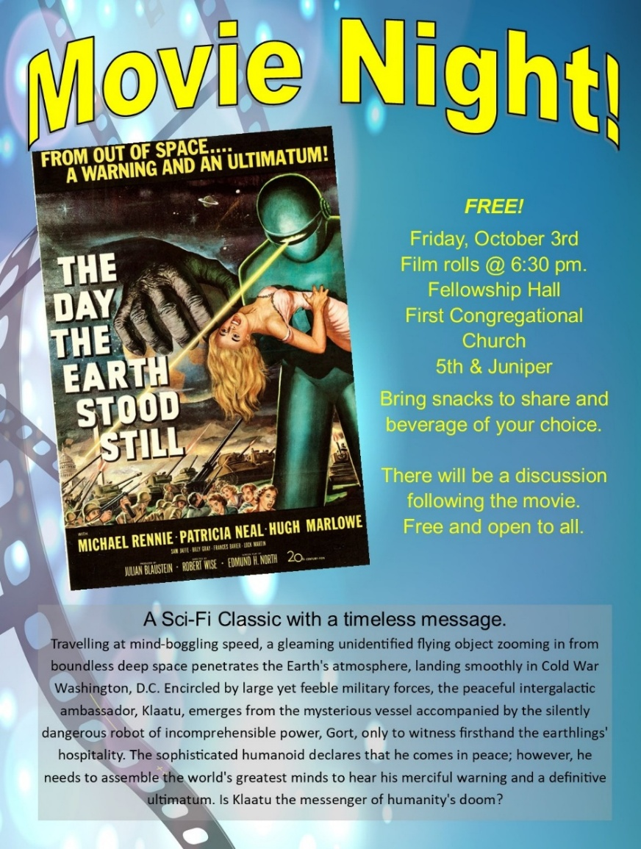

Potluck
Before
Movie Night

Friday, October 3rd
5:15 pm
Fellowship Hall

The Cooking Group is
hosting a Potluck!
Bring a dish to share
and your own table
service.
No food assignments.

0
0
UCC Fellowship - A time to connect and socialize

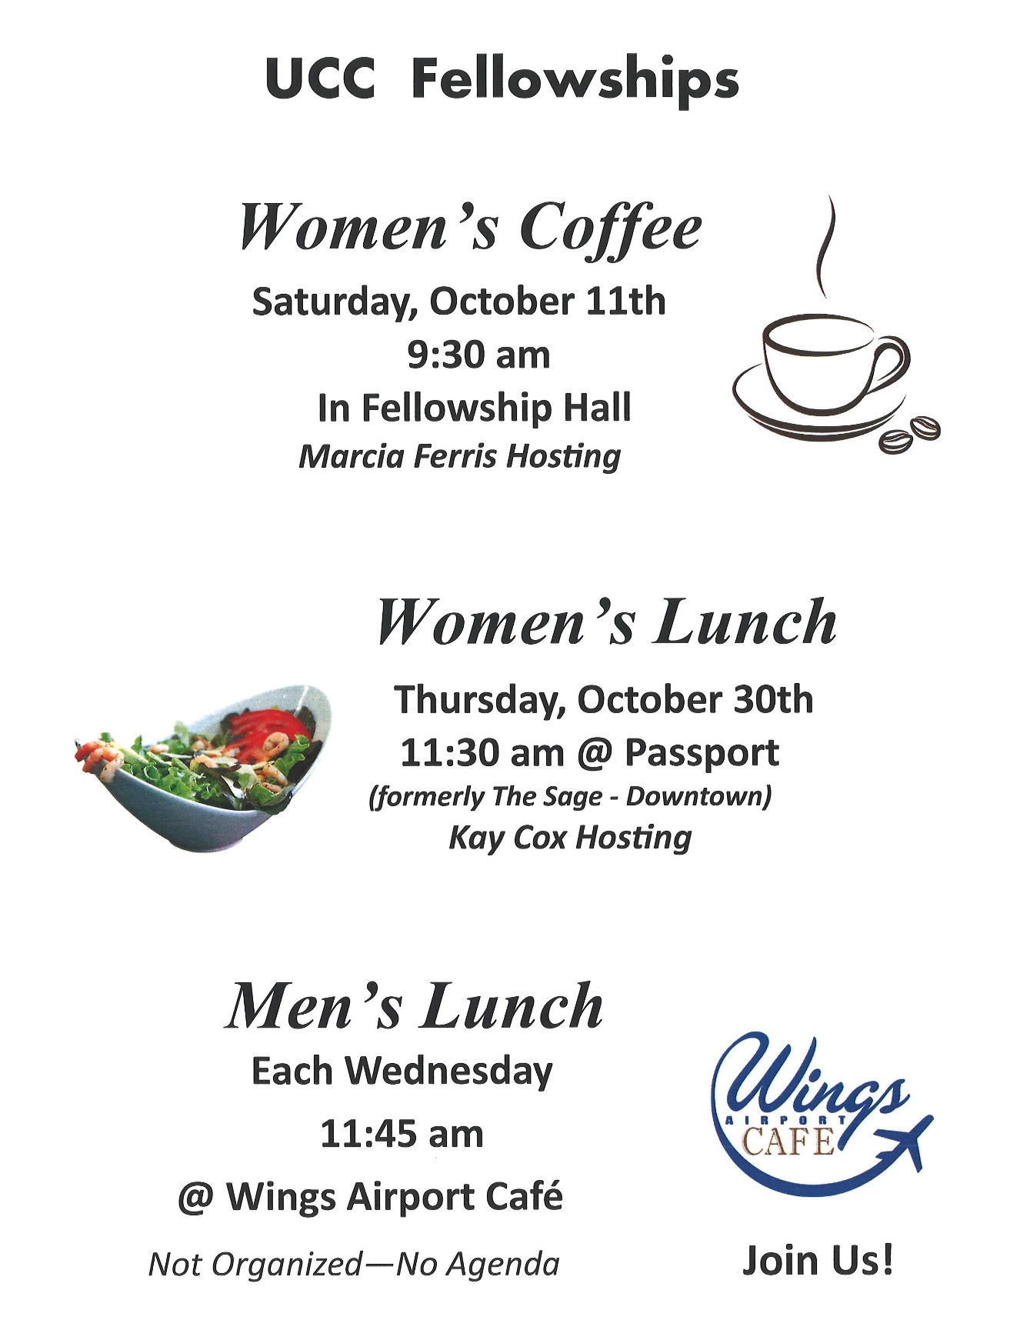

0

October Adult Forum - 11:30 after worship

October 5^{th:} What is our Relational Covenant? Come and learn more about how our relationship with each other is a way to grow together in our faith.

October 12th: Name Change Brainstorm Meeting: The Suggested Names List is not yet complete. If you have suggestions for a new name, email it/them to Dan Hegstad. You can add suggested names until October 11th.
As a name(s) is received it will be added to the list and placed randomly. This list does not reflect the time at which the name(s) was submitted. The list is intentionally not numbered. Also, those who submitted a name(s) are not tracked.
On Sunday, October 12th we will begin the process of selection. At Adult Forum we will ask those in attendance to select their top three names. If you can’t attend the Adult Forum on October 12th, it’s OK. The list will be sent to everyone. You will have until November 1st to vote.
I will compile those names into another list. That list will go to the Possible Name Change Task Force. The Task Force will choose three and submit those three to Voting Members of the Congregation. The results will be tabulated using Ranked Choice Voting. The name then goes to the Church Council for adoption.
It is important to know if you are a “Voting Member.” Voting Members are those who have officially joined the Church. Up until now, anyone can have input and vote. There are folks who attend, are involved in the church, support the church, and are connected in many ways, but only those who have officially joined as Voting Members will take part in the final vote.
As you mull over the list and ponder your suggestions, keep in mind that, while we are United Church of Christ – that’s not changing – and UCC will likely always be part of our official name, we may choose to not include UCC in the part of the name the public sees. For example, our neighbor, Park United Methodist Church, is now known as Park Church. So, you do not necessarily need to connect UCC to your suggestion. Rather than, “Pointy Roof UCC,” we may choose to be known as “Pointy Roof Church.”
Thank You!! Dan Hegstad and Task Force.
Suggested Names List:

- Open Door(s) - Koinonia (Greek for Community)
- Spirit of the Lakes - Spirit of our lakes – SOOL (Soul)
- Tri-Uniting House - Covenant Community
- Grace - Living Sanctuary
- Synergy - First Congregational
- Brainerd - Brainerd Synergy
- Singing Creek Church of the Wild - Open Journey
- Open Door Fellowship - Affirming Spirit Church
- Renewal Collective - Juniper
- The Gathering Place - Together in Spirit
- Spirit of Grace - Rooted & Rising
- Open Spirit Fellowship - Justice & Joy Church
- The Christ Colony - UCC +
- Sunrise - United Church of Christ
- Tapestry - Shalom Collective
- Courageous Faith - The Open Spirit
- Sanctuary of the Wild Grace - Grace Rising
- Kindom Way - Open Hands Fellowship
0

October Birthdays
0
Bob Jones Oct. 7 Kamery Hauan Hahn Oct. 25
Jolene Hojem Oct. 7 Elissa Hartwig Oct. 28
Tom Highum Oct. 8 Tracy Lyons Oct. 28
Eileen Kurpiers Oct. 11 Andrew Pucko Oct. 29
Zachariah Johnson Oct. 11 Elizabeth Paulson Oct. 30
Robert Morgan Oct. 14 Paxie Imsdahl Oct. 31
Barb McColgan Oct. 20 Luann Rice Oct. 31
Cynthia Janes Oct. 25

0
Next Council Meeting
Wednesday, October 16, 2025, 3:30 pm
in-person and via Zoom tinyurl.com/uccbrainerdzoom
Reports are due via email on Tuesday 14th

First Congregational Approved Council Meeting Minutes are available upon request.
Please contact Terri Admin Asst. at the Church Office.
0
Volunteer at Church!
There are many other opportunities for you to share your talents

These committees need your gifts: * Trustees * Stewardship * Members-at-Large
0


TheShop Meal @ First Congregational UCC!

Meal cooking has been scheduled for the fourth Wednesday of each month and beginning October 22nd at 3:00-5:30 pm in the church kitchen and Fellowship Hall.
Save the dates: November 26, December-cancelled for Christmas, January 28, February 25, March 25, April 22, May 27.

A number of youth and the staff from TheShop (Brainerd Baxter Youth Drop-in Center) come over to our kitchen and help prepare a delicious meal that is then brought back to TheShop for the hungry and appreciative teens there.
If you are interested in joining and volunteering your time please contact Breton Monroe, Executive Director @ 218.316.2070 or The Brainerd Baxter Youth Center @218.454.0009
https://theshopbrainerd.org/ https://www.givemn.org/donate/Theshop
0

October Special Offering - TheShop

Sunday October 26th
This month we have an opportunity to help as we give our Fourth Sunday Special Offering to TheShop Brainerd Baxter Youth Center (BBYC). TheShop is a non-profit organization committed to providing community support to all teenagers and young adults as they transition into independence and adulthood. We are a safe space where youthful energy is harnessed into creative energy by providing opportunities to explore potential, build lasting relationships, and establish personal connections.
To donate, send a check with "TheShop” in the memo line to: First Congregational UCC, 415 Juniper St. Brainerd, MN 56401 or donate online using PayPal https://www.paypal.me/uccbrainerd and indicate "TheShop" in the Note.
0


8th Annual Halloween Extravaganza!
Friday, October 31st 4:00 pm - 9:00 pm
You can help the church connect with our neighbors!
      - Donate Candy and/or non-candy item - There is a box located outside the sanctuary for donations of candy and non-candy items.
      - Decorate – Thursday, October 30th 4:00 – 6:00 pm. Pizza provided!
- Volunteer on Halloween Night – Friday, October 31st
  - Make cider and final set up starting at 4:00 pm
  - Hand out candy, serve cider, general friendly help from 5:00 – 8:00 pm (or earlier if trick-or-treaters are scarce). Come for an hour or the entire night!
  - Help with clean-up. Take down and put away the decorations: 8:00-9:00 pm (or as soon as we’re done. More helpers = shorter clean up time!

Costumes are strongly encouraged but not required. Please keep them kid-friendly.

Sign-up sheet in the Narthex starting Sunday, October 5th.

0

Cooking For Everyone

This group is OPEN FOR EVERYONE!

Email Lowell Johnson and he will add you to the member list. You will be notified when and where we will next meet.
0

0
First Congregational Food Shelf Collection

Our church continues to collect non-perishable food items for the Salvation Army Food Shelf. Please consider bringing items and donating.

There are two collection boxes: one in the parking lot entry hallway, the other in the Narthex. Brian Twamley picks up and delivers the food. Thank you!

0

H.U.G.S.
Hosts, Ushers, Greeters, Scripture-readers

Sunday morning greeters/ushers and coffee hosts play an important part in making our church a warm and welcoming place for all. Signup below for your first Sunday as the face of the church! https://www.signupgenius.com/go/10C0E48A9A823A5FFC07-hugs/16034811
0


Friday Book Group

We meet each Friday morning at 10:30 am via zoom.
Church Zoom link: https://tinyurl.com/uccbrainerdzoom

We began reading "Gratitude” by Oliver Sacks the last week of August.
A deeply moving testimony and celebration of how to embrace life. In January 2015, Oliver Sacks was diagnosed with a recurrence of cancer, and he shared this news in a New York Times essay that inspired readers all over the world: "I cannot pretend I am without fear. But my predominant feeling is one of gratitude.... Above all, I have been a sentient being, a thinking animal, on this beautiful planet, and that in itself has been an enormous privilege and adventure." Gratitude consists of four essays that originally appeared in The New York Times , accompanied by a foreword that describes the occasion of each chapter. The foreword is written by Billy Hayes, Oliver Sacks's partner, and Kate Edgar, his long time collaborator.


0
UCC Care Team

For anyone who wishes to join in making calls or visits, the Care Team meets every month on the first Thursday @ 10:00 am.

If you know of anyone who would enjoy a call from the care team, please contact one of our Care Team; Barb Hoeft, Jack and Kay Kraywinkle, Pat Scott, Chris Yager, Deb Griffith, Joey Halvorson (text or email) and Pastor Leslie.
0
0

Garden Gleaning
A Biblical (and environmentally) inspired activity
This is how it works: Gardeners and plant people bring in their “gleanings” to share. This ranges from rhubarb and vegetable plants in the spring to daffodil bulbs, squash and pumpkins in the fall. A table, poster and donation basket are in Narthex entrance. Enjoy the fruits of our labors!
All are welcome to help themselves! All donations are given to the Food Shelf.
Historical note: Begun here circa 1988 when our church began Hunger Action outreach, Central America updates and global food connections.

0
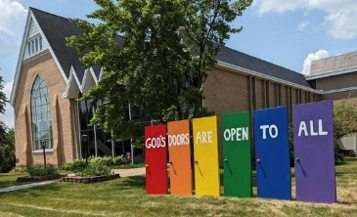
Welcome to our Facility
We are blessed to be able to share our beautiful church facilities for purposes that match the values of the church and its mission which is “To know and share God’s love within us.” We are an open church valuing the diversity of age, culture, gender identity, opinions, physical and mental abilities, and sexual orientation.
To request a space for general use, ask for a “Request for Church Building Use” form and
policy packet from Terri in the church office, at 218-829-2528 or email uccbrainerd@gmail.com. Submit the request form back to Terri in the office, and it will be submitted for approval at the next Council Meeting.

For wedding or funeral use, contact Pastor Leslie: pastorleslieucc@gmail.com

0
The Columbarium & Memorial Garden
First Congregational UCC, Brainerd
The Columbarium is in the historic space that once was our church’s front entry way.
How appropriate it is that our Columbarium now marks another entry way into a new life — where the Spirits of Love and Truth are always present!
The Memorial Garden is located on the south lawn of the church. The Garden provides a place for cremains of your loved one to be buried in the ground among natural plantings. The Garden fee includes the inscription of your loved one’s name on a granite plaque that is mounted on the outside wall of the church.
Should you wish to learn more about the purchase of a niche for your own cremains or for the ashes of a loved one, please call the church office at (218) 829-2528 and a packet of materials will be sent to you via email or regular mail. The Memorial Committee has prepared the information packet, and it contains all the details you will need as you consider inurnment here at First Congregational UCC.

0
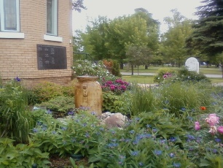
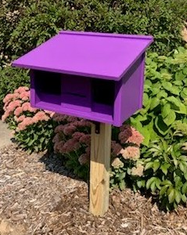
Community Prayer Box

Thank you to our Memorial Committee and the craftsmanship of Jack Kraywinkle, for making Pastor Leslie’s idea for a Community Prayer Box in the Memorial Garden a reality! You can find the prayer box on the South side of the church (the side that faces Juniper Street.)

Community members frequently walk through the garden and this box will offer our wider community an opportunity to share their prayers. Prayer cards and pens are provided, and the box is secured with a padlock, so the submitted prayers don’t fly away with the wind!
Pastor Leslie checks the box weekly and pray for any prayers submitted as well as bring them to the Care Team for prayer as well.

0
Save The Dates! Activities in November
@ First Congregational UCC Brainerd

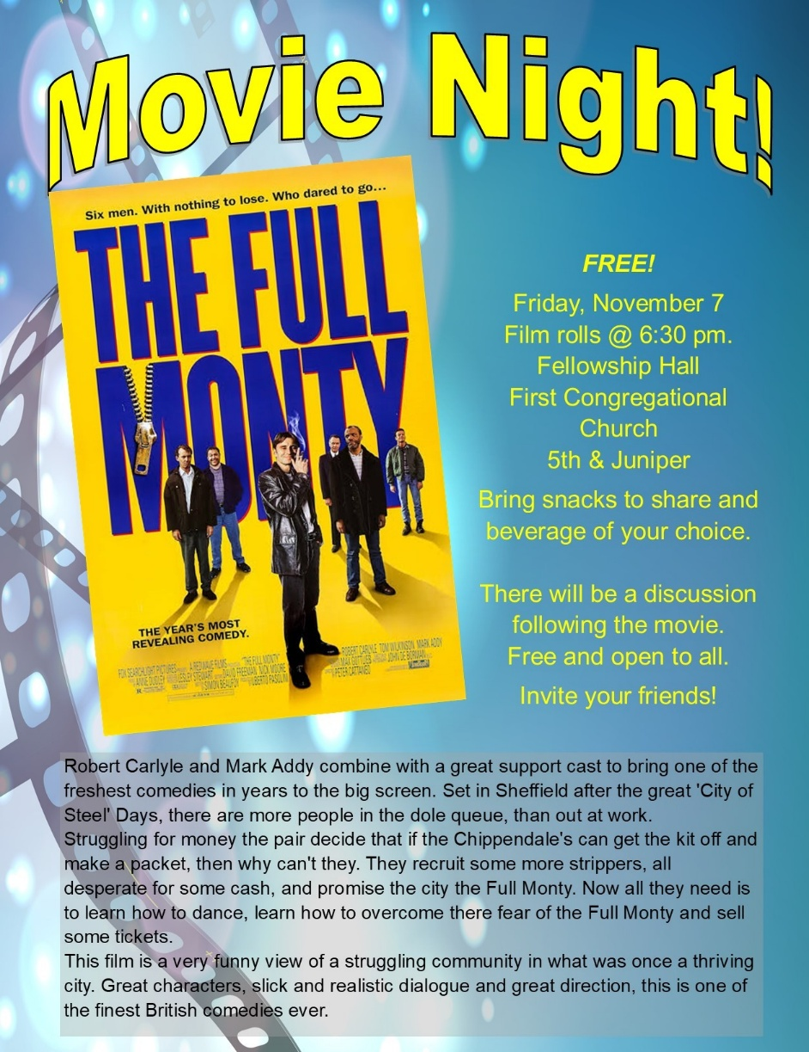

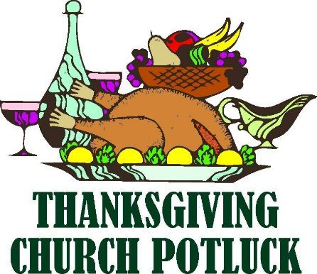
Thanksgiving Potluck
0
First Congregational UCC Brainerd

Sunday, October 16th @ 11:30 am
Fellowship Hall
Open to our Neighbors & Friends
Turkey provided - Bring a side dish to share.
(not necessary)
More information is coming soon!

0

Brainerd Lakes & Surrounding Area Information
~ Opportunities to Know and Share God’s Love ~
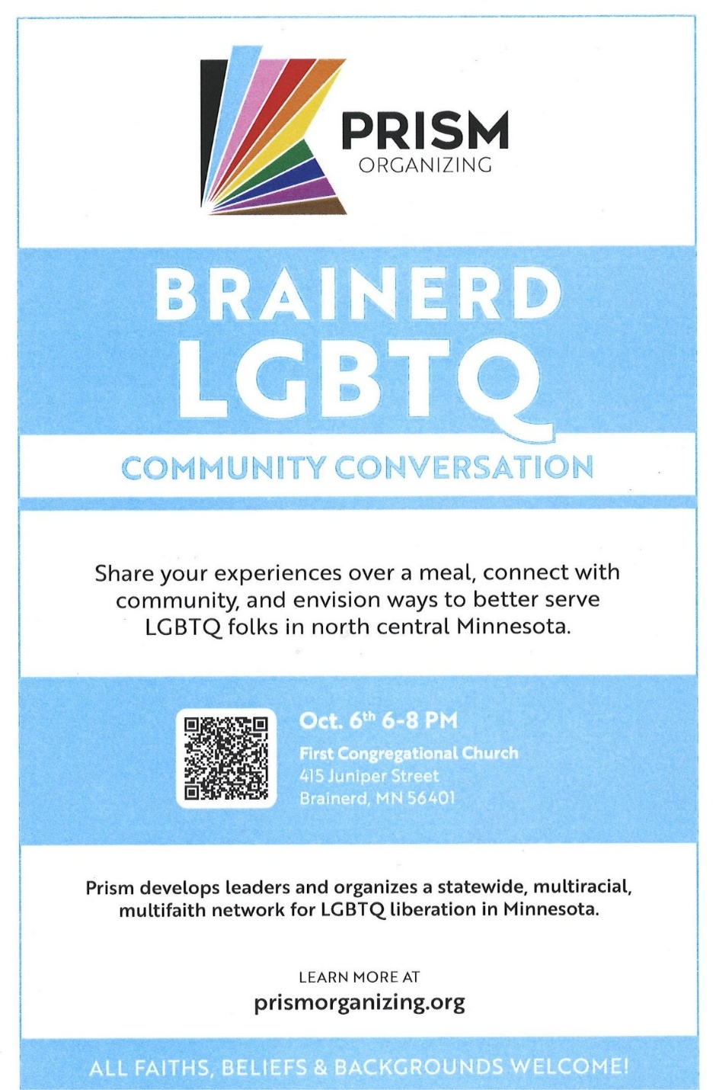

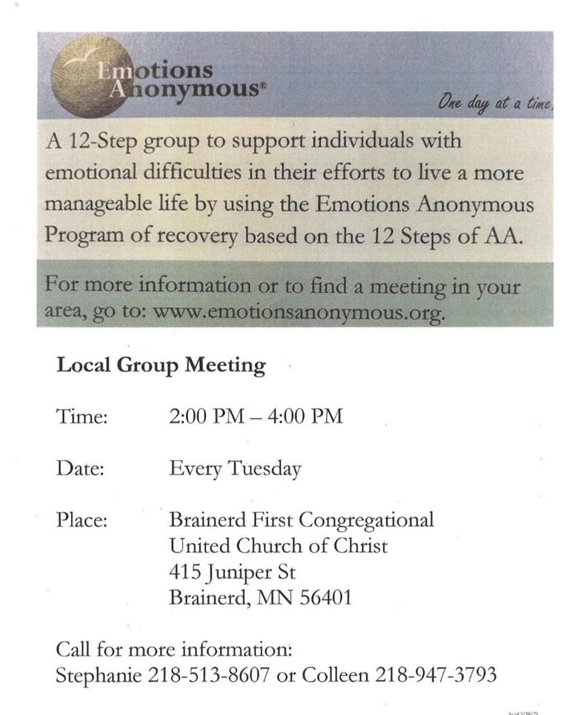
0

0
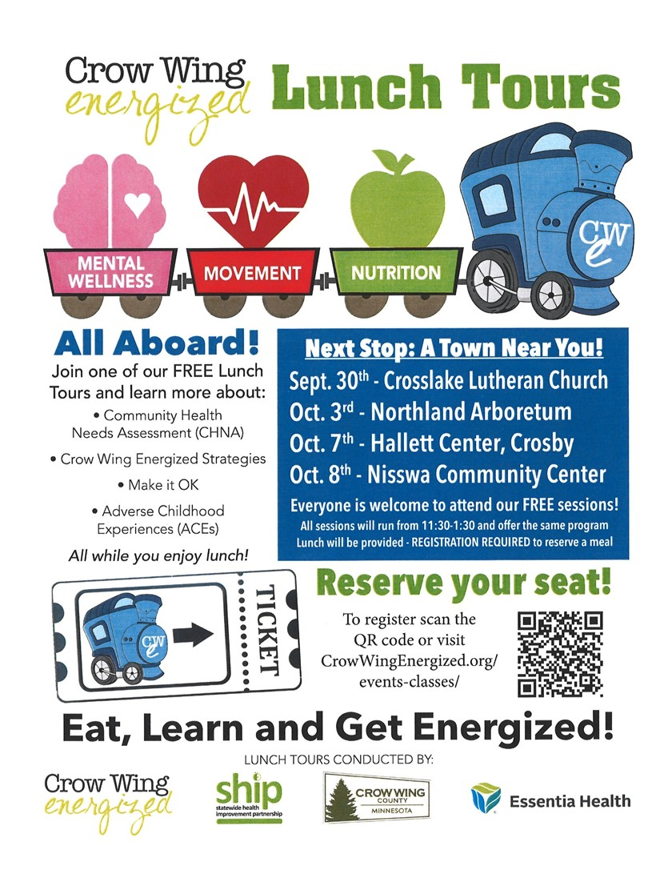
0

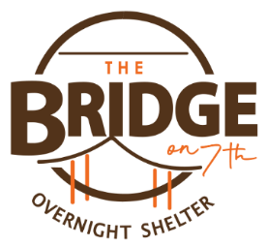
0
The Bridge on 7th - Warming Shelter

The Warming Shelter opened on September 1st.
Located at; 1926 S 7th Street, Brainerd, MN 56401

Our goal is simple; provide a safe and warm place for people to sleep. A good night's sleep, a cup of coffee and a snack are available.
The shelter is open to all guests age 18 and older. The shelter is first come, first served.
Hours are from 7pm to 8am, 7 days a week. Walk-ins are accepted from 7-11pm, then the doors are locked for the night and no further admittance is allowed.
There is no limit to how many nights to stay at the shelter.

Volunteer opportunities can be scheduled at our website: https://www.bridgesofhopemn.org/overnight-shelter
0
0
October 2025 Calendar
Sunday | Monday | Tuesday | Wednesday | Thursday | Friday | Saturday
Y- Yes Meeting in person  FB -Facebook Stream Online  C- Cancelled N-No Meeting  Z-our church Zoom | Office Closed | Office Open  10am – 2pm | Office Hours  10am – 2pm  Pastor Drop-in Hours  11:00 am – 1:00 pm | Office Hours  10am – 2pm  Pastor Drop-in Hours  2:00 – 4:00 pm  w/Daisy | Office Closed
Terri Admin. Asst. Vacation Days: Wed. 15th & Thurs. 16^{th.}  Pastor Leslie Annual Clergy Retreat-out of office: Tues. 21st through-Thurs. 23rd |  | 2 | 11:45pm Men’s 1 Grp@Wings Café-Y  1:30pm PRC Mtg.-Y  4pm Christian Ministry Mtg.-Y  7pm AA Common-Y | 2  10am Care Team-Y | 3  10:30am Bk Grp-Z  5:15pm Potluck before 6:30pm Movie Night-Y Fellowship Hall | 4  10am Council  Retreat-Y  11am-1pm BACP/BLUE Mtg-Y Fellowship Hall
8:30am Bnrd Frnds-Y 5  10am W0rship & Communion-Y&FB Live  *Testimony-Lowell J.  11am Fellowship-Y  11:20 am Adult Forum: Relational Covenant-Y | 6  6-8pm Prism LGBTQ Communication Session-Y  Fellowship Hall | 7  2pm EA-Y  5:30pm OA -Y | 10:30am Trustees Mtg-Y  11:45pm Men’s 8 Grp@Wings Café-Y  3:30pm Exec. Mtg.-Y  7pm AA Common-Y | 9  3:30pm Stewardship Mtg.-Y | 10  10:30am Bk Grp- Z | 9:30am Women’s  Fellowship-Y  11
8:30am Bnrd Frnds-Y 12  10am Worship-Y&FB  *Testimony-Deb G.  11am Fellowship-Y  11:30am Adult Forum-Brainstorm Name Change-Y | 13 | 2pm EA-Y 14  5:30pm OA -Y  4pm Neighbors for Shelter Mtg.-Y | 10am Foundation Mtg.-Z  11:45pm Men’s 15 Grp@Wings Café-Y  1pm Memorial Mtg.-Y  7pm AA Common-Y | 16  3:30pm Council  Mtg.-Y&Z  6:30pm Dist.7AA-Y | 17  10:30am Bk Grp- Z | 18  10am & 12:00pm BLA Indivisible Event-Y Fellowship Hall
8:30am Bnrd Frnds-Y 19  10am Worship-Y&FB Live  *Testimony-Gary W.  11:15am Fellowship-Y  1pm Girl Scout Mtg.Y | 20 | 2pm EA-Y 21  5:30pm OA -Y | 11:45pm Men’s 22 Grp@Wings Café-Y  3-5:30pm TheShop Cooking-Y  7pm AA Common-Y | 23 | 24  10:30am Bk Grp- Z | 25
8:30am Bnrd Frnds-Y 26  10am Worship-Y&FB  *Pledge Sunday  11am Fellowship-Y  *Special Offering – TheShop  * Newsletter Deadline | 27 | 28 | 29  7pm AA Common-Y | 30  11:30am Women’s Lunch @ Passport  4-6pm Halloween Decorating | 10:30am Bk Grp- Z  31  4pm Setup for Halloween  5-9pm Halloween Treats handed-out

