Friendship News, April 2023
First Congregational United Church of Christ, Brainerd
An Open and Affirming Congregation
The Church Office Hours: Wednesdays – Fridays from 10:00 am – 1:00 pm
Pastor Leslie’s Drop-in Hours: Wed. 1:00pm – 3:00pm, Friday 10:00am – 12:00pm
Office phone 218-829-2528 Office E-mail uccbrainerd@gmail.com Pastor’s E-mail: pastorleslieucc@gmail.com Website: www.uccbrainerdmn.org
Schedule a 1 to 1 (in-person or by Zoom or Phone) with Pastor Leslie:
www.calendly.com/pastorleslieucc/1to1
No matter who you are, or where you are on life’s journey, you are welcome here.

Not to Speak Is to Speak
“Not to speak is to speak.” These words repeated in my mind as I read what I consider one of the most hateful, harmful, and un-Christlike Clergy View articles I have ever read in the Brainerd Dispatch. The article, written by Bill Werth of Christ Lutheran Church (Wisconsin Evangelical Lutheran Synod) in Baxter, begins by asking what Jesus would see in the world today. He responds to the question that Jesus would see sin and evil. I don’t disagree with this initial statement; there is a lot of evil, and what we might refer to as sin, in the world today. One doesn’t need to turn on the news for long before hearing stories of violence, starvation, oppression, corruption, and destruction of the planet fill the screen.
But those are not the examples of “evil and sin” that Rev. Werth named in his article. Instead, he went tirade about the LGBTQ community, access to abortion care and nothing else. No mention of the 18 lives taken at the hands of school shooters during the 89 gun-related incidents at school just in the first 3 months of this year.¹ Not a word about the fact that 44% of Brainerd School District students are eligible for free and reduced school lunches.² No, the entire focus of the article was on the “sin” of homosexuality, being transgender, and obtaining an abortion.
After outlining these “sins” the author goes on to call on churches and pastors to “tell people the truth” and remarks that “silence in the face of evil is evil itself” and “Not to speak is to speak.” Well, Rev. Werth, I couldn’t agree more. But I vehemently disagree with your assessment of what the truth is and the true nature of the evil this world is facing. On this day of Transgender Visibility (March 31), I refuse to allow voices like this to perpetuate the baldfaced lie that being transgender is a sin. I refuse to stay silent when scripture is taken out of context and manipulated to support the evil, cruel, and flat out false claim that being lesbian, gay, bisexual, pansexual, or any sexual orientation other than heterosexual is somehow “abnormal.” And I refuse to concede that the Bible says anything definitive about when life begins; if anything, the scriptures make a case for life beginning at the first breath.
The truth is that when Jesus was asked what the greatest commandment is, he replied plainly and simply, “Love the Lord your God with all your heart and with all your soul and with all your mind.’ This is the first and greatest commandment. And the second is like it: ‘Love your neighbor as yourself.” Love God, love your neighbor, love yourself. Start with love. When in doubt, act and speak with love. The truth is that there are currently 424 anti-transgender bills making their way through legislatures in 47 different states - bills that would deny life-saving gender affirming care to thousands of young people, bills that would ban transgender people from serving in the military, bills that seek to remove trans people from public life. These bills and articles like the one written by Rev. Werth will cause great harm and do not follow the example or the words of Christ. Data indicate that 82% of transgender individuals have considered killing themselves and 40% have attempted suicide, with suicidality highest among transgender youth.³
Not to speak is to speak - Bill was right about that. And so I am speaking. I will be sending an adapted version of this article to the Dispatch to be included in Wednesday’s religion section. While many folks give more weight and credibility to the voice of an ordained clergy person, YOUR voices need to be heard! I strongly encourage you to submit letters to the editor at the Brainerd Dispatch expressing your disagreement and disgust with the article titled “A Sanctuary State for Evil” published on Wednesday March 29, 2023.
Here is information from the Dispatch regarding Letter to the Editor: Letters should include the writer's full name, city and a phone number (for verification only). Letters are limited to 300 words. Only one letter per person per week. Letters airing a personal complaint with a private enterprise will not be considered. Letters containing personal attacks will not be considered. Letters endorsing candidates will be limited to 150 words. Send letters to Reader Opinion, Brainerd Dispatch, P.O. Box 974 Brainerd, Minn., 56401 or email them to readeropinion@brainerddispatch.com.

To my transgender, lesbian, gay, bisexual, pansexual, queer beloveds – I see you. God sees you and calls you beloved. You are loved beyond measure and there is nothing you need to do or change about yourself to earn that love.

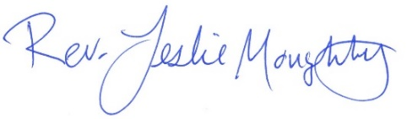
With peace,

¹ https://k12ssdb.org/all-shootings
² https://education.mn.gov/
³ https://pubmed.ncbi.nlm.nih.gov/32345113/

Moderator’s Musings
Easter seems early this year. Is it because we have so much snow still on the ground? Or is it because Easter is a sign of spring, and we are definitely ready for spring. Spring is a wonderful word, don’t you think? It has many meanings. Some are: to come into being, leap, rise, a source of supply, to release from confinement, a time of growth and development, to be resilient.
These spring words could describe what is happening in our local UCC church. We are finding and organizing church history records; preparing a congregation/pastor assessment; have sent in a grant request for pastoral renewal in 2024, a new data base is being developed with up-to-date membership information; we have launched a new facility use policy; our technology team is improving our audio sanctuary system; we have enhanced food collection opportunities for our friends in need.
Rising weekly to support the church community, others clean, usher, and read scripture. They provide music, bulletins, communications via the local newspapers, e-newsletters, and participate in weekly luncheons; prepare communion breads, provide sidewalk and building upkeep, and drive our food collections to where they are needed. We have new adult forums almost weekly.
Care team development is underway; our “cooking for everyone” group is cooking up fund raising ideas; our pastor/parish relations committee is learning and growing in what their role in the church is; each Council department and committee have been communicating their goals and directions during “ministry moments” at Sunday services; recruitment of new committee and Council members is in process; our new social justice coordinator is gathering ideas from our church members, community organizations and other churches on moving forward to address our passions and concerns.

All the while these things are springing forward, we are also thinking about new opportunities and changes that can occur in our church’s future.

Thank you everyone for being part of creating a beautiful spring in our church.
Colleen
Council Moderator

Lent 2023
Sundays at 10:00 am – Worship in-person & live on Facebook
Saturday April 1st – Pick up palm branches for Palm Sunday.
If you are planning to worship online, swing by the church parking lot to take home a palm branch. Branches will be available next to the parking lot door for un-staffed pick up. For those attending in person, palm branches will be given out at the worship service.
Sunday April 2nd 9:55 am – Join us in the narthex (lobby) for a Palm Procession into the sanctuary when worship starts at 10am. All ages!
Friday April 7th 12:00 pm – 6:00 pm Open House Stations of the Cross
Sunday, April 9th 10:00 am – Easter Worship in-person & Live on Facebook
0
First Congregational UCC News & Updates
0

Stations of the Cross - OPEN HOUSE
Good Friday, April 7th @ 12:00 Noon - 6:00 pm
On Friday April 7th from Noon to 6:00 pm we are having the church open to all for "Stations of the Cross through the Lens of Justice".
The following is a description of what to expect.
Walk alongside Christ in his final hours and confront current social justice issues in this reimagined version of stations of the cross. Fourteen stations created by members of the First Congregational United Church of Christ community feature a piece of scripture paired with a piece of art or an image, and an invitation to reflection around a social justice issue. This is an open house-style event, so come anytime between 12:00 noon and 6:00 PM. Go at your own pace, stay as long or as briefly as you desire. All are welcome!

Holy Humor Worship Service
Please join us as we worship with humor and joyful celebration on
Sunday, April 16th 10:00 am.
Get dressed up in a silly costumes and/or funny hats.

Volunteer Recognition Luncheon – April 23rd 11:30 am
The Stewardship Committee will be serving a luncheon in the Fellowship Hall to recognize all volunteers for their unwavering commitment to our church.

Annual Connection Letter
The connection letter was sent out last month to new members, visitors and friends of our church.
Please fill out the form completely and return it to the office in the envelope provided. This information will help us update our membership list and make informed decisions about programs, and much more. Your response is important to help us better connect with one another and better serve our members and visitors. If you have inadvertently been missed and did not receive a letter and would like one, please contact Terri in the church office. Thank you for your prompt response!

Directory Update

An updated directory will be emailed out the first part of May. If you have changes or new contact information, please send it to Terri in the office asap. Note: If you want information added or removed from the directory or a copy mailed to you, please let Terri know.

Mark Your Calendars!

Church Annual Meeting - Sunday May 21st
After Sunday Worship
All voting members are encouraged to attend as we elect new committee members and review the last 12 months. Reports will be emailed the second week of May. Please contact the church office if you need a printed copy mailed to you.

Doris Anderson Memorial
Memorial Service for Doris Anderson will be held on Wednesday May 24, 2023 at 11:00am at the First Congregational Church in Brainerd. Friends and family are invited to gather one hour prior to the start of the service at the church. All are invited to stay for lunch following the service. At the request of Doris, you are invited to wear bright colors to the Memorial Service.
Memorial Offerings may be sent to First Congregational UCC Brainerd, Salvation Army and HART.

April Birthdays

Izzy Armstrong April 1
Alice Widmark April 9
Hans Stadem April 13
Bonnie Crum April 14
Dan Hegstad April 14
Joey Halverson April 15
Emma Ferrie April 23
Colleen Carder April 24
JoAnne Nelson April 24
Mitch Crum April 26

Church Office Hours
Wednesday, Thursday and Fridays - 10:00 am to 1:00 pm.
Please call Terri at the office 218-829-2528 or cell 218-537-1636 for further assistance.

Terri the church Administrative Asstant will be taking vacation days
April 13th & 14th.

Pastor Leslie’s drop-in hours* are as follows:
Wednesdays 2:00 pm – 4:00 pm
Fridays 11:00 am – 1:00 pm
*To make an appointment outside of the drop-in hours, go to calendly.com/pastorleslieucc/1to1 to schedule an appointment, or call or email Pastor Leslie directly.

Pastor Leslie will be taking a comp day on April 26th and
vacation daysApril 27th & 28th.

How to watch Sunday worship The worship service is broadcasted on the church Facebook page and the church's YouTube channel every Sunday at 10:00 am.
To watch worship on Facebook, go to https://www.facebook.com/uccbrainerd/live
Live stream videos are saved and can be viewed at any time.
Financial Help Available Your Church Council voted last year to allow the Pastor's Discretionary Fund to be used to assist church members and others in the Brainerd area who are experiencing financial distress during this time. We received many generous donations! If you need assistance, please email, call, or text Pastor Leslie. Let her know what your situation is and how the church might be of help.
Donate to the church online! We are now accepting your offerings and donations using PayPal. You do not need to have a PayPal account to make an online donation with a credit card. To use PayPal, go to: https://www.paypal.me/uccbrainerd

Church Leadership
Get Involved, Give Back, Grow Connections – Volunteer at Church!
There are many other opportunities for you to share your talents!

--Moderator, serves a 1-year term (may renew for 3 terms). Contact Colleen LeBlanc for more information 218-251-4065

--Treasurer, serves a 1-year term (may renew for 6 terms). The primary role is oversight of bookkeeping, church finances and Executive Committee discussions. This candidate should have a strong background or interest in finance or banking.

--Council Member-At-Large: Attend council meetings, act as a liaison for church members and council, help with nominations, spokesperson for historically underrepresented groups (HUGS).

Committees needing fresh faces and leadership:
-Christian Education -Trustees -Stewardship -Memorial
-Music -Arts -Christian Ministry

Call or text Colleen LeBlanc - Moderator, with your nominations: 218-251-4065

Highlights from the Council Meeting, March 16th, 2023
Thursday, 4:00 pm (In-person and Zoom)
~ These are highlights. If you would like a copy of the full minutes, please contact the church office ~

Present: Colleen LeBlanc, Karen Ford, Tim Anderson (virtual), Deb Griffith, Leslie Moughty, Sue Hadland, Judy Whiteman, Terri Chidester (virtual)
Additions to the Agenda? Terri: New Copier received
February Council Minutes – No corrections to the written minutes. Motion to accept and carried unanimously.
Clerk Report – Karen: Doris Anderson’s death on March 7 in Baxter
Ed Pischko’s death on March 8 in the Twin Cities
Financials – February 2022 Financial Report - Discussion was held and report was placed on file.
Pastor Report – Rev Leslie Highlights: Lilly grant application is completed and submitted. The Care Team was launched on March 15. Sponsoring the October production of the Laramie Project was introduced with further discussion suggested and the decision postponed until April meeting.
Member at Large Report – Alvin: The work party at Alvin’s home to begin the recovery garden was successful. Next party will be on March 27th. Our church and the recovery community were the volunteers present. More work to be done on starting seeds, building the Aldo Leopold benches, possibility of building a water tower for rain water.
Department Reports
- Trustees – Deb: Noted that Trustees are working hard to repair the damages in the parsonage done by a water leak.
- Stewardship – Judy: Noted that Judy does newspaper releases each week.
- Christian Ministry – Sue: Highlight is the preparations for Good Friday Stations of the Cross in the sanctuary.
- Christian Education – Lowell: CE is planning adult forums for April and May. Mary Reardon will join CE Department and Kathy Ogden will also confirm her interest. Steve Newcom is initiating contacts with other area churches for potential partnerships on social justice.
Old Business
- Council Position Nominations – Discussion included the need for more people to fill the vacancies. Work on that continues. Tim will make phone calls.
- Annual Meeting – Sunday, May 21, 2023. Reports due to Terri by May 10. Terri recommended that the documents sent to her be saved in Word. The draft agenda of the meeting includes Nominations/Elections, Renewal of WISE Covenant, Analysis by a task force of cost of keeping parsonage in collection of assets versus paying the pastor for housing costs
- Building Use Forms – Terri: nearly all are collected from non-church requestors.
- Proceeding with department by-laws revisions – The Executive Committee will go forward with department revisions and incorporate them in copies of By-Laws which be available at the annual meeting.
- Follow up to ideas presented by Dan Hegstad (ex: revitalization book group) - Discussion included a suggestion to start a book group re: church revitalization. The book group could research a list of books, sponsor adult forums and fellowship coffee talks.
- Information Points: A question whether the new sound mixer at the back of the sanctuary will be covered when not in use. The Tech Team will be contacted.
New Business
Sponsorship request: “The Laramie Project” play/Stage North Theatre Company/Oct. 2023. Pastor Leslie: Discussion and questions included: Who are the other sponsors? What is the cost of tickets? Method(s) for raising funds to pay for a sponsorship? A decision will be made in April.
Adjournment - 5:24pm
Note: Please see Information Points following below.
…………………………………………………………………………………………………………

Information Points – No Action Needed by Council
- Church Records and Organizing Committee – on-going. Thanks Cynthia Janes, Marcia Ferris, Sharon Carlson, and others for their dedicated work on this.
- Pastor Review: Congregation/Pastor Assessment – still in process
Thanks Cynthia Janes, Pastor Leslie and Karen Ford for their continuing work on this.
- Pastor Renewal Lilly Grant Request –To be sent in by March 15, 2023 – Copies to Council Thanks Kay Cox, Sue Hadland, Deb Griffith, Joe Stattine, and Steve Newcom
- Connection Letter – Completed and sent out; receiving responses. Thanks Terri Chidester
- New Facility Use Policy – Completed and sent out; receiving responses. Thanks Terri Chidester
- Care Team Development – underway. Thanks Barb Hoeft and Pastor Leslie
- Technology Team – Sound mixer purchased and installed. First used on March 5, 2023. Other upgrades in process. Thanks to Izzy Armstrong, Joe Stattine, Dan Hegstad, UCC Foundation
- Food collection baskets: One in back entry; a new one set up in front entryway. Thanks to Tim Anderson, Brian Twamley
- Ministry Moments – Thanks to each department representative for Sunday service presentations.
- Cooking for Everyone - Plans for small home-based meals and cooking experiences fundraiser. Thanks for working on this.
- Cleaning Crew -Thanks!!!!! You are the best – Jan Morton, Barb Stokke, Deb Griffith, Kay Kraywinkle
- Communion Bread Bakers, Ushers, Readers, and others - Thank you!
In the “Parking Lot”
- Manual of Church – https://youtu.be/OsNdRYFIHig
- Social Media - Conference does not have guidelines - What next? https://uccfiles.com/pdf/ASF-SocialMediaGuidelines.pdf
- Creation Justice - Ensuring all that we can to reduce our waste/improve our interactions with nature Jan Kurtz’s info on Creation Justice - When to start this discussion at Council.

Minutes respectfully submitted by Karen Ford, Clerk

Next Regular Council Meeting: Thursday, April 20th, 2023, 4:00 pm
in-person and via Zoom tinyurl.com/uccbrainerdzoom

TheShop Meal with First Congregational UCC

April 5th - 3:45 pm church kitchen.
We meet once a month on the first Wednesday.
We are working with the young people from TheShop (Brainerd/Baxter's Youth Empowerment Center) and are preparing a meal and serving it at TheShop for the participants in the program. Mary Benson is the new point person. If you are interested in helping, please email Mary at marybenson75@gmail.com

April Adult Forums – 11:30 am after worship

April 16th - Poetry Slam: Attend this if you love to read or just listen to good poetry. Participants can bring their favorite poems to read in a round robin fashion with a short reaction /discussion allowed between poems. We will read and discuss poems until our end time of 12:30.
April 30th - Seed Saving: To Be in Relationship with the Sacred - Joy Persall (Ojibwe Metis' descendant): In this forum and conversation, Joy will share seed saving stories from an indigenous view. Seeds are our relatives. What does it mean to be in relationship with seeds? What are the implications of considering a seed as relative? Seeds contain profound spiritual and sacred connections, and implications for relationships. Let's share seeds and stories, and reconnect with the sacred!

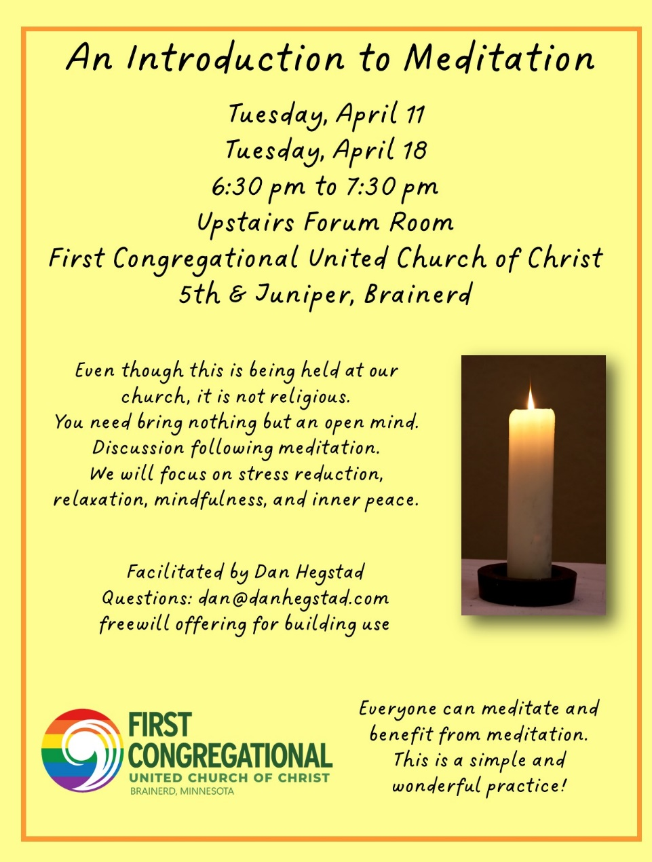

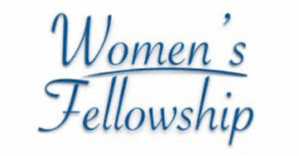
UCC Women’s Group

There is interest in a women's social group. We are planning to start off with 2 times a month: one weekday and one Saturday so we can include everyone.
A lunch has been scheduled by Joy Persall on April 27th 12:00 pm at Sage on Laurel in downtown Brainerd. Please RSVP in the comments under the post in the Connections Facebook Group (www.facebook.com/groups/uccbrainerd) or to Joy Persall.
Contact Marcia Ferris with your ideas about this new group.

UCC Men’s Group - Every Wednesday at Noon

You are invited to a casual fellowship at various locations in the Brainerd Lakes area.
Schedule 2023
First Wednesday: B-Meri
Second Wednesday: El Tequila
Third Wednesday: Dunmire’s East
Fourth Wednesday: Black Bear
Fifth Wednesday: Wings Airport Café

Contact Jack Kraywinkle for more information 612-396-3480 or email: kraywinklej@gmail.com

Cooking For Everyone
This group is OPEN FOR EVERYONE!
Email Lowell johnsonlowells@gmail.com and he will add you to the member list so that you will know when and where we will next meet.

Friday Book Group - 10:00 am
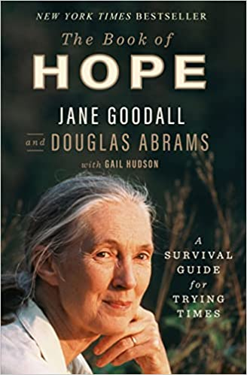
Via Zoom: tinyurl.com/uccbrainerdzoom
We are reading “The Book of Hope, A Survival Guide for Trying Times” by Jane Goodall and Douglas Abrams with Gail Hudson.
In this urgent book, Jane Goodall, the world's most famous living naturalist, and Douglas Abrams, the internationally bestselling co-author of The Book of Joy, explore through intimate and thought-provoking dialogue one of the most sought after and least understood elements of human nature: hope. In The Book of Hope, Jane focuses on her "Four Reasons for Hope": The Amazing Human Intellect, The Resilience of Nature, The Power of Young People, and The Indomitable Human Spirit.

Special Offering Sunday Worship April 23rd
Faith Build-Habitat for Humanity
Habitat for Humanity is a global nonprofit housing organization working in local communities across all 50 states in the US and in more than 70 countries around the world. Habitat works toward our vision by building strength, stability and self-reliance in partnership with people and families in need of a decent and affordable home.
Please send your donation to First Congregational UCC, 415 Juniper St. Brainerd, MN 56401. Make sure to note on your offering: “Special Offering Faith Build/Habitat”. Or for your convenience use our Paypal account at: paypal.me/uccbrainerd
Be sure to note on your offering “Special Offering Faith Build/Habitat” in comments. Thank you!
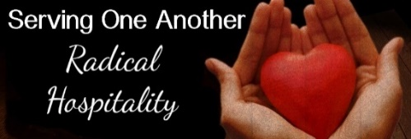
Hosts, Ushers, Greeters, Scripture-readers

Sunday morning greeters/ushers and coffee hosts play an important part in making our church a warm and welcoming place for all. Here’s a secret; it’s FUN!! If each household committed to 3 Sundays a year as greeter/ushers and/or coffee hosts, we would have a full complement of participants. Are you ready to take the leap into RADICAL HOSPITALITY? Give it a go and signup below for your first Sunday as the face of the church! https://www.signupgenius.com/go/10C0E48A9A823A5FFC07-hugs/16034811

First Congregation Food Shelf Collection
Our church continues to collect non-perishable food items for the Salvation Army Food Shelf. There are two collection boxes: one in the parking lot entry hallway, the other in the Narthex. Brian Twamley picks up and delivers the food.
Please consider bringing items and donating. You may also send a money donation to the church; First Congregational UCC, 415 Juniper St. Brainerd, MN 56401. Or for your convenience use our Paypal account at: paypal.me/uccbrainerd Make sure to write in memo “ Food Shelf”. Thank you
Sunshine Cards – Luann Rice
A friendly reminder to send card requests to Luann Rice for those who would appreciate a little sunshine in a card…”Get well, thinking of you”, etc. Contact Luann via email or phone, or to Terri in the office at uccbrainerd@gmail.com with your request.

The Columbarium at First Congregational UCC, Brainerd

The Columbarium is located in the historic space that once was our church’s front entry way.
How appropriate it is that our Columbarium now marks another entry way into a new life — where the Spirits of Love and Truth are always present!
Should you wish to learn more about the purchase of a niche for your own cremains or for the ashes of a loved one, please call the church office at (218) 829-2528 and a packet of materials will be send you via email or regular mail.
The Memorial Committee has prepared the information packet, and it contains all the details you will need as you consider inurnment here at First Congregational UCC.
Have any other questions? Contact Dawn Stattine at dawnstattine@gmail.com

UCC News & Updates!

Mark Your Calendars for the Conference's 2023 Events
First annual National UCC Earth Day Summit to be Held in Minneapolis!

The National Setting of the United Church of Christ is coordinating the First Annual Earth Day Summit with Mayflower UCC in Minneapolis and the Minnesota Conference on Saturday April 22. Plan to attend all or part of a special day filled with inspiring stories of hope!
10:00 AM – 12:30 PM CST - National UCC Summit (on Zoom) featuring renowned climate activist, theologian, and author Jim Antal as the keynote speaker and a panel of expert Minnesota organizers. Register at https://tinyurl.com/uccearth
Saturday 1:30 – 3:00 PM - Program held at Mayflower Church, both in person and live-streamed, 106 E. Diamond Lake Road, Minneapolis. Music, prayer, a call to Action and a Readers’ Theatre presentation “Hope From the Front Lines,” personal stories of courage and hope from rural, small town and urban Minnesota. No registration necessary.
Artists’ Statements
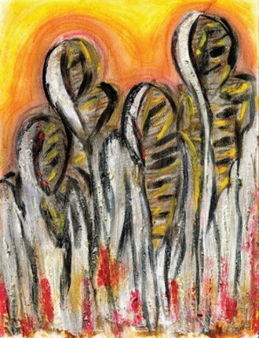
rubble by Carmelle Beaugelin
Inspired by Ezekiel 37:1-14
Conté crayon, charcoal, acrylic, paprika paste, cinnamon
It has been over a decade since my family in Haiti experienced the most traumatic earthquake in the nation’s history. If you were to Google, “Haiti” and “earthquake,” images of collapsed concrete and rubble would emerge. The most disturbing images are those of survivors, covered in white and gray ash and rubble, reaching out for rescuers to salvage them from collapsed buildings. Endless images are found on the internet of arms stretched out, identity-less faces of horror covered in soot, and faces frozen into expressions of despair by the spectating photographer’s lens. When I think of Ezekiel and the story of the dry bones, I think of those images. I’ve often heard sermons where pastors position God’s people as the prophet to call the world into life, but what about God’s people who are, as the bones, facing the despair of death? Their suffering is theologized away by those who consider themselves the righteous “Ezekiels” of the world, whose privilege weighs heavy on the bones of the suffering, like the concrete rubble in Haiti. Rubble speaks to the realities of being made alive and yet not being allowed to live—a nameless multitude of God’s people resurrected yet still bearing the scent of burial spices on their bodies. Who are we in this story? Are we the bones seeking life? Do we perceive ourselves as spectators of suffering? Or will we choose to be participants in healing as active agents of God’s resurrecting power out of the rubble? —Carmelle Beaugelin

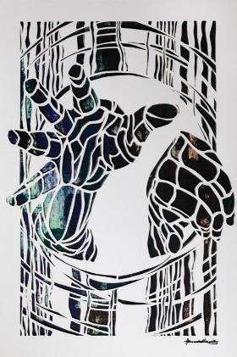
unbind him by Hannah Garrity
Inspired by John 11:1-45
Paper lace over oil paint on linen
As I met with this text, I was drawn to Jesus’ call for Lazarus to be unbound. To represent the fabrics used in preparation for burial, I wrapped a canvas in linen. You’re not really supposed to do that. The canvas was already stretched and gessoed. It was ready to resist the oil paint medium I was applying. However, the texture of the binding cloth matters for this tactile text. I began to scrape the paint onto the woven strands. The linen fabric absorbed the paint as I scraped it on with a palette knife. In the final image, the linen shows through the paint and the paper lace design, representing the bindings. Jesus’ call for unbinding also includes the community. The foreshortened hands of the community, tasked with unbinding his body, reach in toward Lazarus. They reach through the concentric binding lines so that he can go free. Can these bones live? In the strength of community, they can. The community made up of Jews, Gentiles, Samaritans, and others all joined one another at the tomb to grieve for Lazarus that day. They came to support Mary and Martha. Jesus arrives as the community mourns together. Jesus cries in his grief. Their collective tears create the backdrop for this paper lace design. This diverse and neighborly community is who Jesus calls on to do the unbinding. Jesus makes sure that the community knows about this miracle so that they can share the news. Can these bones live? Lazarus lives, and Jesus’ miracle lives on in the telling. —Hannah Garrity

© a sanctified art | sanctifiedart.org

Youth Opportunities

Spring 2023 Youth Gathering: April 28-30, 2023 | Camp Onomia, Onamia. For youth 6th-12th grades. Lori Alford, a licensed marriage and family therapist and long-time faith formation leader in the Minnesota Conference UCC, will guide youth through activities and experiences that help them listen to their bodies, practice stillness and quiet, open up “heart spaces” for connection, and tap into their innate capacity to know, love, and connect. REGISTER
Summer Middle School Camp: July 5-7, 2023 - Osprey Wilds Environmental Learning Center, Sandstone. For youth entering 6th grade through 8th grade. Swim, canoe, hike, and meet some birds of prey. Let’s explore the connection of eco-justice and faith while connecting with new friends and eating some great food! MORE
Summer 2023 Youth Trip to Washington, DC: July 21-28, 2023 - Students from Conference congregations currently enrolled in grades 8-12 are eligible to participate in this service-learning experience focused on the work of legislative advocacy. MORE
﻿Fall Youth Conference Event: October 6-8, 2023 - Osprey Wilds Environmental Learning Center.Through playful discussions, activities, and music, we will reimagine our “wild and precious life” that speaks to who we are, what we value, and how our faith can guide us in the world. MORE

Brainerd Lakes Area Information
~ Opportunities to Know and Share God’s Love ~

Mark Your Calendars!
6th Annual Got Plans? Conference
Friday, April 14, 2023 – 9:00 am – 2:00 pm
Doors open at 8:30 am. Lutheran Church of the Cross
5064 C.R. 13, Nisswa, MN

A light lunch is included. Space is limited for this FREE event. At this event, participants will learn about advance care planning and will have an opportunity to meet with someone on site to write a plan. They will learn about power of attorney versus a health care agent, advance care directives, and guardianship. Space is limited; pre-registration is required.
Visit https//crowwingenergized.org/event/got-plans-6th-annual-conference/
or contact: Kara.Schaefer@EssentiaHealth.org or Karen.Johnson@EssentiaHealth.org

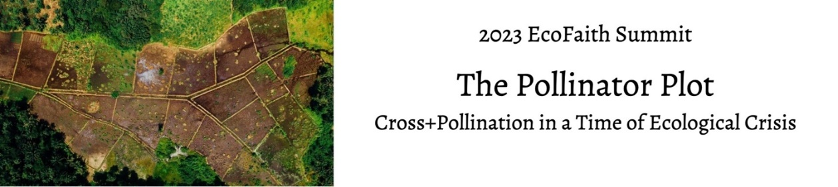
Saturday, April 15, 9:30 – 3:30p.m.
Gloria Dei Lutheran Church, Duluth and on-line
Keynote speaker: Margot Monson, entomologist and beekeeper
https://www.eventbrite.com/e/ecofaith-summit-2023-registration-544635909667

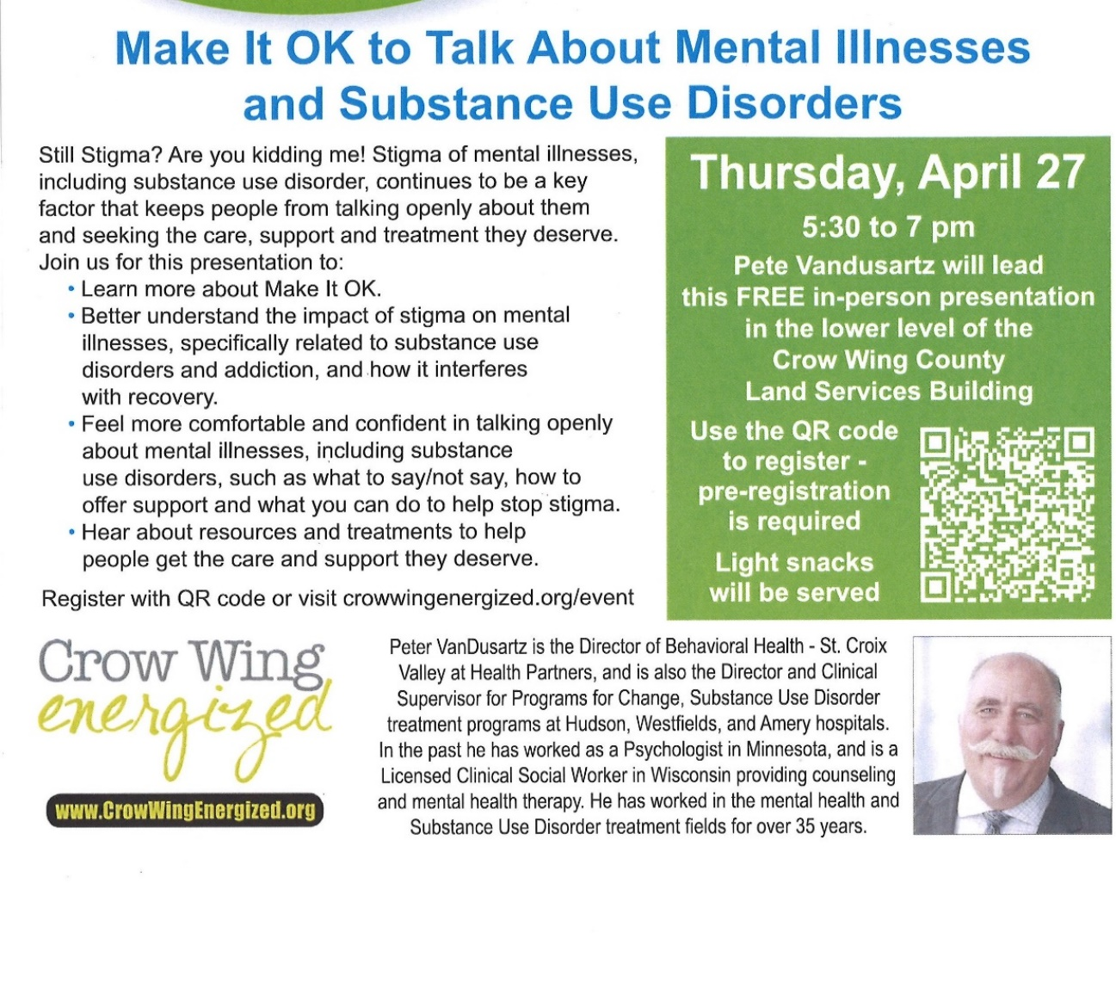

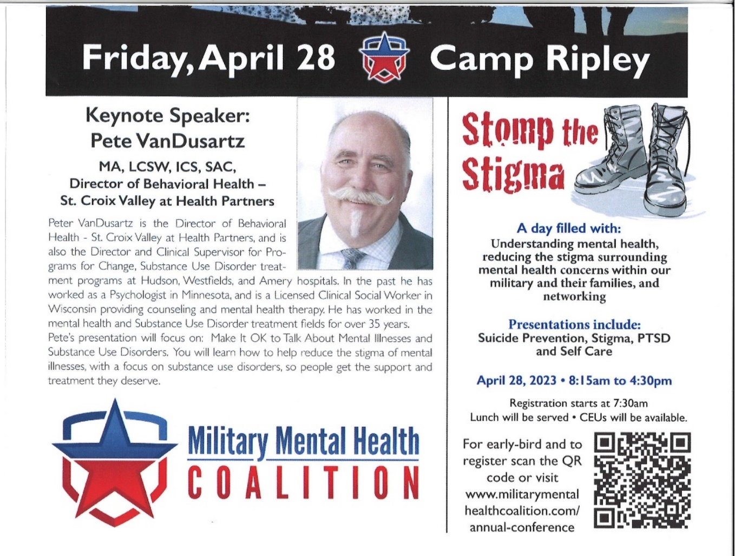

Youth for Understanding
Host Families Needed
There are 13 German high school students, both male and female, needing host families through the Youth for Understanding organization, which I represent. If you or anyone you know of would be able to host one of these students next year, please let me know. Once you have been accepted as host parents, I can give you more specific information.
For general information check out their website: https://www.yfuusa.org/host
Contact Pat Scott at 218-515-0969 or email: patwak@charter.net

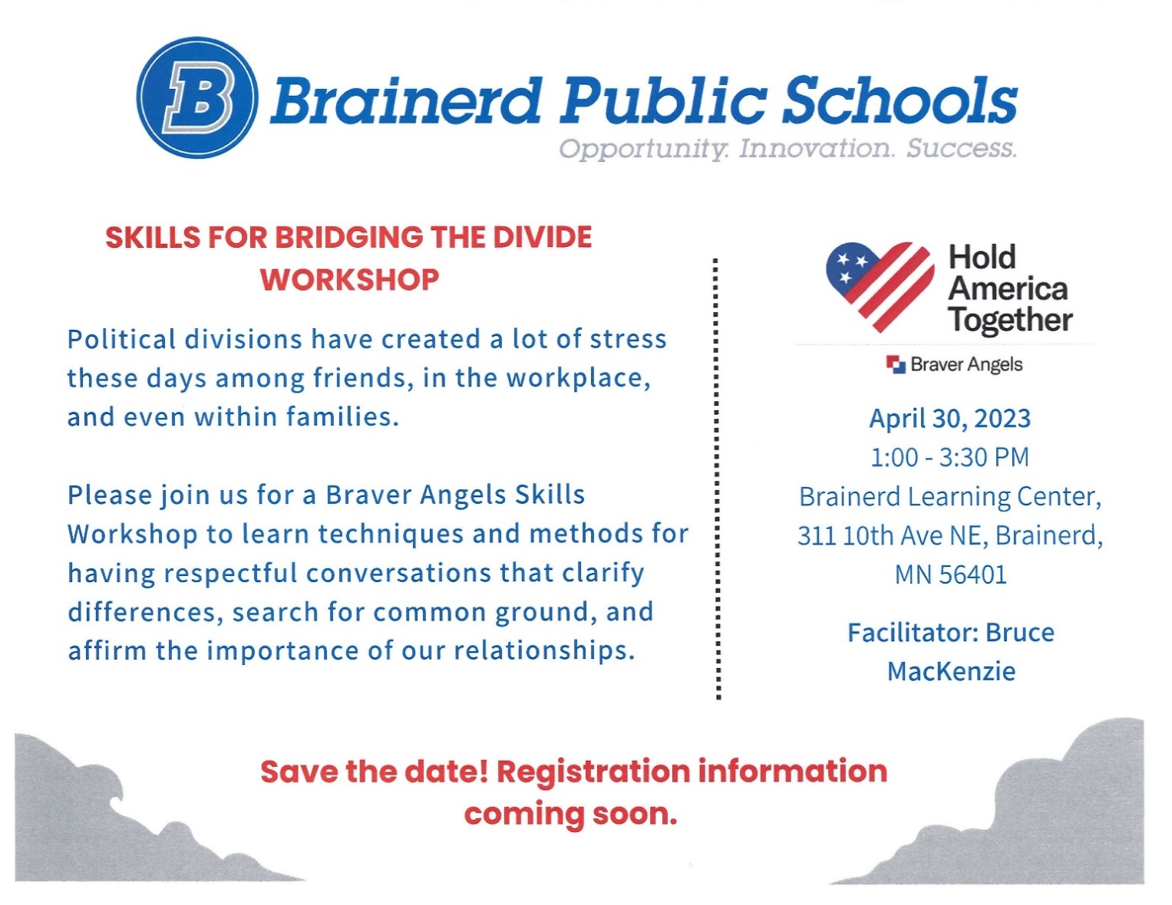

Follow on Facebook
https://www.facebook.com/LakesAreaHabitat
Restore
https://www.lakesareahabitat.org/restore/
April 2023 Calendar
Sunday | Monday | Tuesday | Wednesday | Thursday | Friday | Saturday
 | Office Closed  Open by Appt. | Office Closed  Open by Appt. | Office Hours10am – 1pm  Pastor Drop-in  1pm-3pm | Office Hours  10am – 1pm | Office Hours10am – 1pm Pastor Drop-in  10am-12pm
V or Z –Virtual Online or our Zoom  C- Cancelled | N-None  ? – No update  Y- Yes Mtg. in person |  |  |  |  | 10am-5pm 1  Pickup Plams Parking Lot Door
Palm Sunday 2  8:30am Bnrd Frnds-Y  9:55am Palm Procession  10am Wrship Service & Communion-Y&V  11am Fellowship-Y  11:30 am PPRC Mtg.-Y  Set-up Stations of Cross | 3 | 4  2pm Emotions Anon- Y  5:30pm Overeaters Anon- Y | 12pm Mens Grp @ 5  B-Merri-Y  3:45pm TheShop-Y  Prospective Member Class-Cancelled  4:30pm PPRC Mtg.  7pm AA Common-Y | 6  Maundy Thursday  9am Foundation Mtg.-Z  10am Easter Flowers Delivered | Good Friday 7  10:30am Book Grp.- Z  12pm-6pm Stations of the Cross Open Hrs. | Holy Saturday 8  Set out Easter Flowers
Easter 9  8:30am Bnrd Frnds-Y  10am Wrship Serv-Y&V  11am Fellowship-Y  11:30am Confirmation-Y | 10 | 2pm Emotions 11 Anon-Y  5pm Le Mesa Grp-Y  5:30pm Overeaters Anon-Y  6:30pm Meditation-Y | 10am Care Team-Y 12  12pm Men’s Grp  @ Four Seas-Y  5pm Prospective Member Class-Y&Z  7pm AA Common-Y | Admin Asst. Vacation Day 13  8:30am CM Mtg.-Y  9am Foundation-Z  1pmTrustees Mtg-Y  4pm Exec Team Mtg-Y  7pm AA Dist-Y | Admin Asst. Vacation Day 14  10:30am Book Grp- Z | 15
Holy Humor 16  8:30am Bnrd Frnds-Y 10am Wrship Serv-Y&V  11am Fellowship-Y  11:30 Adult Forum  11:30am Confirmation-Y | 17 | 2pm Emotions 18 Anon-Y  5:30pm Overeaters Anon-Y  6:30pm Meditation-Y | 12pm Men’s Grp 19  @ Dunmire’s East-Y  7pm AA Common-Y | 20  4pm Council Mtg-Y&Z | 21  10:30am Book Grp- Z | 22
8:30am Bnrd Frnds-Y 23 10am Wrship Serv-Y&V  11am Stewardship Volunteer Recognition Brunch-Y  11:30 am Adult Forum-Y  Special Offering:  Faith Build-Habitat  **Newsletter Deadline | 24  5-9pm AAUW-Program Mtg. Fellowship-Y | 2pm Emotions 25 Anon-Y  5pm Le Mesa Grp-V  5:30pm Overeaters Anon-Y | Pastor Comp Day  26  12pm Men’s Grp @ Black Bear-Y | 27  Pastor Vacation Day | 28  Pastor Vacation  Day | 29
30
8:30am Bnrd Frnds-Y 10am Wrship Serv-Y&V
11am Fellowship-Y
11:30am Confirmation-Y
11:30 Adult Forum
adA

