
Friendship News, September 2026
0
First Congregational United Church of Christ, Brainerd
An Open and Affirming Congregation
The Church Office Hours: Tuesday, Wednesday, Thursday from 10:00am – 2:00pm
Office phone 218-829-2528 Office E-mail uccbrainerd@gmail.com
Pastor Leslie’s E-mail: pastorleslieucc@gmail.com Website: www.uccbrainerdmn.org

No matter who you are, or where you are on life’s journey, you are welcome here.

0
Pastor’s Pen
0
A Faithful Farewell
My heart is full - full of hope, full of grief, full of gratitude… It feels a bit unreal that our shared ministry of the last 11+ years is coming to a close in just three weeks. Pastoral calls don’t last forever, and so endings are inevitable, but like other types of anticipated endings, knowing that the ending is coming doesn’t necessarily make it easy. As a congregation within the United Church of Christ, we are blessed to be able to draw on the resources, experience, and wisdom from our faith tradition as we navigate this time of transition.
The relationship between church members and their pastor is unlike any other professional relationship. You have entrusted me with vulnerable moments or your lives, celebrated joys, explored big questions, and traveled a journey of faith together. As a result of these connections, one of the most emotionally difficult elements of ending a pastoral call, is following the recommended boundaries between the departing pastor and parishioners. Most of you should have received a letter in the mail and via email from the Pastoral Relations Committee outlining these boundaries. These guidelines are also on the following page of this newsletter for your reference.
I want to share a ritual I will be engaging in as part of this transition process. After worship on September 20, I will be going through my social media accounts and unfollowing/disconnecting (known as “unfriending” on many platforms which sounds terrible!) from people who have been part of the church. As I go through this process, I will be doing so with care and intention, pausing on each person and saying a prayer of gratitude and blessing. I care deeply about each and every one of you and it is my hope that this ritual will be a blessing for all of us.
I am so deeply grateful to this congregation and to all of you for the last 11 years and 7 months. Our time together has been full of so many tender moments, joy-filled laughter, challenges that have made me a better pastor, sacred experiences of connection, and so much more. I hope to see as many of you as possible at our farewell worship service on September 20 and/or the special fellowship time following the service. I’ll bring the tissues.
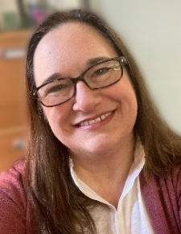
With a multitude of blessings,
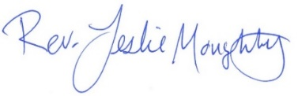

Guidelines for Pastor Leslie’s Departure
0
0
Dear Church,
Every ministry has a beginning and an end. In order to facilitate a healthy transition that will allow everyone to live into a new future, it is important to establish guidelines and boundaries for the departing pastor and the congregation. This allows departing pastors to take their leave, trusting that God will continue to take care of those whom the pastor has served. This trust in God is especially essential at the time of departure, when the reality of the new boundaries becomes real and the temptations to cross those boundaries increase.
These departure guidelines are meant to facilitate a faithful leave-taking on the part of the pastor, freeing everyone to live into a new future as ministries move in new directions separate from each other.
The following departure plan will enable Pastor Leslie to fulfill the UCC Ministerial Code in support of our church’s relationship-building with the next pastor as well as allowing Pastor Leslie to build relationship with her new community.
Boundaries between Congregation and Pastor:
- Pastor Leslie will no longer be available to the congregation or affiliated persons for weddings, baptisms, funerals, church activities, pastoral care, etc.
- The expectation for departing pastors is to observe a no-contact boundary with congregants for a minimum of 1 year following the call of the next settled pastor.
- Following a recommended best practice, Pastor Leslie will unfollow/disconnect from all congregants as well as other individuals with whom she has had a pastoral relationship.
Although Pastor Leslie’s last worship service is Sunday September 20, she will not be relocating immediately. If you see her out in the community it is absolutely ok to say hi and be friendly!
This transition process is holy practice for the myriad greetings and goodbyes that we experience throughout our lives. Every departure is a mixture of emotions. Among them, grief can be the most complicated since new experiences of grief can unearth old grief. We are planning an adult forum on the topic of grief to take place soon after Pastor Leslie’s departure.
We hope you will be able to attend worship on Sunday September 20 for a farewell service to recognize and conclude Pastor Leslie’s share ministry with First Congregational. Following the service we will gather in Fellowship Hall for an extended time of fellowship and farewell.

With Blessings from your Pastor Relations Committee,

Shon Boman, Kay Cox, Jack Kraywinkle, Joe Stattine

0

Moderator’s Column
0
0

Dan Hegstad
This is my second term as Council Moderator. I served in this role about ten years ago, and at that time I served nearly two terms after the Moderator resigned early in his term. Over the years, I have been an active volunteer with many groups and organizations and have served in many different roles. Even so, serving as Council Moderator is unlike anything else I have done.
Every leadership role calls for thinking ahead, planning, staying organized, communicating clearly, anticipating issues, and more. But leadership in a church setting is different. I spent my working life with businesses, and while some principles carry over, a church organization has its own rhythms, responsibilities, and challenges.
I am grateful for the support of the Minnesota Conference of the United Church of Christ. Several seasoned professionals are guiding us through the transition to an Interim Minister. Prospective interim ministers will be vetted before we review resumes, so we are not sailing alone through uncharted waters.
That support will continue as we begin the search for what the Council calls a “settled” pastor. We have been told it may be two years or more before that pastor is truly settled. By then, Ellie, our incoming Moderator for 2027–28, will have passed the gavel to the next Moderator—or perhaps even to another after that.
The people serving on Council will change over time, and the tasks before them will change as well. Through it all, I am thankful we can rely on the guidance and support of the Minnesota Conference of the United Church of Christ.
As we move forward, we wish Pastor Leslie much success as she moves on to the next chapter of her life.

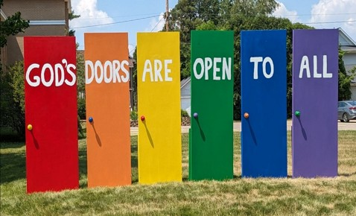
0

Mission Statement of
First Congregational United Church of Christ

“To know and share God’s love within us.”

Purpose Statement of First Congregational United Church of Christ

“First Congregational UCC is a welcoming, inclusive, and progressive community committed to promoting social justice, spiritual growth, and love for all people. We reject discrimination and advocate for equality and dignity for marginalized communities. Through worship, education, and service, we work to make a positive impact on the world and invite all individuals to join us in this journey of faith and service.”

0

Church Office Hours
0

Tuesday, Wednesday, Thursday 10:00 am - 2:00 pm
Closed Mondays and Fridays
The Office is closed Tuesday, September 8th in observance of Labor Day

0
Pastor Leslie’s Workday Schedule

Sunday through Thursday (Days off are Friday and Saturday)
Drop-in Hours: Wednesdays 11:00 am – 1:00 pm
Pastor Leslie’s last Worship Service is September 20th
*Drop-in hours are times set aside for “drop-in” conversations, much like a professor’s office hours.
Everyone is encouraged to make an appointment, especially if the above times are not convenient. You can go to www.calendly.com/pastorleslieucc and select a day and time that works for you, or you can email Pastor Leslie at pastorleslieucc@gmail.com or call/text at 218-656-0096.

0

Stay Connected

How to watch Sunday worship
The worship service is broadcasted on the church Facebook page and YouTube
every Sunday at 10:00 am.

To watch worship on Facebook, go to https://www.facebook.com/uccbrainerd/live
To watch our NEW YouTube channel, go to https://www.youtube.com/@uccbrainerdworship6443

Past church and special services are saved on this YouTube:
https://www.youtube.com/firstcongregationaluccbrainerd

How to stay connected with First Congregational friends and members: Join the private group for our Facebook Connections Page at https://www.facebook.com/groups/uccbrainerd.
Financial Help Available The Pastor's Discretionary Fund is available to assist church members and others in the Brainerd area who are experiencing financial distress with modest financial help. If you need assistance, please email, call, or text Pastor Leslie. Let her know what your situation is and how the church might be of help.
Donate to the church online! We gladly accept offerings and donations using PayPal.
You do not need to have a PayPal account to make an online donation with a credit card. To use PayPal, go to: https://www.paypal.me/uccbrainerd

0
First Congregational UCC News & Updates
0
0


Sunday, September 6th

During the Time with Young Disciples in worship.

School is starting soon! Students are invited to bring their backpacks or other school bags/supplies to church to be blessed by Pastor Leslie during worship.

Each student will be given a token of blessing to put on their backpack as a tangible reminder of God’s love and the congregation’s care for them.

0

Pastor Leslie’s
Farewell Gathering & Potluck
Sunday, September 20th at 11:15 am

Is Pastor Leslie's last day preaching and being our active Pastor. In honor of her service and to wish her happy trials, we will be holding an all-church potluck in her honor during fellowship time.

If weather permits the Potluck will be outside
on church lawn. Bring a lawn chair.
Otherwise, we will be in Fellowship Hall

Pulled Pork provided. Please bring a side dish (optional).
Sign-up Sheet in Narthex.
0


Sunday, September 27th
Worship Service

Worship will be led by Rev. Steve Newcom and C. Onyx Li of Twin Cities Singing Resistance and Music That Builds Community.

A service woven through with singing, grounded in the theme
"The Spirit Goes Before Us."
0


Adult Forum – 11:30 after Worship Service
0

September 6th - Justice Action Teams: Teams will provide an update on their work with time for Q&A and a discussion time. This is your opportunity to hear what the teams are planning and add your perspective.
If you want to join a Justice Team, email Steve Newcom, Pastor of Justice Ministries at snewcom17@gmail.com and/or plan to join us month. It is an open, welcoming process.

September 13th – Joey Halverson Memorial Poetry Slam and Joke Telling: In memory of the passing of our dear friend Joey, we will gather to read poetry and/or tell jokes in her honor. Please come with poetry or jokes, or simply to listen to what Joey would have found worthy or funny.

September 27th - “Songs That Build Community”: A chance to debrief together with Steve Newcom—reflecting on the worship service and sharing our reactions and reflections.


0
Future Justice Action Team Meetings

2026 2027
September 6th January 3rd
November 1st March 7th
May 2nd

0
Volunteer at Church

There are many other opportunities for you to share your talents

These committees need your gifts:

*Treasurer *Clerk * Trustees * Stewardship * Christian Ed * Christian Ministry

Please contact Dan Hegstad or Ellie Burkett if interested in any of these opportunities.

0
Next Council Meeting

Thursday, September 17th, 2026, 2:30 am

in-person and via Zoom tinyurl.com/uccbrainerdzoom

First Congregational Approved Council Meeting Minutes are available upon request.
Please contact Terri Admin Asst. at the Church Office.
0


0

September Birthdays
Mark Utzinger Sept. 8 Mark Stults Sept. 26
Thomas Nelson Sept. 9 Kyd Lukanen Sept. 27
Bob Ogdahl Sept. 12 Leslie Moughty Sept. 29
Kay Kraywinkle Sept. 15 Mark Stadem Sept. 30
Reed Campbell Sept. 23
0
0

UCC Fellowship
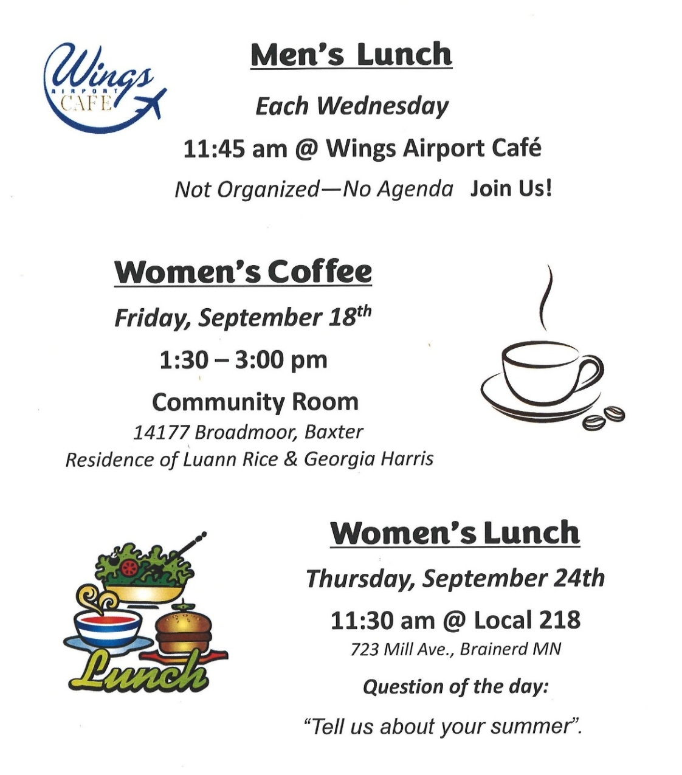
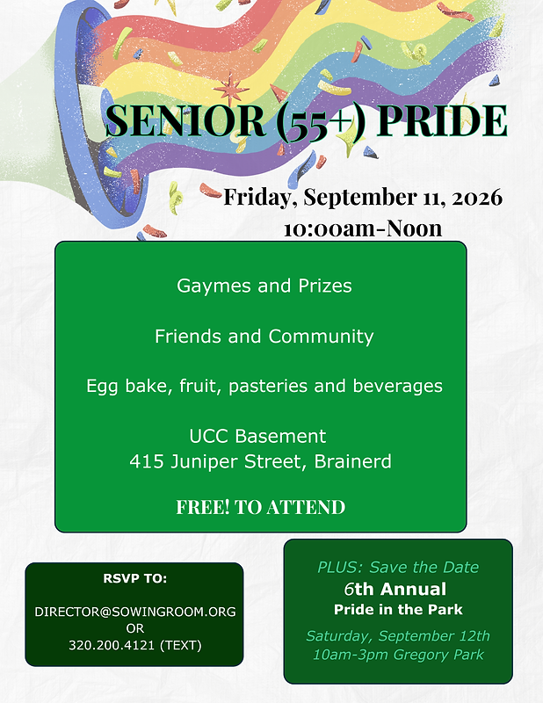

0
0


Special Offering: UCC Missions - Neighbors In Need (NIN)
0

Sunday, September 27th

This month’s Fourth Sunday Special Offering will be given to Gifts to the Neighbors in Need offering support ministries of justice and compassion in the United Church of Christ, including the UCC Office of Public Policy & Advocacy in Washington D.C.

Please send your donation to: First Congregational UCC
415 Juniper St. Brainerd, MN 56401

Or for your convenience use our PayPal account at: paypal.me/uccbrainerd.
Make note on your offering “NIN Room Special Offering.”


First Congregational Food Shelf Collection
0

Our church continues to collect non-perishable food items for the Salvation Army Food Shelf. Please consider bringing items and donating.
There are two collection boxes: one in the parking lot entry hallway, the other in the Narthex. Brian Twamley or Stephanie Lee pick up and deliver the food. Thank you!

0

Garden Gleaning
A Biblical (and environmentally) inspired activity
This is how it works: Gardeners and plant people bring in their “gleanings” to share. This ranges from rhubarb and vegetable plants in the spring to daffodil bulbs in the fall. A table, poster and donation basket are in Narthex entrance. Enjoy the fruits of our labors!
All are welcome to help themselves at no charge! Monetary donations are appreciated and are given to the Salvation Food shelf.
Historical note: Begun here circa 1988 when our church began Hunger Action outreach, Central America updates and global food connections.

Note: Using our resources, recycling, re-purposing, and not wasting our food are all acts of Creation Care and Justice. Garden Gleaning is an Easy-Peasy way to put words into action.

0

UCC Care Team
For anyone who wishes to join in making calls or visits, the Care Team meets every month on the first Thursday @ 10:00 am.

If you know of anyone who would enjoy a call from the care team, please contact one of our Care Team; Jack and Kay Kraywinkle, Pat Scott, Chris Yager, Deb Griffith, Nancy Gould, Tracy Lyons, and Cynthia Janes.

0

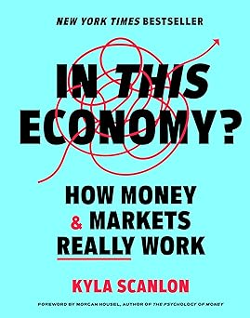
Friday Book Group
0
We meet each Friday morning at 10:30 am via zoom.
Church Zoom link: https://tinyurl.com/uccbrainerdzoom

We are reading; “In this Economy? How Money and Markets Really Work” by Kyla Scanlon.
The book Jon Stewart (The Daily Show) hailed as “essential reading” for anyone who wants to “make informed decisions” and “have a basic understanding of the economy”: an illustrated guide to economics from one of the internet’s favorite financial educators.

0

H.U.G.S.
Hosts, Ushers, Greeters, Scripture-readers
Sunday morning greeters/ushers and coffee hosts play an important part in making our church a warm and welcoming place for all. Signup sheet in the Narthex or call or send an email to the office to be added.

**Notice – Hosts may be reimbursed for snacks/food that are purchased for Fellowship Coffee Hour. Reimbursement Forms are in pocket folders outside the office. Please fill out and submit with receipts in the folder provided next to the form.

0

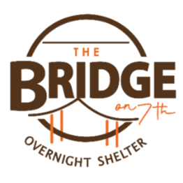
Volunteer Opportunity – Overnight Shelter Bridge on 7th
Sign up for a morning shift as a team of two or/individually. You can choose a time to volunteer online. The staff and shelter guests appreciate our involvement. The link is below. Create an account. Pick a date. They need your birth date and your ok for a background check.

Start at this link to sign up to volunteer: www.bridgesofhopemn.org/volunteer
Then choose a date here: volunteer.bloomerang.co:443/JE/bas6nebexg029t
(They will need your birth date and consent for a background check.)

0
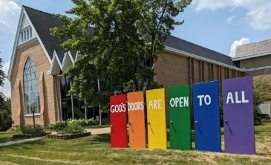
Our Building is a Great Event Venue!
We are blessed to be able to share our beautiful church facilities for purposes that match the values of the church and its mission which is “To know and share God’s love within us.” We are an open church valuing the diversity of age, culture, gender identity, opinions, physical and mental abilities, and sexual orientation. Take a virtual tour of our building by visiting our website at uccbrainermn.org
To request a space for general use, ask for a “Request for Church Building Use” form and policy packet from Terri in the church office, at 218-829-2528 or email uccbrainerd@gmail.com. Submit the request form back to Terri in the office, and it will be submitted for approval at the next Council Meeting.
0
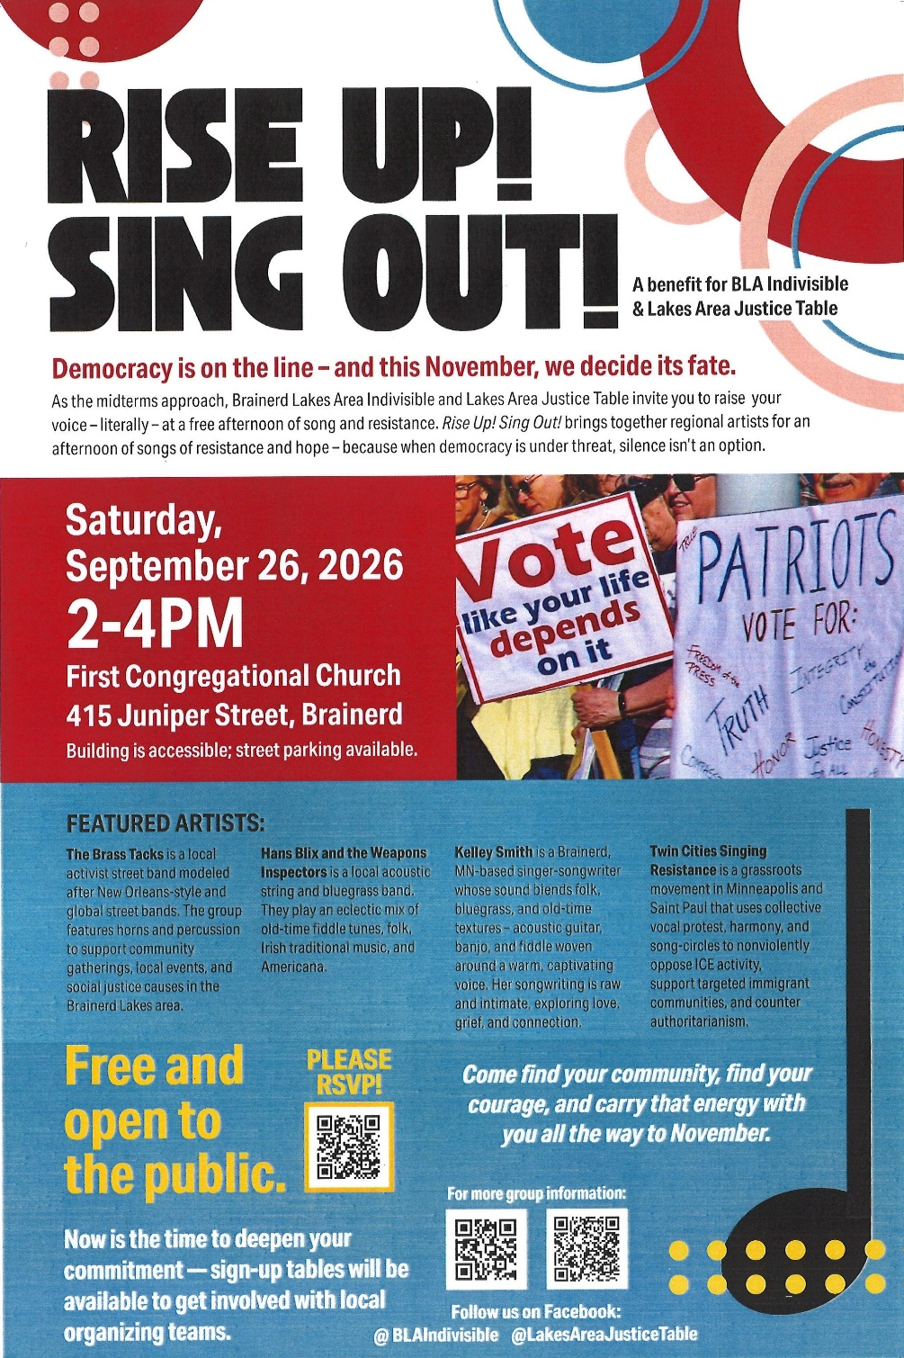

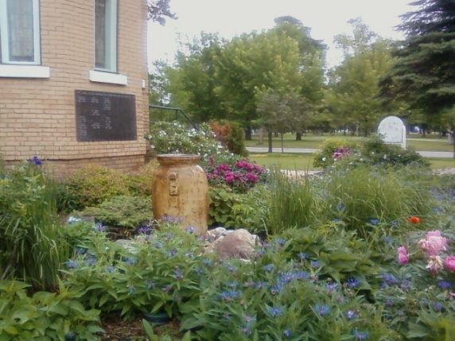
The Columbarium & Memorial Garden
0

The Columbarium is in the historic space that once was our church’s front entry way. How appropriate it is that our Columbarium now marks another entry way into a new life — where the Spirits of Love and Truth are always present!

The Memorial Garden is located on the south lawn of the church. The Garden provides a place for cremains of your loved one to be buried in the ground among natural plantings.

The Garden fee includes the inscription of your loved one’s name on a granite plaque that is mounted on the outside wall of the church. Should you wish to learn more about the purchase of a niche for your own cremains or for the ashes of a loved one, please call the church office at (218) 829-2528 and a packet of materials will be sent to you via email or regular mail.
0

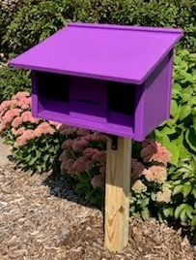
Community Prayer Box

You can find the Community Prayer Box in the Memorial Garden on the South side of the church (the side that faces Juniper Street.)
Community members frequently walk through the garden, and this box will offer our wider community an opportunity to share their prayers. Prayer cards and pens are provided, and the box is secured with a padlock, so the submitted prayers don’t fly away with the wind!
Pastor Leslie checks the box weekly and prays for any prayers submitted as well as sharing them with the Care Team.

0


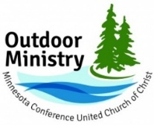
The Outdoor Ministry of the Minnesota Conference UCC offers events for individuals and families of all ages, abilities, and stages of life to experience rest, renewal, and reconnection through a retreat or camp experience.
Upcoming Events Joy as Resistance and Refugia (Adult Event)
The MN Conference UCC is offering a series of three in-person retreats between August 2026 and February 2027. Each retreat stands on its own and is related to the other two in the series. All three retreats will be hosted at Camp Onomia in Onamia, Minnesota. The registration fee for each retreat is $175, and participants who register for all three will receive a 25% discount for all three retreats.
Retreat 2 – Rest and Resilience, November 17-19, 2026
Retreat 3 – Remembering New Beginnings, February 12-15, 2027
Registration: https://www.uccmn.org/programs-support/outdoor.
Download flyer: www.uccmn.org/wp-content/uploads/2026/06/2026-Joy-Retreat-Series.pdf
0
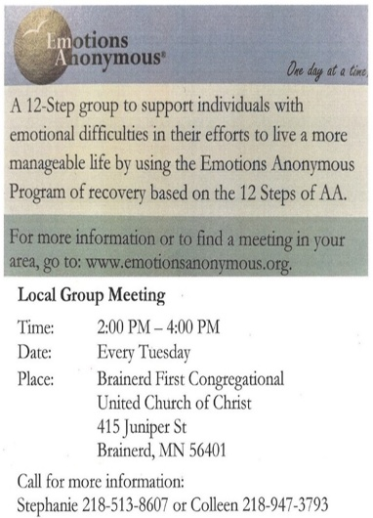

0
Crow Wing County
Military Family Support Group

1st & 3rd Wednesday of each month
7:00-8:00 pm

Meets at First Congregational UCC
415 Juniper St., Brainerd MN 56401

Join us to support military families if you:
Have someone joining the military, have an active military member or have someone that has previously been in the military.

More info: drttbsby@msn.com


0
Brainerd Lakes
& Surrounding Area Information
0

~ Opportunities to Know and
Share God’s Love ~
0

September 2026 Calendar
Sunday | Monday | Tuesday | Wednesday | Thursday | Friday | Saturday
Y- Yes Meeting in person  FB -Facebook Live Stream Online  C- Cancelled N-No Meeting  P-Postponed Z-our church Zoom | Office Closed | Office Hours  10am – 2pm | Office Hours  10am – 2pm  Pastor Drop-in Hours  11:00 am – 1:00 pm | Office Hours  10am – 2pm | Office Closed
Pastor Leslie’s last day in the office is Wednesday 23rd  Pastor Leslie out of the office on vacation Thursday 24th through Wednesday 30th |  | 2pm EA-Y 1  5:30pm OA -Y  6pm BLA Indivisible Civic Mtg. in Fellowship Hall-Y  Pastor Leslie out of the office-Cont. Ed | 11:45pm Men’s Grp 2  @ Wings Cafe-Y  1:30pm PRC Mtg.-Y  7pm Military Family  Support Grp-Y  7pm AA Common-Y | 3  10am Care Team-Y | 4  10:30am Book Grp-Z  Movie Night-C | 5
8:30am Brainerd Friends-Y 6  10am Justice Sunday Worship &  Communion-Y& FB & YouTube  11am Fellowship-Y  11:30am Adult Forum-Justice  Action Teams-Y. | Labor Day 7  5pm BACP/BLUE church-backup | 8  Office Closed Today  2pm EA-Y  5:30pm OA -Y | 11:45am Men’s Grp 9  @ Wings Cafe-Y  2pm Executive Mtg.-Y  7pm AA Common-Y | 10 | 10:30am 11  Book Grp- Z  10am-12pm Senior Pride in Fellowship Hall | 12  10am-3:30pm Pride in the Park-Gregory Park
8:30am Bnrd Frnds-Y 13  10am Worship--Y& FB & YouTube  11:15am Fellowship-Y  11:30am-Adult Forum: Joey Halvorson Poetry Slam & Jokes.-Y | 2pm Trustees  Mtg.-Y 14  3pm Christian Ministry Mtg.-Y  5pm AAUW Mtg. Fellowship-Y | 15  2pm EA-Y  5:30pm OA -Y | 11:45pm Men’s Grp 16  @ Wings Cafe-Y  7pm Military Family  Support Grp-Y  7pm AA Common-Y | 17  2:30pm Council Mtg- Y&Z  6:30pm AA Dist.7-Y | 10:30am Book  Grp- Z 18  1:30pm UCC Women’s Coffee-Arbor  Glen Comnty  Rm.. | 19
8:30am Bnrd Frnds-Y 20 8:45am Choir Practice  10am Pastor Leslie’s Last Worship Service-Choir-Y& FB & YouTube  11:15am Fellowship: Leslie’s  Fairwell & Potluck- Y  6-9pm BLA Indivisible Training in  Fellowship Hall-Y | 21 | 22  2pm EA-Y  5:30pm OA -Y | 11:45pm Men’s Grp 23  @ Wings Café-Y  7pm AA Common-Y  Pastor Leslie’s last day in Office | 24  11:30am Women’s Lunch @ @ 218 Local | 25  10:30am Book  Grp- Z | BLA Ind. 26 12pm Potluck-2pm Program “SingResistance” in Sanctuary-4pm in Fellowship Hall
8:30am Bnrd Frnds-Y 27  10am Worship-Y& FB & YouTube  Rev.Steve Newcome preaching  11:15am Fellowship-Y  11:30am Adult Forum-Steve Newcome  .*Special Offering NIN | 28  Oct. Newsletter Deadline | 29  2pm EA-Y  5:30pm OA -Y | 11:45pm Men’s Grp 30  @ Wings Café-Y  7pm AA Common-Y

