
Friendship News, October 2026
0
First Congregational United Church of Christ, Brainerd
An Open and Affirming Congregation
The Church Office Hours: Tuesday, Wednesday, Thursday from 10:00am – 2:00pm
Office phone 218-829-2528 Office E-mail uccbrainerd@gmail.com
Pastor Leslie’s E-mail: pastorleslieucc@gmail.com Website: www.uccbrainerdmn.org

No matter who you are, or where you are on life’s journey, you are welcome here.
0

Moderator’s Column
0
Dan Hegstad
We are pleased to announce we have an Interim Minister! Her name is Rev. Laura Callender. She is currently serving a church in Kansas City, Missouri. Her tentative start date is November 23rd.
As of this moment the contract is not signed as we are working on a couple of details, none of which are likely to derail our plans.
She and her husband, Bob are planning on visiting us on Sunday, October 4th, but won't be staying long as they have to get back to Kansas City.
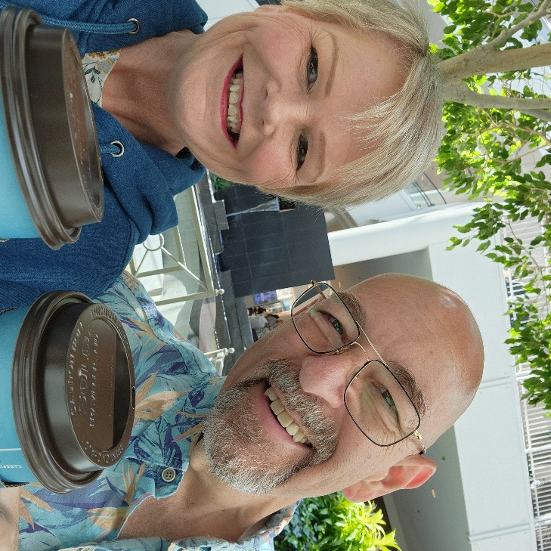
I asked Laura to write a short biography and she wrote:
"Pastor Laura grew up a country bumpkin in Ohio with an insatiable curiosity about God's big world. Unable to consider Episcopal ordination as a young woman, she became a journalist. Her 30 years in that field blessed her with experiencing people and cultures she otherwise never would have known. But God still wanted her in ministry. She was licensed in 2006 as a lay minister and preacher. In 2009, she surrendered fully to God's call. After serving on mission in China for a year, she gave up all she had and went to Seminary, obtaining her MDiv in 2013. Uncomfortable with Episcopal polity and narrow theology, she left that denomination and wandered into the United Church of Christ. Much like when she discovered her heart's real home when she moved to Washington State, she found her real church home had always been the UCC. She and her husband, Bob, have been married 11 years. All their "children" have fur. Bob is an accomplished woodworker and has a wonderful singing voice. We look forward to our time with you! "

0

More from our Moderator Dan Hegstad
There is Congregational and then there is congregational. The Congregational with the capital C is the Congregational Christian Churches which trace their origins back to the New England Puritans. Our roots are with the Congregationalists.
In 1957 the Congregational Christian Churches merged with the Evangelical and Reformed Churches officially establishing the United Church of Christ (UCC.) There are still some Congregational churches, but not all are UCC.
I like to point out that we are “small c” congregational in the sense that we, the congregation, remain autonomous and self-governing.
We take direction and advice from the Minnesota Conference of the United Church of Christ, and they have been very helpful in our transition, they advertised and screened potential applicants. The final decisions are up to us. I like that. When you pledge this month, you will see “Our Church's Wider Mission.” We support the state UCC Conference. October is Stewardship month. Pick up your envelopes on Sunday, Oct. 4th. Please support our local church! We will be setting a 2026-2027 budget in December. Please get your pledge in by Nov. 1st so we have time to evaluate the budget.
Christian Ministry will oversee the Sunday services until our Interim, Laura, arrives in November. Terri, our Administrator, will continue to hold the ship together. The Church Council will meet to make decisions together.
I am fortunate to work with an amazing Church Council. We will keep you involved as we proceed into this transition. Our church is moving forward!

0

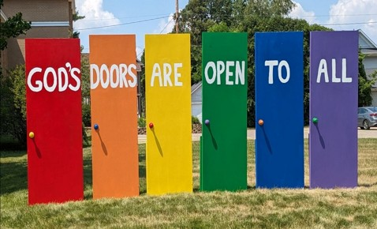
Mission Statement of
First Congregational United Church of Christ
“To know and share God’s love within us.”

Purpose Statement of
First Congregational United Church of Christ
“First Congregational UCC is a welcoming, inclusive, and progressive community committed to promoting social justice, spiritual growth, and love for all people. We reject discrimination and advocate for equality and dignity for marginalized communities. Through worship, education, and service, we work to make a positive impact on the world and invite all individuals to join us in this journey of faith and service.”

0

Church Office Hours
Tuesday, Wednesday, Thursday 10:00 am - 2:00 pm
Closed Mondays and Fridays
Office phone 218-829-2528
Terri Chidester Admin. Asst.

0

Stay Connected
0

How to watch Sunday worship
The worship service is broadcasted on the church Facebook page and YouTube every Sunday at 10:00 am.
To watch worship on Facebook, go to:
https://www.facebook.com/uccbrainerd/live

To watch our NEW YouTube channel, go to https://www.youtube.com/@uccbrainerdworship6443
Past church and special services are saved on this YouTube:
https://www.youtube.com/firstcongregationaluccbrainerd

How to stay connected with First Congregational friends and members: Join the private group for our Facebook Connections Page at: https://www.facebook.com/groups/uccbrainerd.
Financial Help Available: The Pastor's Discretionary Fund is available to assist church members and others in the Brainerd area who are experiencing financial distress with modest financial help. If you need assistance, please email, call, or text Pastor Leslie. Let her know what your situation is and how the church might be of help.
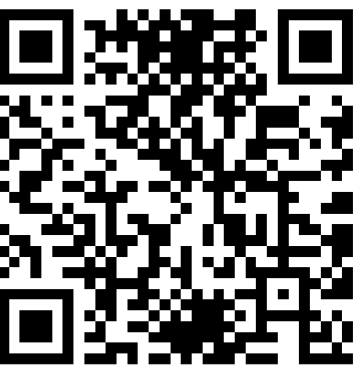
Donate to the church online!
We gladly accept offerings and donations
using the church PayPal account: paypal.biz/uccbrainerd
To use PayPal without an account: www.paypal.com/ncp/payment/MUJ5S7YMLDFM8
Or scan QR code

0
First Congregational UCC News & Updates
0


October Birthdays
Bob Jones Oct. 7 Kamery Hauan Hahn Oct. 25
Jolene Hojem Oct. 7 Elissa Hartwig Oct. 28
Tom Highum Oct. 8 Tracy Lyons Oct. 28
Eileen Kurpiers Oct. 11 Andrew Pucko Oct. 29
Zachariah Johnson Oct. 11 Paxie Imsdahl Oct. 31
Robert Morgan Oct. 14 Luann Rice Oct. 31
Barb McColgan Oct. 20
Cynthia Janes Oct. 25

0

Stewardship Commitment Season is Here
Stewardship Kick-off Sunday, October 4th

Greetings Members & Friends of the First Congregational UCC, Brainerd;
Our Stewardship theme this year is “There Our Hearts Will Be.” Where your treasure is, there your heart will be also. – Matthew 6:21.
The Corinthian church lived in a culture that prized wealth, polish, and competition – and they were tempted to bring those same standards into their faith. Paul reminded them that God’s wisdom does not look like the world’s wisdom, it is not measured by numbers, status or polish but revealed through the Spirit in ways that often seem foolish to the world.
We face those same temptations today, our culture whispers that success is found in bigger paychecks, well-padded retirement accounts, fuller sanctuaries and shinier programs. We catch ourselves comparing our worth against the mega church down the street or a neighbor who seems to have it all together. Stewardship invites us into a different story, not one rooted in comparison or accumulation, but in trust, generosity and grace. Faith and generosity are not automatic; they grow through practice. Likewise, stewardship is not a single act, not a duty to check off, but a way of training our lives in the direction of God’s grace.
Gift by gift, practice by practice, we are shaped into people whose very lives tell the story of God’s abundance. This leads us into a deeper wisdom of God. Each time we give, and we open our hands and hearts we are stretched and reshaped. Over time what feels uncertain begins to grow lighter and joyful.
As we look into the coming year, we invite you to make a financial pledge to sustain and expand our churches’ vital ministry. Your pledge is more than a gift - it is an investment in a church that dares to live out God’s dream of justice, peace and love in the world.
Please prayerfully consider what you are able to pledge. Every gift, large and small, is an act of faith and a building block for the future of our church community.
By mid-December we will set a budget for 2027 based on pledges and dedication. Enclosed are the pledge materials and a (based on your monthly income) chart to help you determine your giving this year.
You can mail back the Commitment Form or bring it with you to worship on Pledge Sunday, October 25th 2026. Final deadline to return your pledge to the office is November 1st.
Thank you for being a part of this church community. With your financial support and your time and talents we will continue to be a church where all are welcome, where hope is renewed and where love takes action.

With Gratitude,
Sarah Jo, Maggie & Marcia
Your UCC Stewardship Committee

0

0
Choir Practice and Worship Singing
Practice: October 4th @ 8:45 am &
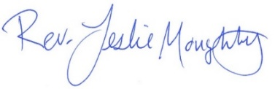
sing for Worship Service 10:00 am
Tentative dates 2026: Nov. 1, 15, 29 & Dec. 13, 27
2027 Jan. 10, 24 - Feb. 7, 21 - March 7, 21 -
April 4, 18 - May 2, 16, 30.
0
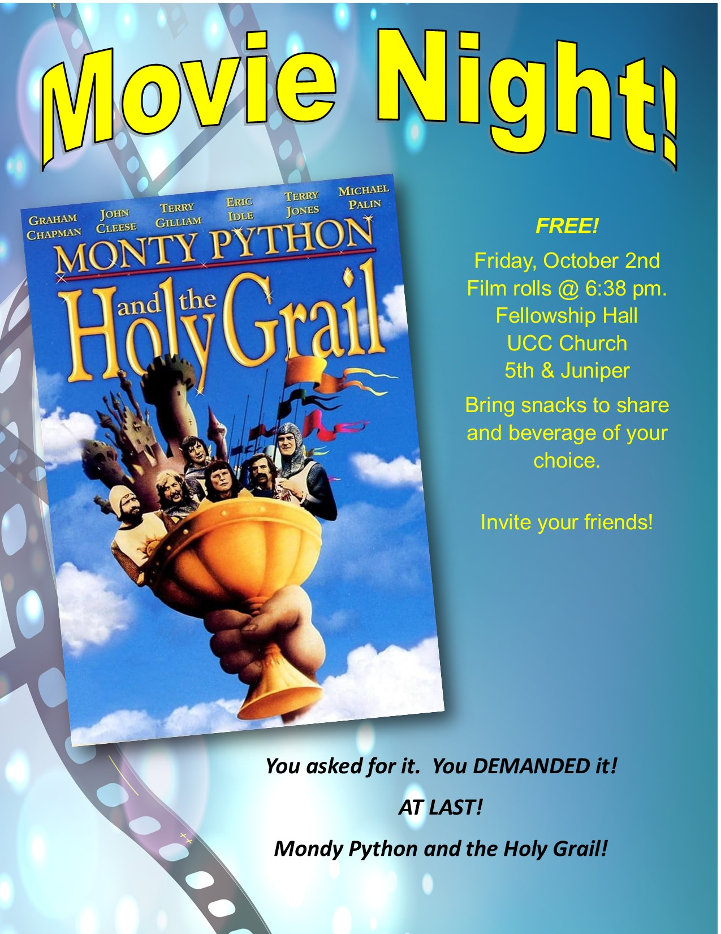

0


0
Get to Know Our New Voting Members

Jean Forbord - Yes, we’re related to Grace. My hometown is Le Sueur in southern Minnesota. We have two sons, Jason and Jared, who have gifted us with four grandchildren, one great grandchild and another due on Thanksgiving. My husband Jim’s work with the DNR has taken us to Mille Lacs, Grand Marais, and 37 years in Brainerd. I have worked as a legal secretary, in two public schools, and two county offices. I enjoy my flowerbeds, reading, biking, quilting and the outdoors. I have been searching and feel I have found my church here. The churchyard signs and, “All are Welcome Here,” brought me into what I feel is genuine. I hope to grow in faith, promote social justice, and serve this church.

Andy Pucko - As an atheist I am always touched and inspired by the phrase "what you do for the least of these you do for me". I accept the mission of this church and the more egalitarian approach to the gospel, in contrast to the view of faith, for example, people like Joel Webbon espouses, which we don't have to repeat here.
The instruction in the last class was especially well taken- I haven't been "retired" too long not to remember how clear and direct communication (and when to shut up) is essential to any organization. If I am accepted I'll try and live up to those standards.
In this long emergency we're living through, everyone needs to find their people, so I formally request that I may shelter with the brainerd UCC.

Barb Vielma - My dad, grandparents, and great-grandparents all attended UCC, so being here is a bit like coming home. There’s even a stained-glass window in the church in memory of my great-grandparents, the Mobergs, which makes it especially meaningful to me. As a former Catholic, I grew tired of the rules, regulations, and misogyny. What I love about UCC is the openness, acceptance, and lack of judgment. It’s wonderful to be part of a church where people can come as they are, be themselves, and know they’re welcome.

0
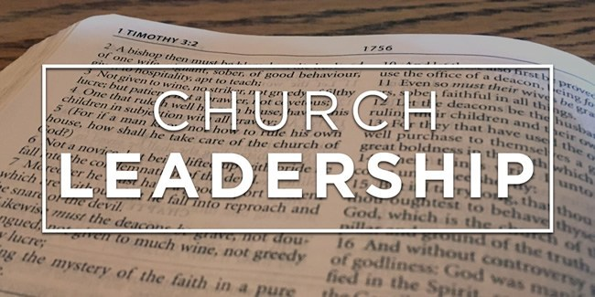
Welcome Our New Leadership!

Mary Reardon – Treasurer
Marcia Ferris – Stewardship

October 18th –


Adult Forum – 11:30 after Worship Service
October 18th -

October 4th – "What Happens When We Grieve?": Please join Kay Cox and us as a church family to share about what many of us may be going through in reaction to Pastor Leslie leaving. Ironically, whether we lose someone to death, retire from a job, or deal with the loss of a dream, the feelings are the same. The intensity may vary, however there are predictable stages we will go through. Where are you right now?

October 18th - Restoring Dignity, Renewing Hope: A Compassionate Approach to Substance Use Recovery: Every person deserves to be treated with dignity, respect, and compassion. This presentation will examine how Essentia health is improving outcomes for people with substance use disorders by combining evidence-based treatment with low-barrier access to care. Together, we will explore how reducing stigma, honoring personal autonomy, and meeting people where they are can help restore hope, support recovery, and strengthen our communities.
Jessica Schwartz, RN/CARN
Essentia Health - Substance Use and Addiction Care Program Manager &
Opioid Grant Project Director

October 25th – Preparing for Dia de los Muertos: Jan Kurtz will guide us through the preparation of an “ofrenda” as per the Mexican tradition. Using photos, candles, incense, and memorabilia, Jan will set up an altar as an example for next week’s church commemoration. Instead of our cultural tendency of denying and fearing death – think Grim Reaper, Day of the Dead offers us LA CATRINA – a dancing skeleton, decked out in her best party dress and
flouncy hat, eager to be back with her family once again. (Think COCO) Next Sunday, we will be remembering our dearly departed. Whose name will you lift up this year? How do you want to be remembered???

October 18th –
Next Council Meeting

Thursday, October 15th, 2026, 3:00 am
in-person and via Zoom tinyurl.com/uccbrainerdzoom
First Congregational Approved Council Meeting Minutes are available upon request.
Please contact Terri Admin Asst. at the Church Office.

0
Volunteer at Church
0
There are many other opportunities for you to share your talents

These committees need your gifts:
*Clerk * Trustees * Christian Ed * Christian Ministry

Please contact Dan Hegstad or Ellie Burkett if interested in any of these opportunities.
October 18th –


Justice Sundays &
October 18th –
Adult Forum Justice Action Team Meeting Dates

2026 2027
September 6th January 3rd
November 1st March 7th
May 2nd
0

September 9, 2026 Justice Table Action Meeting Minutes
DEI/Diversity
Attendance: Tim Anderson, Ryan Kelley, Carla Benjamin, Tracy Lyons, Jan Kurtz
1) Possibility of having movie opportunities regarding LGBTQ+ populations either as a topic or inclusive protagonists. Two movies: The Danish Girl and The Big Eden were recommended. We recommend a movie showing, separate from the First Friday entertainment movies already in progress, to be open to subject matter involving various issues.
We would choose time, movie and provide advertising via Newsletter, bulletins and newspaper news, when decided.
2) Detainees at the Crow Wing County Jail: Troy Schilling, Jail Administrator, offered to do some public speaking.
I sent an email with his offer to Pat Dickson, who forwarded it to her outreach group. Shari Olson, of BLA Indivisible and Northern Neighbors responded, requesting that those two groups coordinate such community outreach. I believe that is the path to pursue at this time and not duplicate their work. They will advise us of any upcoming discussions.
3) Lowell reported on future Open Forums, of which I'll be doing a Day of the Dead "Primer" on October 25. Lowell mentioned this after our discussions were ended, but I mention it as part of Diversity; The November 1st church service will be focused on Dia de Muertos through song, rituals, coffee hour and remembrance.
Submitted by Jan K.
0
WISE
Attendance: Chris Y., Kay C., Kae C., Pat S., Shon B., Lowell J.
We reviewed the confirmed Adult Forums for September and October and discussed 3 additional forums whose dates are not confirmed.
We discussed sponsoring a movie night with a mental health theme. Possibly work in collaboration with the Diversity Team on the date(s) and movie selection.
The FWAC grant was approved and the LAJT will be bringing Carver Harries to Brainerd on February 6 and 7 2027. He will perform his informational comedy show on gender transitioning at CLC.
Lowell has been working with community partners to hopefully bring the Transforming Families program to Brainerd. The biggest need at this point is to identify enough parents or caregivers willing to attend a support group for their transitioning youth.
Lowell also reported on an effort coming from the Sourcewell Community Bridgemakers work group on reducing the stigma around mental illness. They are hoping to pilot a program similar to Connect Effect in the CWC Jail and the Center in Brainerd.
Submitted by Lowell J.
0
Environmental/Creation Care
Justice Action Team: Ellie B., Colleen L, Mark S., Steve N., Barb C., Kay K., Charlene S.
- Barb, Mark and Ellie installed drip irrigation for the seven fruit trees and the lilac in the food forest.
- We are waiting for an estimate from Centauri Solar, but it is being delayed due to the Canadian tariffs
- Ellie met with SunSource. We are keeping that option open for now as well.
- The gas and electric audit is scheduled for Friday, September 25th.
Submitted by Ellie B.
0
Children, Families, Poverty
Attended: Marcia F., Dan H., Emily L. (absent: Sharon C., Cynthia J., Georgia H.)
Emily commented on the value of the school lunches. Childcare is a huge issue and a financial burden for families.
She suggested we look at a partnership with Early Head Start. They provide a teacher, rent and a food program.
It could be a 'purpose' for a couple of empty Sunday School classrooms off the Rainbow Room. Likely 5-6 children.
Emily will look at starting Taco Tuesday again. Volunteers would be helpful. Marcia assisted this spring and had some meaningful dialogue with a few of the teens attending.
Housing is also an issue. Rents have gone up and so have interest rates so buying a home is a challenge, also.
The Bridge on S 7th (homeless shelter) has had a successful first summer. Year around renewal with the city council is March 2027.
Vicky Kinney continues to provide housing and help to formerly homeless residents. We have contributed financially from the Shirley McConnell fund.
Submitted by Marcia F.

October 18th –
Special Offering: Sunday, October 25th TheShop

This month we have an opportunity to help as we give our Fourth Sunday Special Offering to TheShop, Brainerd Baxter Youth Center (BBYC). TheShop is a non-profit organization committed to providing community support to all teenagers and young adults as they transition into independence and adulthood. We are a safe space where youthful energy is harnessed into creative energy by providing opportunities to explore potential, build lasting relationships, and establish personal connections.
To donate, send a check with "TheShop” in the memo line to: First Congregational UCC, 415 Juniper St. Brainerd, MN 56401 or donate online using PayPal https://www.paypal.me/uccbrainerd and indicate "TheShop" in the Note.
October 18th –
UCC Fellowship


Men’s Lunch

Each Wednesday
11:45 am at Wings Airport Café
Not Organized—No Agenda Join Us!


Women’s Lunch

Thursday, October 29th at 11:30 am
at The Local 218 (723 Mill Ave, Brainerd)
Question of the day:
"What do you do when you're upset or mad?"

October 18th –

9th Annual Halloween Extravaganza
Saturday, October 31st
4:00 pm - 9:00 pm
You can help the church connect with our neighbors!

      - Donate Candy and/or non-candy item - There is a box located outside the sanctuary for donations of candy and non-candy items.
      - Volunteer to Decorate – Friday, October 30th 4:00 – 6:00 pm. Pizza provided!
- Volunteer on Halloween Night – Saturday, October 31st
  - Make cider and final set up starting at 4:00 pm
  - Hand out candy, serve cider, general friendly help from 5:00 – 8:00 pm (or earlier if trick-or-treaters are scarce). Come for an hour or the entire night!
  - Help with clean-up. Take down and put away the decorations: 8:00-9:00 pm (or as soon as we’re done. More helpers = shorter clean up time!

Costumes are strongly encouraged but not required. Please keep them kid-friendly.

Sign-up sheet in the Narthex.
October 18th –

First Congregational Food Shelf Collection
October 18th –

Our church continues to collect non-perishable food items for the Salvation Army Food Shelf. Please consider bringing items and donating.
There are two collection boxes: one in the parking lot entry hallway, the other in the Narthex. Brian Twamley or Stephanie Lee pick up and deliver the food. Thank you!

October 18th –

UCC Care Team
For anyone who wishes to join in making calls or visits, the Care Team meets every month on the first Thursday @ 10:00 am.

If you know of anyone who would enjoy a call from the care team, please contact one of our Care Team; Jack and Kay Kraywinkle, Pat Scott, Deb Griffith, Nancy Gould, Tracy Lyons and Cynthia Janes.

October 18th –

Cooking For Everyone

This group is OPEN FOR EVERYONE!

Email Lowell Johnson and he will add you to the member list. You will be notified when and where the cooking group will next meet.

October 18th –

Friday Book Group
We meet each Friday morning at 10:30 am via zoom.
Church Zoom link: https://tinyurl.com/uccbrainerdzoom

We are reading “In this Economy? How Money and Markets Really Work” by Kyla Scanlon.
The book Jon Stewart (The Daily Show) hailed as “essential reading” for anyone who wants to “make informed decisions” and “have a basic understanding of the economy”: an illustrated guide to economics from one of the internet’s favorite financial educators.


October 18th –
Garden Gleaning

A Biblical (and environmentally) inspired activity
This is how it works: Gardeners and plant people bring in their “gleanings” to share. This ranges from rhubarb and vegetable plants in the spring to daffodil bulbs, squash and pumpkins in the fall. A table, poster and donation basket are in Narthex entrance. Enjoy the fruits of our labors! All are welcome to help themselves!
October 18th –
All donations are given to the Food Shelf.

H.U.G.S.
October 18th –
Hosts, Ushers, Greeters, Scripture-readers
Sunday morning greeters/ushers and coffee hosts play an important part in making our church a warm and welcoming place for all.
Online signups are no longer available

Signup sheet in the Narthex or call or send an email to the office to be added.

**Notice – Hosts may be reimbursed for snacks/food that are purchased for Fellowship Coffee Hour. Reimbursement Forms are in pocket folders outside the office. Please fill out and submit with receipts in the folder provided next to the form.

October 18th –

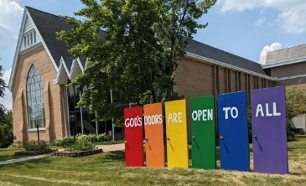
Our Building Is a Great Event Venue!
We are blessed to be able to share our beautiful church facilities for purposes that match the values of the church and its mission which is “To know and share God’s love within us.” We are an open church valuing the diversity of age, culture, gender identity, opinions, physical and mental abilities, and sexual orientation. Take a virtual tour of our building by visiting our website at uccbrainermn.org
To request a space for general use, ask for a “Request for Church Building Use” form and policy packet from Terri in the church office, at 218-829-2528 or email uccbrainerd@gmail.com. Submit the request form back to Terri in the office, and it will be submitted for approval at the next Council Meeting.
For wedding or funeral use, contact the church office.

T
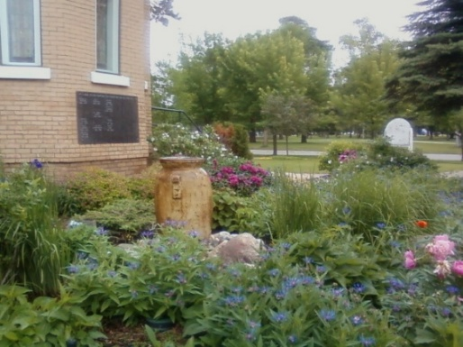
The Columbarium & Memorial Garden
October 18th –
First Congregational UCC, Brainerd
The Columbarium is in the historic space that once was our church’s front entry way. How appropriate it is that our Columbarium now marks another entry way into a new life — where the Spirits of Love and Truth are always present!

The Memorial Garden is located on the south lawn of the church. The Garden provides a place for cremains of your loved one to be buried in the ground among natural plantings.

The Garden fee includes the inscription of your loved one’s name on a granite plaque that is mounted on the outside wall of the church. Should you wish to learn more about the purchase of a niche for your own cremains or for the ashes of a loved one, please call the church office at (218) 829-2528 and a packet of materials will be sent to you via email or regular mail.

0
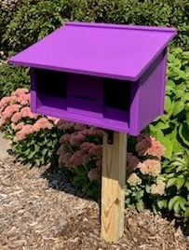
Community Prayer Box

You can find the Community Prayer Box in the Memorial Garden on the South side of the church (the side that faces Juniper Street.)

Community members frequently walk through the garden, and this box will offer our wider community an opportunity to share their prayers. Prayer cards and pens are provided, and the box is secured with a padlock, so the submitted prayers don’t fly away with the wind!

Pastor Leslie checks the box weekly and prays for any prayers submitted as well as sharing them with the Care Team.
October 18th –
0

Save The Date! Join Us in November

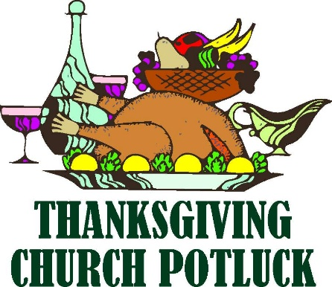
Thanksgiving Day Potluck

Thursday, October 26th @ 11:30 am

Open to our Neighbors & Friends

Turkey & Gravy provided - Bring a side dish to share.
(not necessary)
More information is coming soon!

First Congregational UCC Brainerd – Fellowship Hall

0
October 18th –

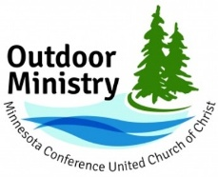

Where the Creator and creation pray, play, and wonder together.
The Outdoor Ministry of the Minnesota Conference UCC offers events for individuals and families of all ages, abilities, and stages of life to experience rest, renewal, and reconnection through a retreat or camp experience. Our goal is to create opportunities for people across the Conference to fall in love with God’s creation, encounter the sacred in the natural world, and experience the deep interconnectedness of nature, human community and one’s own soul.
Upcoming Events
Joy as Resistance and Refugia (Adult Event)
We are living in a collision of crises right now. Amid that collision, the MN Conference UCC is offering a series of three in-person retreats between August 2026 and February 2027. Each retreat stands on its own and is related to the other two in the series. All three retreats will be hosted at Camp Onomia in Onamia, Minnesota. The registration fee for each retreat is $175, and participants who register for all three will receive a 25% discount for all three retreats.
Retreat 2 – Rest and Resilience, November 17-19, 2026
Retreat 3 – Remembering New Beginnings, February 12-15, 2027

Registration at https://www.uccmn.org/programs-support/outdoor.
Download flyer: www.uccmn.org/wp-content/uploads/2026/06/2026-Joy-Retreat-Series.pdf
October 18th –

Brainerd Lakes & Surrounding Area Information
0
~ Opportunities to Know and Share God’s Love ~
0
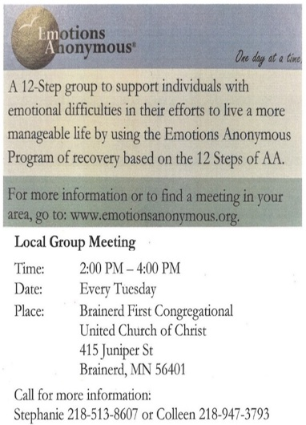


Crow Wing County
Military Family Support Group

1st & 3rd Wednesday
of each month
7:00 - 8:00 pm

Meets at First Congregational UCC
415 Juniper St., Brainerd MN 56401

Join us to support military families if you: have someone joining the military, have an active military member or have someone that has previously been in the military.

More info: drttbsby@msn.com

October 18th –
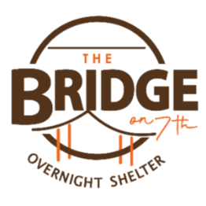
Volunteer Opportunity – Overnight Shelter Bridge on 7th
October 18th –
Sign up for a morning shift as a team of two or/individually. You can choose a time to volunteer online. The staff and shelter guests appreciate our involvement. The link is below. Create an account. Pick a date. They need your birth date and your ok for a background check.

Start at this link to sign up to volunteer: www.bridgesofhopemn.org/volunteer
Then choose a date here: volunteer.bloomerang.co:443/JE/bas6nebexg029t
(They will need your birth date and consent for a background check.)

October 18th –


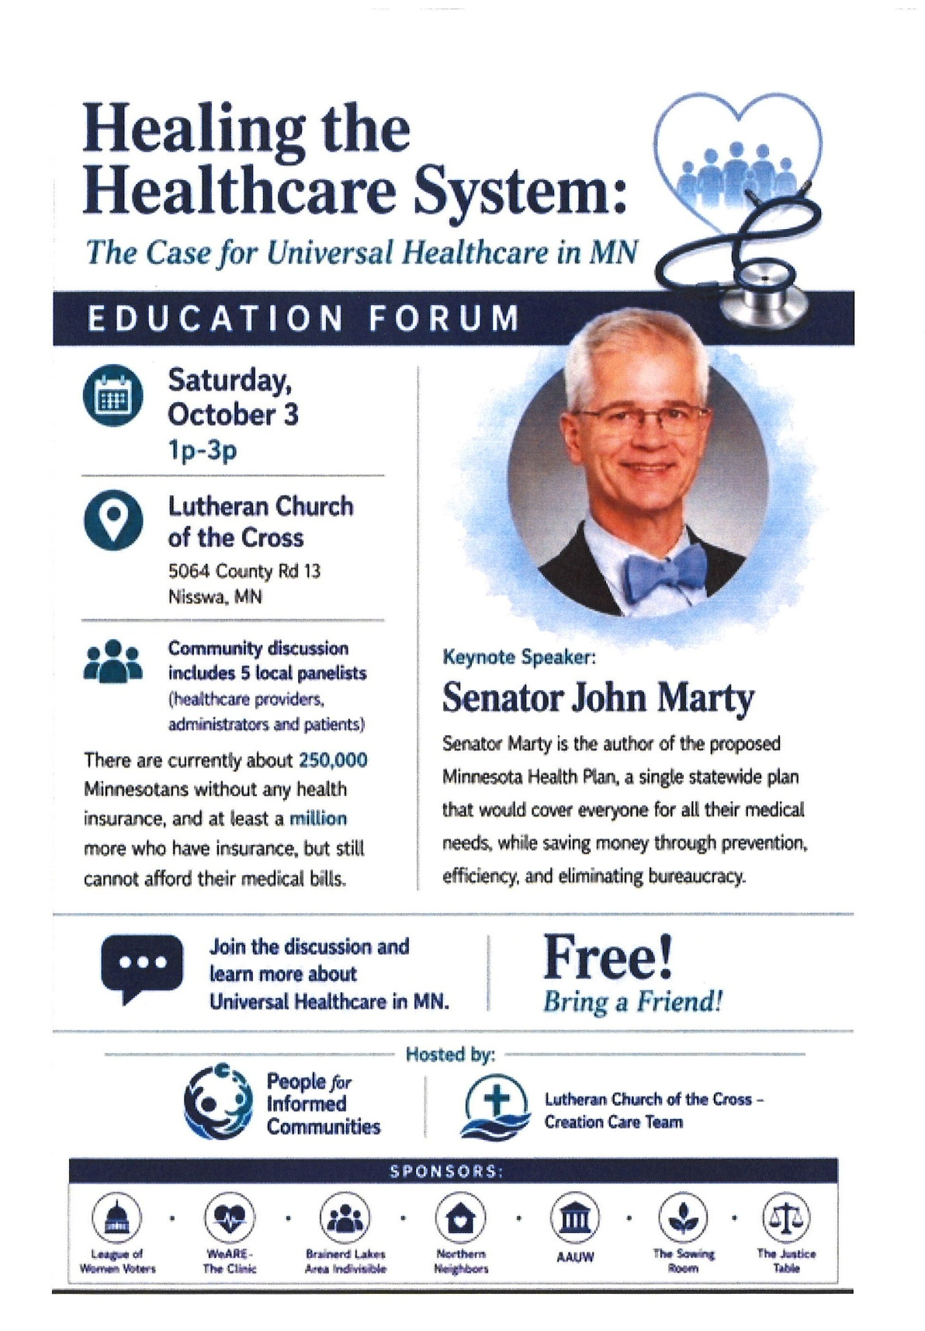
October 18th –
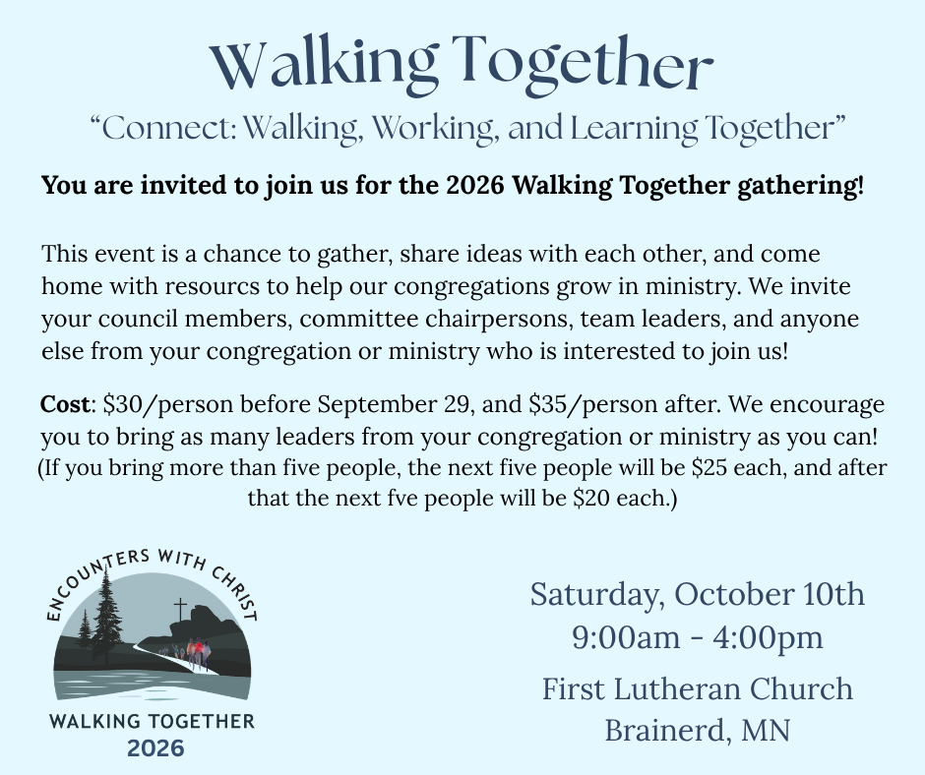
October 18th –

Register Here!

Registration closes October 6th



October 2026 Calendar
Sunday | Monday | Tuesday | Wednesday | Thursday | Friday | Saturday
Y- Yes Meeting in person  FB -Facebook Live Stream Online  C- Cancelled N-No Meeting  P-Postponed Z-our church Zoom | Office Closed | Office Hours  10am – 2pm | Office Hours  10am – 2pm  Pastor Drop-in Hours  11:00 am – 1:00 pm | Office Hours  10am – 2pm | Office Closed
 |  |  |  | 1  10am Care Team-Y | 2  10:30am Book Grp-Z  Movie Night-Y | 2-4pm 3  Movie in Fellowship Hall BACP/ BLUE/LAJT Environment
8:30am Brainerd Friends-Y 4  8:45am Choir Practice  10am Worship, World Communion, Choir-Stewardship Kick-off-Y& FB & YouTube  Stewardship-Testimony  11am Fellowship-Y  11:30am Adult Forum-Grief-Y. | 5  12pm-3:30pm AAUW-Y Fellowship Hall  5pm BACP/BLUE church-backup | 6  2pm EA-Y  5:30pm OA -Y  6pm BLA Indivisible Civics Mtg.-Y Fellowship Hall | 11:45am Men’s Grp 7  @ Wings Cafe-Y  1:30pm Executive Mtg.-Y  Pastoral Relations Mtg.-C  4:30pm Christian Ministry Mtg.-Y  7pm Military Family  Support Grp-Y  7pm AA Common-Y | 8 | 9  10:30am Book  Grp- Z | 10
8:30am Bnrd Frnds-Y 11  10am Worship--Y& FB & YouTube  Stewardship-Testimony  1:15am Fellowship-Y | 10am Foundation Mtg.-Z 12  2pm Trustees  Mtg-Y  Indigenous Peoples’ Day | 13  2pm EA-Y  5:30pm OA -Y  Council Reports Due | 14  11:45pm Men’s Grp  @ Wings Cafe-Y  7pm AA Common-Y | 15  3pm Council Mtg- Y&Z  6:30pm AA Dist.7-Y | 16  10:30am Book  Grp- Z | 17  9:30am-2:30pm AAUW Mtg. Fellowship Hall
8:30am Bnrd Frnds-Y 18 10am Worship--Y& FB & YouTube  Stewardship-Testimony  11:15am Fellowship- Y  11:30am Adult Forum: Substance Use Recover:-Jessica Schwartz | 19 | 20  2pm EA-Y  5:30pm OA -Y | 11:45pm Men’s Grp 21  @ Wings Café-Y  7pm AA Common-Y | 22 | 23  10:30am Book  Grp- Z | . 24
8:30am Bnrd Frnds-Y 25  Pledge Sunday-Testimony  10am Worship-Y& FB & YouTube  11:15am Fellowship-Y  11:30am Adult Forum: Day of the Dead Primer-Jan Kurtz  *Special Offering TheShop  Newsletter Deadline-November | 26 | 27  2pm EA-Y  5:30pm OA -Y | 28  11:45pm Men’s Grp  @ Wings Café-Y  7pm AA Common-Y | 29  11:30am Women’s Lunch @ Local 218 | 30  10:30am Book  Grp- Z  4-6pm Decorate for Halloween | 31  4-9pm Halloween Extravaganza

