
Friendship News, November 2025
0
First Congregational United Church of Christ, Brainerd
An Open and Affirming Congregation
The Church Office Hours: Tuesday, Wednesday, Thursday from 10:00am – 2:00pm
Office phone 218-829-2528 Office E-mail uccbrainerd@gmail.com
Pastor Leslie’s E-mail: pastorleslieucc@gmail.com Website: www.uccbrainerdmn.org

No matter who you are, or where you are on life’s journey, you are welcome here.
0
Pastor’s Pen
0

Gratitude in Difficult Times
You are likely reading this newsletter the day before or soon after the day the Federal Government ceased funding for Supplemental Nutrition Assistance Program (SNAP). The largest food assistance program in the country, SNAP provides much needed funds for low-income individuals and families, including children, seniors, and people with disabilities. In fiscal year 2024, SNAP provided assistance for 41.7 million people including more than 458,000 people in Minnesota and numbers are only increasing.
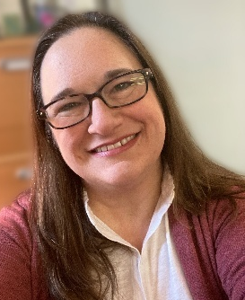
With Thanksgiving only a few weeks away, the theme of gratitude is often at the forefront of articles and social media posts. As we are watching the funding for crucial programs get slashed, focusing on gratitude may feel inappropriate or even wrong. And yet, finding gratitude in the most difficult of times can be important for not losing hope. To be clear, I don’t mean being grateful because you are not affected by these cuts. I mean finding gratitude for the generosity that is on display in communities coming together to help people in need. Or gratitude for the ways in which our Democratic system pushing back against abuses of power. For example, as I am writing this article, I learned that two federal judges have ordered the administration to use contingency funds to cover SNAP costs during the shutdown! I pray that the administration complies so the millions of people who rely on SNAP will receive the help they need.
In the midst of all of this, it is important to help where we can, give what we can, show up for one another. And we must not lose sight of hope, joy and gratitude, to take time to notice where God is at work among us and between us.
With deep gratitude for each of you,
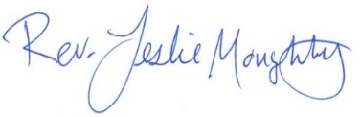
0
Mission Statement of First Congregational UCC
“To know and share God’s love within us.”

Purpose Statement of First Congregational United Church of Christ
“First Congregational UCC is a welcoming, inclusive, and progressive community committed to promoting social justice, spiritual growth, and love for all people. We reject discrimination and advocate for equality and dignity for marginalized communities. Through worship, education, and service, we work to make a positive impact on the world and invite all individuals to join us in this journey of faith and service.”
0
Church Office Hours
Tuesday, Wednesday, Thursday 10:00 am - 2:00 pm
Closed Mondays and Fridays
Please call for assistance - office 218-829-2528

Terri Admin. Asst. Vacation Days: November 11, 12 & 13

The Office will be closed for Thanksgiving Thursday, November 27th
0
Pastor Leslie’s Workday Schedule

Sunday through Thursday (Days off are Friday and Saturday)
Drop-in Hours: Wednesdays 11:00 am – 1:00 pm
*Drop-in hours are times set aside for “drop-in” conversations, much like a professor’s office hours.
Everyone is encouraged to make an appointment, especially if the above times are not convenient. You can go to www.calendly.com/pastorleslieucc and select a day and time that works for you, or you can email Pastor Leslie at pastorleslieucc@gmail.com or call/text at 218-656-0096.
0
Stay Connected

How to watch Sunday worship: The worship service is broadcasted on the church Facebook page and the church's YouTube channel every Sunday at 10:00 am.
To watch worship on Facebook, go to https://www.facebook.com/uccbrainerd/live
**Live stream videos are saved and can be viewed at any time. All memorials, weddings and 12th Night Concert are on our church Facebook page.
How to stay connected with First Congregational friends and members: Join the private group for our Facebook Connections Page at https://www.facebook.com/groups/uccbrainerd.
Financial Help Available The Pastor's Discretionary Fund is available to assist church members and others in the Brainerd area who are experiencing financial distress with modest financial help. If you need assistance, please email, call, or text Pastor Leslie. Let her know what your situation is and how the church might be of help.
Donate to the church online! We are now accepting your offerings and donations using PayPal. You do not need to have a PayPal account to make an online donation with a credit card. To use PayPal, go to: https://www.paypal.me/uccbrainerd
0
First Congregational UCC News & Updates
0

This issue marks the beginning of a new feature in our Newsletter. Three years ago, a congregational survey revealed that the number one reason people attend and stay active in our church is the people. That sense of community is at the heart of who we are. This church has always tried to create many opportunities to work, play, solve problems, and simply spend time together. Many of those opportunities are highlighted in This Week, our calendar of upcoming events, and in the Newsletter itself.
Our Council felt that another meaningful way to strengthen our connections would be to share more of our personal journeys with one another. "In Focus" seeks to offer an in-depth look into the lives of some of our UCC Brainerd community members. Each month, we'll have the chance to learn about the practical, emotional, and spiritual lives of a unique individual within our congregation. At times, such as this month, the story will be that of not just one person, but a long-term couple with a shared journey.
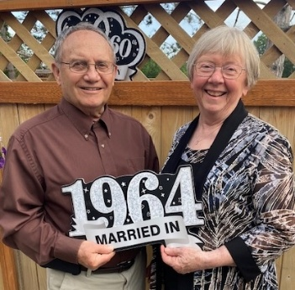
In Focus
0
A Lifetime of Welcome: Judy and Gary Whiteman’s Enduring Legacy at First Congregational UCC
by Cynthia Janes
In October, Charlotte (my wife) and I visited long-time church members Judy and Gary Whiteman. I thought I knew them pretty well, but it occurred to me that there probably was a lot more to learn about their life together, their amazing family, and their remarkable fifty-five-year relationship with First Congregational UCC in Brainerd. Both North Dakota natives, Judy and Gary’s story began when Judy was student teaching home economics in the same school where Gary taught science. Their classrooms were just across the hall from each other, and shared lunches soon blossomed into a lifelong partnership. The dedicated educators got married in 1964 and started their family with the birth of Greg in 1967. Two years later, Gary accepted a teaching position in Brainerd, and just before the move, their second child, Rhonda, arrived.
Settling into their new life in Brainerd, the couple visited a number of churches and found First Congregational UCC to be particularly inviting. By coincidence, the Whitemans joined the church at the same time as Jan and Tom Morton. Both couples were eager to contribute to their new church community.
Judy’s willingness to help was quickly recognized, and she was invited to lead the Sunday School program. Her gift for welcoming newcomers became a hallmark of her service, transforming many visitors into active members. “I followed a lot of wonderful women,” Judy recalls, reflecting on the legacy left by those who came before her and on the joy of seeing new faces become familiar friends. Judy remembers when Norma Miller first introduced Sharon and Rod Carlson to the church many decades ago! Judy was there to welcome them.
As their family grew to include a third child, Lynn, Judy and Gary remained deeply involved in church life at UCC, Brainerd, while continuing their careers in public education. Gary eventually devoted 31 years to the Brainerd School District. At church especially, Judy and Gary became known for their genuine hospitality and ability to connect with others. Fellow-congregants’ cards and notes often mention the couple’s positive impact, e.g., “You were always so welcoming.” This spirit of inclusion at UCC Brainerd was a key reason Judy and Gary had chosen UCC Brainerd over other area churches, and for decades the couple has sought to provide a warm welcome to newcomers.
The couple’s children have followed in their footsteps of service and learning: Greg is a hospitalist at Essentia St. Joe’s, Rhonda teaches music internationally in Bogota, Colombia, and Lynn is a Nurse Educator at Mayo Clinic in Rochester, MN. The Whitemans’ legacy also extends to their eight grandchildren, who are a source of great pride and joy. Judy is affectionately known as “best grandma ever,” and Gary as “best grandpa.” The grandchildren’s career choices continue the family commitment to teaching, learning, and helping others.
Even after more than five decades, Judy and Gary continue to arrive early on Sunday mornings, ensuring that the sanctuary is prepared and programs are available, and greeting congregants. Though her contributions extend well beyond greeting, Judy is happy to be remembered for her welcoming nature. She has served tirelessly in the kitchen, as congregation moderator, on multiple committees, and played a pivotal role in the church’s 150th anniversary celebration. One memorable fundraiser involved making and selling dozens of pasties— a nod to Marian Benest and Louise Smith, church members with roots in MIchigan's Upper Peninsula and Minnesota's mining country, respectively. Although churches are built on structural pillars, human pillars are also required to make a church stand tall---without either, a church will crumble. Judy and Gary have been unbending pillars of our church for over fifty years. Theirs is the story of love—for each other, their family, their church, and the wider world. We are grateful for their enduring presence and the gracious welcome they continue to share with us all.
0
0
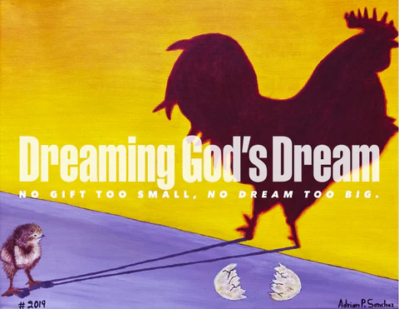
Stewardship Commitment Season

Dear Church Family,
Our theme this year is “Dreaming God’s Dream,
No Gift Too Small. No Dream To Big.”

The Stewardship Pledge Drive for our 2025 budget is nearly over. During worship on October 27th many pledges were returned. Thank you for your thoughtful and prayerful consideration.

If you have not handed in a pledge, a friendly reminder; the Deadline is November 1st. Please mail them, hand them in at Sunday worship or drop them off at the office (slide under the door if after office hours).

Because of you, this church can “Dreaming God’s Dream”.
Your UCC Stewardship Committee;
Sarah Jo Armstrong & Maggie Anderson
0

November Birthdays
Sally Campbell Nov. 1 Maggie Anderson Nov. 16
Eleanor Burkett Nov. 4 Jan Kurtz Nov. 20
Dale Hadland Nov. 9 Mike North Nov. 25
Becky Stadem Nov. 13
0
Next Council Meeting
Wednesday, November 20, 2025, 3:30 pm
in-person and via Zoom tinyurl.com/uccbrainerdzoom
Reports are due via email on Tuesday 18th

First Congregational Approved Council Meeting Minutes are available upon request.
Please contact Terri Admin Asst. at the Church Office.
0
Volunteer at Church!
There are many other opportunities for you to share your talents

These committees need your gifts: * Trustees * Stewardship * Members-at-Large
0

Brunch Bunch
Sunday, November 2, 12:15pm at Wings Cafe.
What’s better than going out for brunch after church? Going to brunch with church friends, of course! Join us for our first Brunch and then mark your calendars for future dates, First Sunday of each month.
Contact Tracy Lyons for information.
0
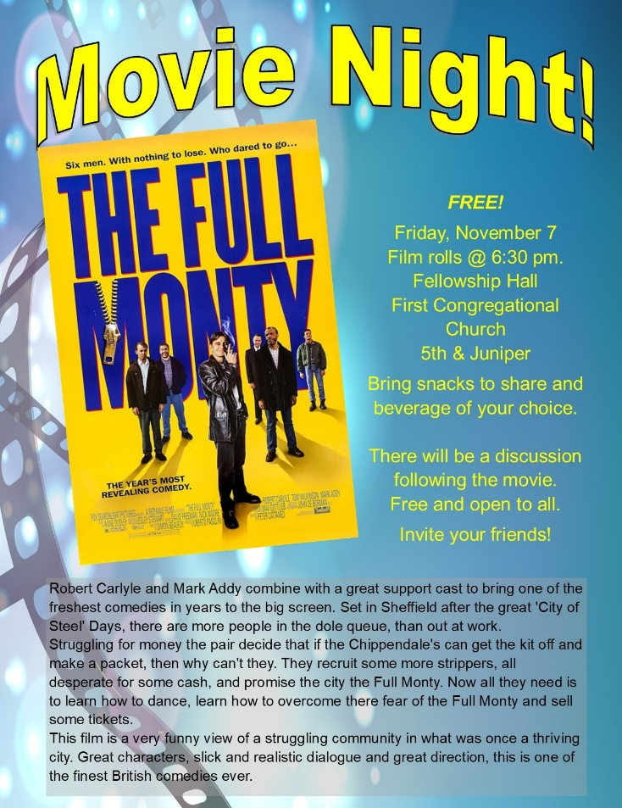
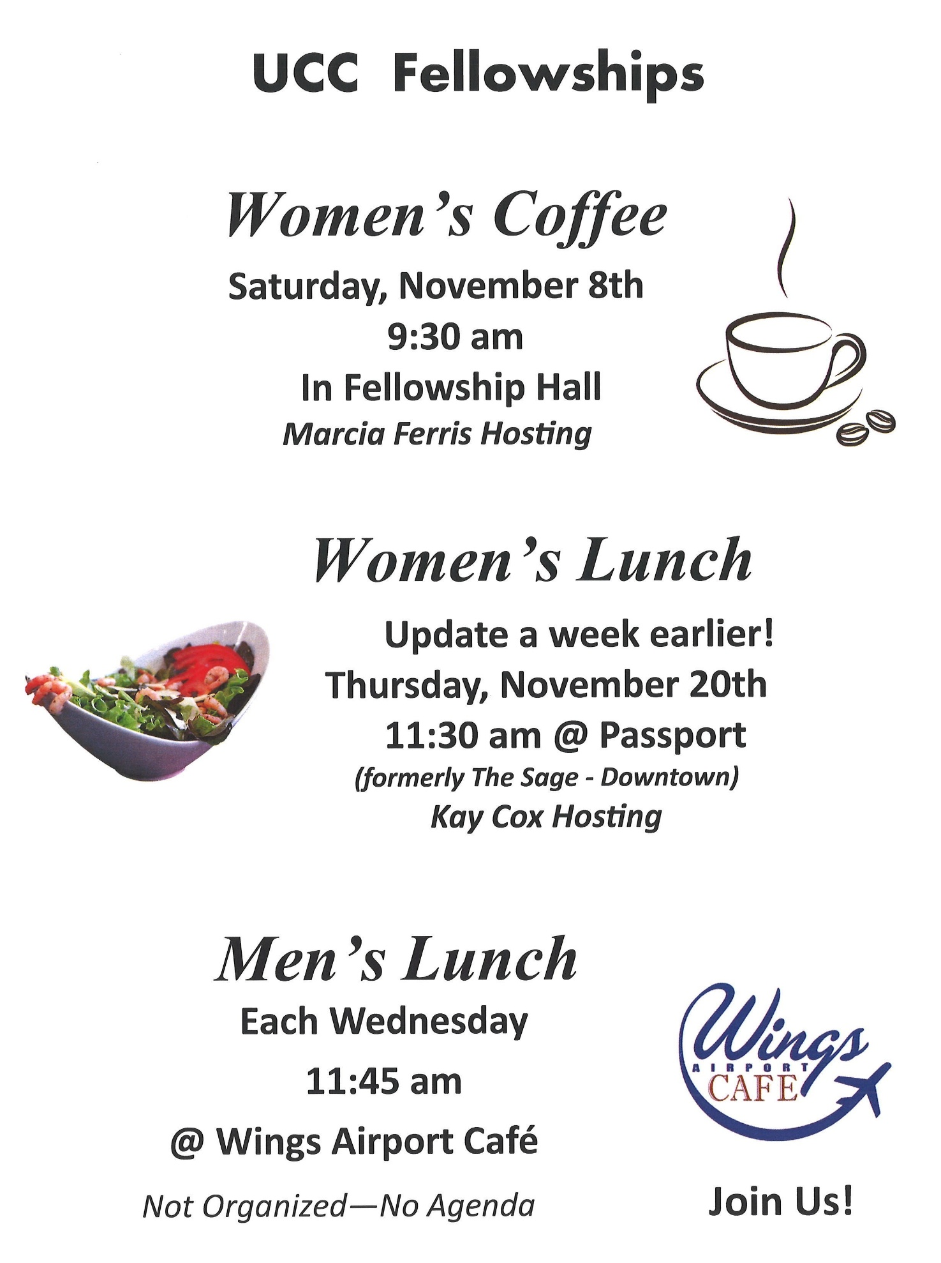
A time to connect and socialize!
0
0
0
0
November Adult Forums - 11:30 am after Sunday Worship


November 16: Justice Sunday - Justice Action Teams: Teams will provide an update on their work with time for Q&A and a discussion time. This is your opportunity to hear what the teams are planning and add your perspective.

If you want to join a Justice Team, email Steve Newcom, Justice Ministries at snewcom17@gmail.com and plan to join us this November. It is an open, welcoming process.

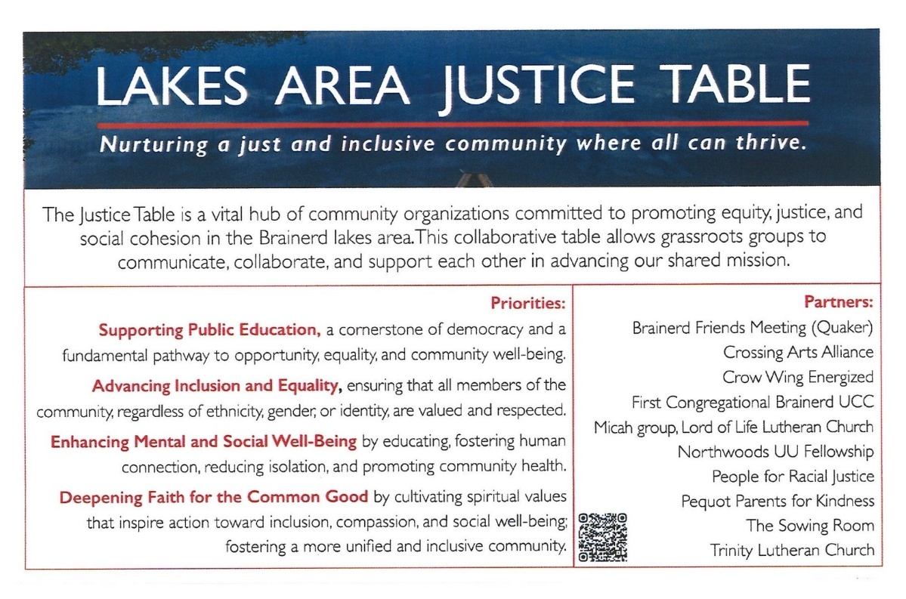

0
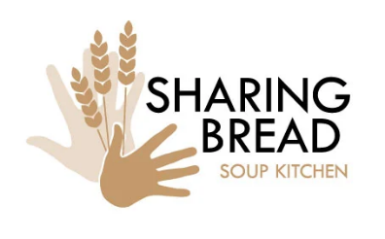
November Special Offering - Sunday November 23rd
Sharing Bread Soup Kitchen

This month we have an opportunity as we give, our Fourth Sunday Special Offering to the Sharing Bread Soup Kitchen. A lifeline for hungry souls in the Brainerd Lakes Area since 1987. The Soup Kitchen’s mission is to demonstrate the love of Christ by providing meals to the hungry of our community.
Please send your donation to First Congregational UCC, 415 Juniper St. Brainerd, MN 56401. Make sure to note on your offering: “Soup Kitchen”. Thank you! Or for your convenience use our Paypal account at: paypal.me/uccbrainerd Be sure to note on your offering “Soup Kitchen” in comments.
0
0

TheShop Meal @ First Congregational UCC!

Meal cooking has been scheduled for the fourth Wednesday of each month at 3:00-5:30 pm in the church kitchen and Fellowship Hall. Join us this month on November 26,

Save future date!
December-cancelled for Christmas, January 28, February 25, March 25, April 22, May 27.

A number of youth and the staff from TheShop (Brainerd Baxter Youth Drop-in Center) come over to our kitchen and help prepare a delicious meal that is then brought back to TheShop for the hungry and appreciative teens there.
If you are interested in joining and volunteering your time please contact Breton Monroe, Executive Director @ 218.316.2070 or The Brainerd Baxter Youth Center @218.454.0009
https://theshopbrainerd.org/ https://www.givemn.org/donate/Theshop


0
Greening the Church

Sunday, November 23rd @ 12:00 – 2:00 pm
Volunteers are welcome to join the Christian Ministry Committee for a festive greening of the church event!

Come and help us prepare the way for the Advent and Christmas season.

0
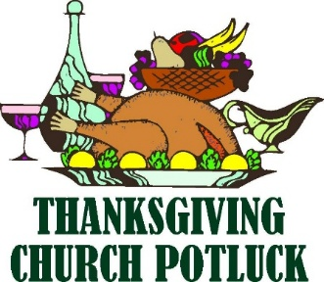
Thanksgiving Day!

Thursday, November 27th @ 11:30 am

Turkey, Vegetable, Mashed Potatoes
& Gravy Provided.
Bring a side dish to share (not necessary)

Open to the Public
Our Neighbors & Friends

First Congregational UCC Brainerd
In Fellowship Hall

0

0

Cooking For Everyone

This group is OPEN FOR EVERYONE!

Email Lowell Johnson and he will add you to the member list. You will be notified when and where we will next meet.
0


First Congregational Food Shelf Collection

Our church continues to collect non-perishable food items for the Salvation Army Food Shelf. Please consider bringing items and donating.

There are two collection boxes: one in the parking lot entry hallway, the other in the Narthex. Brian Twamley picks up and delivers the food. Thank you!

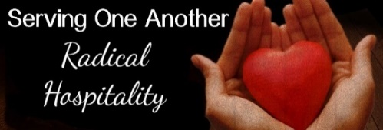
H.U.G.S.
0
Hosts, Ushers, Greeters, Scripture-readers

Sunday morning greeters/ushers and coffee hosts play an important part in making our church a warm and welcoming place for all. Signup below for your first Sunday as the face of the church! https://www.signupgenius.com/go/10C0E48A9A823A5FFC07-hugs/16034811

0

UCC Care Team

For anyone who wishes to join in making calls or visits, the Care Team meets every month on the first Thursday @ 10:00 am.

If you know of anyone who would enjoy a call from the care team, please contact one of our Care Team; Barb Hoeft, Jack and Kay Kraywinkle, Pat Scott, Chris Yager, Deb Griffith, Joey Halvorson (text or email) and Pastor Leslie.
0

Friday Book Group

We meet each Friday morning at 10:30 am via zoom.
Church Zoom link: https://tinyurl.com/uccbrainerdzoom

We are reading "Gratitude” by Oliver Sacks. A deeply moving testimony and celebration of how to embrace life." Gratitude consists of four essays that originally appeared in The New York Times , accompanied by a foreword that describes the occasion of each chapter.
0

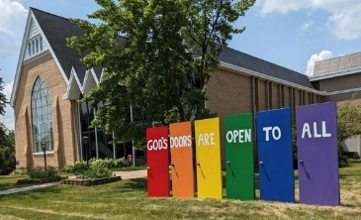
Welcome to our Facility
0
We are blessed to be able to share our beautiful church facilities for purposes that match the values of the church and its mission which is “To know and share God’s love within us.” We are an open church valuing the diversity of age, culture, gender identity, opinions, physical and mental abilities, and sexual orientation.
To request a space for general use, ask for a “Request for Church Building Use” form and
policy packet from Terri in the church office, at 218-829-2528 or email uccbrainerd@gmail.com. Submit the request form back to Terri in the office, and it will be submitted for approval at the next Council Meeting. For wedding or funeral use, contact Pastor Leslie: pastorleslieucc@gmail.com
0

The Columbarium & Memorial Garden
First Congregational UCC, Brainerd
The Columbarium is in the historic space that once was our church’s front entry way.
How appropriate it is that our Columbarium now marks another entry way into a new life — where the Spirits of Love and Truth are always present!
The Memorial Garden is located on the south lawn of the church. The Garden provides a place for cremains of your loved one to be buried in the ground among natural plantings. The Garden fee includes the inscription of your loved one’s name on a granite plaque that is mounted on the outside wall of the church.
Should you wish to learn more about the purchase of a niche for your own cremains or for the ashes of a loved one, please call the church office at (218) 829-2528 and a packet of materials will be sent to you via email or regular mail. The Memorial Committee has prepared the information packet, and it contains all the details you will need as you consider inurnment here at First Congregational UCC.

0
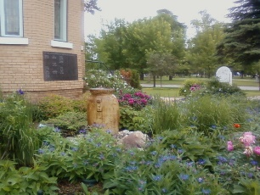
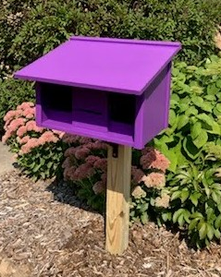
Community Prayer Box

Thank you to our Memorial Committee and the craftsmanship of Jack Kraywinkle, for making Pastor Leslie’s idea for a Community Prayer Box in the Memorial Garden a reality! You can find the prayer box on the South side of the church (the side that faces Juniper Street.)

Community members frequently walk through the garden and this box will offer our wider community an opportunity to share their prayers. Prayer cards and pens are provided, and the box is secured with a padlock, so the submitted prayers don’t fly away with the wind!
Pastor Leslie checks the box weekly and pray for any prayers submitted as well as bring them to the Care Team for prayer as well.
0
0
Save The Dates! Activities in December
@ First Congregational UCC Brainerd

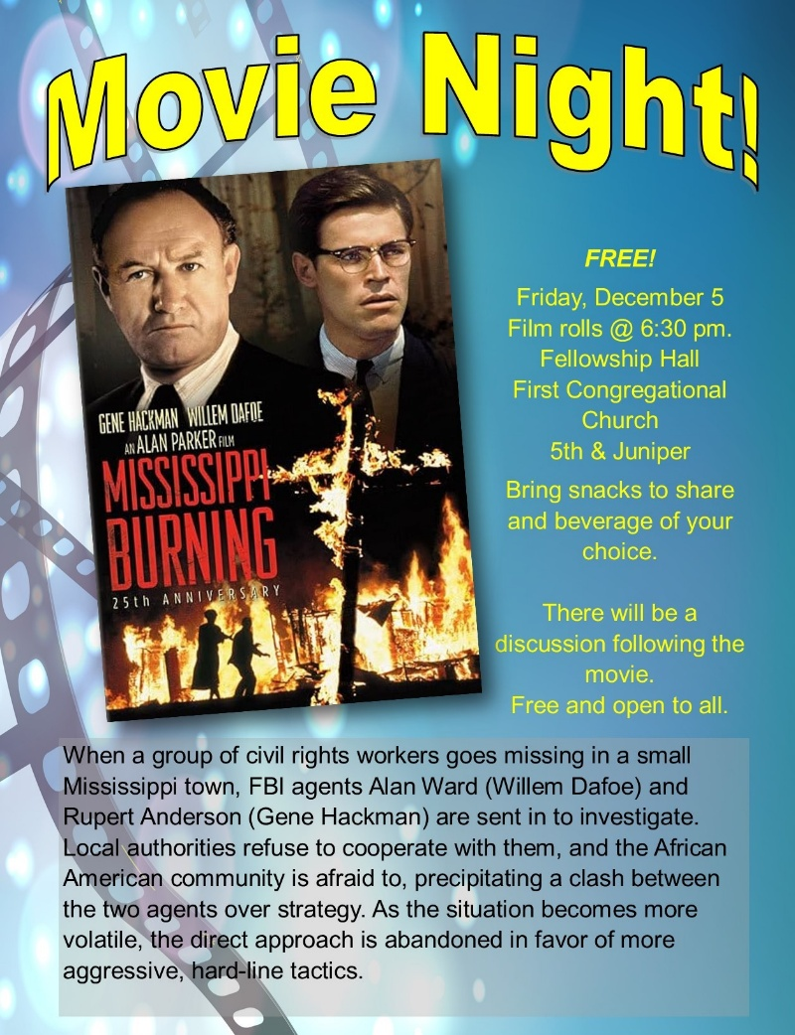

0
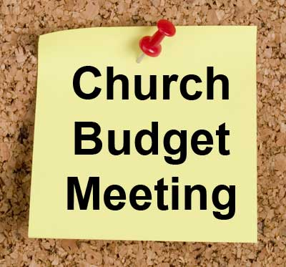
Annual Budget Meeting

Sunday, December 14th, at 11:15 am
after worship in-person and via Zoom
Please attend the congregational budget meeting to review and vote on the 2025 church budget. Meeting packets will be distributed in person on the previous Sunday December 8th and emailed to voting members on December 11th.
Please notify Terri in the office if you need a packet sent to you by snail mail.

0
0
January 2026
Save the Date! First Congregational UCC Event

20th Annual Twelfth Night Concert
Sunday, January 4th, 2026 7:00 pm

First Congregational UCC of Brainerd extends a warm welcome to please join us for our
20th Annual Concert in Celebration of the Twelfth Night of Christmas!

Volunteers are needed as we prepare and organize the event. Call or text Cynthia - 218-513-3956.

0
0

Brainerd Lakes & Surrounding Area Information
~ Opportunities to Know and Share God’s Love ~
0
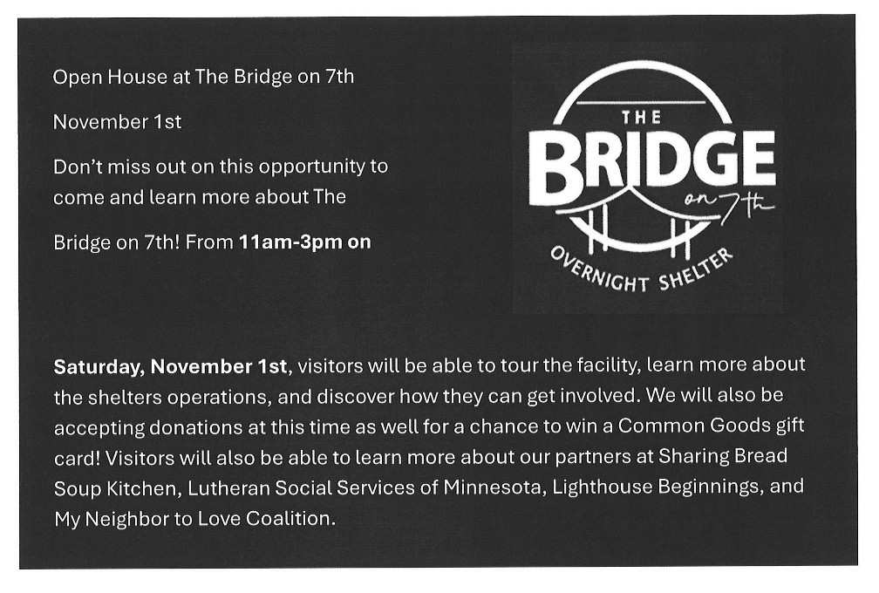
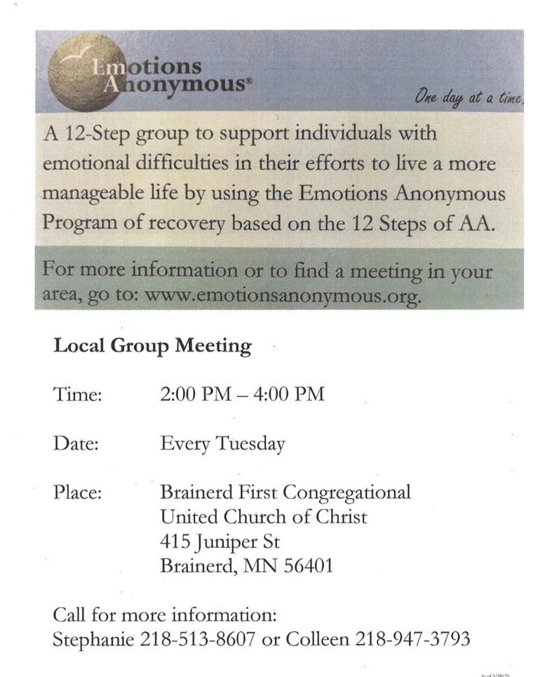
0

0

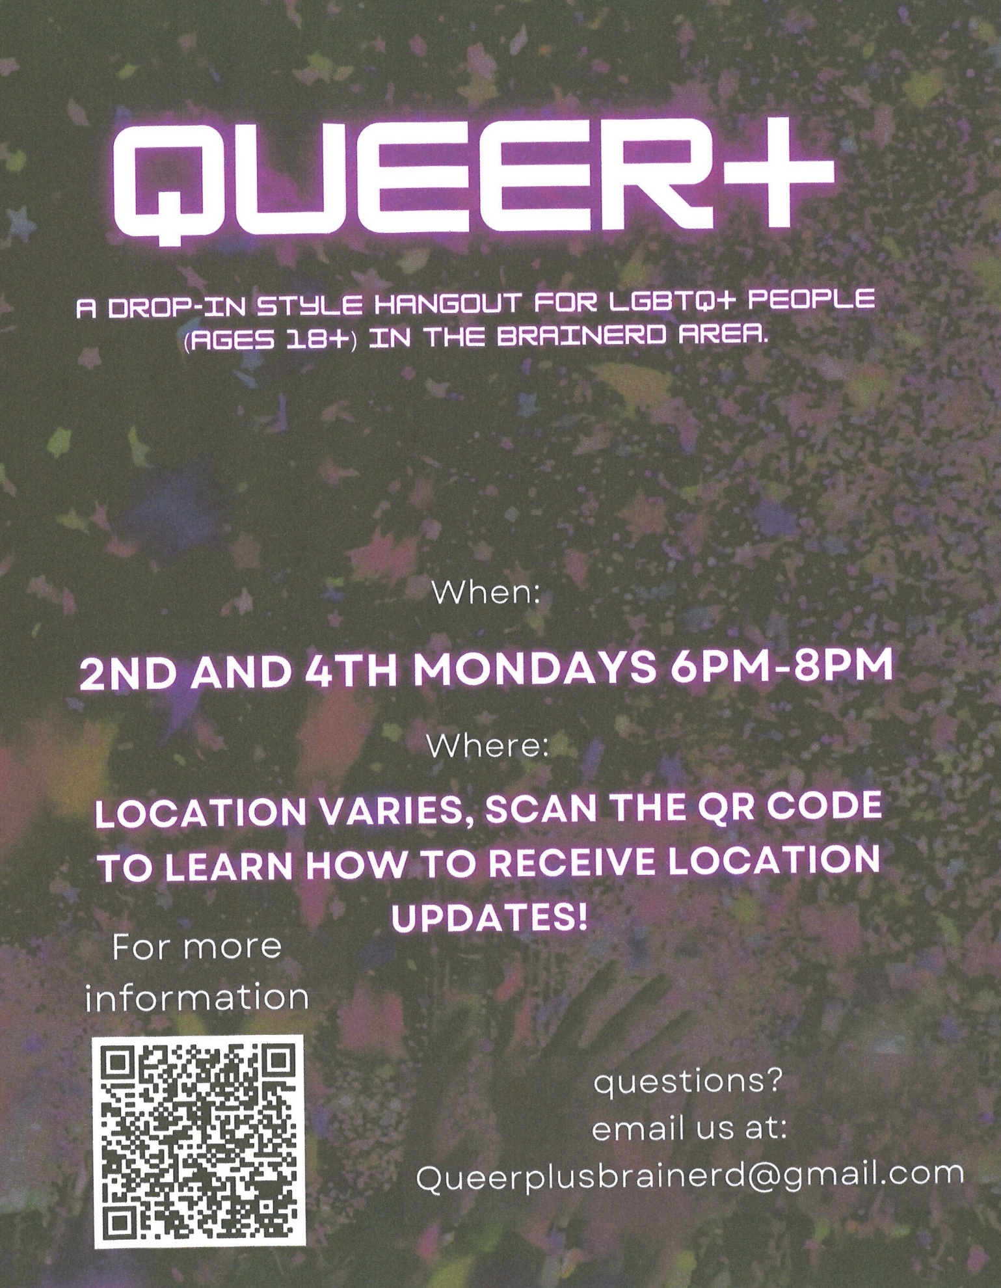
November 2025 Calendar
Sunday | Monday | Tuesday | Wednesday | Thursday | Friday | Saturday
Y- Yes Meeting in person  FB -Facebook Stream Online  C- Cancelled N-No Meeting  Z-our church Zoom | Office Closed | Office Hours  10am – 2pm | Office Hours  10am – 2pm  Pastor Drop-in Hours  11:00 am – 1:00 pm | Office Hours  10am – 2pm | Office Closed | All Saints Day  1  Pledge Commitment Forms Due to Office
Dia de Muertos 2  8:30am Bnrd Frnds-Y  8:30am Choir Practice  10am W0rship, Choir & Communion-Y&FB Live  11am Fellowship-Y  12:15pm Brunch Bunch @ Wings | 3 | 4  2pm EA-Y  5:30pm OA -Y | 11:45pm Men’s 5 Grp @ Wings-Y  1:30pm PRC Mtg.-Y  3:30pm Exec.Mtg.-Y  4pm Christian Ministry-Y  7pm AA Common-Y | 6  10am Care Team-Y  3:30pm Stewardship Mtg.-Y | 7  10:30am Bk Grp-Z  6:30pm Movie Night-Y | 8  9:30am Women’s  Fellowship-Y
8:30am Bnrd Frnds-Y 9  10am W0rship-Y&FB Live  11am Fellowship-Y  11:30am Name Change Task Force Mtg-Y | 10 | 11  2pm EA-Y  5:30pm OA -Y  6:30 pm BLA Indivisible Mtg.-Y | 10:30am Trustees Mtg-Y  11:45pm Men’s 12 Grp @ Wings-Y  7pm AA Common-Y | 13  3:30pm Council  Mtg.-Y&Z | 14  10:30am Bk Grp- Z | 15  9:30am-1:00pm AAUW Mtg.-Y
8:30am Bnrd Frnds-Y 16  8:30am Choir Practice-Y  10am Worship & Choir-Y&FB  11am Fellowship-Y  11:30am Adult Forum-Justice  Table Teams  1pm Girl Scout Mtg.-Y | 17  BLA Indivisible Mtg.-Y Fellowship Hall | 18  2pm EA-Y  5:30pm OA -Y | 19  11:45pm Men’s Grp  @ Wings-Y  7pm AA Common-Y | 20  11:30am Women’s Lunch @ Passport  6:30pm Dist.7AA-Y | 21  10:30am Bk Grp- Z | 22
8:30am Bnrd Frnds-Y 23  10am Worship-Y&FB Live  11:15am Fellowship-Y  12:00pm Greening of the Church-Y  *Special Offering –Soup Kitchen  * Newsletter Deadline | 24 | 25  2pm EA-Y  5:30pm OA -Y | 11:45pm Men’s 26 Grp @ Wings-Y  3-5:30pm TheShop Cooking-Y  7pm AA Common-Y | Thanksgiving Day  Office Closed 27  1:30pm Thanksgiving Potluck -Open to the Public in Fellowship Hall | 28  10:30am Bk Grp- Z | 29
8:30am Bnrd Frnds-Y 30  10am Worship-Y&FB  11am Fellowship-Y  11:30 – Congregational Mtg.-Y Name Change Update & Questions |  | Terri Admin. Asst. Vacation Days  Nov. 11, 12 & 13

