Friendship News, December 2023
0
First Congregational United Church of Christ, Brainerd
An Open and Affirming Congregation
The Church Office Hours: Wednesdays – Fridays from 10:00am – 2:00pm
Pastor Leslie’s Drop-in Hours: Wed. 2:00pm – 4:00pm, Thurs. 11:00am – 1:00pm
Office phone 218-829-2528 Office E-mail uccbrainerd@gmail.com Pastor’s E-mail: pastorleslieucc@gmail.com Website: www.uccbrainerdmn.org
Schedule a 1 to 1 (in-person or by Zoom or Phone) with Pastor Leslie:
www.calendly.com/pastorleslieucc/1to1

No matter who you are, or where you are on life’s journey, you are welcome here.
0
Pastor’s Pen
0
The Gift of Being Present
Advent can be filled with worry about finding the perfect Christmas gifts. Deep down we want people in our lives to know they are special and that we love them. But sometimes we overlook the greatest gift of all… our very presence. Our spiritual ancestors were also worried — often about survival in the midst of political occupation. And the response of the scriptures is “the Holy Living One is with you.” Like a shepherd who never leaves the flock, we are held close. This season, we are invited to be the gift of presence for our loved ones, for our communities, for those who need it most.
So, I hope you will join us each Sunday during this Advent Season, remembering that you are the gift that God decided the world needed on the day you were born.
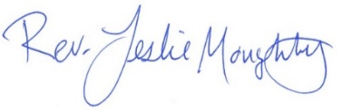
With peace,

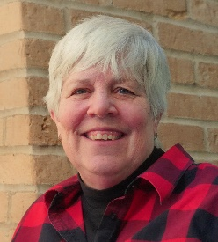
Moderator’s Musings
0

The Holiday and Christmas season is upon us!

It is a time that I contemplate all that I am thankful for: friends, family, a comfortable warm home and food on the table. And when I am talking to God, usually driving, or walking somewhere, I always express my thanks.

Last night when I was walking home from my brothers, staring up at the stars and finding them breathtaking, I as usual, said my thanks for such a spectacular sky; I thought of all of you, who I have met here at First Congregational United Church of Christ, and that too took my breath away.

I believe that God or angels take us on the paths we need to travel. And the path to this Church has been a true blessing in my life. Thank you all for traveling on part of my path. Your passion, generosity, humor, and love of music both humbles me and lifts me up in the good and challenging times of my life. It is an honor and a privilege to serve as your Moderator, thank you!

Blessings and joy to you all during this holiday season and throughout the year!
Mary Reardon

First Congregational UCC News & Updates
0
0
Pastor Leslie’s Workday Schedule

>> Sunday through Thursday (Days off are Friday and Saturday) <<

December Pastor’s Drop-in Hours*
Wednesdays 2:00 – 4:00pm Thursdays 11:00am – 1:00pm

Beginning in January Drop-in Hours*
Wednesdays 11:00am – 1:00pm Thursdays 2:00 – 4:00pm
During Thursday afternoon Pastor Leslie will be joined by Daisy “Minister of Fur Therapy”
*Drop-in hours are times set aside for “drop-in” conversations, much like a professor’s office hours. Pastor Leslie is typically working at the church the rest of the week, but it is possible that she may be in meetings, at a community event, or working off-site.
Pastor Leslie typically works off-site on Tuesdays for sermon research and writing.

Everyone is encouraged to make an appointment if the above times are not convenient.
You can go to www.calendly.com/pastorleslieucc and select a day and time that works for you, or you can email Pastor Leslie at pastorleslieucc@gmail.com or call/text at 218-656-0096.

Pastor Leslie will be out of the office
December 28th through the January 12th

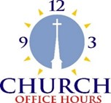
Church Office Hours
0
Wednesday, Thursday, Friday
10:00 am - 2:00 pm
Please call Terri at the office 218-829-2528 or
cell 218-537-1636 for further assistance.
Terri is taking vacation days Thursday, December 21st & Friday the 22nd.
The office will be closed Friday, December 22nd.

How to watch Sunday worship The worship service is broadcasted on the church Facebook page and the church's YouTube channel every Sunday at 10:00 am.
To watch worship on Facebook, go to https://www.facebook.com/uccbrainerd/live
Live stream videos are saved and can be viewed at any time.
Financial Help Available Your Church Council voted last year to allow the Pastor's Discretionary Fund to be used to assist church members and others in the Brainerd area who are experiencing financial distress during this time. We received many generous donations! If you need assistance, please email, call, or text Pastor Leslie. Let her know what your situation is and how the church might be of help.
Donate to the church online! We are now accepting your offerings and donations using PayPal. You do not need to have a PayPal account to make an online donation with a credit card. To use PayPal, go to: https://www.paypal.me/uccbrainerd
0
Small Group Journey Through Advent
Tuesday evenings at 5:30 pm
November 28th - December 19th
In-person in Fellowship Hall and via Zoom

Utilizing the book, Right Here, Right Now: The Practice of Christian Mindfulness by Amy G. Oden, we will intentionally turn our attention away from the preoccupations that distract us from our current experience and cultivate prayerful attention toward the present moment.
A few copies of the book will be available at church on Sunday. The book is also available on Kindle if you would like to start reading now. Light refreshments provided but feel free to bring some to share!

0
Greening the Church
Saturday, December 2nd @ 10:00 am
Join the Christian Ministry Committee for a festive greening of the church event! Come and help us prepare the way for the Advent and Christmas season.
We will have refreshments and fellowship so come one and all!

0
Advent and Christmas Worship
0
December 3rd – Advent 1: “Being Present with Hope” Worship with communion in-person and online at 10:00 am
December 10th – Advent 2: “Being Present with Peace” Worship in-person and online at 10:00 am.
December 17th – Advent 3: “Being Present with Joy” Worship in-person and online at 10:00 am.
December 24th – Advent 4: Christmas Eve “Being Present with Love & Light”
Worship in-person and online at 4:00 pm.
0
Movie Night – First Friday of each Month!
Movie promptly starts at 6:30 pm.

0
Christmas Flowers 2023
You have the opportunity to give a gift in the honor and in memory of your loved one(s). We will use the money to purchase flower arrangements for the altar. All memorials will be listed in the Christmas bulletin.
Please include all of the information below with your gift.
Amount of Memorial Gift: $________ In Memory Of: _________ Your Name: _________
Write your checks to: 1st Congregational Church with Memo: “Christmas Flowers”
Include this information with your check and drop it off at the church office, give at worship offertory, or mail it to: First Congregational Church, 415 Juniper Street Brainerd, MN 56401
You can also donate online! We are now accepting your offerings and donations using PayPal.
You do not need to have a PayPal account to make an online donation with a credit card. To use PayPal, go to: https://www.paypal.me/uccbrainerd Please memo: "Christmas Flowers"
New Member Affirming Service
0
Sunday, December 10th, 10:00 am
First Congregational UCC welcomes three new members to our congregation during worship service. We will affirm these new voting members: Debbie Branson, Denise Slipy, and Kim Slipy, and welcome Stefanie Lee as a continuing covenant member.
Join in the Potluck! Let’s welcome new members, with one of the things we do best, a potluck dinner! Come down to Fellowship after the short budget meeting. Christian Ministry will provide several soups and homemade bread. Bring your favorite dish/dessert to share.

0
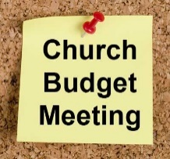
ANNUAL BUDGET Meeting - Congregational Budget Approval
Sunday, December 10th, at 11:15 am after worship
in-person and via Zoom
Please attend the congregational budget meeting to review and vote on the 2024 church budget. Meeting packets will be emailed to voting members on December 1st and distributed in person on the previous Sunday December 3rd before the meeting. Please notify Terri in the office if you need a packet sent to you by mail.

0
December Birthdays
Mary Harder December 1 John Krueger December 12 Karen Ford December 5 Paige Gustafson December 22
Joy Persall December 7 David Furda December 24
Virginia MacArthur December 8 Marcia Mans December 29
Lisa Wigand December 9 Carol Phelps December 29
Jack Kraywinkle December 11 Dave TenEyck December 29
Greta Norlander December 11 Dorothy Highum December 29 Betty Johnson December 12 Maggie Panning December 30 Greg Johnson December 31

Church Leadership
0
Get Involved, Give Back, Grow Connections – Volunteer at Church!
There are many other opportunities for you to share your talents!

--Treasurer, serves a 1-year term (may renew for 6 terms). The primary role is oversight of bookkeeping, church finances and Executive Committee discussions. This candidate should have a strong background or interest in finance or banking.

--Council Member-At-Large: Attend council meetings, act as a liaison for church members and council, help with nominations, spokesperson for historically underrepresented groups (HUGS).

Committees needing fresh faces and leadership:

*Christian Education *Stewardship *Music *Arts

Contact Mary Reardon - Moderator, with your nominations
0 Movie Night is starting up again this month!
Mark your Calendars!
0
Highlights of Council Meeting, Thursday, November 16th, 2023
3:30 pm (In-person and Zoom)
~If you would like a copy of the minutes, please contact the church office ~

Present: Lowell Johnson (Christian Ed), Mary Reardon (Moderator), Leslie (Pastor via Zoom), Terri Chidester (Admin, via Zoom), Alvin Velsvaag (Member-At-Large Mental Health, WISE), Dan Hegstad (PRC and marketing group), Marcia Ferris (Stewardship), Tim Anderson (Assistant moderator), Cynthia Janes (Clerk). Steve Newcom (Social Justice Minister) arrived after a few minutes.
- No additions or corrections to the October minutes. Approved as read.
- Clerk Report— No activity reported by Barb Stokke.
- Financials for October 2023: Financials through October look promising for a much better financial picture at year end than originally predicted by approved 2023 budget Income was higher. The projection for year’s end is that the budget may well balance with the actual at close of 2023. Motion to accept the report carried out.
- Committee Reports
- Trustees: Y’des has been contacted to diagnose the parsonage refrigerator problem.
- Stewardship:
  - Notes on Zoom meeting.
  - About half of the 40 people who use the UCC “Connections” site are UCC inactive.
  - During videoed church service offering can we have a pop-up with information. Dan - Do not have the technology to do this at the present time.
  - Dan - We had 101 views on Facebook last week. Could mean 101 people, but not necessarily. Mary--If a person tunes in and out during the service, they are counted each time they come back in.
- Christian Ministry: They were to meet this week but pastor not available so they will meet Monday.
- Christian Education: Report
- Pastoral Relations: Report, along with supplementary material. (Pls review.)
- Member at Large: Alvin (representing Mental Health) –Verbal report: Does not think WISE is in a very good position now and has been weakened. Alvin has ideas about this but needs to talk with some individuals before he can be more specific.
- Care Team Report: None. Communication with Council needed. Pastor Leslie has talked with the team, strongly requesting that they provide to Council some simple accounting (##s only, not names) of folks they have contacted, tried to contact, sent cards to, etc. Pastor Leslie - Around January would be a good time to have a congregation-wide check-in. Connected to this is our need to document attempts to contact people in membership role who are inactive.
- Pastor Report: Report. “Sabbatical Leave”, below.
Old Business
- Sabbatical leave March 4-June 4, 2024.
- Pastor Leslie: Implementation team so far is Steve Newcom, Sue Hadland. Marcia Ferris was added in this meeting. We will get a list of possible replacement pastors from Council and choose from among them.
- Need to finalize schedule and start contacting replacement pastor candidates. -- Pastor Leslie.
- Survey results dissemination, goal setting - Moderator. Date set for Adult Forum January 7, 2024.
- Further action needed that have been discussed by Council earlier but need next steps:
- Update usher training:
  - Thre are 2-3 sets of instructions for the ushers. Need to consolidate and laminate these. Moderator will do this.
  - If there are two ushers, one should ask as greeter.
  - Pastor Leslie: Hospitality is the whole reason for having ushers. Yes, there are specific instrumental activities, but ushers provide warm hospitality to people coming into the service, especially new people.
New Business
- 2024 Budget Proposal submitted by Executive Committee –Mary Reardon, Moderator
The proposed budget discussion topics:
- Predicted giving has been about 15% greater than actual pledges made before budgeting time.
- Salary increases recommended and their rationale.
- Pastor’s benefits projections
- Trustees start to build fund for making repairs as they come up, especially appliance repair and replacement, so that these expenses will not be such a jolt to Trustees budget.
- New committee: Marketing-- Dan Hegstad
Dan reviewed the committee’s proposal. Discussion—
- The proposal will be framed to be consistent with other standing committees.
Pastor Leslie suggested that a smaller amount ($250) should go into budget as a placeholder.
Respectfully submitted,
Cynthia Janes, Cleark of Council
0
Next Regular Council Meeting: Thursday, December 21st, 2023, 3:30 pm
in-person and via Zoom tinyurl.com/uccbrainerdzoom
0

UCC & TheShop Meal
0
Date Update!

Meal cooking is monthly on the SECOND Thursday of the month.
The next cooking date is December 14th at 3:45 pm.
For the last several years, UCC volunteers have provided a meal to the youth at TheShop - Brainerd Baxter Youth Drop-in Center. A number of youth from TheShop come over to our kitchen and help prepare a delicious meal that is then brought back to TheShop for the hungry and appreciative teens there.
Mary Benson is coordinating the meals, so if you are interested in joining and enjoy cooking with youth, please call or email Mary. 218-839-4990 or marybenson75@gmail.com

0
December Adult Forum - 11:30 am after worship

December 3rd – “Make It Ok”: A presentation regarding "Make It OK." A community campaign to reduce stigma by increasing understanding and creating caring conversations about mental health and illnesses. Presented by Alvin Velsvaag and Kay Cox, members of WISE.
2023 W.I.S.E. Resolution: This Adult Forum is part of our ongoing study of mental illness and the WISE program. First Congregational UCC Brainerd will devote time during the next 12 months learning about mental health issues to become a WISE (Welcoming, Inclusive, Supportive and Engaged around mental health) Congregation registered with the United Church of Christ Mental Health Network. After a year of study and raising awareness around mental health, a vote will be taken at our annual meeting in 2024 to reconfirm our WISE Covenant which will allow us to be designated as a WISE Congregation in the United Church of Christ.
December 17th - Justice Action Teams: Each team will have 3 minutes to provide an update on their work with an additional 5 minutes for Q & A and discussion. This is your opportunity to hear what the teams are planning and add your perspective. If you want to join a justice team, email Steve: snewcom17@gmail.com and plan to join us in December.

0
UCC Women’s Fellowship

Saturday, December 16th at 9:30 am in Fellowship Hall
Contact Marcia Ferris for information.

Thursday, December 28th at 11:30 am. At Grizzly’s in Baxter
Contact Kay Cox for information.

All updates will be posted on the Connections Facebook Group and RSVP’s may be made in the comments under the post at: www.facebook.com/groups/uccbrainerd

0
Friday Book Group
Our group is reading the book, “Gutsy Women”, by Chelsea and
Hilary Clinton.
We meet each Friday morning at 10:30 am via zoom.
Church Zoom link: https://tinyurl.com/uccbrainerdzoom

0
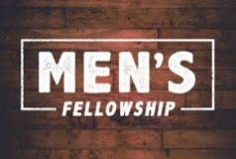
UCC Men’s Fellowship - Every Wednesday at Noon

You are invited to a casual fellowship at various locations in the Brainerd Lakes area.

Weekly Rotating Schedule:
1st Wednesday: B-Merri - 19624 Co. Rd. 3 Brainerd
2nd Wednesday: Four Seas - Brainerd
3rd Wednesday: Dunmire's East - Hwy 210 Brainerd
4th Wednesday: Black Bear - Baxter
5th Wednesday: Wings Airport Café – Hwy 210 Brainerd

Contact Jack Kraywinkle for more information 612-396-3480 or email: kraywinklej@gmail.com

0 Movie Night is starting up again this month!
Mark your Calendars!
Special Offering – UCC Missions Christmas Fund
0 Movie Night is starting up again this month!
Mark your Calendars!
Sunday December 24th
This month we have an opportunity as we give our Special Offering to the Christmas Fund UCC Missions. Administered by the Pension Boards on behalf of the church, helps provide pension and health premium supplementation to low-income retirees, emergency assistance to clergy families in need and Christmas gift checks to hundreds of annuitants. Please send your donation to First Congregational UCC, 415 Juniper St. Brainerd, MN 56401. Make sure to note on your offering: “Christmas Fund”. Thank you! Or for your convenience use our Paypal account at: paypal.me/uccbrainerd Be sure to note on your offering “Christmas Fund” in comments.

0
UCC Care Team

For anyone who wishes to join in on making calls or visits, the Care Team meets every month. Contact the church office for upcoming dates and times.
If you know of anyone who would enjoy a call from the care team, please contact one of our Care Team; Barb Hoeft, Jack and Kay Kraywinkle, Pat Scott, Chris Yager, Joey Halverson, Deb Griffith and Pastor Leslie.

0 Movie Night is starting up again this month!
Mark your Calendars!
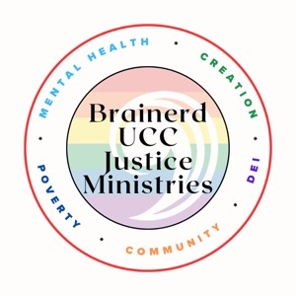
Justice Action Teams
The teams will meet again on December 17 during Adult Forum time. Each team will provide an update on their work with time for Q & A and discussion. This is your opportunity to hear what the teams are planning and add your perspective.

WISE - Mental Health: Alvin, Kay C., Chris, Tracy
Creation Care: Mark, Kay K, Mabel Community Building: Kim, Denise, Jan
Children & Families in Poverty: Georgia, Kim, Deb, Mabel
Diversity, Equity & Inclusion: Tracy, Jack, Chris

If you want to join a justice team, email Steve Newcom Justice Ministries at snewcom17@gmail.com and plan to join us in December. It is an open, welcoming process.

0
First Congregation Food Shelf Collection Boxes
Our church continues to collect non-perishable food items for the Salvation Army Food Shelf. There are two collection boxes: one in the parking lot entry hallway, the other in the Narthex. Brian Twamley picks up and delivers the food.
Please consider bringing items and donating. You may also send a money donation to the church; First Congregational UCC, 415 Juniper St. Brainerd, MN 56401. Or for your convenience use our Paypal account at: paypal.me/uccbrainerd Make sure to write in memo “Food Shelf”. Thank you!
0
0 Movie Night is starting up again this month!
Mark your Calendars!
H.U.G.S.
Hosts, Ushers, Greeters, Scripture-readers
Sunday morning greeters/ushers and coffee hosts play an important part in making our church a warm and welcoming place for all. Here’s a secret; it’s FUN!! If each household committed to 3 Sundays a year as greeter/ushers and/or coffee hosts, we would have a full complement of participants. Are you ready to take the leap into RADICAL HOSPITALITY? Give it a go and signup below for your first Sunday as the face of the church! https://www.signupgenius.com/go/10C0E48A9A823A5FFC07-hugs/16034811

0
The Columbarium at First Congregational UCC, Brainerd
The Columbarium is located in the historic space that once was our church’s front entry way.
How appropriate it is that our Columbarium now marks another entry way into a new life — where the Spirits of Love and Truth are always present!
Should you wish to learn more about the purchase of a niche for your own cremains or for the ashes of a loved one, please call the church office at (218) 829-2528 and a packet of materials will be sent you via email or regular mail.
The Memorial Committee has prepared the information packet, and it contains all the details you will need as you consider inurnment here at First Congregational UCC.
Have any other questions? Contact Dawn Stattine at dawnstattine@gmail.com

0
Save these Dates in January 2024!
Events & Activities at UCC Brainerd
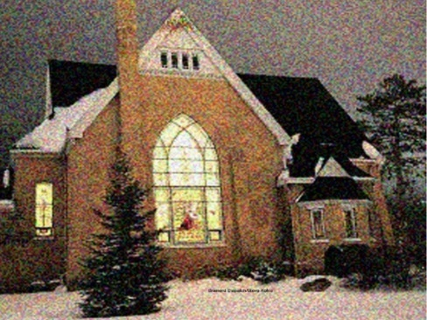
0
18th Annual Twelfth Night Concert
Sunday, January 7, 2023, at 7 p.m.

First Congregational UCC of Brainerd extends a warm welcome to please join us for our 18th Annual Concert in Celebration of the Twelfth Night of Christmas!
Volunteers are needed as we prepare and organize the event. Call or text Cynthia - 218-513-3956.

0
Volunteers for the Warming Shelter
Bridge on 7th
Our church is scheduled to volunteer early January. Please call Deb Griffith to learn more and to sign up. 218-851-2949.

Sign up link: https://whocanbethere.com/SignUp/week-of-dec-4/1V4mz3t0wPg
Training video: https://ministrygrid.lifeway.com/#/easy-link/WPGQ/45c4e6e3-e5dd-4aee-ab62-1f71c6a061bf
0
Mantra - Breath - Meditate
0 Movie Night is starting up again this month!
Mark your Calendars!
Monday, January 15th, 2024
6:00 - 7:00 pm
Upstairs Forum Room (Youth Room)
UCC Brainerd 5th & Juniper St.

Come breathe, chant, and meditate to help relax the body and focus the mind. Being intentional during meditations can create peace of mind and healing for yourself and the world.

Guided by Robin Soderlund
For questions: robinlynnsoderlund@gmail.com
Goodwill offering for facility use.
(Not affiliated with any religious organization)

0
Brainerd Lakes Area Information
~ Opportunities to Know and Share God’s Love ~
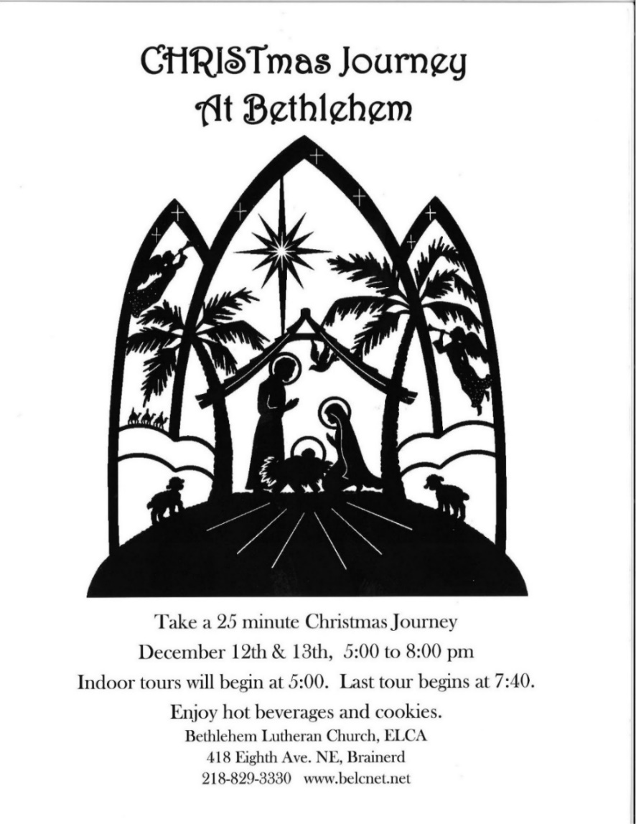
0

December 2023 Calendar
Sunday | Monday | Tuesday | Wednesday | Thursday | Friday | Saturday
Leslie Workday  LeMesa Grp-Meets some Tuesdays @ Gregory Park w/church backup | Leslie Workday | Leslie Workday | Office Hours10am – 2pm  Pastor Drop-in 2pm-4pm | Office Hour  10am – 2pm  Pastor Drop-in  11am – 1pm | Office Hours  10am – 2pm
 |  |  |  |  | 1  10:30am Book Grp-Z  6:30pm Movie Night in Fellowship Hall-Y | 2  10:00am Christian Ministry Greening the church-Y
8:30am Bnrd Frnds-Y 3  10am Wrship & Communion-Y&FB  11am Fellowship-Y  11:30am Adult Forum-Make It Ok/WISE presentation-Y  Hand out Budget Packets | 4  7pm BACP/BLUE church backup | 5  2pm EA-Y  5:30pm OA -Y  5:30pm Small Group Journey through Advent-Y&Z | 6  12pm Men’s Fellowship  @ B-Merri-Y  1:30pm PRC Mtg.-Y  7pm AA Common-Y | 7  10am Care Team Mtg-Y | 8  10:30am Book Grp- Z | 9  9am AAUW Mtg. in Fellowship Hall-Y
8:30am Bnrd Frnds-Y 10  10am Wrship & New Member Affirming Service-Y&FB  11:15am Budget Mtg. Congregation Approval-Y& Z  11:30am Fellwshp Potluck-Y  1pm Northwoods UU Mtg.-Y | 11 | 12  2pm EA-Y  5:30pm OA -Y  5:30pm Small Group Journey through Advent- Y&Z | 13  12pm Men’s Fellowship-@ Four Seas-Y  5:30pm Trustees Mtg.-Y  7pm AA Common-Y | 14  8:30am CM Mtg.-Y  3:45pmTheShop Cooking-Y 4pm Executive Team Mtg.-Y | 15  10:30am Book Grp- Z | 16  9:30am UCC  Women’s Fellowship in Fellowship Hall-Y
8:30am Bnrd Frnds-Y 17 10am Wrship -Y&FB  11am Fellowship-Y  11:30am Adult Forum Justice Team-Y  1pm Girl Scouts Mtg.-Y | 18 | 19  2pm EA-Y  5:30pm OA -Y  5:30pm Small Group Journey through Advent- Y&Z | 20  12pm UCC Men’s Fellowship @ Dunmire’s East-Y  7pm AA Common-Y | Terri Admin 21 Vacation Day  11:30am UCC Women’s Lunch @ Grizzly’s-Y  3:30pm Council Mtg-Y&Z  6:30pm Dist.7 AA-Y | Terri Admin 22 Vacation Day  10:30am Book Grp- Z | 23
Christmas Eve 24  8:30am Bnrd Frnds-Y 4pm Wrship-Y&FB  5pm Fellowship-?  *Special Offering-UCC Missions Christmas Fund  *Newsletter Deadline  1pm Northwoods UU Mtg.-Y | 25  Christmas Day | 26  2pm EA-Y  5:30pm OA -Y | 27  12pm Men’s Grp @  Black Bear Grill-Y  7pm AA Common-Y | 28  Pastor Leslie out of the office thru Jan.12th | 29  10:30am Book Grp- Z | FB –Stream Online  Z- our Zoom  C- Cancelled  N-None  ? – No update  Y- Yes Mtg. in person

