Friendship News, February 2024
0
First Congregational United Church of Christ, Brainerd
An Open and Affirming Congregation
The Church Office Hours: Wednesdays – Fridays from 10:00am – 2:00pm
Pastor Leslie’s Drop-in Hours: Wed. 2:00pm – 4:00pm, Thurs. 11:00am – 1:00pm
Office phone 218-829-2528 Office E-mail uccbrainerd@gmail.com Pastor’s E-mail: pastorleslieucc@gmail.com Website: www.uccbrainerdmn.org
Schedule a 1 to 1 (in-person or by Zoom or Phone) with Pastor Leslie:
www.calendly.com/pastorleslieucc/1to1

No matter who you are, or where you are on life’s journey, you are welcome here.
0
Pastor’s Pen
0
“What will make your heart sing?”
We have been blessed with a very generous grant by the National Clergy Renewal Program and the Lily Endowment to fund a three-month renewal leave for me and three months of support and renewal for the congregation. As many of you know, I was eligible for a 3-month period of renewal after 5 years of service to the church. A myriad of factors resulted in a significant delay but now, after 9 years of serving this incredible congregation, I will be going on a journey of both miles and memories beginning Monday March 4.
You might be wondering why it’s important for clergy take a renewal leave (commonly referred to as a sabbatical) and why the Lily Endowment considers it so important that they would spend hundreds of thousands of dollars every year to make the renewal times especially enriching. Christopher L. Coble, the Endowment’s vice president for religion writes, “Pastors play an important role in nourishing the spiritual lives of individuals and in guiding the work of the Christian congregations they serve. Through these grants, we seek to honor pastors for their extraordinary service and enable them to engage in a brief period of rest and renewal. We have learned that such experiences invigorate the leadership of pastors and bring new vitality to their congregations as well.”
The grant application asked, “What will make your heart sing?” When I pondered this question, I realized that what I needed most was to be with the people I love and care about as well as exploring activities and practices that lift my spirit and nurture my faith. During the three months that I will be away, I will be traveling to New Mexico, Arizona, Los Angels, Seattle, New York, New Hampshire and even Spain! I will be spending time reconnecting with family and dear friends, exploring the spiritual practice of walking meditation, engaging in spiritual direction, taking time for quiet retreat, attending worship in a variety of faith communities, and admiring art in its many forms.
The congregation (that’s you!) will also be using this three-month renewal time to engage in some new experiences, to connect with one another in new ways, and to deepen your faith. March will focus on learning how to tell your stories and experiences of faith as we reclaim the Christian tradition of testimony. The book, “Tell It Like It Is” by Lilian Daniel will guide this time. Free paperback copies are available to those who want to participate.
In April Kay Cox will lead you in using the Meyers-Briggs Personality Type assessment as you learn more about yourselves and each other and to enhance communication and understanding.
Learning about spiritual gifts is the focus for May. Each and every one of you was endowed with gifts by our Creator God. Learning about what gifts we each possess will help us appreciate one another as well as understand and live into the gifts we have each been given.
More information about all of this will continue to be shared over the coming weeks and months. For now, save the date of Sunday March 3! This will be my last Sunday at church and we will be blessing my leave-taking as well as welcoming the coverage pastor, T. Michael Rock. Come share in this festive time!
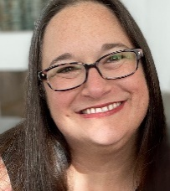
Thank you church, for understanding the need for this gift of time away to rest and renew. I am so grateful for your support and care, and I am excited for the experiences we will all be having during this time.
With peace,
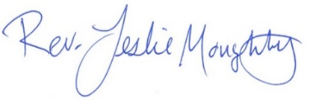

0
Introducing T. Michael Rock – Renewal Leave Pastor
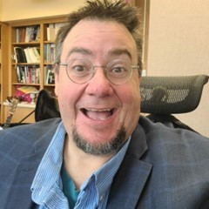
While Pastor Leslie is away on Renewal Leave, the Rev. T. Michael Rock will be shepherding us and supporting our own renewal journey.
Rev. T. Michael Rock has been an ordained minister, a liberation theologian, and an educator in the United Church of Christ since 1996 and until recently served as one of the Co-Pastors and Teachers at Robbinsdale Parkway United Church of Christ in Robbinsdale, Minnesota. He served congregations in Massachusetts and Rhode Island as well. T. Michael is also an activist and experienced trainer in nonviolence, civil disobedience, and sexuality education.
The interview team (Mary Reardon, Marcia Ferris, and Pastor Leslie) are excited about the experience T. Michael brings in many of the areas we will be engaging with in March, April, and May. He has an infectious energy, a compassionate heart, and a deep faith.
You will have an opportunity to meet T. Michael on Sunday March 3 after the worship service to celebrate the beginning of this exciting time of renewal and connection.
I know you all will make him feel welcome!
First Congregational UCC News & Updates
0
At the January Council Meeting, your Church Council adopted the following purpose statement. You will begin to see this in the bulletin, the newsletter, and other materials.
“First Congregational UCC is a welcoming, inclusive, and progressive community committed to promoting social justice, spiritual growth, and love for all people. We reject discrimination and advocate for equality and dignity for marginalized communities. Through worship, education, and service, we work to make a positive impact on the world and invite all individuals to join us in this journey of faith and service.”
0
Pastor Leslie’s Workday Schedule

>> Sunday through Thursday (Days off are Friday and Saturday) <<
2024 New Drop-in Hours*
Wednesdays 11:00am – 1:00pm Thursdays 2:00 – 4:00pm
During Thursday afternoon Pastor Leslie will be joined by Daisy “Minister of Fur Therapy”
*Drop-in hours are times set aside for “drop-in” conversations, much like a professor’s office hours. Pastor Leslie is typically working at the church the rest of the week, but it is possible that she may be in meetings, at a community event, or working off-site.
Pastor Leslie typically works off-site on Tuesdays for sermon research and writing.

Everyone is encouraged to make an appointment if the above times are not convenient.
You can go to www.calendly.com/pastorleslieucc and select a day and time that works for you, or you can email Pastor Leslie at pastorleslieucc@gmail.com or call/text at 218-656-0096.

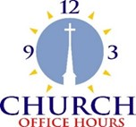
Wednesday, Thursday, Friday
0
10:00 am - 2:00 pm
Please call Terri at the office 218-829-2528 or
218-537-1636 (cell) for further assistance.

Terri Vacation Days: February 21st, 22nd, 23rd & 29th
Office will be closed Friday, February 23rd

How to watch Sunday worship: The worship service is broadcasted on the church Facebook page and the church's YouTube channel every Sunday at 10:00 am.
To watch worship on Facebook, go to https://www.facebook.com/uccbrainerd/live
Live stream videos are saved and can be viewed at any time. All memorials, weddings and 12th Night Concert are on our church Facebook page.
How to stay connected with First Congregational friends and members: Join the private group for our Facebook Connections Page at https://www.facebook.com/groups/uccbrainerd
Financial Help Available Your Church Council voted last year to allow the Pastor's Discretionary Fund to be used to assist church members and others in the Brainerd area who are experiencing financial distress during this time. We received many generous donations! If you need assistance, please email, call, or text Pastor Leslie. Let her know what your situation is and how the church might be of help.
Donate to the church online! We are now accepting your offerings and donations using PayPal. You do not need to have a PayPal account to make an online donation with a credit card. To use PayPal, go to: https://www.paypal.me/uccbrainerd

0

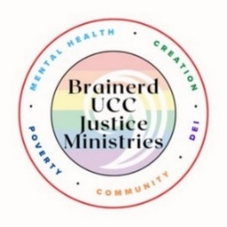
Update from Brainerd UCC Congregational Justice Ministries

Justice Ministries

First Justice Sunday – February 11th
We have 30 congregational members involved with one or more of the five justice priorities identified by the congregation: Mental Health, Creation Justice, Poverty, DEI/LGBTQ, and Community Building.

Every couple of months, we will host a Justice Sunday. On Justice Sunday, we will forgo the traditional fellowship treats, have a justice-focused presentation, share a buffet meal, and provide time for the multiple justice groups to meet. We will have 5-6 Justice Sundays per year.

I want to highlight these are NOT standing committees with elected members but rather open tables around which congregational members gather to lead our congregation into deeper discipleship and impact. Come sit with us.

Justice Sunday Schedule:
10:00-11:00 Worship
11:00-11:15 Gather in the fellowship hall. Coffee & Tea
11:15-11:45 Group Presentation/Engagement
11:45-12:15 Simple meal buffet
12:15-1:15 Justice tables meet
1:15-1:30 Table Reports & Evaluation

We will be joined by Rev. Todd Lippert, founder of the Rural Organizing Project (ROP). ROP has identified a number of priorities focused on rural communities that align strongly with our justice priorities. This gathering will provide an opportunity to explore how our impact might be increased by participation in the Rural Organizing Project.

“The Rural Organizing Project operates under the motto Faith in Democracy, and don't we want to have more faith, more trust, in our democratic process? Don't we want to have more trust that our democracy is really for all of us? We can decide to create that and organize powerfully together so that it happens. We'll talk about faith-based community organizing, the best of what it has done and can do, and the difference it can make in rural areas.”

Rev. Lippert is an ordained minister in the United Church of Christ. Todd served in active pastoral ministry for 17 years, serving two small churches in Dodgeville and Mineral Point, WI, and then as the Senior Minister at First UCC in Northfield, MN. He transitioned out of pastoral ministry as he served two terms in the Minnesota House from 2019 to 2022, representing the Northfield area. He decided not to run for a third term to start the Rural Organizing Project of ISAIAH MN. Todd grew up in a town of 700 people in northwest Iowa, and he has given his professional life to creating compassionate, vital rural communities. Todd's current focus, and the focus of the Rural Organizing Project, is building rural power to create an economy and a democracy that honors the dignity and worth of rural people.

Organizations
~ Brainerd Friends Meeting (Quaker) ~ Crow Wing Energized
~ First Congregational United Church of Christ
~ Micah group - Lord of Life Lutheran Church ~ Northwoods UU Fellowship
~ People for Racial Justice ~ Pequot Parents for Kindness
~ Trinity Lutheran Church

Support for Public Education: The Justice Table met with Superintendent Hahn to discuss how we can provide strategic support to the school board, administration, and teachers. Dr. Hahn said she was deeply appreciative of our concerns and support. She shared that in her entire public education career, she had never experienced this level of antagonism toward teachers and administration. Nor this level of teacher burnout. She emphasized that staff need to know they are supported and valued. In response to her request we have launched…

Show a Little Love campaign, which begins with a 1/2 page Valentine’s Day affirmation of public education teachers and staff.

If you would like to support the Show a Little Love campaign and help purchase this ad ($957), you can make a check to the church with Valentine in the memo line.

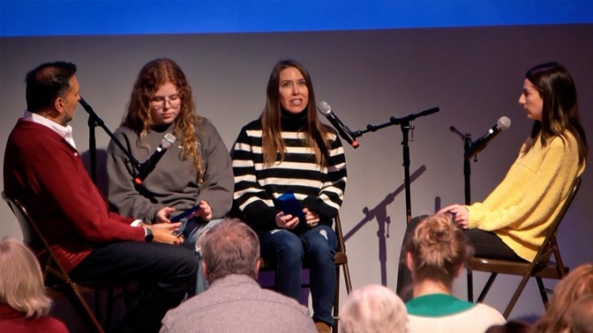
The Justice Table hosted ConnectEffect
in partnership with CLC
January 23, 24 & 25.
Our congregation provided refreshments.

The ConnectEffect examined media, division, identity, human connection, and the difference between the “Real World and the “Screen World” in a deeply personal and deeply disarming way. ConnectEffect took an audience of total strangers with every background and opinion imaginable (true diversity) and quickly equalized and humanized them into ONE DEEPLY CONNECTED GROUP.
0
Church Directory To Be Updated for 2024
Dan Hegstad will also be taking photos of your beautiful faces to be included in the directory after worship on the first two Sundays in March.
If you do not have a picture taken by Dan, please send us an updated photo. Email your photo to Terri in the office at uccbrainerd@gmail.com A jpeg is the best format. Or you may bring a photo into the office or mail it and Terri will scan it for you. Please note if you would like the photo returned.
Has your contact information changed? Do you want to be removed from or added to the directory? Please contact Terri in the office by email or using the information update section on the prayer cards in the back of the pews.
Help us stay connected! Thank you!

February Birthdays
0

Yvonne Leiser February 2 Ann Turnbull February 18
Annie Grabowski February 7 George Sonnichsen February 24
Roger Maas February 11 Colleen LeBlanc February 24
Georgia Harris February 15 Autumn Caldwell February 27
Laurie Lang February 15
Mary Reardon February 17

Church Leadership
0
Get Involved, Give Back, Grow Connections – Volunteer at Church!
There are many other opportunities for you to share your talents!

--Treasurer, serves a 1-year term (may renew for 6 terms). The primary role is oversight of bookkeeping, church finances and Executive Committee discussions. This candidate should have a strong background or interest in finance or banking.

--Council Member-At-Large: Attend council meetings, act as a liaison for church members and council, help with nominations, spokesperson for historically underrepresented groups (HUGS).

Committees needing fresh faces and leadership:

*Christian Education *Stewardship *Music *Arts *Trustees
Contact Mary Reardon - Moderator, with your nominations
0
Highlights from the Council Meeting, January 18th, 2024
Thursday, 3:30 pm (In-person and Zoom)
~ These are highlights. If you would like a copy of the full minutes, please contact the church office ~

December, 2023 Council Minutes: Approved
Clerk Report — Deaths: Betty Johnson (December 27, 2023), Jim Newgord (January 6, 2024)
Financials
December 2023 Financial Report: The church General Fund ended the year with a surplus of $10,480, A deficit of $19,000 was budgeted; therefore, income exceeded the budgeted expenses by nearly $29,454. This was in spite of an unbudgeted cost of over $2900 for partial payment of the recent road repairs on our streets.
Department Reports
Written reports received: Christian Ministry, PRC/Marketing, Trustees (budget only, have not met since last Council mtg), PRC, Pastor Leslie, Christian Ed. PRC has not met since our last Council meeting. No report: Care Team.
Report highlights:
- Christian Ministry (Sue Hadland) like Council opinion on other church groups possibly taking lead of two of the three Sunday worship programs that the congregation is in charge of during Leslie’s sabbatical absence. Discussion by Council : Council will organize these Sunday Worship programs. Lots of good ideas for programs. Wise will be involved.
- Stewardship (Marcia Ferris: Would like to see Outreach get high priority. Church purpose statement? (See Old Business.)
- Christian Education (Lowell Johnson):
  - Adult Forum Schedule: Kay Cox will lead a mock Alano session on 1/21. On 2/11 Steve Newcom will sponsor the Adult Forum time session on Leadership in Rural areas led by the guest preacher that day. On 2/18 Ellie Burkett will lead a session of Death Cafe.
  - Lowell has also been working with the WISE group on reinvigorating our educational programming both within the church and in the community in partnership with Crow Wing Energized.
- PR/Marketing (Dan Hegstad)
- Have been exploring marketing options but have found none that are appropriate or affordable.
- Are considering ads in the Northland Press and/or News Hopper.
- For marketing our church some of the words in the AI-generated purpose statement are very useful, such as “welcoming,” “inclusive,” and “progressive.”
- One of the two big TV’s will be hung on the wall above the organ.
- Sound system: There are a number of people who are responsible for doing our live streaming on Sunday mornings, but not all know how to use the sound system. Training will take place soon.
- Foundation (Dan Hegstad)
Lisa Wigand has stepped down as chair of the Foundation. Charlotte Goedsche will be the new chair. Colleen LaBlanc will be a new Foundation Board member.
- Pastor’s Report:
Received profiles for 3 candidates for Renewal Leave coverage pastor. All three are from the Twin Cities. Mary Reardon, Marcia Ferris, and I will be interviewing candidates in the next week.
Verbal reports:
- Alvin Velsvaag (At-Large): Lowell is now in contact with the officials who are in charge of the WISE program to get a clear understanding of what we need to do to become a WISE congregation, and to get their input on procedure and ideas.
- 12th Night Concert results: Cynthia Janes, Coordinator: Lasted just about one hour and could have been a bit longer; turned out well, people hung around to converse, people went to the Fellowship Hall to view Carla Benjamin’s art and made lots of positive comments about it. That and electric candles were our expenses, the profit of $750 going to the Brainerd High School Music Programs.
Old Business
Follow-up on ushers’ training: Mary meets each week with ushers to review duties. Mary often comes early to be sure that ushers are trained but would like to do more intentional training at an Adult Forum.
Follow-up on last Sunday’s forum on church survey: How do these results relate to all that is now going on in the church? Need to unite activities under a common plan with clear purpose. Can we adopt a statement of purpose? Marcia moved that the AI-generated statement of purpose that was reported in an earlier Council meeting by Sue Hadland be adopted as our statement of purpose for the church. Passed unanimously.
New Business
- Special Offerings for 2024; They will be the same as in 2023.
- Updates for Council Binder from Terri: the Leadership Roster, Special Offerings calendar, and Council Calendar have been updated by Terri and were passed out at this meeting for all to incorporate into the Council binder.
- Appointment of Council leadership committee: Discussed, not appointed.
- Kay Cox moved that for purposes of continuity and training, we add the past-moderator to the Council, and that the past moderator would be a voting member. The motion was seconded and carried unanimously.
- Should the church change its name? Dan Hegstad will be in charge of researching this idea and will take the process slowly and carefully into at least summer, and possibly later. Cynthia suggested that there are really two questions: Should the name be changed, and then if the answer is yes or maybe, what should the new name be? Pastor Leslie said that we need to talk to the Conference before proceeding. Council appointed Dan to explore a name change.
- Deb Griffith announced that there has been a 36% increase in the church insurance for 2024. She will look at other options. Deb added the Church Mutual has many resources that we could take advantage of (e.g., safety suggestions).

Respectively Submitted,
Cynthia Janes, Clerk

Next Regular Council Meeting: Thursday, February 15th, 2024, 3:30 pm
0

in-person and via Zoom tinyurl.com/uccbrainerdzoom
0

Movie Night – First Friday of each Month!
Friday, February 2nd

Come early to visit & settle-in!
Movie promptly starts at 6:30 pm.

Pastor Leslie is hosting the movie is “Noah”.

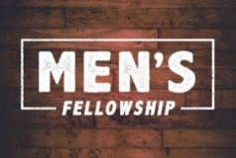
UCC Men’s Fellowship
0

Every Wednesday – 11:45 am @ Perkins

Meet for a casual fellowship at Perkins. Contact Dan Hegstad
@ 218-851-5900 or dan@danhegstad.com

0
UCC & TheShop Meal
SECOND Thursday of the month!
The next cooking date is February 8th at 3:45 pm.
For the last several years, UCC volunteers have provided a meal to the youth at TheShop - Brainerd Baxter Youth Drop-in Center. A number of youth from TheShop come over to our kitchen and help prepare a delicious meal that is then brought back to TheShop for the hungry and appreciative teens there.
Mary Benson is coordinating the meals, so if you are interested in joining and enjoy cooking with youth, please call or email Mary. 218-839-4990 or marybenson75@gmail.com

0
February Adult Forum & Justice Sunday

February 11th @ 11:15 am - First Justice Sunday "Faith in Action: Rural Organizing": Steve Newcom hosting Rev. Todd Lippert from the Rural Organizing Project of ISAIAH. ISAIAH is a vehicle for congregations, clergy, and people of faith to act collectively and powerfully towards racial and economic equity in the state of Minnesota. Join us as we dream together about what even more powerful organizing could look like in Brainerd.
February 18th @11:30 am - "Death Café": Please join our Adult Forum conversation on Sunday, February 18 when Ellie Burkett will facilitate our second Death Cafe. A Death Cafe is a group directed discussion of death with no agenda, objectives or themes. It is a discussion group rather than a grief support or counselling session.The objective is 'to increase awareness of death with a view to help people make the most of their (finite) lives'.

0
Friday Book Group
Our group is reading the book, “Gutsy Women”, by Chelsea and
Hilary Clinton.
We meet each Friday morning at 10:30 am via zoom.
Church Zoom link: https://tinyurl.com/uccbrainerdzoom

0
UCC Care Team
For anyone who wishes to join in on making calls or visits, the Care Team meets every month on the first Thursday at 10:00 am. The next meeting in February is Thursday, February 1st.
If you know of anyone who would enjoy a call from the care team, please contact one of our Care Team; Barb Hoeft, Jack and Kay Kraywinkle, Pat Scott, Chris Yager, Joey Halverson, Deb Griffith, and Pastor Leslie.
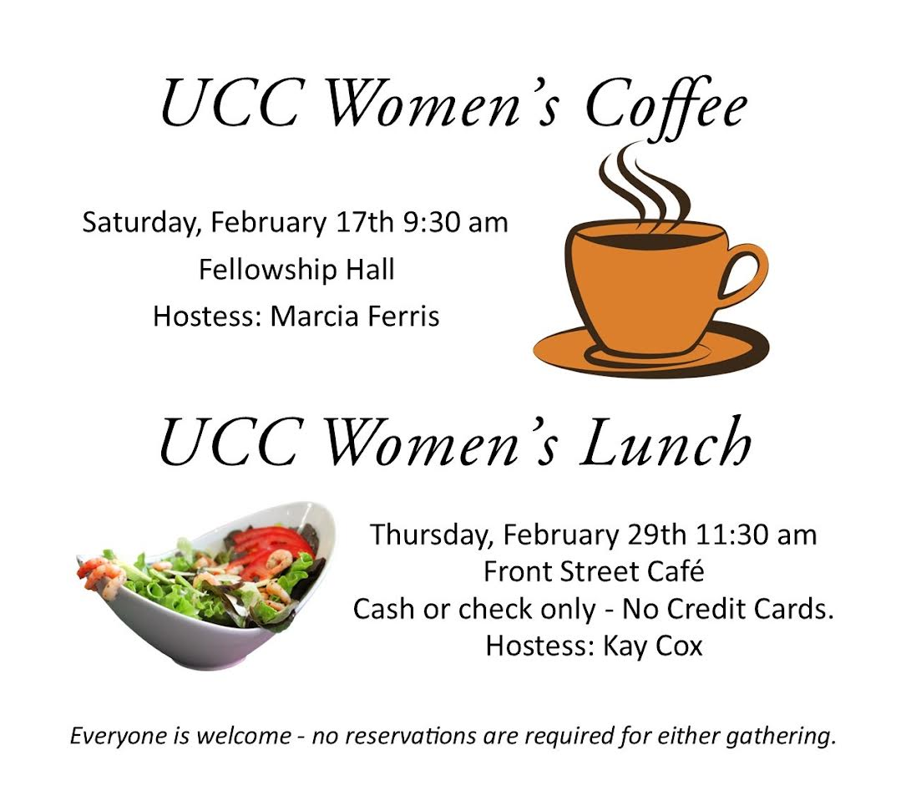
0

All updates will be posted on the Connections Facebook Group and RSVP’s may be made in the comments under the post at: www.facebook.com/groups/uccbrainerd

0
Special Offering Sunday Worship February 25th
My Neighbor to Love Coalition
Ending homelessness in the Brainerd Lakes area with a comprehensive approach. Building homes, connecting people, offering hope. The mission is to increase the stability, health, safety, and wealth of our most economically disadvantaged community members by creating affordable housing in an intentional living community. Our goal is not to keep people more comfortably homeless, but to end homelessness altogether. Building small, connected rental homes within an intentional living community in NW Brainer – Creekside Community. Learn more at: www.mntlc.org

Please send your donation to First Congregational UCC, 415 Juniper St. Brainerd, MN 56401. Or for your convenience use our Paypal account at: paypal.me/uccbrainerd
Make sure to note on your offering: “Special Offering Neighbor to Love”. Thank you!

0
0
February W.I.S.E. Food for Thought
"Not the world, not what's outside of us, but it is what we hold inside that traps us. We may not be responsible for the world that created our minds, but we can take responsibility for the mind with which we create our world. " Gabor Mate

W.I.S.E. Welcoming, Inclusive, Supportive and Engaged

2023 W.I.S.E. Resolution: First Congregational UCC Brainerd will devote time during the next 12 months learning about mental health issues to become a WISE (Welcoming, Inclusive, Supportive and Engaged around mental health) Congregation registered with the United Church of Christ Mental Health Network. After a year of study and raising awareness around mental health, a vote will be taken at our annual meeting in 2024 to reconfirm our WISE Covenant which will allow us to be designated as a WISE Congregation in the United Church of Christ.

0
First Congregational Food Shelf Collection

Our church continues to collect non-perishable food items for the Salvation Army Food Shelf. There are two collection boxes: one in the parking lot entry hallway, the other in the Narthex. Brian Twamley picks up and delivers the food.

Please consider bringing items and donating. You may also send a money donation to the church; First Congregational UCC, 415 Juniper St. Brainerd, MN 56401. Or for your convenience use our Paypal account at: paypal.me/uccbrainerd Make sure to write in memo “Food Shelf”. Thank you!

0 Movie Night is starting up again this month!
Mark your Calendars!

H.U.G.S.
Hosts, Ushers, Greeters, Scripture-readers
Sunday morning greeters/ushers and coffee hosts play an important part in making our church a warm and welcoming place for all. Here’s a secret; it’s FUN!! If each household committed to 3 Sundays a year as greeter/ushers and/or coffee hosts, we would have a full complement of participants. Are you ready to take the leap into RADICAL HOSPITALITY? Give it a go and signup below for your first Sunday as the face of the church! https://www.signupgenius.com/go/10C0E48A9A823A5FFC07-hugs/16034811
0 Movie Night is starting up again this month!
Mark your Calendars!

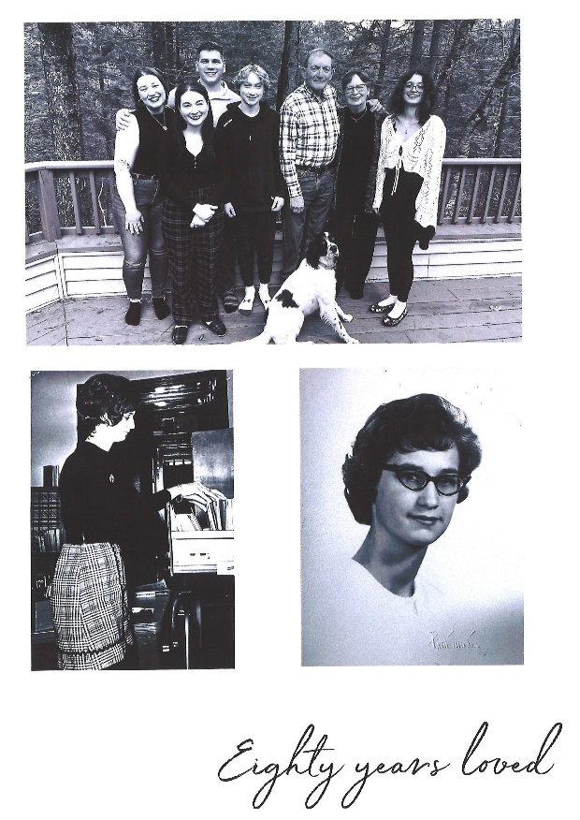

UCC Brainerd hosts Events, Group Meetings & Activities
0
0
Art Exhibit in Fellowship Hall

Carla Benjamin has a new art exhibit in the Fellowship Hall.

10% of purchased artwork will be donated to First Congregational.
Thank you Carla for beautiful artwork!

Visit Carla’s website at: carlabenjamin.com

0
Brainerd Lakes Area Information
~ Opportunities to Know and Share God’s Love ~
0

We have had a lot of folks wondering about the status of our Baxter location. Our staff and volunteers have been working hard to get the store ready, and we have a date set finally! As of February 19th (President's Day) we will be open for shopping at our new location. We will stop taking donations at our current Baxter location on Tuesday, February 13th and resume taking donations at our new location starting the following Tuesday, February 20th. Our Crosby and Crosslake locations will continue to accept donations M-F from 10-6. Our team cannot wait to show off this beautiful new space! Find us at 17140 MN 371, Brainerd, MN.

0
THE BRIDGE ON 7th – Warming Shelter
We are well into our 3rd season at the Bridge on 7th Overnight Shelter.
At the end of 2023 Ann Hunnicutt stepped down as shelter director, and
Bill Wear was promoted to take her place with both the shelter and
Operation Sandwich. Bill has a great understanding of our mission at The Bridge and is excited to work with our staff, guests, and volunteers in this new capacity. As he is typically working overnights, email is a great way to contact him. His email is bill@bridgesofhopemn.org.
So far this season our shelter is staying busy, and unfortunately, we don't expect that to change. To date we have offered over 143 unique individuals 2038 nights of sleep - that is an average of 15 guests each night since we reopened in September. We are thankful to the volunteers and donors that make this program possible.

0
February 2024 Calendar
Sunday | Monday | Tuesday | Wednesday | Thursday | Friday | Saturday
Leslie Workday | Leslie Workday | Leslie Workday | Leslie Workday  New Pastor Drop-in Hrs.  11am-1pm  Office Hours  10am – 2pm | Leslie Workday  New Pastor Drop-in Hrs.  2pm – 4pm Office Hour  10am – 2pm | Office Hours  10am – 2pm
 |  |  |  | 1  10am Care Team Mtg-Y | 2  10:30am Book Grp-Z  6:30pm Movie Night: Fellowship Hall-Y | 3
8:30am Bnrd Frnds-Y 4  10am Wrship & Communion-Y&FB  11am Fellowship-Y  Meet Renewal Leave Pastor T. Michael  after worship | 5  7pm BACP/BLUE via Zoom for the winter | 6  2pm EA-Y  5:30pm OA -Y | 12pm UCC Men’s 7  Fellowship-Perkins -Y  5:30pm Trustees Mtg.-Y&Z  7pm AA Common-Y | 8  8:30 CM Mtg.-Y  3:45pmTheShop Cooking-Y  4pm Executive Team Mtg.-Y | 9  10:30am Book Grp- Z | 10
8:30am Bnrd Frnds-Y 11  10am Wrship -Y&FB  Guest Preacher Rev. Todd Lippert  11am 1st Justice Sunday-Y  w/Steve Newcom hosting Rev. Lippert  1pm Northwoods UU Mtg.-Z | 12 | 13  2pm EA-Y  5:30pm OA -Y | Ash Wednesday 14  5:30 Worship Service  12pm UCC Men’s Fellowship-Perkins -Y  5:30pm Trustees Mtg.-Y  7pm AA Common-Y | 15  3:30pm Council Mtg-Y&Z  6:30pm Dist.7 AA-Y | 16  10:30am Book Grp- Z | 17  UCC Women’s  Fellowship in Fellowship Hall-Y
8:30am Bnrd Frnds-Y 18  10am Wrship -Y&FB  11am Fellowship-Y  11:30 Adult Forum-Death Café w/Ellie Burkett  1pm Girl Scouts Mtg.-Y | 19  . | 20  2pm EA-Y  5:30pm OA -Y | Admin Vacation Day  12pm UCC Men’s 21  Fellowship-Perkins -Y  1:30pm PRC Mtg.-Y  7pm AA Common-Y | Admin Vacation Day  22 | Admin Vacation Day  Office Closed 23  10:30am Book Grp- Z | 24  9:30am-1pm AAUW in Fellowship Hall
8:30am Bnrd Frnds-Y 25  10am Wrship-Y&FB  11am Fellowship-Y  *Special Offering  Our Neighbor To Love  *Newsletter Deadline  1pm Northwoods UU Mtg.-Z | 26  . | 27  2pm EA-Y  5:30pm OA -Y | 28  12pm UCC Men’s Fellowship-Perkins -Y  7pm AA Common-Y | Admin Vacation Day  29  11:30am UCC Women’s Lunch @ Front Street Café-Y  (Cash only) | Admin. Asst. Terri Vacation Days: Feb. 21st 22nd 23rd & 29th | FB –Stream Online  Z- our Zoom  C- Cancelled  N-None  ? – No update  Y- Yes Mtg. in person

