
Friendship News, April 2026
0
First Congregational United Church of Christ, Brainerd
An Open and Affirming Congregation
The Church Office Hours: Tuesday, Wednesday, Thursday from 10:00am – 2:00pm
Office phone 218-829-2528 Office E-mail uccbrainerd@gmail.com
Pastor Leslie’s E-mail: pastorleslieucc@gmail.com Website: www.uccbrainerdmn.org

No matter who you are, or where you are on life’s journey, you are welcome here.
0
Pastor’s Pen
0

Easter: The Good News Is Alive—and Still Unfolding
Each year, Easter arrives with familiar words: “He is risen!” And each year, we are invited to consider what resurrection means—not just then, but now. For many of us, the question of how resurrection happened remains open. I don’t know if it is something that could have been captured on video—but I do know that it is true. Not because of certainty about the mechanics, but because of what resurrection continues to do.
Easter is not just a claim about one moment in history. It is a claim about reality itself—that new life is still possible, still emerging, still unfolding in the world around us. Too often, we treat Easter like a single day and then move on. But Easter is not meant to be contained. Instead, it marks the beginning of a new way of seeing the world—one that looks for signs of life breaking through, even when we least expect it. To live as Easter people is to trust that life can emerge where we assumed there was none—to believe that endings are not always final, and that despair is not the last word—even when fear and uncertainty are still very real.
But resurrection is not only something we witness—it is also something we are invited to participate in. Sometimes resurrection is personal: the courage to begin again, the slow return of hope. At other times, it is communal: when people come together to imagine a future that does not yet exist, when a community finds the courage to grow and become something new—sometimes in quiet, subtle ways, and other times in ways that feel undeniable.
The story of Easter does not skip over death—it moves through it, transforming what seemed final into something still unfolding. In this way, resurrection is not a return to the past, but the emergence of something new, inviting us to release what has been—not because it didn’t matter, but because something new is taking shape.
We all carry places in our lives—and in our life together—that feel uncertain, stretched, or even weary. Easter does not ask us to deny that reality. Instead, it invites us to trust that new life is still possible, even here.
So this Easter season, notice what is growing. Pay attention to moments of unexpected grace. And consider how you might be invited to take part in that new life—personally, and together.
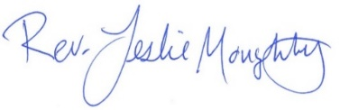
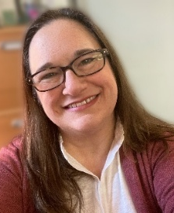
Because Easter is not just something we remember. It is something we live.
With Resurrection Joy,

Mission Statement of First Congregational UCC
“To know and share God’s love within us.”

Purpose Statement of First Congregational United Church of Christ
“First Congregational UCC is a welcoming, inclusive, and progressive community committed to promoting social justice, spiritual growth, and love for all people. We reject discrimination and advocate for equality and dignity for marginalized communities. Through worship, education, and service, we work to make a positive impact on the world and invite all individuals to join us in this journey of faith and service.”

0

Church Office Hours
Tuesday, Wednesday, Thursday 10:00 am - 2:00 pm
Closed Mondays and Fridays
Please call for assistance - office 218-829-2528

0
Pastor Leslie’s Workday Schedule

Sunday through Thursday (Days off are Friday and Saturday)
Drop-in Hours: Wednesdays 11:00 am – 1:00 pm
*Drop-in hours are times set aside for “drop-in” conversations, much like a professor’s office hours.
Everyone is encouraged to make an appointment, especially if the above times are not convenient. You can go to www.calendly.com/pastorleslieucc and select a day and time that works for you, or you can email Pastor Leslie at pastorleslieucc@gmail.com or call/text at 218-656-0096.

0
Stay Connected

How to watch Sunday worship: The worship service is broadcasted on the church Facebook page every Sunday at 10:00 am.
To watch worship on Facebook, go to https://www.facebook.com/uccbrainerd/live
How to stay connected with First Congregational friends and members: Join the private group for our Facebook Connections Page at https://www.facebook.com/groups/uccbrainerd.
Financial Help Available The Pastor's Discretionary Fund is available to assist church members and others in the Brainerd area who are experiencing financial distress with modest financial help. If you need assistance, please email, call, or text Pastor Leslie. Let her know what your situation is and how the church might be of help.
Donate to the church online! We are accepting your offerings and donations using PayPal.
You do not need to have a PayPal account to make an online donation with a credit card. To use PayPal, go to: https://www.paypal.me/uccbrainerd

First Congregational UCC News & Updates
0
0
April 2nd Worship Service
5:30 pm
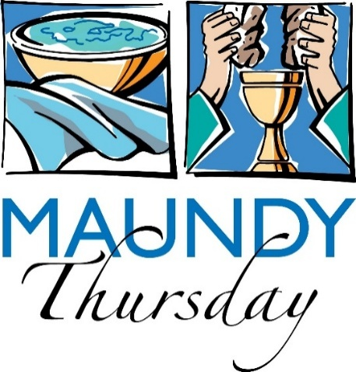

April 5th - Worship Service & Communion
10:00 am




Easter Sunday Potluck
April 5 - 8:30 am
Fellowship Hall
Join us before worship service!
Pancakes, Juice & Coffee Provided.
Bring a dish to share (not required).

April 12th - Worship Service 10:00 am.

The tradition on the Sunday after Easter is to lean into the humorous, the silly, the absurd. All are encouraged to wear bright colors and silly accessories.

0
TACO Tuesdays
A brand new First Congregational UCC Christian Ed Youth Program begins Tuesday, April 7th from 3:00 pm - 8:00 pm in Fellowship Hall/Rainbow Room.

TACO stands for Teaching, Activities, Community, and Outreach.

Emily LeClaire will be leading this after-school program to engage youth from our church and the wider community. The program is planned for the first Tuesday of each month with a break over the summer.

Connect with Emily for more information about youth participation and/or adult volunteer opportunities.

0

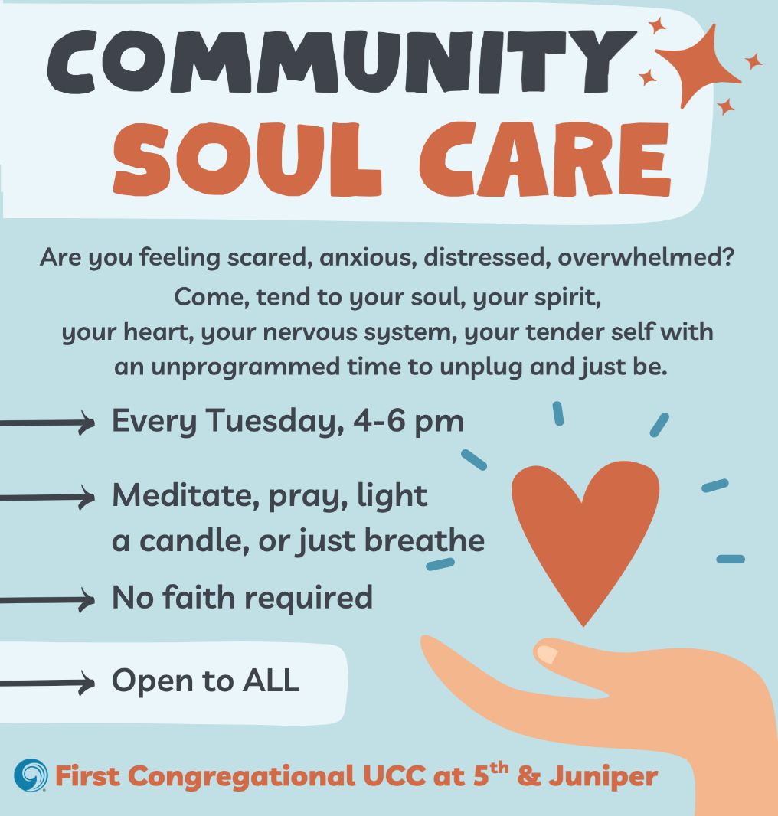

0

Join Our Church Choir
0
Worship Service at 10:00 am

2026 Schedule: April 12 & 26, May 3 & 17.
Fall & Winter dates to be determined
Rehearsal 8:30 am in the Sanctuary
0


Mission Moment - April 19th
Presented by Lori Rubin at Sunday Worship
Habitat for Humanity Faith Build
Lakes Area Habitat for Humanity is dedicated to bringing people together to build homes, communities, and hope. Through the support of volunteers, donors, and community partners, LAHFH helps hardworking families achieve safe, stable, and affordable homeownership. This year, three partner families are preparing to move into their newly completed homes, marking an exciting milestone in their journeys. At the same time, we are preparing to begin construction on three additional homes—two in Brainerd and one in Pillager—continuing our mission to address the growing need for affordable housing in our community.

April Adult Forums - 11:30 after Sunday Worship
0

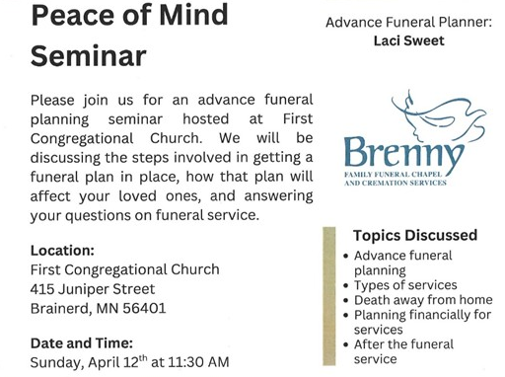

April 19 - Creating Community with Vulnerable Adults: Vicky Kinney from MNTL Coalition will discuss ways to better understand the needs of vulnerable adults, how to better serve, and raise awareness about challenges.


0
Special Offering - Sunday, April 26th
Faith Build-Habitat for Humanity
Habitat for Humanity is a global nonprofit housing organization working in local communities across all 50 states in the US and in more than 70 countries around the world. Habitat works toward our vision by building strength, stability and self-reliance in partnership with people and families in need of a decent and affordable home.
Please send your donation to First Congregational UCC, 415 Juniper St. Brainerd, MN 56401. Make sure to note on your offering: “Special Offering Faith Build”. Or for your convenience use our Paypal account at: paypal.me/uccbrainerd Be sure to note on your offering “Special Offering Faith Build” in comments. Thank you!
Follow on Facebook https://www.facebook.com/LakesAreaHabitat

0
April Birthdays

June LeClaire April 6 Dan Hegstad April 14
Pam Wible April 7 Joey Halverson April 15
Kay Cox April 9 Colleen Carder April 24
Izzy Armstrong April 11 JoAnne Nelson April 24
Bonnie Crum April 14 Austin Newgord April 24

0
Next Council Meeting

Thursday, April 16, 2026, 3:30 pm
in-person and via Zoom tinyurl.com/uccbrainerdzoom
First Congregational Approved Council Meeting Minutes are available upon request.
Please contact Terri Admin Asst. at the Church Office.

0
Volunteer at Church!
There are many other opportunities for you to share your talents
These committees need your gifts: * Trustees * Stewardship *
0


UCC Women’s Thursday Lunch

Thursday, April 30th @ 11:30 am
@ Passport Downtown - Laurel St.
Question: "Have you had any 'supernatural' experiences?"

0

UCC Men’s Lunch

Each Wednesday
11:45 am @ Wings Airport Café
Not Organized—No Agenda Join Us!
0


TheShop Meal @ First Congregational UCC

Meal Cooking in the church kitchen is postponed until further notice.

0

UCC Care Team
For anyone who wishes to join in making calls or visits, the Care Team meets every month on the first Thursday @ 10:00 am.

If you know of anyone who would enjoy a call from the care team, please contact one of our Care Team; Jack and Kay Kraywinkle, Pat Scott, Chris Yager, Deb Griffith, Nancy Gould, Tracy Lyons, Cynthia Janes,
Joey Halvorson (text or email) and Pastor Leslie.


0
Friday Book Group
We meet each Friday morning at 10:30 am via zoom.
Church Zoom link: https://tinyurl.com/uccbrainerdzoom

We are reading "By Any Other Name” by Jodi Picoult. Two women, centuries apart—one of whom is the real author of Shakespeare’s plays—who are both forced to hide behind another name and navigate the barriers for women artists being acknowledged for their work.

0

Cooking For Everyone – Including YOU!
Email Lowell Johnson or Kay Cox to be added to the email/call list. You will be notified when and where they next meet.

0


First Congregational Food Shelf Collection
Our church continues to collect non-perishable food items for the Salvation Army Food Shelf. Please consider bringing items and donating.
There are two collection boxes: one in the parking lot entry hallway, the other in the Narthex. Brian Twamley or Stephanie Lee pick up and deliver the food. Thank you!
Minnesota Foodshare March Campaign – see flyer below for more information
The 2026 March Campaign will run March 1-April 6, 2026! https://gmcc.org/march-campaign/
0
0

H.U.G.S.
Hosts, Ushers, Greeters, Scripture-readers
Sunday morning greeters/ushers and coffee hosts play an important part in making our church a warm and welcoming place for all. Signup with the link below for your first Sunday as the face of the church!

https://www.signupgenius.com/go/10C0E48A9A823A5FFC07-hugs/16034811


0
UCC Volunteer Opportunity – Warming Shelter Bridge on 7th
Sign up for a morning shift as a team of two or/individually. You can choose a time to volunteer online. The staff and shelter guests appreciate our involvement. The link is below. Create an account. Pick a date. They need your birth date and your ok for a background check.
Start here at this link to sign up for volunteering; https://www.bridgesofhopemn.org/volunteer
Then go to this link to choose a date to volunteer at the shelter. They need your birth date and your ok for a background check. https://volunteer.bloomerang.co:443/JE/bas6nebexg029t
0

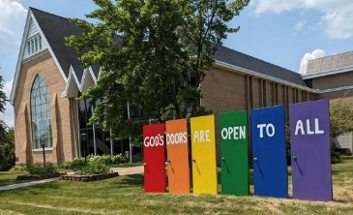
Our Building Is a Great Event Venue!
0
We are blessed to be able to share our beautiful church facilities for purposes that match the values of the church and its mission which is “To know and share God’s love within us.” We are an open church valuing the diversity of age, culture, gender identity, opinions, physical and mental abilities, and sexual orientation.
To request a space for general use, ask for a “Request for Church Building Use” form and policy packet from Terri in the church office, at 218-829-2528 or email uccbrainerd@gmail.com. Submit the request form back to Terri in the office, and it will be submitted for approval at the next Council Meeting. For wedding or funeral use, contact Pastor Leslie: pastorleslieucc@gmail.com

0
The Columbarium & Memorial Garden
First Congregational UCC, Brainerd
The Columbarium is in the historic space that once was our church’s front entry way.
How appropriate it is that our Columbarium now marks another entry way into a new life — where the Spirits of Love and Truth are always present!
The Memorial Garden is located on the south lawn of the church. The Garden provides a place for cremains of your loved one to be buried in the ground among natural plantings. The Garden fee includes the inscription of your loved one’s name on a granite plaque that is mounted on the outside wall of the church. Should you wish to learn more about the purchase of a niche for your own cremains or for the ashes of a loved one, please call the church office at (218) 829-2528 and a packet of materials will be sent to you via email or regular mail.
0
UCC Justice Table Team Meeting Minutes
Sunday, March 22, 2026

WISE Committee Meeting Minutes
Upcoming Forums
- 04/12/26 Funeral Planning
- 04/19/26 Building Community with Vulnerable Adults
- 04/24/26 Justice Tables
- 05/03/26 Healthy Conflict in Congregations
Classes Available via Zoom
- The Damascus Project, "Understanding your Why," (A Stewardship Webinar), Wednesday, March 25, 2026, 6:30 pm - FREE
- "Restorative Conversations," Tuesday, May 12, 2026, 9:00 to 4:00. Register at Lombard Mennonite Peace Center, lmpeacecenter.org, $139 per person
Other
- "Alzheimer's Stories, Friday, April 24th, Gichi Ziibi Center for the Arts, 7:30 pm - 9:00 pm, featuring adults living with Alzheimers, their caregivers, and the Legacy Chorale . Tickets $15 - $20. Purchase tickets at lcgm.booktix.com or call 218-270-8212. Possible Story Circle to follow. Additional Story Circles on Thursday, 4/5/30 @ 7:00 pm and/or Friday, 5/1/26 @ 2:00 pm.
- Alzheimer's/Caregivers/Legacy Chorale - Sing at The Center on Tuesdays, 10-11:30 am.
Upcoming Events
- Movie, "Still Alice"
- Substance Abuse Disorders

Submitted by Kay Cox

0
Creation Care Committee Meeting Minutes
- We are looking into solar power through a solar co-op that is starting in the area. and researching other resources for the project.
- We did a walk through the church to look for areas in need of repair or updating to help increase energy efficiency.
- And we are looking into an Initiative Foundation Grant to help fund these efforts.
- Starting to think about the rain garden, the food forest and a few other outdoor tasks for the spring.
- Let us know if you would like to be a part of this committee effort
--
Submitted by Eleanor "Ellie" Burkett
0
UCC Justice Team Meeting Minutes Poverty: Children, Families, Homelessness & Housing Attended: Marcia Ferris, Sharon Carlson, Dawn Stattine, Alvin Velsvagg
- Tri fold display boards for 1.) My Neighbor to Love Coalition, 2.) Bridges of Hope (Operation Sandwich/Shelter on S 7th,) Sharing Bread Soup Kitchen, Light House Beginnings/Open Arms Day Center. 3.) Habitat for Humanity (Sharon C. will do one.)
- Schedule Mission Moments from our Special Offering agencies. Habitat on April 19.
- MNTLC is building a Fellowship building. They will welcome us to present to their community members. An opportunity to share your skills & befriend residents.
- April 19 - Vicky Kinney, Alan Velsvagg & Lowell Johnson will present an Adult Forum on “Building Community with Vulnerable Adults.”
- MNTLC has a Facebook page you can follow to see what is going on and how you can help. The City of Brainerd (again) did not grant them Statewide Affordable Housing Aid housing funds.
- The Bridge on S 7th homeless shelter will close in April and reopen in the fall. The shelter continues to try to get Brainerd City Council approval to operate year round. The shelter has funding to do this. The collaborative agencies have found housing for many homeless and the shelter population was down the last time Mary Bensen volunteered. To volunteer - see links in our church newsletter & bulletin.
Submitted by Marcia Ferris
0


Baskets for collecting non-perishable food items are at the front and back doors of the church.

Please donate this month.

To donate using Paypal: paypal.me/uccbrainerd
Make sure to include in the memo: Food Shelf.

Brainerd Lakes & Surrounding Area Information
0
~ Opportunities to Know and Share God’s Love ~
0


Free Community First Aid/CPR/AED Training
Saturday, April 4
10:00 am to 4:00 pm
Crow Wing County DFL
223 Washington St., Brainerd, MN 56401
Join us for a free community event to train for First Aid/CPR/AFD. This event is facilitated by Denise Slipy, a certified instructor for the American Heart Association. Don’t miss this opportunity to learn these critically important life-saving skills. Registration is required to ensure adequate training supplies.

Register: https://www.mobilize.us/dfl/event/923092/?force_banner=true&share_context=event_details&share_medium=copy_link

0
Quiet Voices Seen; Art From the Edges
Book Release

Saturday, April 11, from 3-5 PM
The Crossing Arts Alliance will be hosting a book release and art opening for Quiet Voices Seen. Come and view some of the art produced for the book, meet the artists, and view the short video produced for the book. Snacks will be served and there will be lots of interesting conversations!

Crossing Arts Alliance
711 Laurel Street, Brainerd, MN 56401
218-833-0416
info@crossingarts.org

0

Alzheimer's Stories
Presented by the Legacy Chorale and
Community Orchestra
Friday, April 24th at 7:30 pm
Gichi-ziibi Center for the Arts

The concert program shares the lived experiences of people with Alzheimer’s and dementia through music, along with the perspectives of their care partners and loved ones. The program will convey universal themes such as finding strength in facing adversity and discovering purpose in advocacy. This concert is designed to celebrate and uplift our memory care community and inspire all of us to live with kindness and empathy.

The program will be accompanied by a resource fair before and after the concert.
Stories Circles will be offered after the concert, sponsored by the Lakes Area Justice Table.
Concert Tickets:
$20 - Premium Reserved Section
$15 - General Admission

Tickets are available online at https://lcgm.booktix.com/dept/lcgm/e/stories,
or by calling 218-270-8212, or at the door an hour before the performance.

Gichi-ziibi Center for the Arts
602 S 5th Street Brainerd, MN 56401
0

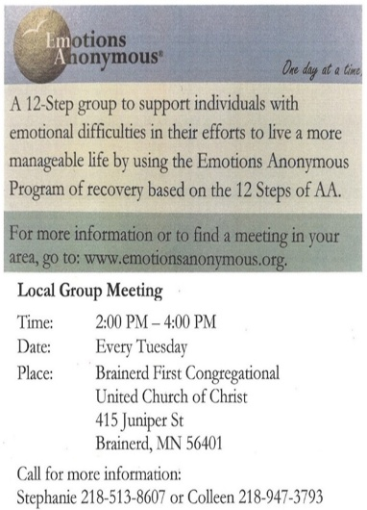

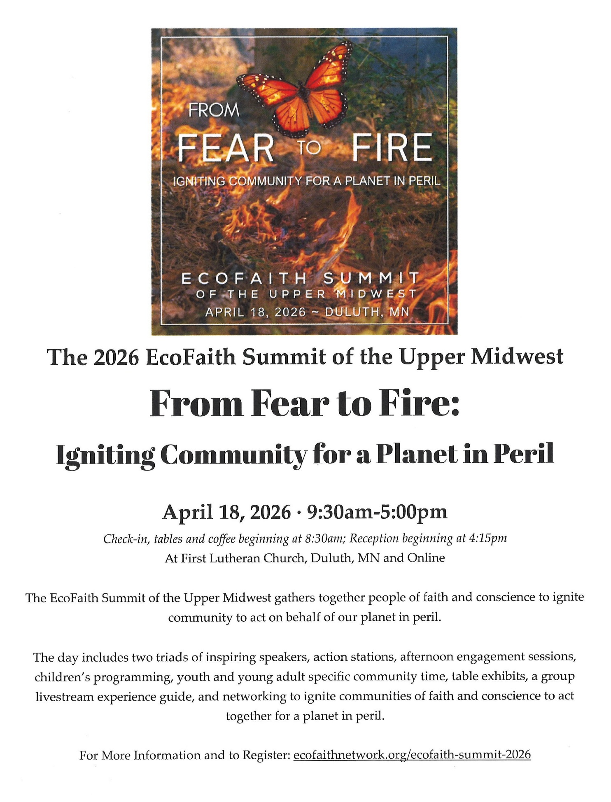
0

0
0

April 2026 Calendar
Sunday | Monday | Tuesday | Wednesday | Thursday | Friday | Saturday
Y- Yes Meeting in person  FB -Facebook Live Stream Online  C- Cancelled P-Postponed  N-No Meeting Z-our church Zoom | Office Closed | Office Hours  10am – 2pm | Office Hours  10am – 2pm  Pastor Drop-in Hours  11:00 am – 1:00 pm | Office Hours  10am – 2pm | Office Closed
 |  |  | 11:45pm Men’s Grp 1  @ Wings Cafe-Y  PRC Mtg.-P  4:30pm Christian Mnstry-Y  7pm AA Common-Y | 10am Care 2  Team-Y  5:30pm Maundy Thursday Worship  Service-Y | Good Friday 3  10:30am Bk Grp-Z  Movie Night-C  Resume in Fall | Holy Saturday 4
8:30am Bnrd Frnds-Y 5  8:30am Breakfast Potluck-Y  10am Easter Sunday Worship & Communion-Y&FB  11am Fellowship-Y | 6  6-8pm BLA Indivisible-Y  Fellowship Hall | 2pm EA-Y 7  3-6pm Community Soul Care-Y  3-6pm TACO Tuesday-Y  5:30pm OA -Y | 10amTrustees-Y 8 11:45am Men’s Grp  @ Wings Cafe-Y  3:30pm Executive Mtg.-Y  7pm AA Common-Y | 9 | 10  10:30am Bk Grp- Z | Women’s Coffee Fellowship-C 11  9:30am-1pm AAUW Mtg. Fellowship Hall-Y
8:30am Bnrd Frnds-Y 12  8:30am Choir Practice-Y  10am Holy Humor Worship  & Choir-Y&FB  11am Fellowship-Y  11:30am-Adult Forum-Funeral  Planning | 13  5-7:30pm BLA Indivisible Mtg. in Fellowship Hall | 2pm EA-Y 14  3-6pm Community Soul Care-Y  5:30pm OA -Y | 15  11:45pm Men’s Grp.  @ Wings Cafe-Y  12pm Memorial Mtg.-Y  7pm AA Common-Y | 16  3:30pm Council Mtg.-Y&Z  6:30pm Dist.7 AA-Y | 17  10:30am Bk Grp- Z | 18
8:30am Bnrd Frnds-Y 19  10am Worship-Y&FB  *Mission Moment: Lori Rubin presentation: Habitat for Humanity  11:15am Fellowship-Y  11:30am Adult Forum- Vulnerable  Adult Presentation-Y  1:00pm BLA Indivisible Mtg-Y. | 20  6-8pm BLI Indivisible Mtg. in Fellowship Hall | 2pm EA-Y 21  3-6pm Community Soul Care-Y  5:30pm OA -Y | 11:45pm Men’s Grp 22  @ Wings Cafe Y  TheShop Cooking-C until further notice  7pm AA Common-Y | 23 | 24  8:00am-5:00pm CLC Honors Program Mtg. Fellowship Hall & 4 rooms-Y  10:30am Bk Grp- Z | 25  Creation Team Movie in Fellowship Hall-Time to be determined
8:30am Bnrd Frnds-Y 26  8:30am Choir Practice-Y  10am Worship & Choir-Y&FB  11:15am UCC Congregation  Budget Mtg.-Y & Zoom  **Special Offering-Habitat  2pm Piano Recital-Sarah Gorham  **Newsletter Deadline | 27  **May Newsletter Deadline | 2pm EA-Y 28  3-6pm Community Soul Care in Sanctuary-Y  5:30pm OA -Y | 11:45pm Men’s Grp 29  @ Wings Cafe Y  7pm AA Common-Y | 30  11:30am Women’s Lunch @ Passport Downtown Brnd.

