
Friendship News, July 2026
0
First Congregational United Church of Christ, Brainerd
An Open and Affirming Congregation
The Church Office Hours: Tuesday, Wednesday, Thursday from 10:00am – 2:00pm
Office phone 218-829-2528 Office E-mail uccbrainerd@gmail.com
Pastor Leslie’s E-mail: pastorleslieucc@gmail.com Website: www.uccbrainerdmn.org

No matter who you are, or where you are on life’s journey, you are welcome here.
0
Pastor’s Pen
0

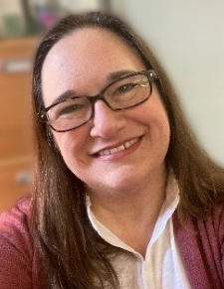
For Everything There is a Season
“For everything there is a season, and a time for every purpose under heaven.” This is the first verse of the third chapter of the book of Ecclesiastes. Frequently read at funerals and the inspiration for the hit song “Turn! Turn! Turn!” the words of this scripture have brought comfort to many as we are reminded that birth and death, joy and grief, every emotion and action all have a time and a place. The church is not exempt from this. Every activity, every ministry, every member and pastor of the church has a season.
After a significant period of prayerful discernment, I have decided that it is time conclude my ministry as Pastor at First Congregational UCC in Brainerd to be and follow God's invitation into a new chapter. My final worship service here will be Sunday September 20, 2026.
I am sure you have questions. Some of you may have more questions than others. There are some questions I will be able to answer right away and some that may need some time. But I will do my best to communicate as much as possible. Please don't hesitate to ask a question. If I am unable to answer, I will simply say so.
More details will be shared in time about the transition and my departure. I will be working with the Pastoral Relations Committee and the staff of the Minnesota Conference to develop a detailed departure plan that aligns with UCC Ministerial Code and fulfills the Minnesota Conference Committee on Ministry requirements. This plan will include appropriate post departure boundaries regarding the congregation, the broader community, and social media. This plan will be clearly communicated prior to my departure with enough time to allow for education and questions.
When I arrived in Brainerd in February 2015, I never imagined that I would be so blessed as to serve this congregation for more than eleven years. As my first ordained call, you all have taught me so much. You have challenged me, supported me, and trusted me with your spiritual lives as well as many milestones, struggles, and celebrations. I will always be deeply grateful to you and the people of First Congregational UCC in Brainerd for inviting me into your lives and allowing me to serve this church as my first call. I am grieving the end of this chapter, while also looking to the future with hope and curious anticipation-for me, and for First Congregational UCC.
May the Holy Spirit of Pentecost continue to call you forward in faith, in compassion, and with deep love for all of God's creation.
With Peace,
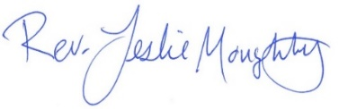

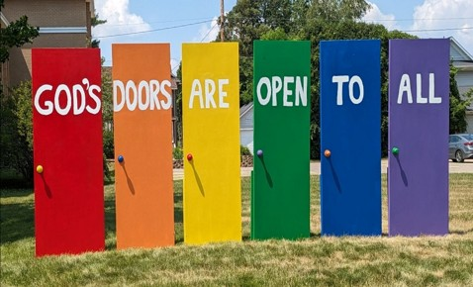
Mission Statement of
0
First Congregational United Church of Christ
“To know and share God’s love within us.”

Purpose Statement of
First Congregational United Church of Christ
“First Congregational UCC is a welcoming, inclusive, and progressive community committed to promoting social justice, spiritual growth, and love for all people. We reject discrimination and advocate for equality and dignity for marginalized communities. Through worship, education, and service, we work to make a positive impact on the world and invite all individuals to join us in this journey of faith and service.”
0

Church Office Hours
Tuesday, Wednesday, Thursday 10:00 am - 2:00 pm
Closed Mondays and Fridays

The Office is closed Thursday, July 2 for the 4th of July weekend.

0
Pastor Leslie’s Workday Schedule
Sunday through Thursday (Days off are Friday and Saturday)
Drop-in Hours: Wednesdays 11:00 am – 1:00 pm
*Drop-in hours are times set aside for “drop-in” conversations, much like a professor’s office hours.
Everyone is encouraged to make an appointment, especially if the above times are not convenient. You can go to www.calendly.com/pastorleslieucc and select a day and time that works for you, or you can email Pastor Leslie at pastorleslieucc@gmail.com or call/text at 218-656-0096.

Pastor Leslie will be out of the office: July 6 and July 20th - 30th
0

Stay Connected

How to watch Sunday worship: The worship service is broadcasted on the church Facebook page every Sunday at 10:00 am.
To watch worship on Facebook, go to https://www.facebook.com/uccbrainerd/live
How to stay connected with First Congregational friends and members: Join the private group for our Facebook Connections Page at https://www.facebook.com/groups/uccbrainerd.
Financial Help Available The Pastor's Discretionary Fund is available to assist church members and others in the Brainerd area who are experiencing financial distress with modest financial help. If you need assistance, please email, call, or text Pastor Leslie. Let her know what your situation is and how the church might be of help.
Donate to the church online! We gladly accept offerings and donations using PayPal.
You do not need to have a PayPal account to make an online donation with a credit card. To use PayPal, go to: https://www.paypal.me/uccbrainerd

First Congregational UCC News & Updates
0
0

Volunteer at Church
There are many other opportunities for you to share your talents

These committees need your gifts:
*Treasurer *Clerk * Trustees * Stewardship * Christian Ed

Please contact Dan Hegstad or Ellie Burkett if interested in any of these opportunities.

0
Moderator’s Message
Dan Hegstad
“The only constant is change.” Change is constant, but it rarely arrives in the same way. Sometimes it comes gradually, almost unnoticed; other times, it seems sudden.
Pastor Leslie is leaving to pursue new opportunities after 11 years of service to our congregation. Marcia and I were her first wedding on July 15th, 2015. We now begin the work of moving forward. First, a task force will update our Church Profile, which introduces our church to prospective interim or transitional pastors.
We have had two interim pastors since I joined our church: Rev. Mary Kay Sauter, between Rev. Paul LeDuc and Rev. Deborah Celley; Rev. Linda Crowe, between Rev. Deborah Celley and Rev. Leslie Moughty. Rev. T. Michael Rock served as a sabbatical coverage Pastor for three months.
I am confident we are ready to manage this transition. Our Church Council is highly capable, and change is not new to us. For two years, we have discussed a potential new name and explored changes to our governance structure, making steady progress. These are significant steps. A change in pastoral leadership is now before us, and while it will be challenging, it can be positive for both Pastor Leslie and our church.
The Chinese character often associated with danger—more accurately, precariousness—and change point includes a sense of opportunity. The real danger is failing to expect change. We can make transition harder through denial, resistance, or attempts to use our power to reverse it. We cannot change the river’s flow, but we can choose the course of our boat.
As we look ahead, our paths begin to diverge: Leslie will follow her path, and our church will follow another. Both roads curve beyond our view. What will we find as we continue? Other churches have traveled this road before us, and we will receive guidance from the Minnesota UCC Conference as they help us find a skilled interim pastor and, eventually, another minister.
So, the question is: what do we expect as we look toward the curve in the road beyond our sight?
I am certain we will grow as a church and become an even stronger resource for our community.
We have faith. It is who we are.
I am excited for Pastor Leslie and the opportunities ahead of her.
I am also excited for our church as we move forward.
Welcome to the journey. You are all needed, and you are all invited.
0


T.A.C.O. Tuesdays for Youth
0

(Paused July & August for the summer;)

TACO stands for Teaching, Activities, Community, and Outreach.

Emily LeClaire leads this after-school program to engage youth of our church and the wider community. Connect with Emily for more information including adult volunteer opportunities.

Scheduled for the First Tuesday of each Month @ 3:00 - 7:00 pm
Fellowship Hall/Rainbow Room.

Fall Kick-off: Tuesday, September 1st

0
UCC Fellowship


Men’s Lunch

Each Wednesday

11:45 am at Wings Airport Café
Not Organized—No Agenda Join Us!

Women’s Lunch

Thursday, July 30th at 11:30 am
at The Local 218 (723 Mill Ave, Brainerd)
Question of the month: “In looking at your family tree, are there any stories you’d like to share.”
0
Next Council Meeting
Thursday, July 14th, 2026, 10:00 am
(note the date and time change)
in-person and via Zoom tinyurl.com/uccbrainerdzoom
First Congregational Approved Council Meeting Minutes are available upon request.
Please contact Terri Admin Asst. at the Church Office.
0

July Birthdays

Gary Whiteman July 4 Chris Yager July 23
Steve Newcom July 17 Stephen Crum July 26

0

Special Offering: Sunday July 26th
0
Salvation Army Food Shelf & Lakes Area Food Shelf

This month’s Fourth Sunday Special Offering will be given to the
Salvation Army Food Shelf & Lakes Area Food Shelf.

Please send your donation to
First Congregational UCC
415 Juniper St. Brainerd, MN 56401

Or for your convenience use our PayPal account at: paypal.me/uccbrainerd.
Make note on your offering “Food Shelf Special Offering.”

Salvation Army Food Shelf

The food shelf offers a wide range of groceries, allowing individuals and families in need to stretch their budgets. Food boxes may include shelf-stable pantry items, breads, cereals, meat and other household necessities.
On occasion, fresh produce is also available.
208 S 5th St, Brainerd, MN 56401 (218) 829-1120
centralusa.salvationarmy.org/northern/brainerdlakes

Lakes Area Food Shelf - Over 40 Years Of Service

Lakes Area Food Shelf was established in 1980 by Donald Messick, a former grocery executive who resided in Pequot Lakes, with the help of the Lutheran Church of the Cross and Christ Community Church, both of Nisswa. Due to its rapid growth, the name became “Lakes Area Food Shelf” in 1991. A 501-c3 public charity, we operate solely on financial, food, and other donations. We have earned the trust of the thousands of people we’ve served each year and have become a primary community resource for people facing hunger and seeking assistance.
Two locations: 7837 Excelsior Rd, Baxter MN 56425
29316 Patriot Avenue, Pequot Lakes MN 56472
lakesareafoodshelf.org

0
First Congregational Food Shelf Collection
Our church continues to collect non-perishable food items for the Salvation Army Food Shelf. Please consider bringing items and donating.
There are two collection boxes: one in the parking lot entry hallway, the other in the Narthex. Brian Twamley or Stephanie Lee pick up and deliver the food. Thank you!

0

0
Garden Gleaning

A Biblical (and environmentally) inspired activity
This is how it works: Gardeners and plant people bring in their “gleanings” to share. This ranges from rhubarb and vegetable plants in the spring to daffodil bulbs in the fall. A table, poster and donation basket are in Narthex entrance. Enjoy the fruits of our labors!
All are welcome to help themselves at no charge! Monetary donations are appreciated and are given to our two local food shelves.
Historical note: Begun here circa 1988 when our church began Hunger Action outreach, Central America updates and global food connections.

Note: Using our resources, recycling, re-purposing, and not wasting our food are all acts of Creation Care and Justice. Garden Gleaning is an Easy-Peasy way to put words into action.

0
UCC Care Team

For anyone who wishes to join in making calls or visits, the Care Team meets every month on the first Thursday @ 10:00 am.

If you know of anyone who would enjoy a call from the care team, please contact one of our Care Team; Jack and Kay Kraywinkle, Pat Scott, Chris Yager, Deb Griffith, Nancy Gould, Tracy Lyons, Cynthia Janes,
Joey Halvorson (text or email) and Pastor Leslie.

0
Friday Book Group

We meet each Friday morning at 10:30 am via zoom.
Church Zoom link: https://tinyurl.com/uccbrainerdzoom

We begin reading the new chosen book on Friday, July 17.
In this Economy? How Money and Markets Really Work
by Kyla Scanlon.

The book Jon Stewart (The Daily Show) hailed as “essential reading” for anyone who wants to “make informed decisions” and “have a basic understanding of the economy”: an illustrated guide to economics from one of the internet’s favorite financial educators.
0


Cooking For Everyone – Including YOU!

Email Lowell Johnson or Kay Cox to be added to the contact list. You will be notified of upcoming events.

0

0

H.U.G.S.
Hosts, Ushers, Greeters, Scripture-readers
Sunday morning greeters/ushers and coffee hosts play an important part in making our church a warm and welcoming place for all. Signup sheet in the Narthex or call or send an email to the office to be added.

**Notice – Hosts may be reimbursed for snacks/food that are purchased for Fellowship Coffee Hour. Reimbursement Forms are in pocket folders outside the office. Please fill out and submit with receipts in the folder provided next to the form.

0

Volunteer Opportunity – Overnight Shelter Bridge on 7th

Sign up for a morning shift as a team of two or/individually. You can choose a time to volunteer online. The staff and shelter guests appreciate our involvement. The link is below. Create an account. Pick a date. They need your birth date and your ok for a background check.

Start at this link to sign up to volunteer: www.bridgesofhopemn.org/volunteer

Then choose a date here: volunteer.bloomerang.co:443/JE/bas6nebexg029t
(They will need your birth date and consent for a background check.)

0
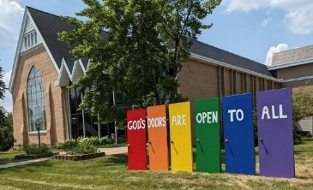
Our Building
Is a Great Event Venue!
We are blessed to be able to share our beautiful church facilities for purposes that match the values of the church and its mission which is “To know and share God’s love within us.” We are an open church valuing the diversity of age, culture, gender identity, opinions, physical and mental abilities, and sexual orientation. Take a virtual tour of our building by visiting our website at uccbrainermn.org
To request a space for general use, ask for a “Request for Church Building Use” form and policy packet from Terri in the church office, at 218-829-2528 or email uccbrainerd@gmail.com. Submit the request form back to Terri in the office, and it will be submitted for approval at the next Council Meeting.
For wedding or funeral use, contact Pastor Leslie: pastorleslieucc@gmail.com
0

Memorial Garden Weekly Weeders
0

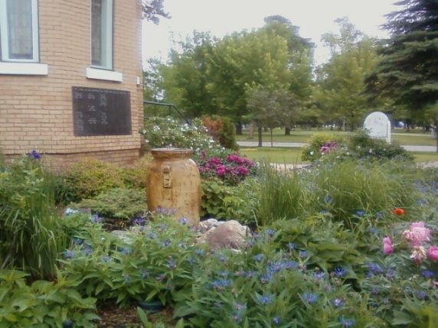
Would you like to help keep the UCC Memorial Garden beautiful? We would love your help!
We'll be weeding every Wednesday at 10am.
Please complete the sign-up survey below and indicate when you are available to help.
Memorial Garden Weekly Weeders

Or contact Becky Twamley to be added to the sign-up. Whether it's just one time, once a month or more often...we are grateful!

0
The Columbarium & Memorial Garden
First Congregational UCC, Brainerd
The Columbarium is in the historic space that once was our church’s front entry way. How appropriate it is that our Columbarium now marks another entry way into a new life — where the Spirits of Love and Truth are always present!

The Memorial Garden is located on the south lawn of the church. The Garden provides a place for cremains of your loved one to be buried in the ground among natural plantings.

The Garden fee includes the inscription of your loved one’s name on a granite plaque that is mounted on the outside wall of the church. Should you wish to learn more about the purchase of a niche for your own cremains or for the ashes of a loved one, please call the church office at (218) 829-2528 and a packet of materials will be sent to you via email or regular mail.

0
Community Prayer Box
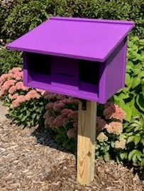
You can find the Community Prayer Box in the Memorial Garden on the South side of the church (the side that faces Juniper Street.)

Community members frequently walk through the garden, and this box will offer our wider community an opportunity to share their prayers. Prayer cards and pens are provided, and the box is secured with a padlock, so the submitted prayers don’t fly away with the wind!

Pastor Leslie checks the box weekly and prays for any prayers submitted as well as sharing them with the Care Team.

0

0
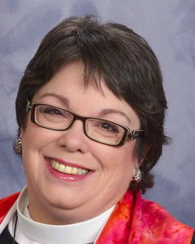

Announcing Interim Conference Minister
Rev. Dr. Bonnie Bates

The Board of the Minnesota Conference UCC is thrilled to share the news that it has selected the Rev. Dr. Bonnie Bates to serve as the Interim Conference Minister, effective July 1, 2026.

Most recently, Bonnie served as Conference Minister for the Penn Northeast Conference from 2017-2025. During her tenure, she worked with the team that merged four Pennsylvania Conference into the Keystone Conference. Prior to that, she served in the Ohio Conference as the Associate Minister for Congregational Vitality and Development and as a licensed interim, extended pulpit supply, and ordained and settled minister.
“The Selection Team was immediately impressed by Bonnie’s breadth of experience,” said Conference Moderator Rev. Sara Morse. “She brings a pastoral depth that will assist us in equipping a courageous church in this season. Bonnie will take the necessary time to help us evaluate our processes and systems, guide us in our healing, and strengthen our covenants with each other across the Conference. To borrow a phrase from a friend, Bonnie is also wicked smart!”
Bonnie earned her B.A. in organization management, an M.A. in human resource development, a Master of Divinity degree, a Doctor of Ministry degree in transformative leadership, and a graduate certificate in gender, sexual, and racial justice. Prior to serving churches and conferences, she spent 25 years in nonprofit management, mostly in human resources, program development, and training.
Currently, Bonnie serves on the Small Town and Rural Church Coalition, Join the Movement to End Racism Advisory Board, and the Colgate Rochester Crozer Divinity School board. She also teaches Covenant and Polity for the Keystone Academy for lay education and is a licensed coach for Christian leaders and a certified spiritual director.
Bonnie was born in rural upstate New York and raised in the Roman Catholic Church. She is the oldest of four children, born into a working-class family. She is a widow who survives her husband of 42 years, the mother of one son and grandmother of five.
The Conference thanks the Search Committee of Danielle Bartz, Sara Morse, Emma North Tony Romaine, Herb Rotunda, and Bob Sicoli for its faithful work.
Welcome, Bonnie!

0

0
Brainerd Lakes & Surrounding Area Information
~ Opportunities to Know and Share God’s Love ~

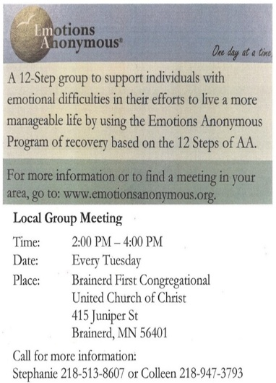
0
Crow Wing County
Military Family Support Group

1st & 3rd Wednesday of each month
7:00-8:00 pm

Meets at First Congregational UCC
415 Juniper St., Brainerd MN 56401

Join us to support military families if you:
Have someone joining the military, have an active military member or have someone that has previously been in the military.

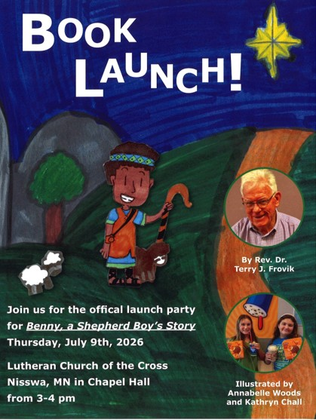
More info: drttbsby@msn.com

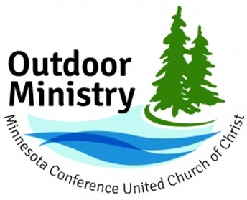
0
The Outdoor Ministry of the Minnesota Conference UCC offers events for individuals and families of all ages, abilities, and stages of life to experience rest, renewal, and reconnection through a retreat or camp experience. Our goal is to create opportunities for people across the Conference to fall in love with God’s creation, encounter the sacred in the natural world, and experience the deep interconnectedness of nature, human community and one’s own soul.

Upcoming Events

Freshwater Faithworks
A new summer program focusing on the intersection of freshwater ecology and faith, with hands-on service-learning, education, exploration, and reflection. Freshwater Faithworks is a collaboration between the Minnesota and Wisconsin Conferences of the UCC.

July 29 - August 2: A four-night adventure for middle schoolers, held at Creekside UCC in Minneapolis and First United Church of Little Falls. Learn more and register at https://www.uccmn.org/event/freshwater-faithworks-middle-school-adventure.

Joy as Resistance and Refugia (Adult Event)
We are living in a collision of crises right now. Amid that collision, the MN Conference UCC is offering a series of three in-person retreats between August 2026 and February 2027. Each retreat stands on its own and is related to the other two in the series. All three retreats will be hosted at Camp Onomia in Onamia, Minnesota. The registration fee for each retreat is $175, and participants who register for all three will receive a 25% discount for all three retreats.

Retreat 1 – Reconnections, August 6-8, 2026
Retreat 2 – Rest and Resilience, November 17-19, 2026
Retreat 3 – Remembering New Beginnings, February 12-15, 2027

Registration will open soon at https://www.uccmn.org/programs-support/outdoor.
Download flyer: www.uccmn.org/wp-content/uploads/2026/06/2026-Joy-Retreat-Series.pdf
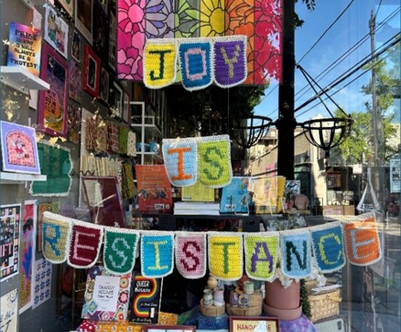

July 2026 Calendar
Sunday | Monday | Tuesday | Wednesday | Thursday | Friday | Saturday
Y- Yes Meeting in person  FB -Facebook Live Stream Online  C- Cancelled N-No Meeting  P-Postponed Z-our church Zoom | Office Closed | Office Hours  10am – 2pm | Office Hours  10am – 2pm  Pastor Drop-in Hours  11:00 am – 1:00 pm | Office Hours  10am – 2pm | Office Closed
Pastor Leslie Vacation:  July 20th through July 30th |  |  | 10am Care Team-Y 1  11:45pm Men’s Grp  @ Wings Cafe-Y  3:30pm Christian Mnstry-Y  7pm Military Family  Support Grp-Y  7pm AA Common-Y | 2  Office Closed | 3  10:30am Bk Grp-Z  Movie Night-C  Resume in Fall | 4  Fourth of July
8:30am Brainerd Friends-Y 5  10am Sunday Worship, Communion-Y&FB  Christian Ministry leads worship  11am Fellowship-Y | 6  Pastor Leslie out of the office  5pm BACP/BLUE church-backup | 7  9am BLA Indivisible Mtg. in Fellowship  2pm EA-Y  TACO Tuesday- Paused till Sept.-P  5:30pm OA -Y | 11:45am Men’s Grp 8  @ Wings Cafe-Y  12pm Memorial Mtg.-Y  3:30pm Executive Mtg.-Y  7pm AA Common-Y | 9 | 10  10:30am Bk Grp- Z | 11  Women’s Coffee-C  Resume in Fall?
8:30am Bnrd Frnds-Y 12  10am Worship-Y&FB  11:15am Fellowship-Y | 13  2pm Trustees-Y  5-7pm BLA Indivisible in Fellowship-Y | 14  10am Council Mtg- Y&Z  2pm EA-Y  5:30pm OA -Y | 11:45pm Men’s Grp 15  @ Wings Cafe-Y  7pm Military Family  Support Grp-Y  7pm AA Common-Y | 16  6:30pm AA  Dist.7-Y | 17  10:30am Bk Grp- Z  **Start reading new book | 18
8:30am Bnrd Frnds-Y 19 10am Worship-Y&FB  11:15am Fellowship-Y | 20  Leslie begins Vacation thru 30th | 21  10am Foundation Mtg.-Z  2pm EA-Y  5:30pm OA -Y | 11:45pm Men’s Grp 22  @ Wings Café-Y  7pm AA Common-Y | 23 | 24  10:30am Bk Grp- Z | 25  4-6pm Wright Wedding Rehearsal  Sanctuary only
8:30am Bnrd Frnds-Y 26  10am Worship-Y&FB  **Rev. Steve Newcom preaching & leading worship  *Special Offering Food Shelves  11:15am Fellowship-Y  Noon-3:30pm Wright Wedding-Y  Sanctuary only | 27  5-7pm BLA Indivisible in Fellowship-Y | 28  2pm EA-Y  5:30pm OA -Y | 29  11:45pm Men’s Grp.  @ Wings Cafe-Y  7pm AA Common-Y | 30  11:30am Women’s Lunch @ The Local 218 | 31  10:30am Bk Grp- Z

