
Friendship News, August 2026
0
First Congregational United Church of Christ, Brainerd
An Open and Affirming Congregation
The Church Office Hours: Tuesday, Wednesday, Thursday from 10:00am – 2:00pm
Office phone 218-829-2528 Office E-mail uccbrainerd@gmail.com
Pastor Leslie’s E-mail: pastorleslieucc@gmail.com Website: www.uccbrainerdmn.org

No matter who you are, or where you are on life’s journey, you are welcome here.
0
Moderator’s Message
0
Dan Hegstad
As you know our congregation is facing some challenging budgetary issues. Council is researching solutions. I'm certain there will not be one solution but likely many. We will likely be implementing systemic changes over the course of several months and maybe longer.
One of the people I've studied from history is James j Hill who built the Great Northern railroad. He was a tough task master. He expected work to be done quickly and correctly. While other railroads built their lines as quickly as possible with the intention of going back and fixing it later, Hill insisted on building his line fast but of sufficient quality that it would not have to be repaired and realigned later. One of the things I admire about Hill is that he sometimes made decisions that wouldn't pay off for decades or even in his lifetime. He was making plans for what is now the BNSF railway in the 1880s. How often do you see that these days?
The changes we are looking at will assure a solid foundation for our church for decades to come.
I have some very good news to share with you! We have received several sizable contributions recently. While these donations are substantial and help
cover our budget deficit for this year they do not close it. We are very grateful for these donations but make no mistake, this does not solve our ongoing issues.
To these anonymous donors I say on behalf of our congregation and Council, THANK YOU in all caps!
These donations indicate incredible confidence in our church! Nobody invests in a failing company.
All of us support our church with what we can. Attendance at service, time served on a committee or task force, contributions of ideas and suggestions, and, of course, financial support as we are able.
We are moving forward with confidence!

Mission Statement of
First Congregational United Church of Christ
“To know and share God’s love within us.”
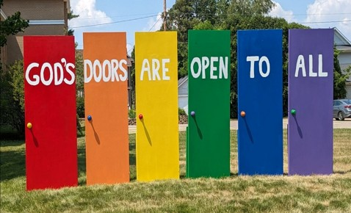
Purpose Statement of
First Congregational United Church of Christ
“First Congregational UCC is a welcoming, inclusive, and progressive community committed to promoting social justice, spiritual growth, and love for all people. We reject discrimination and advocate for equality and dignity for marginalized communities. Through worship, education, and service, we work to make a positive impact on the world and invite all individuals to join us in this journey of faith and service.”

0

Church Office Hours
Tuesday, Wednesday, Thursday 10:00 am - 2:00 pm
Closed Mondays and Fridays

0
Pastor Leslie’s Workday Schedule
Sunday through Thursday (Days off are Friday and Saturday)
Drop-in Hours: Wednesdays 11:00 am – 1:00 pm
*Drop-in hours are times set aside for “drop-in” conversations, much like a professor’s office hours.
Everyone is encouraged to make an appointment, especially if the above times are not convenient. You can go to www.calendly.com/pastorleslieucc and select a day and time that works for you, or you can email Pastor Leslie at pastorleslieucc@gmail.com or call/text at 218-656-0096.

0

Stay Connected

How to watch Sunday worship: The worship service is broadcasted on the church Facebook page and YouTube every Sunday at 10:00 am.

To watch worship on Facebook, go to https://www.facebook.com/uccbrainerd/live
To watch our NEW YouTube channel, go to https://www.youtube.com/@uccbrainerdworship6443
How to stay connected with First Congregational friends and members: Join the private group for our Facebook Connections Page at https://www.facebook.com/groups/uccbrainerd.
Financial Help Available The Pastor's Discretionary Fund is available to assist church members and others in the Brainerd area who are experiencing financial distress with modest financial help. If you need assistance, please email, call, or text Pastor Leslie. Let her know what your situation is and how the church might be of help.
Donate to the church online! We gladly accept offerings and donations using PayPal.
You do not need to have a PayPal account to make an online donation with a credit card. To use PayPal, go to: https://www.paypal.me/uccbrainerd

0
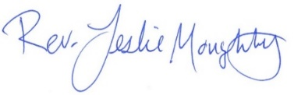
First Congregational UCC News & Updates
0
0
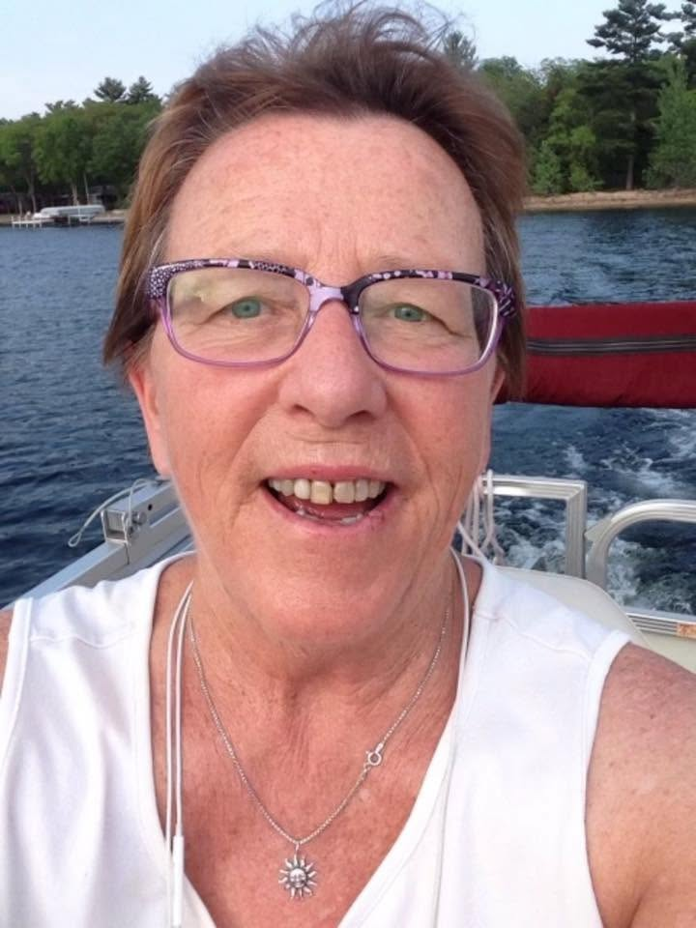
Celebration of Life
Joey Halvorson
Apr 15, 1943 — Jul 20, 2026
JoAnn Margaret Halvorson (Joey) age 83, died on July 20 at her home in Nisswa after an extended battle with ALS. She was born on April 15th, 1943, in Minneapolis, MN.
Visitation and Celebration of Life will be at the First Congregational UCC in Brainerd.
Visitation will be on August 7th from 5:00-7:00pm and August 8th, one hour before the service. Celebration of life service is at 11:00am.
A reception will immediately follow in Fellowship Hall.
https://www.brenny.com/obituaries/joann-joey-halverson

0
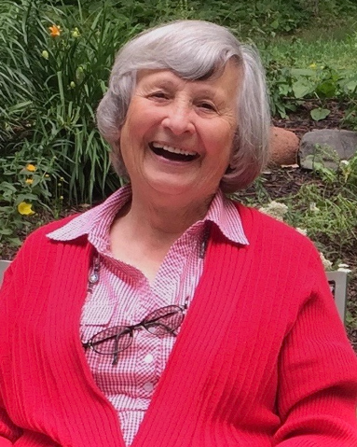
Carol Maxine Crust
Jul 23, 1933 — Jul 19, 2026

Carol Maxine Crust, of Brainerd, Minnesota, passed peacefully at Hills Crossing Senior Living on Sunday, July 19, 2026, surrounded by her children. She was 92 years old.

Carol was a member of First Congregational UCC Brainerd, MN

Carol’s Celebration of Life was held on Friday, July 31, 2026, at 10:30 a.m. at Halvorson-Taylor Life Center, 512 S. 8th Street, Brainerd, MN. A reception followed.

In lieu of flowers, memorials may be directed to the Upper South Long Lake Improvement Association, P.O. Box 201, Brainerd, MN 56401.

https://www.brenny.com/obituaries/carol-crusst

0
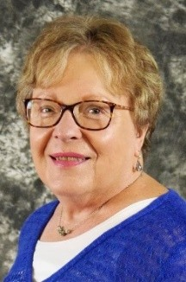
Karen Ford
0

Announcement from Karen’s Family
“Thank you so much to everyone who has shared beautiful messages about our Mom following her passing early Friday morning.
One of Mom’s wishes was to say as many goodbyes as possible while she was still with us. She truly enjoyed so many visits and messages in her final weeks, smiling at the delivery of every single message until the very end. We are so grateful she was able to share those moments with everyone she held close to her heart.
Mom asked that we not hold a memorial service for her. She donated her body to the Mayo Clinic for educational and research purposes. Her cremated remains will eventually be interred at St. Luke’s Cemetery in Eitzen, MN, alongside her husband Don and other family members who preceded her in death.
Mom recently learned about the Wind Phone Project at Wayzata Community Church, where she has been a member since moving to The Orchards of Minnetonka. For those unfamiliar, a wind phone is an unconnected telephone placed in a quiet outdoor space, offering a place where people can symbolically “talk” to their loved ones and let the wind carry their words—a concept that originated in Japan in 2010. Donations made to the Wayzata Community Church Memorial Fund in memory of Karen Ford will help fund this project. I, for one, look forward to visiting the wind phone in Wayzata once it is completed to speak with Mom.”

Obituary
Karen Ann (Buchholtz) Ford, 83, passed away at Little Hospice in Edina, MN on July 24, 2026. She was born in Caledonia, MN on December 5, 1942 to Lester and Leonora (Roble) Buchholtz, and was the eldest sister to Jane, Yvonne, and Bruce.
Karen graduated from Elmhurst College in 1964 and married Jerry Skillen, becoming a loving mother to her son, James Skillen, and daughter, Gail (Skillen) Singsank.
In 1979, Karen married Donald Ford and welcomed her stepdaughter, Susan (Ford) Nickles, to the family. Don and Karen shared 35 wonderful years of marriage until his passing in 2015. Together, they made homes in Wheaton, IL, Maplewood, MN, and Brainerd, MN, and shared great joy in their six grandchildren: Daniel Nickles, Jonathan Nickles, Evan Singsank, Payton Skillen, Lance Skillen, and Erin Singsank.
Karen’s lifelong passion was her love of the arts, especially music, which brought countless cherished friends into her life. She sang in choral groups, including The Legacy Chorale, and served for many years as a dedicated board member for the Lakes Area Music Festival.
Anyone who knew Karen would describe her as having a true servant’s heart. She consistently put others before herself, working tirelessly to support various charitable organizations. Reflecting this giving spirit, Karen requested that friends and family consider making a financial gift
in her memory in lieu of a memorial service. Suggested organizations include The Lakes Area Music Festival, The Hope Chest for Breast Cancer Foundation, or the Wayzata Community Church Memorial Fund.

“Just as ripples spread out when a single pebble is dropped into water, the actions of individuals can have far-reaching effects.” – Dalai Lama

0

0

Exploration Classes
Three Sessions after Sunday Worship at 11:30 am
August 9th, 16th & 23rd
Adult Forum Room
To sign up or for more information contact Pastor Leslie.

0
Volunteer at Church
There are many other opportunities for you to share your talents

These committees need your gifts:
*Treasurer *Clerk * Trustees * Stewardship * Christian Ed * Christian Ministry

Please contact Dan Hegstad or Ellie Burkett if interested in any of these opportunities.

0
Next Council Meeting
Thursday, August 2^{t0h}, 2026, 2:30 am
(note time change)
in-person and via Zoom tinyurl.com/uccbrainerdzoom
First Congregational Approved Council Meeting Minutes are available upon request.
Please contact Terri Admin Asst. at the Church Office.


T.A.C.O. Tuesdays for Youth
0

(Paused July & August for the summer;)

TACO stands for Teaching, Activities, Community, and Outreach.

Emily LeClaire leads this after-school program to engage youth of our church and the wider community. Connect with Emily for more information including adult volunteer opportunities.

Scheduled for the First Tuesday of each Month @ 3:00 - 7:00 pm
Fellowship Hall/Rainbow Room.
0
August Birthdays
Diane Hauan August 8 Deb Muzzy August 19
Brian Twamley August 12 Maria Bertram August 21
Joe Stattine August 13 Brynlee Smith August 26
Shirley Barten August 13 Dana Watson August 27
Debbie Rottschafer August 17

0
UCC Fellowship

Men’s Lunch

Each Wednesday
11:45 am at Wings Airport Café

Not Organized—No Agenda Join Us!

Women’s Lunch

Thursday, August 27th at 11:30 am
at The Local 218 (723 Mill Ave, Brainerd)

0


Emily’s Baby Shower
Sunday, August 30th
11:15 am in Fellowship Hall
First Congregational UCC
415 Juniper Brainerd MN
Baby cupcake treats
0
& beverages will be provided.
(please feel free to bring other treats-not necessary)
A list of needs for Emily and baby Rewden will be available soon!
0


Special Offering: Sunday, August 23rd
The Sowing Room

This month’s Fourth Sunday Special Offering will be given to The Sowing Room.
Through outreach, connections and conversations, The Sowing Room supports projects, programs and initiatives designed to create social cohesion and a sense of belonging for all who live in and those yet to discover North Central Minnesota.
https://www.sowingroom.org

Please send your donation to: First Congregational UCC
415 Juniper St. Brainerd, MN 56401
Or for your convenience use our PayPal account at: paypal.me/uccbrainerd.
Make note on your offering “The Sowing Room Special Offering.”


First Congregational Food Shelf Collection
0

Our church continues to collect non-perishable food items for the Salvation Army Food Shelf. Please consider bringing items and donating.
There are two collection boxes: one in the parking lot entry hallway, the other in the Narthex. Brian Twamley or Stephanie Lee pick up and deliver the food. Thank you!

0
Garden Gleaning

A Biblical (and environmentally) inspired activity
This is how it works: Gardeners and plant people bring in their “gleanings” to share. This ranges from rhubarb and vegetable plants in the spring to daffodil bulbs in the fall. A table, poster and donation basket are in Narthex entrance. Enjoy the fruits of our labors!
All are welcome to help themselves at no charge! Monetary donations are appreciated and are given to the Salvation Food shelf.
Historical note: Begun here circa 1988 when our church began Hunger Action outreach, Central America updates and global food connections.

Note: Using our resources, recycling, re-purposing, and not wasting our food are all acts of Creation Care and Justice. Garden Gleaning is an Easy-Peasy way to put words into action.

0
UCC Care Team

For anyone who wishes to join in making calls or visits, the Care Team meets every month on the first Thursday @ 10:00 am.

If you know of anyone who would enjoy a call from the care team, please contact one of our Care Team; Jack and Kay Kraywinkle, Pat Scott, Chris Yager, Deb Griffith, Nancy Gould, Tracy Lyons, Cynthia Janes and Pastor Leslie.

0
Friday Book Group

We meet each Friday morning at 10:30 am via zoom.
Church Zoom link: https://tinyurl.com/uccbrainerdzoom

We begin reading the new book on Friday, July 31st.
In this Economy? How Money and Markets Really Work
by Kyla Scanlon.

The book Jon Stewart (The Daily Show) hailed as “essential reading” for anyone who wants to “make informed decisions” and “have a basic understanding of the economy”: an illustrated guide to economics from one of the internet’s favorite financial educators.

0
0

H.U.G.S.
Hosts, Ushers, Greeters, Scripture-readers
Sunday morning greeters/ushers and coffee hosts play an important part in making our church a warm and welcoming place for all. Signup sheet in the Narthex or call or send an email to the office to be added.

**Notice – Hosts may be reimbursed for snacks/food that are purchased for Fellowship Coffee Hour. Reimbursement Forms are in pocket folders outside the office. Please fill out and submit with receipts in the folder provided next to the form.

0

Volunteer Opportunity – Overnight Shelter Bridge on 7th
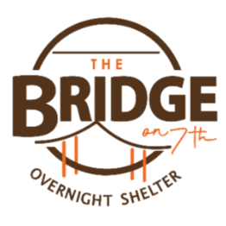
Sign up for a morning shift as a team of two or/individually. You can choose a time to volunteer online. The staff and shelter guests appreciate our involvement. The link is below. Create an account. Pick a date. They need your birth date and your ok for a background check.

Start at this link to sign up to volunteer: www.bridgesofhopemn.org/volunteer

Then choose a date here: volunteer.bloomerang.co:443/JE/bas6nebexg029t
(They will need your birth date and consent for a background check.)

0
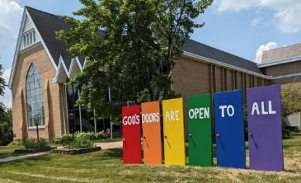
Our Building
Is a Great Event Venue!
We are blessed to be able to share our beautiful church facilities for purposes that match the values of the church and its mission which is “To know and share God’s love within us.” We are an open church valuing the diversity of age, culture, gender identity, opinions, physical and mental abilities, and sexual orientation. Take a virtual tour of our building by visiting our website at uccbrainermn.org
To request a space for general use, ask for a “Request for Church Building Use” form and policy packet from Terri in the church office, at 218-829-2528 or email uccbrainerd@gmail.com. Submit the request form back to Terri in the office, and it will be submitted for approval at the next Council Meeting.
For wedding or funeral use, contact Pastor Leslie: pastorleslieucc@gmail.com

Memorial Garden Weekly Weeders
0

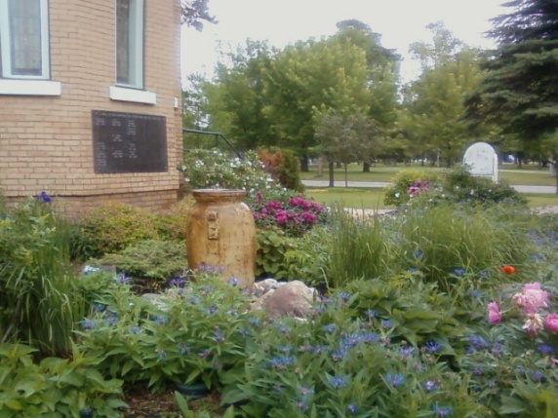
Would you like to help keep the UCC Memorial Garden beautiful? We would love your help!
We'll be weeding every Wednesday at 10am.
Please complete the sign-up survey below and indicate when you are available to help.
Memorial Garden Weekly Weeders

Or contact Becky Twamley to be added to the sign-up. Whether it's just one time, once a month or more often...we are grateful!

0
The Columbarium & Memorial Garden
First Congregational UCC, Brainerd
The Columbarium is in the historic space that once was our church’s front entry way. How appropriate it is that our Columbarium now marks another entry way into a new life — where the Spirits of Love and Truth are always present!

The Memorial Garden is located on the south lawn of the church. The Garden provides a place for cremains of your loved one to be buried in the ground among natural plantings.

The Garden fee includes the inscription of your loved one’s name on a granite plaque that is mounted on the outside wall of the church. Should you wish to learn more about the purchase of a niche for your own cremains or for the ashes of a loved one, please call the church office at (218) 829-2528 and a packet of materials will be sent to you via email or regular mail.

0
Community Prayer Box
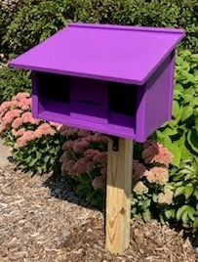
You can find the Community Prayer Box in the Memorial Garden on the South side of the church (the side that faces Juniper Street.)

Community members frequently walk through the garden, and this box will offer our wider community an opportunity to share their prayers. Prayer cards and pens are provided, and the box is secured with a padlock, so the submitted prayers don’t fly away with the wind!

Pastor Leslie checks the box weekly and prays for any prayers submitted as well as sharing them with the Care Team.

0
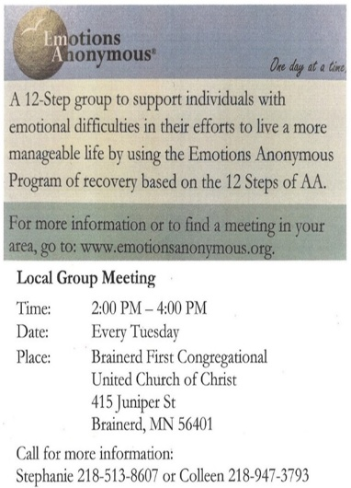

0
Crow Wing County
Military Family Support Group

1st & 3rd Wednesday of each month
7:00-8:00 pm

Meets at First Congregational UCC
415 Juniper St., Brainerd MN 56401

Join us to support military families if you:
Have someone joining the military, have an active military member or have someone that has previously been in the military.

More info: drttbsby@msn.com


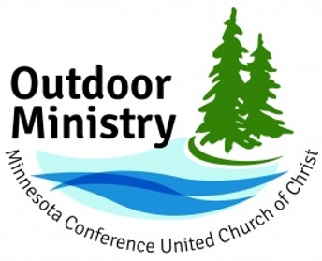
0

Upcoming Events
Joy as Resistance and Refugia (Adult Event)
We are living in a collision of crises right now. Amid that collision, the MN Conference UCC is offering a series of three in-person retreats between August 2026 and February 2027. Each retreat stands on its own and is related to the other two in the series. All three retreats will be hosted at Camp Onomia in Onamia, Minnesota. The registration fee for each retreat is $175, and participants who register for all three will receive a 25% discount for all three retreats.

Retreat 1 – Reconnections, August 6-8, 2026
Retreat 2 – Rest and Resilience, November 17-19, 2026
Retreat 3 – Remembering New Beginnings, February 12-15, 2027

Registration will open soon at https://www.uccmn.org/programs-support/outdoor.
Download flyer: www.uccmn.org/wp-content/uploads/2026/06/2026-Joy-Retreat-Series.pdf
0
Brainerd Lakes & Surrounding Area Information
~ Opportunities to Know and Share God’s Love ~
0

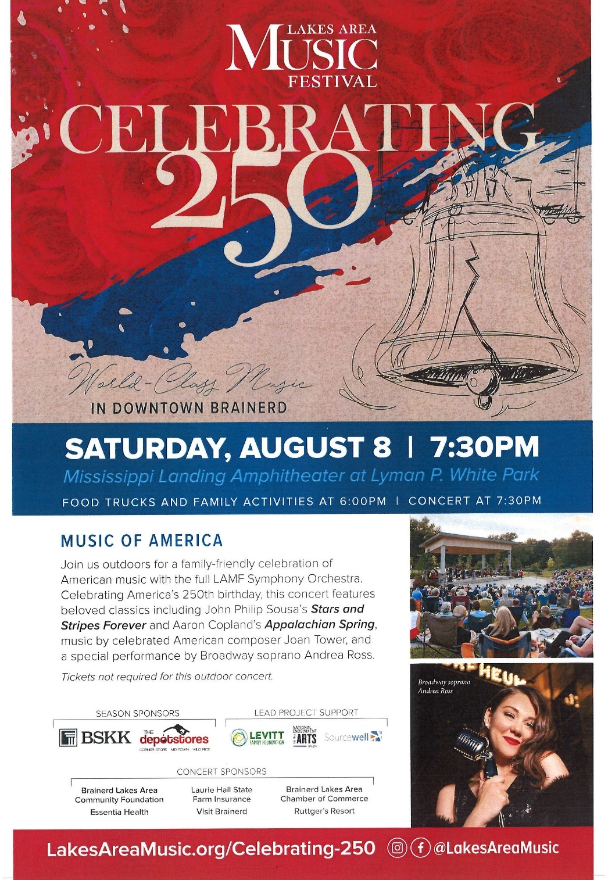

Promoting neighborhood unity, safety, police-community
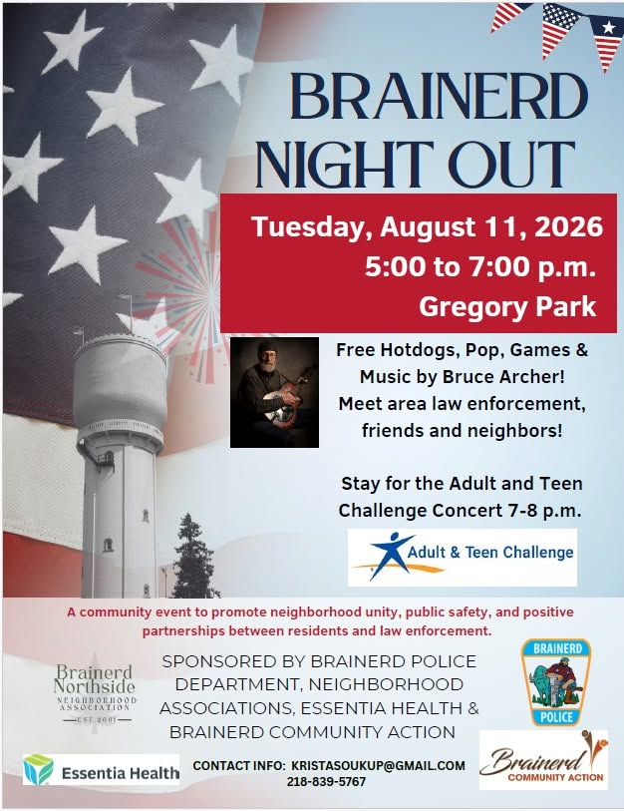
partnerships; and crime, drug and violence prevention.

August 2026 Calendar
Sunday | Monday | Tuesday | Wednesday | Thursday | Friday | Saturday
Y- Yes Meeting in person  FB -Facebook Live Stream Online  C- Cancelled N-No Meeting  P-Postponed Z-our church Zoom | Office Closed | Office Hours  10am – 2pm | Office Hours  10am – 2pm  Pastor Drop-in Hours  11:00 am – 1:00 pm | Office Hours  10am – 2pm | Office Closed | 1
8:30am Brainerd Friends-Y 2  10am Sunday Worship &  Communion-Y& FB &  YouTube Live  11am Fellowship-Y | 3  5pm BACP/BLUE church-backup | 2pm EA-Y 4  TACO Tuesday-  Paused till Sept.-P  5:30pm OA -Y  6pm BLA Indivisible Civic Mtg.-Y Fellowship Hall | 11:45pm Men’s Grp 5  @ Wings Cafe-Y  1:30pm PRC Mtg.-Y  3:30pm Christian Mnstry-Y  7pm Military Family  Support Grp-Y  7pm AA Common-Y | 6  10am Care Team-Y | 7  10:30am Bk Grp-Z  Movie Night-C  5-7pm Joey Halvorson Visitation-1st Congregational UCC Brainerd | 8  Joey Halvorson - 10am Visitation,  11am Celebration of Life with Lunch following
8:30am Brainerd Friends-Y 9  10am Sunday Worship-Y& FB &  YouTube Live  11am Fellowship-Y  11:30am-Members Class #1-Adult Forum Rm.-Y | 10  2pm Trustees Mtg.-Y | 11  5pm Brainerd Night Out - Neighborhood Picnic in Gregory Park-Y | 11:45am Men’s Grp 12  @ Wings Cafe-Y  2pm Executive Mtg.-Y  7pm AA Common-Y | 13 | 14  10:30am Bk  Grp- Z | 15  Women’s Coffee-C  Resume in Fall?
8:30am Bnrd Frnds-Y 16  10am Worship--Y& FB &  YouTube Live  11:15am Fellowship-Y  11:30am-Members Class #2-Adult Forum Rm.-Y | 17  5-7pm BLA Indivisible in Fellowship-Y | 18  2pm EA-Y  5:30pm OA -Y | 11:45pm Men’s Grp 19  @ Wings Cafe-Y  7pm Military Family  Support Grp-Y  7pm AA Common-Y | 20  2:30pm Council Mtg- Y&Z  6:30pm AA  Dist.7-Y | 21  10:30am Bk  Grp- Z | 22
8:30am Bnrd Frnds-Y 23 10am Worship--Y& FB &  YouTube Live  11:15am Fellowship-Y  11:30am-Members Class #3-Adult Forum Rm.-Y  *Special Offering-The Sowing Rm.  *Newsletter Deadline | 24 | 25  2pm EA-Y  5:30pm OA -Y | 11:45pm Men’s Grp 26  @ Wings Café-Y  12pm Memorial Mtg.-Y  7pm AA Common-Y | 27  11:30am Women’s Lunch @ 218 Local | 28  10:30am Bk  Grp- Z | 29
8:30am Bnrd Frnds-Y 30  10am Worship-Y& FB &  YouTube Live  11:15am Fellowship-Y  11:30am Emily LeClaire Baby Shower-Y | 31

