Friendship News, August 2023
First Congregational United Church of Christ, Brainerd
An Open and Affirming Congregation
The Church Office Hours: Wednesdays – Fridays from 10:00am – 2:00pm
Pastor Leslie’s Drop-in Hours: Wed. 2:00pm – 4:00pm, Thurs. 11:00am – 1:00pm
Office phone 218-829-2528 Office E-mail uccbrainerd@gmail.com Pastor’s E-mail: pastorleslieucc@gmail.com Website: www.uccbrainerdmn.org
Schedule a 1 to 1 (in-person or by Zoom or Phone) with Pastor Leslie:
www.calendly.com/pastorleslieucc/1to1
No matter who you are, or where you are on life’s journey, you are welcome here.
Pastor’s Pen

Who Has Shaped Your Faith?
There are many heroes of the faith, people we admire and wish to be. However, there are even more ordinary people of faith—those doing what they can with what they have, to make a difference. Over the last six weeks (or seven if you read this after July 30) we have heard the stories of important and yet often overlooked people of faith in our biblical narratives. We have heard stories of courage, compassion, persistence, and deep connection to the presence of God.
While these stories are inspiring and illuminating, there are many more stories of people who have shaped and inspired our faith. People in our families, religious leaders, friends, and others, who made a significant impression upon us. Our communal art piece in the narthex is growing with names of people you have written on paper circles, and I am hoping that a few of you will share a bit about one or two of those people in your life.
During worship on August 20, the Christian Ministry committee will be leading worship and the sermon time will be comprised of a few of you sharing for 2-3 minutes about someone who shaped your faith. No professional speaking experience needed! If you are interested, please connect with Sue Hadland or me.
With peace,

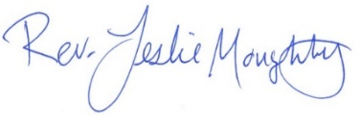

Pastor Leslie Out of the Office

Pastor Leslie will be out of the office from Monday 8/14 – Sunday 8/20 for Continuing Education and Monday 8/21 – Saturday 9/2 for personal leave. Pastor Leslie will be back in worship on Sunday 9/3 to lead worship with Rev. Kelly Gallagher, Associate Conference Minister for the United Church of Christ Minnesota Conference.
Rev. Mark Ford will be on call for Pastoral Care Emergencies beginning 8/20. He can be reached at 218-829-6069 or 218-232-8131. The weekly email and the Sunday bulletin will have more information regarding Pastoral Care coverage for 8/14 – 8/19.

0
First Congregational UCC News & Updates
Pastor Leslie’s Workday Schedule
>> Sunday through Thursday (Days off are Friday and Saturday) <<
Pastor’s Drop-in Hours*
Wednesdays 2:00 – 4:00pm Thursdays 11:00am – 1:00pm
*Drop-in hours are times set aside for “drop-in” conversations, much like a professor’s office hours. Pastor Leslie is typically working at the church the rest of the week, but it is possible that she may be in meetings, at a community event, or working off-site.
Pastor Leslie typically works off-site on Tuesdays for sermon research and writing.

Everyone is encouraged to make an appointment if the above times are not convenient.
You can go to www.calendly.com/pastorleslieucc and select a day and time that works for you, or you can email Pastor Leslie at pastorleslieucc@gmail.com or call/text at 218-656-0096.
0
Summer Office Hours
Church Office Hours: Wednesday, Thursday, Friday
10:00 am - 2:00 pm (extended for the summer)
Please call Terri at the office 218-829-2528 or
cell 218-537-1636 for further assistance.
Terri Admin. Asst. Vacation Day Thursday, August 10th
0
August Birthdays

Cindy Furda August 1
Nicole Grabowski August 2 Jill Carlson August 17
Diane Hauan August 8 Maria Bertram August 21
Jeanne Flint August 7 Cameo Ellis August 22
Bodie Brooks August 10 Shawn McAllister August 22
Brian Twamley August 12 Jeanne Schaeffer August 23
Shirley Barten August 13 Terry Boman August 27
Joseph Stattine August 13 Dana Watson August 27
Addison Ferrie August 15 Arlene Jones August 28
Emma Widmark August 16 Samuel Stadem August 30
0
How to watch Sunday worship The worship service is broadcasted on the church Facebook page and the church's YouTube channel every Sunday at 10:00 am.
To watch worship on Facebook, go to https://www.facebook.com/uccbrainerd/live
Live stream videos are saved and can be viewed at any time.
0
Financial Help Available Your Church Council voted last year to allow the Pastor's Discretionary Fund to be used to assist church members and others in the Brainerd area who are experiencing financial distress during this time. We received many generous donations! If you need assistance, please email, call, or text Pastor Leslie. Let her know what your situation is and how the church might be of help.
Donate to the church online! We are now accepting your offerings and donations using PayPal. You do not need to have a PayPal account to make an online donation with a credit card. To use PayPal, go to: https://www.paypal.me/uccbrainerd

0
July Council Meeting
~If you would like a copy of the full minutes, please contact the church office ~

Next Regular Council Meeting: Thursday, August 17th, 2023, 4:00 pm
in-person and via Zoom tinyurl.com/uccbrainerdzoom

Church Leadership
0
Get Involved, Give Back, Grow Connections – Volunteer at Church!
There are many opportunities for you to share your talents!

--Treasurer, serves a 1-year term (may renew for 6 terms). The primary role is oversight of bookkeeping, church finances and Executive Committee discussions. This candidate should have a strong background or interest in finance or banking.

--Council Member-At-Large: Attend council meetings, act as a liaison for church members and council, help with nominations, spokesperson for historically underrepresented groups (HUGS).

Committees needing fresh faces and leadership:
-Christian Education -Trustees
-Stewardship -Music -Arts

Call or text Mary Reardon - Moderator, with your nominations: 612-201-2967

0
Summer Bible Study
Final week - Monday 12:00 pm August 7th
In-person & Zoom
Join Pastor Leslie in a series featuring “Faces of Our Faith”.
Through scripture, art, and conversation, we’ll dig deep into the bold and untold stories of those often overlooked in our biblical narratives.

0
AUGUST FUNraisers!
0

Sponsored by the UCC Cooking Group

DON’T MISS THIS FABULOUS
PONTOON TOUR!
FRIDAY, AUGUST 25, 5:00 PM

Tour beautiful SYLVAN LAKE with Captain Dave Kavanaugh,
Mayor of East Gull Lake. Dave has lived, worked and played on and in
Sylvan Lake for over 50 years. See sites such as Camp Confidence,
Patrick Spradlin’s home, Eunice Wieboldt’s home and others!

Your tour includes a delicious GOURMET BOX DINNER,
Followed by a YUMMY DESSERT Served by
Marina Grabowski Off of her dock as we glide by!

$40 OR 2 FOR $75 and includes wine, dinner, dessert & shoreline tour of
upper & lower Sylvan. Space is limited to 12 Passengers.

Call or Text CYNTHIA JANES TODAY 218-513-3956
& reserve your spot TODAY!
RAIN DATE TBA.

When each event is advertised in the church announcements, a location, ticket price and coordinator and their phone number will be listed. Please call that person with your RSVP. Most events will have a limit on the number of participants. Payments can be made at the time of the event. Join us for one or all and share a fun time with church members and friends.

Other FUNdraisers Coming Soon!
*Outdoor BBQ Picnic *Cooking with a Pro *"New to Me"
*Chili Cookoff *Harvest Dinner
*"Soup's On" *Ancient Stories, Modern Food

If you would like to help with any of the events, or would like to host one yourself, call the event host, Lowell Johnson or Sharon Carlson.

0
W.I.S.E. Group Meeting
(Welcoming Inclusive Supportive and Engaged around mental illness) will meet on August 13th 11:00 am, after worship service during fellowship time at the long table to discuss plans for the upcoming year.
Anyone interested in joining, is welcome to attend!
0
UCC Women’s Fellowship
0
Saturday, August 19th at 9:30 am in the Fellowship Hall for coffee and goodies. Contact Marcia Ferris for more information.
Thursday, August 31st 11:30 am at B-Merri at the Woods in Merrifield. Contact Kay Cox for information about the weekday luncheons.
All updates will be posted on the Connections Facebook Group and RSVP’s may be made in the comments under the post at: www.facebook.com/groups/uccbrainerd

0
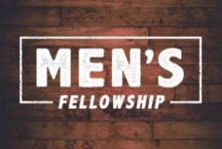
UCC Men’s Fellowship - Every Wednesday at Noon
You are invited to a casual fellowship at various locations in the Brainerd Lakes area.
Schedule 2023
First Wednesday: B-Meri
Second Wednesday: Four Seas in Brainerd
Third Wednesday: Dunmire’s East
Fourth Wednesday: Black Bear
Fifth Wednesday: El Tequila in Baxter
Contact Jack Kraywinkle for more information 612-396-3480 or email: kraywinklej@gmail.com

0
TheShop Meal with First Congregational UCC
“Fun with Food and Friends”!
***Mark your calendars!
Thursdays, August 24th, & September 21st (held in Gregory Park).
Organized by the Region 5 Economic Development Commission and Sprout, we receive 10 CSA boxes of local organic vegetables delivered to the church. At 3:34 pm the TheShop youth learn how to prepare the month's veggies, prepare a meal and enjoy eating together at 6:00 pm. The youth would like to have the adults bring their favorite music from the old days, and they will bring their favorite more modern music.
Contact Lowell Johnson at johnsonlowells@gmail.com if you are interested in volunteering with this exciting project.

0
Special Offering Sunday Worship August 27th
TheShop - BBYC
This month we have an opportunity to help as we give our Fourth Sunday Special Offering to TheShop Brainerd Baxter Youth Center (BBYC). TheShop is a non-profit organization committed to providing community support to all teenagers and young adults as they transition into independence and adulthood. We are a safe space where youthful energy is harnessed into creative energy by providing opportunities to explore potential, build lasting relationships, and establish personal connections. To donate, send a check with "TheShop" in the memo line to: First Congregational UCC, 415 Juniper St. Brainerd, MN 56401 or donate online using PayPal and indicate "TheShop" in the Note. payl.me/uccbrainerd
0

Thank you to The Foundation & Memorial Committees
0
The trustees wish to give a shout out to two committees who have helped
with funding two projects this year.

Our first shout out goes to The Foundation Committee who financed the repair of water pipes in the upstairs bathroom in the parsonage. The house was built in the early 1900’s and you can imagine the toll those old lead pipes have endured in that 100 year span. Thanks to Pike Plumbing for their expert modern day PVC pipe repair and church members Ryan Kelly and Tim Anderson for repairing the first floor dining room ceiling that was opened up by Pike for better pipe viewing.
Our second shout out goes to The Memorial Committee who are taking on the funding to update the outdoor memorial (Columbarium) Garden. As some of you may know Sue and Dale Hadland had given upkeep money and Dale and his crew put in a lot of sweat equity to keep it looking great. The garden has long been a source of joy and appreciation to all those (both our congregation and the local neighborhood) who have sat on its benches by the living water fountain and been comforted by the flowers and private area. Over the summer the garden will be having a facelift which may include taking out some overgrown bushes, weeds etc., etc. A landscaping company has been contacted and we are in hopes work can begin soon. Be on the lookout for the transformation!

UCC Care Team
0

In March the Care Team with 6 people was formed with the purpose of reaching out to our congregation to ask how their lives are post covid, is our church still valid to them and if they needed anything from our church.
The current church directory was split up between the team and contacts were made and at our April meeting brief summaries were given for all who were contacted. While some were not available and some did not call back, the consensus for most was that the call was very appreciated.
In April a Congregational Care Team Visitation List was created to keep track of those parishioners who were homebound; living in a facility; living with chronic conditions; the bereaved and those with other concerns. Those who would like prayers are lifted up during worship and those wishing a pastoral call or visit are given to Pastor Leslie.
For anyone who wishes to join in on making calls or visits, the Care Team meets every month, on the second Wednesday at 10:00 am at church.

If you know of anyone who would enjoy a call from the care team, please contact one of our Care Team; Barb Hoeft, Jack and Kay Kraywinkle, Pat Scott, Chris Yager, Joey Halverson, Deb Griffith and Pastor Leslie.

0
Friday Book Group - 10:00 am
Via Zoom: tinyurl.com/uccbrainerdzoom

We continue to read "Water Always Wins: Thriving in an Age of Drought and Deluge by Erica Gies.
“A hopeful journey around the world and across time, illuminating better ways to live with water".
0
First Congregation Food Shelf Collection Boxes
0
Our church continues to collect non-perishable food items for the Salvation Army Food Shelf. There are two collection boxes: one in the parking lot entry hallway, the other in the Narthex. Brian Twamley picks up and delivers the food.
Please consider bringing items and donating. You may also send a money donation to the church; First Congregational UCC, 415 Juniper St. Brainerd, MN 56401. Or for your convenience use our Paypal account at: paypal.me/uccbrainerd Make sure to write in memo “Food Shelf”. Thank you!

0
Hosts, Ushers, Greeters,
Scripture-readers
Sunday morning greeters/ushers and coffee hosts play an important part in making our church a warm and welcoming place for all. Here’s a secret; it’s FUN!! If each household committed to 3 Sundays a year as greeter/ushers and/or coffee hosts, we would have a full complement of participants. Are you ready to take the leap into RADICAL HOSPITALITY? Give it a go and signup below for your first Sunday as the face of the church! https://www.signupgenius.com/go/10C0E48A9A823A5FFC07-hugs/16034811

0
Garden Gleaning
A Biblical (and environmentally) inspired activity
Gardeners and plant people bring in their “gleanings” to share. This ranges from rhubarb in the spring to daffodil bulbs in the fall. A table, poster and donation basket are in Narthex entrance. Enjoy the fruits of our labors! All are welcome to help themselves – no charge! All monetary donations are given to the Food Shelf.
Historical note: Begun here circa 1988 when our church began Hunger Action outreach, Central America updates and global food connections.

0
Adult Forum
Adult Forum will resume in the Fall.
Contact Lowell Johnson if you have an idea for a presentation.
johnsonlowells@gmail.com

0
New Hearing Loop System Installed!
Sanctuaries don’t always have the best acoustics for people with hearing loss.
If you have a T-coil enabled hearing aid, you can now utilize the church’s new telecoil hearing system. The system will work best in the front section of the sanctuary. Your hearing aid must be enabled to receive the audio signal. Please contact your supplier if you need help in activating this feature.
0

Brainerd Lakes Area Information
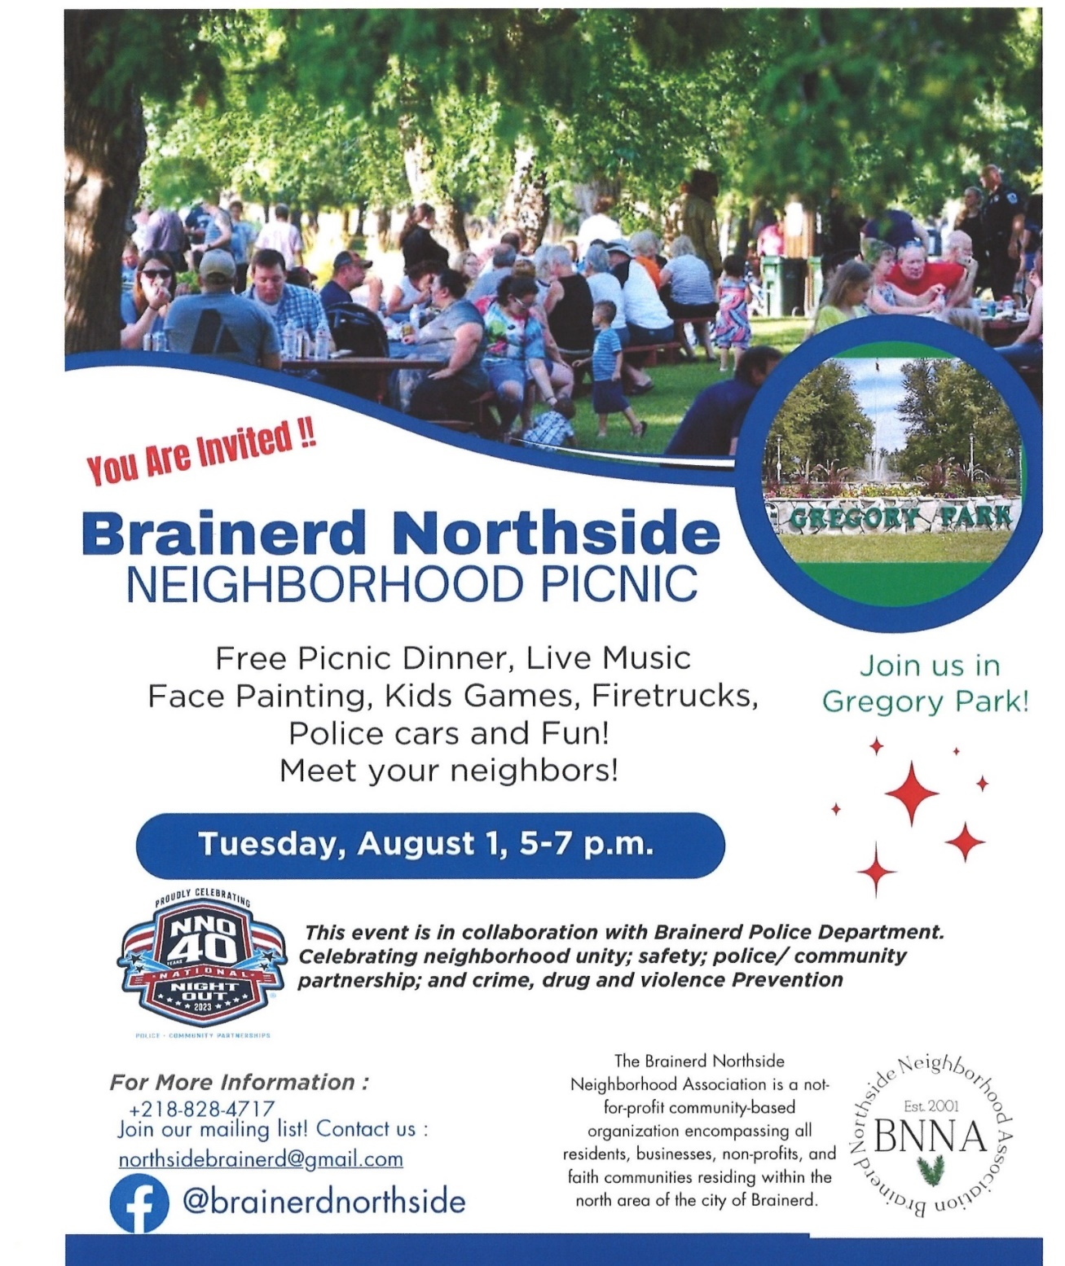
~ Opportunities to Know and Share God’s Love ~

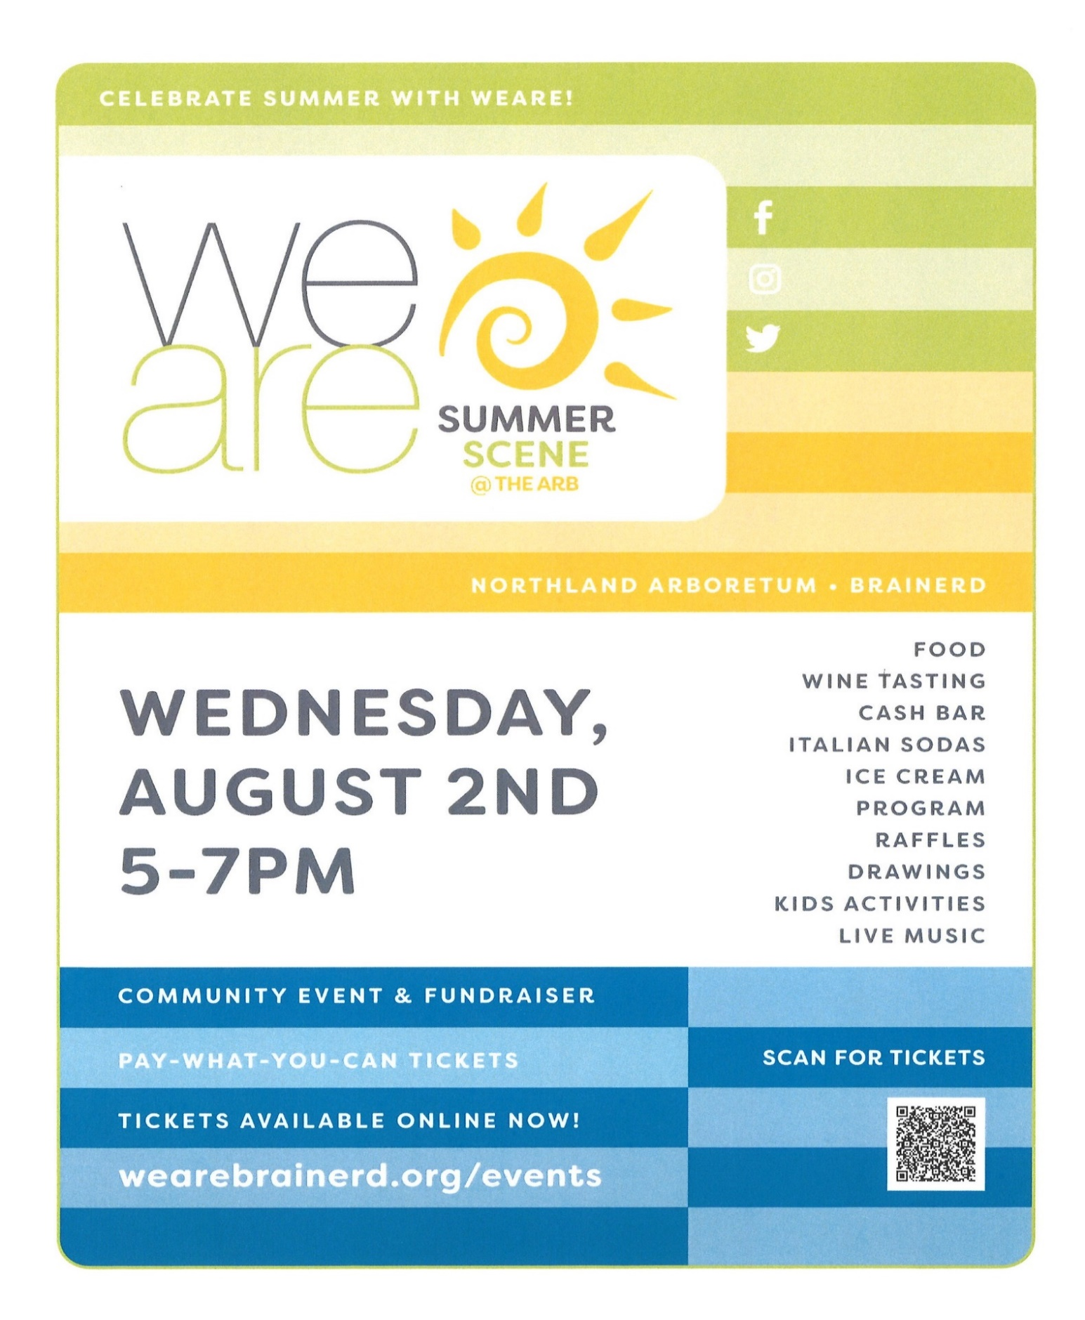

Mark Your Calendars for Upcoming Events!

2023 Walk to End Alzheimer's®

Brainerd Lakes Area September 23rd
Held annually in more than 600 communities nationwide, the Alzheimer's Association Walk to End Alzheimer's® is the world's largest fundraiser for Alzheimer's care, support and research. This event is the celebration of the work that has been being done throughout the year, so don't wait to join in. While there is no fee to register for Walk, all participants are encouraged to raise critical funds that allow the Alzheimer’s Association to provide 24/7 care and support and advance research toward methods of prevention, treatment and, ultimately, a cure. https://act.alz.org/Brainerd to register your team!

Play worship 06/11-25/23
The Brainerd Lakes Pride Weekend.
Pride in the Park Picnic is September 9th 10:00 am – 4:00 pm in Gregory Park.
Follow their Facebook Page for other Pride Activities that weekend.
Facebook.com/BrainerdLakesPride

Play worship 06/11-25/23
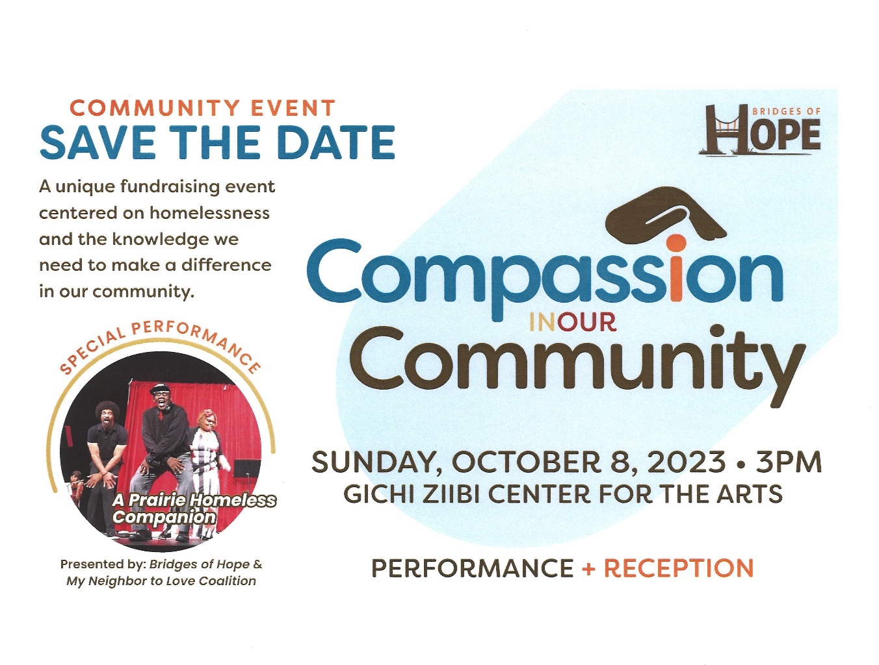
Play worship 06/11-25/23

August 2023 Calendar
Sunday | Monday | Tuesday | Wednesday | Thursday | Friday | Saturday
Leslie Workday  LeMesa Grp-Meets Tuesdays @ Gregory Park w/church backup | Leslie Workday | Leslie Workday | Office Hours10am – 2pm  Pastor Drop-in 2pm-4pm | Office Hour  10am – 2pm  Pastor Drop-in  11am – 1pm | Office Hours10am – 2pm
 |  | 2pm Emotions 1  Anon- Y  5:30pm Overeaters Anon- Y | 2  12pm Mens Grp-Y @  B-Merri  7pm AA Common-Y | 3  10am Care Team-Y | 4  10:30am Book Grp-Z  . | 5
6  8:30am Bnrd Frnds-Y  10am Wrship & Communion Serv-Y&V  11am Fellowship-Y  11:30 am PPRC-Y | 7  12pm Summer Bible Study-Y&Z (final) | 2pm Emotions 8  Anon-Y  5:30pm Overeaters  Anon-Y  Decorate Fellowship for Fika tomorrow | 12pm Men’s Grp 9  @ 4 Seas-Y  1-3pm Swedish Fika Program-Sharon C-Y.  7pm AA Common-Y | Terri Admin 10  Asst. Day Off  9am CM Mtg-Y  5:30pm Trustees-Y  7pm BLUE-in Park-Y/church backup | 11  10:30am Book Grp- Z | 12
8:30am Bnrd Frnds-Y 13  10am Wrship Serv-Y&V  11am Fellowship-Y  11am WISE Mtg. Y  Pastor Leslie begins Continuing Ed | 14  3:30pm Exec. Team Mtg.-Y& Z | 15  2pm Emotions Anon-Y  5:30pm Overeaters Anon-Y | 16  12pm Men’s Grp-@ Dunmire’s East-Y  7pm AA Common-Y  Pastor Drop-in Hrs.-C | 17  4pm Council Mtg-  Y&Z  6:30pm Dist.7 AA-Y  Pastor Drop-in Hrs.-C | 18  10:30am Book Grp- Z | 19  9:30am Women’s Fellowship in Fellowship Hall-Y
8:30am Bnrd Frnds-Y 20 10am Wrship Serv-Y&V  Supply Pastor  11am Fellowship-Y  Pastor Leslie begins Personal Leave | 21 | 22  2pm Emotions Anon-Y  5:30pm Overeaters Anon-Y | 23  12pm Men’s Grp @ Black Bear Grill-Y  7pm AA Common-Y  Pastor Drop-in Hrs.-C | 24  3:45p TheShop cooking & 6pm Dinner in church-Y  Pastor Drop-in Hrs.-C | 25  10:30am Book Grp- Z  5pm Fundraiser Pontoon Tour Lake Sylvan | 26
8:30am Bnrd Frnds-Y 27  10am Wrship Serv-Y&V  Supply Pastor  11am Fellowship-Y  Special Offering:  “TheShop”  **Newsletter Deadline | 28  12pm Summer Bible Study-Y&Z | 29  2pm Emotions Anon-Y  5:30pm Overeaters Anon-Y | 30  12pm Men’s Grp @ El Tequila-Y  Pastor Drop-in Hrs.-C | 31  11:30am Women’s Fellowship-Y@  B-Merri in the Woods  Pastor Drop-in Hrs.-C | Pastor Leslie returns from Retreat & Personal Leave  Sept. 3rd. | V –Virtual Online  Z- our Zoom  C- Cancelled  N-None  ? – No update  Y- Yes Mtg. in person

