
Friendship News, March 2026
0
First Congregational United Church of Christ, Brainerd
An Open and Affirming Congregation
The Church Office Hours: Tuesday, Wednesday, Thursday from 10:00am – 2:00pm
Office phone 218-829-2528 Office E-mail uccbrainerd@gmail.com
Pastor Leslie’s E-mail: pastorleslieucc@gmail.com Website: www.uccbrainerdmn.org

No matter who you are, or where you are on life’s journey, you are welcome here.
0
Pastor’s Pen
0

What the Heck is Lent for Anyway?
Last month I wrote about the misunderstanding that the season of Lent has, for many, become a season about sacrifice and atonement, but that it hasn’t always been that way. Originally, Lent was a season for new converts to learn about the Christian faith and to prepare for their baptism which took place on Easter.
The way many Christians have observe Lent, and the way I have been instructed to observe Lent throughout my life, has often seemed…vapid. I couldn’t quite put my finger on what was missing for me. I recently read an article titled “Your Lenten Discipline Might Be the Problem” posted on the Ministry Matters website that helped shed more light on what I was feeling. The article began as follows:
There's a version of Lent that makes you a worse person.
Not because the practices are bad. Not because prayer, fasting, and reflection are wrong. But because it's entirely possible to spend forty days focused on your own spiritual refinement while the world outside your prayer closet continues to burn—and to come out the other side feeling better about yourself. Lighter. Cleaner. Ready for Easter.
That's the version we need to talk about.
Lent has always carried three pillars: prayer, fasting, and almsgiving. The tradition is ancient, rooted in the desert fathers and the early church's preparation of catechumens for baptism. For most of Christian history, these three practices were understood as inseparable. You couldn't fast without giving what you didn't eat to someone who was hungry. You couldn't pray without being interrupted by the neighbor in need.
Somewhere along the way—especially in middle-class American Christianity—we kept the prayer and the fasting and quietly let the almsgiving become optional. We turned Lent into a self-improvement project dressed in sackcloth. (emphasis mine)

As I read that last sentence, something clicked. My understanding of the faith and the way Jesus has never been limited to self-improvement. Becoming a better human is certainly a big part of it, but if that improvement doesn’t turn outward toward my neighbors and the world, then it’s missing the point. God doesn’t ask us to make sacrifices and improve our prayer life solely for our own benefit. Co-creating the kin-dom of God on earth as it is in heaven, is at the core of our faith. In the words of the author,
“Lent was never designed to make us better individuals. It was designed to make us a different kind of people - the kind whose practices reshape not just their inner life but their shared life, whose fasting is connected to someone else's hunger, whose prayer leads somewhere beyond personal peace. What would it look like if your congregation's Lenten discipline this year was chosen not by asking "what would help me grow?" but by asking "what does our community need us to give up?"
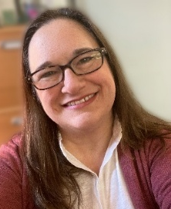
I’m curious how each of you might answer that question, for yourselves as an individual and for us as a congregation. What do we each need to give up or let go of in order better serve the community? What do we as a church need to give up or let go of, in order to better serve God’s children? This could be a way of doing things, or a perception that we hold. It could be an asset of some sort or a program that is taking up too much of our energy. I really would love to hear your thoughts about this. So once you’ve had a chance to ponder this for a bit, send me an email, or write me a note, or tell me over coffee at fellowship. Let’s make this season Lent about a transformation that leads to resurrection and hope for all.
With Peace,
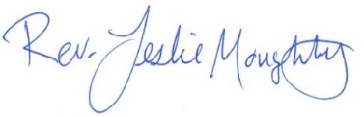

Mission Statement of First Congregational UCC
“To know and share God’s love within us.”

Purpose Statement of First Congregational United Church of Christ
“First Congregational UCC is a welcoming, inclusive, and progressive community committed to promoting social justice, spiritual growth, and love for all people. We reject discrimination and advocate for equality and dignity for marginalized communities. Through worship, education, and service, we work to make a positive impact on the world and invite all individuals to join us in this journey of faith and service.”
0

Church Office Hours
Tuesday, Wednesday, Thursday 10:00 am - 2:00 pm
Closed Mondays and Fridays
Please call for assistance - office 218-829-2528
0
Pastor Leslie’s Workday Schedule

Sunday through Thursday (Days off are Friday and Saturday)
Pastor Leslie Vacation Days: March 2nd through March 9th
For emergency pastoral care needs during this time, please contact
Rev. Steve Rye at 765-491-7338
Drop-in Hours: Wednesdays 11:00 am – 1:00 pm
*Drop-in hours are times set aside for “drop-in” conversations, much like a professor’s office hours.
Everyone is encouraged to make an appointment, especially if the above times are not convenient. You can go to www.calendly.com/pastorleslieucc and select a day and time that works for you, or you can email Pastor Leslie at pastorleslieucc@gmail.com or call/text at 218-656-0096.
0

Stay Connected
0

How to watch Sunday worship: The worship service is broadcasted on the church Facebook page every Sunday at 10:00 am.
To watch worship on Facebook, go to https://www.facebook.com/uccbrainerd/live

How to stay connected with First Congregational friends and members: Join the private group for our Facebook Connections Page at https://www.facebook.com/groups/uccbrainerd.
Financial Help Available The Pastor's Discretionary Fund is available to assist church members and others in the Brainerd area who are experiencing financial distress with modest financial help. If you need assistance, please email, call, or text Pastor Leslie. Let her know what your situation is and how the church might be of help.
Donate to the church online! We are accepting your offerings and donations using PayPal.
You do not need to have a PayPal account to make an online donation with a credit card. To use PayPal, go to: https://www.paypal.me/uccbrainerd

First Congregational UCC News & Updates
0
0


Join Our Church Choir
Worship Service at 10:00 am

2026 Schedule
March 1,15 & 29, April 12 & 26, May 3 & 17.
Fall & Winter dates to be determined
Rehearsal 8:30 am in the Sanctuary

0

Annual Connection Letter & Church Directory

Our church is sending out the letter in the near future. Keep your eyes on your mailbox and send back the completed form asap! Your response is important to help us better connect with one another and better serve our members and visitors.
If you do not receive a letter and would like one, please contact Terri in the church office.

This information will help us update our membership list, the Church Directory and make informed decisions about programs, and much more.

Please Help us stay connected and return the completed form by April 15th. Thank you!
0


0

Easter Flowers 2026
You have the opportunity to give a gift in the name of your loved one(s).
We will use the money to purchase flower arrangements for the altar.
All memorials will be listed in the Easter bulletin.
* * * * * * * * * * * * * * * * * * * * * * * * * * * * * * * *
Please fill out the following completely.

Amount of Memorial Gift: $___________________________________

In Memory Of: ________________________________________________
________________________________________________
________________________________________________

Your Name(s): ________________________________________________

Write your check to: “First Congregational Church”
Memo: “Easter Flowers”
Leave this form with your check in the offering plate,
the church office, or mail it to:
First Congregational Church
415 Juniper Street Brainerd, MN 56401
0

March Birthdays

Emily LeClaire March 2 Jonathan Howard March 23
Sharon Carlson March 4 Steve Samuelson March 23
Mike Imsdahl March 6 Melinda Ellis March 27
Marina Grabowski March 16 Pat Scott March 29
Tim Anderson March 21 Janet Merzenich March 31
Deb Griffith March 21

0
Next Council Meeting

Thursday, March 19, 2026, 3:30 pm
in-person and via Zoom tinyurl.com/uccbrainerdzoom
First Congregational Approved Council Meeting Minutes are available upon request.
Please contact Terri Admin Asst. at the Church Office.

0
Volunteer at Church!
There are many other opportunities for you to share your talents
These committees need your gifts: * Trustees * Stewardship *
0
0
UCC Fellowship


Women’s Saturday Coffee

March 21st @ 9:30 am
In Fellowship Hall


Women’s Thursday Lunch

Thursday, March 26th @ 11:30 am
@ Passport
Downtown - Laurel St.


Men’s Lunch

Each Wednesday
11:45 am @ Wings Airport Café
Not Organized—No Agenda Join Us!

0

March Adult Forums
11:30 after Sunday Worship

March 15 – Building Community with Vulnerable Adults: Vicky Kinney from MNTL Coalition will discuss ways to better understand the needs of vulnerable adults, how to better serve, and raise awareness about challenges.

March 22 – Justice Sunday - Justice Action Teams: Each team will provide an update on their work with time for Q&A and a discussion time. This is your opportunity to hear what the teams are planning and add your perspective.
0


TheShop Meal @ First Congregational UCC

Meal Cooking in the church kitchen is postponed until further notice.
0
0

Sunday, March 29th
UCC Missions - OGHS
One Great Hour of Sharing
This Lent congregations across the United Church of Christ will take part in the One Great Hour of Sharing (OGHS) offering. One Great Hour of Sharing is a Special Mission Offering that supports partners worldwide with ministries that fund health, education, and agricultural development, emergency relief, refugee ministries, and both international and domestic disaster response.

Please send your donation to First Congregational UCC, 415 Juniper St. Brainerd, MN 56401. Make sure to note on your offering: “Special Offering One Great Hour of Sharing (OGHS)”.
Or for your convenience use our PayPal account at: paypal.me/uccbrainerd
Be sure to note on your offering “Special Offering One Great Hour of Sharing (OGHS)” in the notes. Thank you!

0

UCC Care Team
For anyone who wishes to join in making calls or visits, the Care Team meets every month on the first Thursday @ 10:00 am.
If you know of anyone who would enjoy a call from the care team, please contact one of our Care Team; Jack and Kay Kraywinkle, Pat Scott, Chris Yager, Deb Griffith, Nancy Gould, Tracy Lyons, Cynthia Janes,
Joey Halvorson (text or email) and Pastor Leslie.

0
Friday Book Group
We meet each Friday morning at 10:30 am via zoom.
Church Zoom link: https://tinyurl.com/uccbrainerdzoom

We are reading "By Any Other Name” by Jodi Picoult. Two women, centuries apart—one of whom is the real author of Shakespeare’s plays—who are both forced to hide behind another name and navigate the barriers for women artists being acknowledged for their work.
0

Cooking For Everyone – Including YOU!
Email Lowell Johnson or Kay Cox to be added to the email/call list. You will be notified when and where they next meet.
0


First Congregational Food Shelf Collection
Our church continues to collect non-perishable food items for the Salvation Army Food Shelf. Please consider bringing items and donating.
There are two collection boxes: one in the parking lot entry hallway, the other in the Narthex. Brian Twamley or Stephanie Lee pick up and deliver the food. Thank you!
Minnesota Foodshare March Campaign – see flyer below for more information
The 2026 March Campaign will run March 1-April 6, 2026! https://gmcc.org/march-campaign/
0

H.U.G.S.
0
Hosts, Ushers, Greeters, Scripture-readers
Sunday morning greeters/ushers and coffee hosts play an important part in making our church a warm and welcoming place for all. Signup with the link below for your first Sunday as the face of the church!

https://www.signupgenius.com/go/10C0E48A9A823A5FFC07-hugs/16034811


0
UCC Volunteer Opportunity – Warming Shelter Bridge on 7th
Sign up for a morning shift as a team of two or/individually. You can choose a time to volunteer online. The staff and shelter guests appreciate our involvement. The link is below. Create an account. Pick a date. They need your birth date and your ok for a background check.
Start here at this link to sign up for volunteering; https://www.bridgesofhopemn.org/volunteer
Then go to this link to choose a date to volunteer at the shelter. They need your birth date and your ok for a background check. https://volunteer.bloomerang.co:443/JE/bas6nebexg029t
0

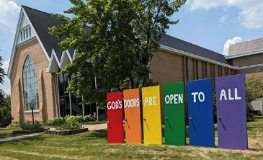
Our Building Is a Great Event Venue!
We are blessed to be able to share our beautiful church facilities for purposes that match the values of the church and its mission which is “To know and share God’s love within us.” We are an open church valuing the diversity of age, culture, gender identity, opinions, physical and mental abilities, and sexual orientation.
To request a space for general use, ask for a “Request for Church Building Use” form and
policy packet from Terri in the church office, at 218-829-2528 or email uccbrainerd@gmail.com. Submit the request form back to Terri in the office, and it will be submitted for approval at the next Council Meeting. For wedding or funeral use, contact Pastor Leslie: pastorleslieucc@gmail.com

0
The Columbarium & Memorial Garden
First Congregational UCC, Brainerd
The Columbarium is in the historic space that once was our church’s front entry way.
How appropriate it is that our Columbarium now marks another entry way into a new life — where the Spirits of Love and Truth are always present!
The Memorial Garden is located on the south lawn of the church. The Garden provides a place for cremains of your loved one to be buried in the ground among natural plantings. The Garden fee includes the inscription of your loved one’s name on a granite plaque that is mounted on the outside wall of the church.
Should you wish to learn more about the purchase of a niche for your own cremains or for the ashes of a loved one, please call the church office at (218) 829-2528 and a packet of materials will be sent to you via email or regular mail.
0
0
Save the Date – April Adult Forum Presentation
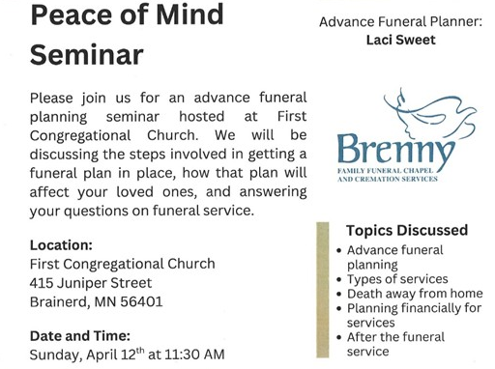

0
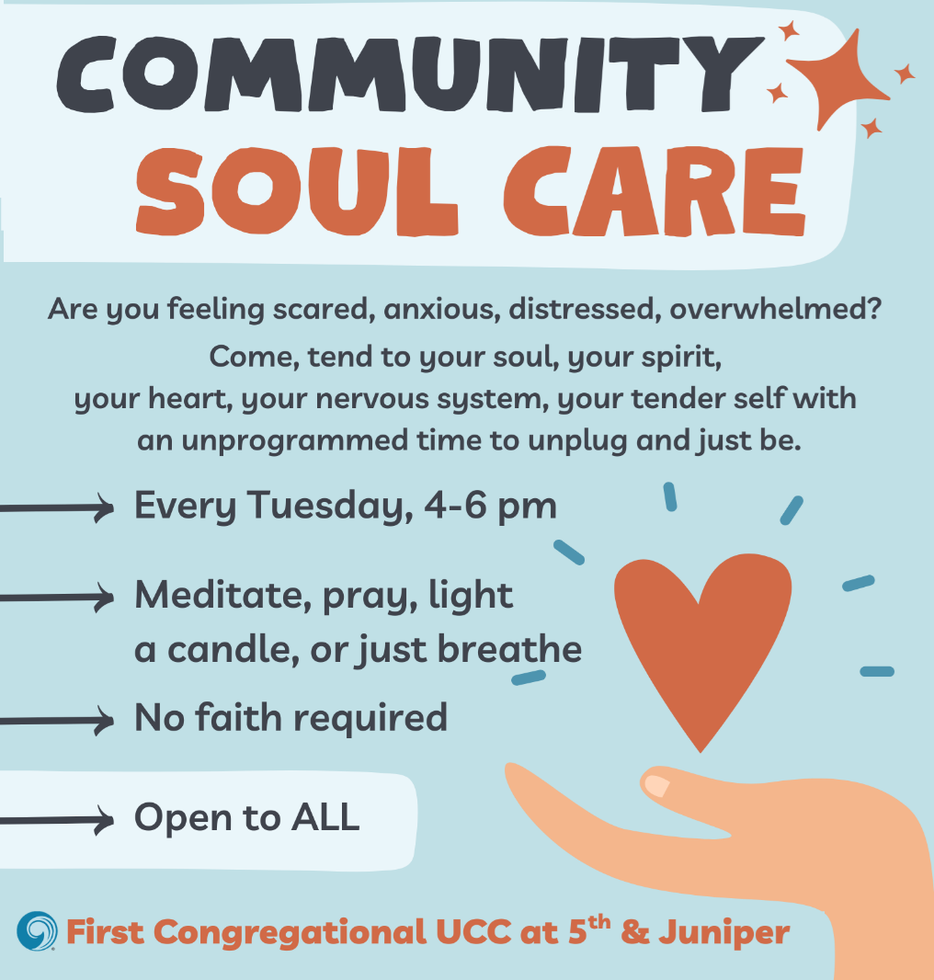

Brainerd Lakes & Surrounding Area Information
0
~ Opportunities to Know and Share God’s Love ~
0

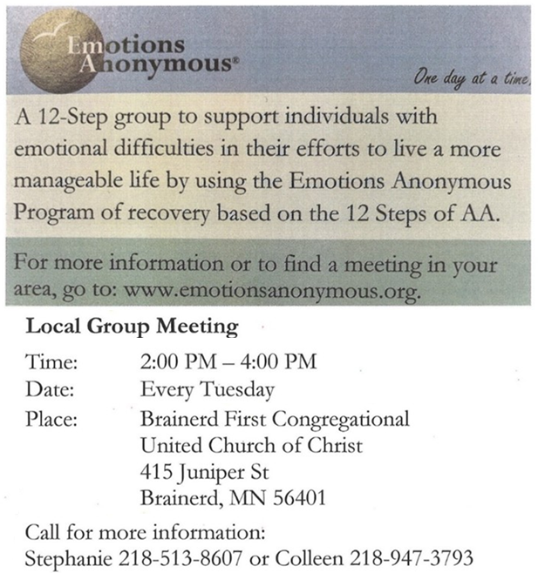

Baskets for collecting non-perishable food items are at the front and back doors of the church.
Please donate this month.
To donate using Paypal: paypal.me/uccbrainerd
Make sure to include in the memo: Food Shelf.


0

0
0

March 2026 Calendar
Sunday | Monday | Tuesday | Wednesday | Thursday | Friday | Saturday
Y- Yes Meeting in person  FB -Facebook Live Stream Online  C- Cancelled  N-No Meeting  Z-our church Zoom | Office Closed | Office Hours  10am – 2pm | Office Hours  10am – 2pm  Pastor Drop-in Hours  11:00 am – 1:00 pm | Office Hours  10am – 2pm | Office Closed
8:30am Bnrd Frnds-Y 1  8:30am Choir Practice  10am W0rship, Communion  & Choir-Y&FB  11am Fellowship-Y  6-8pm BLA Indivisible Knitting Group-Y Fellowship Hall | 2 | 2pm EA-Y 3  3-6pm Community Soul Care in Sanctuary-Y  5-9pm BLA Indivisible in Fellowship Hall-Y  5:30pm OA -Y | 11:45pm Men’s Grp 4  @ Wings Cafe-Y  1:30pm PRC Mtg.- ? Reschedule  4:30pm Christian  Ministry-? Reschedule  7pm AA Common-Y | 5  10am Care Team-Y | 6  10:30am Bk Grp-Z  6:30pm Movie Night-Y | 7
8:30am Bnrd Frnds-Y 8  Rev. Emily Goldswaithe Preaching  10am W0rship & Choir-Y&FB  11am Fellowship-Y | 9  6-8pm BLA Indivisible-Y  Fellowship Hall | 2pm EA-Y 10  3-6pm Community Soul Care in Sanctuary-Y  5:30pm OA -Y | 10amTrustees-Y 11 11:45am Men’s Grp  @ Wings Cafe-Y  3:30pm Executive Mtg.-Y  7pm AA Common-Y | 12 | 13  10:30am Bk Grp- Z | 14
8:30am Bnrd Frnds-Y 15  8:30am Choir Practice  10am W0rship, Communion  & Choir-Y&FB  11am Fellowship-Y  11:30am-Adult Forum-Vulnerable  Adult Presentation  1pm Girl Scout Mtg.-Y | 16 | 2pm EA-Y 17  3-6pm Community Soul Care in Sanctuary-Y  5:30pm OA -Y | 18  11:45pm Men’s Grp.  @ Wings Cafe-Y  7pm AA Common-Y | 19  3:30pm Council Mtg.-Y&Z  6:30pm Dist.7 AA-Y | 20  10:30am Bk Grp- Z | 21  Women’s Coffee-Y  *Note date change
8:30am Bnrd Frnds-Y 22  10am Worship-Y&FB  11:15am Fellowship-Y  11:30am Adult Forum-Justice Sunday: Justice Team Mtgs.-Y  **April Newsletter Deadline | 23  4:30-8pm AAUW in Fellowship Hall-Y | 2pm EA-Y 24  3-6pm Community Soul Care in Sanctuary-Y  5:30pm OA -Y | 11:45pm Men’s Grp 25  @ Wings Cafe Y  TheShop Cooking-church kitchen-C until further notice  7pm AA Common-Y | 26  11:30am Women’s Lunch @ Passport downtown Brainerd | 27  10:30am Bk Grp- Z | 28  12pm-4pm BLA Indivisible in Fellowship Hall-Y
8:30am Bnrd Frnds-Y 29  8:30am Choir Practice  10am Worship & Choir-Y&FB  11:15am Fellowship-Y  **Special Offering UCC Missions-  One Great Hour of Sharing | 30 | 2pm EA-Y 31  3-6pm Community Soul Care in Sanctuary-Y  5:30pm OA -Y |  | *Pastor Leslie Vacation Days: March 2nd through March 9th

https://ministrymatters.com/2026-02-19_your_lenten_discipline_might_be_the_problem/, accessed February 26, 2026

