Friendship News, September 2023
First Congregational United Church of Christ, Brainerd
An Open and Affirming Congregation
The Church Office Hours: Wednesdays – Fridays from 10:00am – 2:00pm
Pastor Leslie’s Drop-in Hours: Wed. 2:00pm – 4:00pm, Thurs. 11:00am – 1:00pm
Office phone 218-829-2528 Office E-mail uccbrainerd@gmail.com Pastor’s E-mail: pastorleslieucc@gmail.com Website: www.uccbrainerdmn.org
Schedule a 1 to 1 (in-person or by Zoom or Phone) with Pastor Leslie:
www.calendly.com/pastorleslieucc/1to1
No matter who you are, or where you are on life’s journey, you are welcome here.

Pastor Leslie Out of the Office
0
Pastor Leslie will be out of the office from Monday 8/21 – Saturday 9/2 for personal leave. Pastor Leslie will be back in worship on Sunday 9/3 to lead worship with Rev. Kelly Gallagher, Associate Conference Minister for the United Church of Christ Minnesota Conference.
Rev. Mark Ford will be on call for Pastoral Care Emergencies beginning from
8/20 – 9/2. He can be reached at 218-829-6069 or 218-232-8131.

Pastor Leslie’s Workday Schedule
>> Sunday through Thursday (Days off are Friday and Saturday) <<
Pastor’s Drop-in Hours*
Wednesdays 2:00 – 4:00pm Thursdays 11:00am – 1:00pm
*Drop-in hours are times set aside for “drop-in” conversations, much like a professor’s office hours. Pastor Leslie is typically working at the church the rest of the week, but it is possible that she may be in meetings, at a community event, or working off-site.
Pastor Leslie typically works off-site on Tuesdays for sermon research and writing.

Everyone is encouraged to make an appointment if the above times are not convenient.
You can go to www.calendly.com/pastorleslieucc and select a day and time that works for you, or you can email Pastor Leslie at pastorleslieucc@gmail.com or call/text at 218-656-0096.

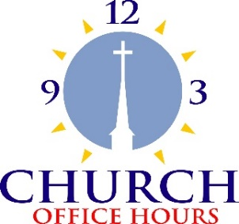
Church Office Hours
Wednesday, Thursday, Friday
10:00 am - 2:00 pm
Please call Terri at the office 218-829-2528 or
cell 218-537-1636 for further assistance.
0

0
First Congregational UCC News & Updates
0

September Birthdays

Duane Shatava Sept. 1 Kay Kraywinkle Sept. 15
Todd Froemming Sept. 3 Allison Crum Sept. 19
Mark Utzinger Sept. 8 Lynn Fox Sept. 24
Thomas Nelson Sept. 9 Kaylo Brooks Sept. 25
Hanna Moscho Sept. 11 Mark Stults Sept. 26
Robert Ogdahl Sept. 12 Kyd Lukanen Sept. 27
Lois McBroom Sept. 14 Judy Whiteman Sept. 28
Rod Carlson Sept. 14 Leslie Moughty Sept. 29 Wayne Milinkovich Sept. 14 Mark Stadem Sept. 30

0

How to watch Sunday worship The worship service is broadcasted on the church Facebook page and the church's YouTube channel every Sunday at 10:00 am.
To watch worship on Facebook, go to https://www.facebook.com/uccbrainerd/live
Live stream videos are saved and can be viewed at any time.
Financial Help Available Your Church Council voted last year to allow the Pastor's Discretionary Fund to be used to assist church members and others in the Brainerd area who are experiencing financial distress during this time. We received many generous donations! If you need assistance, please email, call, or text Pastor Leslie. Let her know what your situation is and how the church might be of help.
Donate to the church online! We are now accepting your offerings and donations using PayPal. You do not need to have a PayPal account to make an online donation with a credit card. To use PayPal, go to: https://www.paypal.me/uccbrainerd
0
August Council Meeting
~If you would like a copy of the full minutes, please contact the church office ~

Present: Mary Reardon (Moderator), Judy Whiteman (Stewardship), Deb Griffith,(Trustees), Alvin Velslaag (At Large), Cynthia Janes (Clerk), Lowell Johnson (Christian Ed), Shon Boman (Pastor-Parish Relations), Terri Chidester (Admin. Asst.) via Zoom.
Absent: Tim Anderson (Assistant Moderator), Pastor Leslie (on leave), Christian Ministry
Additions to the Agenda (Moderator) - Rather than adding it to the agenda, at this point Lowell presented several items that were essentially his monthly report to Council.
1.Lowell met with a group wanting to move “100 Conversations” forward.
2.The Crossing Arts Alliance has agreed to be the fiscal agent on a grant proposal for the story project, “Crow Wing Community Stories Project,” which captures stories of marginalized people.
3 “Indigenous People Day” is coming. Lowell suggested that the church do the “blanket exercise.” Lowell explained that this exercise helps us see what happened to Indian treaties. He also noted that probably there will be a mural painted on a wall in one of the County buildings.
4.It was also mentioned that Bridges of Hope is doing a production called “A Prairie Homeless Companion.”
Approval of June Council Minutes - Approved as corrected. (Correction was to strike a partial sentence.)
Clerk Report - No activity reported by Barb Stokke.
Financials - The July, 2023 Financial Report was discussed. Some concern about the rate at which we are exceeding income, which we need to do to balance the (deficit) budget by the end of the year. Report accepted.
Department Reports
1. General:
a. Cynthia (Clerk) communicated to Becky Twamley (Memorial Committee chair) that even though the Memorial Committee meets monthly, their report should be sent to the Clerk ahead of the following Council Meeting. Becky agreed.
b. No word on whether Pastor Leslie has communicated with Barb Hoeft (chair of Congregational Care Team) to submit Congregational Care Team reports after their meetings.
2. Trustees – Deb amplified on her written report.
3. Stewardship – Written report.
4. Christian Ministry—Written report
5. Members at large
a. Alvin mentioned at an after-church meeting of interested parties resulted in about 12 people gathering to discuss WISE plans. This project will get up and running in September. There will be a monthly WISE report in the church’s monthly newsletter.
b. Kay (PPRC Written report.
6. Care Team Report—Report not received.
7. Pastor’s Report – Rev Leslie—Report not received.
Old Business
A. Pride Picnic in the Park is scheduled for September 9, 10-3. Mary R and Cynthia volunteered to head this. We have a good number of sign-ups for all shifts except for tear down/carry back to church. Sheet sent around again at worship service August 27, with specific need for the latter function, and people did sign up for these. So we are set for personnel. Cynthia may bring reminders of how far we have come (old t-shirts and newspapers from the 80’s-90’s).
B. After church on September 17 for Adult Forum will be an all-church brainstorming session for mission and vision statements, as well as to outline the next steps for the survey results.
C. Laramie Project October 12-15. Still need a way to raise $$ for the church’s table at this event.
D. Stewardship ideas presented last month: Judy Whiteman reported that Stewardship Committee will take the next steps. Probably theme for this year’s campaign: “Because of you, our church changes lives.”
E. The Executive Committee recommends renewing the CD at MMFU for 13 months at 5.05%. Motion to approve the recommendation passed unanimously.
New Business - We need to discuss an orientation for new members. (Next month.)

Respectfully submitted, Cynthia Janes, Clerk of Council

0
Next Regular Council Meeting: Thursday, September 21st, 2023, 4:00 pm
in-person and via Zoom tinyurl.com/uccbrainerdzoom
0
0 Movie Night is starting up again this month!
Mark your Calendars!
First Congregational is Hosting Senior Pride Brunch

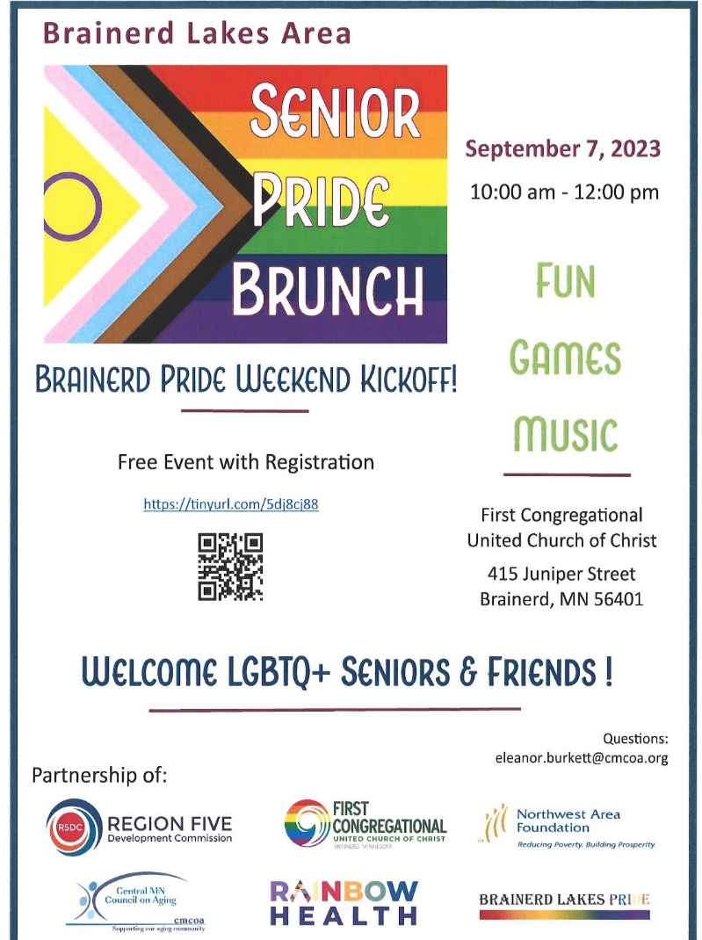

0 Movie Night is starting up again this month!
Mark your Calendars!
September Adult Forum
11:30 after worship

Brainstorming for Our Church Future: September 17th - Join us as we hold a brainstorming session on what our church could look like in the future. Bring your wild ideas!
Prioritizing Congregational Justice Concerns: September 24th - Last spring we identified congregational justice concerns and passions. In this session, we will use a group activity to group similar concerns and passions and identify our social justice priorities. Please plan to join us as we set congregational justice priorities. We need your voice and perspective.
0 Movie Night is starting up again this month!
Mark your Calendars!
0 Movie Night is starting up again this month!
Mark your Calendars!
Fall FUNraisers in September!
Sponsored by the UCC Cooking Group

Join the Carlson's and the Johnson's for a
Fall Venison Feast
Monday, September 11th at 5:00 pm
The menu includes Roast Venison, Garden Veggies,
Homemade Wild Rice Cranberry Bread and Apple Torte.

Rod and Lowell will be "manning the grill" while Sharon and Colleen will
be drinking wine and Sparkling Cider with the guests.
Come and enjoy good food and fine friends.
Tickets are $40 per person
(Checks made out to Brainerd UCC) Reserve your spot (limited seating)
Call Sharon at 218-828-1581.

The feast is held at Carlson’s. Address: 10575 Kade Pt Road, just 4 miles south of Brainerd.
______________________________________________________________

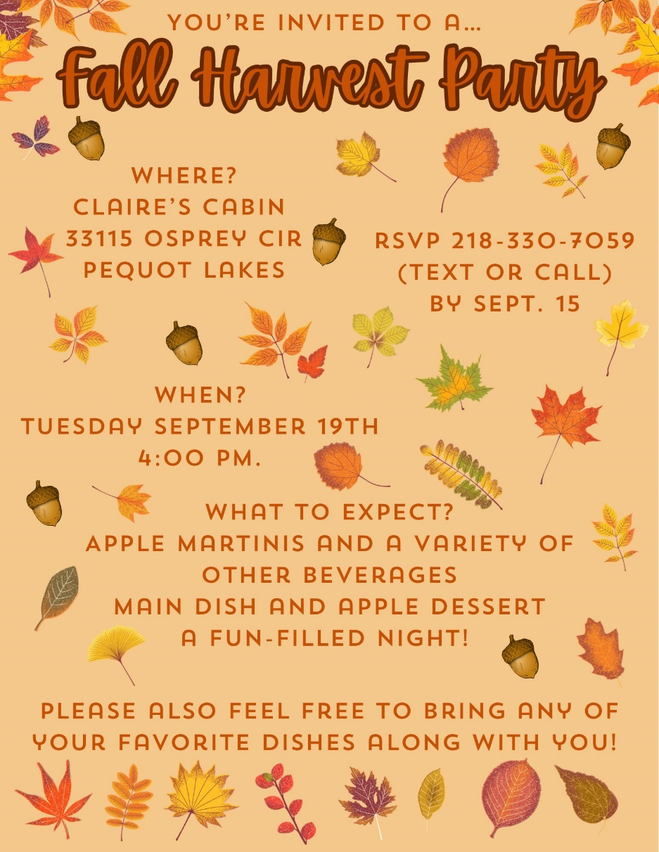

More FUNdraisers Coming Soon!
*Outdoor BBQ Picnic *Cooking with a Pro *"New to Me"
*Chili Cookoff *"Soup's On" *Ancient Stories, Modern Food

If you would like to help with any of the events, or would like to host one yourself, call the event host, Lowell Johnson or Sharon Carlson.

0 Movie Night is starting up again this month!
Mark your Calendars!
2023 W.I.S.E. Resolution:
Study of mental illness and the WISE program

First Congregational UCC Brainerd will devote time during the next 12 months learning about mental health issues to become a WISE (Welcoming, Inclusive, Supportive and Engaged around mental health) Congregation registered with the United Church of Christ Mental Health Network.
After a year of study and raising awareness around mental health, a vote will be taken at our annual meeting in 2024 to reconfirm our WISE Covenant which will allow us to be designated as a WISE Congregation in the United Church of Christ.

W.I.S.E. word on Neurodiversity
Have you or someone you know been told you are “stupid,” “lazy,” or “just not paying attention?” Have you lost out on jobs or friendships because you find social interactions difficult? Do numbers and letters get mixed up when you look at them? These are examples of neurodiversity (specifically, ADHD, autism spectrum and dyslexia).
What does it mean to be neurodivergent?
Dictionary: “Being neurodivergent means having a brain that works differently from the average or “neurotypical” person.” That doesn’t mean their brain is inferior or lacking; they have unique strengths as well as challenges.
For instance, my husband did so poorly on grade school intelligence tests he was considered developmentally delayed, yet he did so well on the military aptitude test that he qualified to pick any MOS (military occupational specialty).
The Zurich institute reports that around 15–20% of the global population (up to 1/5) is neurodivergent.
According to the Cleveland Clinic, some examples of famous and successful people who are neurodivergent include:
- Animal scientist and author Temple Grandin.
- Oscar-winning actor Sir Anthony Hopkins.
- Musician and singer Florence Welch.
- Olympic gold medalist Simone Biles.
- Climate activist Greta Thunberg
How can you support people who are neurodivergent? Use many of the same skills you’d use to support anyone: listen, and don’t judge. Lead to their strengths. Treat everyone with respect and try to communicate in ways that they prefer (for example, by text rather than phone calls).
0 Movie Night is starting up again this month!
Mark your Calendars!
UCC Women’s Fellowship
0 Movie Night is starting up again this month!
Mark your Calendars!
Saturday, September 9th Cancelled!

Thursday, September 28th 11:30 am at Dock 77 on Gull Lake.
Contact Kay Cox for information about the weekday luncheons.

All updates will be posted on the Connections Facebook Group and RSVP’s may be made in the comments under the post at: www.facebook.com/groups/uccbrainerd

0 Movie Night is starting up again this month!
Mark your Calendars!
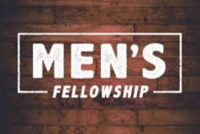
UCC Men’s Fellowship - Every Wednesday at Noon
You are invited to a casual fellowship at various locations in the Brainerd Lakes area. Rotating Weekly Schedule 2023
First Wednesday: B-Meri
Second Wednesday: Four Seas in Brainerd
Third Wednesday: Dunmire’s East
Fourth Wednesday: Black Bear
Fifth Wednesday: El Tequila in Baxter
Contact Jack Kraywinkle for more information 612-396-3480 or email: kraywinklej@gmail.com

0
TheShop Meal with First Congregational UCC
“Fun with Food and Friends”!

September 21st (held in Gregory Park).
Organized by the Region 5 Economic Development Commission and Sprout, we receive 10 CSA boxes of local organic vegetables. TheShop youth prepare the month's veggies, for a meal and enjoy eating together at 6:00 pm.
Contact Lowell Johnson at johnsonlowells@gmail.com if you are interested in joining.

0
Special Offering Sunday Worship September 24th
UCC Missions Neighbors In Need
In 2023, the Neighbors in Need “BEHOLD!” theme continues. This year’s focus is on environmental justice. Plastics, electronics, and other non-compostable wastes are being shipped across, and even tossed into, our waterways, launched into space, and buried in landfills. We must be better stewards of our planet!
To donate, send a check with "NIN” in the memo line to: First Congregational UCC, 415 Juniper St. Brainerd, MN 56401 or donate online using PayPal and indicate "NIN" in the Note. payl.me/uccbrainerd
0
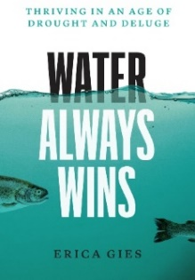
Friday Book Group - 10:00 am
0
Via Zoom: tinyurl.com/uccbrainerdzoom

We continue to read "Water Always Wins: Thriving in an Age of Drought and Deluge by Erica Gies.
“A hopeful journey around the world and across time, illuminating better ways to live with water".

0
UCC Care Team

The Care Team was formed with the purpose of reaching out to our congregation to ask how their lives are post covid, is our church still valid to them and if they needed anything from our church.
Contacts were made and while some were not available and some did not call back, the consensus for most was that the call was very appreciated.
A Congregational Care Team Visitation List was created to keep track of those parishioners who were homebound; living in a facility; living with chronic conditions; the bereaved and those with other concerns. Those who would like prayers are lifted up during worship and those wishing a pastoral call or visit are given to Pastor Leslie.
For anyone who wishes to join in on making calls or visits, the Care Team meets every month, on the second Wednesday at 10:00 am at church.
If you know of anyone who would enjoy a call from the care team, please contact one of our Care Team; Barb Hoeft, Jack and Kay Kraywinkle, Pat Scott, Chris Yager, Joey Halverson, Deb Griffith and Pastor Leslie.
0
First Congregation Food Shelf Collection Boxes
Our church continues to collect non-perishable food items for the Salvation Army Food Shelf. There are two collection boxes: one in the parking lot entry hallway, the other in the Narthex. Brian Twamley picks up and delivers the food.
Please consider bringing items and donating. You may also send a money donation to the church; First Congregational UCC, 415 Juniper St. Brainerd, MN 56401. Or for your convenience use our Paypal account at: paypal.me/uccbrainerd Make sure to write in memo “Food Shelf”. Thank you!

0
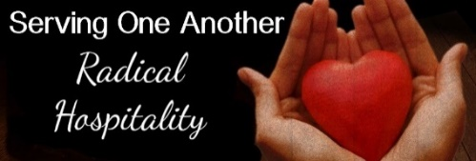
Hosts, Ushers, Greeters,
Scripture-readers
Sunday morning greeters/ushers and coffee hosts play an important part in making our church a warm and welcoming place for all. Here’s a secret; it’s FUN!! If each household committed to 3 Sundays a year as greeter/ushers and/or coffee hosts, we would have a full complement of participants. Are you ready to take the leap into RADICAL HOSPITALITY? Give it a go and signup below for your first Sunday as the face of the church! https://www.signupgenius.com/go/10C0E48A9A823A5FFC07-hugs/16034811

0
Last Month for Garden Gleaning!
0
A Biblical (and environmentally) inspired activity
Gardeners and plant people bring in their “gleanings” to share. This ranges from rhubarb in the spring to daffodil bulbs in the fall. A table, poster and donation basket are in Narthex entrance. Enjoy the fruits of our labors! All are welcome to help themselves – no charge! All monetary donations are given to the Food Shelf. Historical note: Begun here circa 1988 when our church began Hunger Action outreach, Central America updates and global food connections.
0
The Columbarium at First Congregational UCC, Brainerd
The Columbarium is located in the historic space that once was our church’s front entry way.
How appropriate it is that our Columbarium now marks another entry way into a new life — where the Spirits of Love and Truth are always present!
Should you wish to learn more about the purchase of a niche for your own cremains or for the ashes of a loved one, please call the church office at (218) 829-2528 and a packet of materials will be sent you via email or regular mail.
The Memorial Committee has prepared the information packet, and it contains all the details you will need as you consider inurnment here at First Congregational UCC.
Have any other questions? Contact Dawn Stattine at dawnstattine@gmail.com

0
Upcoming Conference Events

- September 8–10: Women's Retreat
- September 22-24: Women's Wilderness Walk: From the Inside Out
- September 29–October 1: 2023 Queer Walk
- October 6-8: Fall Youth Conference Event
- October 20-22: Young Adult Retreat
- ﻿October 22-24: Faith Formation Leader Retreat

0

Brainerd Lakes Area Information
~ Opportunities to Know and Share God’s Love ~

September 7th, Noon at Chalberg Theater, CLC
Central Lakes College celebrates the 25th Season of Cultural Thursday, a program initiated by member Jan Kurtz, when she was an instructor in the CLC Spanish Department. Join Jan as she presents a celebration of Cultures and Languages. She has invited Oscar and Michelle Gonzalez to dance, Gary Payne to take a bow, tidbits on travel, language glitches and insights into cultural communications. There will be information on the CLC Foundation’s scholarships, Gary’s tips for travel in 3rd World countries and Jan’s book on display!

The Brainerd Lakes Pride Weekend
Pride in the Park Picnic is September 9th 10:00 am – 4:00 pm in Gregory Park.
Follow their Facebook Page for other Pride Activities that weekend.
Facebook.com/BrainerdLakesPride
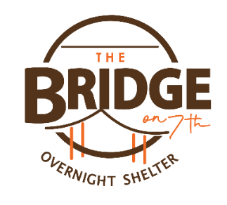
Opening night - September 20th!

Coming back for our 3rd season, The Bridge on 7th Overnight Shelter will host the first night of sleep on Wednesday, September 20th.
Adults 18+ who are experiencing homelessness are welcome to check in from 7 PM - 11 PM each night for a safe, warm place to sleep. Our staff will be happy to offer guests a hot cup of coffee and some snacks, as well as toiletries and a change of clothes if needed. Check out time is 8 AM each day with no limit to how many nights you can stay.
This shelter is funded by individuals, churches, grant funders, and businesses in the community that see a need to help our neighbors who are unsheltered. We appreciate your support!

First Congregational members and friends have been volunteering. It's a rewarding experience. Chris Yager and Deb Griffith have organized our team when it's our week. Talk to them for more info. We can use more volunteers! There's a video training and a background check (easy!) And of course a confidentiality pledge. We will be volunteering for their fundraiser in October.

2023 Walk to End Alzheimer's®

Brainerd Lakes Area September 23rd
Held annually in more than 600 communities nationwide, the Alzheimer's Association Walk to End Alzheimer's® is the world's largest fundraiser for Alzheimer's care, support and research. This event is the celebration of the work that has been being done throughout the year, so don't wait to join in. While there is no fee to register for Walk, all participants are encouraged to raise critical funds that allow the Alzheimer’s Association to provide 24/7 care and support and advance research toward methods of prevention, treatment and, ultimately, a cure. https://act.alz.org/Brainerd to register your team!

Play worship 06/11-25/23

Upcoming Events!
Play worship 06/11-25/23
Mark Your Calendars!

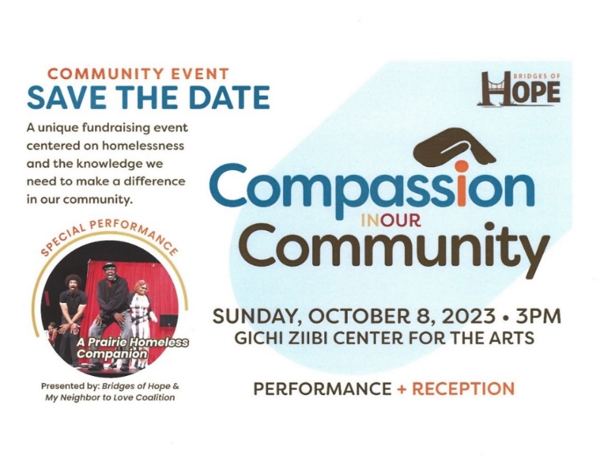
Play worship 06/11-25/23
Play worship 06/11-25/23
Play worship 06/11-25/23

September 2023 Calendar
Sunday | Monday | Tuesday | Wednesday | Thursday | Friday | Saturday
Leslie Workday  LeMesa Grp-Meets Tuesdays @ Gregory Park w/church backup | Leslie Workday | Leslie Workday | Office Hours10am – 2pm  Pastor Drop-in 2pm-4pm | Office Hour  10am – 2pm  Pastor Drop-in  11am – 1pm | Office Hours 1  10am – 2pm | 2  9am LAMF Board Mtg.-Y
3  8:30am Bnrd Frnds-Y  10am Wrship & Communion Serv-Y&V w/ Rev. Kelly Gallagher  11am Fellowship-Y | 4  7pm BACP church backup  Labor Day-Pastor Leslie Day Off | 2pm Emotions 5  Anon- Y  3:30pm Stewardship Mtg-Y  5:30pm Overeaters Anon- Y | 12pm Mens Grp-Y 6  @ B-Merri  1:30 PRC Mtg.-Y  7pm AA Common-Y | 7  10am -Noon Senior LBGQ+ Pride Luncheon in Fellowship Hall-Y | 8  10:30am Book Grp-Z  .  3rd Annual Brainerd Lakes Pride begins | 9  Women’s Fellowship Cancelled  1-4pm Pride in the Park Picnic @ Gregory Pk
8:30am Bnrd Frnds-Y 10  10am Wrship Serv-Y&V  11am Fellowship-Y | 11  5pm Fall Venison Feast @ Carlson’s | 2pm Emotions 12  Anon-Y  5:30pm Overeaters  Anon-Y | 12pm Men’s Grp 13  @ 4 Seas-Y  2pm Care Team Mtg.-Y.  5:30pm Trustees Mtg.-Y  7pm AA Common-Y | 14  9am CM Mtg-Y  4pm Executive Team Mtg-Y  7pm BLUE-church backup | 15  10:30am Book Grp- Z | 16  9:30am-1pm AAUW 60th Annual Celebration in Fellowship Hall
8:30am Bnrd Frnds-Y 17  10am Wrship Serv-Y&V  11am Fellowship-Y  11:30 am Adult Forum-Brainstorm church future-Y | 18  3:30pm Exec. Team Mtg.-Y& Z | 2pm Emotions 19  Anon-Y  4pm Fall Harvest Party-Y  5:30pm Overeaters  Anon-Y | 20  12pm Men’s Grp-@ Dunmire’s East-Y  7pm AA Common-Y | 21  4pm Council Mtg-  Y&Z  3:45p TheShop cooking & 6pm Dinner in church-Y  6:30pm Dist.7 AA-Y | 22  10:30am Book Grp- Z | 23
8:30am Bnrd Frnds-Y 24 10am Wrship Serv-Y&V  Stewardship Kickoff  11am Fellowship-Y  11:30 am Adult Forum- Justice Table-Y  *Special Offering-Neighbors in Need  *Newsletter Deadline | 25 | 26  2pm Emotions Anon-Y  5:30pm Overeaters Anon-Y | 27  12pm Men’s Grp @ Black Bear Grill-Y  7pm AA Common-Y | 28  11:30am Women’s Fellowship Luncheon @ Dock 77 on Gull Lake | 29  10:30am Book Grp- Z | 30
 |  |  |  |  | Pastor Leslie returns from Personal Leave  Sept. 3rd | V –Virtual Online  Z- our Zoom  C- Cancelled  N-None  ? – No update  Y- Yes Mtg. in person

