
Friendship News, September 2025
0
First Congregational United Church of Christ, Brainerd
An Open and Affirming Congregation
The Church Office Hours: Tuesday, Wednesday, Thursday from 10:00am – 2:00pm
Office phone 218-829-2528 Office E-mail uccbrainerd@gmail.com
Pastor Leslie’s E-mail: pastorleslieucc@gmail.com Website: www.uccbrainerdmn.org

No matter who you are, or where you are on life’s journey, you are welcome here.
0
Pastor’s Pen
0

Finding Hope in Hard Times
I had planned on writing my article for this month’s newsletter before leaving for a week of vacation. But in typical ADHD fashion, that didn’t happen. Sometimes my procrastination or difficulty with perceiving time can end up being a blessing in disguise. In the time between when I planned to have a task completed and the time I actually end up completing it, I sometimes experience something that is relevant to the task I had procrastinated, or an event happens that changes my perspective. Sadly, there are times when the delay means a tragedy occurs and I have an opportunity to address it.
When I’m on vacation, I do my best to restrict how much news I consume. But on Wednesday August 27 I decided to take a look at the headlines and my heart sunk when I read about yet another school shooting, this one in our own backyard of Minneapolis. I’m sure my first thoughts were similar to many of yours. I was both shocked and also not surprised. Saddened and angry that this keeps happening to our children. I grieved for the families of those who were killed but also for the children who survived and had to experience such a traumatic and life-altering event. I felt exasperated that there are already so many challenges facing our country right now, that this tragedy threatens to overflow our metaphorical cup holding all of the feelings of fear and anger and grief and helplessness.
What are we to do? I could write paragraph after paragraph about engaging in local politics, and calling your legislators, encouraging engagement in protests, etc. and all of those things are valid and important. But first and foremost, I want to make sure that we are tending to our spirits and our hearts. For many, it can be really easy to become frozen in feelings of fear and overwhelm. In those moments, we have to take the time to care for ourselves and each other.
So yes, pray. Pray for the healing of the world but also pray for the healing of your own heart and spirit. Pray to not become numb to the tragedies of the world but to also not be overwhelmed by them. Pray for the courage to reach out for support and care of others when you need it and to offer support and care as you are able to. Pray that you might be able to discern what is within your ability to change and to allow God and the wider community to take on the rest. Offer prayers of gratitude – intentionally looking for and consistently naming reasons to be grateful can help us shift our mindset out of hopelessness. Pray prayers of lament and anger, grief and rage. God is big enough to hold our most raw emotions so don’t feel like you need to hold back.
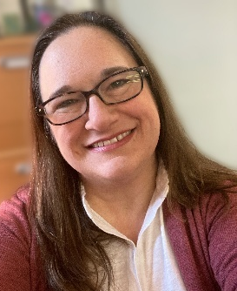
Pray. It’s not the whole answer in times like this, but intentionally connecting to the Divine, connecting to the loving source of all that is and that shall be, connecting to that which connects us all, is something we can all do no matter where we are or how we are feeling. When we feel connected – to the Holy, to other people, to community – we are more able to face the things that stop us in our tracks. You are never alone. And you are loved beyond measure. Always.
With Peace,
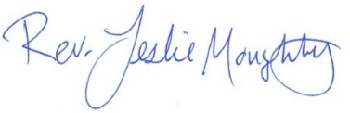
0

Mission Statement of First Congregational UCC
“To know and share God’s love within us.”

Purpose Statement of First Congregational United Church of Christ
“First Congregational UCC is a welcoming, inclusive, and progressive community committed to promoting social justice, spiritual growth, and love for all people. We reject discrimination and advocate for equality and dignity for marginalized communities. Through worship, education, and service, we work to make a positive impact on the world and invite all individuals to join us in this journey of faith and service.”

0
Church Office Hours
Tuesday, Wednesday, Thursday 10:00 am - 2:00 pm
Closed Mondays and Fridays

Please call Admin. Asst. Terri at the office 218-829-2528

Pastor Leslie’s Workday Schedule

Sunday through Thursday (Days off are Friday and Saturday)
Drop-in Hours: Wednesdays 11:00 am – 1:00 pm Thursdays 2:00 – 4:00 pm

Pastor Leslie will be out of the office on vacation August 25th through September 1st
*Drop-in hours are times set aside for “drop-in” conversations, much like a professor’s office hours.
Everyone is encouraged to make an appointment, especially if the above times are not convenient. You can go to www.calendly.com/pastorleslieucc and select a day and time that works for you, or you can email Pastor Leslie at pastorleslieucc@gmail.com or call/text at 218-656-0096.

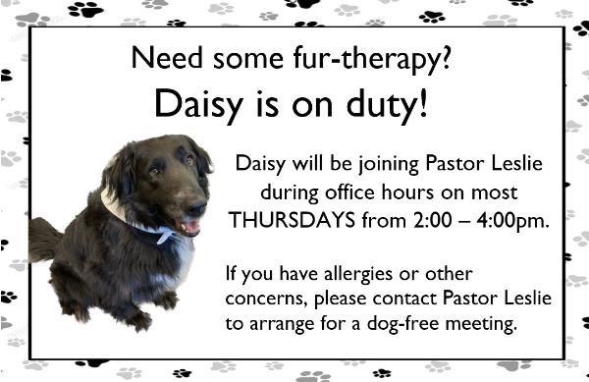

0
Stay Connected

How to watch Sunday worship: The worship service is broadcasted on the church Facebook page and the church's YouTube channel every Sunday at 10:00 am.
To watch worship on Facebook, go to https://www.facebook.com/uccbrainerd/live
**Live stream videos are saved and can be viewed at any time. All memorials, weddings and 12th Night Concert are on our church Facebook page.
How to stay connected with First Congregational friends and members: Join the private group for our Facebook Connections Page at https://www.facebook.com/groups/uccbrainerd.
Financial Help Available The Pastor's Discretionary Fund is available to assist church members and others in the Brainerd area who are experiencing financial distress with modest financial help. If you need assistance, please email, call, or text Pastor Leslie. Let her know what your situation is and how the church might be of help.
Donate to the church online! We are now accepting your offerings and donations using PayPal. You do not need to have a PayPal account to make an online donation with a credit card. To use PayPal, go to: https://www.paypal.me/uccbrainerd
0
First Congregational UCC News & Updates
0

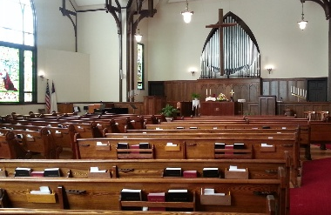
Our Sanctuary has a New look
The trustees are pleased to announce our sanctuary carpet and wood floor have a new facelift. Tykes Carpet installed new carpet and 3rd Generation refinished the wood floor.

Please join the trustees in thanking the Memorial Committee for funding this project!
0
0
Sunday September 7th – 10:00 am Worship Service
& Backpack Blessing during Time with Youth

Worship will be held in the Fellowship Hall
0

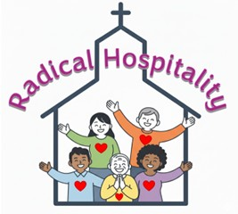
Sunday, September 14th at 11:30 am
Usher Training in the Sanctuary
Led by Pastor Leslie & Christian Ministry
Our ushers and greeters are often the first impression someone has of our church. Ushers play a very important role in making sure the worship service flows smoothly and that everyone who walks through our doors on Sunday morning feels welcome and comfortable. While the process of providing hospitality might seem like common sense, the role of our ushers requires some training to do it well.
If you are interested in ushering for the first time, or if you have served as an usher for years, please join us and learn how to provide radical hospitality to visitors and members alike.
0


Sunday, September 21st
Blessing of the Animals Worship Service
10:00 am in Gregory Park

We will gather for worship in Gregory Park by the Pavilion for an ecumenical Blessing of the Animals service with Park United Methodist Church and St. Paul’s Episcopal Church.
Fellowship will be in the Pavilion after the service.
Bring a lawn chair for yourself and an extra one if you can.
0

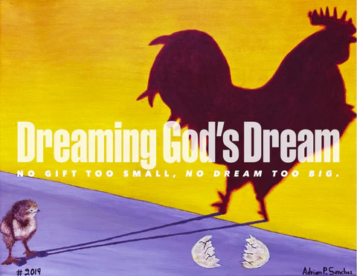
Stewardship Kick-off
Sunday, September 28th

Our stewardship theme this year, “Dreaming God’s Dream” will guide us in understanding the impact our congregation can make in our communities when we generously support the work of our church. Stay tuned!
0

0

Special Offering Sunday Worship, September 28th
UCC Missions Neighbors In Need
Gifts to the Neighbors in Need offering support ministries of justice and compassion in the United Church of Christ, including the UCC Office of Public Policy & Advocacy in Washington D.C.
To donate, send a check with "Neighbors In Need (NIN)" in the memo line to: First Congregational UCC, 415 Juniper St. Brainerd, MN 56401 or donate online using PayPal https://www.paypal.me/uccbrainerd and indicate "NIN" in the Note.

0
Next Council Meeting
Wednesday, September 18, 2025, 3:30 pm
in-person and via Zoom tinyurl.com/uccbrainerdzoom
Reports are due via email on Monday, 15th

First Congregational Approved Council Meeting Minutes are available upon request.
Please contact Terri Admin Asst. at the Church Office.

0
Volunteer at Church!
There are many other opportunities for you to share your talents

These committees need your gifts: * Trustees * Stewardship *

0

September Birthdays

Mark Utzinger Sept. 8 Kaylo Brooks Sept. 25
Thomas Nelson Sept. 9 Mark Stults Sept. 26
Jack Merzenich Sept. 12 Kyd Lukanen Sept. 27
Bob Ogdahl Sept. 12 Judy Whiteman Sept. 28
Lois McBroom Sept. 14 Leslie Moughty Sept. 29
Kay Kraywinkle Sept. 15 Mark Stadem Sept. 30
Reed Campbell Sept. 23
0
0

Click this link for an audio version of the following article about the process of potentially changing the name of the church.
Or go to https://www.youtube.com/watch?v=veNkYwSMbiw
Good day!
We are ready to move to the next step in the process of possibly changing our name. We started in 2023, and we are now to the point where you will submit suggestions. This is a significant milestone in the 153-year history of our church!
Last fall, we asked you to list words which describe our church or words you would like to describe our church. You came up with well over 100 words! We sent those words to our volunteer consultant, Jonathan Weise, who analyzed, evaluated, and categorized the words.
Recently, our Possible Name Change Task Force went a step further by adding definition to the list. The document is Mission, Vision and Core Values. This is what you the members and friends of First Congregational United Church of Christ, Brainerd, Minnesota say define us as a congregation. These are the words which form the foundation for decision making and, in this case, select a new name if we choose to do so.
Now is the time to send me suggestions. Email me: dan@danhegstad.com
If you have a name or names you’ve been thinking about, just send them to me.
For some, ideas seem to come out of the blue. Most of us, however, may want a little help.
Here is what I suggest - First, read over the Mission, Vision and Core Values document. Then read it again. I suggest reading it out loud. That will activate other portions of your brain. Maybe print it out and highlight words that seem to stand out. We want you and your excellent, powerful brain to take in these words and the concepts. Spend enough time with this so that it takes root. Again, we will use this for much more than a possible new name. This will guide us for a long time.
Next, set aside some time to listen. Yes, listen. It has been my experience that the creative spirit whispers. Call it God, The Universe, The Collective Consciousness – it doesn’t shout. It can make itself known by calling your attention to a word on a page, something in an ad, or a word spoken by someone in a crowd. Pay attention! God is still speaking!
I suggest finding a time to sit and do nothing. No screen. No book. No music. Just sit. Don’t try. Sit. Quiet. Listen to your thoughts. Write down anything that seems remotely relevant. When you’re done, you’re not done. keep listening. More may come. These can be the best ideas! Don’t dismiss anything! It may only be a word. Write it down because it may spark another idea.
Lastly, remember that an institution, product or person can “grow into” their name. Our performing arts center is a perfect example. The first choice was uninspired. Fortunately, people, members of our church! Suggested Gichi Ziibi, which refers to the Mississippi River. At first, some people had concerns. It’s a name they have never heard before. It was difficult to pronounce and challenging to remember. Logic says no way. But given time it has become what I think is an excellent choice. It is now memorable and unique.
So, read through the Mission, Vision and Core Values document several times. Listen. Think, but not too much. Write down everything. Even fragments of an idea are valuable.
You will send your ideas to me, but I don’t keep track of the person who sent them. I won’t remember either. No judgement here. If your name is chosen, nobody will know except you and God. Our task force will choose the top candidates.
Thank you, Dan Hegstad @ dan@danhegstad.com
If you have questions, please take a few minutes to watch this short video:
Video Produced by Dan Hegstad & Jonathan Weise: https://youtu.be/w-gQGsMLoGA
0
0
UCC Fellowships - A time to connect, socialize and enjoy some local food.
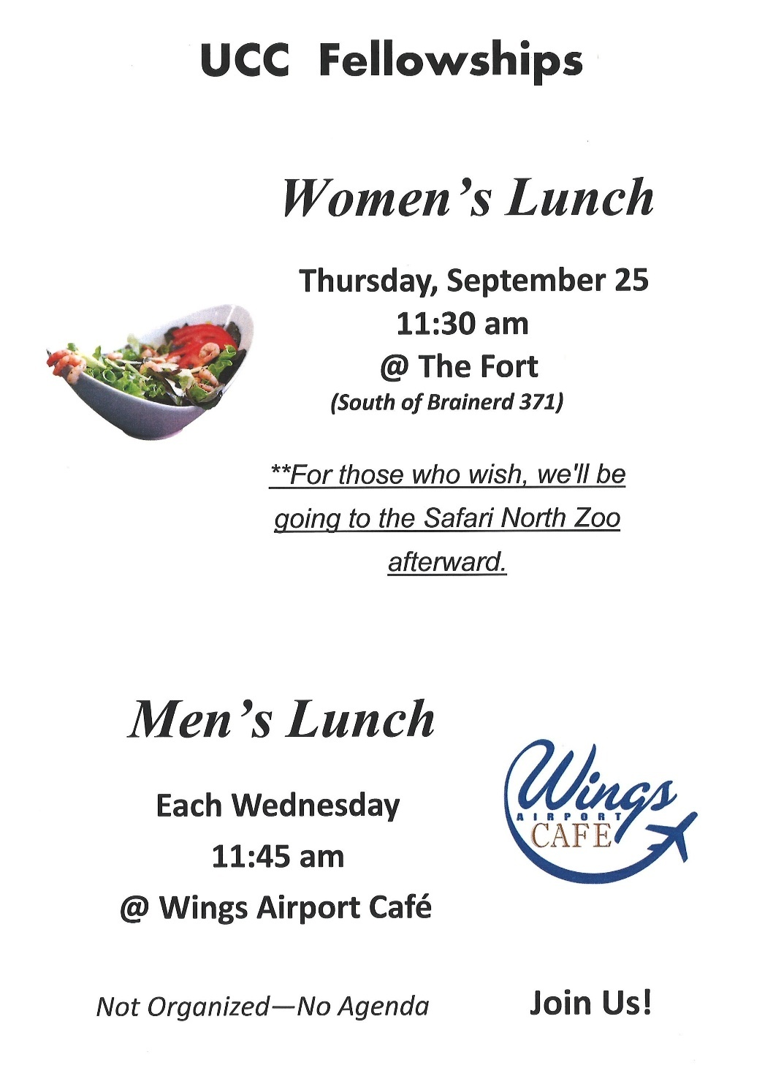


0
First Congregational Food Shelf Collection

Our church continues to collect non-perishable food items for the Salvation Army Food Shelf. Please consider bringing items and donating.

There are two collection boxes: one in the parking lot entry hallway, the other in the Narthex. Brian Twamley picks up and delivers the food. Thank you!

0


H.U.G.S.
0
Hosts, Ushers, Greeters, Scripture-readers

Sunday morning greeters/ushers and coffee hosts play an important part in making our church a warm and welcoming place for all. Signup below for your first Sunday as the face of the church! https://www.signupgenius.com/go/10C0E48A9A823A5FFC07-hugs/16034811

**Notice – Hosts may be reimbursed for snacks/food that are purchased for Fellowship Coffee Hour. Reimbursement Forms are in pocket folders outside the office. Please fill out and submit with receipts in the folder provided next to the form.


0
Friday Book Group
0

We meet each Friday morning at 10:30 am via zoom.
Church Zoom link: https://tinyurl.com/uccbrainerdzoom

We began reading "Gratitude” by Oliver Sacks the last week of August.
A deeply moving testimony and celebration of how to embrace life. In January 2015, Oliver Sacks was diagnosed with a recurrence of cancer, and he shared this news in a New York Times essay that inspired readers all over the world: "I cannot pretend I am without fear. But my predominant feeling is one of gratitude.... Above all, I have been a sentient being, a thinking animal, on this beautiful planet, and that in itself has been an enormous privilege and adventure." Gratitude consists of four essays that originally appeared in The New York Times , accompanied by a foreword that describes the occasion of each chapter. The foreword is written by Billy Hayes, Oliver Sacks's partner, and Kate Edgar, his long time collaborator.

0
UCC Care Team

For anyone who wishes to join in making calls or visits, the Care Team meets every month on the first Thursday @ 10:00 am.

If you know of anyone who would enjoy a call from the care team, please contact one of our Care Team; Barb Hoeft, Jack and Kay Kraywinkle, Pat Scott, Chris Yager, Deb Griffith, Joey Halvorson (text or email) and Pastor Leslie.
0


Cooking For Everyone

This group is OPEN FOR EVERYONE!
Email Lowell johnsonlowells@gmail.com and he will add you to the member list so that you will know when and where we will next meet.
0


Garden Gleaning
0
A Biblical (and environmentally) inspired activity
This is how it works: Gardeners and plant people bring in their “gleanings” to share. This ranges from rhubarb and vegetable plants in the spring to daffodil bulbs in the fall. A table, poster and donation basket are in Narthex entrance. Enjoy the fruits of our labors!
All are welcome to help themselves! All donations are given to the Food Shelf.
Historical note: Begun here circa 1988 when our church began Hunger Action outreach, Central America updates and global food connections.

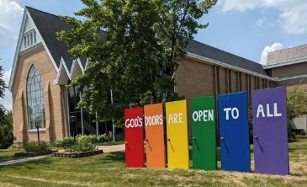
Welcome to our Facility
0
We are blessed to be able to share our beautiful church facilities for purposes that match the values of the church and its mission which is “To know and share God’s love within us.” We are an open church valuing the diversity of age, culture, gender identity, opinions, physical and mental abilities, and sexual orientation.
To request a space for general use, ask for a “Request for Church Building Use” form and
policy packet from Terri in the church office, at 218-829-2528 or email uccbrainerd@gmail.com. Submit the request form back to Terri in the office, and it will be submitted for approval at the next Council Meeting.

For wedding or funeral use, contact Pastor Leslie: pastorleslieucc@gmail.com

0
The Columbarium & Memorial Garden
First Congregational UCC, Brainerd
The Columbarium is in the historic space that once was our church’s front entry way.
How appropriate it is that our Columbarium now marks another entry way into a new life — where the Spirits of Love and Truth are always present!
The Memorial Garden is located on the south lawn of the church. The Garden provides a place for cremains of your loved one to be buried in the ground among natural plantings. The Garden fee includes the inscription of your loved one’s name on a granite plaque that is mounted on the outside wall of the church.
Should you wish to learn more about the purchase of a niche for your own cremains or for the ashes of a loved one, please call the church office at (218) 829-2528 and a packet of materials will be sent to you via email or regular mail. The Memorial Committee has prepared the information packet, and it contains all the details you will need as you consider inurnment here at First Congregational UCC.

0
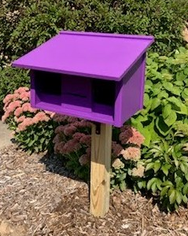
Community Prayer Box

Thank you to our Memorial Committee and the craftsmanship of Jack Kraywinkle, for making Pastor Leslie’s idea for a Community Prayer Box in the Memorial Garden a reality! You can find the prayer box on the South side of the church (the side that faces Juniper Street.)

Community members frequently walk through the garden and this box will offer our wider community an opportunity to share their prayers. Prayer cards and pens are provided, and the box is secured with a padlock, so the submitted prayers don’t fly away with the wind!
Pastor Leslie checks the box weekly and pray for any prayers submitted as well as bring them to the Care Team for prayer as well.

0
Save The Dates! – Fall Activities begin in October

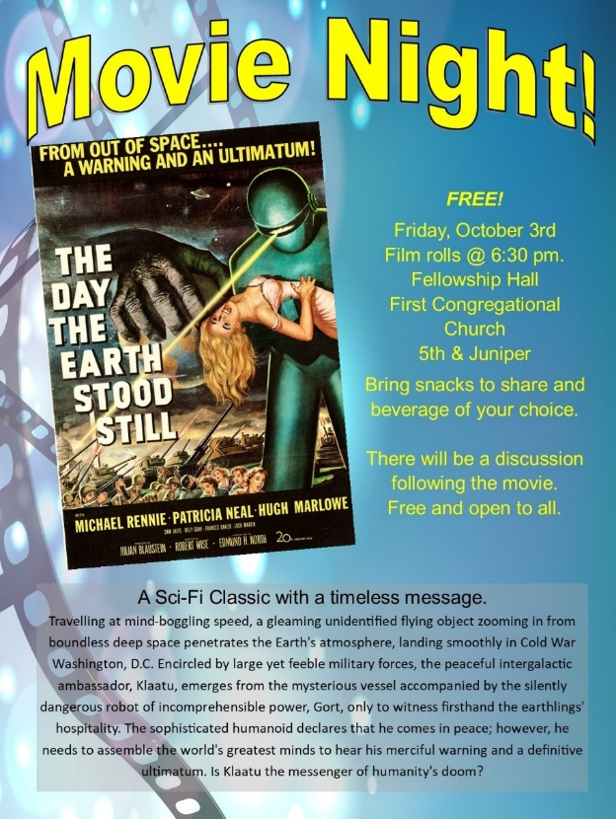

UCC Saturday Women’s Fellowship

October 11th @ 9:30 am
in Fellowship Hall
.
Marcia Ferris hosting

0
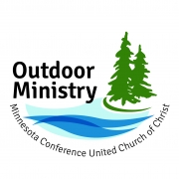

0

"Weaving Our Soul Stories in Wild Spaces"

Outdoor Ministry 2025
You are all invited to experience the MN Conference Outdoor Ministry as we take this season to “Weave our Soul Stories in Wild Spaces.” Many of our in-person events will be located at Camp Onomia to offer consistency, while book studies and resources will be available online. “Wild” Worship liturgies are also in the works for congregations looking to add earth-based Christian elements to their worship services.

For more ﻿Information and registration: www.uccmn.org/programs-support/outdoor/

Women’s Retreat | September 12 – 14 Cost: $250
Paula J. Pederson — psychologist, interculturalist, and facilitator with the Center for Courage and Renewal — joins singer-songwriter Sara Thomsen to weave deeper connections of self with creation and the Divine. This is open to all women no matter age, pronouns, and spiritual identity.

Let us gather at the altar of nature as we learn to listen, learn, and heal.
Let us go forth to be good stewards of the Earth in all the ways that bring wholeness to all living creatures.
0

Brainerd Lakes & Surrounding Area Information
~ Opportunities to Know and Share God’s Love ~


0
The Warming Shelter
The Bridge on 7th

The Warming Shelter opens on September 1st.
Located at; 1926 S 7th Street, Brainerd, MN 56401

Our goal is simple; provide a safe and warm place for people to sleep. You will not be required to sign up for anything and our check-in process is quick and easy. A good night's sleep, a cup of coffee and a snack are available. However, if you do need help, our staff is ready to connect you with resources when you're ready.
The shelter is open to all guests age 18 and older. The shelter is first come, first served. On your first night you will be asked to sign our guest agreement.
When the shelter is open for the season, the hours are from 7pm to 8am, 7 days a week. Walk-ins are accepted from 7-11pm, then the doors are locked for the night and no further admittance is allowed.
There is no limit to how many nights you can stay at the shelter. As long as you are following the simple rules outlined in the guest agreement and there is space available, you are welcome.
Volunteer opportunities can be scheduled at our website: https://www.bridgesofhopemn.org/overnight-shelter
0
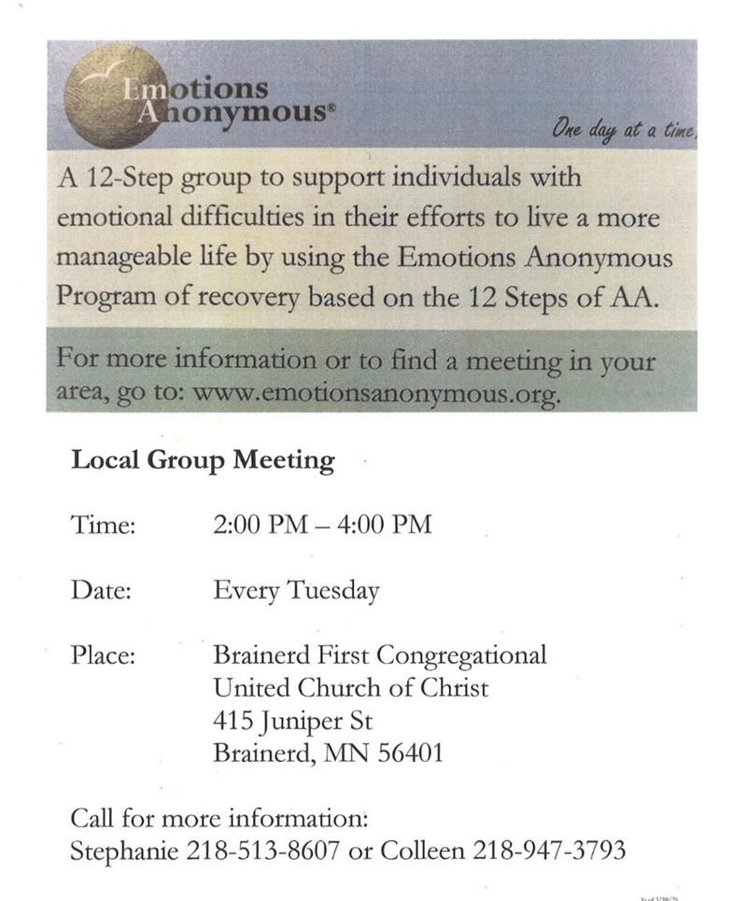
0

0

0
This two-day summit combines social cohesion with inclusive economies and This two-day summit combines social cohesion with inclusive economies and workforce, equity in education, and environmental justice. Join other individuals and organizations as we connect in ways that weave community and offer authentic conversations, as well as a place to find a slice of joy, celebration and a chance to breathe.

0

0
September 2025 Calendar
Sunday | Monday | Tuesday | Wednesday | Thursday | Friday | Saturday
Y- Yes Meeting in person  FB -Facebook Stream Online  C- Cancelled N-No Meeting  Z-our church Zoom | Office Closed | Office Open  10am – 2pm | Office Hours  10am – 2pm  Pastor Drop-in Hours  11:00 am – 1:00 pm | Office Hours  10am – 2pm  Pastor Drop-in Hours  2:00 – 4:00 pm  w/Daisy | Office Closed
 | Labor Day 1  9am-2pm BlA Indivisible-Y  7pm BACP/BLUE backup  Pastor Leslie Vacation | 2pm EA-Y 2  5:30pm OA -Y  Pastor Leslie back from vacation | 11:45pm Men’s 3 Grp@Wings Café-Y  4pm Christian Ministry Mtg.-Y  7pm AA Common-Y | 4  10am Care Team-Y | 5  10:30am Bk Grp-Z  Movie Night-C | 6
8:30am Bnrd Frnds-Y 7  10am W0rship – Communion & Backpack Blessing-Y&FB  Worship service held in Fellowship Hall  11am Fellowship-Y  11:30am Membership Class-Y | 8 | 9  2pm EA-Y  5:30pm OA -Y | 10:30am Trustees Mtg-Y  11:45pm Men’s 10 Grp@Wings Café-Y  3:30pm Exec. Mtg.-Y  7pm AA Common-Y | 11 | 12  10:30am Bk Grp- Z | Women’s 13  Fellowship-C  10am-4pm Brainerd Lakes Pride in Gregory Park-Y Church info table TBD
8:30am Bnrd Frnds-Y 14  10am Worship-Y&FB  11am Fellowship-Y  11:30am Usher Training in Sanctuary-Y | 15 | 2pm EA-Y 16  5:30pm OA -Y | 11:45pm Men’s 17 Grp@Wings Café-Y  7pm AA Common-Y | 3:30pm Council 18  Mtg.-Y&Z  6:30pm Dist.7AA-Y | 19  10:30am Bk Grp- Z | 20
8:30am Bnrd Frnds-Y 21  10am Worship & Animal/Pet Blessing @ Gregory Park-Y  11:15am Fellowship @ Gregory Park Pavilion-Y | 22 | 2pm EA-Y 23  5:30pm OA -Y | 11:45pm Men’s 24 Grp@Wings Café-Y  11:30am Women’s Lunch @ The Fort – South of Brainerd on 371. Ladies are visiting Safari North afterwards.  *Newsletter Deadline  7pm AA Common-Y | 25  4:30pm-8:30pm BLA Indivisible-Y | 26  10:30am Bk Grp- Z | 27
8:30am Bnrd Frnds-Y 28  10am Worship-Y&FB  *Stewardship Kick-off  11am Fellowship-Y  *Special Offering - NIN | 29 | 30

