
Friendship News, December 2025
0
First Congregational United Church of Christ, Brainerd
An Open and Affirming Congregation
The Church Office Hours: Tuesday, Wednesday, Thursday from 10:00am – 2:00pm
Office phone 218-829-2528 Office E-mail uccbrainerd@gmail.com
Pastor Leslie’s E-mail: pastorleslieucc@gmail.com Website: www.uccbrainerdmn.org

No matter who you are, or where you are on life’s journey, you are welcome here.
0
Pastor’s Pen
0

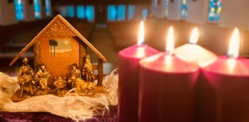
What Child Is This?
We have had such a long, warm, autumn that without the recent snowstorm, it would be hard to believe that Christmas is right around the corner! Thankfully the season of Advent helps prepare our hearts and minds for Christmas as we wait for the “already and not yet” birth of Jesus.
I have felt a heaviness in myself and in many of you as the Christmas season approached this year. Many of us are in the midst of significant grief for a variety of reasons; many of us are feeling deep anxiety about the future of our country and our lives as a result; many of us are deeply troubled by the injustices and atrocities occurring both in our own country and around the world; many of us are profoundly disturbed by the climate crisis and the lackadaisical approach to correcting the course we are on.
When discerning a theme for Advent this year, our Christian Ministry committee and I looked for a series that acknowledged the reality of our lives while offering a meaningful word of Hope, Peace, Joy, and Love. This year, our worship will center around the Christmas carol “What Child is This?” and the nativity. One of the most beloved carols we know, “What Child Is This?”, came into focus as a way to do what the carol does–ask and answer the question of Jesus’ identity. The “anchor image” (visual metaphor) for this series is the nativity scene. The renderings of the nativity typically paint a kind of romantic vision of a “silent night.” Yet the actual reality of each of these characters was fragile and difficult. This worship series is meant to help us know more about who Jesus is by looking at the actual lives and circumstances of these narratives. And to see that God is also with us in our fragility, as we are to be with others. The Good News is that God chose to enter our trauma-filled world in order to know us, tend to us, teach us how to be in these times.
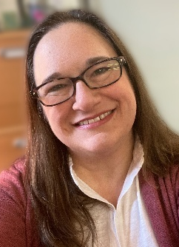
In the words of Rev. Dr. Marcia McFee, “Advent is usually about waiting. But we cannot wait to have hope; it is essential now. We cannot wait to work for peace; lives are at stake. We cannot wait to embrace joy, even and especially when it seems in short supply. We cannot wait to love, most of all, because we are the ones who follow the saving love of Jesus Christ, God-With-Us.”
I hope you will join us each week in Advent and on Christmas Eve as we journey through Advent together.
With deep gratitude for each of you,
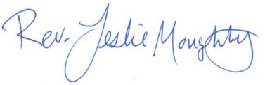

Mission Statement of First Congregational UCC
“To know and share God’s love within us.”
0

Purpose Statement of First Congregational United Church of Christ
“First Congregational UCC is a welcoming, inclusive, and progressive community committed to promoting social justice, spiritual growth, and love for all people. We reject discrimination and advocate for equality and dignity for marginalized communities. Through worship, education, and service, we work to make a positive impact on the world and invite all individuals to join us in this journey of faith and service.”

0
Church Office Hours
Tuesday, Wednesday, Thursday 10:00 am - 2:00 pm
Closed Mondays and Fridays
Please call for assistance - office 218-829-2528

Terri Admin. Asst. Vacation Days: Tuesday, December 23 & Wednesday, December 24

The Office will be closed on Christmas Day, December 25th
0
Pastor Leslie’s Workday Schedule

Sunday through Thursday (Days off are Friday and Saturday)
Drop-in Hours: Wednesdays 11:00 am – 1:00 pm
*Drop-in hours are times set aside for “drop-in” conversations, much like a professor’s office hours.
Pastor Leslie Vacation Days: December 7 & December 28 through January 8
Rev. Daren Blanck preaching worship Sunday, December 7
Christian Ministry leads worship Sunday, December 28
Everyone is encouraged to make an appointment, especially if the above times are not convenient. You can go to www.calendly.com/pastorleslieucc and select a day and time that works for you, or you can email Pastor Leslie at pastorleslieucc@gmail.com or call/text at 218-656-0096.

0
Stay Connected

How to watch Sunday worship: The worship service is broadcasted on the church Facebook page every Sunday at 10:00 am.
To watch worship on Facebook, go to https://www.facebook.com/uccbrainerd/live
**Live stream videos are saved and can be viewed at any time. All memorials, weddings and 12th Night Concert are on our church Facebook page.
How to stay connected with First Congregational friends and members: Join the private group for our Facebook Connections Page at https://www.facebook.com/groups/uccbrainerd.
Financial Help Available The Pastor's Discretionary Fund is available to assist church members and others in the Brainerd area who are experiencing financial distress with modest financial help. If you need assistance, please email, call, or text Pastor Leslie. Let her know what your situation is and how the church might be of help.
Donate to the church online! We are accepting your offerings and donations using PayPal.
You do not need to have a PayPal account to make an online donation with a credit card. To use PayPal, go to: https://www.paypal.me/uccbrainerd
First Congregational UCC News & Updates
0
0

Advent & Christmas Worship
November 30: Advent 1: “King of Kings” (Hope) Worship at 10:00 am.
December 7: Advent 2: “The Silent Word” (Peace) Worship with communion at 10:00 am
December 14: Advent 3: “Son of Mary” (Joy) Worship at 10:00 am.
December 21: Advent 4: “Enthroned by Love” (Love) Worship at 10:00 am.
December 24: Christmas Eve: “The Babe” Worship at 4:00 pm.
December 28: Sunday After Christmas: “This, This…”
0
Upgraded Video and Media
We started live-streaming our Sunday Service during COVID and a good number of folks tuned in. When we resumed in-person worship, we continued to stream live. Now, several years later, we see a significant number of folks watch live or watch the recording during the week. We may have 40 to 50 in the Sanctuary on Sunday morning, and 8 to 12 people watching live online. That is a significant percentage, and we can assume that some of those watching have others watching with them as well. Further, if we look at the number of views throughout the week, we see many more. I don’t trust that the number we see is accurate, however. I do not believe that 150 people watched by Thursday. Many of those are “bots” that check content or maybe Martians. But even if it’s 10% of that number, that’s another 15 views by real people.
The video feed is a significant part of our presence in the world. If people are considering visiting or joining a church, they typically first visit the website and watch a video. It is essential to have a good online presence.
With that in mind, we believe it is time to upgrade our video feed and media in the Sanctuary and Fellowship Hall. After a lot of research, education, and bids from good technology companies, we are ready to move forward.
Bids have come in significantly higher than expected, so we kept researching options. We found a very knowledgeable gentleman, Mike Schmitt, who has done work for the UCC churches in Hackensack and Walker. Mike confirmed that the equipment we were considering was a good choice, and he has agreed to install it in our church for a very reasonable fee.
Without going into too much detail, here is what we are proposing:
Sanctuary:
New remote control high-definition cameras for the Sanctuary, along with all the necessary switching and interface hardware.
Mounting a second monitor (TV) on the right side of the Sanctuary. We will be able to display video, graphics, and song lyrics (you can’t clap while holding a hymnal!) on these monitors, which will be controlled and fed from the AV booth in the back of the Sanctuary.
The new system will allow us to send high-definition video with graphics. People watching on YouTube will have the opportunity to donate through a QR Code graphic. YouTube also has the option of real-time closed captions. YouTube videos are far more reliable than Facebook, and we can archive them indefinitely. Our current system doesn’t do any of that.
Fellowship Hall:
We will install a high-quality audio system and hang a large monitor on the east wall. There will be an interface for audio and video that should be operable by almost anyone. If a group wants to meet in Fellowship Hall (a source of income for the church), they will have access to an excellent speaker system with video capabilities. Also, this system will be fed live from the Sanctuary, so if we have an overflow crowd for a large wedding or funeral, they will have a good experience.
What’s next?
One of our church members volunteered to build the Audio/Video “booth” in the Sanctuary. We will pay for the materials needed.
Millie Gjertson gave money to the memorial committee for upgrades to Fellowship Hall. The acoustic ceiling came from Millie’s donation, and the room is much quieter. It is likely that some of her donation will fund at least a portion of the Fellowship Hall upgrades.
Our Foundation will be asked to donate.
We are pleased to announce that Don Bennett will make a generous donation to ensure the completion of this project. Thank you, Don!
Lastly, you have the opportunity to contribute. If you feel that these upgrades are worthy of your support, you are enthusiastically encouraged to do so!
If you have any questions or would like more detailed information, please contact Dan Hegstad or Joe Stattine.

0
Join Brunch Bunch

Sunday, December 7, 12:15pm at Wings Cafe.
What’s better than going out for brunch after church? Going to brunch with church friends, of course! Join us for our first Brunch and then mark your calendars for future dates, First Sunday of each month. Contact Tracy Lyons for information.

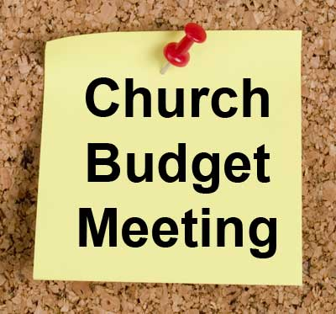
0
ANNUAL BUDGET Meeting
Congregational Budget Approval

Sunday, December 14, at 11:15 am after worship
in-person and via Zoom
tinyurl.com/uccbrainerdzoom

All voting Members are encouraged to attend the congregational budget meeting to review and vote on the 2026 church budget. Meeting packets will be distributed in person on the previous Sunday, December 7, and emailed to voting members on December 9. Please notify Terri in the church office if you need a packet sent to you by snail mail.
0
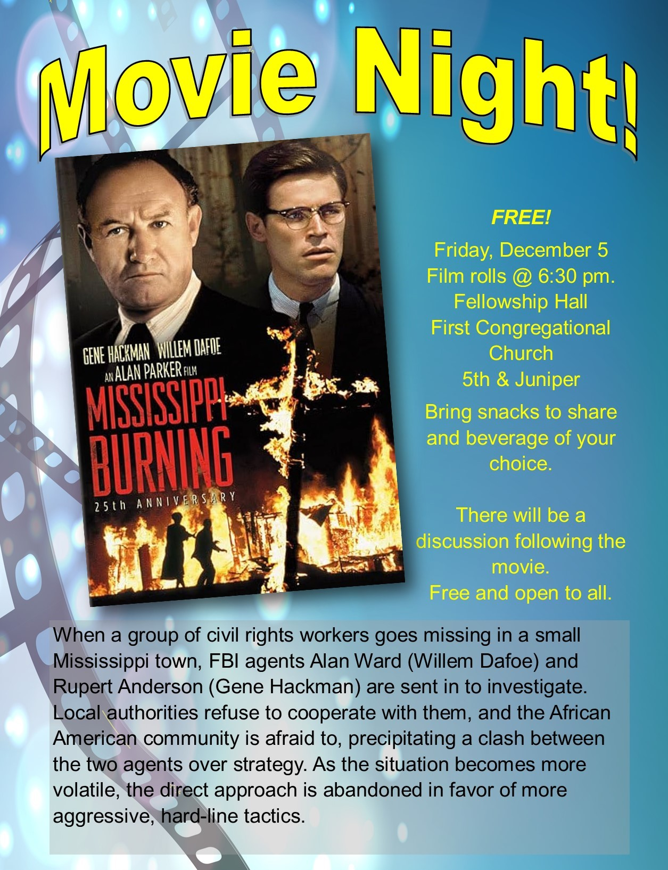
0
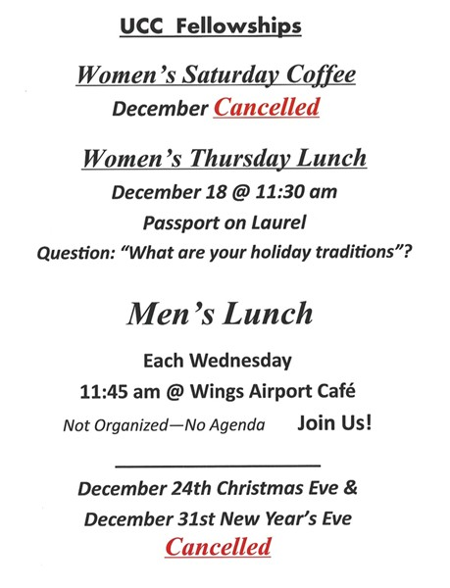

0
0
Christmas Flowers 2025

You have the opportunity to give a gift in honor and in memory of your loved one(s). We will use the money to purchase flower arrangements for the altar. All memorials will be listed in the Christmas bulletin.

Please include all of the information below with your gift.
Amount of Memorial Gift: $________
In Memory Of: ___________________
Your Name(s): ___________________
Write your checks to: 1st Congregational Church with Memo: “Christmas Flowers”
Include this information with your check and drop it off at the church office, give at worship offertory, or mail it to: First Congregational Church, 415 Juniper St. Brainerd, MN 56401
You can also donate online! We accept your offerings and donations using PayPal.
You do not need to have a PayPal account to make an online donation with a credit card. To use PayPal, go to: https://www.paypal.me/uccbrainerd Please memo: "Christmas Flowers"
0

0
Fall 2025 UCC Justice Table Team Meetings
Adult Forums
September 28th DEI Meeting Minutes
DEI Table Goals - Education, Support, Advocacy
- Legal issues for LGBT individuals and family (outfront)
- Strengthen air connection with The Sewing Room - Invite Dawn to do an adult forum
- Need to meet in between Justice Sundays
- Look at important dates for the LGBTQ community (i.e. coming out day, Trans Day of Remembrance, Days of visibility, etc) and determine how we might create events/programming that relate.
Submitted by Pastor Leslie
Members of this group:
Tracy Lyons, Denise Slipy, Emily LeClaire, Dan Hegstad, Deb Griffith, Kim Slipy
November 11th WISE Meeting Minutes
In Attendance: Pat Scott, Lowell Johnson, Shawn Boman, Deb Griffith, Stephanie Lee
We discussed a number of ideas today:
1. Suicide prevention workshops, to be followed by a presentation at church. Deb, Stephanie, and Kay Cox plan to attend.
2. Neurodiversity: We discussed getting a speaker or panel on this issue. We could get Sara Lund, author of Blessed Minds. Her expenses would be paid by the UCC to speak to our church, but Lowell would like to get funds to have her speak to the community at large. Other possible speakers would be Henry Halburg, CLC student, Claribel Severson, PhD, Dr. Niefert, Tracy Lyons, and/or Leslie Moughty on Autism and ADHD.
3. How to Talk to People: Possible speakers on Microaggression would be Claribel Severson and Michael Erickson. This would be related in terms of thinking about how we speak about the mentally ill and neurodiverse.
4.Films: This could be done on a different Friday from Dan Hegstad’s monthly Movie Night, or perhaps a weekend matinee. Ideas: Inside Out, an animated film about emotions, could be an intergenerational activity. Eleanor Oliphant is Completely Fine. Still Alice. Short Ted talks could be done as Adult Forums.
5. Emotional Intelligence
6. Mental Health and Climate Crisis: Lowell passed around an interview with Dan Siegel in the September/October 2024 Psychotherapy Networker about the topic of the Western mindset of Self which focuses on the individual, vs our interdependence with other people, animals, and the Earth. We thought about coordinating on this with the Ecology group.

0
December Birthdays

John Krueger December 1 Carol Phelps December 29
Joy Persall December 7 Dorothy Highum December 29
Jack Kraywinkle December 11 Maggie Panning December 30
0
Greta Norlander December 11 Greg Johnson December 31

0
Next Council Meeting
Update! Thursday, December 11, 2025, 3:30 pm
in-person and via Zoom tinyurl.com/uccbrainerdzoom
Reports are due via email on Tuesday 8th

First Congregational Approved Council Meeting Minutes are available upon request.
Please contact Terri Admin Asst. at the Church Office.
0
Volunteer at Church!
There are many other opportunities for you to share your talents

These committees need your gifts: * Trustees * Stewardship *
0


Join Our Church Choir
December 14th

Rehearsal 8:30 am in the Sanctuary
Worship Service at 10:00 am

0

December Special Offering - UCC Missions - Christmas Fund
Sunday Worship – December 28
This month we have an opportunity as we give our Special Offering to the Christmas Fund UCC Missions. Administered by the Pension Boards on behalf of the church, helps provide pension and health premium supplementation to low-income retirees, emergency assistance to clergy families in need and Christmas gift checks to hundreds of annuitants. To donate, send a check with "Christmas Fund” in the memo line to: First Congregational UCC, 415 Juniper St. Brainerd, MN 56401 or donate online using PayPal https://www.paypal.me/uccbrainerd and indicate "Christmas Fund" in the Note.

0
UCC Volunteer Opportunity - The Bridge on 7th
The Bridge on S 7th homeless shelter reopened in September. Bridges of Hope continues working with Brainerd City Council to get authorization for the shelter to be year round.
Mornings (6:30-8am) do not work for many of our church team (there is no evening volunteer opportunity.) Deb Griffith & Marcia agreed moving forward that we will sign up as teams of two or/individually. Our church used to have a week designated for our volunteers. You can choose a time to volunteer online. It’s a great workout helping the guests check out, cleaning and changing the beds for the next night. The staff and shelter guests appreciate our involvement. The link is below. Create an account. Pick a date. They need your birth date and your ok for a background check. https://volunteer.bloomerang.co:443/JE/bas6nebexg029t
Marcia Ferris & Mary Benson (Brainerd Friends Meeting/Quakers) volunteered November 22.
0
0

TheShop Meal @ First Congregational UCC!

A number of youth and the staff from TheShop (Brainerd Baxter Youth Drop-in Center) come over to our kitchen and help prepare a delicious meal that is then brought back to TheShop for the hungry and appreciative teens there.
Meal cooking has been scheduled for the fourth Wednesday of each month at 3:00-5:30 pm in the church kitchen and Fellowship Hall. December is cancelled for Christmas.

Save future date! Jan. 28, Feb. 25, March 25, April 22, May 27.
If you are interested in joining and volunteering your time please contact Breton Monroe, Executive Director @ 218.316.2070 or The Brainerd Baxter Youth Center @218.454.0009
https://theshopbrainerd.org/ https://www.givemn.org/donate/Theshop
0
Cooking For Everyone

This group is OPEN FOR EVERYONE!

Email Lowell Johnson and he will add you to the member list. You will be notified when and where we will next meet.
0
First Congregational Food Shelf Collection

Our church continues to collect non-perishable food items for the Salvation Army Food Shelf. Please consider bringing items and donating.

There are two collection boxes: one in the parking lot entry hallway, the other in the Narthex. Brian Twamley picks up and delivers the food. Thank you!
0

H.U.G.S.
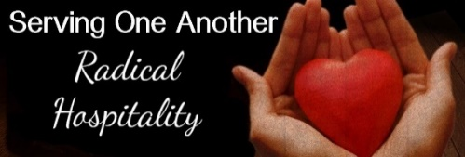
Hosts, Ushers, Greeters, Scripture-readers

Sunday morning greeters/ushers and coffee hosts play an important part in making our church a warm and welcoming place for all. Signup below for your first Sunday as the face of the church! https://www.signupgenius.com/go/10C0E48A9A823A5FFC07-hugs/16034811
0

UCC Care Team
0

For anyone who wishes to join in making calls or visits, the Care Team meets every month on the first Thursday @ 10:00 am.

If you know of anyone who would enjoy a call from the care team, please contact one of our Care Team; Barb Hoeft, Jack and Kay Kraywinkle, Pat Scott, Chris Yager, Deb Griffith, Joey Halvorson (text or email) and Pastor Leslie.
0

0
Friday Book Group

We meet each Friday morning at 10:30 am via zoom.
Church Zoom link: https://tinyurl.com/uccbrainerdzoom

We are reading "Gratitude” by Oliver Sacks. A deeply moving testimony and celebration of how to embrace life." Gratitude consists of four essays that originally appeared in The New York Times , accompanied by a foreword that describes the occasion of each chapter.

0
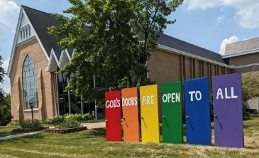
Welcome to our Facility
We are blessed to be able to share our beautiful church facilities for purposes that match the values of the church and its mission which is “To know and share God’s love within us.” We are an open church valuing the diversity of age, culture, gender identity, opinions, physical and mental abilities, and sexual orientation.
To request a space for general use, ask for a “Request for Church Building Use” form and
policy packet from Terri in the church office, at 218-829-2528 or email uccbrainerd@gmail.com. Submit the request form back to Terri in the office, and it will be submitted for approval at the next Council Meeting. For wedding or funeral use, contact Pastor Leslie: pastorleslieucc@gmail.com

0
The Columbarium & Memorial Garden
First Congregational UCC, Brainerd
The Columbarium is in the historic space that once was our church’s front entry way.
How appropriate it is that our Columbarium now marks another entry way into a new life — where the Spirits of Love and Truth are always present!
The Memorial Garden is located on the south lawn of the church. The Garden provides a place for cremains of your loved one to be buried in the ground among natural plantings. The Garden fee includes the inscription of your loved one’s name on a granite plaque that is mounted on the outside wall of the church.
Should you wish to learn more about the purchase of a niche for your own cremains or for the ashes of a loved one, please call the church office at (218) 829-2528 and a packet of materials will be sent to you via email or regular mail. The Memorial Committee has prepared the information packet, and it contains all the details you will need as you consider inurnment here at First Congregational UCC.
0

Save The Dates!
0
@ First Congregational UCC Brainerd

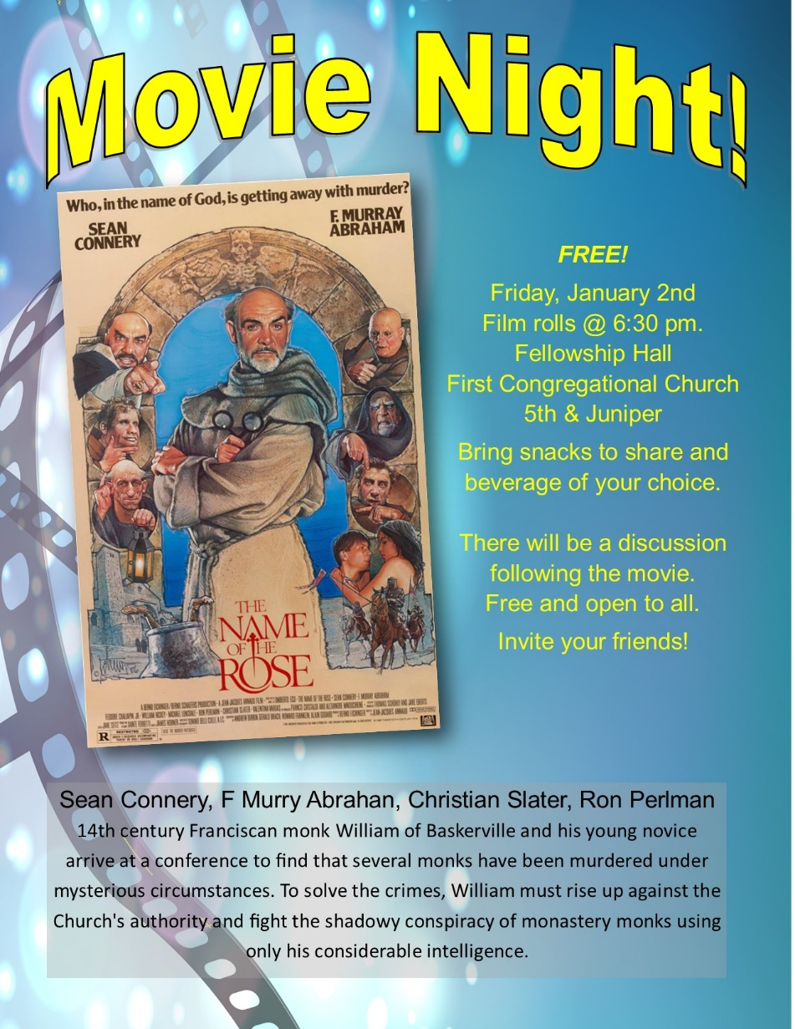

0

20th Annual Twelfth Night Concert
Sunday, January 4th 2026
@ 7:00 pm
First Congregational UCC of Brainerd extends a warm welcome to please join us for our 20th Annual Concert in Celebration of the Twelfth Night of Christmas!
Volunteers are needed as we prepare and organize the event. Call or text Cynthia Janes.
0

Brainerd Lakes & Surrounding Area Information
0
~ Opportunities to Know and Share God’s Love ~
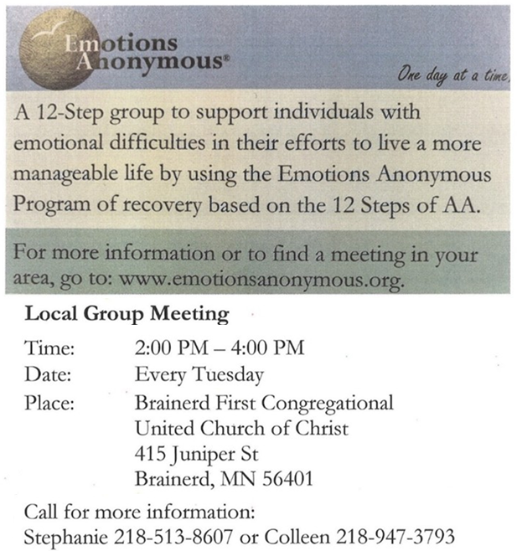
0

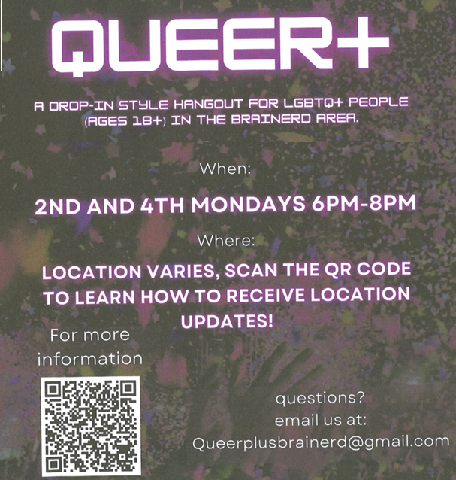

0
December 2025 Calendar
Sunday | Monday | Tuesday | Wednesday | Thursday | Friday | Saturday
Y- Yes Meeting in person  FB -Facebook Stream Online  C- Cancelled  N-No Meeting  Z-our church Zoom | Office Closed | Office Hours  10am – 2pm | Office Hours  10am – 2pm  Pastor Drop-in Hours  11:00 am – 1:00 pm | Office Hours  10am – 2pm | Office Closed
Terri Admin. Asst. Vacation Days; Dec. 23 & 24  Pastor Leslie Vacation Days; Sun. Dec. 7 & Sun. Dec.28 through Sun. Jan. 4. | 1 | 2  2pm EA-Y  5:30pm OA -Y | 11:45pm Men’s 3 Grp @ Wings-Y  1:30pm PRC Mtg.-Y  3:30pm Exec. Mtg.-Y  4pm Christian Ministry-Y  7pm AA Common-Y | 4  10am Care Team-Y | 5  10:30am Bk Grp-Z  6:30pm Movie Night-Y | 6  Girl Scout Overnight Christmas Party in Rainbow & Fellowship Hall
8:30am Bnrd Frnds-Y 7  10am W0rship-Y&FB Live  *Rev. Daren Blanck Preaching  11am Fellowship-Y  Budget Packets available for Congregation Members | 8 | 2pm EA-Y 9  5:30pm OA -Y  Budget Packets Emailed to Congregation Members | 10:30am Trustees Mtg-Y  11:45pm Men’s 10 Grp @ Wings-Y  7pm AA Common-Y | 11  3:30pm Council  Mtg.-Y&Z | 12  10:30am Bk Grp- Z | 13  Women’s  Fellowship-C  9:30am-1:00pm AAUW Mtg.-Y
8:30am Bnrd Frnds-Y 14  8:30am Choir Practice-Y  10am Worship & Choir-Y&FB  11:15 am Annual Budget Meeting-Y & Zoom  Fellowship-Y following Budget Mtg.  1pm Girl Scout Mtg.-Y | 15 | 16  2pm EA-Y  5:30pm OA -Y | 17  11:45pm Men’s Grp  @ Wings-Y  5:30pm Blue Christmas Worship Service  7pm AA Common-Y | 18  11:30am Women’s Lunch @ Passport  6:30pm Dist.7AA-Y | 19  10:30am Bk Grp- Z | 20
8:30am Bnrd Frnds-Y 21  10am Worship-Y&FB Live  11:15am Fellowship-Y | 22 | 23  2pm EA-Y  5:30pm OA -Y | Christmas Eve 24  11:45pm Men’s Grp @ Wings-C  4pm Christmas Eve Worship Service  TheShop Cooking-C  7pm AA Common-Y | Christmas Day 25  Office Closed | 26  10:30am Bk Grp- Z | 27
8:30am Bnrd Frnds-Y 28  10am Worship-Y&FB  Christian Ministry Leads Worship  11am Fellowship-Y  *Special Offering – Christmas Fund  *Newsletter Deadline | 29 | 30  2pm EA-Y  5:30pm OA -Y | New Year’s Eve 31  11:45pm Men’s Grp @ Wings-C | January 1 2026  New Years Day  Office Closed

