Friendship News, January 2025

0

First Congregational United Church of Christ, Brainerd

An Open and Affirming Congregation

The Church Office Hours: Wednesdays – Fridays from 10:00am – 2:00pm

Office phone 218-829-2528 Office E-mail [*uccbrainerd@gmail.com*](mailto:uccbrainerd@gmail.com)

Pastor Leslie’s E-mail: [*pastorleslieucc@gmail.com*](mailto:pastorleslieucc@gmail.com)Website: [*www.uccbrainerdmn.org*](http://www.uccbrainerdmn.org)

*No matter who you are, or where you are on life’s journey, you are welcome here.*

0

**Pastor’s Pen**

0

***The Work of Christmas***

The arrival of these first days of January often signal to us the end of the Christmas season. The gifts have been exchanged, the carols have been sung, the family visits made. As I walked through the Minneapolis airport on Christmas Day, all of the shops with Christmas products were advertising their clearance prices. By now our Christmas trees are beginning to take on a certain crispiness, reminding us that taking ornaments off a tree is not nearly as fun as putting them on. In other words, the party’s over.

But wait. Wait just a minute. We are not done here yet! A child has been born, who has been named Emmanuel, God-with-us. Many of my friends have shared with me that feeling of arriving home with their new baby for the first time. It is the feeling of excitement and uneasiness at the realization that this child that they were sent home with would be their responsibility. It was now their task to take care of the child’s needs. One friend told me that upon arriving home from the hospital with their daughter, she and her partner could do nothing but look at the baby, and then look at each other with a scared expression that communicated, “Okay, this is about to get real.”

As we celebrated the birth of Jesus on December 25th, we must remind ourselves that Christmas has not ended. Birth is a beginning! In our liturgical calendar, we are still celebrating the season of Christmas. On January 6th the Christian Church celebrates the arrival of three wise men to the manger, ushering in the season of Epiphany, a season that poses question “How do we, the church, live our mission in light of the nativity?” In other words, what does Christ’s birth mean for how we live and love and care for one another, especially the poor and marginalized? Or perhaps we could put it this way: “Ok, church, this is about to get real.”

This time of year, always reminds me of this poem by Howard Thurman:

**The Work of Christmas by Howard Thurman**

When the song of the angels is stilled,

When the star in the sky is gone,

When the kings and the princes are home,

When the shepherds are back with their flock,

The work of Christmas begins:

To find the lost,

To heal the broken,

To feed the hungry,

To release the prisoner,

To rebuild the nations,

To bring peace among brothers,

To make music in the heart.

In these coming months, may we look around and discover the ways in which God is calling us to live this coming season as a Christmas people.

With Peace,

0

Purpose Statement of First Congregational United Church of Christ

***“First Congregational UCC is a welcoming, inclusive, and progressive community committed to promoting social justice, spiritual growth, and love for all people. We reject discrimination and advocate for equality and dignity for marginalized communities. Through worship, education, and service, we work to make a positive impact on the world and invite all individuals to join us in this journey of faith and service.”***

Mission Statement of First Congregational UCC

***“To know and share God’s love within us.”***

0

**Church Office Hours**

**Wednesday, Thursday, Friday 10:00 am - 2:00 pm**

Please call Admin. Asst. Terri at the office 218-829-2528

***The Office will be closed on New Year’s Day, January 1st, 2025***

***Terri Admin. Asst. Day Off: Friday, January 17th***

***The Church Office will be closed***

0

**Pastor Leslie’s Workday Schedule**

0

**>> Sunday through Thursday (Days off are Friday and Saturday) <<**

**Drop-in Hours\***

**>> Wednesdays 11:00 am – 1:00 pm Thursdays 2:00 – 4:00 pm *<<***

*\*Drop-in hours are times set aside for “drop-in” conversations, much like a professor’s office hours. Pastor Leslie is typically working at the church the rest of the week, but it is possible that she may be in meetings, at a community event, or working off-site.*

Everyone is encouraged to make an appointment if the above times are not convenient.

You can go to [*www.calendly.com/pastorleslieucc*](http://www.calendly.com/pastorleslieucc/) and select a day and time that works for you, or you can email Pastor Leslie at [*pastorleslieucc@gmail.com*](mailto:pastorleslieucc@gmail.com) or call/text at 218-656-0096.

**Pastor Leslie is out of the office**

**12/25/24 through 01/09/25**

**For Pastoral Care please call Rev. Mark Ford at 218-232-8131**

0

**First Congregational UCC News & Updates**

0

**Our website is getting a new look!**

**We will make an announcment when it’s live!**

***www.uccbrainerdmn.org***

0

**Stay Connected**

0

0

**How to watch Sunday worship:** The worship service is **broadcasted on the church Facebook page and the church's YouTube channel every Sunday at 10:00 am.**  
To watch worship on Facebook, go to [*https://www.facebook.com/uccbrainerd/live*](https://www.facebook.com/uccbrainerd/live)  
***\*\*Live stream videos are saved and can be viewed at any time. All memorials, weddings and 12th Night Concert are on our church Facebook page.***

**How to stay connected with First Congregational friends and members:** Join the private group for our Facebook Connections Page at [*https://www.facebook.com/groups/uccbrainerd*](https://www.facebook.com/groups/uccbrainerd)*.*

**Financial Help Available** Your Church Council voted last year to allow the Pastor's Discretionary Fund to be used to assist church members and others in the Brainerd area who are experiencing financial distress during this time. We received many generous donations! If you need assistance, please email, call, or text Pastor Leslie. Let her know what your situation is and how the church might be of help.

**Donate to the church online!**We are now accepting your offerings and donations using **PayPal.** You do not need to have a PayPal account to make an online donation with a credit card. To use PayPal, go to: [*https://www.paypal.me/uccbrainerd*](https://www.paypal.me/uccbrainerd)

0

0

**2025 Youth Programming**

The Christian Ed Committee and a few others at the church are interested in providing activities for our youth during Fellowship Hour following Worship. The rough idea is to do a combination of active games and art projects.

We would also like to include adults in these yet to be planned activities. If you are interested in being part of planning and implementing these relationship building opportunities, contact Lowell Johnson.

0

**Special Announcment - Gift to My Neighbor to Love Coalition**

From Pastor Leslie: A few years ago, we received a generous gift from the estate of a beloved member, Shirley McConnell Utzman in the amount of $30,000. The one stipulation was that the Pastor would be the one to decide the use of the funds. This felt like an immense gift and a huge responsibility. Knowing Shirley’s passion for justice, specifically around issues of equality and poverty, I have been praying, listening to community members, and waiting for what felt like the right opportunity to make good use of these funds.

At the last council meeting, Marcia Ferris brought it to our attention that My Neighbor to Love Coalition was raising funds to complete construction of a multi-family 12-plex and a generous donor is offering to match each donation dollar-for-dollar up to $100,000 and they have $75,000 left to match. We discussed donating a portion of the gift from Shirley to this effort.

0

I met with MNTLC founder and chair of the board, Vickey Kinney, and I am thrilled to announce that we are donating $10,000 to MNTLC! This gift will help create safe, affordable housing in a caring community for 14-38 people who are currently experiencing homelessness. This gift is the largest donation MNTLC has received from a church thus far. In addition, I am excited for our congregation to deepen our relationship with My Neighbor to Love Coalition with volunteering in a multitude of ways. Stay tuned for opportunities to get involved!

0

**UCC Volunteers for the Warming Shelter**

0

**Bridge on 7th**

**The week of December 29, 2024 - January 4, 2025, is our church's week volunteering at the Warming Shelter.**

**Here is the sign up link for the week of December 29th**

[*https://whocanbethere.com/SignUp/week-of-december-29/2na8cvq2*](https://whocanbethere.com/SignUp/week-of-december-29/2na8cvq2)

*If you have any questions at all, please talk with Deb Griffith when in church or by phone.*Thank you always for considering volunteering for this worthy cause.

0

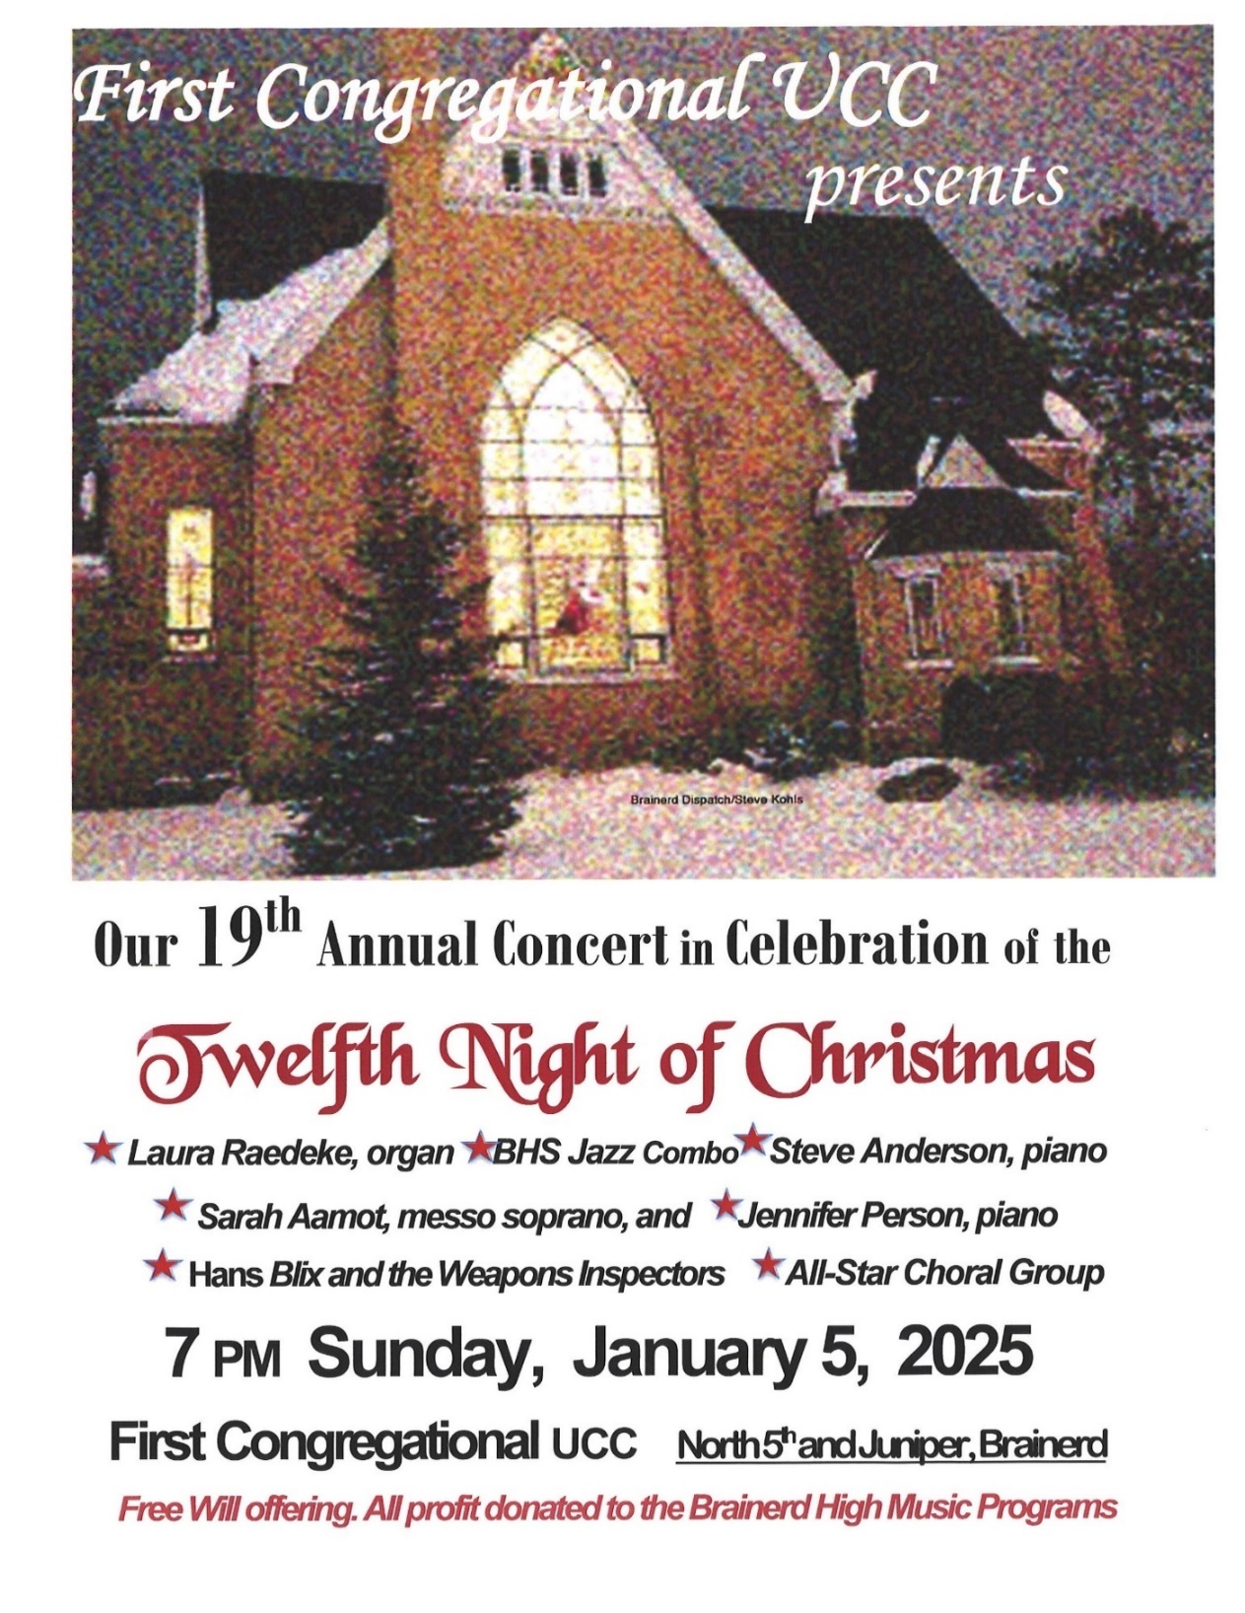

**January Adult Forums - 11:30 after worship**

0

**January 5th – “Poetry Slam”:** If you love to read or just listen to good poetry, bring your favorite poems to read in a round robin fashion> A short reaction/discussion time between poems. We will read and discuss poems until our end time of 12:30.

**January 26th – Justice Sunday - Justice Action Teams:** We will meet again during Adult Forum time. Each team will provide an update on their work with time for Q&A and a discussion time. This is your opportunity to hear what the teams are planning and add your perspective.

**\*WISE - Mental Health**: Alvin, Kay C., Chris, Tracy, Deb, Lowell, Mike & Sue, Pat, Sarah Jo, Shon \***Creation Care**: Mark, Kay K, Mabel, Barb C., Claire, Joy, Ellie **\*Community Building/DEI/LGBTQ**: Kim, Chris, Dan, Jack, Jan, Tracy **\*Children & Families in Poverty**: Georgia, Kim, Deb, Mabel, Colleen L., Cynthia, Marcia, Sharon & Rod

If you want to join a Justice Team, email Steve Newcom, Justice Ministries at[*snewcom17@gmail.com*](mailto:snewcom17@gmail.com) and plan to join us this November.  It is an open, welcoming process.

0

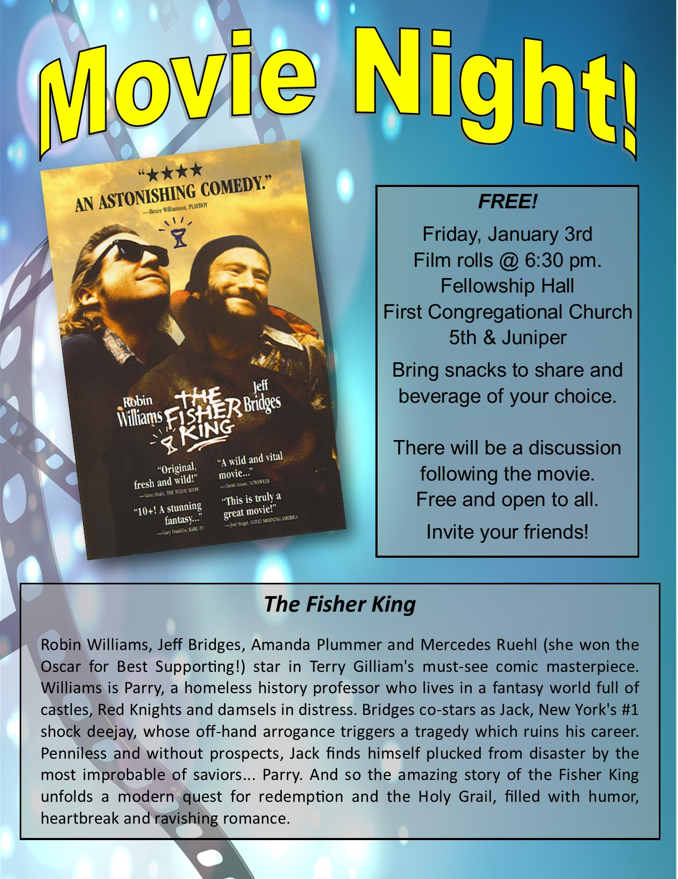

0

0

**January Birthdays**

0

Lilja Behr January 1 Barb Hoeft January 8 Macyn Harder McBroom January 7 Marcia Ferris January 13

0

0

**Church Leadership**

**Get Involved, Give Back, Grow Connections – Volunteer at Church!**

***There are many other opportunities for you to share your talents!***

**Council & Committees needing fresh faces and leadership:**

\***Council Member-At-Large:** Attend council meetings, act as a liaison for church members and council, help with nominations, spokesperson for historically underrepresented groups (HUGS).

**\*Christian Education *Music *Arts *Trustees**

*Contact Mary Reardon - Moderator with your nominations*

0

**First Congregational Council Minutes, December 19, 2024**

*~If you would like a copy of any of the Council Minutes, please contact the church office ~*

**Present:** Mary Reardon (Moderator,) Cynthia Janes (Treasurer/Zoom,) Pastor Leslie, Deb Griffith, Dan Hegstad, Marcia Ferris, Lowell Smith, Terri (Office Admin/Zoom.) Established a Quorum of 6 voting members**. Excused:** Georgia Harris (Sec.), Kay Cox, Sue Hadland, Kim Slipy (Vice Moderator.)

Marcia volunteered to take minutes for the meeting.

**Opening Prayer**

**Clerk’s Report –** Karen Ogdahl died 12/8/24. Memorial Service is Friday, 12/20/24

**Treasurer’s Report –** We had a $17,366 road improvement expense, partially offset by $8,700 that has been paid by Foundation. Remainder may be paid.

Our Interim minister’s pay is in the General Fund ($4,900) and should be paid from the Sabbatical Grant. It looks like a $14,000 deficit.

Mary brought up Fundraisers**.** Suggestions are a Fat Tuesday pancake meal, a garage sale (with not every item marked!) The Cooking Group doing a recipe book, a Harvest Dinner. We need to bring in outside people and not just draw from our members who are already donating.

**Pastor and Committee Reports (additions to written reports.)**

**Christian Education** – Lowell said Kathy Ogden has married and will be moving to North Dakota. They have been having kids activities after church during Fellowship time and planning Adult Forums. He needs more committee members. Other members could share interesting topics. There is a request to incorporate some more traditional Sunday School learning as well.

**Stewardship (update) –** 4 more pledges came in bringing us to 55 pledges (same as last year.) and about 16 who donate but do not pledge. = **74**

**Marketing –** Dan reported on a new website (prototype done) that gives us a more modern look. Dan gave thanks to Greta N. for her work with this and also the great posters and Facebook boosts.

It was noted we were listed wrong in the Crow Wing County Resource booklet. First Congregational (no UCC.) The Dispatch publishes it every year, but information is handled by Crow Wing County.

**Old Business:**

Choir Director – Mary will meet with Jennifer in January to determine a schedule.

Special Offerings – January we will do the Bridge on 7th (homeless shelter.) We will discuss the rest at the January meeting. My Neighbor to Love. Habitat for Humanity. We Are. Salvation Army. The Shop. PRIDE. The Soup Kitchen. UCC offerings are One Great Hour of Sharing (March) Strengthen the Church (May) Neighbors in Need (September) and The Christmas Fund (December.)

Sound System – There continues to be issues with the video and sound system, the interface between the two. Dan and Joe are researching a simpler system. Mary Reardon attended a workshop at Annual Conference led by the tech guy at Hackensack UCC and recommended connecting with him.

**New Business:**

Council Leadership for 2025-2026. Everyone presently on Council who was in attendance is still on board with their terms. We do need to recruit more members for our committees.

Building Use Application. Brainerd Lakes Area People’s March for Our Future. January 18, 2025,10-Noon. Form submitted by Sally Boos. Marcia Ferris is involved; so are Kim S. and Joe Stattine. Lowell moved to approve. Dan 2nd. All were in favor.

McConnell Justice Fund – Marcia explained that My Neighbor to Love has matching funds for Phase 2 and needs funding for completing the building that is going up now. Phase 3 just got funding and will move forward as well, but Phase 2 is an urgent need. Marcia proposed some of the McConnell funds to go toward ending homelessness in this area. No vote is needed but everyone agreed that this would be a high impact mission appropriate for the Justice funds. Leslie will call Vicky Kinney to see where they are at, but we will donate a minimum $3,000.00 to the project. Any amount given doubles.

**Meeting Adjourned at 5:40 PM.**

**Respectfully submitted, Marcia Ferris (sub Sec.)**

0

**Next Regular Council Meeting:**

***Thursday, January 16th 2025, 4:30 pm***

**in-person and via Zoom** [*tinyurl.com/uccbrainerdzoom*](http://tinyurl.com/uccbrainerdzoom)

**Reports are due Monday, January 13th.**

0

**UCC Care Team**

For anyone who wishes to join in making calls or visits, **the Care Team meets every month on the first Thursday @ 10:00 am**.

**Meeting Date Change: Thursday, January 16th**

If you know of anyone who would enjoy a call from the care team, please contact one of our Care Team; *Barb Hoeft, Jack and Kay Kraywinkle, Pat Scott, Chris Yager, Deb Griffith, Joey Halvorson (text or email) and Pastor Leslie.*

**Christmas Flowers Removed**

0

***Sunday, January 12th after worship***.

Christmas flowers may be removed from the sanctuary.

The donors of the plants get first choice!

0

0

**UCC & TheShop Meal!**

Meal cooking is **Wednesday, January 22 at 3:30 – 5:30 pm.** First Congregational has provided a space in the Fellowship Hall and kitchen where youths prepare a meal for the youth at TheShop - Brainerd Baxter Youth Drop-in Center. A number of youth and staff from TheShop come over to our kitchen and help prepare a delicious meal that is then brought back to TheShop for the hungry and appreciative teens there.

If you are interested in joining and enjoy cooking with youth, please contact Breton Monroe

Executive Director, #218.316.2070 or TheShop #218.454.0009. [*https://theshopbrainerd.org/*](https://theshopbrainerd.org/)

0

**January Special Offering – Warming Shelter Bridge on 7th**

**Sunday Worship – January 26th**

Bridges of Hope, in partnership with law enforcement, Crow Wing County, nonprofit organizations, church partners, and community members recognized the need for a safe place for homeless adults (ages 18+) to sleep in our community. This group has come together in a collaborative effort to address homelessness by providing a low-barrier warming shelter that offers a safe place for individuals to rest for the night.

To donate, send a check with "Warming Shelter” in the memo line to: First Congregational UCC, 415 Juniper St. Brainerd, MN 56401 or donate online using PayPal [*https://www.paypal.me/uccbrainerd*](https://www.paypal.me/uccbrainerd)and indicate "Warming Shelter" in the Note.

**Friday Book Group**

0

**We meet each Friday morning at 10:30 am via zoom**.

Church Zoom link: [*https://tinyurl.com/uccbrainerdzoom*](https://tinyurl.com/uccbrainerdzoom)

We are reading “**There Was an Old Woman: Reflections on These Strange, Surprising, Shining Years” by Andrea Carlisle.** In these personal essays, Carlisle looks for new ways to bring herself more fully to this time of life, such as daily walks with other women and connecting to the natural world that surrounds her houseboat on an Oregon river at the foot of a forest.

Those curious about, approaching, or living in old age will find wisdom and insight in her unique perspective. In a voice that rings with clarity, humor, and humility, Carlisle shows us that old age is not another country where we can expect to find the Old Woman grimly waiting but is instead an expansion of the borders in the country, we’re most familiar with: ourselves.Contact Pat Scott for more information.

0

**H.U.G.S.**

**Hosts, Ushers, Greeters, Scripture-readers**

Sunday morning greeters/ushers and coffee hosts play an important part in making our church a warm and welcoming place for all. Signup below for your first Sunday as the face of the church! [*https://www.signupgenius.com/go/10C0E48A9A823A5FFC07-hugs/16034811*](https://www.signupgenius.com/go/10C0E48A9A823A5FFC07-hugs/16034811)

0

0

0

**First Congregational Food Shelf Collection**

**Our church continues to collect non-perishable food items for the Salvation Army Food Shelf. Please consider bringing items and donating.**

**There are two collection boxes: one in the parking lot entry hallway, the other in the Narthex. Thank you, Brian Twamley and Stephanie Lee, for picking up and delivering the food to the Salvation Army.**

**You may also send a money donation to the church;** First Congregational UCC

415 Juniper St. Brainerd, MN 56401. Or for your convenience use our Paypal account at: [*paypal.me/uccbrainerd*](https://www.paypal.com/paypalme/uccbrainerd) **Make sure to write in memo “Food Shelf”.**

0

|  |
| --- |
|  |

**Welcome to our Facility**

0

It is the policy and privilege of the First Congregational United Church of Christ (UCC) Brainerd, to share its beautiful church facilities for purposes that match the values of the church and its mission which is “to know and share God’s love within us.” We are an open church valuing the diversity of age, culture, gender identity, opinions, physical and mental abilities, and sexual orientation.

To request a space for general use, ask for a “Request for Church Building Use” form and policy packet from the church office, administrative assistant Terri at 218-829-2528 or email *uccbrainerd@gmail.com.* Submit the request form to the administrative assistant. For wedding or funeral use, contact the Pastor Leslie: [*pastorleslieucc@gmail.com*](mailto:pastorleslieucc@gmail.com)

0

**Answer this Bible Trivia and Win a Prize**

Be the first person to call or email the office with the correct answer to this trivia question and win some UCC Swag:

*Which Gospel includes the story of the three wise men (or Magi)?*

**Last Month’s Winner: Mark Stults!**

0

0

**Looking Ahead – Annual Connection Letter**

0

Our church will be sending out a letter and kindly requests for you to fill out and return. This information will help us update our membership list, the Church Directory and make informed decisions about programs, and much more. Your response is important to help us better connect with one another and better serve our members and visitors. **So, towards the end of February,** keep your eyes on your mailbox!

If you do not receive a letter and would like one, please contact Terri in the church office.

0

**Brainerd Lakes Area Information**

0

**~ Opportunities to Know and Share God’s Love ~**

0

**The Bridge on 7th – Overnight Shelter**

**Provide Hope, One Night of Sleep at a Time**

For many individuals in our community, winter brings added stress, as cold nights and harsh conditions leave those experiencing homelessness without a safe, warm place to sleep. The challenge of finding shelter and support can feel overwhelming—but thanks to The Bridge on 7th, our neighbors don’t have to face this alone.

The Bridge on 7th is a low-barrier warming shelter providing a safe place to sleep for individuals 18+ who are experiencing homelessness in the Brainerd Lakes Area. Thanks to supporters like you, we’ve provided over **1,611 nights** of safe, warm sleep this year to those who would otherwise have faced the cold alone.

As temperatures continue to drop, the need for the shelter grows. Your support ensures The Bridge on 7th remains open to provide this essential service to those in need.

Thank you for considering this opportunity to make a difference. Your generosity can help us to continue helping our neighbors in need, one night at a time.

With gratitude,  
Bill Wear, *Shelter Manager, The Bridge on 7th www.bridgesofhopemn.org/donate*

Your gift directly impacts those we serve, providing safety and warmth to individuals in need.

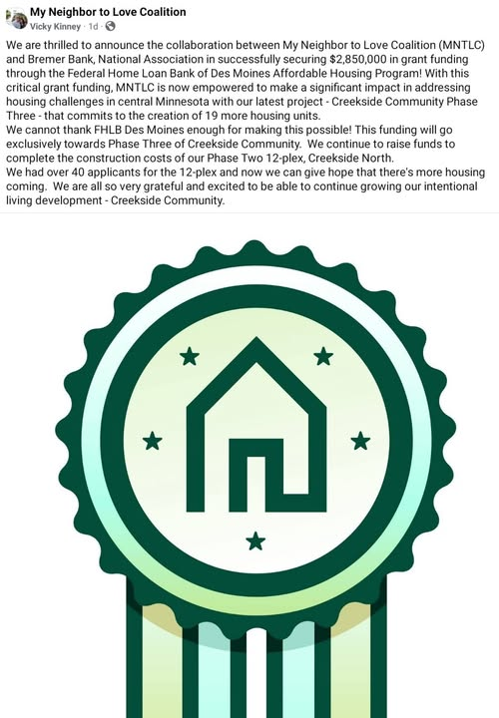

0

0

0

0

|  |
| --- |
| January 2025 Calendar |

|  |  |  |  |  |  |  |
| --- | --- | --- | --- | --- | --- | --- |
| Sunday | Monday | Tuesday | Wednesday | Thursday | Friday | Saturday |
| **Y- Yes Meeting in person**  **FB -Facebook Stream Online**  **Z-our church Zoom** | **C- Cancelled**  **N - No Meeting**  **? - No update**  **TBD - To be determined** | ***Pastor Leslie out of the office 12/25/24 through 01/09/25*** | Office Hours  10am – 2pm  Pastor Drop-in Hours  11:00 am – 1:00 pm | Office Hour  10am – 2pm  Pastor Drop-in Hours  2:00 – 4:00 pm  **w/Daisy** | Office Hours  10am – 2pm |  |
|  |  |  |  |  |  |  |
|  |  |  | ***Church Office Closed***  11:45pm Men’s **1**  Grp @Wings Café-**C**  7pm AA Common-**Y** | **2**  Care Team Mtg. changed to 16th  6:30pm Dist. 7AA-**Y** | **3**  10:30am Bk Grp-**Z**  6:30pm Movie Night | **4**  9:30am-1pm AAUW Mtg.-**Y** Fellowship Hall |
| 8:30am Bnrd Frnds-**Y 5**  10am Wrship & Communion-**Y**&**FB**  11am Fellowship-**Y**  11:15am Adult Forum-“Poetry Slam-**Y**  **7pm Twelfth Night Concert** | **6**  7pm BACP/ BLUE-Z | 2pm EA-**Y**   **7**  5:30pm OA -**Y** | **8**  10am Trustees-**Y&Z**  11:45pm Men’s  Grp @Wings Café-**Y**  7pm AA Common-**Y** | **9**  4:30pm Exec. Team Mtg**.-Y**&**Z**  6:30pm NAMI Mtg.-**Y** | **10**  10:30am Bk Grp- **Z**  **Pastor Leslie back in Office** | Women’s **11**  Fellowship in Fellowship Hall**-Y**  Host Marcia Ferris |
| 8:30am Bnrd Frnds-**Y** **12**  10am Wrship -**Y**&**FB**  11:45am Fellowship-**Y**  1:30pm Girl Scouts-**Y**  **Remove Christmas Flowers** | **13** | **14**  10am Foundation Mtg. via Zoom  2pm EA-**Y**  5:30pm OA -**Y** | 10am Renewal Team-**Y**  11:45pm Men’s **15**  Grp @Wings Café-**Y**  7pm AA Common-**Y** | **16**  10am Care Team Mtg.-**Y**  4:30pm Council Mtg-**Y**&**Z**  6:30pm Dist.7AA-**Y** | ***Terri Admin.* 17  *Asst. Day Off - The Church Office is Closed***  10:30am Bk Grp- **Z** | **18**  9am-Noon BLA Peoples March for Our Future/Inauguration Weekend Gathering-**Y** |
| 8:30am Bnrd Frnds-**Y 19**  10am Wrship **-Y**&**FB**  11am Fellowship-**Y** | **20** | **21**  2pm EA-**Y**  5:30pm OA -**Y** | **22**  11:45pm Men’s Grp-**Y**  1:30 PRC Mtg. -**Y**  3:45pm TheShop cooking-**Y**  7pm AA Common-**Y** | **23**  6:30pm NAMI Mtg.-**Y** | **24**  10:30am Bk Grp- **Z** | **25**  9:30am-3pm Area 35 AA – Potluck and Speakers Fellowship Hall |
| 8:30am Bnrd Frnds-**Y 26**  10am Sunday Wrship-**Y**&**FB**  **Justice Sunday**  11am Fellowship-**Y**  11:30 am Adult Forum: Justice Tables-**Y**  ** Newsletter Deadline  **Special Offering:  Warming Shelter | **27**  . | **28**  2pm EA-**Y**  5:30pm OA -**Y** | **29**  11:45pm Men’s Grp-**Y**  7pm AA Common-**Y** | **30**  11:30am Women’s Lunch @ Baia  Della Baxter-**Y** | **31** |  |