Friendship News, June 2025

0

First Congregational United Church of Christ, Brainerd

An Open and Affirming Congregation

The Church Office Hours: Wednesdays – Fridays from 10:00am – 2:00pm

Office phone 218-829-2528 Office E-mail [*uccbrainerd@gmail.com*](mailto:uccbrainerd@gmail.com)

Pastor Leslie’s E-mail: [*pastorleslieucc@gmail.com*](mailto:pastorleslieucc@gmail.com)Website: [*www.uccbrainerdmn.org*](http://www.uccbrainerdmn.org)

*No matter who you are, or where you are on life’s journey, you are welcome here.*

0

**Pastor’s Pen**

0

***A Road Paved with Good Intentions***

I’m not sure when or where I learned the concept that good intentions only go so far; that our impact matters just as much, if not more. This idea can be applied to our personal relationships, the goals we set for ourselves, policies set by organizations and governments, and much more. The simplest way I have heard this explained was using the metaphor of playing catch. You throw a frisbee to a friend, but something happens and instead of flying through the air toward your friend, it curves to one side and hits a stranger in the back of the head. Your intention was not to hit the person in the back of the head with a frisbee. But most of us would still apologize and see what we could do to make the situation better. Whether we mean to or not, if our actions cause harm, it’s important for us to take responsibility and seek to make any necessary repairs to the relationship or the situation.

I was reminded of this concept this week when I joined a small group of clergy for a meeting with a staffer at Rep. Pete Stauber’s office in Hermantown followed by a press conference. While only 5 of us were allowed in the meeting at Stauber’s office, more than 60 people showed up in support for the press conference. Sounds great right? And it was! But as the five of us walked across the parking lot of the strip mall where Stauber’s office is located to the location for the press conference, a woman ran up to us and asked if we were with the protest. She explained that the cars from the group had filled up the parking lot and it was causing the businesses to suffer. In particular, one of the wait staff from the restaurant was concerned that it was about to be time for the lunch rush and she had rent to pay.

How would you respond? The press was waiting, and we were on a timeline. Asking everyone to move their cars right then and there would have disrupted the entire event. A colleague of mine was the first to respond. She said she was very sorry, but we would be wrapping up in 10-15 minutes. I know she meant well and was focused on staying on schedule. But this response seemed to dismiss the woman’s concerns and offered no attempt to fix the situation.

My role at this event was not as one of the organizers or coordinators, but as a participant so I wasn’t sure that I could do much to change the situation. But, I did what was within my power - I apologized. I apologized with authentic compassion and empathy. I acknowledged that we had clearly not considered how our press conference would impact the local businesses. I told her that I would make sure people knew to move their cars as soon as possible and I would encourage everyone to patronize the businesses before we left.

As the press conference ended, I asked the organizer to make the announcement and 15-20 of us headed to the restaurant for lunch. After lunch was over, I stopped on my way out to talk to the bartender and our waitress. I again apologized for taking up all the parking and likely messing up their business during the lunch rush. “Well, you came to eat lunch so that makes up for it!” one of them responded. I doubt that it completely made up for it, but I hope it helped.

Often when we are engaging in advocacy and social justice actions, even with the best of intentions, we do things that end up hurting the very people we are hoping to help. Sometimes it’s because we don’t ask the people being impacted what they need, and we ride in like knights on horses to save the day. Only to find out that what we thought was a good solution, actually caused more harm. Like donating mini shampoos to a shelter for the unhoused but they already have thousands of hotel shampoos and don’t have room for more, so they throw them away which costs them time and money. Sometimes it’s because we are so focused on a goal, we don’t stop to think about how each piece of what we are doing could cause harm.

As we continue to do the work of God in the world, to be the hands and feet of Christ to our neighbors, I want us all (including me!) to remember this. It’s easy to get swept up in the “doing” that we don’t spend enough time talking to the people we are trying to help or thinking through the possible unintended consequences of our plans. We remember the story of the man Jesus encountered at the pool called Bethzatha. He had been ill for 38 years, but before taking any action, Jesus asked the man, “Do you want to be made well?” If we are to truly provide help and healing for God’s people, we need more than good intentions. And just taking that extra step to consider the impact, can make all the difference in the world.

With Peace,

0

Mission Statement of First Congregational UCC

***“To know and share God’s love within us.”***

0

0

0

Purpose Statement of First Congregational United Church of Christ

***“First Congregational UCC is a welcoming, inclusive, and progressive community committed to promoting social justice, spiritual growth, and love for all people. We reject discrimination and advocate for equality and dignity for marginalized communities. Through worship, education, and service, we work to make a positive impact on the world and invite all individuals to join us in this journey of faith and service.”***

0

**Church Office Hours**

**New Hours**

**Tuesday, Wednesday, Thursday 10:00 am - 2:00 pm**

**Closed Mondays and Fridays**

Please call Admin. Asst. Terri at the office 218-829-2528

**Pastor Leslie’s Workday Schedule**

**Sunday through Thursday (Days off are Friday and Saturday)**

**Drop-in Hours: Wednesdays 11:00 am – 1:00 pm Thursdays 2:00 – 4:00 pm**

*\*Drop-in hours are times set aside for “drop-in” conversations, much like a professor’s office hours.*

Everyone is encouraged to make an appointment, especially if the above times are not convenient.

You can go to [*www.calendly.com/pastorleslieucc*](http://www.calendly.com/pastorleslieucc/) and select a day and time that works for you, or you can email Pastor Leslie at [*pastorleslieucc@gmail.com*](mailto:pastorleslieucc@gmail.com) or call/text at 218-656-0096.

0

**Stay Connected**

**How to watch Sunday worship:** The worship service is **broadcasted on the church Facebook page and the church's YouTube channel every Sunday at 10:00 am.**  
To watch worship on Facebook, go to [*https://www.facebook.com/uccbrainerd/live*](https://www.facebook.com/uccbrainerd/live)  
***\*\*Live stream videos are saved and can be viewed at any time. All memorials, weddings and 12th Night Concert are on our church Facebook page.***

**How to stay connected with First Congregational friends and members:** Join the private group for our Facebook Connections Page at [*https://www.facebook.com/groups/uccbrainerd*](https://www.facebook.com/groups/uccbrainerd)*.*

**Financial Help Available** The Pastor's Discretionary Fund is available to assist church members and others in the Brainerd area who are experiencing financial distress with modest financial help. If you need assistance, please email, call, or text Pastor Leslie. Let her know what your situation is and how the church might be of help.

**Donate to the church online!**We are now accepting your offerings and donations using **PayPal.** You do not need to have a PayPal account to make an online donation with a credit card. To use PayPal, go to: [*https://www.paypal.me/uccbrainerd*](https://www.paypal.me/uccbrainerd)

0

**First Congregational UCC News & Updates**

0

0

**New Church Council & Committee Members**

**Moderator: Kim Slipy**

**Assistant Moderator: Dan Hegstad**

**Clerk: Barb Stokke**

**Christian Ministry: Denise Slipy**

**Christian Education: Emily LeClaire**

**Members-at-Large: Tracy Lyons**

0

**Summertime Reminders**

**\*\* Movie Night - TheShop Cooking &**

**Adult Forum will resume in the Fall \*\***

0

****Our Congregational Justice Tables are open gatherings where members come together to lead our church into deeper discipleship and greater impact. With over 30 participants engaged across four justice priorities, these are not standing committees, but Spirit-led teams grounded in action and community.

Justice Tables meet every other month on the fourth Sunday of September, November, January, March, and May from 11:30 AM to 1:00 PM. Come join us! For more info contact Steve Newcom.

**Mental Health**

**WISE Report – Meeting Notes, Sunday, May 25, 2025**

Present: Pat Scott, Lowel Johnson, Kay Cox, Deb Griffith

A. Follow-up on becoming a WISE congregation:

1. Lowell will reinitiate contact with Vicky Harvey within the next week.

2. We will pursue a panel on Neurodivergence in September.

3. We will request reaffirmation of the WISE covenant by the end of September.

B. Deb and Pat will set up a date to reorganize the WISE information rack.

*Respectfully submitted, Pat Scott*

**Families in Poverty**

**Meeting Notes, Sunday, May 25, 2025**

Present: Marcia Ferris, Charlene Sennweld, Steve Newcom, Cynthia Janes

(Because Charlene was new to the Group, Steve filled her in on the Group’s path so far.)

We then discussed the Group’s current focus: Strategizing how to persuade the City Council to re-think its vote to deny a permit for a year-round shelter for homeless adults:

1. A new coalition has come together to work on this issue and is made up of the following organizations: Open Arms, the Soup Kitchen, Our Neighbor to Love, some incognito county officials, and the Shelter on 7th.
2. The Brainerd City Council’s failure to issue a permit for the shelter to go year-round has nothing to do with funding. The funds are available. All the Council has to do is give its ok, but Kelly Bevans was the only person on the Council to vote for issuing the permit in the last vote.
3. At the present time, it is unclear why the great majority of Brainerd City Council are against year-round presence of the homeless shelter. Some think that it is because they fear that homeless people from the “outside” will come to Brainerd and use the shelter as their home. A threat to public safety has also been mentioned.
4. The coalition’s next step will be taken next week, with the participation of Marcia Ferris and Emily LeClaire of the Poverty Group, as well as Deb Griffith and Pastor Leslie. Some or all of them will interview Council members, with the goal of understanding why they denied the request for a permit. Then they plan to find research that demonstrates either that these fears are not part of other cities’ experiences with homeless shelters and the homeless population or supports our plan to keep the shelter open year-round.

*Respectfully submitted, Cynthia Janes and Marcia Ferris, Acting Clerks*

**Diversity and Inclusion**

Meeting Notes May 25, 2025

We discussed the following possiblities:

* Provide seed money for WeARE to provide gender-affirming items such as chest binders, wigs, etc, to those in need. This would be a financial contribution from the McConnell fund. Pastor Leslie met with WeARE’s LGBTQ liason and they are drafting a proposal.
* Participate in Brainerd Lakes Pride Weekend, including a table at Pride in the Park, and possbily a drag event.
* ****Bringing OutFront presenter Matt Lewellyn to lead a series of four workshops available to the wider community starting in September.
* Exploring rideshare options for members attending Twin Cities Pride
* Organizing a letter-writing campaign to Minnesota lawmakers in support of justice and equity initiatives

*- Respectfully submitted, Rev. Leslie Moughty*

0

**Church Directory 2025**

0

**The updated directory was emailed out last month May. If you inadvertently did not receive one, please let Terri know in the church office. Also if you need a hard copy to pick up or mailed to you.**

0

**Next Council Meeting: *Wednesday, June 19, 2025, 3:30 pm***

**in-person and via Zoom** [*tinyurl.com/uccbrainerdzoom*](http://tinyurl.com/uccbrainerdzoom)

**Reports are due via email on Monday, June 16th to Kim Slipy, Moderator &**

**Terri Chidester, Admin. Asst.**

**First Congregational Approved Council Meeting Minutes are available upon request. Please contact Terri Admin Asst. at the Church Office.**

0

**Get Involved, Give Back, Grow Connections – Volunteer at Church!**

***There are many other opportunities for you to share your talents!***

**Committees needing your gifts: * Trustees * Stewardship**

0

**June Birthdays**

Sarah Jo Armstrong June 5 Lowell Johnson June 20

Ryan Kelley June 8 Dawn Stattine June 22

Shelly Trimble June 8 Patrick Bertram June 23

Barb Stokke June 10 Claire Steen June 25

Becky Twamley June 10 Steve Waller June 25

Larry Anderson June 14 James Flath June 27

0

**Membership Classes begin on June 8th at 11:30 am**

**Council Room on 2nd Floor**

If you are interested in becoming a voting member of the church, or just want to learn about the congregation and the United Church of Christ, join us for the first session of prospective member classes.

0

**Special Offering Sunday Worship June 22nd - WeARE**

Advocates for Reproductive Education (WeARE) is a 501c3 nonprofit organization, committed to promoting and providing comprehensive reproductive education and healthcare services for youth, young adults, and the underserved in Brainerd and the surrounding community.

Through community collaboration, led by compassionate healthcare professionals, the underserved living in the Brainerd Lakes Area are empowered to make informed decisions about their health and wellbeing.

Please send your donation to First Congregational UCC, 415 Juniper St. Brainerd, MN 56401.

Or for your convenience use our Paypal account at: [*paypal.me/uccbrainerd*](https://www.paypal.com/paypalme/uccbrainerd). Make note on your offering **“*WeAre Special Offering.”*** WeARE on Facebook: [*www.facebook.com/WeAREbrainerd*](http://www.facebook.com/WeAREbrainerd)

**Fellowship Opportunities**

0

A time to connect, socialize and enjoy some local food.

***Men’s Lunch***

Each Wednesday at 11:45 am at Wings Airport Café.

No agenda, no leaders, just food and conversation.

Join us!

***Women’s Lunch***

Details for the June lunch are TBD.

Please check the “This Week” weekly email and/or

the worship bulletin for updates.



***Saturday Women’s Coffee***

Our Saturday gathering is paused for the Summer.

0

**Friday Book Group**

**We meet each Friday morning at 10:30 am via zoom**.

Church Zoom link: [*https://tinyurl.com/uccbrainerdzoom*](https://tinyurl.com/uccbrainerdzoom)

We are reading, "Aging as a Spiritual Practice: A Contemplative Guide to Growing Older" by Lewis Richmond.  
  
A wise, compassionate book that guides readers through the four key stages of aging—such as “Lightning Strikes” (the moment we wake up to our aging)—as well as the processes of adapting to change, embracing who we are, and appreciating our unique life chapters.  
Breath by breath, moment by moment, Richmond’s teachings inspire limitless opportunities for a joy that transcends age.

*Contact Pat Scott for more information.*

0

**UCC Care Team**

0

For anyone who wishes to join in making calls or visits, **the Care Team meets every month on the first Thursday @ 10:00 am**.

If you know of anyone who would enjoy a call from the care team, please contact one of our Care Team; *Barb Hoeft, Jack and Kay Kraywinkle, Pat Scott, Chris Yager, Deb Griffith, Joey Halvorson (text or email) and Pastor Leslie.*

0

**Cooking For Everyone**

**This group is OPEN FOR EVERYONE!**

Email Lowell [*johnsonlowells@gmail.com*](mailto:johnsonlowells@gmail.com) and he will add you to the member list so that you will know when and where we will next meet.

0

**Garden Gleaning**

***A Biblical (and environmentally) inspired activity***

This is how it works: Gardeners and plant people bring in their “gleanings” to share. This ranges from rhubarb and vegetable plants in the spring to daffodil bulbs in the fall. A table, poster and donation basket are in Narthex entrance. Enjoy the fruits of our labors!

**It’s RHUBARB time!**

All are welcome to help themselves – no charge! All donations are given to the Food Shelf.

*Historical note: Begun here circa 1988 when our church began Hunger Action outreach, Central America updates and global food connections.*

Note: Using our resources, recycling, re-purposing, and not wasting our food are all acts of Creation Care and Justice. Garden Gleaning is an Easy-Peasy way to put words into action.

0

**H.U.G.S.**

**Hosts, Ushers, Greeters, Scripture-readers**

Sunday morning greeters/ushers and coffee hosts play an important part in making our church a warm and welcoming place for all. Signup below for your first Sunday as the face of the church! [*https://www.signupgenius.com/go/10C0E48A9A823A5FFC07-hugs/16034811*](https://www.signupgenius.com/go/10C0E48A9A823A5FFC07-hugs/16034811)

0

**First Congregational Food Shelf Collection**

**Our church continues to collect non-perishable food items for the Salvation Army Food Shelf. Please consider donating.**

**There are two collection boxes: one in the parking lot entry hallway, the other in the Narthex. Thank you, Brian Twamley and Stephanie Lee, for picking up and delivering the food to the Salvation Army.**

**You may also send a financial donation to the church;** First Congregational UCC

415 Juniper St. Brainerd, MN 56401. Or for your convenience use our PayPal account at: [*paypal.me/uccbrainerd*](https://www.paypal.com/paypalme/uccbrainerd) **Make sure to write in memo “Food Shelf”.**

0

**Welcome to our Facility**

0

We are blessed to be able to share our beautiful church facilities for purposes that match the values of the church and its mission which is “To know and share God’s love within us.” We are an open church valuing the diversity of age, culture, gender identity, opinions, physical and mental abilities, and sexual orientation.

To request a space for general use, ask for a “Request for Church Building Use” form and policy packet from the church office, administrative assistant Terri at 218-829-2528 or email *uccbrainerd@gmail.com.* Submit the request form to the administrative assistant.

For wedding or funeral use, contact Pastor Leslie: [*pastorleslieucc@gmail.com*](mailto:pastorleslieucc@gmail.com)

0

**The Columbarium & Memorial Garden**

**First Congregational UCC, Brainerd**

The Columbarium is in the historic space that once was our church’s front entry way.

How appropriate it is that our Columbarium now marks another entry way into a new life — where the Spirits of Love and Truth are always present!

The Memorial Garden is located on the south lawn of the church. The Garden provides a place for cremains of your loved one to be buried in the ground among natural plantings. The Garden fee includes the inscription of your loved one’s name on a granite plaque that is mounted on the outside wall of the church.

Should you wish to learn more about the purchase of a niche for your own cremains or for the ashes of a loved one, please call the church office at (218) 829-2528 and a packet of materials will be sent to you via email or regular mail. The Memorial Committee has prepared the information packet, and it contains all the details you will need as you consider inurnment here at First Congregational UCC.

0

**Community Prayer Box**

Thank you to our Memorial Committee and the craftsmanship of Jack Kraywinkle, for making Pastor Leslie’s idea for a Community Prayer Box in the Memorial Garden a reality! You can find the prayer box on the South side of the church (the side that faces Juniper Street.)

Community members frequently walk through the garden and this box will offer our wider community an opportunity to share their prayers. Prayer cards and pens are provided, and the box is secured with a padlock, so the submitted prayers don’t fly away with the wind!

Pastor Leslie checks the box weekly and pray for any prayers submitted as well as bring them to the Care Team for prayer as well.

](https://www.uccmn.org/programs-support/outdoor/)

0

**"Weaving Our Soul Stories in Wild Spaces"**

**Outdoor Ministry 2025**

You are all invited to experience the *MN Conference Outdoor Ministry* as we take this season to *“Weave our Soul Stories in Wild Spaces.”* Many of our in-person events will be located at Camp Onomia to offer consistency, while book studies and resources will be available online. “Wild” Worship liturgies are also in the works for congregations looking to add earth-based Christian elements to their worship services.

**For more ﻿Information and registration:**[***www.uccmn.org/programs-support/outdoor/***](https://www.uccmn.org/programs-support/outdoor/)

**Family Camp** | July 11 – 13 Cost: $150 – $450

Family Camp is back! This camp is open to all individuals, couples, and families of all sizes. There will be swimming, canoeing, fishing, worship, art, relaxing, and so much more available.

**Night Hawk Summer Youth Camp** | July 13 – 18 Cost: $350

Love the late nights and later mornings? In this awesome program, campers stay up late into the night and sleep late into the morning. God’s creation is a whole different adventure during the dark hours. We are partnering with the ELCA to offer this camp to youth who have finished grades 6-12.

**Clergy Family Retreat** | August 10 – 12 Cost: $75 – $180

Hey clergy! We know the weight of the world and your service to your settings can be heavy. The MN Conference would like to offer you and your family an affordable getaway. There will be plenty of time to relax, fish, swim, and canoe. All ordained, licensed, chaplain, and retired clergy (single, couple, or family) are welcome to attend.

**Great Lakes Collaborative Summit** | August 24 – 26 Cost: $185 – $235

This is a partner collaboration retreat with all UCC conferences around the great lakes and UCCanada. Join us for this three-day event, to discern what it means to be good stewards to our lakes and watersheds. Keynote speaker is Ched Meyer, editor of *Watershed Discipleship* and author of the recently released book *Affluenza and Resisting Plutocracy: Luke’s Jesus and Sabbath Economics*.

**Women’s Retreat** | September 12 – 14 Cost: $250

Paula J. Pederson — psychologist, interculturalist, and facilitator with the Center for Courage and Renewal — joins singer-songwriter Sara Thomsen to weave deeper connections of self with creation and the Divine. This is open to all women no matter age, pronouns, and spiritual identity.

*Let us gather at the altar of nature as we learn to listen, learn, and heal.  
Let us go forth to be good stewards of the Earth in all the ways that bring wholeness to all living creatures.*

**Brainerd Lakes & Surrounding Area Information**

0

**~ Opportunities to Know and Share God’s Love ~**



0

0

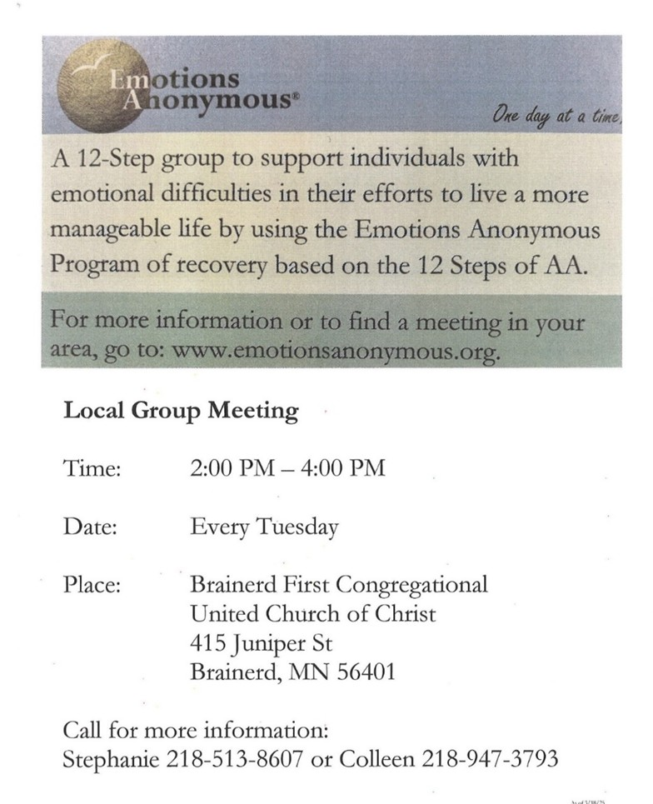

0

0

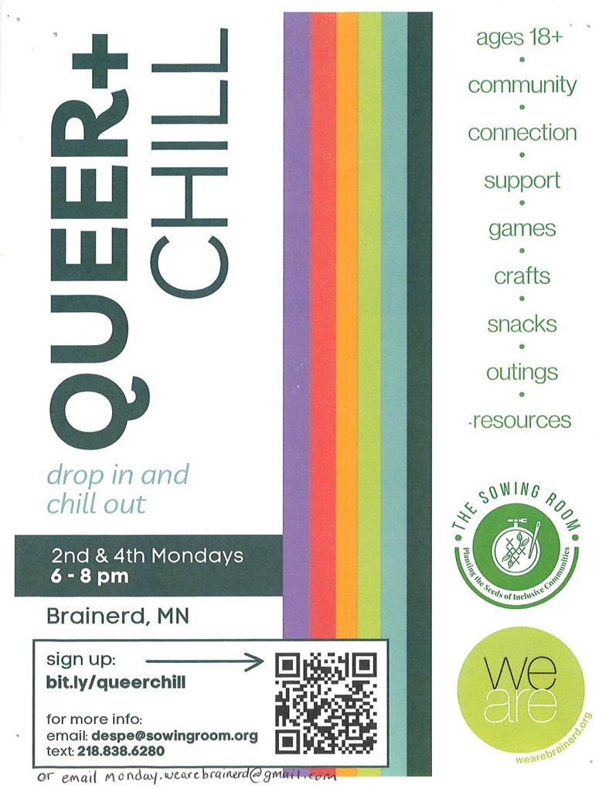

0

0

|  |
| --- |
| June 2025 Calendar |

|  |  |  |  |  |  |  |
| --- | --- | --- | --- | --- | --- | --- |
| Sunday | Monday | Tuesday | Wednesday | Thursday | Friday | Saturday |
| **Y- Yes Meeting in person**  **FB -Facebook Stream Online**  **C- Cancelled N-No Meeting**  **Z-our church Zoom** | **Office** Closed | Office Open  10am – 2pm | Office Hours  10am – 2pm  Pastor Drop-in Hours  11:00 am – 1:00 pm | Office Hours  10am – 2pm  Pastor Drop-in Hours  2:00 – 4:00 pm  **w/Daisy** | Office Closed |  |
|  |  |  |  |  |  |  |
| 8:30am Bnrd Frnds-**Y 1**  10am Wrship & Communion-Y&**FB**  11am Fellowshp-**Y** | **2** | Office Open **3**  2pm EA-**Y**  5:30pm OA -**Y** | 11:45pm Men’s **4**  Grp@Wings Café-**Y**  4pm Christian Ministry-**Y**  7pm AA Common-**Y** | **5**  10am Care Team-**Y**  4-8:30pm Indivisible Grp. Mtg-**Y** | Office Closed **6**  10:30am Bk Grp-**Z**  ~~Movie Night-~~**~~C~~** | **7**  . |
| 8:30am Bnrd Frnds-**Y 8**  10am Wrship-Y&**FB**  11am Fellowshp-**Y**  11:30 am Membership Classes begin- Council Rm upstairs | **9** | **10**    2pm EA-**Y**  5:30pm OA -**Y** | 11:45pm Men’s **11**  Grp@Wings Café-**Y**  3:30pm Exec. Mtg.-**Y**  4-5pm Homeless Coalition Mtg. in Fellowship Hall-**Y**  7pm AA Common-**Y** | **12**  Pastor Leslie out of Office-MN Conf.Training | Office Closed **13**  10:30am Bk Grp- **Z**  **Annual MN Conference** | ~~Women’s~~ **14** ~~Fellowshp~~-**C**  10am-4pm Indivisible Grp-Y Fellowship Hall  **Annual MN Conference** |
| **15**  8:30am Bnrd Frnds-**Y**  8:30am Choir Practice**-Y**  10am Wrship & Choir-**Y**&**FB**  11am Fellowshp-**Y** | **16**  1pm AAUW Steering Mtg-**Y** | 2pm EA-**Y 17**  3pm Trustees Mtg.-**Y**  5:30pm OA -**Y** | 11:45pm Men’s **18**  Grp@Wings Café-**Y**  7pm AA Common-**Y** | **19**  3:30pm Council Mtg.-**Y&Z**  6:30pm Dist.7AA-**Y** | Office Closed **20**  10:30am Bk Grp- **Z** | **21**  Wedding |
| 8:30am Bnrd Frnds-**Y 22**  10am Wrship**-Y**&**FB**  11:15am Fellowshp-**Y**  **\*Special Offering WeARE**  **\*Newsletter Deadline** | **23** | **24**  2pm EA-**Y**  4-5pm Homeland Coalition Mtg. in Fellowship Hall-**Y**  5:30pm OA -**Y** | 11:45pm Men’s **25**  Grp@Wings Café-**Y**  7pm AA Common-**Y** | **26**  11:30am Women’s Lunch @ TBD  6pm AA Dist. Special Mtg.-**Y** | Office Closed **27**  10:30am Bk Grp- **Z** | **28** |
| 8:30am Bnrd Frnds-**Y**  **29**  10am Justic Sunday Wrship-**Y**&**FB**  11am Fellowshp-**Y** | **30** |  |  |  |  |  |