Friendship News, January 2024
0
First Congregational United Church of Christ, Brainerd
An Open and Affirming Congregation
The Church Office Hours: Wednesdays – Fridays from 10:00am – 2:00pm
Pastor Leslie’s Drop-in Hours: Wed. 2:00pm – 4:00pm, Thurs. 11:00am – 1:00pm
Office phone 218-829-2528 Office E-mail uccbrainerd@gmail.com Pastor’s E-mail: pastorleslieucc@gmail.com Website: www.uccbrainerdmn.org
Schedule a 1 to 1 (in-person or by Zoom or Phone) with Pastor Leslie:
www.calendly.com/pastorleslieucc/1to1

No matter who you are, or where you are on life’s journey, you are welcome here.
0
Pastor’s Pen
0
Drawn In: Living the Creative Life with God
God created the heavens and the earth... and called it good!
We know our God by many names – Divine Mystery, Holy Love, Father, Mother, Holy One, Rock of Ages, Ancient of Days, Elohim, Adonai, just to name a few. One name that I have consistently been drawn to is Creator. Creator of the cosmos, creator of all that we are and all we experience. But God is not the only creator. We too are creators. Co-creators with God helping to create a world that God envisions for us.
On Sunday January 14, we will begin a new 5-week worship series called “Drawn In: Living the Creative Life with God.” We will connect with our inherent creativity and nurture this foundational aspect of being human, giving us renewed energy for passionate work, delightful play, and creative problem solving to make this world a better place for all.
It’s important to remember that creativity is not only typically “artistic” activities. Any kind of “making” is inherently creative (making someone feel welcome, making a clean house for someone, making deliveries of groceries to shut-ins, making food for the potluck, etc.). In fact, we are all creating so much all the time. The question becomes, “are we creating more good in the world?” When we recognize both the extraordinarily artistic as well as seemingly-mundane as acts of creation, this recognition helps us to claim our creative life with God.
With peace,
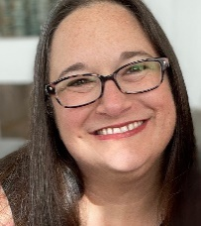
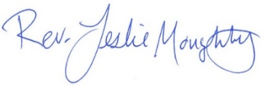

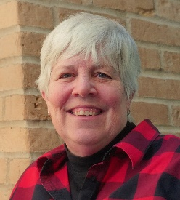
Moderator’s Musings
0

Welcome to the New Year 2024!
Last year at First Congregational United Church of Christ was almost back to normal after the major Covid outbreak. It has been a wonderful and exciting year:

- A huge THANK YOU to all those who work on the committees, you are the engine that keeps us going!
- Thank you to those who volunteer for: Coffee hour, Readings, Ushering, Cleaning, Sound and Video and all the other areas needing help; as well as the wonderful welcome to our visitors. Thank you, Thank you, Thank you!
- We have “officially” added 4 new members to our roles and more people popping in the doors.
- We have added some “Doors” to the front of our church which is setting us apart as “That Church!” Which in my opinion is a good thing!
- We have started a “Justice Ministry/Outreach” with Steve Newcom ministering focus.
- We now have a Marketing team to help get the “Word” out about what our church has happening, that the community will be interested in attending.
- A Care Team is now in place: Barb Hoeft, Jack and Kay Kraywinkle, Pat Scott, Chris Yager, Joey Halverson, and Deb Griffith. So, if you need assistance or know someone please give them, or Pastor Leslie a shout.
- We have been blessed to share time on this earth with: Doris Anderson, Cheri Maxwell, Betty Johnson, Edwin Pishko, Beverly Madland.
- The PRC team hosted a training session on healthy communication here. Joined by the Hackensack UCC and led by Kelly Gallager, UCC Regional Minister.
- We have taken a church wide survey to help us see where we are, (where) and what is important to our church family. We will be reviewing the survey results, church wide, during the Adult Forum January 13th.
- Many of our parishioners have volunteered their time, energy and homes and have done some lovely social/fundraisers, this past year.
- Though we passed a deficit budget last year it appears as though we will finish the year in the black. Excluding the $17,000 street assessment from the city.
…these are just a few…
There is an energy, an excitement that is welling up in the church. I hope you feel it too! There is more to come this year as well, events and opportunities to help spread the love to those in our community and church!
Thank you, Lord for a wonderful 2023 and may we share your light in 2024!
Mary Reardon

First Congregational UCC News & Updates
0
0
Pastor Leslie is on vacation from 12/27/23 through 01/12/24
Rev. Marc Blakesley will lead worship on Sunday January 7th
For emergency Pastoral care during this time, contact
Rev. Mark Ford of Lakes Area Presbyterian by calling church 218-828-6069 or
cell 218-232-8131

Pastor Leslie’s Workday Schedule

>> Sunday through Thursday (Days off are Friday and Saturday) <<

Beginning in January Drop-in Hours*
Wednesdays 11:00am – 1:00pm Thursdays 2:00 – 4:00pm
During Thursday afternoon Pastor Leslie will be joined by Daisy “Minister of Fur Therapy”
*Drop-in hours are times set aside for “drop-in” conversations, much like a professor’s office hours. Pastor Leslie is typically working at the church the rest of the week, but it is possible that she may be in meetings, at a community event, or working off-site.
Pastor Leslie typically works off-site on Tuesdays for sermon research and writing.

Everyone is encouraged to make an appointment if the above times are not convenient.
You can go to www.calendly.com/pastorleslieucc and select a day and time that works for you, or you can email Pastor Leslie at pastorleslieucc@gmail.com or call/text at 218-656-0096.

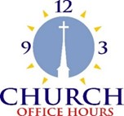
Church Office Hours
0
Wednesday, Thursday, Friday
10:00 am - 2:00 pm
Please call Terri at the office 218-829-2528 or
cell 218-537-1636 for further assistance.

How to watch Sunday worship The worship service is broadcasted on the church Facebook page and the church's YouTube channel every Sunday at 10:00 am.
To watch worship on Facebook, go to https://www.facebook.com/uccbrainerd/live
Live stream videos are saved and can be viewed at any time.
Financial Help Available Your Church Council voted last year to allow the Pastor's Discretionary Fund to be used to assist church members and others in the Brainerd area who are experiencing financial distress during this time. We received many generous donations! If you need assistance, please email, call, or text Pastor Leslie. Let her know what your situation is and how the church might be of help.
Donate to the church online! We are now accepting your offerings and donations using PayPal. You do not need to have a PayPal account to make an online donation with a credit card. To use PayPal, go to: https://www.paypal.me/uccbrainerd

0
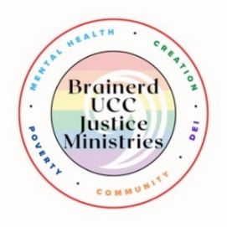
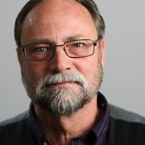
Update from Brainerd UCC Congregational Justice Ministries

The congregation is advancing its justice ministries around 5 areas of justice concern. Mental Health: Children and Families/Poverty, Creation Justice, DEI/LGBTQ, and Community Building. I am excited to share that we have 30 people engaged with this work. That's incredible and a powerful testament to this congregation's justice commitment. We will provide updates as the work unfolds.
I want to highlight these are NOT standing committees with elected members but rather open tables around which congregational members gather to lead our congregation into deeper discipleship and impact around their area of concern and passion. If you have an interest in joining a table let Steve Newcom know - snewcom17@gmail.com

In addition to the internal work of the congregation, I have also organized the Lakes Area Justice Table which includes:
Crow Wing Energized
First Congregational United Church of Christ
Micah group - Lord of Life Lutheran Church
Northwoods UU Fellowship
People for Racial Justice
Pequot Parents for Kindness
Trinity Lutheran Church We have a website which provides an overview here:
https://sites.google.com/kaleo.center/justicetable/home

One upcoming event is ConnectEffect on January 23, 24 & 25

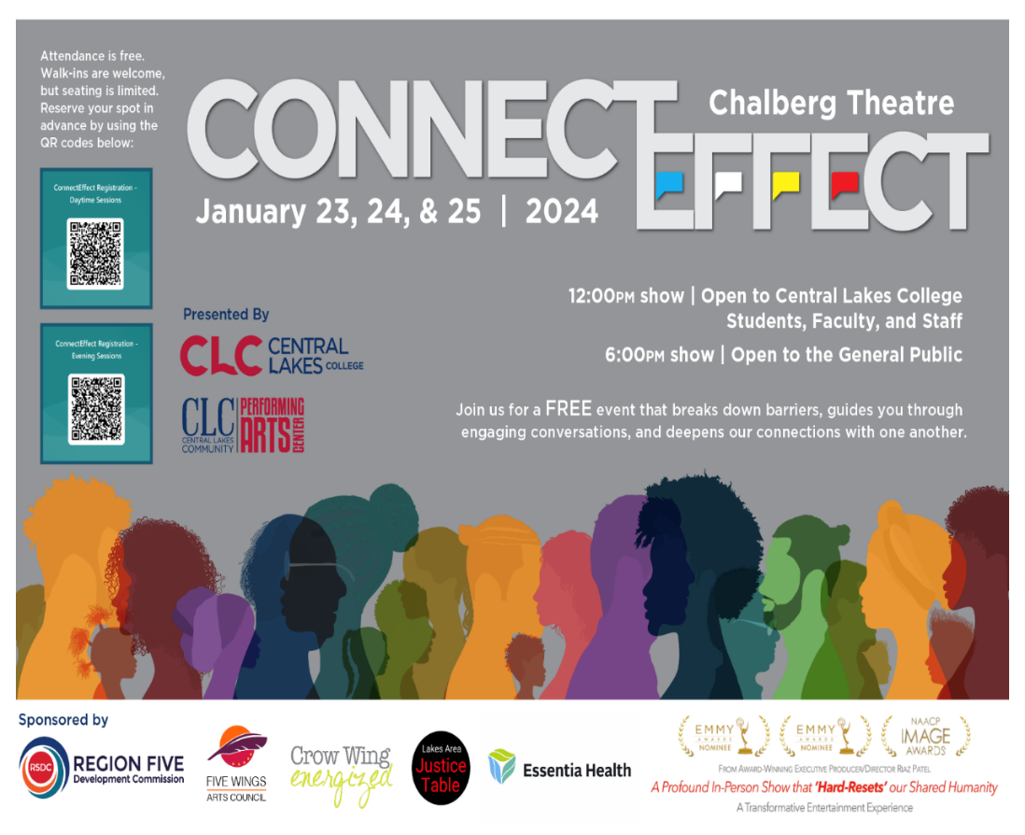

Annual Connection Letter
0
Our church will be sending out a letter and kindly request, for you to fill out and return. This information will help us update our membership list and make informed decisions about programs, and much more. Your response is important to help us better connect with one another and better serve our members and visitors. So, towards the end of January, keep your eyes on your mailbox! If you do not receive a letter and would like one, please contact Terri in the church office.

0
Movie Night – First Friday of each Month!
Come Early to Visit & Settle-in! Movie promptly starts at6:30 pm.
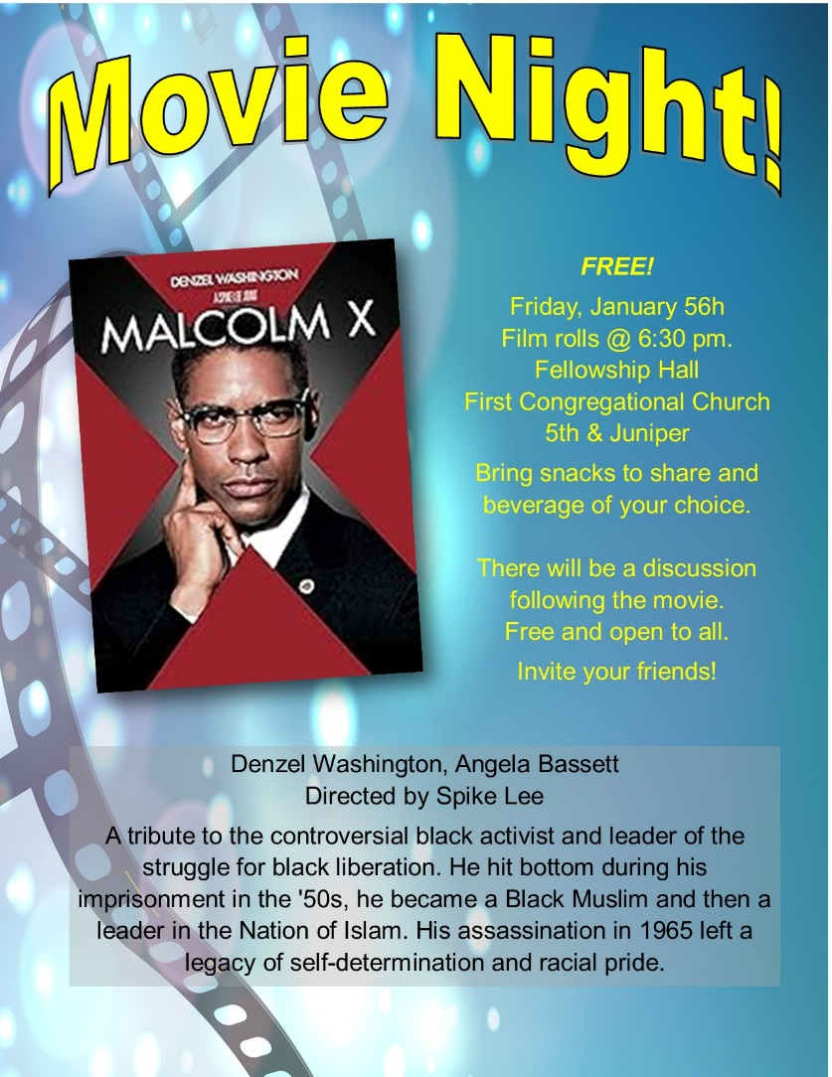

Host needed for February! Call Dan Hegstad to sign-up!
0
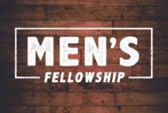
January UPDATE! UCC Men’s Fellowship
Every Wednesday – Noon @ Perkins

For the month of January, meet for a casual fellowship at Perkins.
Contact Jack Kraywinkle for more information 612-396-3480 or email: kraywinklej@gmail.com

18th Annual Twelfth Night Concert
0
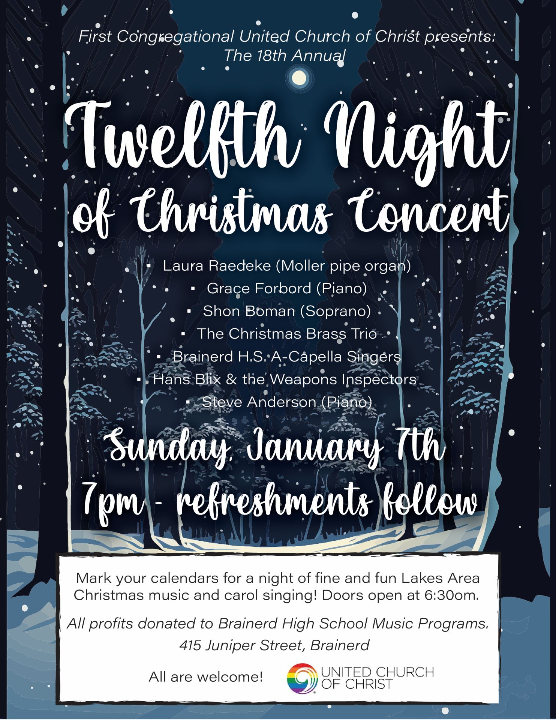

January Birthdays
0

Lilja Behr January 1 Marcia Ferris January 13
Linda Downs January 5 Karen Widmark January 13
Macyn Harder McBroom January 7 Betty Alderman January 16
Deb Lundberg January 8 Pam Patrick January 22
Barb Hoeft January 8 David Schaeffer January 26

Church Leadership
0
Get Involved, Give Back, Grow Connections – Volunteer at Church!
There are many other opportunities for you to share your talents!

--Treasurer, serves a 1-year term (may renew for 6 terms). The primary role is oversight of bookkeeping, church finances and Executive Committee discussions. This candidate should have a strong background or interest in finance or banking.

--Council Member-At-Large: Attend council meetings, act as a liaison for church members and council, help with nominations, spokesperson for historically underrepresented groups (HUGS).

Committees needing fresh faces and leadership:

*Christian Education *Stewardship *Music *Arts

Contact Mary Reardon - Moderator, with your nominations

0
If you would like a copy of the December 21st, 2023 Council Minutes,
please contact the church office

Next Regular Council Meeting: Thursday, January 18th, 2024, 3:30 pm
in-person and via Zoom tinyurl.com/uccbrainerdzoom

0

Volunteers for the Warming Shelter
Bridge on 7th
Our church is scheduled to volunteer, Sunday January 7th to Sunday, January 14th. Please call Deb Griffith for more information at 218-851-2949.

The sign up link is:
https://whocanbethere.com/SignUp/week-of-jan-7ucc/1VPQvJtZ1XE

Training video: https://ministrygrid.lifeway.com/#/easy-link/WPGQ/45c4e6e3-e5dd-4aee-ab62-1f71c6a061bf

UCC & TheShop Meal
0
SECOND Thursday of the month!
The next cooking date is January 11th at 3:45 pm.
For the last several years, UCC volunteers have provided a meal to the youth at TheShop - Brainerd Baxter Youth Drop-in Center. A number of youth from TheShop come over to our kitchen and help prepare a delicious meal that is then brought back to TheShop for the hungry and appreciative teens there.
Mary Benson is coordinating the meals, so if you are interested in joining and enjoy cooking with youth, please call or email Mary. 218-839-4990 or marybenson75@gmail.com

0
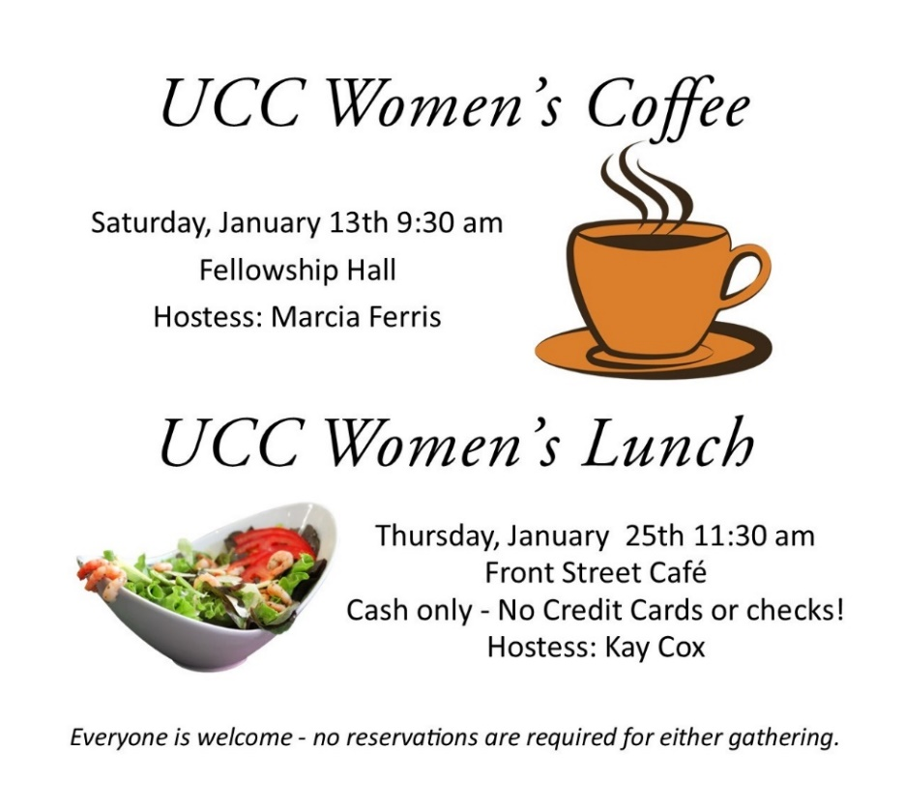

All updates will be posted on the Connections Facebook Group and RSVP’s may be made in the comments under the post at: www.facebook.com/groups/uccbrainerd

W.I.S.E. Welcoming, Inclusive, Supportive and Engaged
0

January Food for Thought: "We are all blessed, and we are all blighted. Every day each of us does our sums. The question is, what do we count?" - Louise Penny

2023 W.I.S.E. Resolution: First Congregational UCC Brainerd will devote time during the next 12 months learning about mental health issues to become a WISE (Welcoming, Inclusive, Supportive and Engaged around mental health) Congregation registered with the United Church of Christ Mental Health Network. After a year of study and raising awareness around mental health, a vote will be taken at our annual meeting in 2024 to reconfirm our WISE Covenant which will allow us to be designated as a WISE Congregation in the United Church of Christ.
0
January Adult Forums – 11:30 am after worship
January 14th – “Church Survey”: Mary Reardon will be reviewing the results of the churchwide survey. This will help us see where we are, (where) and what is important to our church family.
January 21st - “Intro to Al-Anon”: Did you know that 1 in 3 people live with or are acquainted with someone who has a drinking problem?
If you've ever wondered what Al-Anon is or worried about someone else's drinking, please join Kay Cox for a mock Al-Anon meeting (12-step support group for friends and families of alcohol abusers). You may be surprised at what you learn!

0
Friday Book Group
Our group is reading the book, “Gutsy Women”, by Chelsea and
Hilary Clinton.
We meet each Friday morning at 10:30 am via zoom.
Church Zoom link: https://tinyurl.com/uccbrainerdzoom

Christmas Cleanup
Saturday, January 13th at 11:00 am.

VOLUNTEERS NEEDED to take the tree down and the other Christmas greens and move everything to storage for next year. Please take an hour or so and join in the fun! THANKS FOR VOLUNTEERING!

Christmas Flowers Removed
Sunday, January 14th after worship.
Christmas flowers may be removed from the sanctuary.The donors of the plants get first choice!

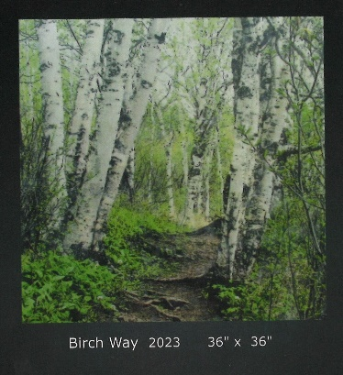
Art Exhibit in Fellowship Hall

Carla Benjamin has a new art exhibit in the Fellowship Hall.

10% of purchased artwork will be donated to First Congregational.
Thank you Carla for beautiful artwork!

Visit Carla’s website at: carlabenjamin.com

Special Offering – The Bridge on 7th Warming Shelter
Sunday January 28th
Bridges of Hope, in partnership with law enforcement, Crow Wing County, nonprofit organizations, church partners, and community members recognized the need for a safe place for homeless adults (ages 18+) to sleep in our community. This group has come together in a collaborative effort to address homelessness by providing a low-barrier warming shelter that offers a safe place for individuals to rest for the night.
Please send your donation to First Congregational UCC, 415 Juniper St. Brainerd, MN 56401. Or for your convenience use our Paypal account at: paypal.me/uccbrainerd
Make sure to note on your offering: “Special Offering Warming Shelter”. Thank you!

0
UCC Care Team

For anyone who wishes to join in on making calls or visits, the Care Team meets every month. Contact the church office for upcoming dates and times.
If you know of anyone who would enjoy a call from the care team, please contact one of our Care Team; Barb Hoeft, Jack and Kay Kraywinkle, Pat Scott, Chris Yager, Joey Halverson, Deb Griffith, and Pastor Leslie.

First Congregational Food Shelf Collection
0 Movie Night is starting up again this month!
Mark your Calendars!

Our church continues to collect non-perishable food items for the Salvation Army Food Shelf. There are two collection boxes: one in the parking lot entry hallway, the other in the Narthex. Brian Twamley picks up and delivers the food.
Please consider bringing items and donating. You may also send a money donation to the church; First Congregational UCC, 415 Juniper St. Brainerd, MN 56401. Or for your convenience use our Paypal account at: paypal.me/uccbrainerd Make sure to write in memo “Food Shelf”. Thank you!
0 Movie Night is starting up again this month!
Mark your Calendars!
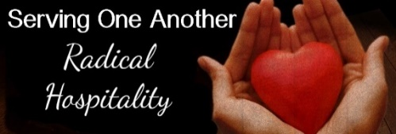
H.U.G.S.
Hosts, Ushers, Greeters, Scripture-readers
Sunday morning greeters/ushers and coffee hosts play an important part in making our church a warm and welcoming place for all. Here’s a secret; it’s FUN!! If each household committed to 3 Sundays a year as greeter/ushers and/or coffee hosts, we would have a full complement of participants. Are you ready to take the leap into RADICAL HOSPITALITY? Give it a go and signup below for your first Sunday as the face of the church! https://www.signupgenius.com/go/10C0E48A9A823A5FFC07-hugs/16034811

0 Movie Night is starting up again this month!
Mark your Calendars!
First Congregational member Joey Halvorson Citizen of the Year!
A well deserved honor! Many First Congregational UCC family were there to 'surprise' her! Watch the video here: https://www.youtube.com/watch?v=oIGq1nFjyy0

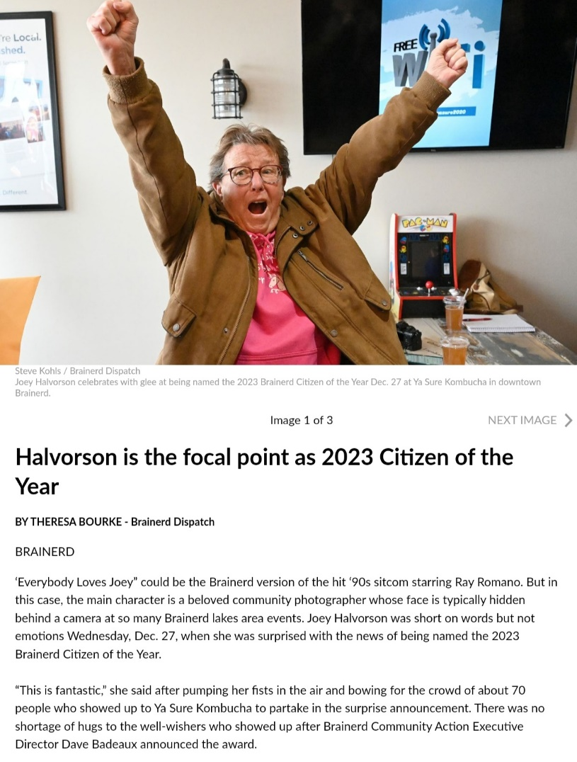

UCC Brainerd hosts Events, Group Meetings & Activities
0
0

Mantra - Breath - Meditate
Each Monday, beginning on January 15th, 2024
6:00 - 7:00 pm
Upstairs Forum Room (Youth Room)
UCC Brainerd 5th & Juniper St.
Come breathe, chant, and meditate to help relax the body and focus the mind. Being intentional during meditations can create peace of mind and healing for yourself and the world.

Guided by Robin Soderlund
For questions: robinlynnsoderlund@gmail.com
Goodwill offering for facility use.
(Not affiliated with any religious organization)

Brainerd Lakes Area Information
0
~ Opportunities to Know and Share God’s Love ~
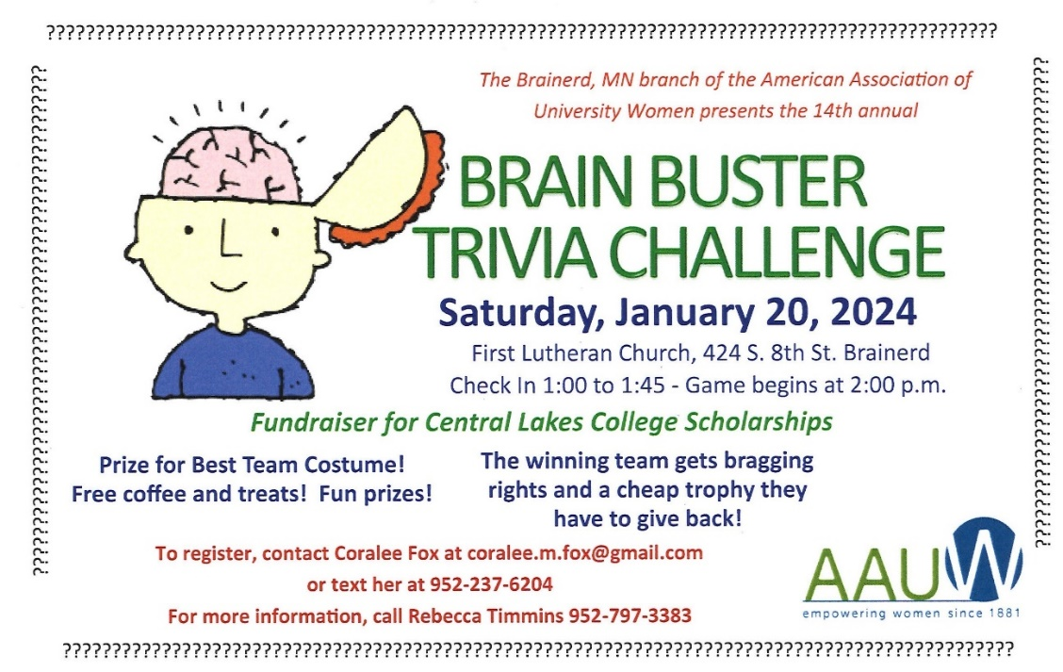
0

January 2024 Calendar
Sunday | Monday | Tuesday | Wednesday | Thursday | Friday | Saturday
Leslie Workday | Leslie Workday | Leslie Workday | Leslie Workday  New Pastor Drop-in Hrs.  11am-1pm  Office Hours  10am – 2pm | Leslie Workday  New Pastor Drop-in Hrs.  2pm – 4pm Office Hour  10am – 2pm | Office Hours  10am – 2pm
Pastor Leslie on Vacation Dec. 27th through January 12th | New Year’s Day 1 | 2  2pm EA-C  5:30pm OA -Y | 3  12pm Men’s Fellowship-Perkins -Y | 4  10am Care Team Mtg-Y | 5  10:30am Book Grp-Z  6:30pm Movie Night in Fellowship Hall-Y | 6
8:30am Bnrd Frnds-Y 7  10am Wrship & Communion-Y&FB w-Rev. Marc Blakesley  11am Fellowship-Y  7pm Twelfth Night Concert | 8  7pm BACP/BLUE via Zoom | 9  2pm EA-C  5:30pm OA -Y | 10  12pm CM Mtg.-Y  12pm Men’s Fellowship-Perkins -Y  7pm AA Common-Y | 11  8:30am Foundation Mtg-Z-?  3:45pmTheShop Cooking-Y  4pm Executive Team Mtg.-Y | 12  10:30am Book Grp- Z  Last day of Pastor Leslie’s vacation | 13  9:30am UCC  Women’s Fellowship in Fellowship Hall-Y  110am Christmas Cleanup-Y
8:30am Bnrd Frnds-Y 14  10am Wrship -Y&FB  11am Fellowship-Y  11:30am Adult Forum-Church Survey-Y  Remove Christmas Flowers  1pm Northwoods UU Mtg.-Z | 15  6pm Mantra-Breath-Meditate-Adult Forum Rm. | 16  2pm EA-Resumed-Y  5:30pm OA -Y | 17  12pm Men’s Fellowship-Perkins -Y  5:30pm Trustees Mtg.-Y  7pm AA Common-Y | 18  3:30pm Council Mtg-Y&Z  6:30pm Dist.7 AA-Y | 19  10:30am Book Grp- Z | 20
8:30am Bnrd Frnds-Y 21  10am Wrship -Y&FB  11am Fellowship-Y  11:30 Adult Forum-Intro to Alanon  1pm Girl Scouts Mtg.-Y | 22  6pm Mantra-Breath-Meditate-Adult Forum Rm. | 23  2pm EA-Y  5:30pm OA -Y | 24  12pm Men’s Fellowship-Perkins -Y  1:30pm PRC Mtg.-Y  7pm AA Common-Y | 25 11:30am UCC Women’s Lunch @ Front Street Café-Y | 26  10:30am Book Grp- Z | 27
8:30am Bnrd Frnds-Y  28  10am Wrship-Y&FB  11am Fellowship-Y  *Special Offering- Warming Shelter Bridge on 7th  *Newsletter Deadline  1pm Northwoods UU Mtg.-Z | 29  6pm Mantra-Breath-Meditate-Adult Forum Rm. | 30  2pm EA-Y  5:30pm OA -Y | 31  12pm Men’s Fellowship-Perkins -Y  7pm AA Common-Y |  |  | FB –Stream Online  Z- our Zoom  C- Cancelled  N-None  ? – No update  Y- Yes Mtg. in person

