
Friendship News, May 2026
0
First Congregational United Church of Christ, Brainerd
An Open and Affirming Congregation
The Church Office Hours: Tuesday, Wednesday, Thursday from 10:00am – 2:00pm
Office phone 218-829-2528 Office E-mail uccbrainerd@gmail.com
Pastor Leslie’s E-mail: pastorleslieucc@gmail.com Website: www.uccbrainerdmn.org

No matter who you are, or where you are on life’s journey, you are welcome here.
0
Pastor’s Pen
0

Are You WISE about Mental Health?
“…even though my illness was a trial to you, you did not treat me with contempt or scorn. Instead, you welcomed me as if I were an angel of God, as if I were Christ Jesus himself.” (Galatians 4:14)

What does someone with a mental health issue look like? Could you pick them out of a crowd? People who live with a mental illness look like me. They look like your dentist, or your neighbor, or your parent, or the person sitting next to you in the pew on a Sunday morning. Maybe they look like you. According to the National Institute of Mental Health approximately 1 in 5 adults live with a mental illness.
Since May is National Mental Health Awareness Month, this seemed like a good time to highlight our church’s inclusion as a W.I.S.E. Congregation. W.I.S.E. is a designation within the United Church of Christ that stands for being Welcoming, Inclusive, Supportive, and Engaged around the issues of mental health. The members of First Congregational UCC adopted a WISE covenant on July 17, 2020 which expresses our commitment to continuing to learn about mental health, support and advocate for people living with a mental illness or mental health challenges. (View the covenant here: tinyurl.com/wisebrainerd)
Being a WISE congregation doesn’t mean we are expected to diagnose or “fix” people with a mental illness any more than we would be expected to treat or fix someone with a broken bone. Our goal is to be as welcoming as possible of those living with mental health challenges, to be supportive of all who are affected by mental illnesses, and to live into our commitment to be WISE about mental health.
Finally, if you are experiencing difficulty with your mental health, please don’t hesitate to reach out for help. If you are in crisis, call the local Mobile Crisis Line at 218-828-4357 or call the national crisis line at 9-8-8. Mobile Crisis is also available to simply talk or to make referrals. Northern Pines has a Mental Health Urgent Care with drop-in hours from 10am-7pm located at 823 Maple Street in Brainerd. For less urgent needs, you can also reach out to your physician or make an appointment with a mental health provider. And of course, I am here to be a supportive, listening ear as well as to help connect you to resources in the community. Don’t let fear or stigma get in the way of your mental wellness. God desires for each of us to experience wholeness and abundant life.
With Peace,
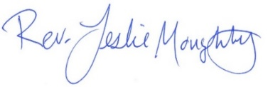

Mission Statement of First Congregational UCC
“To know and share God’s love within us.”

Purpose Statement of First Congregational United Church of Christ
“First Congregational UCC is a welcoming, inclusive, and progressive community committed to promoting social justice, spiritual growth, and love for all people. We reject discrimination and advocate for equality and dignity for marginalized communities. Through worship, education, and service, we work to make a positive impact on the world and invite all individuals to join us in this journey of faith and service.”

0
Church Office Hours
Tuesday, Wednesday, Thursday 10:00 am - 2:00 pm
Closed Mondays and Fridays

Please call for assistance - office 218-829-2528
Admin Asst. Terri vacation day; Tuesday, May 5th

0
Pastor Leslie’s Workday Schedule

Sunday through Thursday (Days off are Friday and Saturday)
Drop-in Hours: Wednesdays 11:00 am – 1:00 pm
*Drop-in hours are times set aside for “drop-in” conversations, much like a professor’s office hours.
Everyone is encouraged to make an appointment, especially if the above times are not convenient. You can go to www.calendly.com/pastorleslieucc and select a day and time that works for you, or you can email Pastor Leslie at pastorleslieucc@gmail.com or call/text at 218-656-0096.

0
Stay Connected

How to watch Sunday worship: The worship service is broadcasted on the church Facebook page every Sunday at 10:00 am.
To watch worship on Facebook, go to https://www.facebook.com/uccbrainerd/live
How to stay connected with First Congregational friends and members: Join the private group for our Facebook Connections Page at https://www.facebook.com/groups/uccbrainerd.
Financial Help Available The Pastor's Discretionary Fund is available to assist church members and others in the Brainerd area who are experiencing financial distress with modest financial help. If you need assistance, please email, call, or text Pastor Leslie. Let her know what your situation is and how the church might be of help.
Donate to the church online! We are accepting your offerings and donations using PayPal.
You do not need to have a PayPal account to make an online donation with a credit card. To use PayPal, go to: https://www.paypal.me/uccbrainerd

First Congregational UCC News & Updates
0
0
Audio Video Update
Do you remember when you rented VHS tapes at Video Update? Well, this isn’t that. If you’ve been in the sanctuary in the past few weeks, you’ve noticed the construction. We are upgrading our live video feed and building a “media control center” for both video and audio.
What’s going on? We started doing live video feeds during COVID. After COVID we continued with a video streaming system from a company called MEVO. The wireless cameras are controlled by a phone or tablet. It works, but not well. We tried upgrading the wireless infrastructure in the sanctuary. It’s better but not nearly good enough.
Why? We learned during COVID that people like the option. People who are ill, shut-ins, or folks who can’t drive. Marcia and I have watched when we’re traveling. We see former members who live elsewhere watching, and I think some still support us financially.
Also, when someone is considering attending or joining a church, they first watch the video. If we’re serious about attracting new members, a quality video presentation is a must.
Our MEVO system only works with Facebook. Our new system will stream live and be archived on YouTube as high quality video and you won’t need a Facebook account to watch.
Our MEVO system communicates via Wi-Fi. It should be reliable, but it is not. Our new system will be fully wired. Everything will communicate via physical wires.
Each Sunday, we have 10 or so folks watching live. By Wednesday or Thursday, Facebook frequently shows 150 views. Now, we have no illusion that 150 real people watched the full video, but I think it is realistic to believe that we are likely to have as many online views as the number of folks who were in church on Sunday. This is significant. We will have the ability to show a QR code on the video so folks can donate if they wish. Our church is not just the folks who come on Sunday. Some are members who have moved. They watch and contribute.
Lastly, offering live and recorded video will be important as we market our beautiful church as a wedding venue.
Big Bucks. We contacted two companies that sell and install video and audio for churches and others. Bids were $50,000 and $70,000. Clearly, that’s not the answer.
However, we learned a lot about how to do this. We found Mike Schmidt who has retired to Walker and has installed systems in several churches. Mike guided us through selecting the proper hardware and is doing the electronic installation.
We can do this! Our “task force” consists of Jeff Behr, Joe Stattine, Izzy and Sarah Jo Armstrong, Pam Wible and me. We asked Dale Menk, a member and professional carpenter, how much he would charge to do the framing. He said he loves our church and volunteered his time. However, Dale doesn’t do sheetrock, but Denise Slipy volunteered her time and supplies. Izzy and Sarah Jo are volunteering to do the trim.
But we have a deficit budget. None of the funds for this project, about $30,000, are from our general fund. This is not contributing to our current deficit. A generous donation from Don Bennett got us started. If you like this project and would like to contribute, please contact Terri in the Church Office; uccbrainerd@gmail.com or 218-829-2528. Also, we received a grant of $5000 from our Foundation and $4000 from the Memorial Fund.
But wait, there’s more! Beyond video, we are adding a second TV monitor to the right side of the sanctuary. We will send content to the two monitors from our new Media Control Center. We may show lyrics, graphics supporting a sermon, videos and more. You can’t clap while holding a hymnal!
We are adding audio and video to Fellowship Hall. A new TV/Monitor will soon be installed on the east wall. A PA system and media control that anyone can operate will be installed.
When we have an overflow crowd from the sanctuary for a large funeral or wedding, for example, we will be able to feed the video and audio to Fellowship Hall.
Did that answer all the questions? If not, call, text or email me. 218-851-5900 or dan@danhegstad.com
0
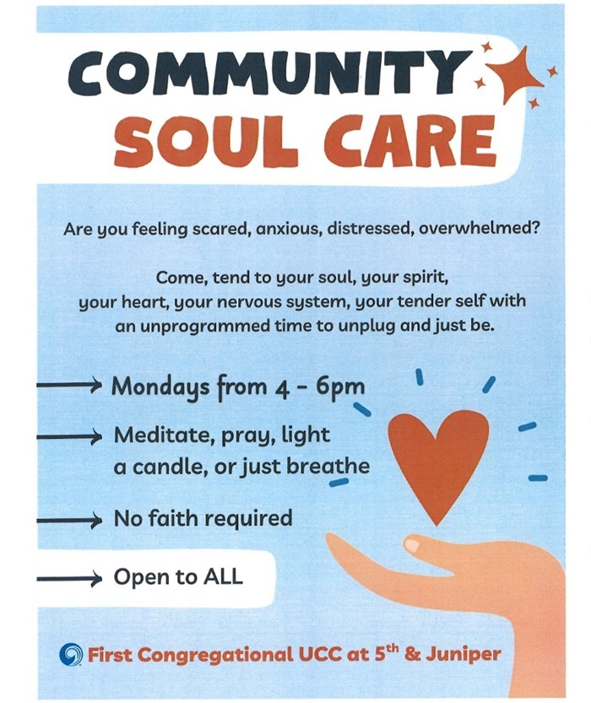
0

Community Soul Care will continue through May 18th.
Sign-up to host in the Narthex or call the office.
0
T.A.C.O. Tuesdays for Youth

Tuesday, May 5th 3:00 - 6:00 pm in Fellowship Hall/Rainbow Room.

TACO stands for Teaching, Activities, Community, and Outreach.

Emily LeClaire leads this after-school program to engage youth from our church and the wider community. Scheduled for the First Tuesday of each Month (will pause in the summer.)

Connect with Emily for more information including adult volunteer opportunities
0
UCC Fellowship Men’s Lunch

Each Wednesday
11:45 am @ Wings Airport Café
Not Organized—No Agenda Join Us!

0

Join Our Church Choir

Come sing with us during Worship at 10:00 am

2026 Schedule: May 3 & 17
Fall & Winter dates to be determined
Rehearsal 8:30 am in the Sanctuary


0
May Adult Forums - 11:30 after Worship Service

May 3rd - “Mothers Story Circle”: Join us as we tell stories about the influence of our mothers in our lives, and/or the influence of being a mother yourself.
May 24th - Justice Sunday - Justice Action Teams:
We will meet during Adult Forum time. Each team will provide an update on their work with time for Q&A and a discussion time. This is your opportunity to hear what the teams are planning and add your perspective
0


”Grounds & Indoor Church Cleaning Day”
Monday May 11th
9:00 am – 2:00 pm
Pizza Lunch provided
Hosted by Trustee & Creation Care Environmental Team
We invite you to participate in our annual “spring church cleaning” event. Volunteers are welcome to join us for an hour or longer. Outdoor tasks will include raking flower beds, applying mulch, maintaining rain gardens, collecting ground debris, and blowing off and possibly stripping the parking lot. If you have lawn rakes, and spade shovels, please bring them.
Indoor activities will focus on cleaning stairwells, dusting stair railings, polishing sanctuary wood windowsills, pews, the altar area, and the indoor Columbarium area. If you have cleaning rags, please bring them.
0
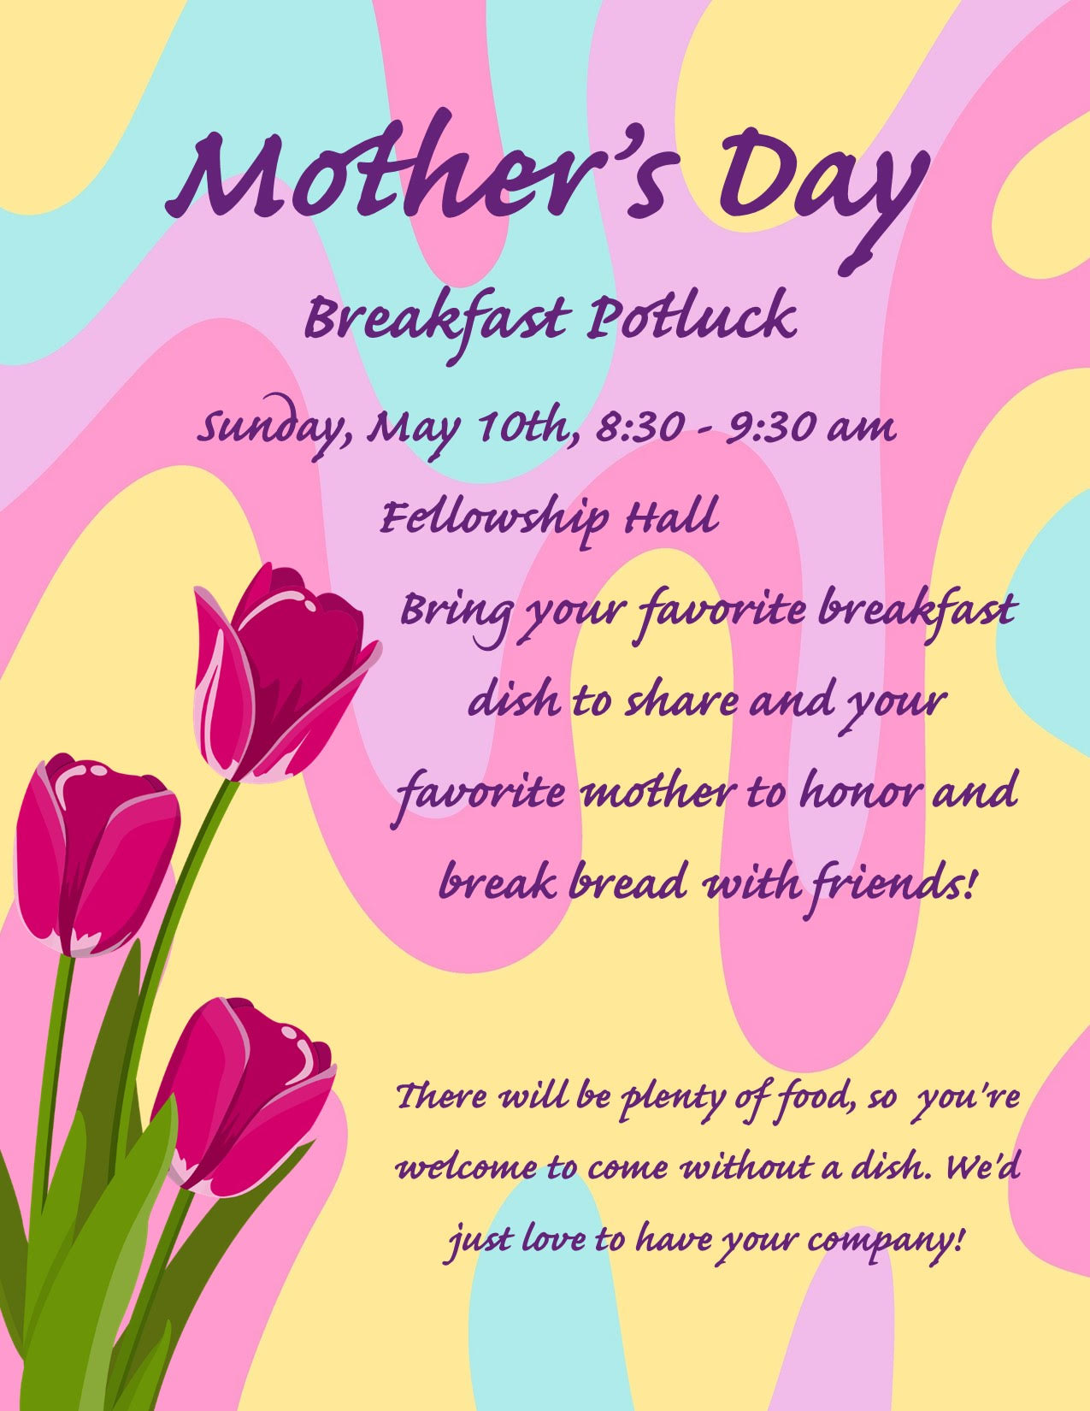
0

0

First Congregational UCC Annual Meeting

May 17th After Sunday Worship
in-person & Zoom

Zoom Link: tinyurl.com/uccbrainerdzoom

If the Zoom meeting window does not automatically launch, click "Launch Meeting"
By phone: dial 1 312 626 6799, Meeting ID: 645 235 0419, password: 56401

All voting members are encouraged to attend as we elect new committee members and review the last 12 months. Reports will be emailed to voting members the second week of May. Please contact the church office if you need a printed copy mailed to you.

UCC Fellowship - Women’s Lunch
0

Thursday, May 28th @ 11:30 am
@ Airport Wings Café
0


May Birthdays
Ellen Pishko May 3 Carla Benjamin May 17
Terri Chidester May 5 Janice Morton May 22
Sue Hadland May 9 Nancy Waller May 25
Lynn Fox May 11 Tony Newgord May 29
Laura Raedeke May 16 Charlotte Goedsche May 30

0


4th Sunday Special Offering: May 24th
UCC Missions – Strengthen the Church
The Strengthen the Church (STC) Offering reflects the shared commitment of people across the United Church of Christ to cooperatively build up the UCC. The funds raised support leadership development, new churches, youth ministry, and innovation in existing congregations.
As God calls our congregations to be the church in new ways, your generosity will plant new churches, awaken new ideas in existing churches and develop the spiritual life in our youth and young adults.
Please send your donation to First Congregational UCC, 415 Juniper St. Brainerd, MN 56401. Or for your convenience use our Paypal account at: paypal.me/uccbrainerd Make note on your offering “STC Special Offering.” Thank you!

0
Next Council Meeting
Thursday, May 21st, 2026, 3:30 pm
in-person and via Zoom tinyurl.com/uccbrainerdzoom
First Congregational Approved Council Meeting Minutes are available upon request.
Please contact Terri Admin Asst. at the Church Office.

0

UCC Care Team
For anyone who wishes to join in making calls or visits, the Care Team meets every month on the first Thursday @ 10:00 am.

If you know of anyone who would enjoy a call from the care team, please contact one of our Care Team; Jack and Kay Kraywinkle, Pat Scott, Chris Yager, Deb Griffith, Nancy Gould, Tracy Lyons, Cynthia Janes,
Joey Halvorson (text or email) and Pastor Leslie.
0

Volunteer at Church!
0
There are many other opportunities for you to share your talents
These committees need your gifts:
*Treasurer *Clerk * Trustees * Stewardship * Christian Ed

0

Friday Book Group

We meet each Friday morning at 10:30 am via zoom.
Church Zoom link: https://tinyurl.com/uccbrainerdzoom

We are reading "By Any Other Name” by Jodi Picoult. Two women, centuries apart—one of whom is the real author of Shakespeare’s plays—who are both forced to hide behind another name and navigate the barriers for women artists being acknowledged for their work.

0

Cooking For Everyone – Including YOU!
Email Lowell Johnson or Kay Cox to be added to the contact list. You will be notified of upcoming events.

0


First Congregational Food Shelf Collection
Our church continues to collect non-perishable food items for the Salvation Army Food Shelf. Please consider bringing items and donating.
There are two collection boxes: one in the parking lot entry hallway, the other in the Narthex. Brian Twamley or Stephanie Lee pick up and deliver the food. Thank you!

0

H.U.G.S.
Hosts, Ushers, Greeters, Scripture-readers
Sunday morning greeters/ushers and coffee hosts play an important part in making our church a warm and welcoming place for all. Signup with the link below for your first Sunday as the face of the church!
signupgenius.com/go/10C0E48A9A823A5FFC07-hugs/16034811


0
UCC Volunteer Opportunity – Overnight Shelter Bridge on 7th
Sign up for a morning shift as a team of two or/individually. You can choose a time to volunteer online. The staff and shelter guests appreciate our involvement. The link is below. Create an account. Pick a date. They need your birth date and your ok for a background check.
Start here at this link to sign up for volunteering;
https://www.bridgesofhopemn.org/volunteer Then go to this link to choose a date to volunteer at the shelter. They need your birth date and your ok for a background check. https://volunteer.bloomerang.co:443/JE/bas6nebexg029t
0

Garden Gleaning
0
A Biblical (and environmentally) inspired activity
This is how it works: Gardeners and plant people bring in their “gleanings” to share. This ranges from rhubarb and vegetable plants in the spring to daffodil bulbs in the fall. A table, poster and donation basket are in Narthex entrance. Enjoy the fruits of our labors!
All are welcome to help themselves – no charge! All monetary donations are given to the Food Shelf.
Historical note: Begun here circa 1988 when our church began Hunger Action outreach, Central America updates and global food connections. Note: Using our resources, recycling, re-purposing, and not wasting our food are all acts of Creation Care and Justice. Garden Gleaning is an Easy-Peasy way to put words into action.
0
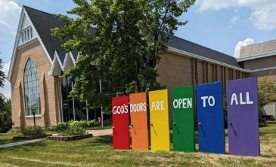
Our Building Is a Great Event Venue!
We are blessed to be able to share our beautiful church facilities for purposes that match the values of the church and its mission which is “To know and share God’s love within us.” We are an open church valuing the diversity of age, culture, gender identity, opinions, physical and mental abilities, and sexual orientation.
To request a space for general use, ask for a “Request for Church Building Use” form and policy packet from Terri in the church office, at 218-829-2528 or email uccbrainerd@gmail.com. Submit the request form back to Terri in the office, and it will be submitted for approval at the next Council Meeting. For wedding or funeral use, contact Pastor Leslie: pastorleslieucc@gmail.com

0
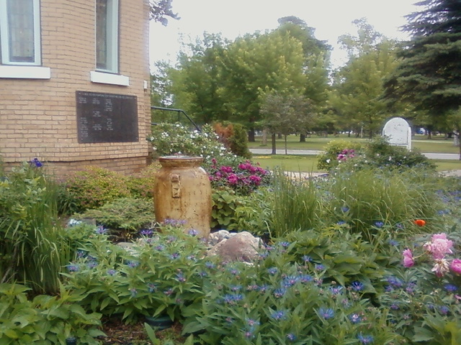
The Columbarium & Memorial Garden
First Congregational UCC, Brainerd
The Columbarium is in the historic space that once was our church’s front entry way.

How appropriate it is that our Columbarium now marks another entry way into a new life — where the Spirits of Love and Truth are always present!

The Memorial Garden is located on the south lawn of the church. The Garden provides a place for cremains of your loved one to be buried in the ground among natural plantings.

The Garden fee includes the inscription of your loved one’s name on a granite plaque that is mounted on the outside wall of the church. Should you wish to learn more about the purchase of a niche for your own cremains or for the ashes of a loved one, please call the church office at (218) 829-2528 and a packet of materials will be sent to you via email or regular mail.

0
0
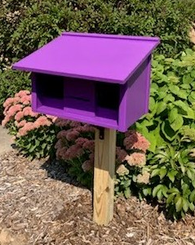
Community Prayer Box

You can find the Community Prayer Box in the Memorial Garden on the South side of the church (the side that faces Juniper Street.)

Community members frequently walk through the garden and this box will offer our wider community an opportunity to share their prayers. Prayer cards and pens are provided, and the box is secured with a padlock, so the submitted prayers don’t fly away with the wind!

Pastor Leslie checks the box weekly and pray for any prayers submitted as well as bring them to the Care Team for prayer as well.

Brainerd Lakes & Surrounding Area Information
0
~ Opportunities to Know and Share God’s Love ~
0


Open House at TheShop
May 2nd 5:00 - 7:00 pm

TheShop is non-profit organization committed to providing community support to all teens and young adults as they transition into independence and adulthood. It is a space where youthful energy is harnessed into creative energy with opportunities to explore potential, build lasting relationships, and establish personal connections. If you have ever been curious about The Shop, this is your opportunity to learn about its mission and to meet some fabulous young people. The BBYC is located at 723 Washington St in Brainerd.

0

Crow Wing County Military Family
Support Group

Beginning Wednesday, May 6

1st & 3rd Wednesday of each month 7:00-8:00 pm

Meets at First Congregational UCC
415 Juniper St. Brainerd MN 56401

Join us to support military families if you: Have someone joining the military, have an active military member or have someone that has previously been in the military.

More info:
drttbsby@msn.com

0
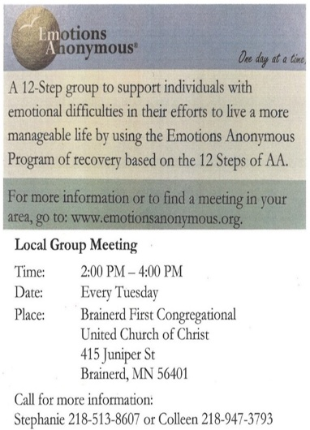



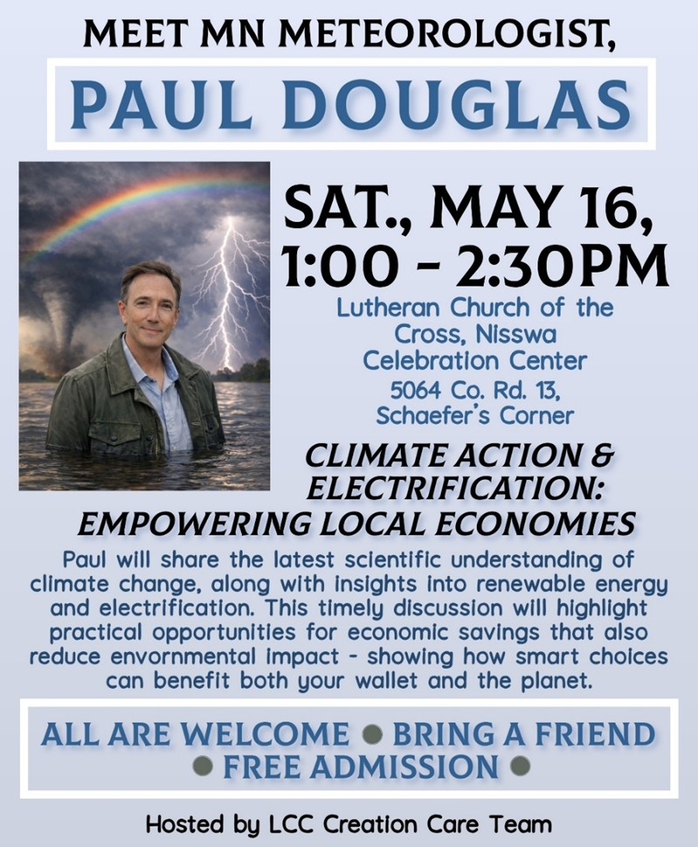

May 2026 Calendar
Sunday | Monday | Tuesday | Wednesday | Thursday | Friday | Saturday
Y- Yes Meeting in person  FB -Facebook Live Stream Online  C- Cancelled  P-Postponed  N-No Meeting  Z-our church Zoom | Office Closed | Office Hours  10am – 2pm | Office Hours  10am – 2pm  Pastor Drop-in Hours  11:00 am – 1:00 pm | Office Hours  10am – 2pm | Office Closed  1  10:30am Bk Grp-Z | 2
8:30am Bnrd Frnds-Y 3  8:30am Choir Practice-Y  10am Sunday Worship, Communion & Choir-Y&FB  11am Fellowship-Y  11:30am Adult Forum-  Mothers Story Circle  2-4pm AAUW Mtg. in  Fellowship Hall | 4  4-6pm Community Soul Care-Y  5-7pm BLA Indivisible in Fellowship-Y | 5  Admin Asst  Terri Day Off  2pm EA-Y  3-6pm TACO  Tuesday-Y  5:30pm OA -Y | 11:45pm Men’s Grp 6  @ Wings Cafe-Y  PRC Mtg.-Y  4:30pm Christian Mnstry-Y  7pm Military Family  Support Grp.-Y  7pm AA Common-Y | 7  10am Care  Team-Y | 8  10:30am Bk Grp-Z  Movie Night-C  Resume in Fall | 9
8:30am Bnrd Frnds-Y 10  8:30am Mother’s Day Breakfast  Potluck-Y  10am Sunday Worship -Y&FB  11am Fellowship-Y | 9am- 11  4pm Church & Grounds Cleanup -Y  6pm Community Soul Care-Y | 12  2pm EA-Y  5:30pm OA -Y | 10amTrustees-Y 13 11:45am Men’s Grp  @ Wings Cafe-Y  3:30pm Executive Mtg.-Y  7pm AA Common-Y | 14 | 15  10:30am Bk Grp- Z | 16
8:30am Bnrd Frnds-Y 17  8:30am Choir Practice-Y  10am Worship  & Choir-Y&FB  11:15am Annual Mtg-Y&Z  Fellowship after Mtg.-Y | 18  4-6pm Community Soul Care-Y | 19  2pm EA-Y  5:30pm OA -Y | 20  11:45pm Men’s Grp.  @ Wings Cafe-Y  12pm Memorial Mtg.-Y  7pm AA Common-Y | 21  3:30pm Council -YZ  6:30pm Dist.7 AA-Y | 22  10:30am Bk Grp- Z | 23
8:30am Bnrd Frnds-Y 24  Justice Sunday:  10am Worship-Y&FB  11:15am Fellowship-Y  11:30am Justice Table Teams-Y  *Special Offering STC  *Newsletter Deadline | 25  Memorial Day | 26  2pm EA-Y  5:30pm OA -Y | 11:45pm Men’s Grp 27  @ Wings Café-Y  TheShop Cooking-C until further notice  7pm AA Common-Y | 28  11:30am Women’s Lunch @ Wings Café-Airport | 29  10:30am Bk Grp- Z | 30
8:30am Bnrd Frnds-Y 31
10am Worship-Y&FB
11am Fellowship-Y

