Friendship News, April 2024
0
First Congregational United Church of Christ, Brainerd
An Open and Affirming Congregation
The Church Office Hours: Wednesdays – Fridays from 10:00am – 2:00pm
Office phone 218-829-2528 Office E-mail uccbrainerd@gmail.com
Pastor T.Michael’s E-mail: tmichaelrock@gmail.com Website: www.uccbrainerdmn.org

No matter who you are, or where you are on life’s journey, you are welcome here.
0
Pastor’s Pen
0
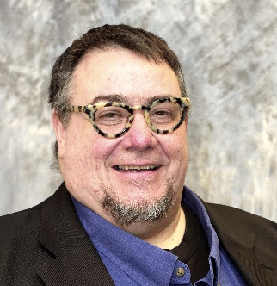
T. Michael Rock – Renewal Leave Pastor

One of the greatest gifts I have ever received was the encouragement to use my imagination. What is often labeled as a childish or reserved only for artists and dreamers, I believe imagination is one of the essential tools of spiritual life. In this Easter season, we are all about entering the story of dying and resurrecting. This is not a story about the afterlife. It is a story about what is happening right now. It is right in front of us. What are we dying to? What are we rising to? These are visions that are hard to comprehend with heads. No book learning or reasoning will help us enter the liminal space that is Easter. The experience is meant to be felt and imagined.
As a congregation during this time of renewal for Pastor Leslie and for us, we continue to move and change and adapt to the world we live in. Our calls to love and justice are different today than they were years ago. Most of our rituals and language is subject to change as we learn and grow and mature in our faith. Using our collective imaginations has helped you build a more inclusive, more welcoming congregation. Imagination is used by prophets in every faith tradition. Prophets do the work of lamenting the injustice and separateness that exist in our lives and they imagine a new future. We love the prophet Isaiah who envisions a world where we are each called by our name and known by God. We follow the prophet Amos who envisions a world where justice flows like water in an ever-flowing stream. We celebrate modern day prophets like Dr. King who imagined a world where every child was judged, not by the color of their skin, but by the content of their character. Many of us wept when the American Youth Poet Laureate, Amanda Gorman prophesied on the last inauguration day, “And every known nook of our nation and every corner called our country, our people diverse and beautiful will emerge, battered and beautiful.” We could actually see it happen as we imagined with her.
My hope and prayer for this congregation is to keep imagining during this time of renewal. Imagine what renewal looks like for you. Imagine what freedom and liberation look like for marginalized members of the wider Brainerd community. Imagine yourself with the time and energy to do the inner work of racial justice and equity in this congregation and the places we live. Imagine the love waiting to be shared. Imagine the rich and wonderful ways we will celebrate together and how it will heal our losses and comfort us in our pain and confusion. We need imagination to get us through.
With imagination and love,
T. Michael

Rev. T. Michael Rock has been an ordained minister, liberation theologian, and educator in the United Church of Christ and is currently a Professor for Spiritual Formation and Contextual Education at United Theological Seminary of the Twin Cities. T. Michael also guides the Contextual Education and Spiritual Direction programs for United. He has served as a Spiritual Director and teacher of Spiritual Direction for over 20 years and has 30 years of congregational leadership serving UCC congregations in Minnesota, Rhode Island and Massachusetts. Throughout his career T. Michael has volunteered as a trauma-informed chaplain for prisons, police, at George Floyd Square, the World Trade Center, Occupy Wall Street, and other places of tragedy, violence, and transformation. T. Michael is also an activist on the local and national level and an experienced trainer in nonviolence, civil disobedience, and sexuality education.

First Congregational UCC News & Updates
0
0
“First Congregational UCC is a welcoming, inclusive, and progressive community committed to promoting social justice, spiritual growth, and love for all people. We reject discrimination and advocate for equality and dignity for marginalized communities. Through worship, education, and service, we work to make a positive impact on the world and invite all individuals to join us in this journey of faith and service.”

0
Pastor T.Michael’s Workday Schedule

>> Friday, Saturday & Sunday <<
Fridays 10:00am to 4:00pm
Saturdays by appointment as needed
March 15 through April 20
May 3 through May 18
May 31 through June 1

Leading Worship Services:
March 17, 24 & 31
April 7, 14 & 21
May 5, 12, 19 & June 2

you can email Pastor T.Michael at tmichaelrock@gmail.com or call/text at 612-275-0387.

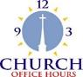
Church Office Hours
0
Wednesday, Thursday, Friday
10:00 am - 2:00 pm
Please call Terri at the office 218-829-2528 or
218-537-1636 (cell) for further assistance.

How to watch Sunday worship: The worship service is broadcasted on the church Facebook page and the church's YouTube channel every Sunday at 10:00 am.
To watch worship on Facebook, go to https://www.facebook.com/uccbrainerd/live
**Live stream videos are saved and can be viewed at any time. All memorials, weddings and 12th Night Concert are on our church Facebook page.

How to stay connected with First Congregational friends and members: Join the private group for our Facebook Connections Page at https://www.facebook.com/groups/uccbrainerd
Follow Pastor Leslie on her blog during Renewal: renewal24.weebly.com.

Financial Help Available Your Church Council voted last year to allow the Pastor's Discretionary Fund to be used to assist church members and others in the Brainerd area who are experiencing financial distress during this time. We received many generous donations! If you need assistance, please email, call, or text Pastor Leslie. Let her know what your situation is and how the church might be of help.
Donate to the church online! We are now accepting your offerings and donations using PayPal. You do not need to have a PayPal account to make an online donation with a credit card. To use PayPal, go to: https://www.paypal.me/uccbrainerd
0
W.I.S.E
0

Short, and Very Important Survey
Coming MONDAY April 1st to Your Inbox!

Members and Friends of First Congregational will be receiving a survey on Monday, April 1. This is no April Fool’s joke!
The purpose of the survey is to find out people's experiences, perceptions, and desires to learn more about mental health issues.

Our WISE team will use the survey data to design programming as we continue our journey to officially becoming a WISE congregation.

The online survey has only 9 questions, and they provide space for your candid thoughts. So please take just a few minutes to sit down with a cup of coffee or beverage of choice and share your experiences, perceptions, and ideas. Your input will help guide and shape our WISE planning, so that we can develop programs that are a great fit for this congregation.

Coming to your inbox on Monday!
from The WISE Team

April Birthdays
0

Pam Wible April 7 Bonnie Crum April 14
Alice Widmark April 9 Dan Hegstad April 14
Kay Cox April 9 Colleen Carder April 24
Izzy Armstrong April 11 JoAnne Nelson April 24
Hans Stadem April 13 Austin Newgord April 24
Joey Halverson April 15

Annual Connection Letter
0

The connection letter was sent out last month to new members, visitors, and friends of our church. If you have not done so already please fill out the form completely and return by April 15th to the office in the envelope provided. This information will help us update our membership list and make informed decisions about programs, and much more. Your response is important to help us better connect with one another and better serve our members and visitors. If you have inadvertently been missed and did not receive a letter and would like one, please contact Terri in the church office. Thank you for your prompt response!

0

Half Day Retreat on Discovering Spiritual Gifts
w/ Rev. T. Michael Rock
Saturday, April 6
Breakfast at 8:30am
Retreat from 9:00 am to Noon

Fredrick Buechner – “Where your great gifts meet the world’s great needs, there is the place where the Spirit dwells.”
Come for breakfast and stay for stories and discovery of spiritual gifts. We will learn about the varieties of gifts and the ways we are called to serve. Communities of faith are strong and effective when spiritual gifts are known, practiced and nurtured. All are welcome.
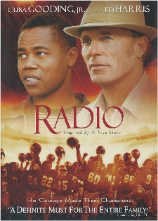
Movie Night
0
Changed to Saturday, April 6th at 6:30 pm
The movie is “Radio” and hosted by Joe Stattine and Carla Benjamin.
Come early and settle in. The movie starts promptly at 6:30.
Bring snacks to share and beverage of your choice. There will be a discussion following the movie. Free and open to all. Invite your friends.

HOLY HUMOR / HOLY FOOL SUNDAY
0
Sunday, April 7

The tradition on the Sunday after Easter is to lean into the humorous, the silly, the absurd. Today, I will introduce you to a part of me that few have seen. During the sermon, I will transform into “Rocky the Clown”. Rocky is a “fool for Christ” and will lead us in a mimed celebration of Holy Communion with the help of some friends. They will be gentle and sweet clown who knows the trauma of being outcast. They will also invite T. Michael to return following the service to lead the Adult Forum on Spiritual Gifts. All are invited to dress / act / dance as foolish as you feel called to do.

April Adult Forums
0

April 7th 1:00 pm - “Discovering Spiritual Gifts with Rev. T. Michael Rock”: We will learn about the varieties of gifts and the ways we are called to serve. Communities of faith are strong and effective when spiritual gifts are known, practiced and nurtured. All are welcome.
April 21st 11:30 am after worship – Understanding & Preserving Our Freshwater Resources: Dive into the fundamentals of watersheds and their role in maintaining water quality. We will explore the impacts of our actions on freshwater resources.Presentation by Elizabeth Uebelacher Northern Waters Trust
April 28th 12:00-1:15 pm after Volunteer Recognition Brunch – Justice Table Committees: We are also a congregation deeply involved in the community, with members serving the community in powerful and creative ways. Thirty congregational members are involved with one or more of the five justice priorities identified by the congregation: Mental Health, Creation Justice, Poverty, DEI/LGBTQ, and Community Building. Everyone is welcome. If you are interested in these areas, please plan to join a table.

0
UCC & TheShop Meal
SECOND Thursday of the month
April 11th at 3:45 pm.
First Congregational is working with the young people from TheShop (Brainerd/Baxter's Youth Empowerment Center) and are preparing a meal and serving it at TheShop for the participants in the program.

Mary Benson is the point person. If you are interested in helping, please email Mary at marybenson75@gmail.com

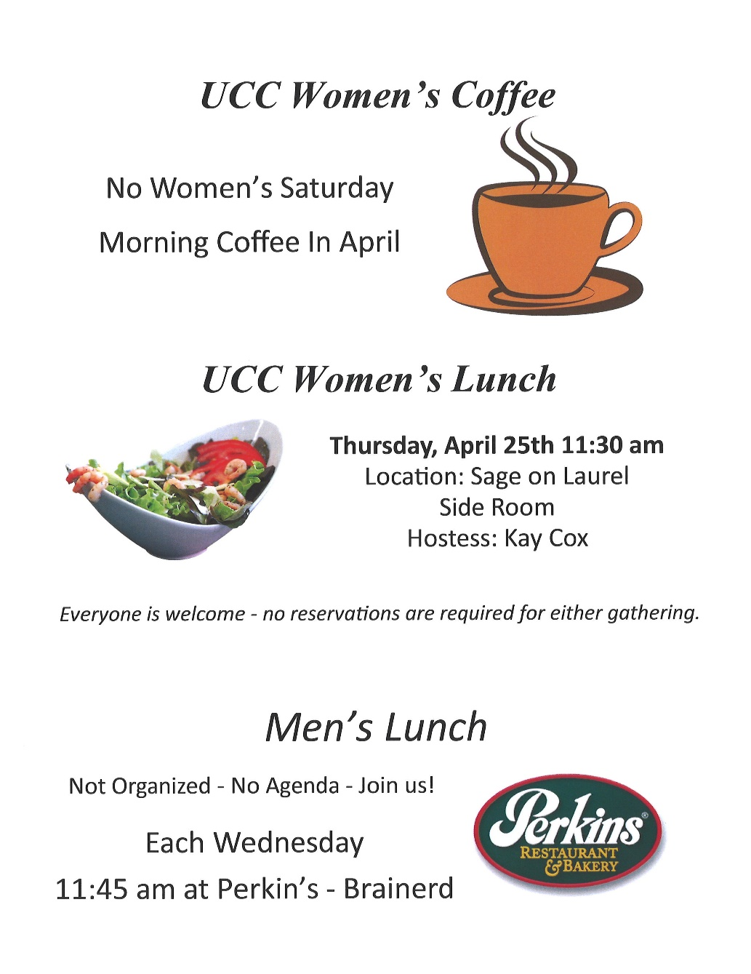
0

0
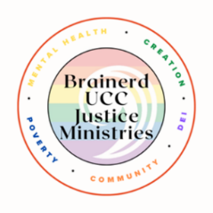
Justice Sunday
Sunday Worship Service - April 28th
Dr. Rev. Steve Newcom & Kay Cox lead worship
Justice Tables - Following our Volunteer Appreciation Brunch, we will gather from 12:00-1:15 pm. We are also a congregation deeply involved in the community, with members serving the community in powerful and creative ways. Thirty congregational members are involved with one or more of the five justice priorities identified by the congregation: Mental Health, Creation Justice, Poverty, DEI/LGBTQ, and Community Building.
Everyone is welcome. If you are interested in these areas, please plan to join a table.
Steve Newcom
Justice Ministries & Lakes Area Justice Table
First Congregational UCC
763-458-5604 (cell)
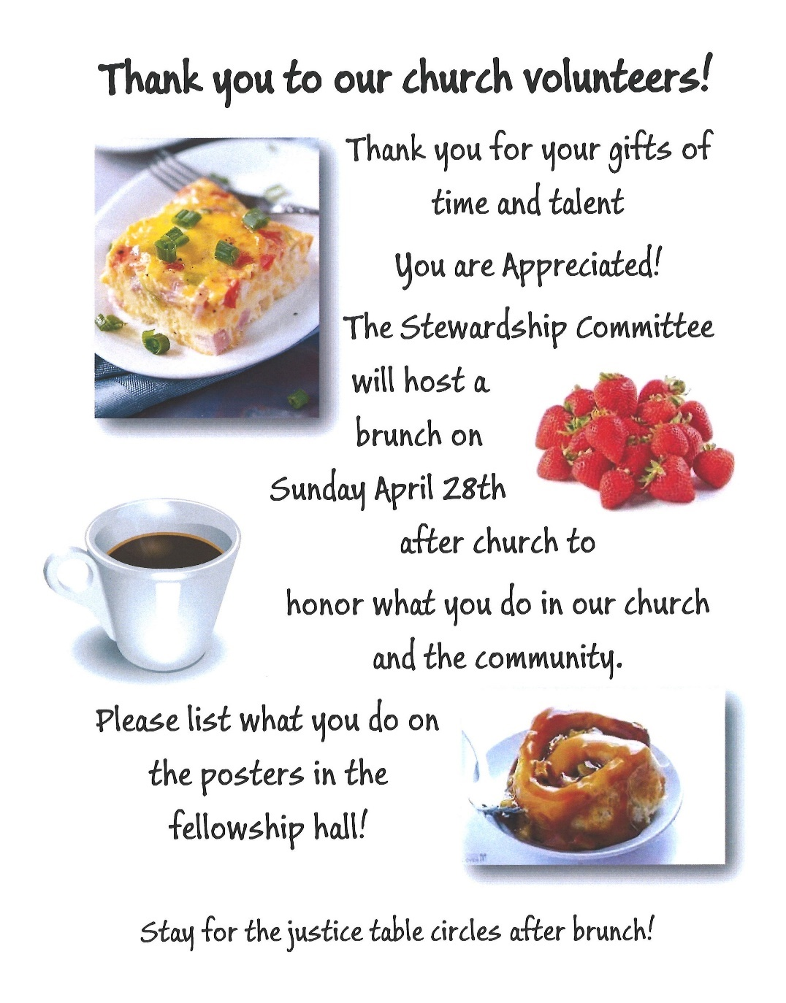
0

0
Church Directory Updated 2024

An updated directory will be emailed out the first part of May. If you need a copy mailed to you, please let Terri know in the office.
Note: The Connection letter sent out last month will provide what is needed for the directory. Make sure to fill out that form completely and send it back to the office asap.

Dan Hegstad took photos of your beautiful faces to be included in the directory. If you did not have a picture taken by Dan, please send us an updated photo. Email your photo to Terri in the office at uccbrainerd@gmail.com A jpeg is the best format. Or you may bring a photo into the office or mail it and Terri will scan it for you. Please note if you would like the photo returned.

Church Leadership
0
Get Involved, Give Back, Grow Connections – Volunteer at Church!
There are many other opportunities for you to share your talents!

--Assistant Moderator: Serves a 1-year term (may renew for 3 terms). Serve as Moderator in case of absence or incapacity of the Moderator. Participate in the service for reception of new members as the representative of the Church Council. Serve as liaison between the Council and the various small group ministries functioning within the Church. Serve as an ex-officio member of the Long-Range Planning Committee.
--Clerk: Serves a 1-year term (may renew for 6 terms Be a member of the Church Council and serve as Council secretary and keep a written record of all congregational meetings. Prepare a written summary of the actions of the Council. Maintain an accurate record of Church member’s names with the date and mode of their reception and removal as members. Maintain a record of baptisms, marriages, and deaths. Issue letters of transfer and/or certificates of membership upon request. Prepare, or direct preparation by Church staff, of a roster of members prior to each congregational meeting listing all members and their active/inactive status. The roster shall be used to determine eligibility to vote at congregational meetings and shall be the basis for reporting church size and for payment of per capita assessments. Preserve on file, all official documents, including the Articles of Incorporation, Bylaws, minutes, memorial gifts, contracts, reports, and correspondence of the church. Serve as, or appoint a Church Historian to keep a record of events of historical interest to the church.
--Treasurer: serves a 1-year term (may renew for 6 terms). The primary role is oversight of bookkeeping, church finances and Executive Committee discussions. This candidate should have a strong background or interest in finance or banking.

--Council Member-At-Large: Attend council meetings, act as a liaison for church members and council, help with nominations, spokesperson for historically underrepresented groups (HUGS).

Committees needing fresh faces and leadership:

*Christian Education *Stewardship *Music *Arts *Trustees
Contact Mary Reardo -Moderator, or Tim Anderson-Asst. Moderator with your nominations

Highlights from the Council Meeting, March 21st, 2024
0
Thursday, 3:30 pm (In-person and Zoom)
~ These are highlights. If you would like a copy of the full minutes, please contact the church office ~

Present: Alvin Velsvaag (At-Large—Mental Health), Deb Griffith (Trustees), Lowell Johnson (Christian Ed), Dan Hegstad (Marketing), Kay Cox (PRC), Steve Newcom (Justice Ministry), Marcia Ferris (Stewardship), Cynthia Janes (Clerk), Sue Hadland (Christian Ministry), Terri Chidester (Admin. Asst.)(Zoom), T. Michael Rock (Pastor) (Zoom) Absent: Mary Reardon (Moderator) and Tim Anderson (Asst. Moderator)
February 2024 Council Minutes—No additions or corrections. Approved as read.
Clerk Report — no changes reported
Review of Financials It was noted that our balance is low because we paid the $13,000 due to the City of Brainerd for road improvements on streets bounding the church.
Reports
Annual Connections Letter information: Terri and Marcia—Letters are going out starting today, asking for updated information for the next issue of the church directory.
Care Team: Not received
Christian Ed. Report.
WISE pre-commitment survey gets emailed Tuesday, April 2.
Christian Ministry: Report. Sue asked for clarification on the Sunday dates that T. Michael will not be in attendance. Pastor T. Michael replied that the dates are April 28 and Memorial Day Sunday (Mary 26?) Steve Newcom will preach on April 28, and the WISE group will present the service on May 26.
Justice Ministry: Report
Marketing: Attached Dan remarked that it’s “nice to have a budget and a committee.” He also mentioned the church’s Easter ad that was in the recent Brainerd Dispatch.
Mental Health: (verbal): Alvin called our attention to the fact that even though “WISE” is about welcoming and including people with mental health issues, the acronym stands for “Welcoming, inclusive, Supportive and Engaged,” does not actually mention mental health. Reminder: The book launch that contains testimonials of mentally ill people in the community will take place on April 14 at St Joseph’s hospital Cafeteria 2-4 pm. The companion video is now available on the Energized You Tube website. Dan Hegstad did eleven interviews. https://youtu.be/KInFDauGEc4?si=-GBmOuMIUHX5XUQ0
PRC: Report. Kay said that the committee will not meet again until Pastor Leslie returns
Stewardship: Report. Poster information is also attached. Marcia will be putting up two posters, side by side, one noting our church - based volunteer roles, and one for the community work in which a person is involved.
Trustees : Report plus Trustees financials. The organ needs work, according to Moe, who discovered some bowed pipes while doing the organ tune-up. Some pipes need to be re-shaped. Their proposal for repairing these pipes is in the Trustees packet for this month. It would cost about $9,000 to repair the two pipes. Deb has talked with Nancy Gould about the issue and has sent the Moe proposal to Laura Raedeke. She will also contact Grace Forbord to see it she can tell us when this kind of work was last done. Deb was advised to get another opinion and another bid on this work.
Pastor: Report and Verbal. Mary Reardon’s mom’s memorial service will be Saturday, March 23, at 10:30 am. Afterwards, in Fellowship Hall, coffee and cake will be served.
Executive Committee:
Annual pastoral job performance evaluation has been completed by the Executive Committee and presented by Moderator Mary Reardon to Pastor Leslie prior to her sabbatical starting. There were two parts: Part I was an AI (CHAT-GPT) analysis of the 2023 survey data related to the Pastor. Part II was an update by the Executive Committee based on our own experiences and observations. Each member of the Executive Committee performed his or her own update, and these were amalgamated into a single updated evaluation. Question from Clerk: What happens to this report now? PRC? Conference?
T. Michael said that in his experience, pastors’ performance reviews are always shredded after the review has been presented to and discussed with the pastor. No one else needs to see it.
Speaking for the Executive Committee, the Clerk said that this review will go on record as having been done, and now will be shredded.
Other news:
June 7-8th at College of St. Benedict (St. Joseph) the annual MN UCC Annual Conference meeting. Funds are available for two adults and a youth delegate to attend, in addition to Pastor Leslie. Pastor Leslie asked that Council think about this opportunity. Mary Reardon has said that she plans to attend. Pastor Newcom will attend, as well, as part of his work. Kay Cox said that she will consider being the second congregation member to attend.
Old Business
Nominating committee update: (Assistant Moderator Tim Anderson is the chair, per church by-laws.)
Moderator: Mary will stay on a second year as moderator.
Assistant Moderator: Candidate(s)?
Clerk/Secretary: Candidate(s)?
Treasurer: Candidate(s)? Cynthia Janes offered to serve as Treasurer. (She can no longer hear well enough to take minutes, so is resigning as Clerk.)
*Postponed in Tim’s absence.
Choir director info. Update: (Mary Reardon) Postponed in Mary’s absence.
Last month: Council voted to consider getting a new choir director, starting with doing research on the local going rate locally. Mary Reardon will investigate this and report back to Council.
March - Food Share Month: (Marcia) Marcia said we can write checks or donate food (checks are better because of their flexibility and matching funds in March.) Baskets for food are inside both church entrances.
New Business
Annual Pride in the Park info. Attached.
2023 Survey results and Annual Goal setting by Council (Cynthia) Cynthia reported that she has written up the results of the congregational parts of the 2023 survey, and that there are many interesting ideas that might be helpful in annual goal setting. She asked when that is typically done. She said that without goals, how do we decide what to do as a church, what direction(s) to take? How do we know how we have done at the end of the year? How do we evaluate our performance? (Answer: It is not necessarily “typically” done but has been done in the past by some moderators.) Council discussed and decided that this fall we should set goals.
Noteworthy upcoming calendar items:
Sunday, March 24: Newsletter deadline.
Friday, March 29: Good Friday casual gathering & Video – T. Michael & colleague
Sunday, March 31: Easter, including pot-luck breakfast from 8:30-9:30.
Thursday, April 18: Finalize Council Leadership Nominations
Updated! Wed., May 29: Annual reports due to Terri
Updated! Sunday, June 16: Congregational Annual Meeting: Annual Church
Report/Elections for June 2024 - May 2025.
Respectively Submitted,
Cynthia Janes, Clerk

0

Next Regular Council Meeting: Thursday, April 18th, 2024, 3:30 pm
in-person and via Zoom tinyurl.com/uccbrainerdzoom
0

0

Friday Book Group
We meet each Friday morning at 10:30 am via zoom.
Church Zoom link: https://tinyurl.com/uccbrainerdzoom
We are finishing the book, “Gutsy Women”, by Chelsea and Hilary Clinton.
This month we will begin reading the non-fiction book about animals, “Eight Bears: Mythic Past and Imperiled Future”, by Gloria Dickie.
Contact Pat Scott for more information.
0

Cooking for Everyone

Cooking for Everyone is a loosely knit group of church folks who like to cook and eat good food, and occasionally do fundraisers for the c hutch. If you would like to be included on the email list, contact Lowell Johnson at johnsonlowells@gmail.com

0

UCC & TheShop Meal
SECOND Thursday of the month!
The next cooking date is April 11th at 3:45 pm.
First Congregational is working with the young people from TheShop (Brainerd/Baxter's Youth Empowerment Center) and are preparing a meal and serving it at TheShop for the participants in the program. Mary Benson is the point person. If you are interested in helping, please email Mary at marybenson75@gmail.com

Special Offering Sunday Worship - April 28th
0
Faith Build-Habitat for Humanity
Habitat for Humanity is a global nonprofit housing organization working in local communities across all 50 states in the US and in more than 70 countries around the world. Habitat works toward our vision by building strength, stability and self-reliance in partnership with people and families in need of a decent and affordable home.
Please send your donation to First Congregational UCC, 415 Juniper St. Brainerd, MN 56401. Make sure to note on your offering: “Special Offering Faith Build/Habitat”. Or for your convenience use our Paypal account at: paypal.me/uccbrainerd
Be sure to note on your offering “Special Offering Faith Build/Habitat” in comments. Thank you!
Follow on Facebook https://www.facebook.com/LakesAreaHabitat
Restore https://www.lakesareahabitat.org/restore/

0

UCC Care Team

For anyone who wishes to join in on making calls or visits, the Care Team meets every month on the first Thursday at 10:00 am. The next meeting is Thursday, April 4th. If you know of anyone who would enjoy a call from the care team, please contact one of our Care Team; Barb Hoeft, Jack and Kay Kraywinkle, Pat Scott, Chris Yager, Joey Halverson, Deb Griffith, and Pastor Leslie.

H.U.G.S.
Hosts, Ushers, Greeters, Scripture-readers
Sunday morning greeters/ushers and coffee hosts play an important part in making our church a warm and welcoming place for all. Signup below for your first Sunday as the face of the church! https://www.signupgenius.com/go/10C0E48A9A823A5FFC07-hugs/16034811

First Congregatinal Food Shelf Collection
0

Our church continues to collect non-perishable food items for the Salvation Army Food Shelf. Please consider bringing items and donating.
There are two collection boxes: one in the parking lot entry hallway, the other in the Narthex. Brian Twamley picks up and delivers the food. Thank you!

You may also send a money donation to the church; First Congregational UCC
415 Juniper St. Brainerd, MN 56401. Or for your convenience use our Paypal account at: paypal.me/uccbrainerd Make sure to write in memo “Food Shelf”.

Brainerd Lakes Area Information
0
~ Opportunities to Know and Share God’s Love ~
0

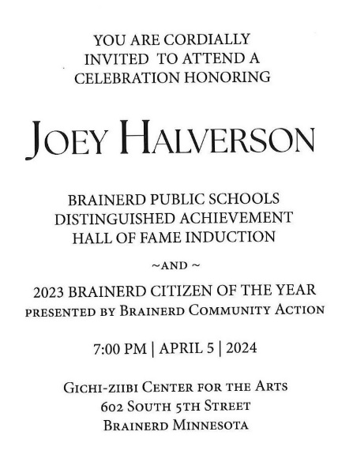
0
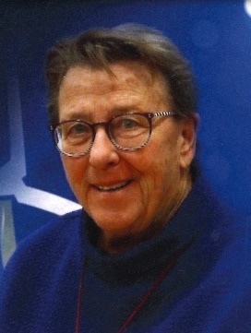

0

0

Faith Community Announcement from CWE
Crow Wing Energized, the community health movement supported by Essentia Health and Crow Wing County, is pleased to offer several upcoming events and classes. These events are free but pre-registration is required.
Matter of Balance Classes: Do you have any concerns about falling? During this class, you will learn about how to manage any fear of falling and increase your activity level. There are two options to pick from starting in April!: If you are interested in a Brainerd location, this will be held at Woodland Good Samaritan Home on Thursdays from 1 to 3:00 pm. The class meets once a week from April 4 to May 23. If you are interested in a Crosslake location, this will be held at Crosslake Lutheran Church on Tuesdays from 10:00 am to noon. The class will meet once a week from April 9 to May 28. Classes are free. Follow this link to register for either of these sessions. Events & Classes - Crow Wing Energized
Got Plans? Advance Care Planning: The best time to complete an advance care plan is BEFORE you have an emergency or health scare. During this event, you will learn about estate planning with our expert – Virginia ‘Ginny’ Knudson, atty. You will learn more about guardianship and advance care planning from Ashley Gage and Nita Loken. You will have an opportunity to complete this important document if you haven’t completed this document yet. It is free; light refreshments will be served. It will be held on Tuesday, April 16 from 9:00 am to noon at the Lord of Life Lutheran Church in Baxter. Follow this link to register: Got Plans? Advance Care Planning Event - Crow Wing Energized
This event is FREE!
You can buy the book at this event.
Pre-registration is required
Bold Yet Seldom Told-Book Launch - Crow Wing Energized

UCC News & Updates!
0
2024 Conference Retreats & Events
0

Below is a brief highlight of each event; you can find full details on the Conference's website.
To help facilitate a more comprehensive and secure registration process, the Conference has implanted a new registration system for overnight events in 2024.
Check out CampDoc!

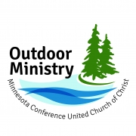
Our Whole Lives

April 12-14 | Camp Eden Wood in Eden Prairie, MN

Spring 2024 Conference Youth Event: "You Belong"
April 19 –21 | Camp Onomia, Onamia, MN Rev. Claire Klein, Facilitator
Great Lakes & West Central Regional Youth Event
July 17-20 | Augustana College, Rock Island Illinois

Clergy Family Retreat:
"What Do You Mean We Don’t Have to Plan Anything?"
August 11–13 | Camp Onomia, Onamia, MN

Women’s Retreat: "You Are a Story"
Friday, September 13 – Sunday, September 15 | Camp Onomia, Onamia, MN
Martha Brunell, Facilator

Fall 2024 Conference Youth Event
October 11–13 | Osprey Wilds Environmental Learning Center

April 2024 Calendar
Sunday | Monday | Tuesday | Wednesday | Thursday | Friday | Saturday
Leslie Workday |  |  | Office Hours  10am – 2pm | Office Hour  10am – 2pm | Office Hours  10am – 2pm  Rev. T. Michael 10am-4pm
 | 1  7pm BACP/BLUE via Zoom for the winter | 2  WISE pre-commitment Survey emailed  2pm EA-Y  5:30pm OA -Y | 3  11:45pm Men’s  Fellowship-Perkins -Y  7pm AA Common-Y | 4  10am Care Team Mtg.-Y  6:15pm Thrive Minist-Y | 5  10:30am Book Grp-Z  7pm Joey Halvorson Recognition Event | 8:30 am - Noon 6  Half Day Retreat w/ Rev.T. Michael  6:30pm Movie Night: Fellowship Hall-Y  TBD-Girl Scout Adult Training-Forum Rm
8:30am Bnrd Frnds-Y 7  10am Holy Humor Wrship & Communion-Y&FB Rev.T. Michael  Testimony - Jan Morton  11am Fellowship-Y  Justice Table Meets  1pm Adult Forum “Spiritual Gifts"  w/Rev. T. Michael | 8  7pm BACP/BLUE via Zoom for the winter | 9  2pm EA-Y  5:30pm OA -Y | 10  11:45pm Men’s  Fellowship-Perkins -Y  5:30pm Trustees-Y  7pm AA Common-Y | 11 8:30am Christian Ministry Mtg.-Y  3:34pm TheShop-Y  4pm Exec.Team Mtg.-Y&Z  6:15pm Thrive Minist-Y | 12  10:30am B00k Grp- Z | 13  9:30am-1pm AAUW Meeting in Fellowship Hall  TBD-Girl Scout Adult Training-Forum Rm
8:30am Bnrd Frnds-Y 14  10am Wrship -Y&FB Rev.T.Michael  Testimony – Lowell Johnson  11am Fellowship-Y | 15  **Connection Letter Due | 16  2pm EA-Y  5:30pm OA -Y | 11:45pm Men’s 17  Fellowship-Perkins -Y  7pm AA Common-Y | 18  3:45pmTheShop  Cooking-Y  3:30pm Council Mtg-Y&Z  6:15pm Thrive Minist-Y  6:30pm Dist.7AA-Y | 19  10:30am Book Grp- Z | 20
8:30am Bnrd Frnds-Y 21  10am Wrship -Y&FB Rev.T .Michael  Testimony – Denise Slipy  11am Fellowship-Y  11:30 Adult Forum “Understanding & Preserving Our Freshwater Resources”-Y  1-4pm Girl Scouts Mtg.-Y | 22  . | 23  2pm EA-Y  5:30pm OA -Y | 24  11:45pm Men’s  Fellowship-Perkins -Y  7pm AA Common-Y | 25  11:30am UCC Women’s Luncheon @ Sage on Laurel downtown Brainerd  6:15pm Thrive Minist-Y | 26  10:30am Book Grp- Z  ** Rev. T. Michael not in office today | 27  3pm Stewardship set-up for Volunteer Recognition Brunch tomorrow
8:30am Bnrd Frnds-Y 28  10am Justice Sunday Wrship-Y&FB  Rev. Steve Newcom & Kay Cox lead  Testimony TBD  11am Volunteer Recognition Brunch-Y  11:30 Adult Forum Justice Table-Y  *Special Offering Faith Build  *Newsletter Deadline | 29  . | 30  2pm EA-Y  5:30pm OA -Y |  | Y- Yes Mtg. in person  FB –Stream Online  Z- our Zoom  C- Cancelled  N-None  ? – No update |  | **There will NOT be a Saturday UCC Women’s Fellowship this month

