Friendship News, October 2022
First Congregational United Church of Christ, Brainerd
An Open and Affirming Congregation
Church Office is currently closed due to Covid. Please call to make an appointment.
Office phone 218-829-2528 Office E-mail uccbrainerd@gmail.com Pastor’s E-mail: pastorleslieucc@gmail.com Website: www.uccbrainerdmn.org
Schedule a 1 to 1 (in-person or by Zoom or Phone) with Pastor Leslie:
www.calendly.com/pastorleslieucc/1to1
No matter who you are, or where you are on life’s journey, you are welcome here.
Pastor’s Pen – Home, Sweet Home
It’s good to be home! The last 5 weeks have been such a wonderful and blessed time of renewal, rest, and rejuvenation. Out of curiosity, I did some quick calculations and learned that during my time away, I traveled more than 7,000 miles and set foot in 5 different states on two coasts. I utilized almost every common form of transit including planes, trains, and automobiles, a bus, a subway, and two ferries. I spent time with old friends and made a few new friends. I deepened relationships with family including my two wonderful nieces Lucienne and Callaina. I hiked the Staircase Falls trail in the Olympic National Park in Washington (I had to use my cane but I did it!)
I spent hours in silent meditation, sitting meditation, walking meditation, sitting in silence listening to the waves of the Atlantic Ocean crash against the rocks. I took in hundreds of pieces of artwork from Andy Warhol to Claude Monet, Roy Lichtenstein to Henri Matisse, Frida Kahlo to Kara Walker and Jean- Michel Basquiat. I watched 9 year-olds play in a soccer jamboree and 6 year-olds play a softball game.
There were moments of heartache and moments of epiphany; moments of grief and moments of hope; moments of deep peace and moments of exuberant joy and uncontained laughter. I am the same person I was before I left in August, and I am changed.
I am so grateful to everyone who made this time away possible. From our incredible Admin, Terri Chidester, to the members of the Christian Ministry Committee, to those folks who organized and led worship services, to Pastors Lilja and Rory who covered for pastoral care. And to all of you who showed up for worship, for groups, in leadership roles, those who donated your time and your money to the church and its ministries before and during my renewal leave… THANK YOU!
We are entering a new season as individuals, and as a congregation – a season of reinvention and discerning God’s invitation for us in this time. I am excited to be on this journey with you!
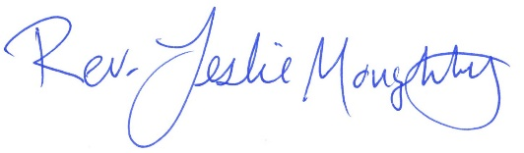
With many blessings,

Moderator’s Musings
Our Stewardship Department, during the month of October, is reminding us of our opportunities to financially support the works of our Church.

At the same time, the Council, is working on ways to balance our budget. So far, we have made transfers from non-generating interest accounts to accounts that will generate interest. We are looking at updating our facility use policy and how donations for its use are being received. We are investigating long term investment strategies. We continue to look for a person to serve on our Council as treasurer to help us with budget decisions. Do you see ways to cut costs or increase revenue? Please let a Council member know of your ideas.

As the Stewardship folks ask for your pledge commitment, we thank you for considering and deciding to help us “make ends meet”!

Colleen

First Congregational UCC News & Updates

How to watch Sunday worship The worship service is broadcasted on the church Facebook page and the church's YouTube channel every Sunday at 10:00 am.
To watch worship on Facebook, go to https://www.facebook.com/uccbrainerd/live
To watch on YouTube, go to https://www.youtube.com/firstcongregationaluccbrainerd
Live stream videos are saved and can be viewed at any time.
Worship Bulletins are available for download each week at http://tinyurl.com/UCCBrainerdBulletins.The bulletins will be ready for download first thing Sunday morning. They are available in both Word and PDF formats and are labeled by date. You can download the document and print it at home or follow along on your screen.
We can also send a copy of the bulletin in the mail each week as we have been doing for some of our home-bound members. Just contact Terri in the office.
Financial Help Available Your Church Council voted last year to allow the Pastor's Discretionary Fund to be used to assist church members and others in the Brainerd area who are experiencing financial distress during this time. We received many generous donations! If you need assistance, please email, call, or text Pastor Leslie. Let her know what your situation is and how the church might be of help.
Donate to the church online! We are now accepting your offerings and donations using PayPal. You do not need to have a PayPal account to make an online donation with a credit card. To use PayPal, go to: https://www.paypal.me/uccbrainerd

October Birthdays

Robert Jones Oct. 7 Kamery Hauan Hahn Oct. 25
Jolene Hojem Oct. 7 Cynthia Janes Oct. 25
Eileen Kurpiers Oct. 11 Ellimae Kalinoski Oct. 26
Robert Morgan Oct. 14 Elissa Hartwig Oct. 28
Andrea Bertram Oct. 15 Tracy Lyons Oct. 28
James Newgord Oct. 15 Andrew Pucko Oct. 29
Megan Kath Oct. 16 Elizabeth Paulson Oct. 30
Louis Grabowski Oct. 20 Paxie Imsdahl Oct. 31
Luann Rice Oct. 31

Church Office Hours
Wednesday, Thursday and Fridays
10:00 am to 1:00 pm.
Please call Terri at the office 218-829-2528 or 218-537-1636 for further assistance.

Pastor Leslie’s drop-in hours* are as follows:
Wednesdays 2:00 pm – 4:00 pm
Fridays 11:00 am – 1:00 pm

To make an appointment outside of the drop-in hours, go to calendly.com/pastorleslieucc/1to1 to schedule an appointment, or call or email Pastor Leslie directly.

Church Leadership
Get Involved, Give Back, Grow Connections – Volunteer at Church!

There are many opportunities for you to share your talents!
--Treasurer, serves a 1-year term (may renew for 6 terms). The primary role is oversight of bookkeeping, church finances and Executive Committee discussions. This candidate should have a strong background or interest in finance or banking.

--Council Member-At-Large: Attend council meetings, act as a liaison for church members and council, help with nominations, spokesperson for historically underrepresented groups (HUGS).

Committees needing fresh faces and leadership:
-Christian Education -Trustees -Stewardship -Memorial
-Music -Arts -Christian Ministry

Call or text Colleen LeBlanc - Moderator, with your nominations: 218-251-4065

Highlights of Council Meeting, September 15th, 2022
4:00 pm (In-person and Zoom)
~ These are highlights. If you would like a copy of the full minutes, please contact the church office ~
Present: Colleen LeBlanc, Marcia Ferris, Alvin Velshaug, Karen Ford, Lowell Johnson, Marina Grabowski, Tim Anderson, Joe Stattine
Absent: Leslie Moughty Zoom: Terri Chidester, Deb Griffith
August Council Minutes - Approved with no changes
Clerk Report – Karen – No activity
Financials
  - Joe Stattine reported on Internal audit/review conducted by Reed Campbell and Joe Stattine. Review will be taken under advisement before the 2023 budget is presented for approval by congregation.
  - Marcia Ferris reported on the budget preparation schedule and process.
  - Financial reports prepared by Terri Chidester. Total income from January – August 2022 is $106,285.83. Total expenses for January – August 2022 are $135,417.96. 150th Anniversary: Total income was $6,825.00. Expenses were $4,330.75.
  - Tim Anderson reported that he was still working on securing information on Minnesota Law and use of the church building and equipment.
  - Deb Griffith and Colleen are reviewing the proper procedure for organizations who use the church facilities. Resources may include checking with other churches in the community and listening closely to the opinions of the groups currently using the church facilities.
Pastor Report – Rev Leslie – No report as Pastor Leslie is on renewal.
Member at Large Report – Alvin Velshaug – there will soon be a forum scheduled on making dream catchers.
Department Reports
- Trustees – Deb Griffith – LED lightbulbs as was the choice for replacement are not available in the dimmable form. It will cost $1500-2000 to replace all the bulbs in the sanctuary.
- Stewardship – Marcia Ferris – See reports of department meeting. See also comments above on the process and schedule. Marcia also expressed the need to update information on members who are not attending regularly. Marcia requested permission to duplicate information sheet to be included in the Stewardship letter. Approved by acclimation.
- Christian Ministry – Marina Grabowski – Department has placed revision of by-laws in the future on the calendar since the members have been planning worship services during Pastor Leslie’s Renewal time.
- Christian Education – Lowell Johnson – Forums have been scheduled.
Old Business
- A request was received by the Indigenous Peoples’ Day Planning Committee for use of the church facility on November 3, 2022. A Motion was made and Seconded and approved unanimously. Note: There will need to be a UCC person in charge at this event to assist with questions etc. The form will need to be altered to include this information.
- Colleen LaBlanc will resend the link for the Manual of Church and requests that council members review in time for October meeting.
- 150th Anniversary Report.
Respectfully submitted: Karen Ford, Clerk

Next Regular Council Meeting: October 20th, 2022, 4:00 pm in-person & via Zoom

Stewardship Commitment Season is Here
Rooted in love ~ Soaring into the Future
Thank you for being a faithful participant at Brainerd UCC! Energized by celebrating our 150th Anniversary, we are soaring into the future.

Pledge materials will be handed out Sunday, Oct. 2nd. Envelopes will be mailed to those not in attendance that day. Pledge Sunday is Oct. 23rd.

It is crucial that we maintain a high level of participation to continue being a light in the Brainerd Lakes community. All types of contributions are welcomed and cherished. You are warmly invited to shine here by sharing your resources.

In faith, First Congregational UCC Stewardship Committee, Judy, Marcia, Carla & Sarah Jo)

Hosts, Ushers, Greeters, Scripture-readers
Sunday morning greeters/ushers and coffee hosts play an important part in making our church a warm and welcoming place for all. Here’s a secret; it’s FUN!! If each household committed to 3 Sundays a year as greeter/ushers and/or coffee hosts we would have a full complement of participants. For instance, I plan to take 2 Sundays in August to greet/usher and 2 Sundays in February to Host Coffee.
The Christian Ministry Committee is working on simplified instructions for these duties and one of us will be available to guide you through your first go if needed. Are you ready to take the leap into RADICAL HOSPITALITY? Give it a go and signup below for your first Sunday as the face of the church! https://www.signupgenius.com/go/10C0E48A9A823A5FFC07-hugs/16034811
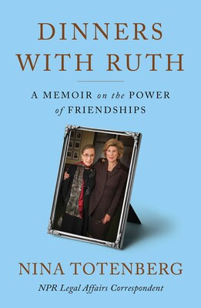
Friday Book Group - 10:00 am
Via Zoom: tinyurl.com/uccbrainerdzoom
October 14th we will start a new book, “DINNERS WITH RUTH: A Memoir on the Power of Friendships”, by Nina Totenberg.

Meets at Noon each Wednesday of the month

Weekly rotating Schedule
1st Wednesday: B-Merri - 19624 Co. Rd. 3 Brainerd
2nd Wednesday: Yesterday's Gone Bar & Grill - 219 So. 9th St. Brainerd
3rd Wednesday: Dunmire's on the Lakes - 19090 MN 371 Brainerd
4th Wednesday: Dennis Drummond Wine Co. - 11919 Thiesse Rd. Brainerd
5th Wednesday: El Tequila Mexican Restaurant - 7399 Garrison Rd. Baxter

October Adult Forum - 11:30 after worship

October 2nd: "The Gentle Art of Swedish Death Cleaning" - Swedish author Margareta Magnusson, aged somewhere "between 90 and 100," describes Swedish death cleaning as "going through all my belongs and deciding how to get rid of the things I do not want anymore." But even more difficult is getting rid of things you can't part with! Sharon Carlson will share some great ideas of how to get organized and downsize your "treasures."
October 9th: “UCC Activism/Immigration involvement in the 1980s. And now?” – In the 1980s, our UCC church participated in activities surrounding the Central American Overground Railroad, a little known piece of U.S. history to this day. In her book, Northern Shores/ Southern Borders: Revelations of a Bilingual Life, Jan Kurtz includes a Chapter called “First Congregational Church: A Hotbed of Activist?” (p. 126) sharing our UCC Minnesota connections with the Sanctuary movement and Central American refugees headed to Canada. Join us to share our stories and/or learn of them for the first time. Who are the current refugee? How will we respond this time? If you have her book, bring it along. If not, she will have copies for sale – proceeds donated to the Kurtz-Poland CLC Spanish Scholarship fund.
October 23rd: “Introduction to Day of the Dead” - Jan Kurtz will present rituals and how
combining cultures gives us more grieving and celebration options. This will be in
prep for the following Sunday's service.
October 30th: “Story Circle” - Jan Kurtz will facilitate a round-about of stories of
folks that have been in our midst since 1972 to present. Stories to be of those passed or still sitting right next to us. A chance to celebrate their lives and everyone here now, enriching all of us.

Do you have ideas for topics or connections with people who might be willing to lead Adult Forums? If so contact Lowell Johnson at 218-820-5290 or johnsonlowells@gmail.com
Special Offering - Sunday October 23rd - Crisis Line
The Crisis Line provides confidential and anonymous telephone support to people in distress and crisis, and to serve as a lifeline for positive change by connecting our clients to area resources and to give support and encouragement.
Serving friends and neighbors in Aitkin, Cass, Crow Wing, Morrison, Todd, and Wadena Counties it is a service that helps people when they are in crisis, or before their problems become a crisis. You can also call for a referral to resources in the area and surrounding counties. Your donation can help the Crisis Line & Referral Service provide services to improve the quality of life and improve the mental health of the community you live in.
Please send your donation to First Congregational UCC, 415 Juniper St. Brainerd, MN 56401. Make sure to note on your offering: “Crisis Line Special Offering”. Thank you! Or for your convenience use our Paypal account at: paypal.me/uccbrainerd
Be sure to note on your offering “Crisis Line Special Offering” in comments.

UCC TheShop Meal Update!

The next scheduled meal cooking is Wednesday, November 16th at 3:45 pm. New volunteers will be helping with the meal!
For the last several years, UCC volunteers have provided a meal to the youth at TheShop - Brainerd Baxter Youth Drop-in Center. On the third Wednesday of the month, 3-4 youth from TheShop come over to our kitchen and help prepare a delicious meal that is then brought back to TheShop for the hungry and appreciative teens there.
If you are interested about joining this effort, contact Sharon Carlson 218-828-1581or Lowell Johnson 218-820-5290 or johnsonlowells@gmail.com

Choir Update! Mark Your Calendar!
Our first rehearsal will be November 20th at 8:30 am.
Choir is going to look a little different this year.
We are going to sing for two seasons, the advent season and the lent season. We will of course sing for Christmas and Easter.
We would like to invite anyone that would like to sing during those seasons to join us. Or you can just choose one or the other and join us for that. Sometimes things get very busy and you don’t have an entire year to commit. I’d like to see you with us for any time that you can send your heavenly voices out to the congregation. If you have any questions you can text or call Diane Hauan at 218–839–0669.

The Columbarium at First Congregational UCC, Brainerd
The Columbarium is located in the historic space that once was our church’s front entry way. How appropriate it is that our Columbarium now marks another entry way into a new life — where the Spirits of Love and Truth are always present! Should you wish to learn more about the purchase of a niche for your own cremains or for the ashes of a loved one, please call the church office at (218) 829-2528. Terri Chidester, Admin. Asst., can send you a packet of materials via email or regular mail. The Memorial Committee has prepared the information packet, and it contains all the details you will need as you consider inurnment here at First Congregational UCC. Have any other questions? Contact Dawn Stattine at dawnstattine@gmail.com

Are You Called to the Jail?
Over the last 10 years or so, A number of UCC and other community folks have been volunteering in the Crow Wing County Jail. Covid shut down this programming. There is an effort now to bring back valuable programming to the residents of the jail. If you have any interest in this effort, contact Lowell Johnson 218-820-5290 for more information on the wide range of volunteer opportunities there.

Brainerd Lakes Area Information ~ Opportunities to Know and Share God’s Love ~

You are invited to the first Cultural Thursday presentation of the year!
Cultural Thursdays is proud to present – Tales of Laughing Fox: Anishinaabe Culture and History through Storytelling and Native American Flute Performance. Join us in the Chalberg Theater or via Zoom on Thursday, October 6th at noon for a one-of-a-kind cultural education opportunity.
Michael Laughing Fox Charette is a Native American storyteller, poet, and member of the Red Cliff Band of Lake Superior Chippewa, located in Northern Wisconsin. As a self-taught Native flute player, he enhances his stories with hauntingly beautiful flute and storytelling performance. His work as both a visual and performance artist is varied and tied together by the traditional wisdom of the Anishinaabe people, which is respectfully incorporated into his work. Michael Laughing Fox Charette weaves traditional storytelling with his own experiences.
Please encourage your friends, family and neighbors from far and wide to be a part of the event. You can register here for the Zoom webinar if you’re participating from afar or the convenience of your desk.

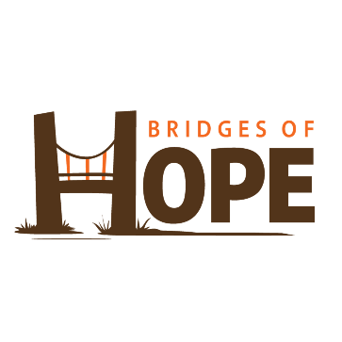
Bridges of Hope - OVERNIGHT SHELTER UPDATE
Bridges of Hope is excited to announce that our Overnight Shelter reopened for season number two on Thursday, September 15th! We hosted seven individuals who otherwise would have had nowhere to sleep. Our shelter director, Ann Hunnicutt, and our incredible staff are returning for the second season. Last year we were open for 147 consecutive nights and offered 78 unique adults 942 nights of sleep. We fully expect this year to be much busier, based on calls that our office staff have received recently regarding homelessness.
The shelter will be open from 7 PM to 8 AM this year, accepting walk ins from 7 PM - 11 PM. All guests must be 18+.
Mark your calendars for another Sleep Out at Bethlehem Lutheran on the nights of November 7th-10th. If you or anyone you know would like to volunteer to Sleep Out so that others can Sleep Inside, email ann@bridgesofhopemn.org to get on the list!
If you have a group of adults that would like to volunteer, we are going to be offering volunteer opportunities this season. Contact Ann for more information.
*First Congregational is volunteering 3 ½ hour shifts (no overnight shift) from October 16th – 23rd. If you would like to volunteer or for more information please call
Chris Yager (temporary point person) 425-286-5456.

Out of the Darkness Nisswa Walk
Saturday, October 15th, 2022

The Pines at Grand View Lodge
23521 Nokomis Ave. Nisswa, MN 56468

Register at Afsp.org/Nisswa

Community Mental Health Resource Fair
When: Saturday, October 29, 2022
Time: 8:30 am to 3:00 pm
Where: First Lutheran Church
424 So 8th St; Brainerd, MN
Cost: Free but registration is required – Lunch will be served
Registration link: Community Mental Health Resource Fair - Crow Wing Energized
At the opening of the event, we will share information about our 100 Community Conversations project, the new 988 #, and Resourceful. Attendees can attend up to three of the following presentations (info of each presentation is on registration link): *Adverse Childhood Experiences (ACEs) *Changing the Narrative *Lethal Means *Make It Ok *More Resilient Minnesota *Naloxone training *Postvention *Question, Persuade, Refer (QPR) *Resourceful *SAVE
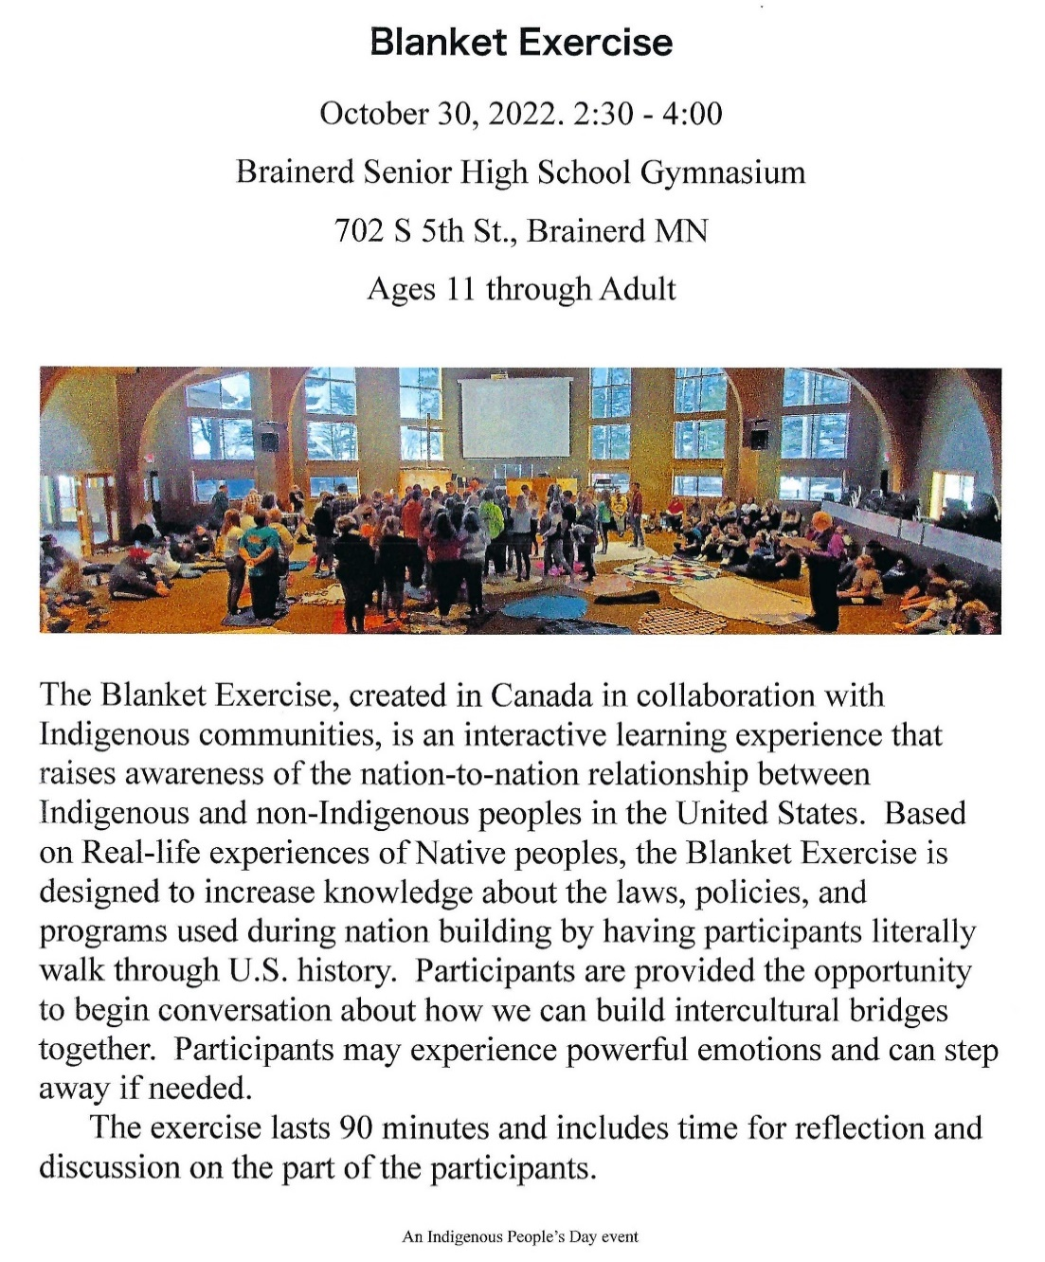

Church Calendar October 2022
Sunday | Monday | Tuesday | Wednesday | Thursday | Friday | Saturday
 | Office Closed  Open by Appt. | Office Closed  Open by Appt. | Office Hours  10am – 1pm  Pastor Drop-in 2-4pm | Office Hours  10am – 1pm | Office Hours  10am – 1pm  Pastor Drop-in  11am-1pm | 1
9am Brnrd Frnds-Y 2  10am Wrshp/Communion-Y&V  Stewardship Testimonies  11am Fellowship -Y  11:30 Adult Forum-Y  Pldge Pkt. Handout | 3  7pm BACP in church-Y | 4  2pm Emotions Anon- Y  5:30pm Overeaters Anon-Y | 5  10am Pryr Crcl-Y  12pm Mens Grp  @ B-Merri-Y  7pm AA Common-Y | 6  Mail out remaining Pledge Packets | 7  10:30am Bk Grp- Z | 8
9am Brnrd Frnds-Y 9  10am Worship-Y&V  Stewardship Testimonies  11am Fellowship  11:30 Adult Forum-Y | 10 | 11  2pm Emotions Anon- Y  5pm LARJP Mtg.-Y  5:30pm Overeaters Anon-Y | 12  9am Fndtion Mtg-? Y&Z  10am Pryr Crcl-Y  12pm Memorial-Y  12pm Mens Grp-@ Yesterday’s Gone-Y  7pm AA Common- Y | 13  6:30 BLUE-Park/church backup-Y | 14  10:30am Bk Grp- Z  Start new Book | 15
9am Brnrd Frnds-Y 16  10am Worship-Y&V  Stewardship Testimonies  11am Fellowship Y | 17 | 18  2pm Emotions Anon- Y  5:30pm Overeaters Anon-Y | 19 10am Pryr Crcl-Y  12pm Mens Grp @Dunmire’s North-Y  7pm AA Common-Y | 20  4pm Council Mtg –  7pm AA Dist.-Y | 21  10:30am Bk Grp- Z | 22
9am Brnrd Frnds-Y 23  10am Worship-Y&V  Pledge Sunday  11am Fellowship-Y  11:30 Adult Forum-Y  Special Offering  Crisis Line  Newsletter Deadline | 24 | 25  2pm Emotions Anon-Y  5pm LeMesa-Y  5:30pm Overeaters Anon-Y | 26  10am Pryr Crcl-Y  12pm Mens Grp @Dennis Drummond Wine Co.-Y  7pm AA Common-Y | 27 | 28  10:30am Bk Grp- Z | 29
9am Brnrd Frnds-Y 30  10am Worship-Y&V  11am Fellowship-Y  11:30 Adult Forum-Y | 31  Council Committee & Department Budget Request due to Terri Admin Asst |  |  | Terri Admin Asst Vacation Days  October 12th & 13th | V or Z– Zoom or Virtual Online  C – Cancelled  Y – Meeting held  ? – No updates | *Sun. Bk Stdy on hold  *Choir practice resumes in Nov.

