
Friendship News, January 2026
0
First Congregational United Church of Christ, Brainerd
An Open and Affirming Congregation
The Church Office Hours: Tuesday, Wednesday, Thursday from 10:00am – 2:00pm
Office phone 218-829-2528 Office E-mail uccbrainerd@gmail.com
Pastor Leslie’s E-mail: pastorleslieucc@gmail.com Website: www.uccbrainerdmn.org

No matter who you are, or where you are on life’s journey, you are welcome here.
0
Pastor’s Pen
0

The Work of Christmas
The gifts have been exchanged, the carols have been sung, the family visits made. As I walked through the Minneapolis airport on Christmas Day, all of the shops with Christmas products were advertising their clearance prices. By now our Christmas trees are beginning to take on a certain crispiness, reminding us that taking ornaments off a tree is not nearly as fun as putting them on. In other words, the party’s over.
But wait just a minute. We are not done here yet! A child has been born, who has been named Emmanuel, God-with-us. Many of my friends have shared with me that feeling of arriving home with their new baby for the first time. It is the feeling of excitement and uneasiness at the realization that this child that they were sent home with would be their responsibility. It was now their task to take care of the child’s needs. One friend told me that upon arriving home from the hospital with their daughter, she and her partner could do nothing but look at the baby, and then look at each other with a scared expression that communicated, “Okay, this is about to get real.”
As we celebrated the birth of Jesus on December 25th, we must remind ourselves that Christmas has not ended. Birth is a beginning! In our liturgical calendar, we are still celebrating the season of Christmas. On January 6th the Christian Church celebrates the arrival of three wise men to the manger, ushering in the season of Epiphany, a season that poses question “How do we, the church, live our mission in light of the nativity?” In other words, what does Christ’s birth mean for how we live and love and care for one another, especially the poor and marginalized? Or perhaps we could put it this way: “Ok, church, this is about to get real.”
This time of year always reminds me of this poem by Howard Thurman:
The Work of Christmas by Howard Thurman
When the song of the angels is stilled,
When the star in the sky is gone,
When the kings and the princes are home,
When the shepherds are back with their flock,
The work of Christmas begins:
To find the lost, to heal the broken, To feed the hungry, to release the prisoner,
To rebuild the nations, to bring peace among brothers, to make music in the heart.
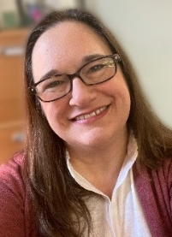
In these coming months, may we look around and discover the ways in which God is calling us to live this coming season as a Christmas people.
With Peace,
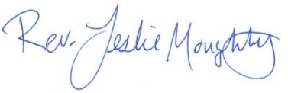
Mission Statement of First Congregational UCC
0
“To know and share God’s love within us.”

Purpose Statement of First Congregational United Church of Christ
“First Congregational UCC is a welcoming, inclusive, and progressive community committed to promoting social justice, spiritual growth, and love for all people. We reject discrimination and advocate for equality and dignity for marginalized communities. Through worship, education, and service, we work to make a positive impact on the world and invite all individuals to join us in this journey of faith and service.”

0
Church Office Hours
Tuesday, Wednesday, Thursday 10:00 am - 2:00 pm
Closed Mondays and Fridays
Please call for assistance - office 218-829-2528

The Office will be closed on New Year’s Day, January 1st, 2026

0
Pastor Leslie’s Workday Schedule

Sunday through Thursday (Days off are Friday and Saturday)
Drop-in Hours: Wednesdays 11:00 am – 1:00 pm
*Drop-in hours are times set aside for “drop-in” conversations, much like a professor’s office hours.
Pastor Leslie is out of the office 12/28/25 through 01/08/26
Rev. Emily Goldswaithe leads and is preaching worship Sunday, January 4
For Pastoral Care emergencies please call Rev. Mark Ford at 218-232-8131
For non-emergencies, please contact someone on the Care Team
Everyone is encouraged to make an appointment, especially if the above times are not convenient. You can go to www.calendly.com/pastorleslieucc and select a day and time that works for you, or you can email Pastor Leslie at pastorleslieucc@gmail.com or call/text at 218-656-0096.

0
Stay Connected

How to watch Sunday worship: The worship service is broadcasted on the church Facebook page every Sunday at 10:00 am.
To watch worship on Facebook, go to https://www.facebook.com/uccbrainerd/live
**Live stream videos are saved and can be viewed at any time. All memorials, weddings and 12th Night Concert are on our church Facebook page.
How to stay connected with First Congregational friends and members: Join the private group for our Facebook Connections Page at https://www.facebook.com/groups/uccbrainerd.
Financial Help Available The Pastor's Discretionary Fund is available to assist church members and others in the Brainerd area who are experiencing financial distress with modest financial help. If you need assistance, please email, call, or text Pastor Leslie. Let her know what your situation is and how the church might be of help.
Donate to the church online! We are accepting your offerings and donations using PayPal.
You do not need to have a PayPal account to make an online donation with a credit card. To use PayPal, go to: https://www.paypal.me/uccbrainerd
First Congregational UCC News & Updates
0
0
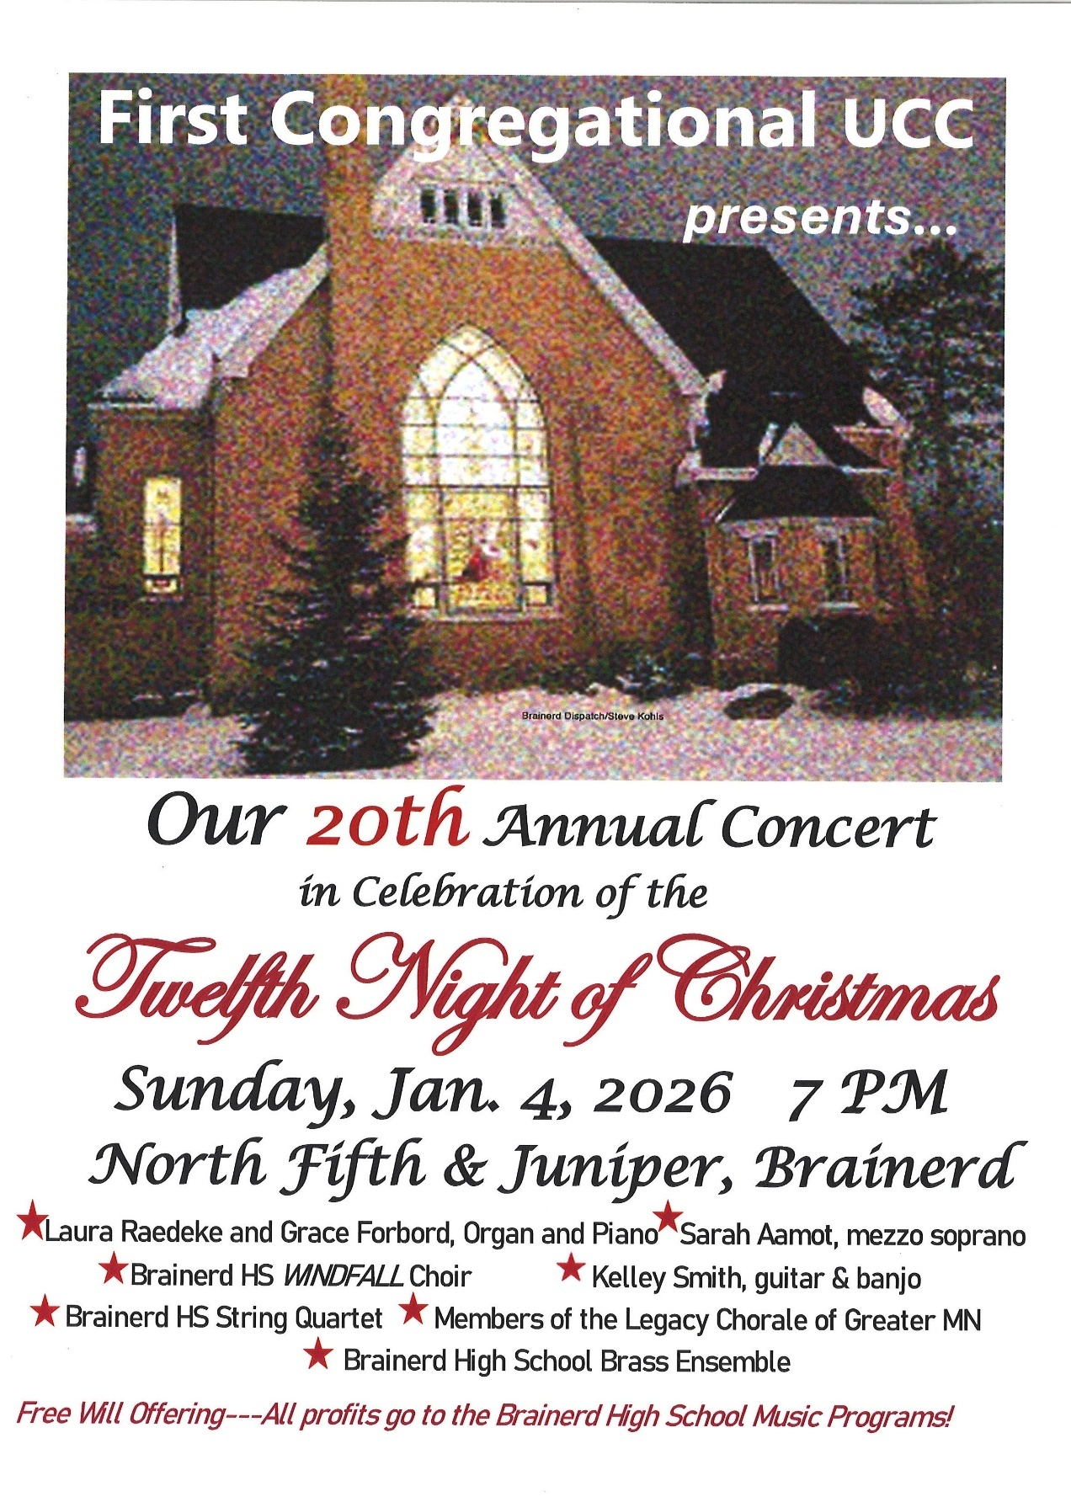

0
Special Announcment - Gift to My Neighbor to Love Coalition
0
Join us in supporting this important fundraising effort for My Neighbor to Love Coalition. 19 families who need a home this holiday season will be able to move in Creekside with your help!

The First Congregational United Church of Christ is offering a challenge! They will match up to $4500 if other faith communities or individuals are willing to donate.

If you been thinking about giving to our "A Home for the Holidays" campaign - NOW IS THE TIME! Help us match this offer and reach our goal to furnish 19 new housing units.
0
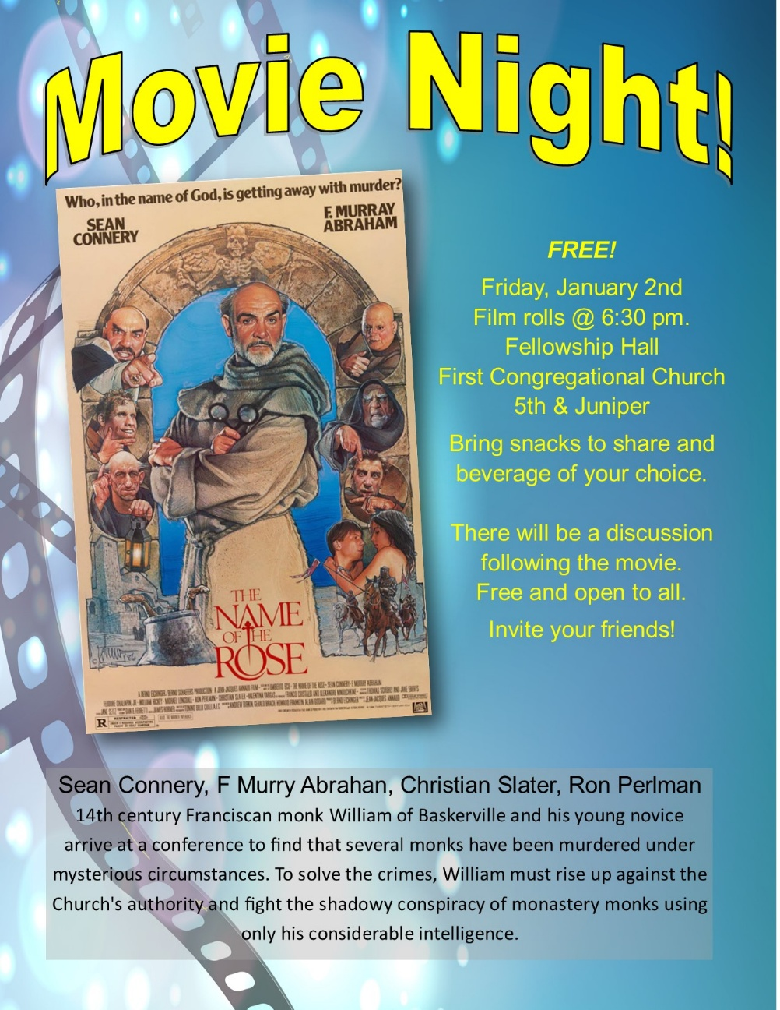

0
Join Brunch Bunch
0

Sunday, January 4, 12:15pm at Wings Cafe.
What’s better than going out for brunch after church? Going to brunch with church friends, of course! Join us for our first Brunch and then mark your calendars for future dates, First Sunday of each month. Contact Tracy Lyons for information.

0

UCC Care Team
For anyone who wishes to join in making calls or visits, the Care Team meets every month on the first Thursday @ 10:00 am.
Meeting Date Change: Thursday, January 8th

If you know of anyone who would enjoy a call from the care team, please contact one of our Care Team; Jack and Kay Kraywinkle, Pat Scott, Chris Yager, Deb Griffith, Joey Halvorson (text or email) and Pastor Leslie.

0

January Adult Forums - 11:30 after worship
0

January 11 – Suicide Aware "SafeTALK": Presenting understanding and language use with resource materials gathered from SafeTALK with Destiny Tinnes. Minnesota Suicide Prevention Regional Coordinator, North Central Region & Region V+ Mental Health.

January 25 - Justice Sunday Justice Action Teams: We will meet during Adult Forum time. Each team will provide an update on their work with time for Q&A and a discussion time. This is your opportunity to hear what the teams are planning and add your perspective.
WISE – Mental Health, Creation Care, Community Building/DEI/LGBTQ, Children & Families in Poverty.
If you want to join a Justice Team, email Steve Newcom, Justice Ministries at snewcom17@gmail.com and plan to join us this January. It is an open, welcoming process.


0
Ungreening the Church
Saturday, January 10 @ 11:30 am

Join Christian Ministry in taking down and putting away the Christmas decorations. Thank you for volunteering!

0

Christmas Flowers Pick Up
Sunday, January 11th after worship.

Christmas flowers will be removed from the sanctuary during the “Un-greening” of the church on Saturday January 10. If you made a donation toward the flowers, you are more than welcome to choose one to take home. The flowers will be available during the un-greening and after worship the following day (Sunday, January 11.)
The donors of the flowers get first choice!

0


0
0
January Birthdays
Scott Furness January 3 Marcia Ferris January 13
Deb Lundberg January 8

0
Next Council Meeting
Update! Thursday, January 22, 2026, 3:30 pm
in-person and via Zoom tinyurl.com/uccbrainerdzoom

First Congregational Approved Council Meeting Minutes are available upon request.
Please contact Terri Admin Asst. at the Church Office.

0
Volunteer at Church!
There are many other opportunities for you to share your talents

These committees need your gifts: * Trustees * Stewardship *
0
0
Join Our Church Choir

2026 Schedule:
Jan. 11 & 25, No choir in February,
March 1,15 & 29, April 12 & 26, May 3 & 17.
Rehearsal 8:30 am in the Sanctuary
Worship Service at 10:00 am

0

January Special Offering – Warming Shelter Bridge on 7th
Sunday Worship – January 26th
Bridges of Hope, in partnership with law enforcement, Crow Wing County, nonprofit organizations, church partners, and community members recognized the need for a safe place for homeless adults (ages 18+) to sleep in our community. This group has come together in a collaborative effort to address homelessness by providing a low-barrier warming shelter that offers a safe place for individuals to rest for the night.
To donate, send a check with "Warming Shelter” in the memo line to: First Congregational UCC, 415 Juniper St. Brainerd, MN 56401 or donate online using PayPal https://www.paypal.me/uccbrainerd and indicate "Warming Shelter" in the Note.
0

TheShop Meal @ First Congregational UCC!

A number of youth and the staff from TheShop (Brainerd Baxter Youth Drop-in Center) come over to our kitchen and help prepare a delicious meal that is then brought back to TheShop for the hungry and appreciative teens there.
January 28th is the next meal cooking date at 3:00-5:30 pm in the church kitchen.
Each month is scheduled for the fourth Wednesday of each month. Save future date! Feb. 25, March 25, April 22, May 27.
If you are interested in joining and volunteering your time please contact Breton Monroe, Executive Director @ 218.316.2070 or The Brainerd Baxter Youth Center @218.454.0009
https://theshopbrainerd.org/ https://www.givemn.org/donate/Theshop


0
Cooking For Everyone

This group is OPEN FOR EVERYONE!

Email Lowell Johnson and he will add you to the member list. You will be notified when and where they next meet.
0

0

Upgraded Video and Media
0
We started live-streaming our Sunday Worship Service during COVID and a good number of folks tuned in. When we resumed in-person worship, we continued to stream live. Now, several years later, we see a significant number of folks watch live or watch the recording during the week. We may have 40 to 50 in the Sanctuary on Sunday morning, and 8 to 12 people watching live online. That is a significant percentage, and we can assume that some of those watching have others watching with them as well. Further, if we look at the number of views throughout the week, we see many more. I don’t trust that the number we see is accurate, however. I do not believe that 150 people watched by Thursday. Many of those are “bots” that check content or maybe Martians. But even if it’s 10% of that number, that’s another 15 views by real people.
The video feed is a significant part of our presence in the world. If people are considering visiting or joining a church, they typically first visit the website and watch a video. It is essential to have a good online presence.
With that in mind, we believe it is time to upgrade our video feed and media in the Sanctuary and Fellowship Hall. After a lot of research, education, and bids from good technology companies, we are ready to move forward.
Bids have come in significantly higher than expected, so we kept researching options. We found a very knowledgeable gentleman, Mike Schmitt, who has done work for the UCC churches in Hackensack and Walker. Mike confirmed that the equipment we were considering was a good choice, and he has agreed to install it in our church for a very reasonable fee.
Without going into too much detail, here is what we are proposing:
Sanctuary:
New remote control high-definition cameras for the Sanctuary, along with all the necessary switching and interface hardware.
Mounting a second monitor (TV) on the right side of the Sanctuary. We will be able to display video, graphics, and song lyrics (you can’t clap while holding a hymnal!) on these monitors, which will be controlled and fed from the AV booth in the back of the Sanctuary.
The new system will allow us to send high-definition video with graphics. People watching on YouTube will have the opportunity to donate through a QR Code graphic. YouTube also has the option of real-time closed captions. YouTube videos are far more reliable than Facebook, and we can archive them indefinitely. Our current system doesn’t do any of that.
Fellowship Hall:
We will install a high-quality audio system and hang a large monitor on the east wall. There will be an interface for audio and video that should be operable by almost anyone. If a group wants to meet in Fellowship Hall (a source of income for the church), they will have access to an excellent speaker system with video capabilities. Also, this system will be fed live from the Sanctuary, so if we have an overflow crowd for a large wedding or funeral, they will have a good experience.
What’s next?
One of our church members volunteered to build the Audio/Video “booth” in the Sanctuary. We will pay for the materials needed.
Millie Gjertson gave money to the memorial committee for upgrades to Fellowship Hall. The acoustic ceiling came from Millie’s donation, and the room is much quieter. It is likely that some of her donation will fund at least a portion of the Fellowship Hall upgrades.
Our Foundation will be asked to donate.
We are pleased to announce that Don Bennett will make a generous donation to ensure the completion of this project. Thank you, Don!
Lastly, you have the opportunity to contribute. If you feel that these upgrades are worthy of your support, you are enthusiastically encouraged to do so!
If you have any questions or would like more detailed information, please contact Dan Hegstad or Joe Stattine.
0
2025 Justice Table Team Report
Children, Families, Poverty, Homelessness & Housing
November 16, 2025 11:30-12:30
Marcia Ferris, Sharon Carlson, Leslie Moughty
Unable to attend – Mabel Schultz, Georgia Harris, Cynthia Janes

JAIL OUTREACH: Jan Kurtz (who had to leave) gave Marcia information that she is going to be volunteering at the jail working with Spanish companion and translation. She will also learn more about ICE detainees. Dan Hegstad is also volunteering at the jail doing an IMPACT program for inmates within 90 days of release.
HOMELESS SHELTER: Marcia & Mary Benson (Quaker Friend) have signed up to volunteer at The Bridge on S. 7th. The Shelter reopened in September. Bridges of Hope continues working with Brainerd City Council to get authorization for the shelter to be year round. Mornings do not work for many of our church team now (now there is no evening volunteer opportunity.) Deb Griffith & Marcia agreed we will sign up as teams of two or/ individually. The link is below. Create an account. They need an ok and your birth date for a background check. You can choose a time to volunteer online. 6:30-8am. It’s a great workout helping the guests check out, cleaning and changing the beds for the coming night. https://volunteer.bloomerang.co:443/JE/bas6nebexg029t
MY NEIGHBOR TO LOVE COALITION: Marcia went to The Bridge on S 7th Open House on Nov. 1st and talked to Vicky Kinney who had a table there. Our church teams of Environment/Creation Care, Mental Health, DEI/LGBTQ and our Poverty/Homeless team all agreed that MNTLC is a good mission to support as all our focus areas come together there. Sharon suggested we get an information table showing what the Coalition is doing, how we have helped and what can we do now. Marcia will contact Vicky about pictures, handouts and more information. January is our target month to do a display. The Phase One 4 plex is done, the Phase Two 12 plex is done - our church gave $10,000 (there was a matching grant to total $20,000) for the 12 plex. Phase 3, has 19 units and is being completed. There is a ‘Home for the Holidays’ fundraiser to buy furnishings and finishes. That makes 35 housing units for people in real need of housing. Phase 4 will involve one more building. For a grand total of over 50 units to help this area end homelessness! MNTLC also has a community room and offers a supportive environment to assure residents continued success.
Submitted by Marcia Ferris


0
First Congregational Food Shelf Collection

Our church continues to collect non-perishable food items for the Salvation Army Food Shelf. Please consider bringing items and donating.
There are two collection boxes: one in the parking lot entry hallway, the other in the Narthex. Brian Twamley or Stephanie Lee pick up and deliver the food. Thank you!
0
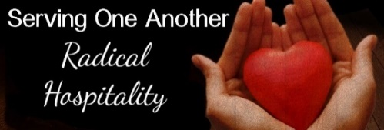
0

H.U.G.S.
Hosts, Ushers, Greeters, Scripture-readers
Sunday morning greeters/ushers and coffee hosts play an important part in making our church a warm and welcoming place for all. Signup with the link below for your first Sunday as the face of the church!

https://www.signupgenius.com/go/10C0E48A9A823A5FFC07-hugs/16034811
0

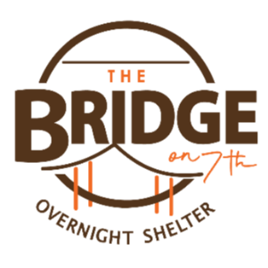
UCC Volunteer Opportunity – Warming Shelter Bridge on 7th
Sign up for a morning shift as a team of two or/individually. You can choose a time to volunteer online. The staff and shelter guests appreciate our involvement. The link is below. Create an account. Pick a date. They need your birth date and your ok for a background check.
Start here at this link to sign up for volunteering; https://www.bridgesofhopemn.org/volunteer
Then go to this link to choose a date to volunteer at the shelter. They need your birth date and your ok for a background check. https://volunteer.bloomerang.co:443/JE/bas6nebexg029t


0
Friday Book Group

We meet each Friday morning at 10:30 am via zoom.
Church Zoom link: https://tinyurl.com/uccbrainerdzoom

We are reading "Gratitude” by Oliver Sacks. A deeply moving testimony and celebration of how to embrace life." Gratitude consists of four essays that originally appeared in The New York Times , accompanied by a foreword that describes the occasion of each chapter.

0
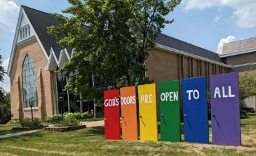
Welcome to our Facility
We are blessed to be able to share our beautiful church facilities for purposes that match the values of the church and its mission which is “To know and share God’s love within us.” We are an open church valuing the diversity of age, culture, gender identity, opinions, physical and mental abilities, and sexual orientation.
To request a space for general use, ask for a “Request for Church Building Use” form and
policy packet from Terri in the church office, at 218-829-2528 or email uccbrainerd@gmail.com. Submit the request form back to Terri in the office, and it will be submitted for approval at the next Council Meeting. For wedding or funeral use, contact Pastor Leslie: pastorleslieucc@gmail.com

0
0
The Columbarium & Memorial Garden
First Congregational UCC, Brainerd
The Columbarium is in the historic space that once was our church’s front entry way.
How appropriate it is that our Columbarium now marks another entry way into a new life — where the Spirits of Love and Truth are always present!
The Memorial Garden is located on the south lawn of the church. The Garden provides a place for cremains of your loved one to be buried in the ground among natural plantings. The Garden fee includes the inscription of your loved one’s name on a granite plaque that is mounted on the outside wall of the church.
Should you wish to learn more about the purchase of a niche for your own cremains or for the ashes of a loved one, please call the church office at (218) 829-2528 and a packet of materials will be sent to you via email or regular mail. The Memorial Committee has prepared the information packet, and it contains all the details you will need as you consider inurnment here at First Congregational UCC.

0
Brainerd Lakes & Surrounding Area Information
~ Opportunities to Know and Share God’s Love ~
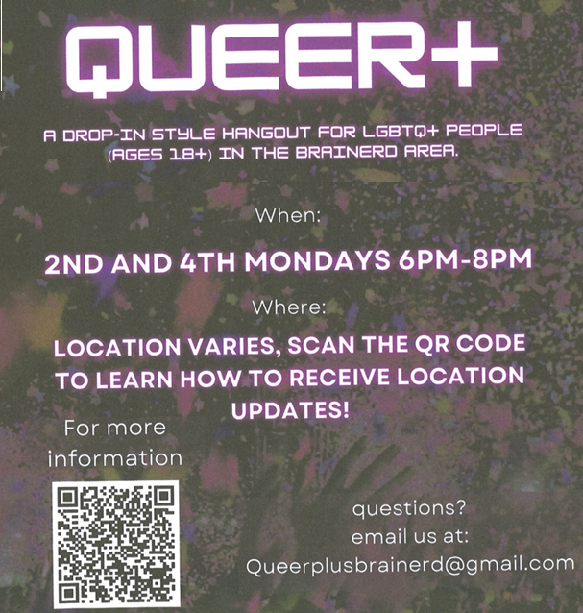
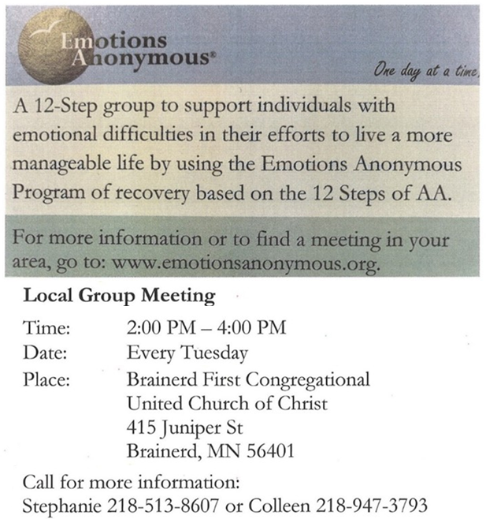
0

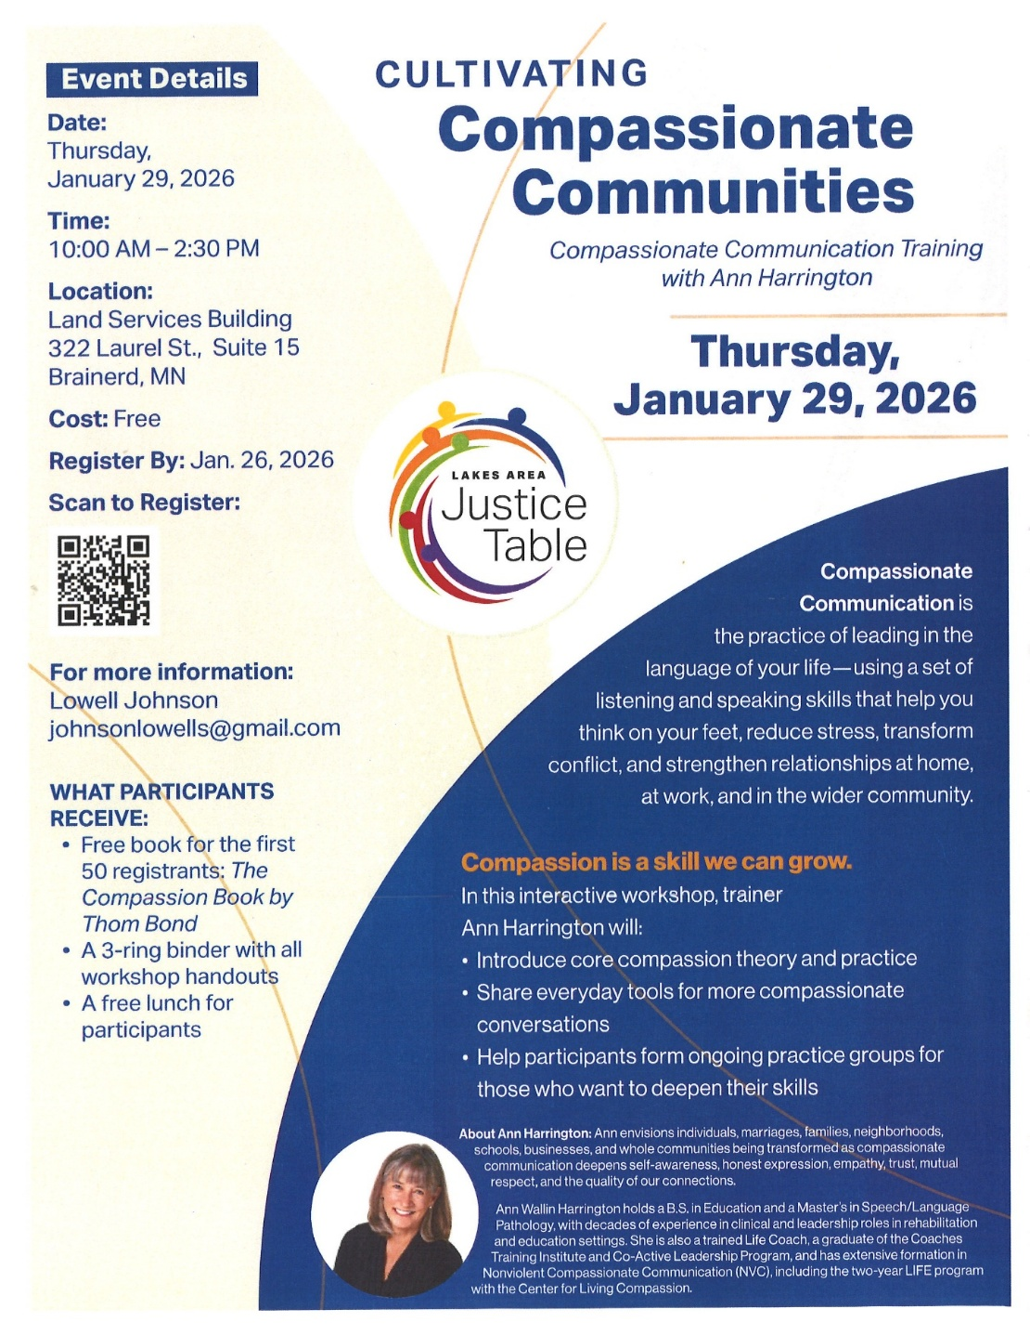
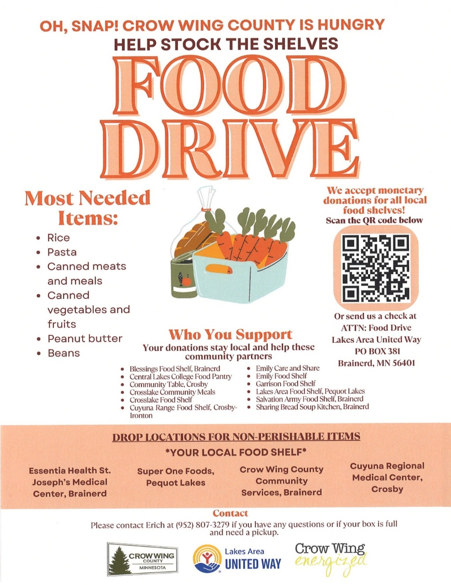

Janaury 2026 Calendar
Sunday | Monday | Tuesday | Wednesday | Thursday | Friday | Saturday
Y- Yes Meeting in person  FB -Facebook Live Stream Online  C- Cancelled  N-No Meeting  Z-our church Zoom | Office Closed  Pastor Leslie Vacation through Sun. Jan. 4. | Office Hours  10am – 2pm | Office Hours  10am – 2pm  Pastor Drop-in Hours  11:00 am – 1:00 pm | Office Hours  10am – 2pm  New Year’s Day 1  Church Office Closed | Office Closed  2  10:30am Bk Grp-Z  6:30pm Movie Night-Y | 3
8:30am Bnrd Frnds-Y 4  10am W0rship & Communion-Y&FB  *Rev. Emily Goldswaithe  Preaching  11am Fellowship-Y  12:15p Brunch Bunch @ Wings Café  7:00pm Twelfth Night | 5 | 6  2pm EA-Y  5:30pm OA -Y | 7  11:45pm Men’s Grp @ Wings Cafe-Y  12pm Memorial Mtg.-Y  1:30pm PRC Mtg.-Y  4pm Christian Ministry-Y  7pm AA Common-Y | 8  Rescheduled - 10am Care Team-Y | 9  10:30am Bk Grp-Z | 10  Women’s Coffee -C  10am BLA DSA Potluck in Fellowship Hall  11:30am Un-Greening the Church
8:30am Bnrd Frnds-Y 11  8:30am Choir Practice-Y  10am W0rship & Choir-Y&FB  11am Fellowship-Y  11:30am Adult Forum “SafeTALK” | 12 | 13  10am Foundation Mtg.-Z  2pm EA-Y  5:30pm OA -Y | Trustees-N 14 11:45pm Men’s Grp @ Wings Cafe-Y  3:30pm Executive Team Mtg.-Y  7pm AA Common-Y | 15  6:30pm Dist.7AA-Y | 16  10:30am Bk Grp- Z  6:00pm Justice Table-Creation Care Team Movie Night-Fellowship Hall | 17
8:30am Bnrd Frnds-Y 18  10am Worship-Y&FB  11am Fellowship-Y  1pm Girl Scout Mtg.-Y | 19 | 20  2pm EA-Y  5:30pm OA -Y | 21  11:45pm Men’s Grp  @ Wings Cafe-Y  7pm AA Common-Y | 22  3:30pm Council Mtg.-Y & Z | 23  10:30am Bk Grp- Z | 24
8:30am Bnrd Frnds-Y 25  8:30am Choir Practice  10am Worship & Choir-Y&FB  11:15am Fellowship-Y  Justice Sunday-Adult Forum “Justice Table Team Mtgs.-Y  **Special Offering Warming Shelter-  Bridge on 7th  **Newsletter Deadline for February | 26 | 27  2pm EA-Y  5:30pm OA -Y | 28  11:45pm Men’s Grp @ Wings Cafe Y  TheShop Cooking-Y  7pm AA Common-Y | 29  11:30am Women’s Lunch @ The Spot 371 | 30  10:30am Bk Grp- Z | 31

